Supplementary information

Maximizing the value of liquid products and minimizing carbon loss in hydrothermal processing of biomass: An evolution from carbonization to humification
Nader Marzban ^{a,b*}, Judy A Libra ^{a*}, Vera Susanne Rotter ^{b}, Christiane Herrmann ª, Kyoung S. Ro ^{c}, Svitlana Filonenko ^{d*}, Thomas Hoffmann ª, Markus Antonietti ^{d}
ª Leibniz Institute for Agricultural Engineering and Bioeconomy e.V. (ATB), Max-Eyth-Allee 100, 14469 Potsdam, Germany
^{b} Department of Environmental Technology, Chair of Circular Economy and Recycling Technology, Technische Universität Berlin, 10623 Berlin, Germany
^{c} USDA-ARS, Coastal Plains Soil, Water & Plant Research Center, Florence, SC 29501, USA
^{d} Max-Planck Institute of Colloids and Interfaces, Department of Colloid Chemistry, Am Mühlenberg 1, 14476 Potsdam, Germany
*Corresponding authors: nmarzban@atb-potsdam.de, jlibra@atb-potsdam.de, Svitlana.Filonenko@mpikg.mpg.de

Table S1 The mean value and standard deviation of organic compounds, N, P, K, Ash%, COD, TS%, VS%, and pH of cow manure digestate
Sugars  (g/kgFM) | Aromatics  (g/kgFM) | Acids  (g/kgFM) | N-Kjeld  (g/kgFM) | P  (g/kgFM) | K  (g/kgFM) | Ash% | COD  (g/kgFM) | TS% | VS% | pH
Glucose = 0.09 ± 0.00 | Guaiacol = 0.01 ± 0.008 | Acetic = 0.23 ± 0.00 | 5.70 ± 0.03 | 14.85  ±0.12 | 47.3 ±6.39 | 27.20 ± 0.18 | 81.16 ± 0.27 | 8.4 ± 0.05 | 72.98 ± 0.18 | 7.90 ± 0.01

Sucrose = 1.01 ± 0.02
Note: Fructose, the organic acids (butyric, caproic, valeric, propionic, lactic, formic), alcohols (methanol, ethanol, propanol and butanol) were under detection limit of 0.02 g/L and aromatics (catechol, cresol, furfural, phenol, HMF) were under detection limit of 0.02 mg/L.

Table S2 Fiber analysis of digested cow manure using VLUDFA method for determination of cellulose, hemicellulose, and lignin content. NDF, neutral detergent fiber, ADF, acid detergent fiber, ADL (acid detergent lignin) were used to estimate hemicellulose = NDF – ADF, cellulose = ADF – ADL, and lignin = ADL.
NDF% | ADF% | ADL% | Cellulose | Hemicellulose | Lignin
77.40 ±0.26 | 67.51 ±0.75 | 26.62 ±0.49 | 40.89 ±0.46 | 9.89 ±0.96 | 26.62 ±0.49

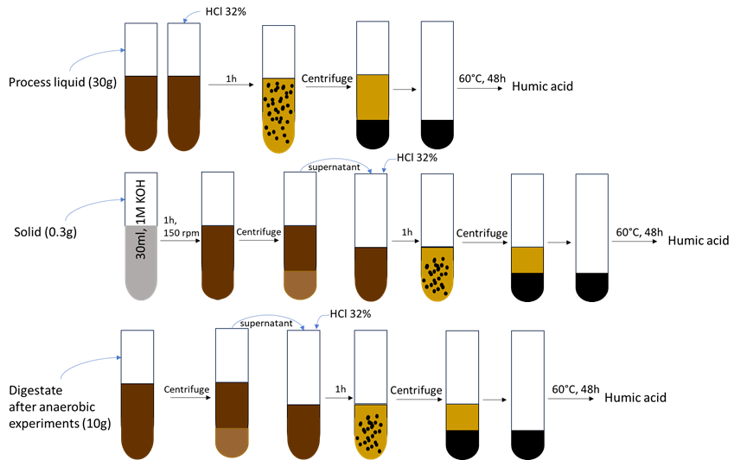
Fig. S1 Schematic of A-HA extraction from solid (A-HAs), process liquid (A-HAl) and anaerobically digested HTC and HTH process liquid

Fig. S2 A-HA extraction from solid: visual appearance of a) supernatant including A-HA extracted from solid products, and b) supernatant after precipitation and removal of A-HA, c) dried extracted A-HA,s

Table S3 Analysis performed for the feedstock digestate, HT-solids and process liquids and A-HAs produced from HTC and HTH processes
 | Digestate | HT-Solid | Process liquid | A-HAs
HPLC- aromatics, sugars, acids | × | × | × | -
GC- fatty acids and alcohols | × | × | × | -
TC, TIC, TOC | - | - | × | -
ICP-OES | × | × | × | -
Ash%, TS, VS% | × | × | × | ×
Elemental-CHNS | × | × | - | ×
FTIR, UV, SEM, XRD | - | - | - | ×
N- Kjeldahl, and IC | - | - | × | -
HHV (MJ/kg)* | × | × | - | ×
* HHV (MJ/kg) of feedstock (digestate), solid and A-HAs extracted from solid and liquid products, was calculated based on correlation (HHV (MJ/kg)=0.3853.C+44.98/O) reported in (Marzban et al., 2022).

Table S4 Content and lumped parameters of HTC and HTH liquids, the inoculum used for biogas experiments
Name of sample | HTC | HTH-5KOH | Digestate | HTH-4KOH-HCl | HTH-4KOH-pH 8 | HTH-4KOH-pH 6.86
Amount (g) | 33.0 ±0.04 | 9.9 ±0.02 | 6.0  ±0.0 | 12.8  ±0.02 | 14.7  ±0.00 | 14.0  ±0.03
TS% | 2.2 | 11.5 | 8.3 | 9.0 | 6.3 | 4.9
VS% | 51.5 | 35.3 | 72.8 | 27.9 | 34.4 | 46.5
pH | 7.8 | 8.0 | 7.9 | 8.0 | 8.0 | 6.8
Inoculum (g) | 30.5  ±0.27 | 30.1  ±0.00 | 30.0  ±0.0 | 30.0  ±0.0 | 30.0  ±0.0 | 30.0  ±0.0
COD (g/kgFM) | 26.4 | 59.1 | 81.2 | 53.1 | 47.1 | 44.3

Fig. S3 Changes in pH, and reductions in K and ammonium concentrations of HTH-4KOH using cation exchange resins. Note the HTH-4KOH-pH 8, was adjusted in 5 minutes, with K= 17095 (mg/L)

Analytical methods
Fiber analysis of feedstock: Feedstock fiber analysis was carried out using an FIBRETHERM FT12 Automated Fiber Analyzer from C. Gerhardt GmbH & Co. KG, Königswinter, Germany, following (2012) guidelines (methods 6.5.1, 6.5.2, and 6.5.3). The feedstock, after drying at 60°C and grinding, underwent analysis in triplicate. Each analysis involved placing 0.5g of the sample into a filter bag. The fractions of hemicellulose, cellulose, and lignin were determined based on the fiber fractions of the feedstock. These fractions, including neutral detergent fiber (NDF), acid detergent fiber (ADF), and acid detergent lignin (ADL), were estimated as follows: hemicellulose = NDF – ADF, cellulose = ADF – ADL, and lignin = ADL.
Elemental Analysis, Ash%, VS%: Carbon, hydrogen, nitrogen, and sulfur elements of solid products and humic acids were determined for 0.1g DM(60) samples with the Elemental Analyzer Vario ELIII (Elementar Analysensysteme, Hanau, Germany). The solid samples were dried at 60°C for 48 h for analysis, and the elemental results were corrected and reported as wt%, db and wt%, daf. The total solids (TS%) and ash content (ash%) in the feedstock and solids were measured by drying at 105°C for 24 hours, followed by 550°C for 5 hours. The volatile solids (VS%) were calculated as the difference between TS% and ash%.
Aromatics: The aromatics (HMF, furfural, catechol, phenol, guaiacol, and cresol) were quantitatively analyzed in the HT-solids and liquids. For the solids, a 1g sample of wet solid was mixed with 40 ml of distilled water at 60°C for 30 minutes at 150 rpm, followed by filtration using a PTFE syringe filter. Prior to the measurement of aromatics in process liquid samples, 1ml of sample was diluted 1:4 with a 10% acetonitrile solution, and filtered with PTFE-syringe filters (Neolab PTFE 0.2µm-green). Aromatics concentrations were measured using an HPLC system (Dionex ICS 3000; Thermo Fisher Scientific Inc., USA) equipped with a Eurospher C18 column.
Sugars and Organic Acids: Sugars (fructose, glucose, sucrose, xylose, and arabinose), and organic acids (formic acid, lactic acid, and acetic acid) were extracted from the solids. A 1g sample of wet solid was mixed with 40 ml of distilled water at 60°C for 30 minutes at 150 rpm, and the resulting solution was filtered using a PTFE syringe filter. The process liquid samples were diluted 1:4 with deionized water, and analyzed with the Ultimate 3000 UPLC system from DIONEX (column: Eurokat H (300mm; 8 mm, 10 µm), company KNAUER) and 0.01 N sulfuric acid was used as mobile phase.
Fatty Acids and Alcohols: Fatty acids (propionic, butyric, valeric, and caproic) and alcohols (ethanol, methanol, propanol, and butanol) were measured using gas chromatography (GC) on a 7890A gas chromatograph from Agilent Technologies (USA). Samples were prepared by mixing 5g of the process liquid or wet solid with 1ml of Carrez reagent I (30% acetate or zinc sulphate solution) and 1ml of Carrez reagent II (15% potassium ferrocyanide solution), and subsequent addition of 0.5ml of phosphoric acid (85%) and 5ml of deionized water. The final solution was centrifuged for 10 min at 4500 rpm, and 2 ml of the supernatant was filtered through a disposable filter (Sartorius, 0.2µm cellulose acetate, non-sterile blue) directly into the autosampler vessel. Theses fatty acids were labled as GC-fatty acids.
ICP-OES: The trace elements, phosphorus, and sulfur contents of the solids were analyzed with an ICP-OES (ICAP6300 Duo, Thermo Fisher Scientific Inc., USA) equipped with an autosampler. A 0.1gDM(60) ground sample of solid was dissolved in 8ml HNO3 for 20 minutes in a microwave system. For liquid samples, 10 ml were digested with 6 ml HNO3 for 20 minutes in a microwave system. The solutions were then cooled down to 60°C and injected into the ICP-OES.
N-Kjeldahl, Nitrate, Nitrite, and Ammonium: Total Kjeldahl nitrogen was determined following DIN EN 25663 for process liquids. The Nitrate, nitrite, and ammonium concentrations in the process liquid were determined using an Ion Chromatograph (ICS 1000 from Thermo Fisher Scientific Inc., USA ) with a Dionex Ion Pac AS 11-HC column. Liquid samples underwent centrifugation and filtration through a 0.2-micrometer pore size syringe filter. Subsequently, the samples were diluted 1:100 to maintain analyte concentrations within the range of 10 mg to 100 mg for precise measurement.
TC and TOC: The total carbon (TC) and total organic carbon (TOC) in the process liquid were measured using a Shimadzu TOC-5050A Analyzer. The TOC was obtained by subtracting the total inorganic carbon (TIC) concentration from the TC concentration. The chemical oxygen demand (COD) of digestate was measured using LCK 014 kit from HACH LANGE GMBH (Willstätterstraße 11, D-40549 Düsseldorf, Germany).
Characterization and analysis of humic acids: The Ash%, TS%, VS%, elemental analysis were performed similar to solids. The FTIR spectra of the humic acids were recorded using a Nicolet iS5 ATR-FTIR device (Thermo Scientific, Madison, WI, USA). Phase characterization of the humic acids was was conducted via powder X-ray diffraction (XRD) on Bruker D8 Advanced diffractometer with Cu-Kα radiation source (λ = 0.154 nm) coupled with NaI scintillation counter-ScintiDetector. The samples were measured incrementally at a rate of 0.03° step-1 within the range 5°≤2θ≥90°. To examine the surface morphology of the humic acids, a Phenom ProX Desktop SEM-EDX instrument (USA) was employed. UV-Vis Spectroscopy was conducted using the T70+ UV/VIS Spectrometer (PG Instruments LTD) at a constant temperature of 60 °C for the initial 40 minutes. The spectra of humic acids were collected in a 1 mm cuvette within the wavelength range of 350 to 700 nm.
Higher Heating Value (HHV): The higher heating value (HHV) of the feedstock, solids and A-HA was calculated based on a correlation (Equation (2)) presented in a previous study. The calculation involved the carbon and oxygen percentages of the samples on a dry basis.
HHV(MJ/kg)=0.3853C+44.98/O

Table S5 Results for solids and humic acids produced in the five runs: mass recovered, yields, % volatile solids (%VS).
Name of run | pH initial | Mass (g DM) |  |  |  | Volatile solids (wt%,db) |  |  |  | Yield (wt%,db)
Name of run | pH initial | FS | Char | HA from solids | HA from liquid | FS | HC | HA,s | HA,l | Solid | HA,S | HA,L
HTC | 7.89 | 51.14 | 28.73 | 4.68 | 3.52 | 72.75 | 68.80 | 59.09 | 61.50 | 56.18 | 9.15 | 6.88
HTH-1 | 9.34 | 50.46 | 28.35 | 3.56 | 3.48 | 72.75 | 65.04 | 60.38 | 74.85 | 56.18 | 7.06 | 6.89
HTH-2 | 10.08 | 51.06 | 29.04 | 6.39 | 4.35 | 72.75 | 61.73 | 67.68 | 96.43 | 56.87 | 12.51 | 8.52
HTH-4 | 11.80 | 49.78 | 22.19 | 6.76 | 6.63 | 72.75 | 49.62 | 62.74 | 95.00 | 44.58 | 13.58 | 13.32
HTH-5 | 13.25 | 49.17 | 21.21 | 7.51 | 10.93 | 72.75 | 43.67 | 60.50 | 95.77 | 43.14 | 15.28 | 22.23

Table S6 Process conditions, inputs and yields for digested cow manure as feedstock (%solids = 8.3%)
Name of run | Time (min) | T  (°C) | KOH (g) | pH initial | pH end | Gas (ml) | Pmax (bar) | Mass Char (g DM) | Solid yield  (wt%)
HTC | 240 | 240 | 0 | 7.89 | 7.61 | 1760 | 39.9 | 28.73 | 56.18
HTH-1KOH | 240 | 240 | 1×(7.58)=7.58 | 9.34 | 8.07 | 1100 | 40.0 | 28.35 | 56.18
HTH-2KOH | 240 | 240 | 2×(7.58)=15.16 | 10.08 | 8.73 | 235 | 34.6 | 29.04 | 56.87
HTH-4KOH | 360 | 240 | 4×(7.58)=30.32 | 11.80 | 9.77 | 0 | 31.5 | 22.19 | 44.58
HTH-5KOH | 240 | 240 | 5×(7.58)=37.9 | 13.25 | 9.87 | 0 | 30.7 | 21.21 | 43.14

Table S7 Comparison of the concentrations of total (TC), inorganic (TIC) and organic (TOC) carbon in the process liquid from the five runs and the TOC after the precipitation of the A-HA (TOC(HA)).
Name | Process liquid |  |  |  | After HA precipitation |  |  |  | Comparison TOC(HTH) to TOC(HTC) (%) | Comparison  TOC(HA) to  TOC(HTC) (%)
Name | TC  (mg/L) | TOC (mg/L) | TIC (mg/L) |  | TC(HA) (mg/L) | TOC(HA) (mg/L) | TIC(HA) (mg/L) |  | Comparison TOC(HTH) to TOC(HTC) (%) | Comparison  TOC(HA) to  TOC(HTC) (%)
HTC | 11225 | 9232 | 1993 |  | 7756 | 7769 | -13 |  | 0 | -15.8
HTH-1KOH | 13801 | 11367 | 2434 |  | 8941 | 8760 | 181 |  | 18.8 | -5.1
HTH-2KOH | 16288 | 12958 | 3330 |  | 9686 | 9561 | 125 |  | 28.8 | 3.6
HTH-4KOH | 23074 | 19401 | 3673 |  | 12911 | 12628 | 283 |  | 52.4 | 36.8
HTH-5KOH | 26147 | 22781 | 3366 |  | 13601 | 13373 | 228 |  | 59.5 | 44.9

Fig. S4 Elemental composition of solids (wt%,daf) from HTC and HTH runs and the humic acids recovered from the solids and process liquids compared to the digestate and humic acid from Sigma Aldrich Chemicals. (daf: dry ash-free)
Table S8 Average values and standard deviations (SD) of individual sugars, aromatics, acids, and alcohols in HTC and HTH solid and liquid products
 |  | HTC |  | HTH-1KOH |  | HTH-2KOH |  | HTH-4KOH |  | HTH-5KOH
 |  | Liquid (g/L) | Solid (g/kg DM) | Liquid (g/L) | Solid (g/kg DM) | Liquid (g/L) | Solid (g/kg DM) | Liquid (g/L) | Solid (g/kg DM) | Liquid (g/L) | Solid (g/kg DM)
Sugars | Glucose | 0.12 | 1.08 | 0.03 | 0.75 | 0.33 | 1.68 | 0.93 | 2.63 | 1.56 | 4.67
 |  | ±0.01 | ±0.05 | ±0 | ±0.01 | ±0.01 | ±0.06 | ±0.13 | ±0.02 | ±0.15 | ±0.01
 | Sucrose | 0 | 0 | 0.15 | 2.11 | 0.75 | 3.44 | 0.92 | 2.63 | 1.06 | 3.19
 |  | ±0 | ±0 | ±0 | ±0.01 | ±0.01 | ±0.02 | ±0.04 | ±0.03 | ±0.12 | ±0.01
 | Fructose | 0 | 0 | 0.03 | 0 | 0.06 | 0 | 0.11 | 0.32 | 0.21 | 0.63
 |  | ±0 | ±0 | ±0 | ±0 | ±0.01 | ±0 | ±0.04 | ±0 | ±0.05 | ±0
 | Xylose | 0.04 | 0 | 0.05 | 1.92 | 0.11 | 2.33 | 0.16 | 0.45 | 0.27 | 0.81
 |  | ±0 | ±0 | ±0 | ±0.01 | ±0.01 | ±0.11 | ±0.05 | ±0 | ±0.06 | ±0.01
 | Arabinose | 0.07 | 0 | 0.14 | 0 | 0.27 | 0 | 0.63 | 1.78 | 0.79 | 2.37
 |  | ±0.01 | ±0 | ±0 | ±0 | ±0.01 | ±0 | ±0.06 | ±0.01 | ±0.08 | ±0.05
Acids | Acetic | 1.48 | 7.92 | 1.87 | 6.19 | 2.25 | 6.23 | 2.75 | 7.8 | 2.76 | 8.29
 |  | ±0 | ±0.16 | ±0.03 | ±0.15 | ±0.03 | ±0.07 | ±0.02 | ±0.11 | ±0.1 | ±0.24
 | Lactic | 1.86 | 3.75 | 3.29 | 7.54 | 4.43 | 7.95 | 8.11 | 23.02 | 8.47 | 25.42
 |  | ±0.03 | ±0.16 | ±0.01 | ±0.08 | ±0.02 | ±0.35 | ±0.17 | ±0.16 | ±0.18 | ±0.06
 | Formic | 1.05 | 3.85 | 2.23 | 6.35 | 2.71 | 5.77 | 3.51 | 9.97 | 3.51 | 10.53
 |  | ±0.01 | ±0.05 | ±0.01 | ±0.04 | ±0.04 | ±0.01 | ±0.11 | ±0.01 | ±0.16 | ±0.15
 | Propionic | 0.06 | 0.6 | 0.07 | 0.42 | 0.08 | 0.38 | 0.15 | 0.45 | 0.11 | 0.57
 |  | ±0.003 | ±0.04 | ±0 | ±0.11 | ±0 | ±0 | ±0.73 | ±0.01 | ±0 | ±0.12
 | Butyric | 0 | 0 | 0.02 | 0 | 0.03 | 0 | 0.04 | 0.11 | 0.02 | 0.12
 |  | ±0 | ±0 | ±0 | ±0 | ±0 | ±0 | ±0.004 | ±0 | ±0 | ±0
 | Valeric | 0.03 | 0.2 | 0.04 | 0.21 | 0.06 | 0.17 | 0.11 | 0.26 | 0.1 | 0.39
 |  | ±0 | ±0 | ±0 | ±0 | ±0 | ±0 | ±0 | ±0 | ±0 | ±0
 | Caproic | 0.08 | 0 | 0.08 | 0.31 | 0.06 | 0.28 | 0 | 0 | 0.04 | 0
 |  | ±0.01 | ±0 | ±0.01 | ±0.06 | ±0.01 | ±0.018 | ±0 | ±0 | ±0.01 | ±0
Alcohols | Methanol | 0 | 2.84 | 0.63 | 1.94 | 0.61 | 1.43 | 1 | 2.1 | 0.84 | 1.95
 |  | ±0 | ±0.470 | ±0.172 | ±0.16 | ±0.127 | ±0.56 | ±0.047 | ±0.211 | ±0.245 | ±0.117
 | Ethanol | 0 | 0 | 0 | 0 | 0 | 0 | 0 | 0 | 0 | 0
 |  | ±0 | ±0 | ±0 | ±0 | ±0 | ±0 | ±0 | ±0 | ±0 | ±0
 | Propanol | 0 | 0 | 0 | 0 | 0 | 0 | 0 | 0 | 0 | 0
 |  | ±0 | ±0 | ±0 | ±0 | ±0 | ±0 | ±0 | ±0 | ±0 | ±0
 | Butanol | 0 | 0 | 0 | 0 | 0 | 0 | 0 | 0 | 0 | 0
 |  | ±0 | ±0 | ±0 | ±0 | ±0 | ±0 | ±0 | ±0 | ±0 | ±0
Aromatics | HMF | 0.03 | 1.28 | 0 | 0 | 0 | 0 | 0.19 | 0.14 | 0.01 | 0
 |  | ±0.003 | ±0.001 | ±0 | ±0 | ±0 | ±0 | ±0.011 | ±0 | ±0.001 | ±0
 | Furfural | 0.03 | 1.01 | 0.01 | 0.38 | 0 | 0.08 | 0 | 0.12 | 0.01 | 0.03
 |  | ±0 | ±0.001 | ±0 | ±0.001 | ±0 | ±0.001 | ±0.001 | ±0.001 | ±0 | ±0
 | Catechol | 0.3 | 17 | 0.27 | 5.94 | 0.26 | 5.65 | 0 | 3.84 | 0.03 | 5.14
 |  | ±0.01 | ±0.107 | ±0.003 | ±0.01 | ±0.004 | ±0.053 | ±0 | ±0.008 | ±0.02 | ±0.074
 | Phenol | 0.21 | 3.84 | 0.18 | 2.22 | 0.16 | 2.25 | 0.01 | 1.53 | 0.02 | 1.13
 |  | ±0.008 | ±0.009 | ±0 | ±0.003 | ±0.02 | ±0.02 | ±0.018 | ±0.003 | ±0.012 | ±0.019
 | Guaiacol | 0.45 | 5.26 | 0.28 | 4.27 | 0.24 | 4.09 | 0.04 | 2.51 | 0 | 2.38
 |  | ±0 | ±0.034 | ±0.004 | ±0.009 | ±0.007 | ±0.008 | ±0.019 | ±0.005 | ± | ±0.002
 | Cresol | 0.02 | 0.85 | 0 | 0 | 0 | 0 | 0 | 0.5 | 0.02 | 0
 |  | ±0.003 | ±0 | ±0 | ±0 | ±0 | ±0 | ±0 | ±0.003 | ±0.001 | ±0

Fig. S5 The content of N-Kjeld, NH4-N, NO2-N, NO3-N (g/L) in feedstock, and process liquids of HTC and HTH

Fig. S6 HHV (MJ/kg) of feedstock, solids, and A-HAs extracted from solid and liquid products of HTC and HTH processes

Sigma - HA | HTC- HA | HTH-1KOH- HA
HTH-2KOH- HA | HTH-4KOH- HA | HTH-5KOH- HA
Fig. S7 SEM of HA from Sigma and A-HAs recovered from HTC and HTH process liquid

Sigma-Aldrich- HA | 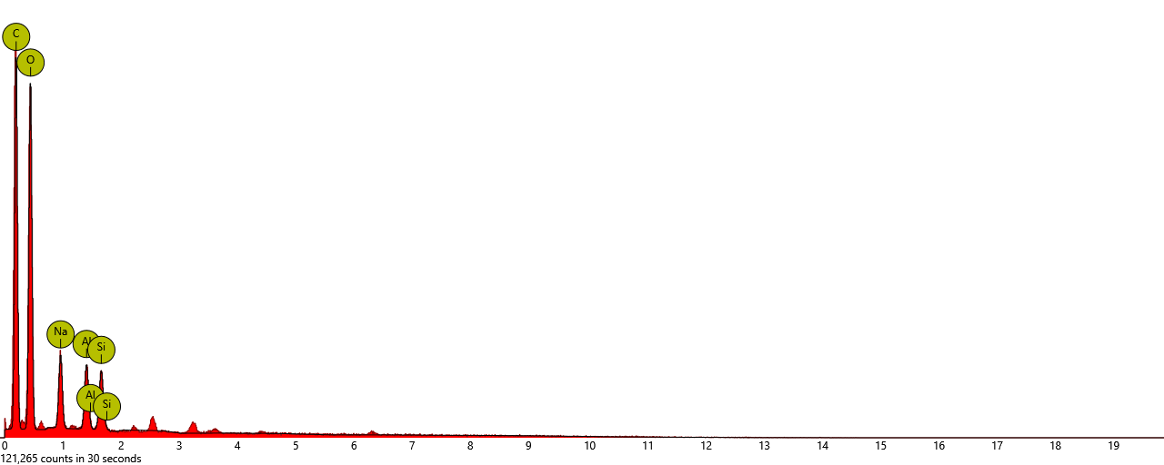
  Element | wt.%
  C | 46.60
  O | 45.90
  Na | 3.83
  Al | 2.04
  Si | 1.63
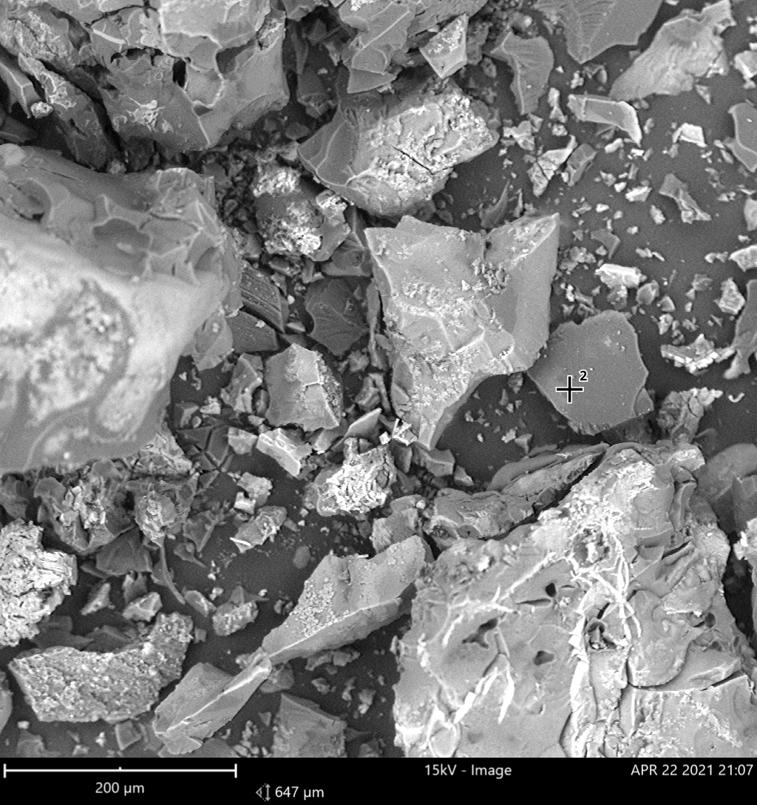  HTC- HA | 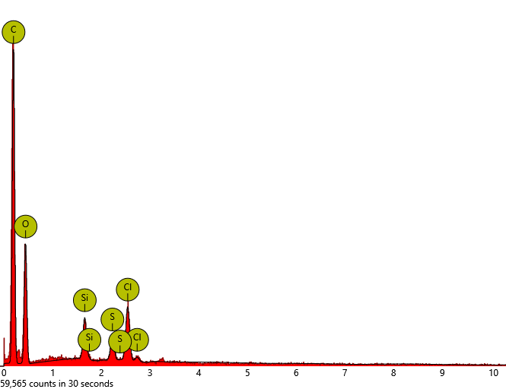
  Element  Symbol | wt.%
  C | 61.04
  O | 33.36
  Cl | 2.94
  Si | 1.55
  S | 1.12
HTH-1KOH- HA | 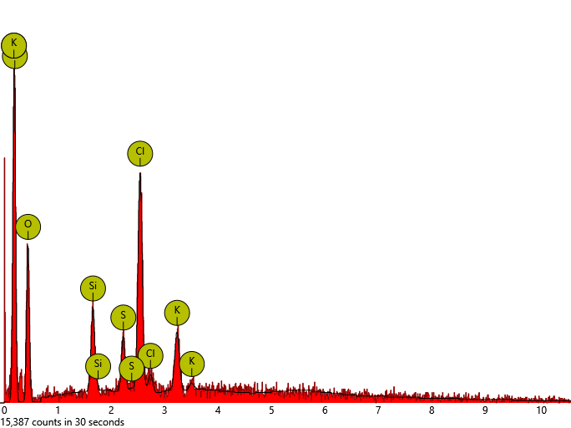
  Element  Symbol | wt.%
  C | 56.93
  O | 29.27
  Cl | 7.51
  K | 2.74
  Si | 1.94
  S | 1.62
HTH-4KOH- HA | 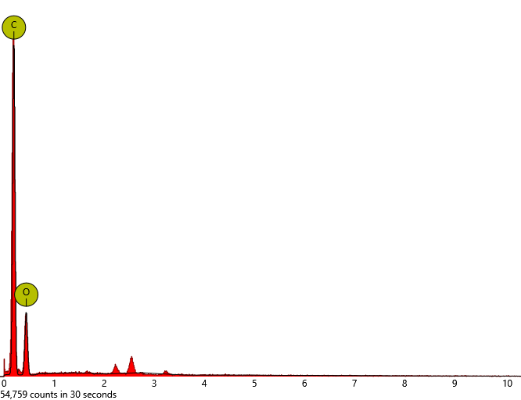
  Element  Symbol | Weight  Conc.
  C | 67.01
  O | 32.99
HTH-5KOH- HA | 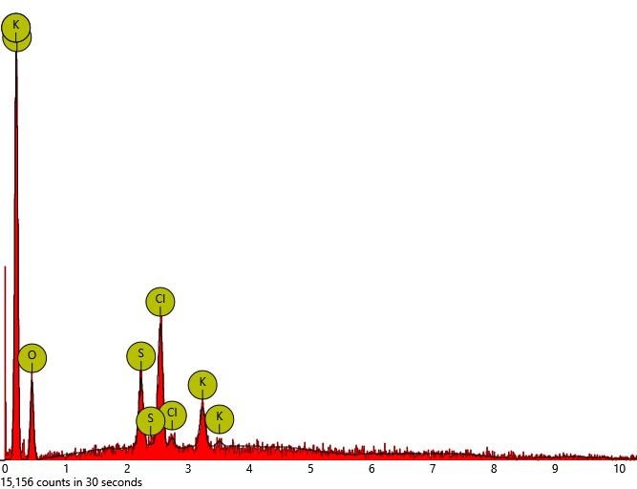
  Element  Symbol | Weight  Conc.
  C | 68.70
  O | 21.20
  Cl | 5.28
  S | 2.52
  K | 2.30

Fig. S8 SEM-EDX analysis of the HA from Sigma Aldrich and those extracted from HTC and HTH liquid phase, note: the EDX data for HTH2-KOH is not available

Fig. S9 percentage increase of biogas and methane yield compared to digestate used as feedstock of hydrothermal experiments.

a) | b) | c)
d) | e)
Fig. S10 Individual figures for the cumulative biogas and methane production for HTC and HTH liquids compared to digestate (feedstock of hydrothermal experiments)

Table S9 Comparison between the values of A-HAs, acids, sugars of digestate, HTC and HTH-5KOH process liquids, before and after biogas production
Input and output (g/kgFM) | digestate | HTC | HTH-5KOH
Input HA | 0.13 | 0.24 | 1.73
Output HA* | - | 0.63 | 1.93
% Changes in HA (wt%) in output compared to input* | - | +162.5** | +11.56**
Input acids | 0.23 | 1.53 | 2.23
Output acids* | 0.12 | 0.32 | 0.61
% Changes in acid in output compared to input* | -47.83 | -79.08 | -72.65
Input total sugar | 1.10 | 0.22 | 3.88
Output total sugar* | 1.08 | 0.65 | 0.68
% Changes in sugars in output compared to input* | -1.82 | +195.45** | -82.47
*output takes into account the difference between concentrations in biogas digestate and in inoculum, based on equation 2 and 3. This method also was used to estimate the changes in acetic acid, sugars. ** means the content was increased after anaerobic digestion.

