Table S1 Test plan for effects of biochar types on different plant performance
Test ID | Vegetation species | Biochar application ratio (%) | Biochar types
NB | R. tomentosa | 0 | -
WB | R. tomentosa | 5 | Wood biochar
EB | R. tomentosa | 5 | Eggshell biochar
RB | R. tomentosa | 5 | Rice biochar
SB | R. tomentosa | 5 | Soybean biochar
PB | R. tomentosa | 5 | Peanut shell biochar
NB | S. arboricola | 0 | -
WB | S. arboricola | 5 | Wood biochar
EB | S. arboricola | 5 | Eggshell biochar
RB | S. arboricola | 5 | Rice biochar
SB | S. arboricola | 5 | Soybean biochar
PB | S. arboricola | 5 | Peanut shell biochar
NB | C. edithiae | 0 | -
WB | C. edithiae | 5 | Wood biochar
EB | C. edithiae | 5 | Eggshell biochar
RB | C. edithiae | 5 | Rice biochar
SB | C. edithiae | 5 | Soybean biochar
PB | C. edithiae | 5 | Peanut shell biochar

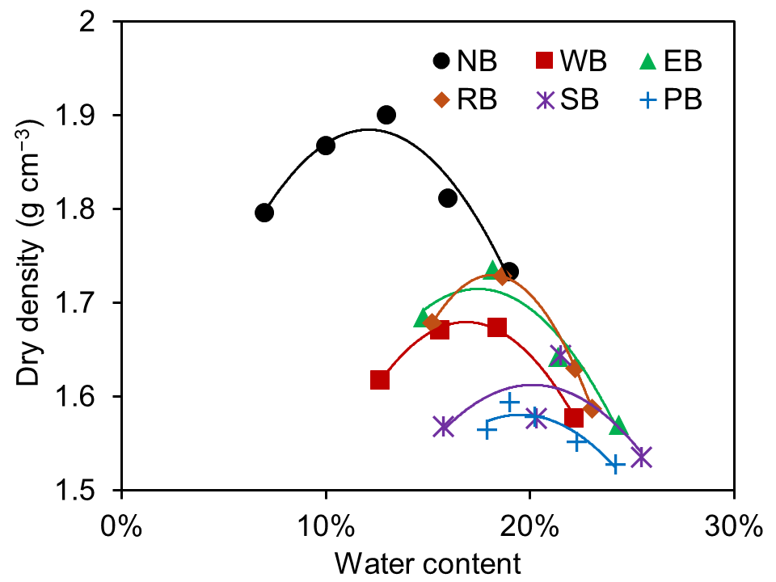
Figure S1. Compaction curves for soil and soil mixed with different types of biochar at 5% ratio. (NB: soil without biochar; WB: soil with wood biochar; EB: soil with eggshell biochar; RB: soil with rice biochar; SB: soil with soybean biochar; PB: soil with peanut shell biochar)

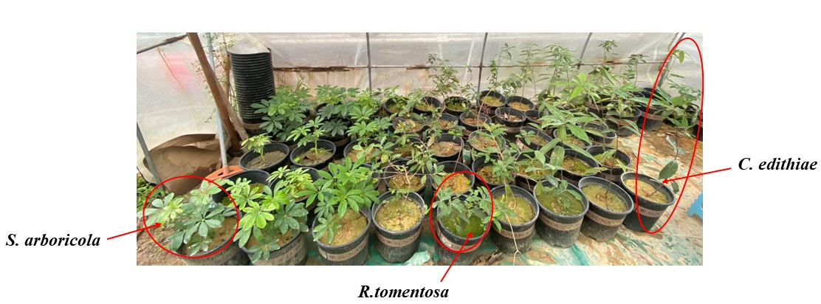
(a)
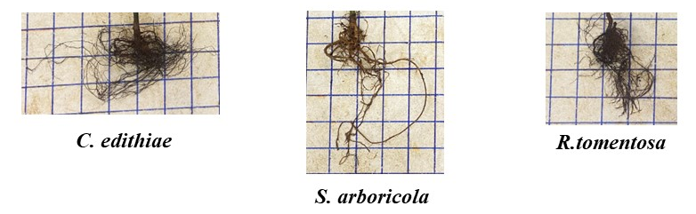
(b)
Figure S2. The plant shoot performance (a) and plant root performance after 5 months of growth (Note: the length and width of the grid is 50 mm).

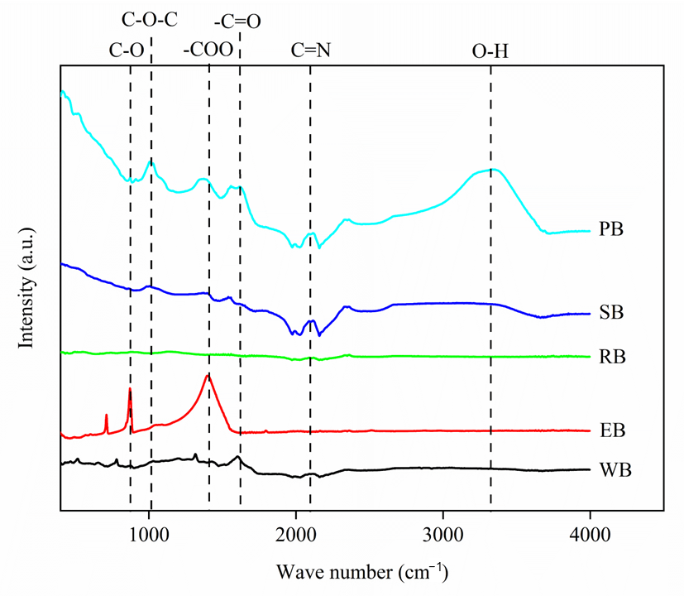
Figure S3. Fourier transform infrared (FTIR) adsorption spectrum of various biochars (WB: wood biochar, EB: eggshell biochar, RB: rice biochar, SB: soybean biochar, PB: peanut shell biochar.)

