Supporting Information
Preparation of nano Cu-Mo₂C interface supported on ordered mesoporous biochar of ultrahigh surface area for reverse water gas shift reaction
Xueyuan Panª, Hao Sun^{a*}, Mingzhe Maª, Haiquan Liaoª, Guowu Zhan^{b*}, Kui Wang^{a,c*}, Mengmeng Fan^{c}, Jingcheng Xu^{c}, Linfei Ding^{c}, Kang Sunª, Jianchun Jiangª
ª Key Lab. of Biomass Energy and Material, Jiangsu Province, Key and Open Lab. of Forest Chemical Engineering, SFA, National Engineering Lab. for Biomass Chemical Utilization, Institute of Chemical Industry of Forest Products, Chinese Academy of Forestry, Nanjing 210042, China
^{b} Academy of Advanced Carbon Conversion Technology, College of Chemical Engineering, Huaqiao University, Xiamen, Fujian, 361021, China
^{c} Co-Innovation Center of Efficient Processing and Utilization of Forest Resources, Nanjing Forestry University, Nanjing 210042, China
* Corresponding author at: Institute of Chemical Industry of Forest Products, Chinese Academy of Forestry, Nanjing 210042, China.
E-mail address: sunhao@icifp.cn (H. Sun); gwzhan@hqu.edu.cn (G. Zhan); wangkui@caf.ac.cn (K. Wang)

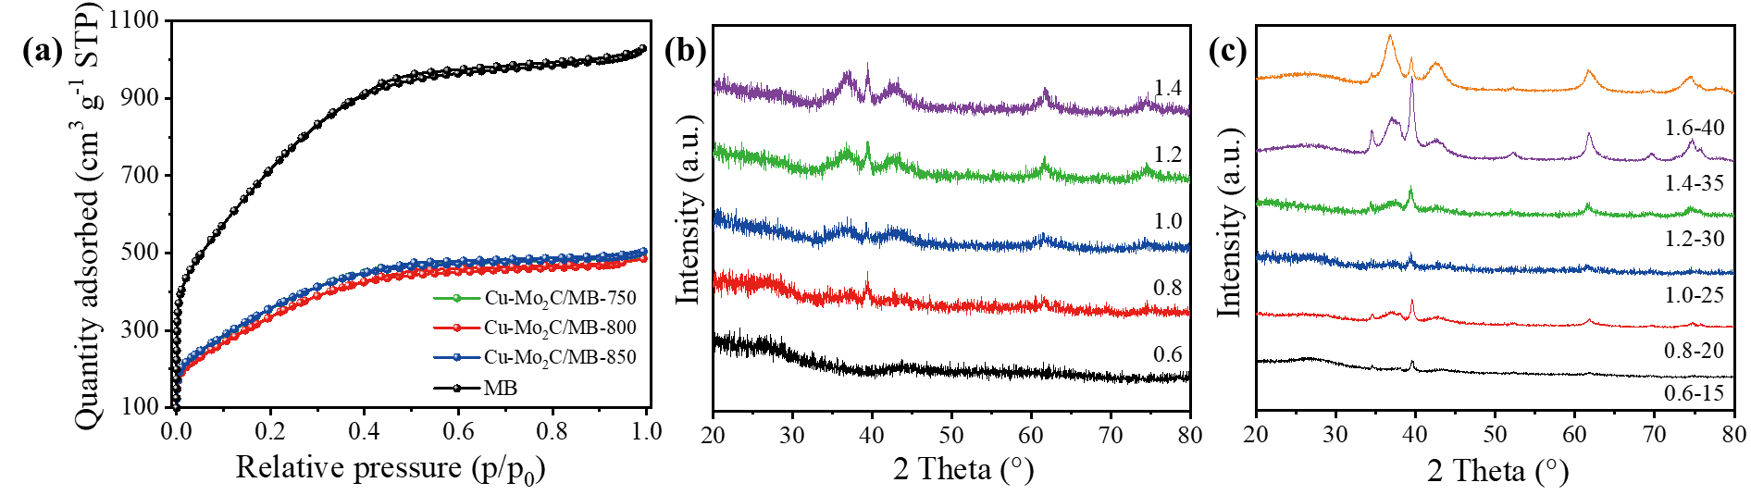
Fig. S1. (a) The N₂ adsorption-desorption isotherms patterns of MB and 0.8wt.%Cu-20wt.%Mo₂C/MB catalysts at different carburizing temperatures, and XRD patterns of Cu-Mo₂C/MB catalysts with (b) different Cu loading and (c) different Cu-Mo₂C loading.

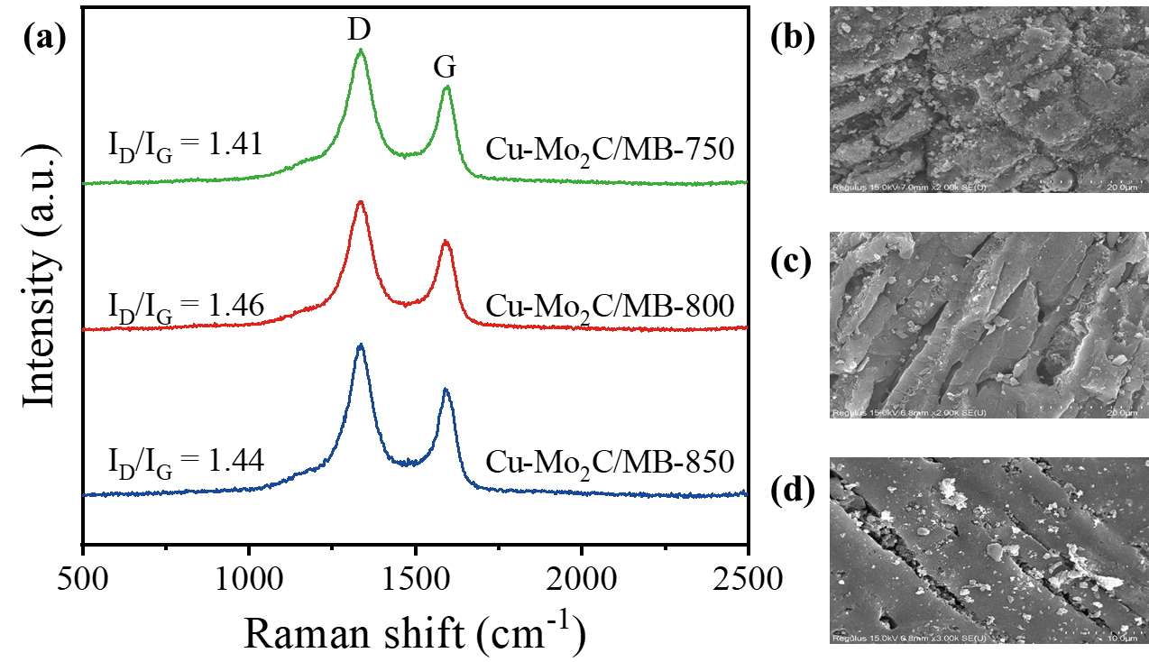
Fig. S2. (a) The Raman patterns of 0.8wt%Cu-20wt%Mo₂C/MB catalysts at different carburizing temperatures, and the SEM images of 0.8wt%Cu-20wt%Mo₂C/MB catalysts at carburizing temperatures of (b) 750 ℃, (c) 800 ℃ and (d) 850 ℃.
Raman spectroscopy was conducted to further determine the surface structures of the catalysts and reveal their phase composition. As shown in Fig. S2(a), the typical bands of carbon materials at 1330 cm⁻¹ (D band) and 1590 cm⁻¹ (G band), where the ordering of the carbon is shown by the intensity ratio of the D to G bands (I_{D}/I_{G}) (Baklanova et al. 2017). It is clear that the disorder structures of the catalysts exhibit similarities at different carburizing temperatures.

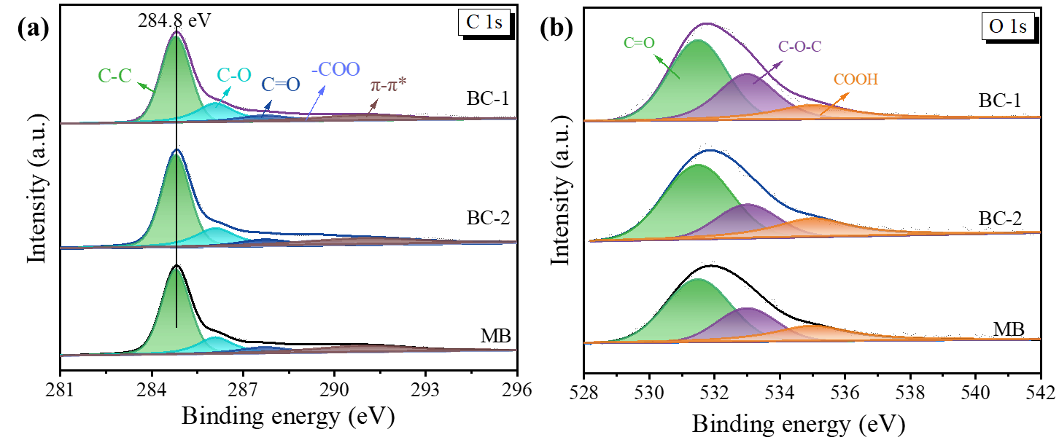
Fig. S3. The XPS spectra of (a) C 1s, and (b) O 1s of BC-1, BC-2, and MB.

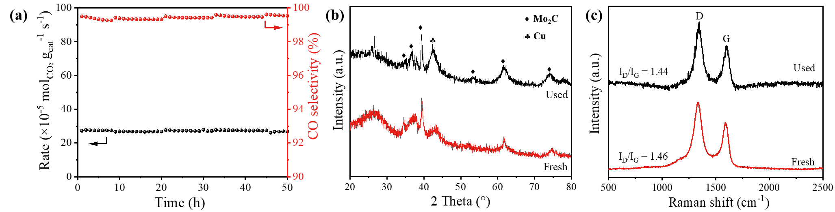
Fig. S4. (a) Stability evolution over 1.4wt.%Cu-35wt.%Mo₂C/MB-800 catalyst, (b) XRD and (c) Raman patterns of catalysts before and after reaction.

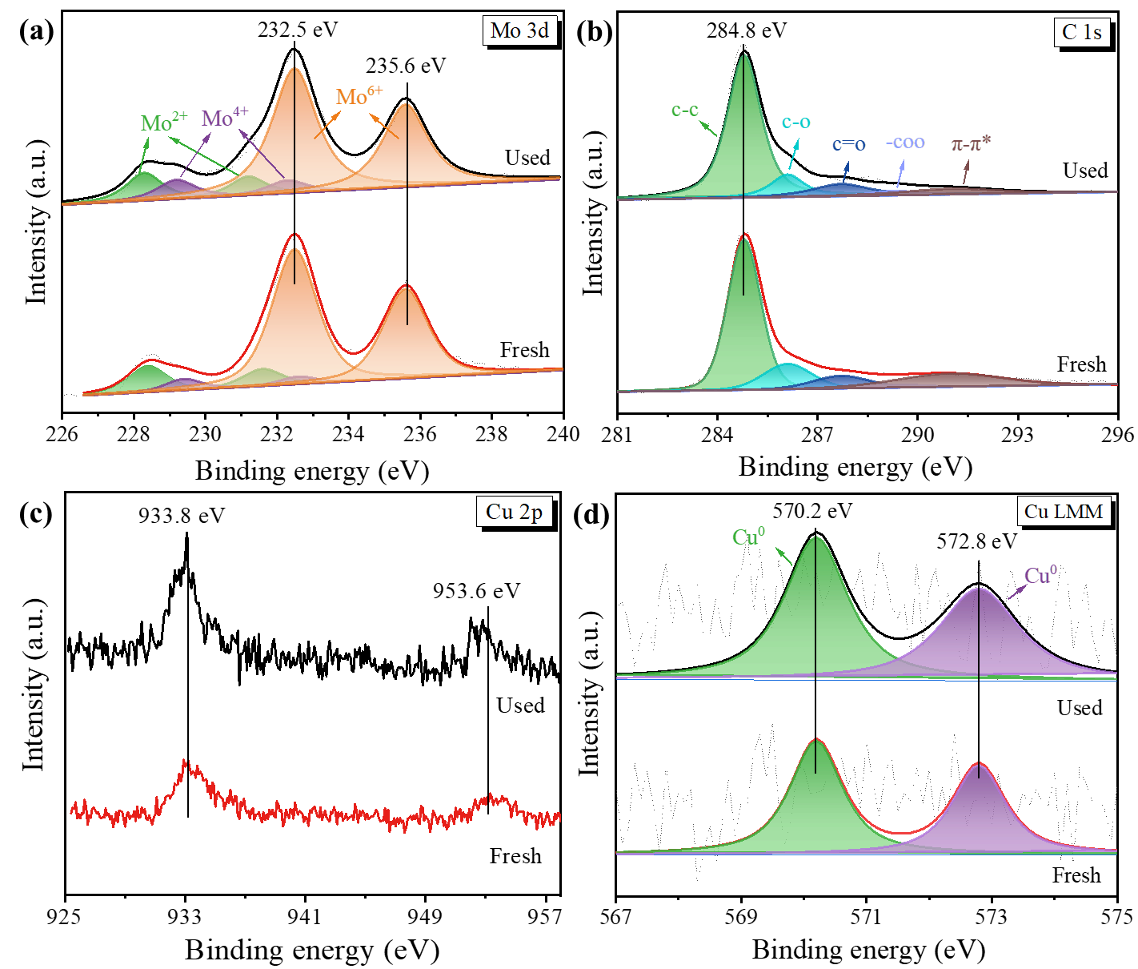
Fig. S5. The XPS spectra of (a) Mo 3d, (b) C 1s, (c) Cu 2p, and (d) Cu AES spectra of catalysts before and after reaction.

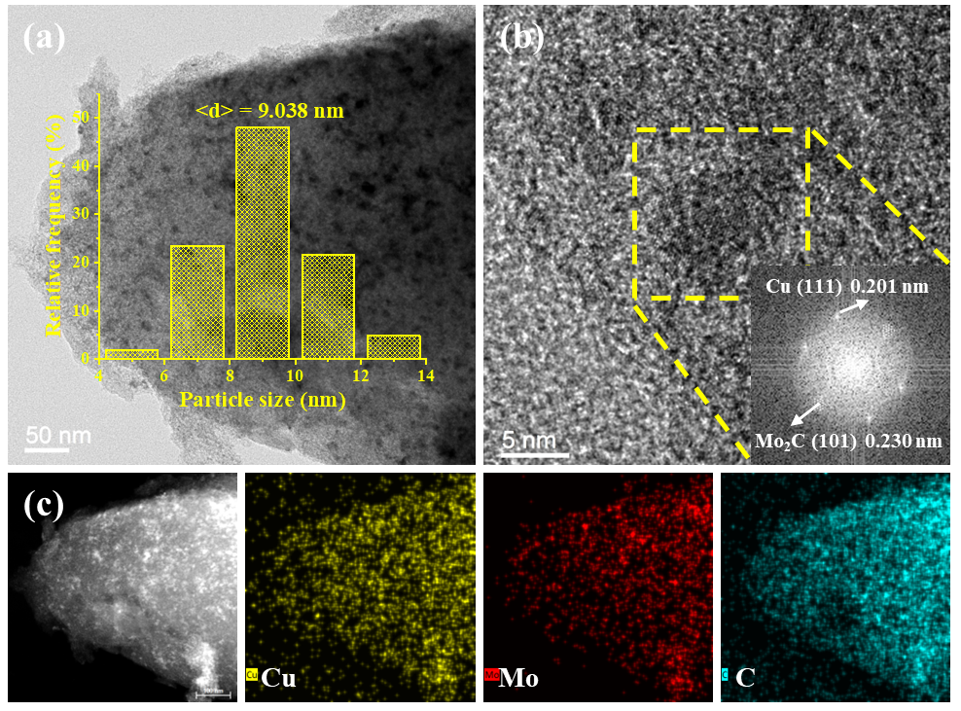
Fig. S6. (a) TEM images of the used 1.4wt.%Cu-35wt.%Mo₂C/MB-800 catalyst at 50 nm (The inset is distributions and mean diameters (<d>) of nanoparticles), (b) HRTEM image of the used 1.4wt.%Cu-35wt.%Mo₂C/MB-800 catalyst, (c) EDS spectra of the used 1.4wt.%Cu-35wt.%Mo₂C/MB-800 catalyst.
Table S1. Characteristics of specific surface area and pore structure of MB and Cu-Mo₂C/MB catalysts.
Sample | S_{BET}  (m²/g)ª | V_{total}  (cm³/g)^{b} | V_{meso}  (cm³/g)^{c} | Mo  (wt.%)^{d}
MB | 2693 | 1.56 | 0.81 | -
0.8wt.%Cu-20wt.%Mo₂C/MB-750 | 1361 | 0.76 | 0.36 | 15.32
0.8wt.%Cu-20wt.%Mo₂C/MB-800 | 1281 | 0.73 | 0.38 | 16.02
0.8wt.%Cu-20wt.%Mo₂C/MB-850 | 1356 | 0.76 | 0.38 | 17.32
ª Total surface area (S_{BET}) obtained according to BET method with a 3 m²/g standard deviation.
^{b} Total pore volume (V_{total}) obtained according to volume absorbed at P/P₀ = 0.99.
^{c} Mesopore volume (V_{meso}) derived from the NLDFT model.
^{d} Mo Loading obtained according to XPS.

Table S2. Compositions and positions of Mo 3d_{5/2}, Cu 2p_{1/2} for all samples.
Catalyst | Mo 3d_{5/2} binding energy/eV |  |  |  | Cu 2p_{1/2} binding energy/eV
Catalyst | Mo²⁺ | Mo⁴⁺ | Mo⁶⁺ |  | Cu⁰ | Cu⁺
0.8wt.%Cu-20wt.%Mo₂C/MB-750 | 5.06 | 3.92 | 91.02 |  | 62.58 | 37.42
0.8wt.%Cu-20wt.%Mo₂C/MB-800 | 13.74 | 5.51 | 80.75 |  | 56.09 | 43.91
0.8wt.%Cu-20wt.%Mo₂C/MB-850 | 14.11 | 5.78 | 80.11 |  | 41.39 | 58.61

Table S3. Comparison of CO₂ conversion rate and CO selectivity for the as-prepared and reported catalysts.
Catalyst | CO₂/H₂ | GHSV  （ml/g/h） | P  (Mpa) | T  (°C) | Rate  (×10⁻⁵mol_{CO2}/g_{cat}/s) | S_{CO}  (%) | Ref
Cu/Mo₂C-C | 1:2 | 300000 | 0.1 | 500 | 27.74 | 99.1 | This work
α-Mo₂C/C | 1:3 | 100000 | 0.1 | 500 | 14.50 | 100 | (Ahmadi Khoshooei et al. 2024)
Cs-Mo₂C | 1:2 | 12000 | 0.1 | 500 | 1.19 | ~95 | (Zhang et al. 2019)
Cs-Mo₂C | 1:4 | 12000 | 0.1 | 500 | 1.25 | ~98 | (Zhang et al. 2019)
Cu-Mo₂C | 1:4 | 12000 | 0.1 | 500 | 1.55 | ~96 | (Zhang et al. 2019)
MoN/NC | 1:3 | 8000 | 0.1 | 500 | 1.01 | 100 | (Jiang et al. 2022)
Mo₂C@N-C | 1:3 | 24000 | 0.1 | 400 | 1.56 | 99.5 | (Ma et al. 2020)
1K-Cu/Mo₂C | 1:2.5 | 84000 | 0.1 | 500 | 12.20 | 100 | (Xu et al. 2021)
Mo₂C/SBA-15 | 1:1 | 60000 | 0.1 | 500 | 4.09 | 98 | (Marquart et al. 2021)
Mo₂C/SiO₂ |  |  |  |  | 6.32 | 98 | (Marquart et al. 2021)
Cu-Mo₂C-C | 1:4 | 60000 | 0.1 | 400 | 0.85 | 100 | (Xiong et al. 2018)
Cu–Mo₂C–NC |  |  |  |  | 1.72 | 100 | (Xiong et al. 2018)
Mo_{x}C | 1:3 | 3000a | 0.1 | 400 | - | 98 | (Liu et al. 2020)
MoC/γ-Al₂O₃ | 1:3 | 60000 | 0.3 | 500 | 1.34 | 100 | (Sun et al. 2021)
Pt/CeO₂ | 1:3 | 72000 | 0.1 | 450 | 2.12 | 99 | (Zhao et al. 2021)
Co−Fe@(N)G | 1:3 | 6000 | 0.1 | 500 | 1.04 | 98 | (Peng et al. 2021)
K-Mo₂C/γ-Al₂O₃ | 1:3 | 13320 | 2.1 | 450 | 1.74 | 99.3 | (Juneau et al. 2020)
NiCu-Saponite | 1:4 | 15000 | 0.1 | 500 | 1.97 | 89 | (Nityashree et al. 2020)
NiCo-Saponite |  |  |  |  | 1.82 | 37 | (Nityashree et al. 2020)
Ni-Saponite |  |  |  |  | 2.12 | 16 | (Nityashree et al. 2020)

References
Ahmadi Khoshooei M, Wang X, Vitale G, Formalik F, Kirlikovali KO, Snurr RQ, Pereira-Almao P, Farha OK （2024） An active, stable cubic molybdenum carbide catalyst for the high-temperature reverse water-gas shift reaction. Science 384: 540-546. http://doi.org/10.1126/science.adl1260
Baklanova ON, Vasilevich AV, Lavrenov AV, Drozdov VA, Muromtsev IV, Arbuzov AB, Trenikhin MV, Sigaeva SS, Temerev VL, Gorbunova OV, Likholobov VA, Nizovskii AI, Kalinkin AV （2017） Molybdenum carbide synthesized by mechanical activation an inert medium. J Alloy Compd 698: 1018-1027. http://doi.org/10.1016/j.jallcom.2016.12.186
Jiang Y, Sung Y, Choi C, Bang GJ, Hong S, Tan X, Wu T-S, Soo Y-L, Xiong P, Li MM-J, Hao L, Jung Y, Sun Z （2022） Single-Atom Molybdenum-N₃ Sites for Selective Hydrogenation of CO₂ to CO. AngewChem Int Ed 61: e202203836. http://doi.org/10.1002/anie.202203836
Juneau M, Vonglis M, Hartvigsen J, Frost L, Bayerl D, Dixit M, Mpourmpakis G, Morse JR, Baldwin JW, Willauer HD, Porosoff MD （2020） Assessing the viability of K-Mo₂C for reverse water-gas shift scale-up: molecular to laboratory to pilot scale. Energy Environ Sci 13: 2524-2539. http://doi.org/10.1039/d0ee01457e
Liu X, Pajares A, Calinao Matienzo DJD, Ramirez de la Piscina P, Homs N （2020） Preparation and characterization of bulk Mo_{X}C catalysts and their use in the reverse water-gas shift reaction. Catal Today 356: 384-389. http://doi.org/10.1016/j.cattod.2019.11.011
Ma Y, Guo Z, Jiang Q, Wu K-H, Gong H, Liu Y （2020） Molybdenum carbide clusters for thermal conversion of CO₂ to CO via reverse water-gas shift reaction. J Energy Chem 50: 37-43. http://doi.org/10.1016/j.jechem.2020.03.012
Marquart W, Raseale S, Prieto G, Zimina A, Sarma BB, Grunwaldt J-D, Claeys M, Fischer N （2021） CO₂ reduction over Mo₂C-based catalysts. ACS Catal 11: 1624-1639. http://doi.org/10.1021/acscatal.0c05019
Nityashree N, Price CAH, Pastor-Perez L, Manohara GV, Garcia S, Maroto-Valer MM, Reina TR （2020） Carbon stabilised saponite supported transition metal-alloy catalysts for chemical CO₂ utilisation via reverse water-gas shift reaction. Appl Catal B Environ 261: 118241. http://doi.org/10.1016/j.apcatb.2019.118241
Peng L, Jurca B, Primo A, Gordillo A, Parvulescu VI, Garcia H （2021） Co-Fe clusters supported on N-doped graphitic carbon as highly selective catalysts for reverse water gas shift reaction. ACS Sustain Chem Eng 9: 9264-9272. http://doi.org/10.1021/acssuschemeng.1c01401
Sun G, Mottaghi-Tabar S, Ricardez-Sandoval L, Simakov DSA （2021） Highly active, selective and stable reverse water gas shift catalyst based on high surface area MoC/gamma-Al₂O₃ synthesized by reverse microemulsion. Top Catal 64: 414-430. http://doi.org/10.1007/s11244-020-01411-y
Xiong K, Zhou G, Zhang H, Shen Y, Zhang X, Zhang Y, Li J （2018） Bridging Mo₂C–C and highly dispersed copper by incorporating N-functional groups to greatly enhance the catalytic activity and durability for carbon dioxide hydrogenation. J Mater Chem A 6: 15510-15516. http://doi.org/10.1039/c8ta04096f
Xu J, Gong X, Hu R, Liu Z-w, Liu Z-t （2021） Highly active K-promoted Cu/β-Mo₂C catalysts for reverse water gas shift reaction: effect of potassium. Mol Catal 516: 111954. http://doi.org/10.1016/j.mcat.2021.111954
Zhang Q, Pastor-Perez L, Jin W, Gu S, Reina TR （2019） Understanding the promoter effect of Cu and Cs over highly effective beta-Mo₂C catalysts for the reverse water-gas shift reaction. Appl Catal B Environ 244: 889-898. http://doi.org/10.1016/j.apcatb.2018.12.023
Zhao Z, Wang M, Ma P, Zheng Y, Chen J, Li H, Zhang X, Zheng K, Kuang Q, Xie Z-X （2021） Atomically dispersed Pt/CeO₂ catalyst with superior CO selectivity in reverse water gas shift reaction. Appl Catal B Environ 291: 120101. http://doi.org/10.1016/j.apcatb.2021.120101

