Insights into the effects of biomass feedstock and pyrolysis conditions on the energy storage capacity and durability of standard biochar-based phase-change composites

Dimberu G. Atinafu, Ji Yong Choi, Jihee Nam, Yujin Kang, Sumin Kim*
Department of Architecture and Architectural Engineering, Yonsei University, Seoul 03722, Republic of Korea
* Corresponding author, E-mail: kimsumin@yonsei.ac.kr

*Corresponding author: kimsumin@yonsei.ac.kr

Basic properties of biochar
The biochar samples are standard materials provided by the UK Biochar Research Centre at the University of Edinburgh and distributed for common global research and development purposes (Mašek et al., 2018). The biomass feedstocks were pyrolyzed at 550 and 700 °C with a kiln residence time of 15 min and up to 98 °C min^{–1} heating rate. Therefore, the biochar materials data are available at https://www.biochar.ac.uk/standard_materials.php. Furthermore, the properties of biochar materials can be evaluated following measurement techniques.
Table S1. Basic properties of biochar materials
Properties | Biochar
Properties | MSP550 | MSP700 | RH550 | RH700 | WSP550 | WSP700
Total carbon (C_{tot}) (wt%) | 75.4±2.75 | 79.2±0.07 | 48.69±2.37 | 47.3±1.82 | 68.3±1.1 | 69.0±1.32
p^{H} | 9.8±0.21 | 9.7±0.3 | 9.7±0.26 | 9.8±0.64 | 9.9±0.16 | 10.0±0.19
Biochar C stability (% C-basis) | 94.9±0.65 | 98.9±0.14 | 95.3±0.22 | 100.2±0.27 | 96.5±0.3 | 100.9±0.21
Total nitrogen (wt%) | 0.8±0.09 | 1.0±0.03 | 1.04±0.09 | 0.8±0.08 | 1.4±0.10 | 1.3±0.03
Total ash (wt%) | 12.2±1.00 | 11.6±0.17 | 47.93±5.43 | 47.9±5.43 | 21.3±1.09 | 23.8±2.33

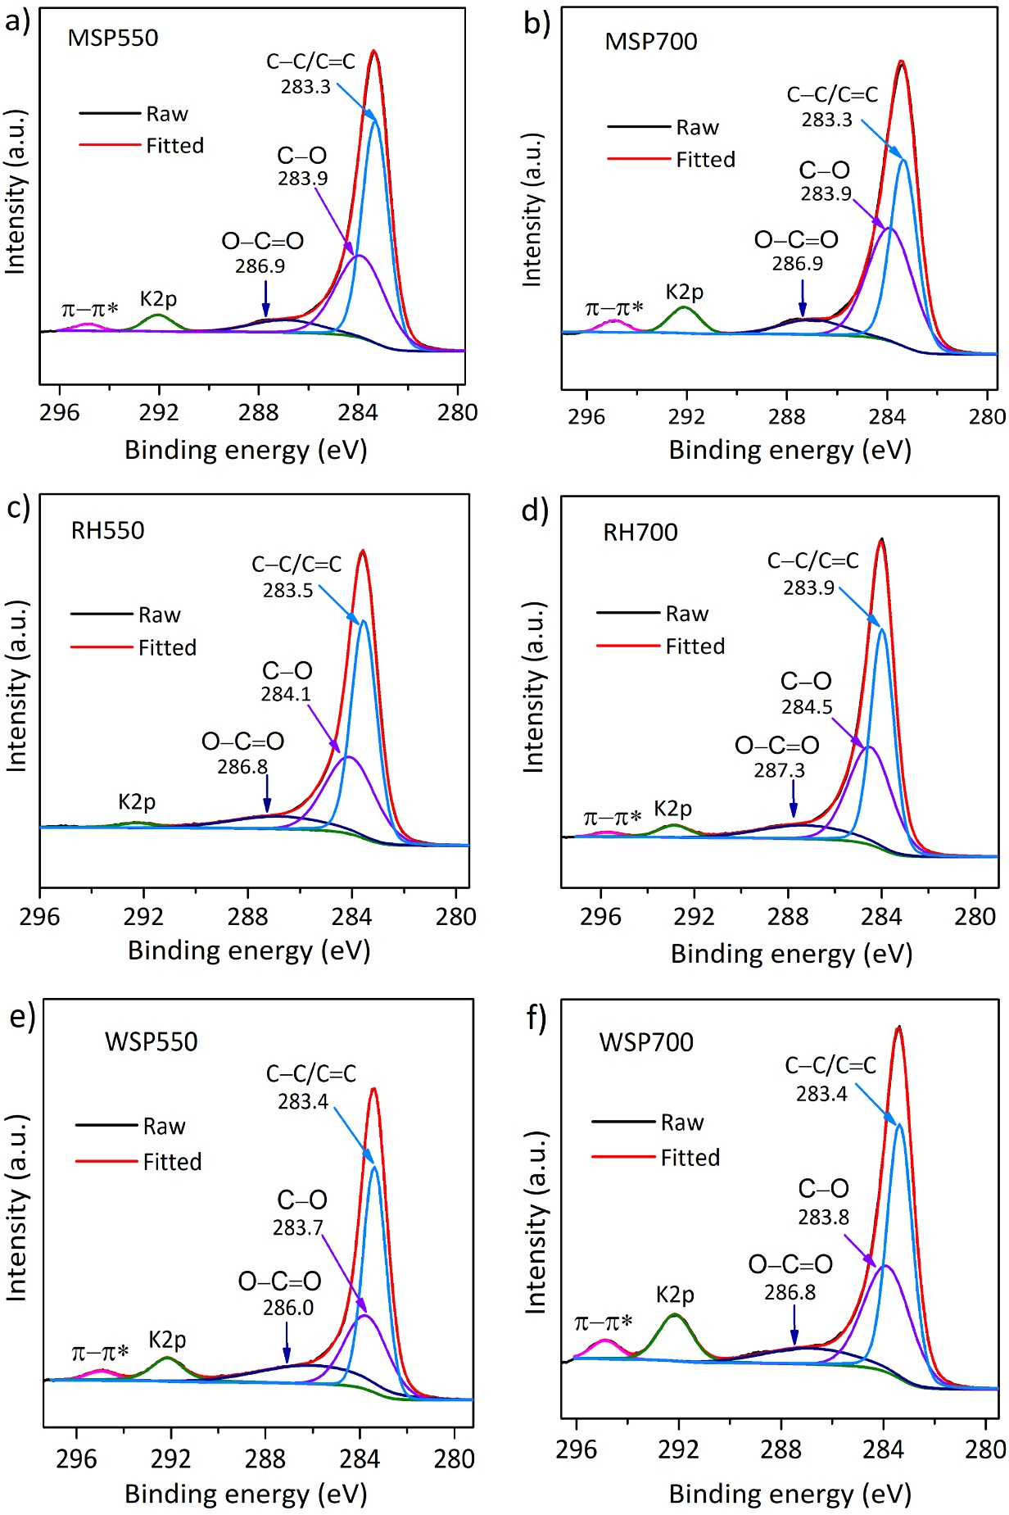
Fig. S1. The C 1s XPS spectra recorded for standard biochar materials.
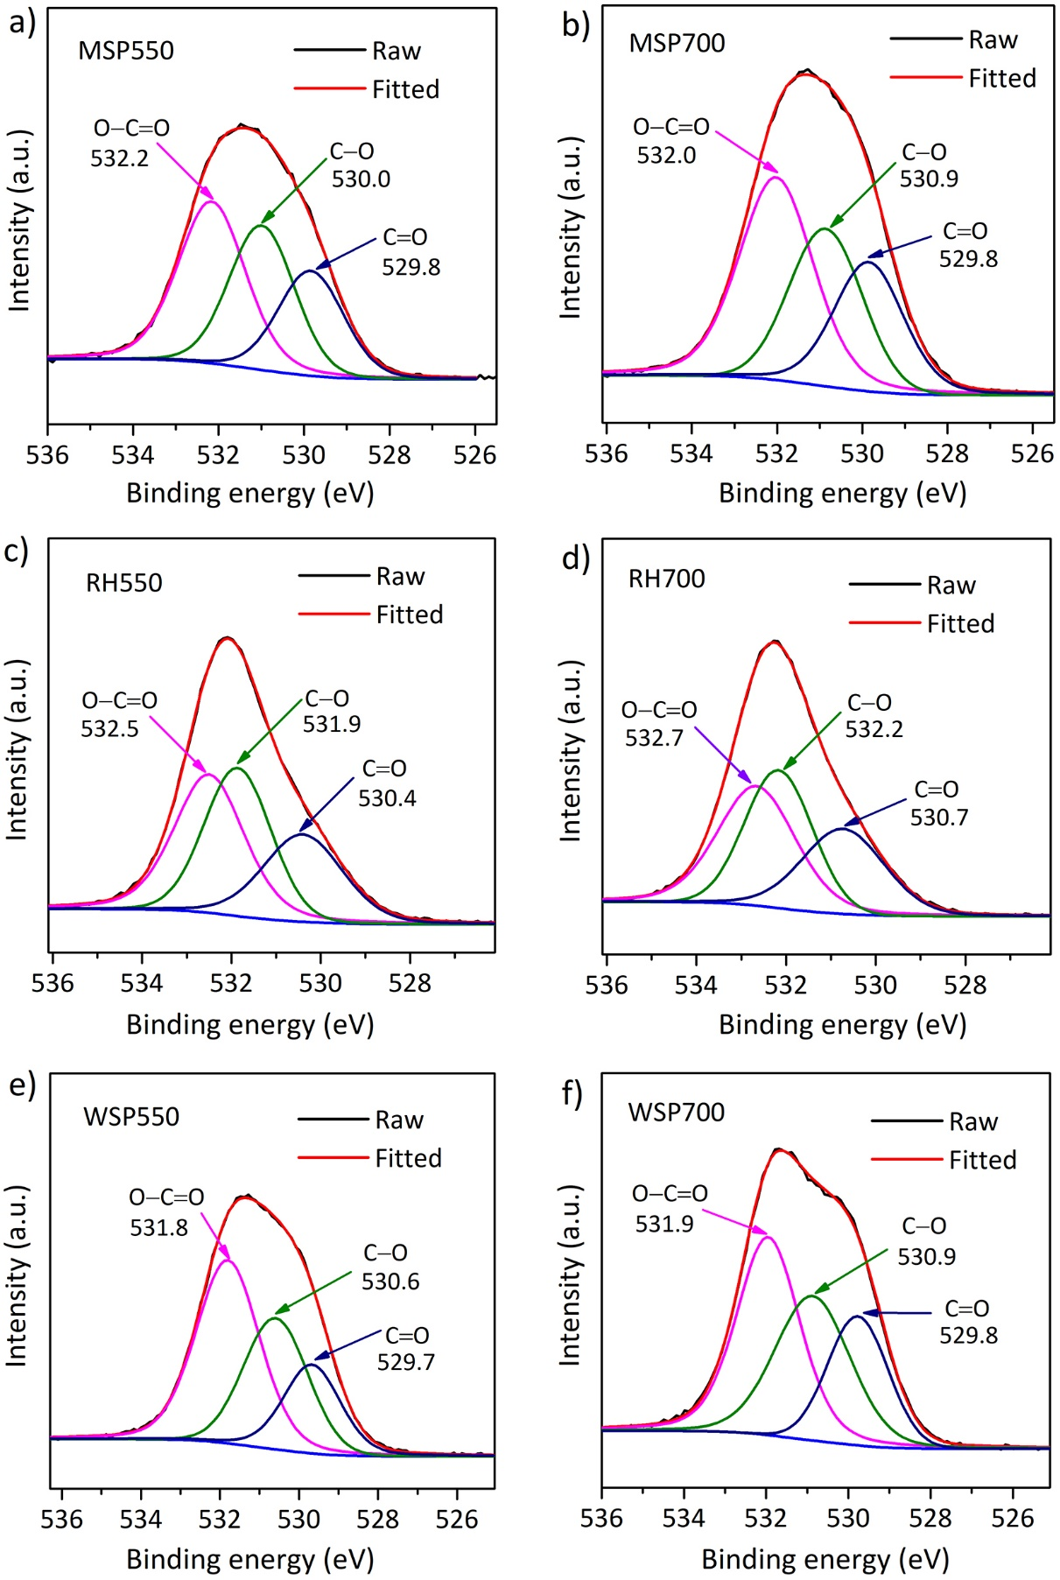
Fig. S2. The O 1s XPS spectra recorded for standard biochar materials.

Reference
Mašek, O., Buss, W., & Sohi, S. (2018). Standard Biochar Materials. Environmental Science & Technology, 52(17), 9543–9544. https://doi.org/10.1021/acs.est.8b04053

