Table S1 Soil extracellular enzymatic activities within different aggregates under biochar and fertilizer regimes.
Aggregate | Treatment | CBH  (nmol h⁻¹g⁻¹) | BG  (nmol h⁻¹g⁻¹) | LAP  (nmol h⁻¹g⁻¹) | NAG  (nmol h⁻¹g⁻¹) | AKP  (nmol h⁻¹g⁻¹) | UE  (μg d⁻¹ g⁻¹)
Bulk soil | CK | 77.43±6.39b | 58.41±8.58c | 48.97±4.37d | 434.21±1.46a | 110.68±1.82bc | 5.26±0.02b
Bulk soil | TF | 87.58±7.58b | 58.15±14.56c | 59.02±3.94c | 442.36±16.60a | 157.37±36.54abc | 5.69±0.41b
Bulk soil | OF | 106.86±8.47a | 255.65±8.07a | 82.32±6.31a | 443.71±4.44a | 198.59±71.51a | 6.23±0.20a
Bulk soil | CK+B | 56.38±11.83c | 42.35±3.97c | 40.19±3.58e | 287.19±16.57c | 100.37±5.84c | 3.4±0.26c
Bulk soil | TF+B | 62.94±2.16c | 58.95±4.32c | 62.67±6.70c | 296.82±7.71c | 151.67±5.15abc | 6.51±0.19a
Bulk soil | OF+B | 87.08±6.09b | 172.93±18.64b | 72.28±3.12b | 317.01±7.88b | 181.09±48.23ab | 5.25±0.13b
>2 mm | CK | 39.55±5.41b | 144.68±26.75a | 103.49±3.30a | 347.02±10.83a | 177.56±16.3a | 6.14±0.22a
>2 mm | TF | 44.99±5.44b | 67.12±6.97bc | 66.75±5.83c | 275.91±12.71b | 136.26±6.94bc | 4.90±0.12b
>2 mm | OF | 23.45±3.75d | 38.70±18.38c | 34.17±1.25d | 275.71±18.41b | 105.89±7.47c | 5.10±0.58b
>2 mm | CK+B | 26.76±2.92cd | 69.03±9.24bc | 41.61±3.92d | 155.12±8.46d | 151.36±9.82ab | 5.02±0.08b
>2 mm | TF+B | 34.93±9.38bc | 66.00±17.39bc | 69.82±7.29c | 195.29±2.84c | 162.46±40.38ab | 5.28±0.16b
>2 mm | OF+B | 64.78±2.44a | 83.27±11.93b | 91.14±3.22b | 207.04±4.88c | 160.04±23.78ab | 5.36±0.16b
0.25-2 mm | CK | 47.13±1.19d | 85.44±14.98c | 59.69±4.16c | 176.29±15.42c | 110.21±8.91b | 3.80±0.19c
0.25-2 mm | TF | 59.83±3.71c | 163.75±1.16a | 72.29±3.52b | 212.35±5.36b | 113.80±20.72b | 5.12±0.19b
0.25-2 mm | OF | 96.68±7.10a | 104.31±12.07c | 55.67±2.44c | 253.94±5.78a | 142.23±18.77a | 5.33±0.17b
0.25-2 mm | CK+B | 34.56±2.70e | 44.15±6.20d | 35.79±1.85d | 78.41±2.57d | 94.87±13.20b | 5.82±0.16a
0.25-2 mm | TF+B | 69.26±6.46c | 47.00±5.77d | 57.24±2.60c | 173.48±5.97c | 108.29±6.69b | 5.98±0.22a
0.25-2 mm | OF+B | 83.78±10.16b | 133.56±15.30b | 78.82±3.04a | 176.57±7.00c | 144.62±20.26a | 5.91±0.27a
<0.25 mm | CK | 35.83±6.90e | 146.43±11.18a | 46.69±1.67b | 176.30±6.19b | 164.72±10.64a | 6.53±0.22a
<0.25 mm | TF | 66.28±6.48c | 92.97±3.58b | 44.37±4.33b | 196.44±1.82a | 155.98±10.21ab | 5.73±0.10b
<0.25 mm | OF | 95.67±2.40b | 69.43±14.46c | 49.73±1.94b | 197.51±7.10a | 92.46±16.66c | 5.00±0.17cd
<0.25 mm | CK+B | 50.05±7.84d | 27.62±5.55d | 44.31±2.61b | 177.23±7.79b | 135.11±4.81b | 4.60±0.07e
<0.25 mm | TF+B | 73.67±3.80c | 35.64±11.08d | 45.93±2.78b | 179.14±7.63b | 147.16±20.49ab | 4.73±0.06de
<0.25 mm | OF+B | 112.72±7.14a | 34.97±1.51d | 55.47±4.43a | 175.54±4.52b | 135.67±9.10b | 5.21±0.28c
ANOVA
Fertilizer (F) |  | 215.273*** | 71.198*** | 58.081*** | 52.711*** | 2.346 | 24.365***
Biochar (B) |  | 1.841 | 186.652*** | 6.116* | 1510.806*** | 0.010 | 7.506**
Aggregate (A) |  | 139.907*** | 39.103*** | 78.811*** | 1686.322*** | 6.359** | 0.624
F*B |  | 8.459*** | 28.194*** | 175.989*** | 32.141*** | 4.311* | 31.549***
F*A |  | 18.756*** | 115.271*** | 33.772*** | 36.189*** | 9.343*** | 39.231***
B*A |  | 25.776*** | 18.567*** | 3.284* | 162.968*** | 1.258 | 75.123***
F*B*A |  | 11.128*** | 34.164*** | 74.597*** | 23.394*** | 1.291 | 32.018***
Values are the mean ± standard deviation (n=3). Note: BG, β-1,4-glucosidase; CBH, β-D-cellobiosidase; NAG, β-1,4-Nacetylglucosaminidase; LAP, L-leucine aminopeptidase; AP, alkaline phosphatase. Different letters within the same column denote significant differences (p < 0.05, Duncan’s HSD post-hoc analysis, n = 3) under biochar and fertilizer regimes. * represents p < 0.05; ** represents p < 0.01; *** represents p < 0.001.

Table S2 ANOVA at the dominant bacterial phyla within soil aggregates under biochar and fertilizer regimes.
 | ANOVA | Proteobacteria | Actinobacteriota | Chloroflexi | Acidobacteriota | Myxococcota | Gemmatimonadota | Bacteroidota | Firmicutes | Nitrospirota
Whole | Fertilizer | 0.880 | 7.298** | 1.128 | 0.860 | 2.472 | 0.182 | 4.735* | 45.065*** | 4.737*
Whole | Biochar | 0.26 | 12.188** | 1.392 | 1.763 | 0.710 | 3.379** | 2.428 | 48.169*** | 12.715**
Whole | Aggregate | 0.50 | 8.266** | 0.619 | 1.353 | 0.573 | 10.705*** | 9.430*** | 37.401*** | 41.186***
Whole | Fertilizer*Biochar | 0.316 | 2.624 | 1.204 | 1.278 | 3.002 | 0.350 | 0.317 | 128.194*** | 1.105
Whole | Fertilizer*Aggregate | 1.515 | 1.520 | 1.150 | 0.724 | 0.329 | 3.425** | 1.120 | 7.992*** | 4.684**
Whole | Biochar*Aggregate | 0.697 | 0.824 | 0.392 | 0.235 | 0.244 | 1.805 | 0.569 | 18.872*** | 3.644*
Whole | Fertilizer*Biochar*Aggregate | 0.207 | 0.536 | 0.151 | 0.292 | 0.483 | 0.294 | 0.810 | 3.018* | 0.690
Habitat generalists | Fertilizer | 0.214 | 5.827** | 3.369* | 1.182 | 0.552 | 2.638 | 10.039*** | 5.725** | 3.243*
Habitat generalists | Biochar | 1.501 | 3.361 | 0.314 | 0.552 | 0.082 | 14.046*** | 3.553 | 15.947*** | 16.422**
Habitat generalists | Aggregate | 0.760 | 5.713** | 0.189 | 0.059 | 0.261 | 0.114 | 12.207*** | 1.025 | 2.462
Habitat generalists | Fertilizer*Biochar | 0.313 | 3.106 | 1.266 | 3.781* | 3.752* | 0.793 | 1.284 | 0.969 | 0.596
Habitat generalists | Fertilizer*Aggregate | 0.300 | 2.089 | 0.898 | 0.636 | 0.663 | 2.312* | 1.702 | 0.656 | 2.119
Habitat generalists | Biochar*Aggregate | 0.562 | 0.305 | 0.375 | 0.194 | 0.243 | 1.179 | 0.916 | 0.601 | 0.276
Habitat generalists | Fertilizer*Biochar*Aggregate | 0.466 | 0.833 | 0.914 | 0.195 | 0.330 | 0.588 | 0.491 | 0.814 | 1.649
Habitat specialists | Fertilizer | 18.309*** | 56.556*** | 7.529** | 1.898 | 19.969*** | 3.318* | 24.297*** | 147.610*** | 17.482***
Habitat specialists | Biochar | 11.033** | 0.507 | 0.019 | 1.096 | 46.387*** | 0.998 | 15.134*** | 248.865*** | 116.841***
Habitat specialists | Aggregate | 3.584* | 1.224 | 11.540*** | 16.334*** | 6.818** | 0.352 | 12.971*** | 82.502*** | 14.652***
Habitat specialists | Fertilizer*Biochar | 14.807*** | 0.792 | 6.783** | 1.980 | 9.802*** | 3.639* | 12.844*** | 92.258*** | 14.452***
Habitat specialists | Fertilizer*Aggregate | 3.79** | 7.778*** | 2.958* | 0.926 | 1.945 | 2.756* | 0.527 | 16.791*** | 9.618***
Habitat specialists | Biochar*Aggregate | 0.801 | 0.365 | 2.023 | 3.063* | 3.134* | 4.835** | 2.580 | 38.576*** | 25.029**
Habitat specialists | Fertilizer*Biochar*Aggregate | 1.281 | 1.100 | 4.794** | 0.959 | 4.279** | 1.954 | 3.807** | 5.932*** | 0.947
* represents p < 0.05; ** represents p < 0.01; *** represents p < 0.001.

Table S3 ANOVA at the observed OTUs and Shannon index under biochar and fertilizer regimes.
 | Whole |  | Habitat generalists |  | Habitat specialists
ANOVA | Observed OTUs | Shannon index | Observed OTUs | Shannon index | Observed OTUs | Shannon index
Fertilizer | 5.003* | 1.037 | 2.251 | 2.463 | 34.762*** | 9.781***
Biochar | 51.554*** | 10.834** | 13.836*** | 14.410*** | 5.560* | 19.272***
Aggregate | 28.507*** | 16.748*** | 5.994** | 13.173*** | 82.984*** | 2.421
Fertilizer*Biochar | 2.513 | 8.108** | 0.177 | 1.199 | 5.197** | 0.339
Fertilizer*Aggregate | 4.423** | 0.637 | 1.917 | 5.054*** | 7.786*** | 2.324*
Biochar*Aggregate | 1.008 | 1.167 | 0.716 | 0.448 | 1.401 | 5.168**
Fertilizer*Biochar*Aggregate | 1.268 | 2.103 | 0.404 | 1.474 | 2.498* | 1.007

Table S4 PERMANOVA testing the effects of fertilizer, biochar, aggregate, and their interaction on bacterial meta-community and sub-community structures.
 |  | Df | SS | F | R² | P
Whole | Fertilizer | 1 | 0.142 | 5.246 | 0.054 | 0.001
Whole | Biochar | 2 | 0.175 | 3.236 | 0.066 | 0.001
Whole | Aggregate | 3 | 0.364 | 4.482 | 0.138 | 0.001
Whole | Fertilizer:Biochar | 2 | 0.124 | 2.284 | 0.047 | 0.001
Whole | Fertilizer:Aggregate | 3 | 0.113 | 1.390 | 0.043 | 0.022
Whole | Biochar:Aggregate | 6 | 0.249 | 1.530 | 0.094 | 0.002
Whole | Fertilizer:Biochar:Aggregate | 6 | 0.174 | 1.068 | 0.066 | 0.231
Whole | Residuals | 48 | 1.301 |  | 0.492
Habitat generalists | Fertilizer | 1 | 0.083 | 2.276 | 0.029 | 0.001
Habitat generalists | Biochar | 2 | 0.131 | 1.787 | 0.045 | 0.001
Habitat generalists | Aggregate | 3 | 0.212 | 1.938 | 0.074 | 0.001
Habitat generalists | Fertilizer:Biochar | 2 | 0.104 | 1.425 | 0.036 | 0.001
Habitat generalists | Fertilizer:Aggregate | 3 | 0.114 | 1.044 | 0.040 | 0.249
Habitat generalists | Biochar:Aggregate | 6 | 0.259 | 1.182 | 0.090 | 0.001
Habitat generalists | Fertilizer:Biochar:Aggregate | 6 | 0.214 | 0.978 | 0.075 | 0.67
Habitat generalists | Residuals | 48 | 1.754 |  | 0.611
Habitat specialists | Fertilizer | 1 | 2.771 | 16.274 | 0.115 | 0.001
Habitat specialists | Biochar | 2 | 3.599 | 10.565 | 0.149 | 0.001
Habitat specialists | Aggregate | 3 | 2.496 | 4.885 | 0.104 | 0.001
Habitat specialists | Fertilizer:Biochar | 2 | 1.483 | 4.354 | 0.062 | 0.001
Habitat specialists | Fertilizer:Aggregate | 3 | 1.489 | 2.915 | 0.062 | 0.001
Habitat specialists | Biochar:Aggregate | 6 | 2.330 | 2.280 | 0.097 | 0.001
Habitat specialists | Fertilizer:Biochar:Aggregate | 6 | 1.758 | 1.720 | 0.073 | 0.001
Habitat specialists | Residuals | 48 | 8.175 |  | 0.339

Table S5 Topological properties of ecological networks of bacterial meta-community and sub-community within soil aggregates.
 | Aggravate | Total nodes | Total links |  | Degree | Average clustering coefficient | Average path length | Diameter
 | Aggravate | Total nodes | Positive | Negative
Whole | Bulk soil | 507 | 140 | 548 | 2.714 | 0.045 | 6.156 | 16
Whole | >2 mm | 328 | 41 | 245 | 1.744 | 0.019 | 7.533 | 20
Whole | 0.25-2 mm | 457 | 48 | 490 | 2.354 | 0.002 | 6.855 | 19
Whole | <0.25 mm | 449 | 46 | 414 | 2.049 | 0.006 | 7.373 | 20
Habitat generalists | Bulk soil | 383 | 93 | 287 | 1.984 | 0.043 | 10.038 | 24
Habitat generalists | >2 mm | 415 | 86 | 351 | 2.106 | 0.032 | 9.987 | 25
Habitat generalists | 0.25-2 mm | 398 | 101 | 302 | 2.025 | 0.056 | 8.241 | 19
Habitat generalists | <0.25 mm | 364 | 87 | 272 | 1.973 | 0.04 | 9.135 | 26
Habitat specialists | Bulk soil | 85 | 14 | 261 | 6.471 | 0.049 | 2.824 | 6
Habitat specialists | >2 mm | 88 | 21 | 169 | 4.318 | 0.042 | 3.368 | 8
Habitat specialists | 0.25-2 mm | 79 | 1 | 174 | 4.43 | 0 | 3.24 | 7
Habitat specialists | <0.25 mm | 60 | 0 | 668 | 22.267 | 0.241 | 1.63 | 3

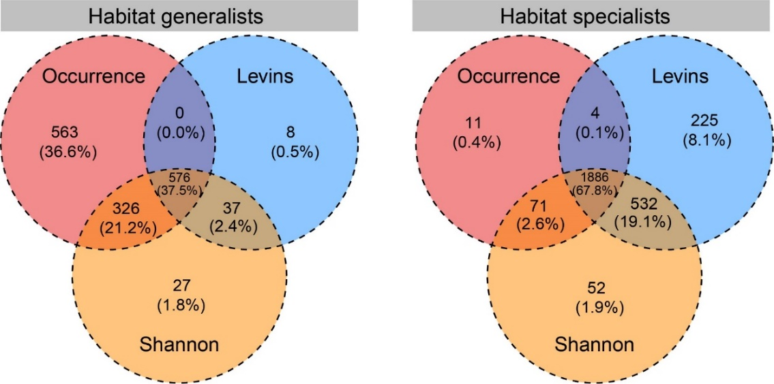
Fig. S1 The Venn diagram showing the number of bacterial OTUs shared among three different methods defining habitat specialization (i.e., Levins’ niche breadth; Shannon diversity; and occurrence) for habitat generalists and specialists, respectively. Values in brackets represent the percentage of the total OTUs identified by three methods. Only the OTUs shared by three methods were considered as habitat generalists and specialists, respectively.

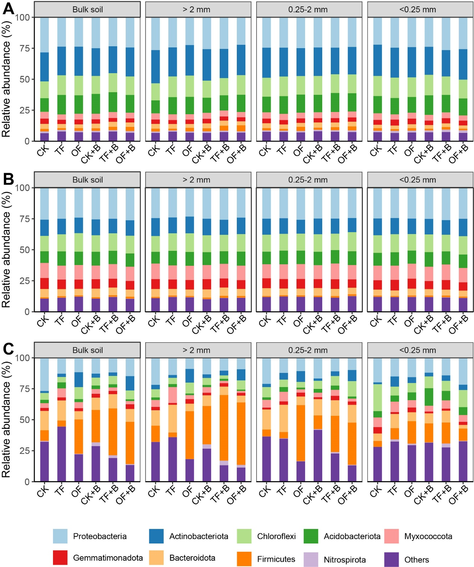
Fig. S2 The relative abundance of the dominant phyla of bacterial meta-community (A) and sub-community (B: habitat generalists and C: habitat specialists) within soil aggregates under biochar and fertilizer regimes.

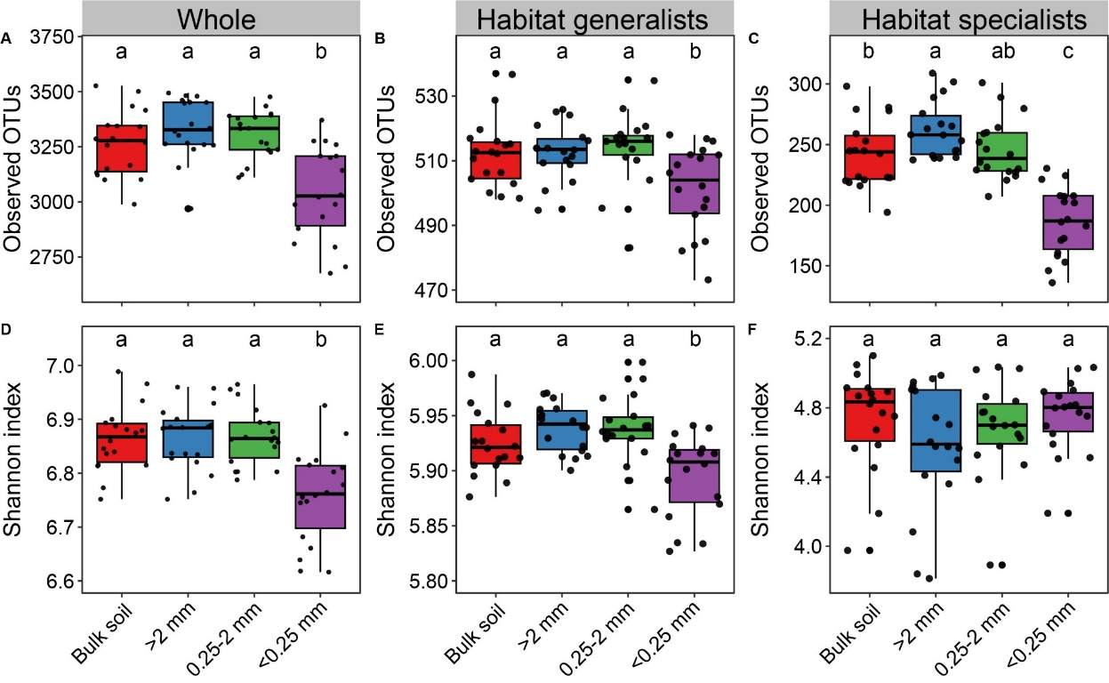
Fig. S3 The observed OTUs (A-C) and Shannon index (D-F) of bacterial meta-community and sub-community within soil aggregates. Different lowercase letters indicate significant differences (p < 0.05) at the different treatments.

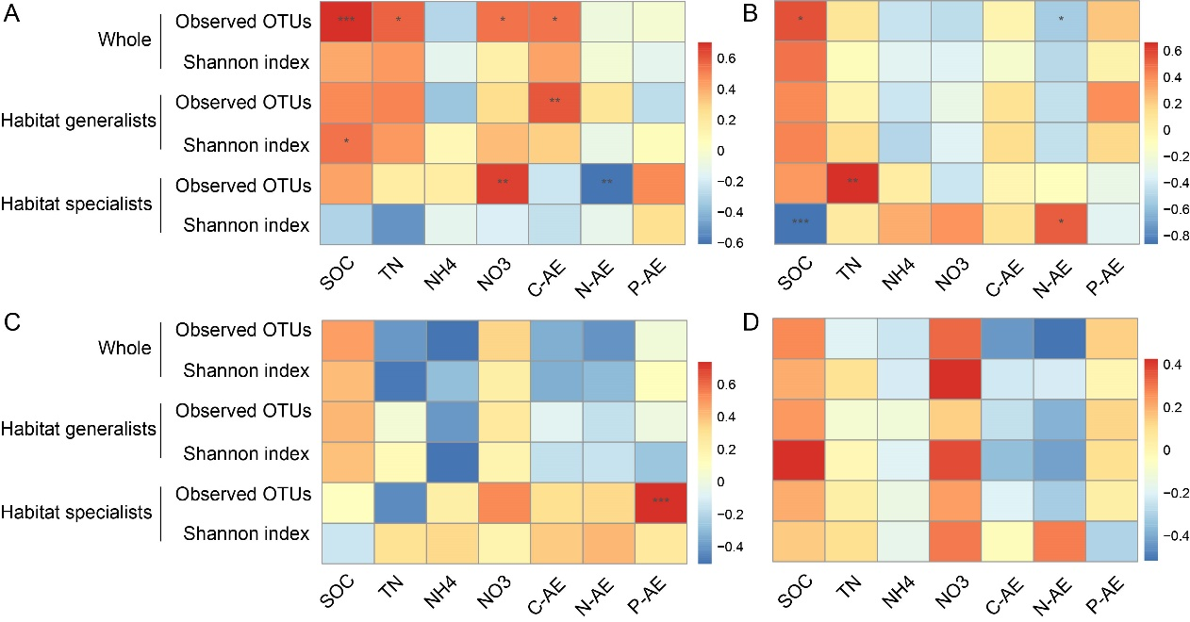
Fig. S4 Pearson correlation analysis between soil properties and extracellular enzymatic stoichiometry versus relative alpha diversities of bacterial meta-community and sub-community. * represents p < 0.05; ** represents p < 0.01; *** represents p < 0.001

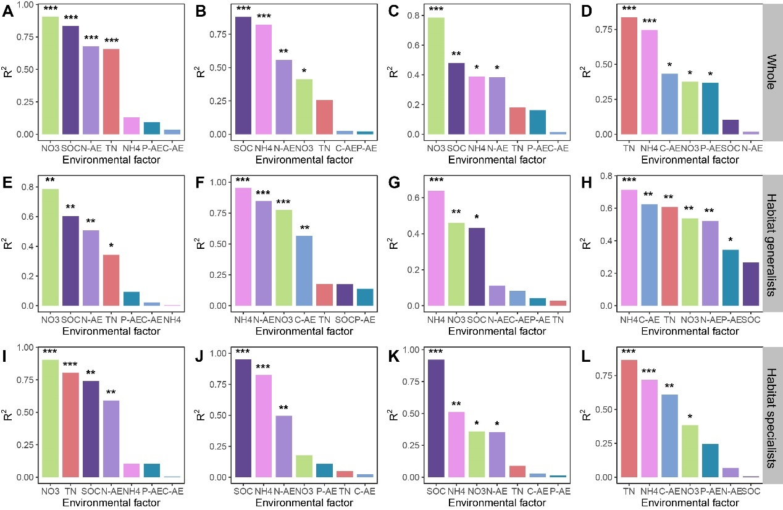
Fig. S5 The significance of each soil properties and extracellular enzymatic stoichiometry on the bacterial meta-community and sub-community structures within aggregates was examined using Enfit function. Bulk soil: A, E, I; soil particle size >2 mm: B, F, J; soil particle size between 0.25-2 mm: C, G, K; soil particle size <0.25 mm: D, H, L.

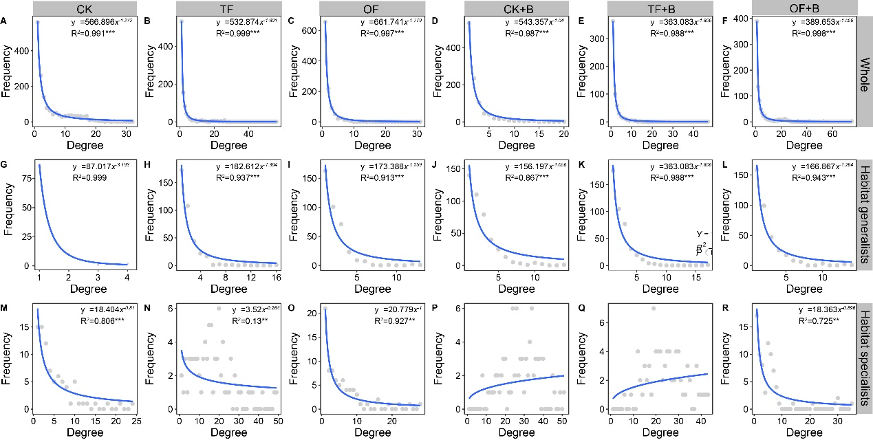
Fig. S6 Degree distribution for the ecological networks of bacterial meta-community and sub-community under biochar and fertilizer regimes.
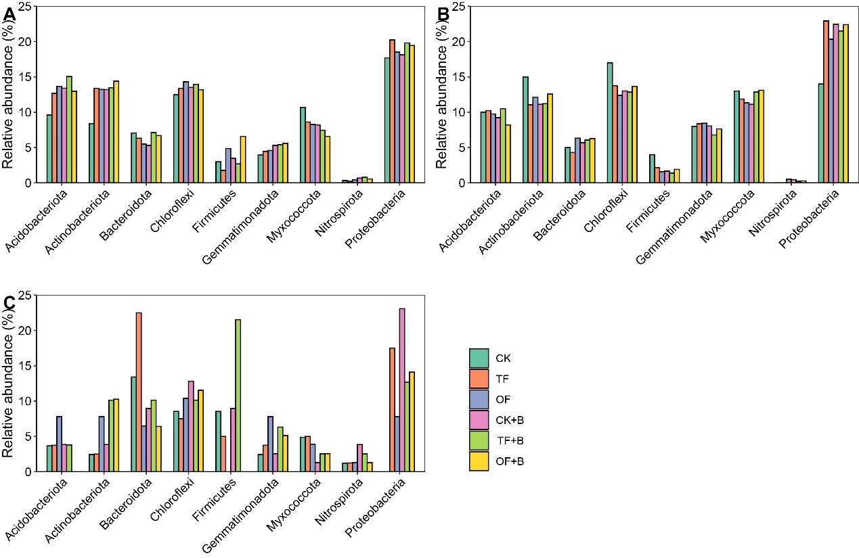
Fig. S7 Proportion of phylogenetic lineages of the total nodes in the co-occurrence networks of bacterial meta-community (A) and sub-community (B: habitat generalists and C: specialists) under biochar and fertilizer regimes.

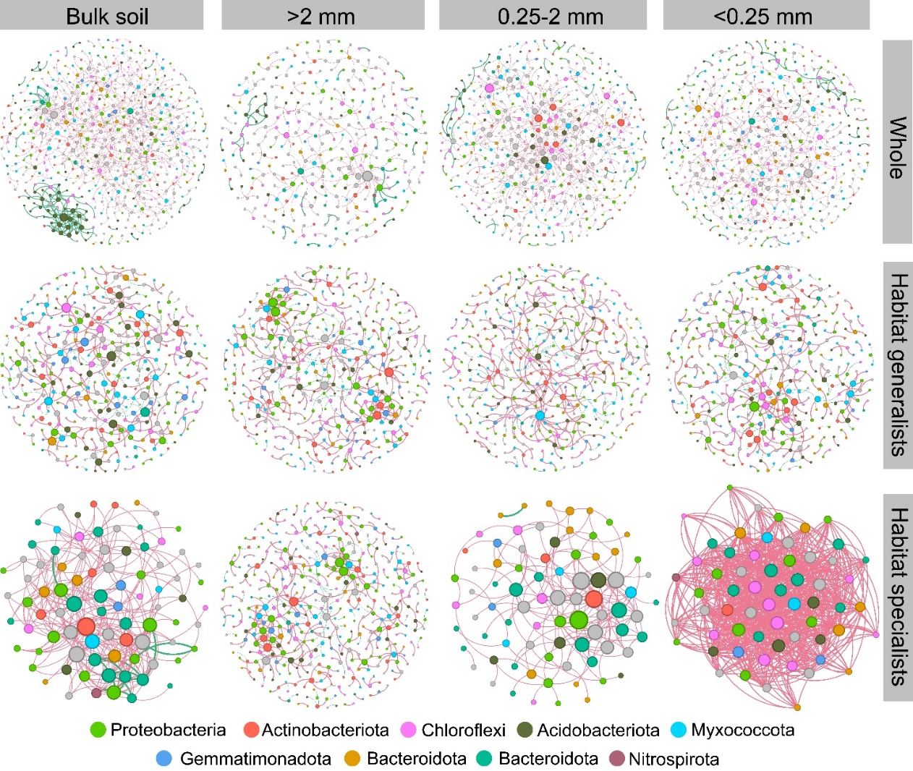
Fig. S8 Ecological networks of bacterial meta-community and sub-community within soil aggregates. The node size was related to the node degree.

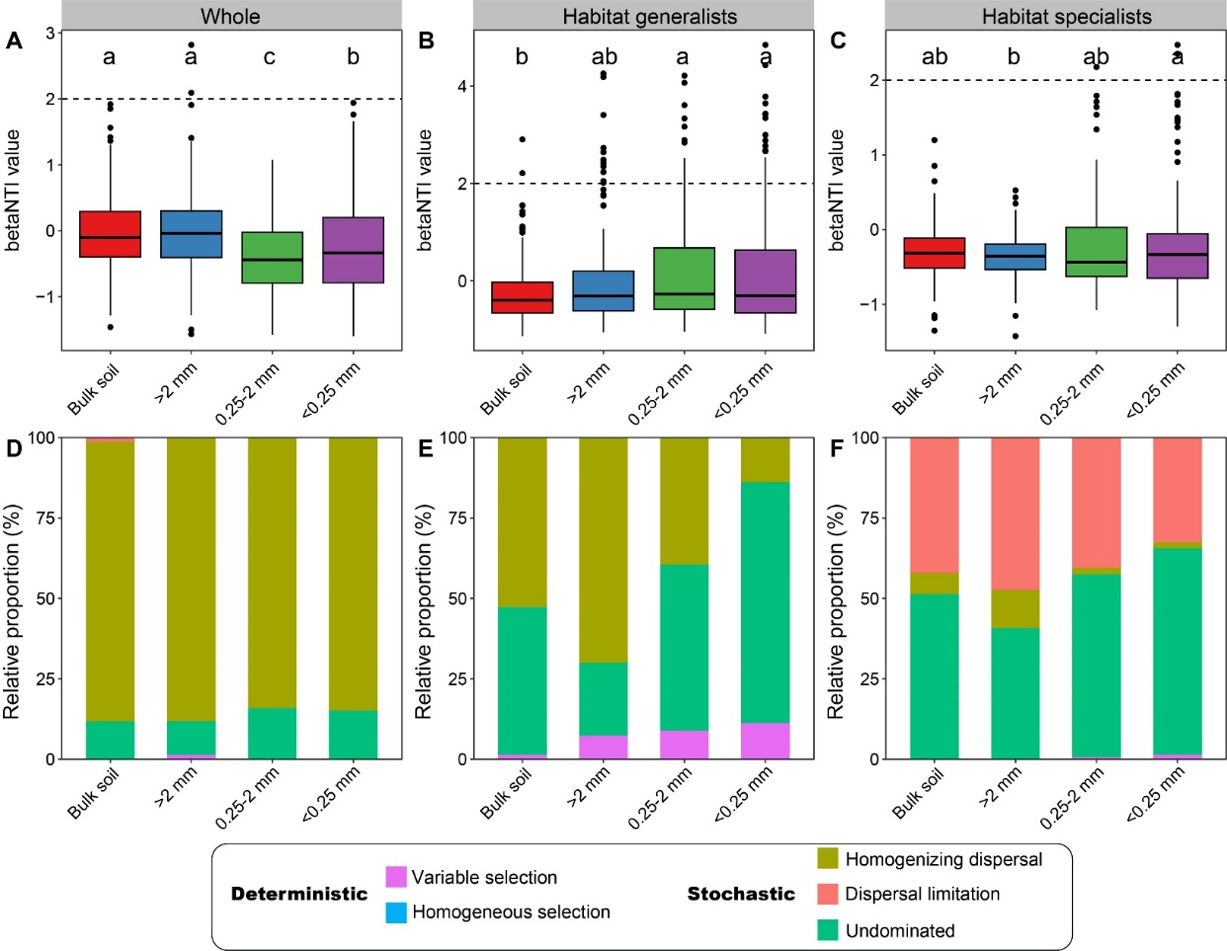
Fig. S9 The betaNTI value of bacterial meta-community (A) and sub-community assembly (B, C) within soil aggregates. Summary of ecological processes that affected the bacterial meta-community and sub-community assembly within soil aggregates (D-F). Relative proportion was given for the relative contribution of each process to the community assembly, as indicated by different colors. Different lowercase letters indicate significant differences (p < 0.05) at the different treatments.

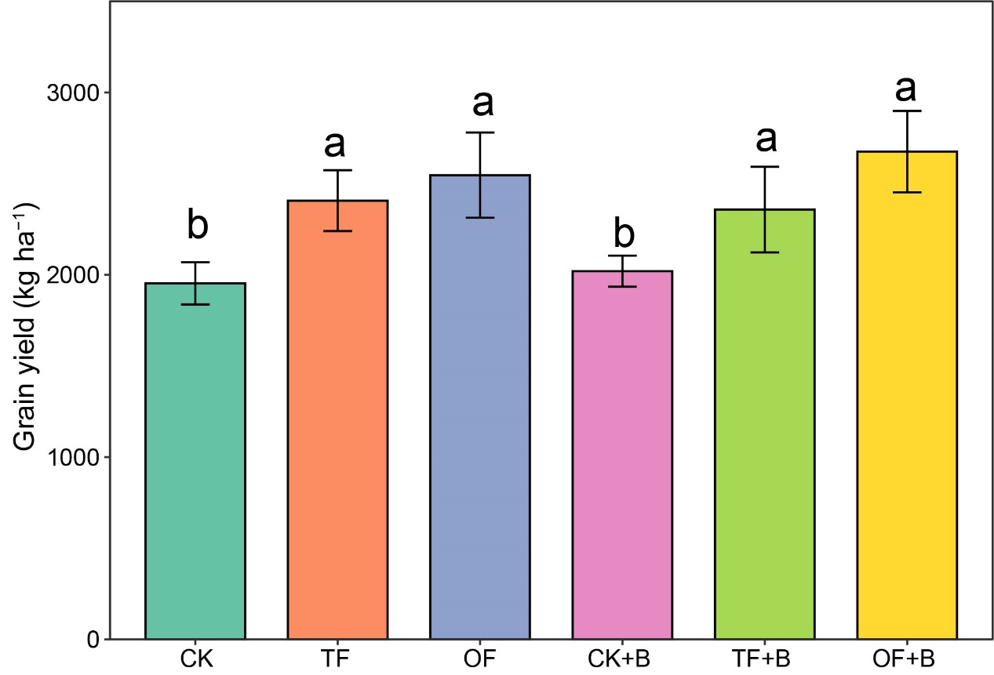
Fig. S10 The yield of proso millet under biochar amendment and fertilizer regimes in 2022. Different lowercase letters indicate significant differences (p < 0.05) at the different treatments.

