Biomaterial-derived Porous Carbon Doped with Heteroatoms as a Separator Coating for High Energy Density Zn‒I Batteries

Shanshuai Chen ^{a,b}, Liu Tian^{a,b}, Xiaoqiang Feng ^{a,b}, Huanyu Bao ^{a,b *},Hongliang Wang^{c*}
ª School of Breeding and Multiplication (Sanya Institute of Breeding and Multiplication)，Hainan University, Sanya 572025
^{b} College of Tropical Agriculture and Forestry, Hainan University, Danzhou 571737
^{c} College of Agronomy and Biotechnology, China Agricultural University, Beijing 100193
* Corresponding author, E-mail: 996593@hainanu.edu.cn and Hlwang@cau.edu.cn.

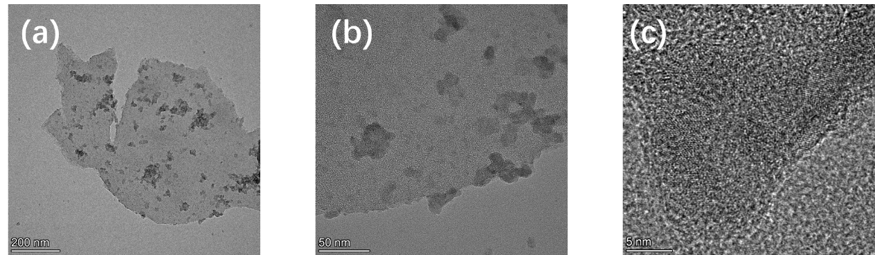
Figure S1. TEM images of NP-PC with different scale bar.

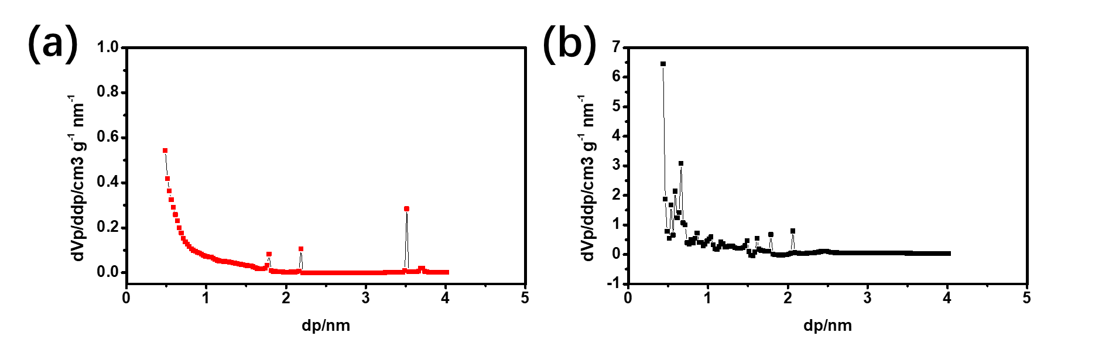
Figure S2. the pore-size distribution of N-PC (a) and NP-PC (b).

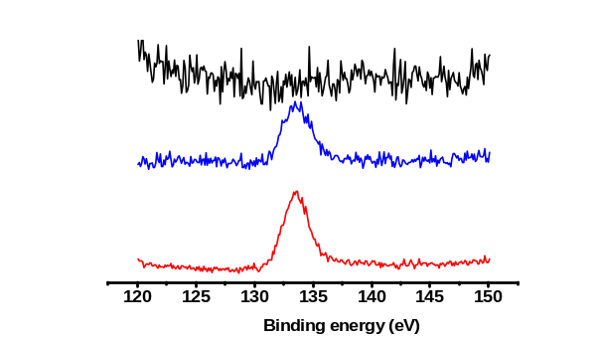
Figure S3. High-resolution XPS spectra of N-PC (black), P-PC (blue) and NP-PC (red) showing the fitted P 2p peaks.

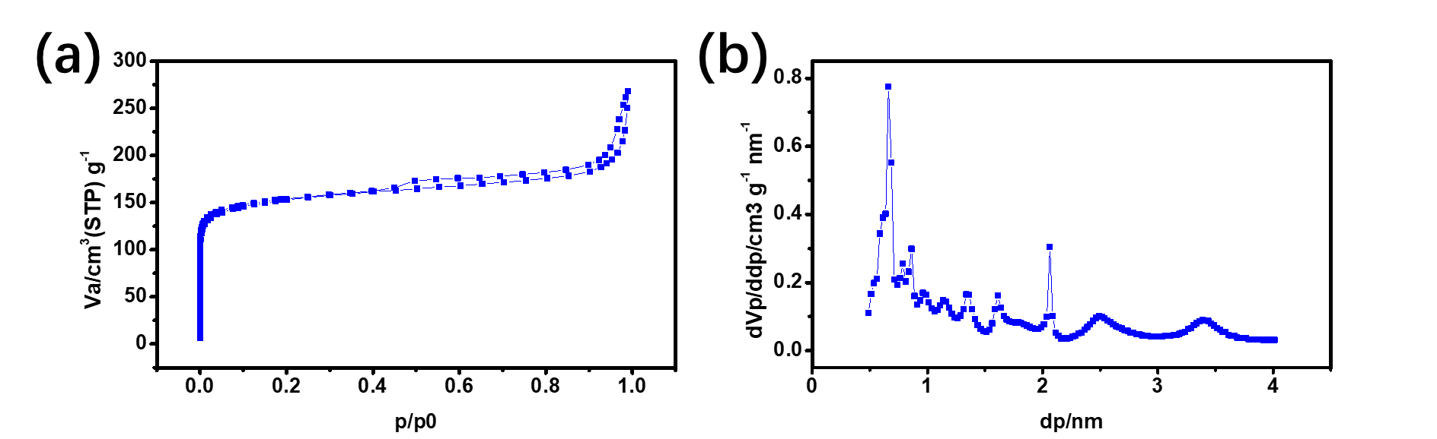
Figure S4. N₂ adsorption‒desorption isotherm curve of P-PC.
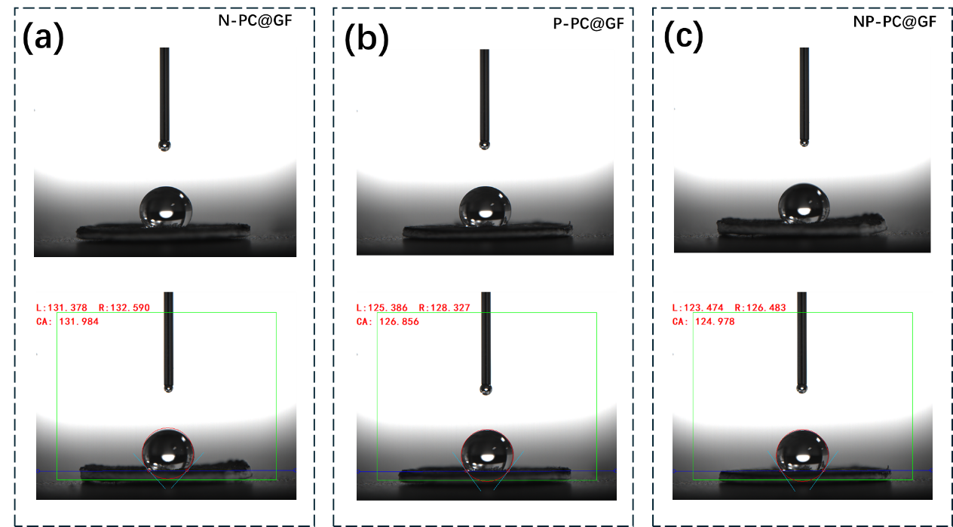
Figure S5. Comparison of electrolyte (2 m ZnSO₄ in H₂O) wetting and ion transport properties of N-PC@GF (a) and P-PC@GF (b) and NP-PC@GF (c).

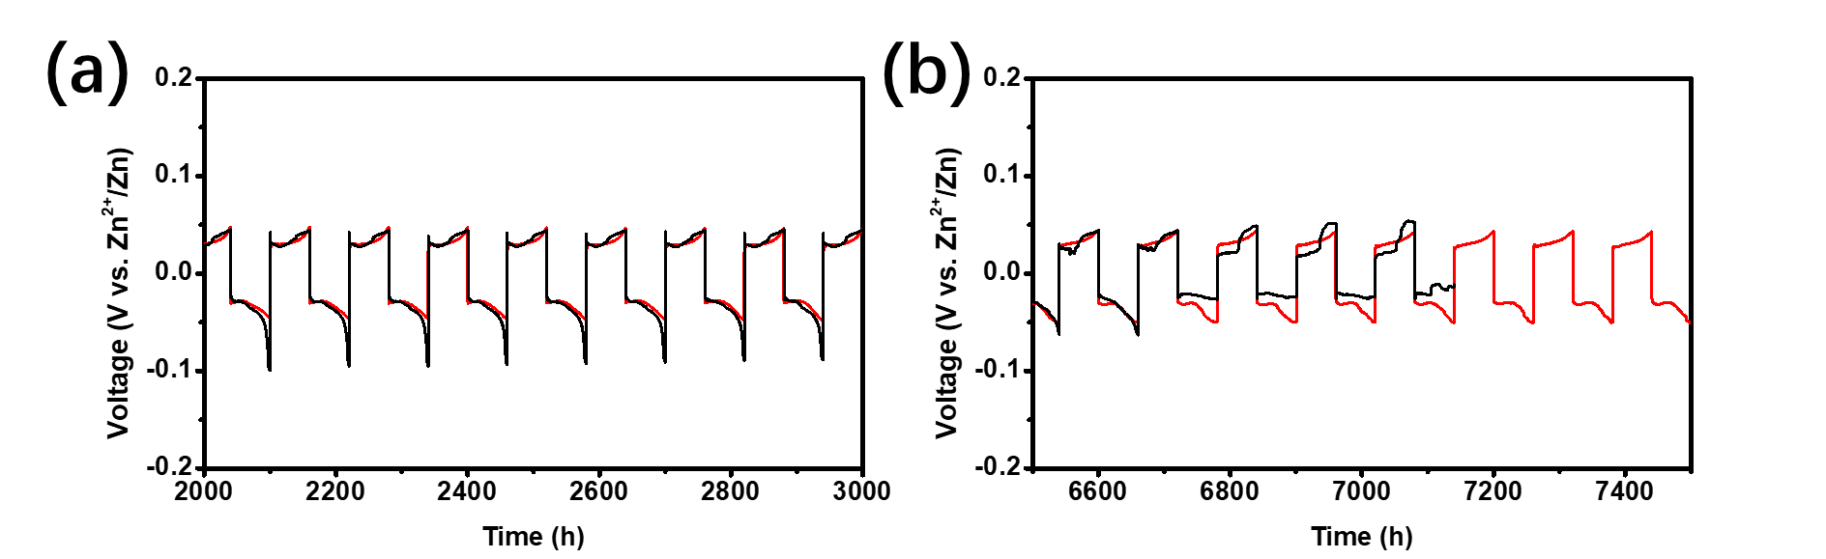
Figure S6. The time-voltage profiles of the specific times for the Zn//Zn symmetry cells with the N-PC@GF (black) and NP-PC@GF (red) separator.

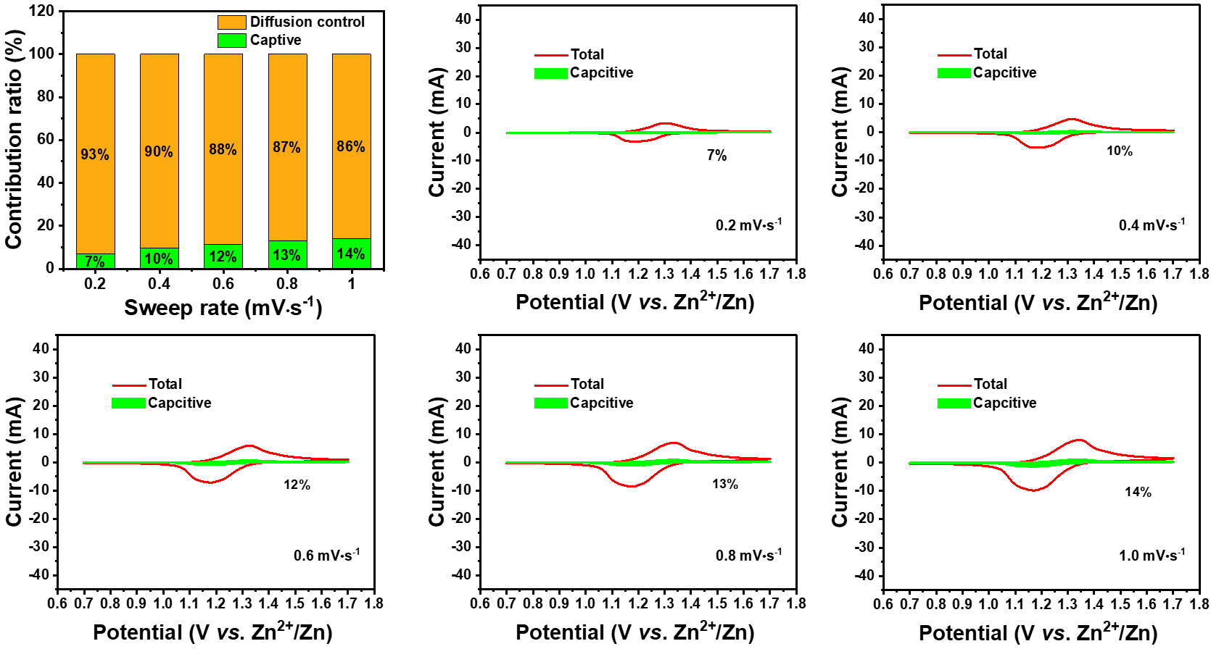
Figure S7. capacitance and diffusion-controlled contributions at different scan rates of N-PC@GF separator.

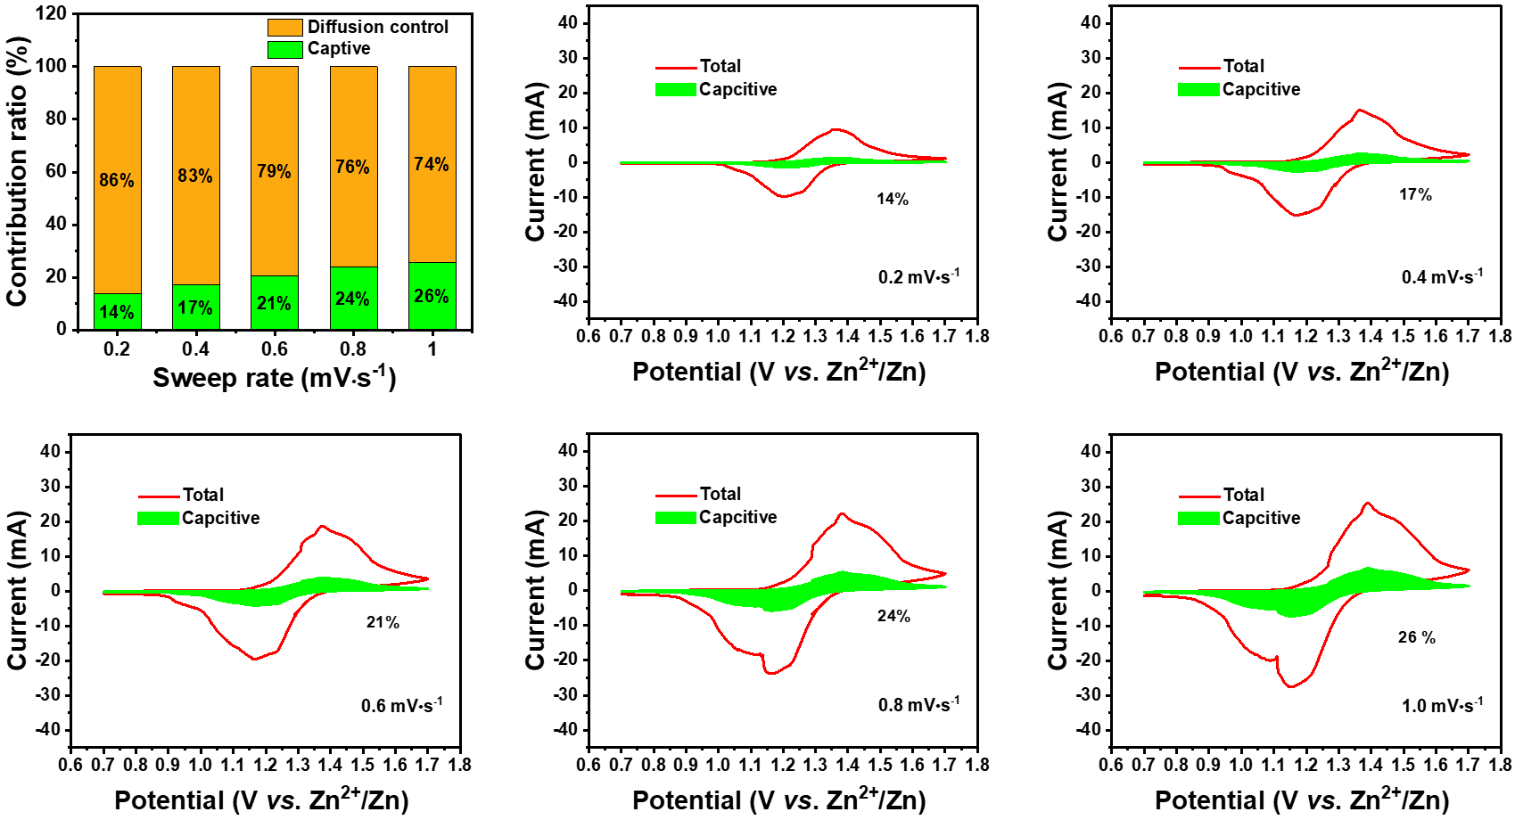
Figure S8. capacitance and diffusion-controlled contributions at different scan rates of NP-PC@GF separator.

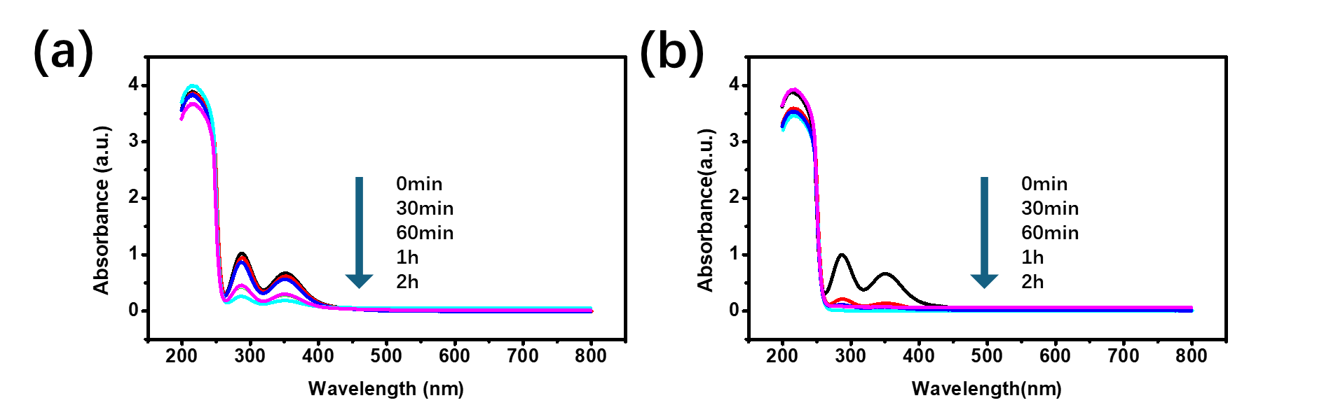
Figure S9. UV/Vis curves of polyiodide solution before and after adding N-PC (a) and NP-PC (b).

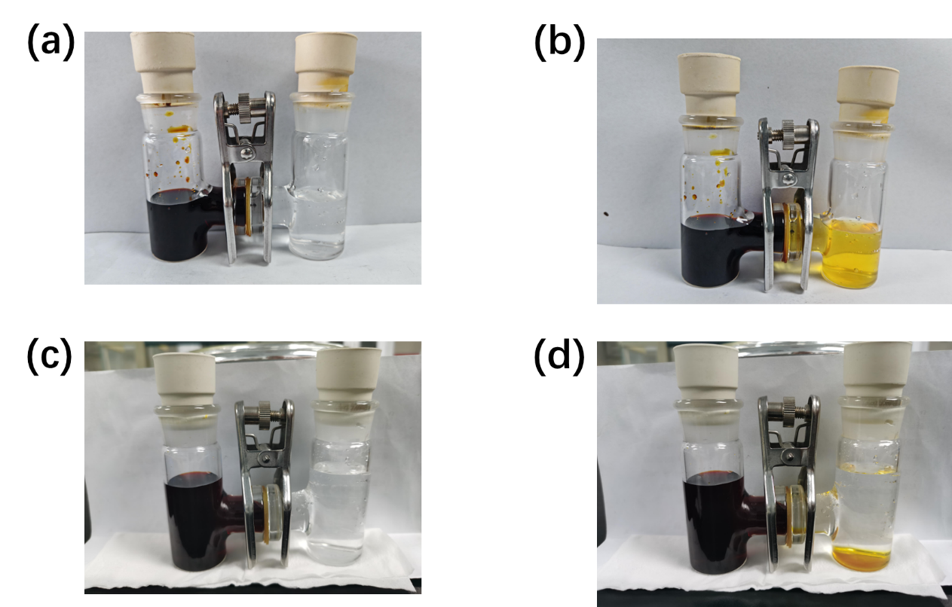
Figure S10. Optical images of visual shuttle effect by H-type glass cells with the I_{x}²⁻ solution for N-PC@GF (a&b) and NP-PC@GF (c&d) separator.

