Supplementary Materials

Remediation of emerging inorganic contaminants in soils and water using pristine and engineered biochar- A review

Sabry M. Shaheen^{1*}, Habib Ullah², Yuejun Wu³, Ahmed Mosa⁴, Yueru Fang⁵, Yu Shi⁶, Juan Liu⁶, Manish Kumar⁷, Han Zhang⁸, Baogang Zhang⁹, Ronghua Li⁵, Jianxu Wang¹⁰, Vasileios Antoniadis¹¹, Sang Soo Lee^{12*}, Jörg Rinklebe^{1*}

¹University of Wuppertal, School of Architecture and Civil Engineering, Institute of Foundation Engineering, Water- and Waste-Management, Laboratory of Soil- and Groundwater-Management, Pauluskirchstraße 7, 42285 Wuppertal, Germany
² Innovation Center of Yangtze River Delta, Zhejiang University, Zhejiang 311400, China
³School of Environmental Science and Technology, Hainan University, Haikou, 570228, China
⁴ Soils Department, Faculty of Agriculture, Mansoura University, 35516 Mansoura, Egypt
⁵College of Natural Resources and Environment, Northwest A&F University, Yangling, Shaanxi 712100, China
⁶School of Environmental Science and Engineering, Guangzhou University, Guangzhou, 510006, China
⁷Amity Institute of Environmental Sciences, Amity University, Noida, India
⁸School of Energy and Environmental Engineering, University of Science and Technology Beijing, Beijing, 100083, China
⁹School of Water Resources and Environment, China University of Geosciences, Beijing 100083, China
¹⁰ State Key Laboratory of Environmental Geochemistry, Institute of Geochemistry, Chinese Academy of Sciences, 550082 Guiyang, P.R. China
¹¹Laboratory of Soil Science, University of Thessaly, Fytokou Street, 384 46, Volos, Greece
¹²Department of Environmental and Energy Engineering, Yonsei University, Wonju, 26493, Republic of Korea

*Correspondence authors:
Prof. Dr. Jörg Rinklebe; E-mail: rinklebe@uni-wuppertal.de
Prof. Dr. Sabry Shaheen; E-mail: shaheen@uni-wuppertal.de
Prof. Dr. Sang Soo Lee; E-mail: cons@yonsei.ac.kr

(A)
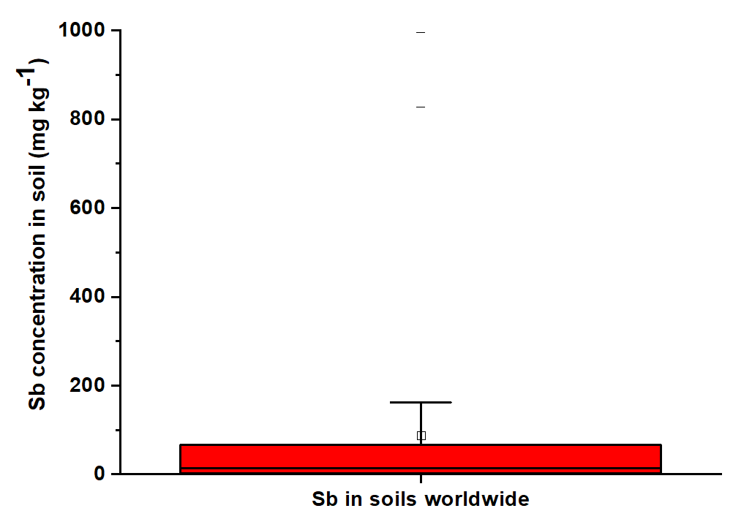
(B)
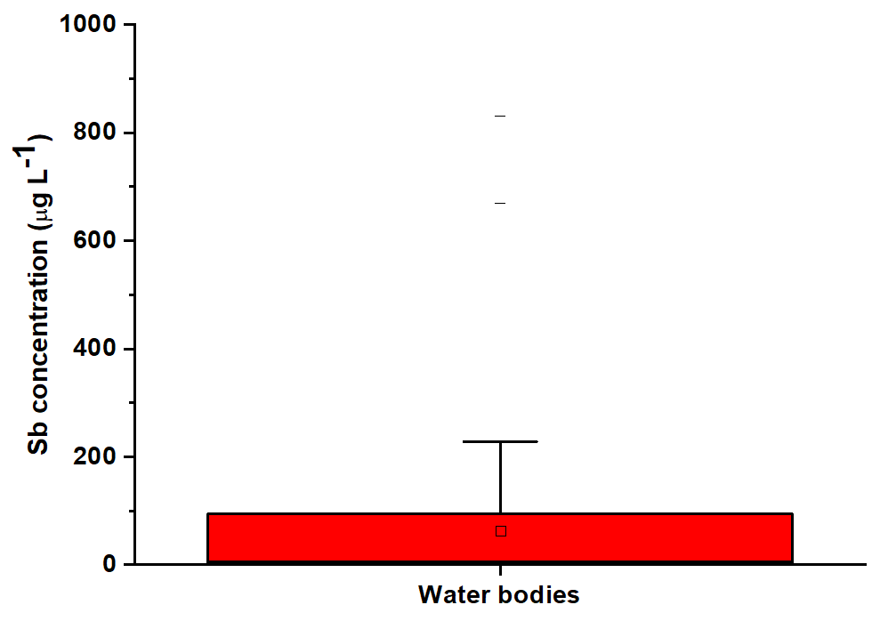
(C)
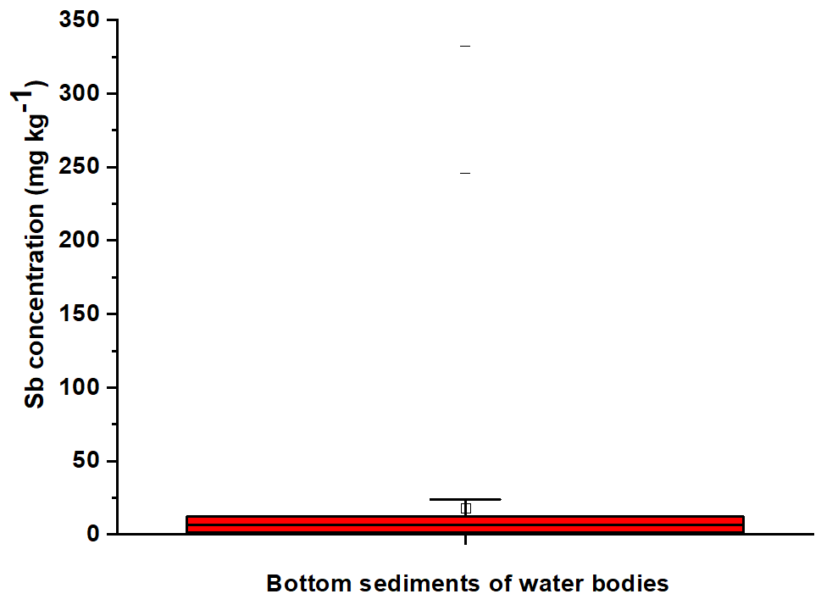

Fig S1. (A) Sb concentration soils worldwide (A), in water bodies (B), and in bottom sediments of water bodies (C).

(A)
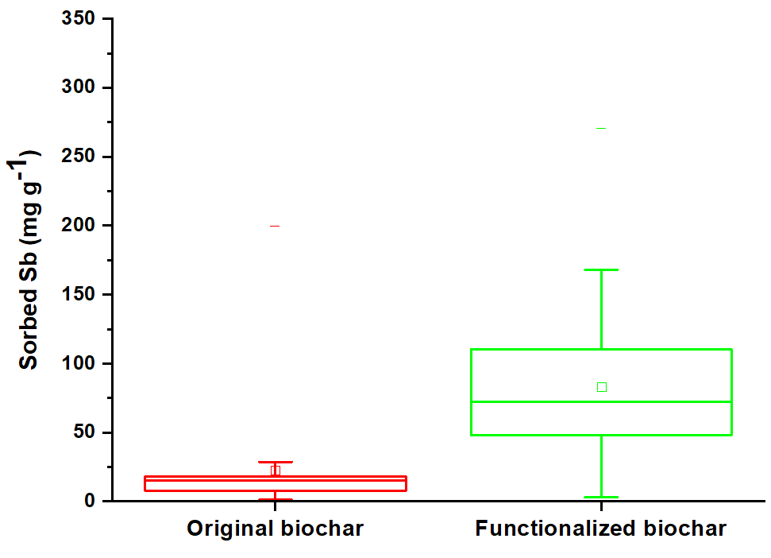
(B)
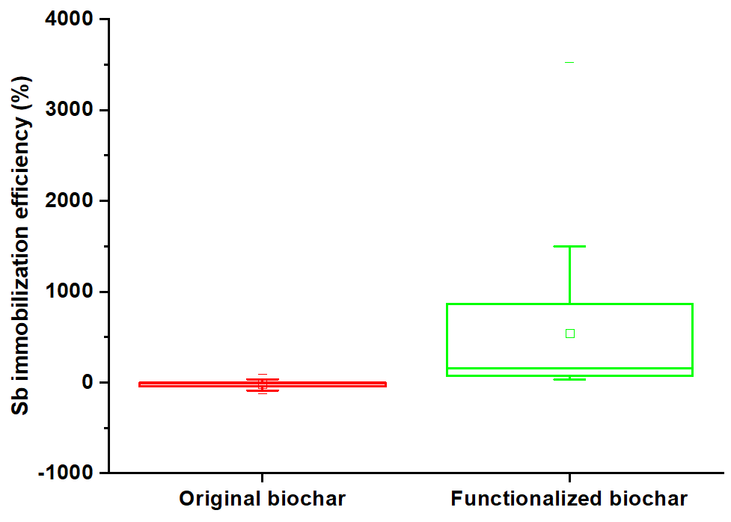

Fig S2: Sb sorption capacity (A), and immobilization efficiency (B) onto pristine and functionalized biochars.

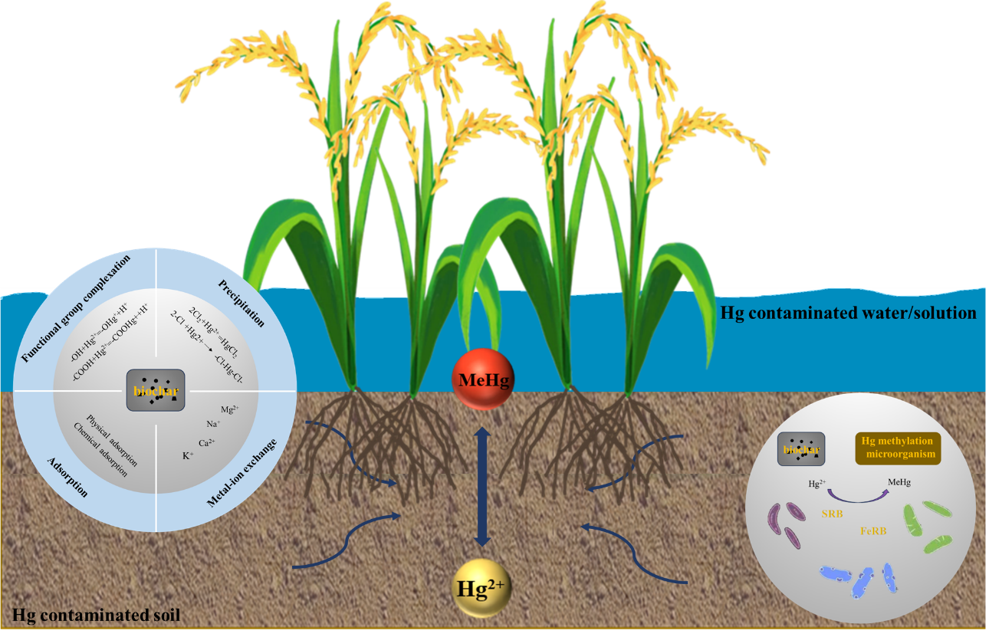
Figure S3: Transformation and mechanisms of Hg immobilization in biochar treated paddy soils

