Collaborative modification strategy to improve the formation of biochar-derived persistent free radicals for aniline removal via peroxymonosulfate activation
Zilong Zhao^{1,2,}, Shuting Zhu¹, Shuyu Qi¹, Ting Zhou¹, Yang Yang¹, Feng Wang¹, Qi Han¹, Wenyi Dong^{1,3,4,5}, Hongjie Wang^{1,3,4,5}, Feiyun Sun¹
¹ (School of Civil and Environmental Engineering, Harbin Institute of Technology Shenzhen, Shenzhen 518055, PR China)
² (Low-Carbon and Ecological Environmental Protection Research Center, Chongqing Academy of Science and Technology, Chongqing 401120, PR China)
³ (Shenzhen Key Laboratory of Water Resource Utilization and Environmental Pollution Control, Shenzhen, 518055, PR China)
⁴ (State Key Laboratory of Urban Water Resource and Environment, School of Environment, Harbin Institute of Technology, Harbin, 150090, PR China)
⁵ (Joint Laboratory of Urban High Strength Wastewater Treatment and Resource Utilization, Harbin Institute of Technology (Shenzhen), Shenzhen, 518055, PR China)

Supplementary materials
- Text S1. Characterization and analysis methods
- Fig. S1. Effect of urea and Na₂CO₃ content on PFR concentration (a,d), g-value (b,e), and aniline removal efficiency (c,f) using MB500 (initial pH = 7, aniline concentration = 10 mg L^{‒1}, PMS concentration = 0.15 g L^{‒1}, MB500 dosage = 0.5 g L^{‒1}).
- Fig. S2. SEM images of MBC at different pyrolysis temperatures.
- Fig. S3. Changes in FTIR spectra (a) and oxygen containing functional group content of modified biochar at various pyrolysis temperatures (b).
- Fig. S4. Effect of nitrogen source precursors on PFRs concentration (a), g-values of PFRs (b), and aniline removal efficiency (c).
- Fig. S5. Spearman correlation analysis between PFRs concentration and porous structures of biochar.
- Fig. S6. Comparison of nitrogen heterocyclic structures in the raw (a), and modified biochar with Na₂CO₃ alone (b), urea alone (c), and urea and Na₂CO₃ (d).
- Fig. S7. Effect of coexisting anions at 5 mg L^{‒1} (a) and 200 mg L^{‒1} (b) on aniline removal efficiency and reaction rate constants in the MB500/PMS catalytic system (initial pH = 7, aniline concentration = 10 mg L^{‒1}, PMS concentration = 0.2 g L^{‒1}, MB500 dosage = 0.7 g L^{‒1}, reaction time = 30 min).
- Fig. S8. Effect of repeated cycles on aniline removal efficiency in the MB500/PMS catalytic system (initial pH = 7, aniline concentration = 10 mg L^{‒1}, PMS concentration = 0.2 g L^{‒1}, MB500 dosage = 0.7 g L^{‒1}, reaction time = 30 min).
- Fig. S9. Effect of initial pH on adsorption removal of aniline by MB500 (aniline concentration = 10 mg L^{‒1}, MB500 dosage = 0.7 g L^{‒1}).
- Fig. S10. Adsorption kinetics of aniline on MB500: curve fitting analysis at varying initial pH levels (aniline concentration = 10 mg L^{‒1}, MB500 dosage = 0.7 g L^{‒1}).
- Fig. S11. Influence of pH variation on the zeta potential of MB500.
- Fig. S12. EPR spectra of spin-trapping adducts: •OH, SO₄•– (a), O₂•– (b), and ¹O₂ (c) generated by the MB500/PMS catalytic system.
- Fig. S13. Temporal variation of concentration of reactive species in the MB500/PMS catalytic system (initial pH = 7, aniline concentration = 10 mg L^{‒1}, PMS concentration = 0.2 g L^{‒1}, MB500 dosage = 0.7 g L^{‒1}).
- Fig. S14. Effect of N₂ purging on aniline removal by the MB500/PMS catalytic system (initial pH = 7, aniline concentration = 10 mg L^{‒1}, PMS concentration = 0.2 g L^{‒1}, MB500 dosage = 0.7 g L^{‒1}).
- Table S1 Detailed analysis of ash composition in corncob after combustion at 550 ℃.
- Table S2 Specific surface area, total pore volume, and average pore diameter of MBC at different pyrolysis temperatures.
- Table S3 Kinetic parameters for aniline adsorption onto MB500 at different initial pH values.

Text S1. Characterization and analysis methods
The concentrations of various oxygen containing functional groups, including phenolic hydroxyl, lactone, and carboxyl groups, on the biochar surface were quantified using the Boehm titration method. The procedure employed was as follows: Three aliquots, each containing 0.10 g of biochar, were weighed into separate 25 mL centrifuge tubes. To each tube, 10 mL of a 0.05 mmol L^{‒1} solution of NaHCO₃, Na₂CO₃, or NaOH was added. The tubes were sealed and placed in a constant-temperature shaker, where they were agitated at 200 rpm for 24 h at 25 ℃. A control experiment was conducted simultaneously without biochar. After the shaking period, the solutions were filtered through a 0.45 μm filter membrane. The filtrate was then titrated with a 0.05 mol L^{‒1} HCl solution using a potentiometric titrator until the pH reached 4.4, the endpoint being marked by a color change of methyl orange. The concentrations of different oxygenated functional groups were determined based on the volume of HCl consumed.
The concentration of persistent free radicals (PFRs) is linearly related to the quadratic integration of their electron paramagnetic resonance (EPR) spectra. In this study, 1,1-diphenyl-2-picrylhydrazine (DPPH), a stable solid free radical with a spectrum similar to that of PFRs in biochar, was employed as a standard substance. To quantify the concentration of PFRs in biochar, regression curves were established by correlating the quadratic integration of the EPR spectra of DPPH with the PFRs concentration at different mass fractions. The procedure involved loading a precise amount of biochar particles into a micropipette, which was sealed with vacuum grease at one tip. The samples were then continuously monitored for free radical signals using an EPR spectrometer (Magnetech ESR5000) equipped with a signal cavity. The typical EPR measurement parameters were as follows: microwave power of 0.1 mW, modulation amplitude of 0.2 mT, center field strength of 337.0 mT, and a sweep time of 40 s.
Reactive species in the reaction system were detected using EPR, with 5,5-dimethyl-1-pyrroline oxide (DMPO) as the capture agent for •OH and O₂•–, and 2,2,6,6-tetramethylpyridine (TEMP) as the capture agent for ¹O₂. For the detection of O₂•–, methanol solution was used as a scavenger of •OH, which rapidly reacts with •OH, thereby allowing detection of O₂•– produced in the reaction solution. The remaining experimental steps were consistent with those described in section 2.3. At various time points, reaction solutions were transferred into centrifuge tubes containing either DMPO or TEMP, shaken well, and then loaded into a micropipette, which was sealed with vacuum grease at one tip. The micropipette was then placed into the standard resonator of an EPR spectrometer (EMXplus-6/1) for detection. The specific parameter settings were as follows: microwave power of 6.325 mW, modulation amplitude of 0.1 mT, modulation frequency of 100 kHz, center field strength of 351.0 mT, and sweep time of 30 s.

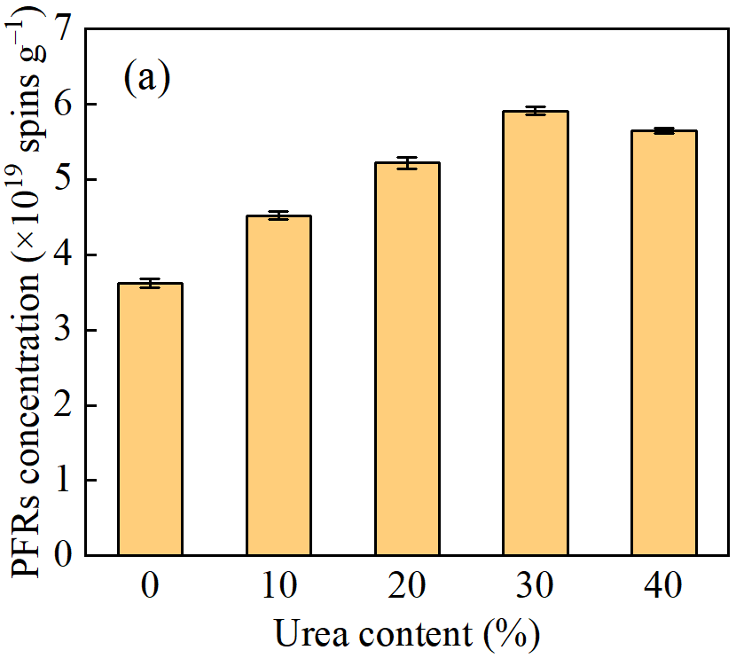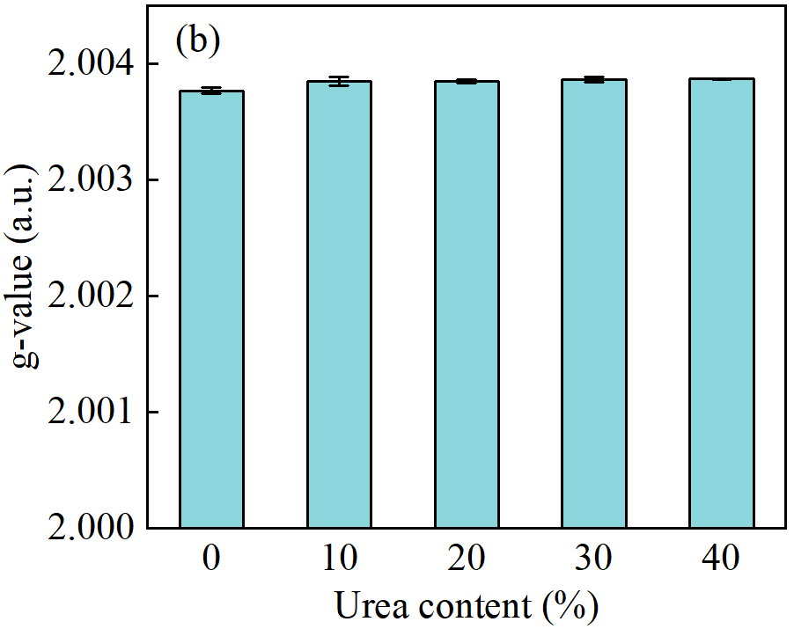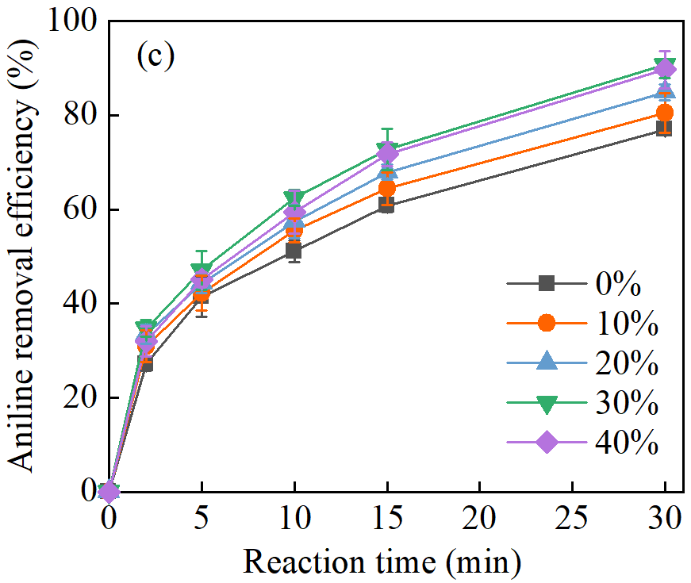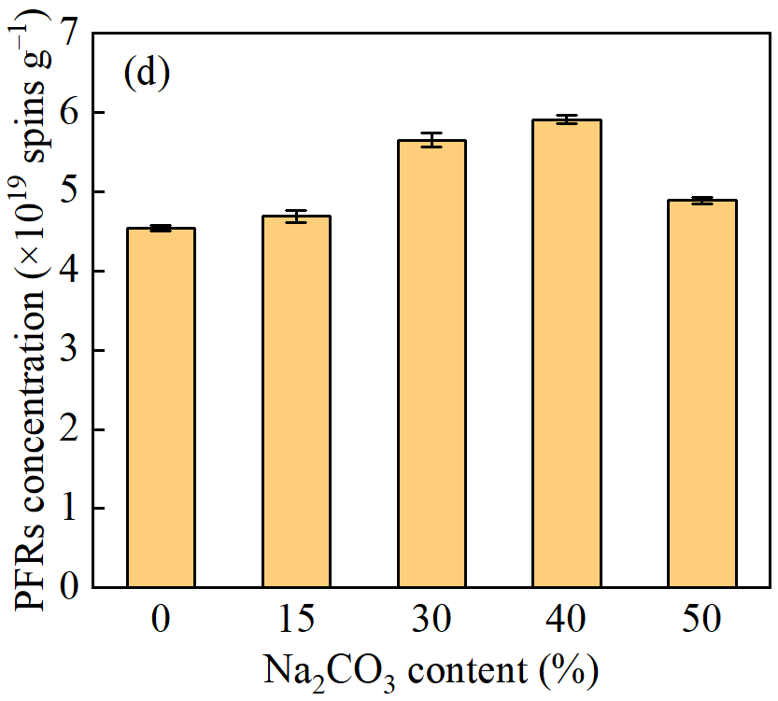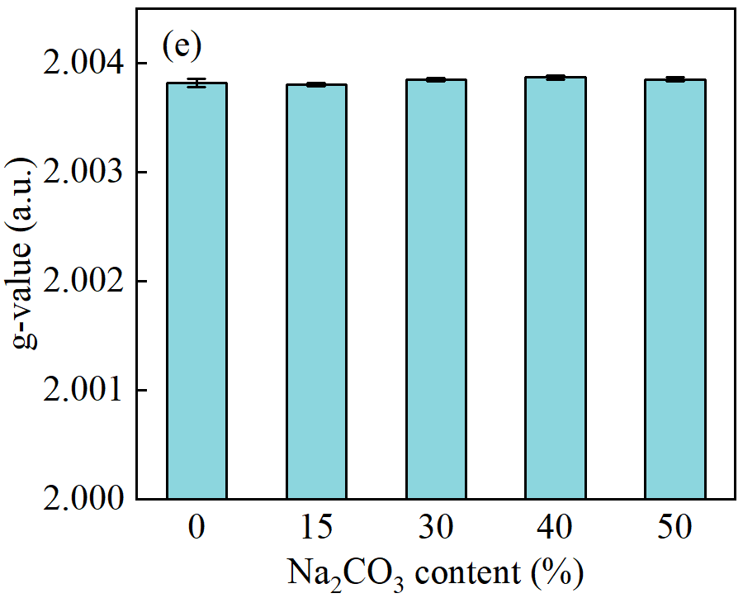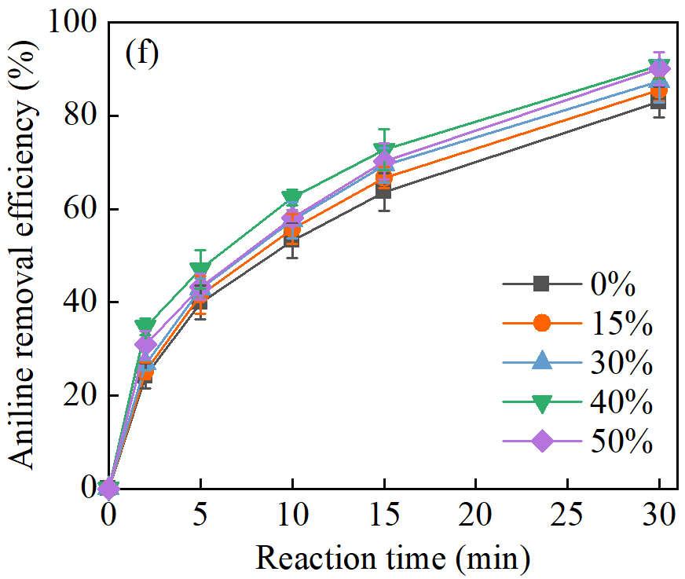
Fig. S1. Effect of urea and Na₂CO₃ content on PFR concentration (a,d), g-value (b,e), and aniline removal efficiency (c,f) using MB500 (initial pH = 7, aniline concentration = 10 mg L^{‒1}, PMS concentration = 0.15 g L^{‒1}, MB500 dosage = 0.5 g L^{‒1}).

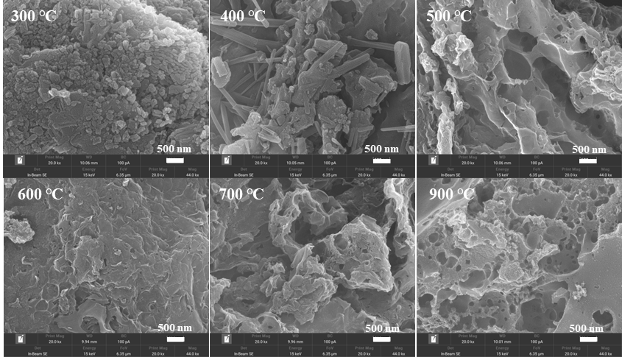
Fig. S2. SEM images of MBC at different pyrolysis temperatures.

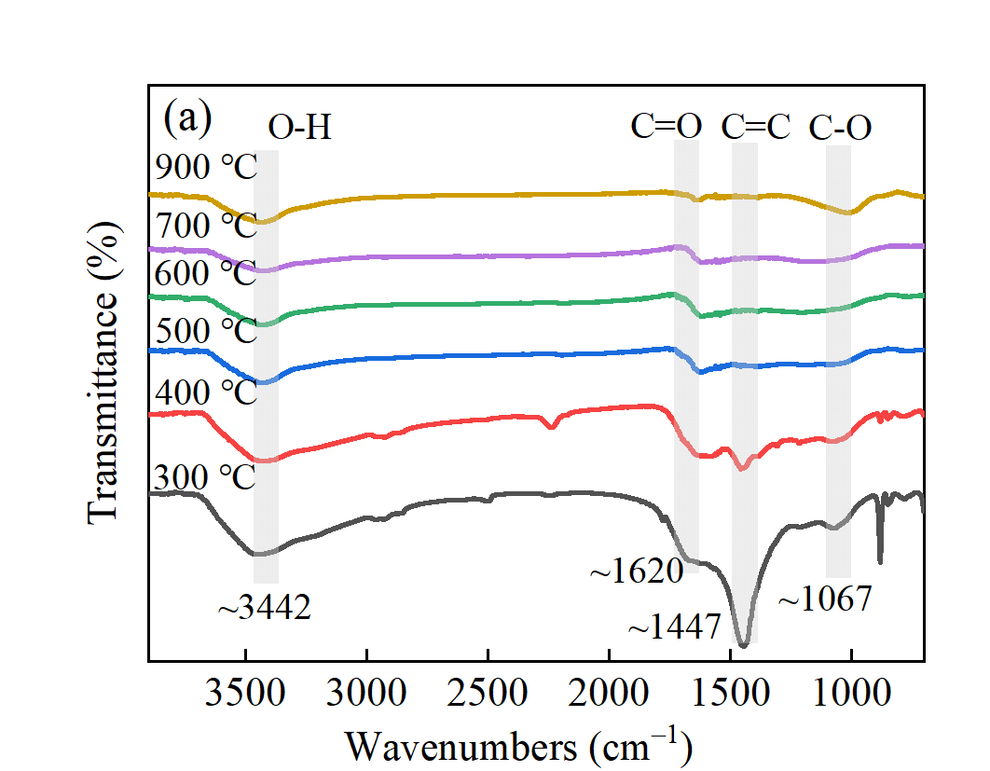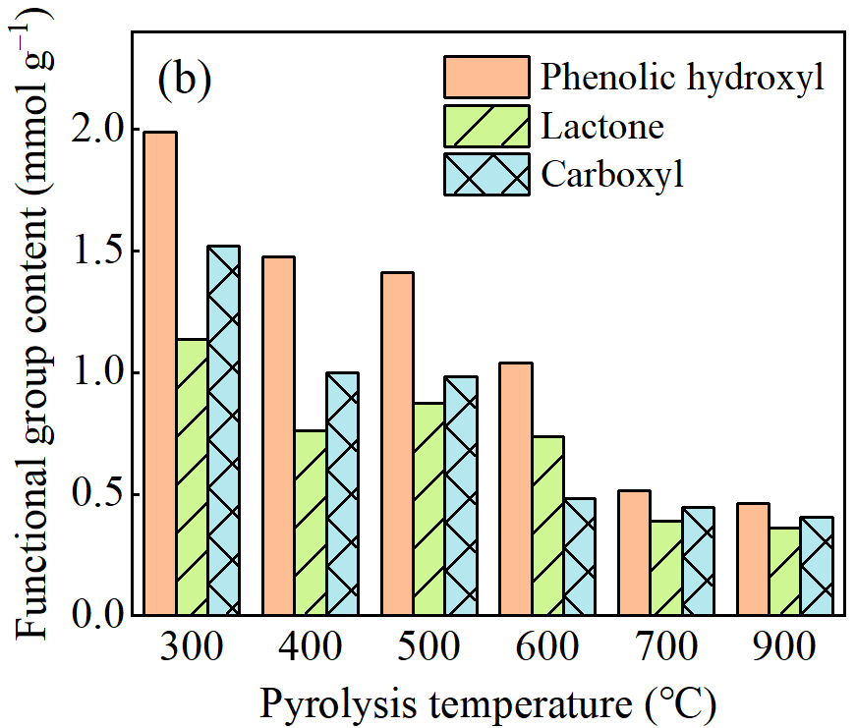
Fig. S3. Changes in FTIR spectra (a) and oxygen containing functional group content of modified biochar at various pyrolysis temperatures (b).

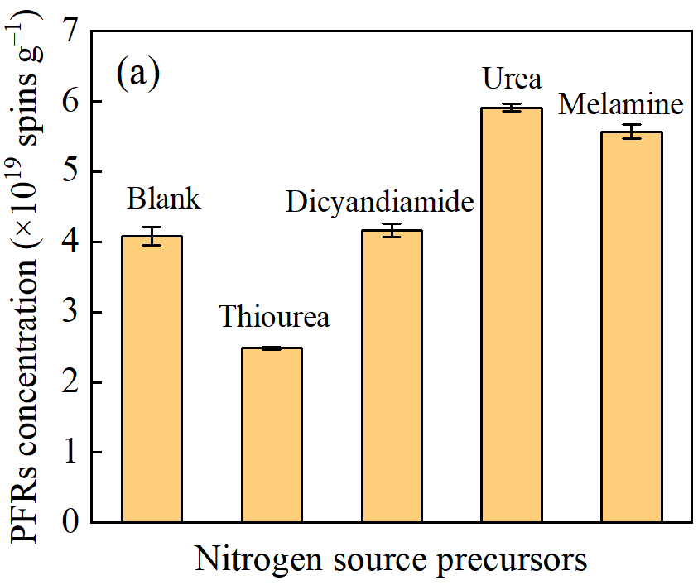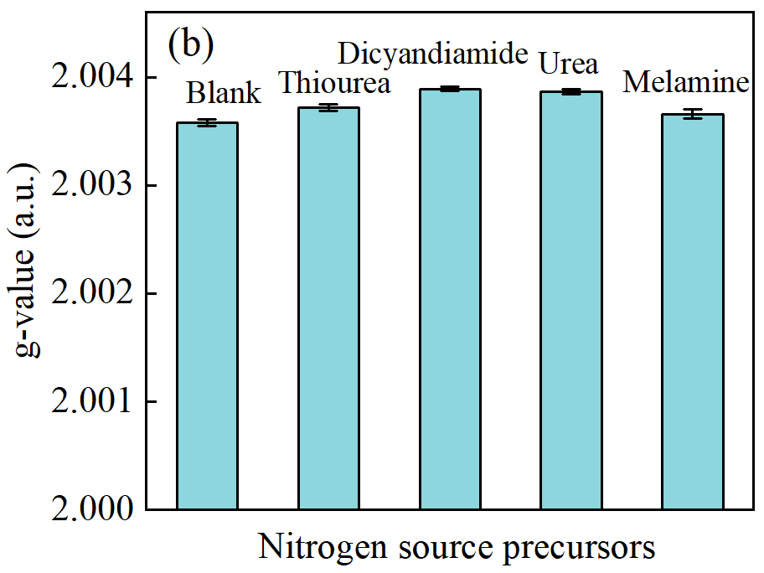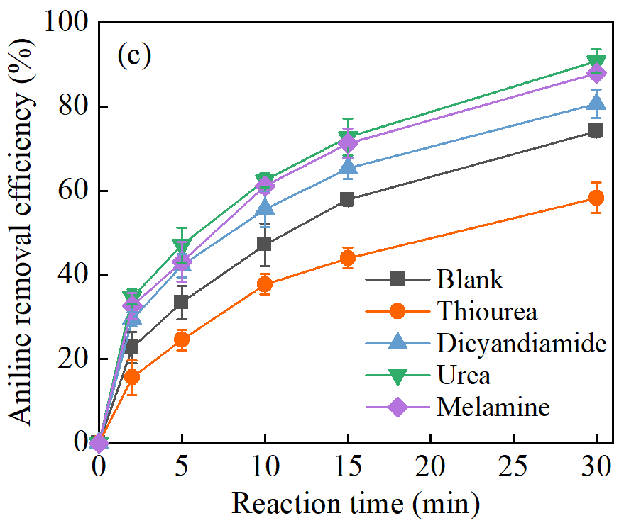
Fig. S4. Effect of nitrogen source precursors on PFRs concentration (a), g-values of PFRs (b), and aniline removal efficiency (c).

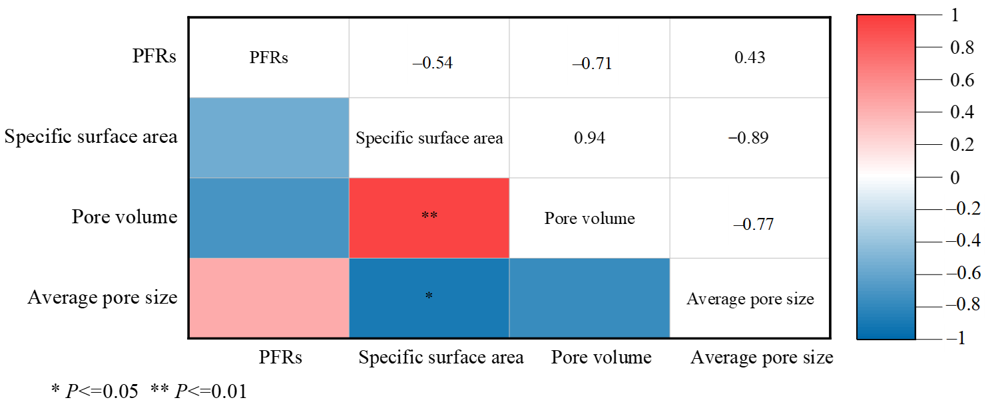
Fig. S5. Spearman correlation analysis between PFRs concentration and porous structures of biochar.
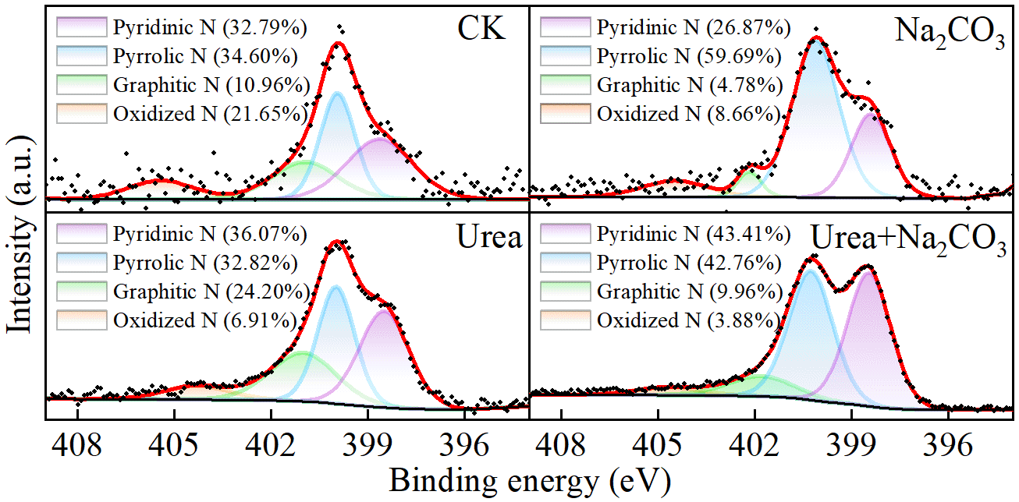
Fig. S6. Comparison of nitrogen heterocyclic structures in the raw (a), and modified biochar with Na₂CO₃ alone (b), urea alone (c), and urea and Na₂CO₃ (d).

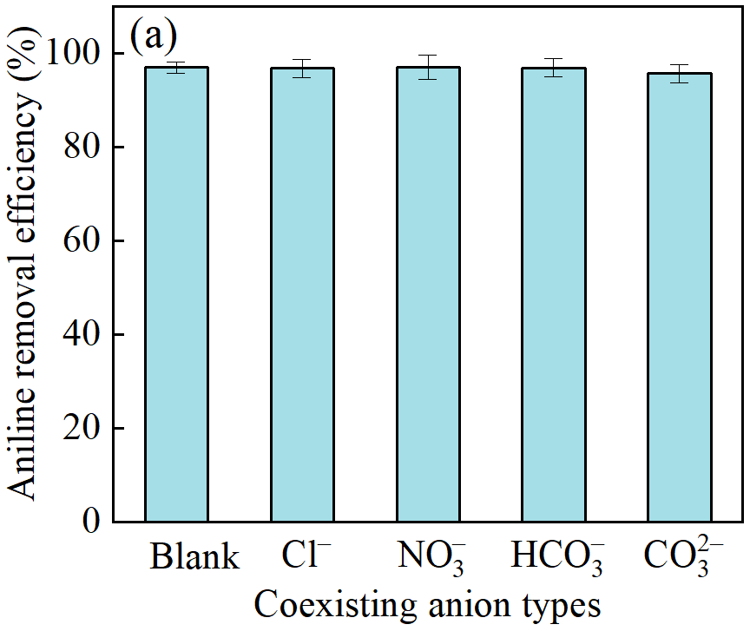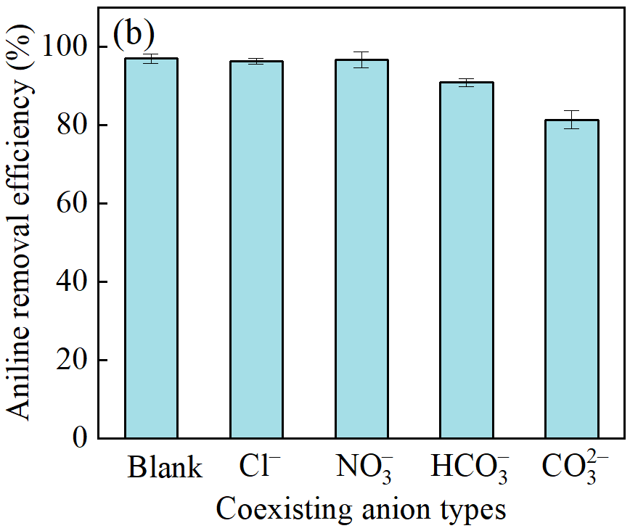
Fig. S7. Effect of coexisting anions at 5 mg L^{‒1} (a) and 200 mg L^{‒1} (b) on aniline removal efficiency and reaction rate constants in the MB500/PMS catalytic system (initial pH = 7, aniline concentration = 10 mg L^{‒1}, PMS concentration = 0.2 g L^{‒1}, MB500 dosage = 0.7 g L^{‒1}, reaction time = 30 min).

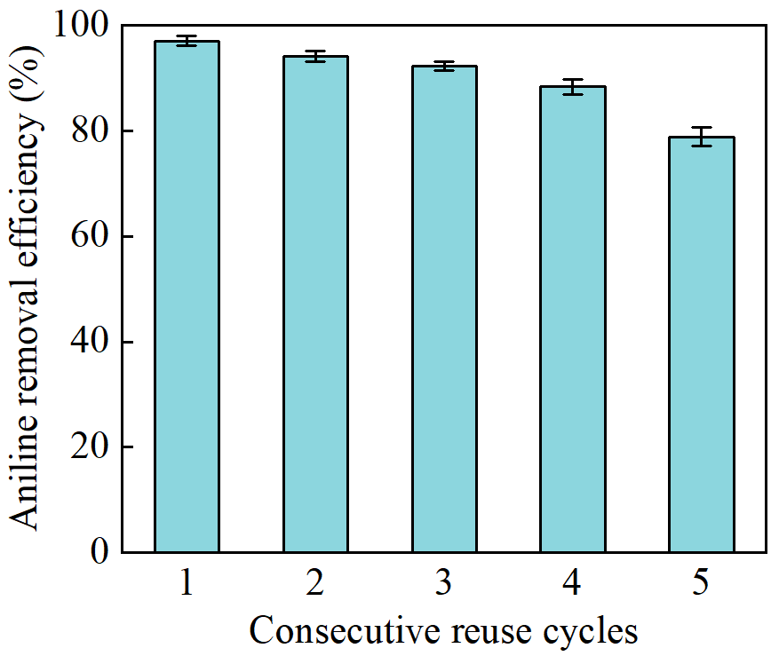
Fig. S8. Effect of repeated cycles on aniline removal efficiency in the MB500/PMS catalytic system (initial pH = 7, aniline concentration = 10 mg L^{‒1}, PMS concentration = 0.2 g L^{‒1}, MB500 dosage = 0.7 g L^{‒1}, reaction time = 30 min).
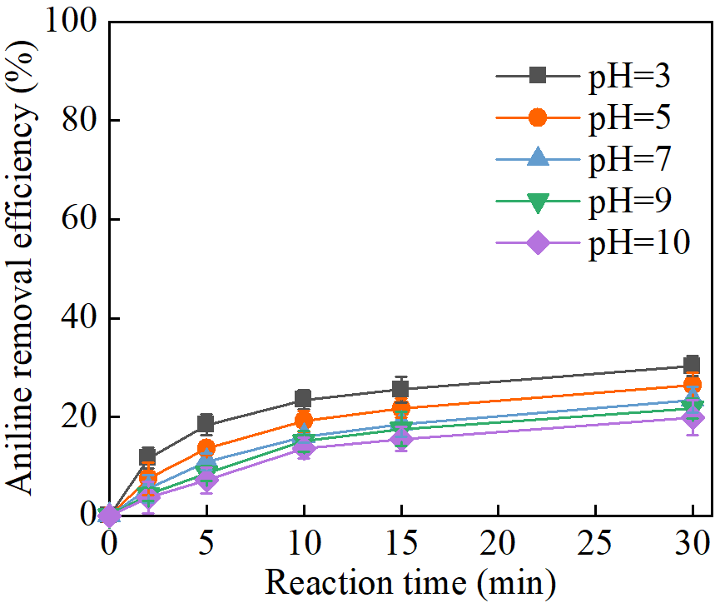
Fig. S9. Effect of initial pH on adsorption removal of aniline by MB500 (aniline concentration = 10 mg L^{‒1}, MB500 dosage = 0.7 g L^{‒1}).
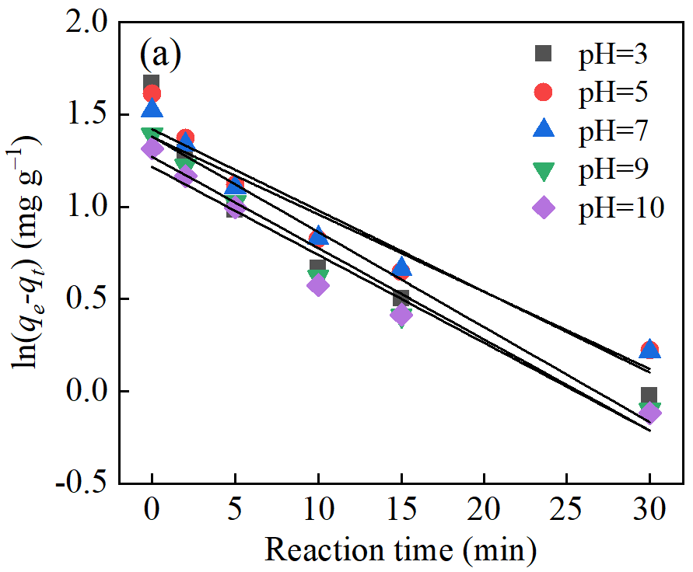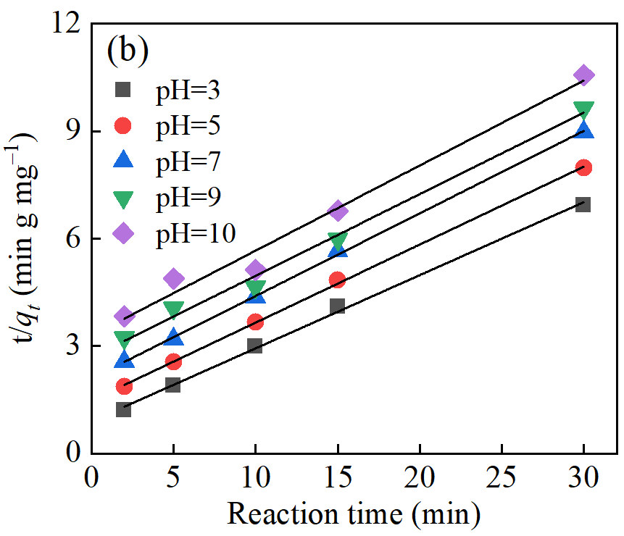
Fig. S10. Adsorption kinetics of aniline on MB500: curve fitting analysis at varying initial pH levels (aniline concentration = 10 mg L^{‒1}, MB500 dosage = 0.7 g L^{‒1}).
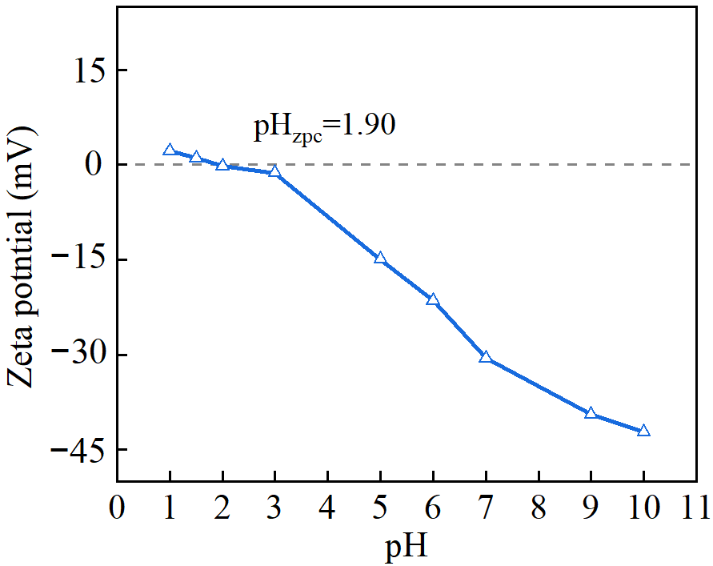
Fig. S11. Influence of pH variation on the zeta potential of MB500.
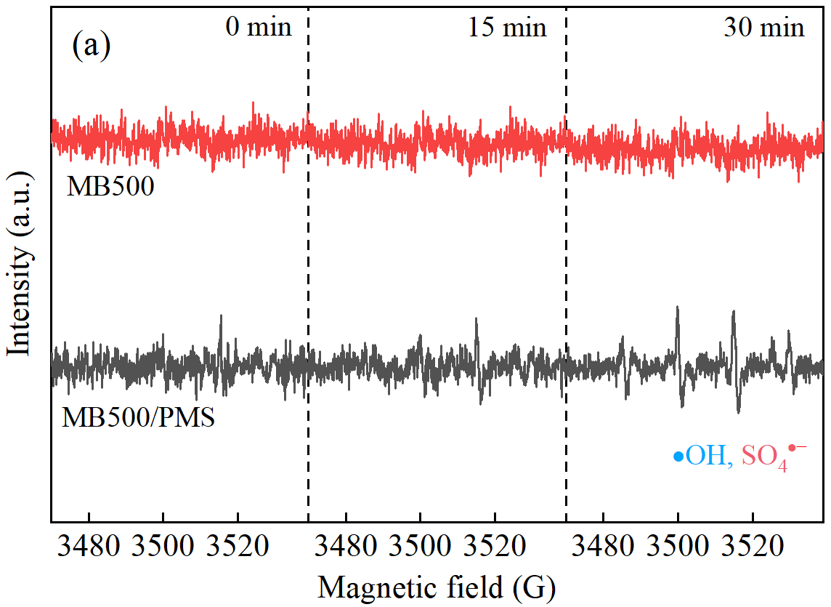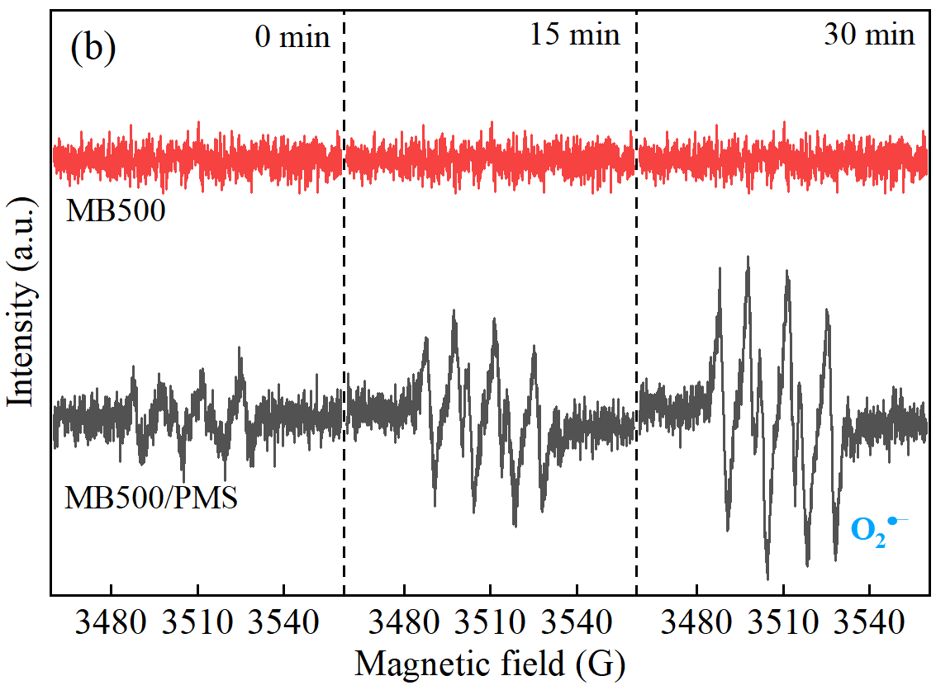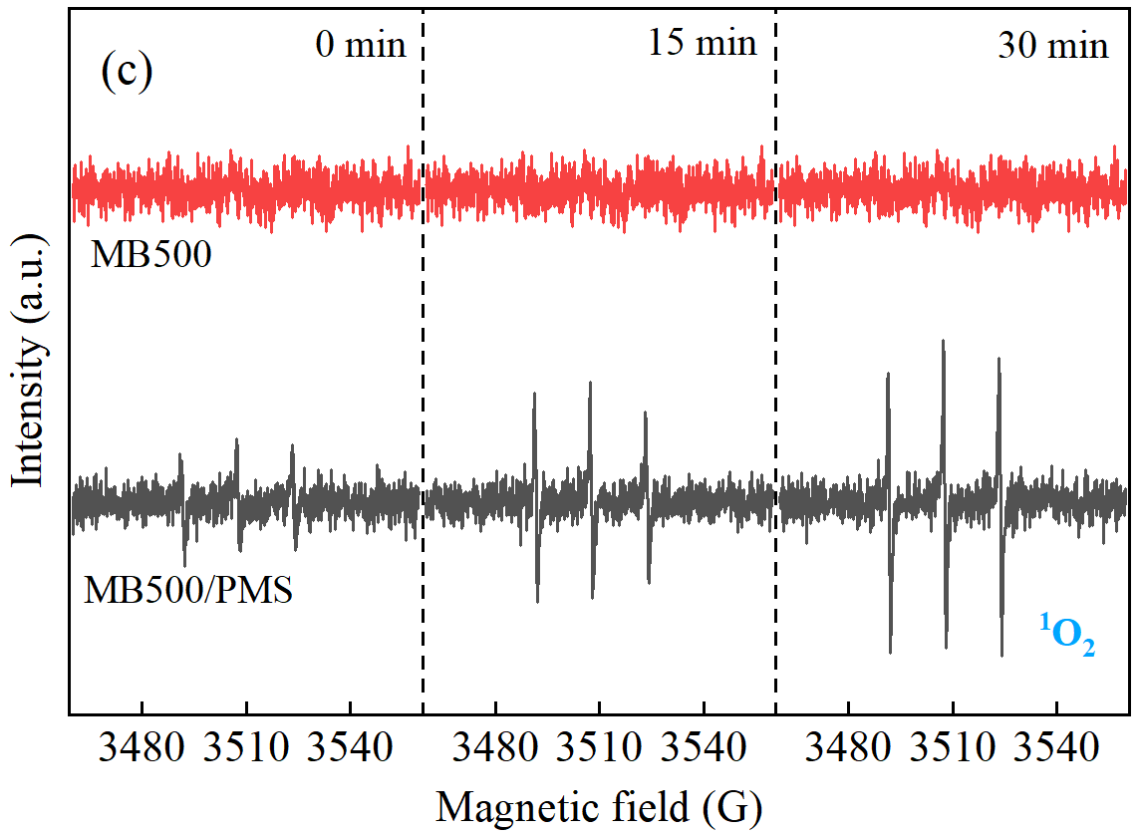
Fig. S12. EPR spectra of spin-trapping adducts: •OH, SO₄•– (a), O₂•– (b), and ¹O₂ (c) generated by the MB500/PMS catalytic system.
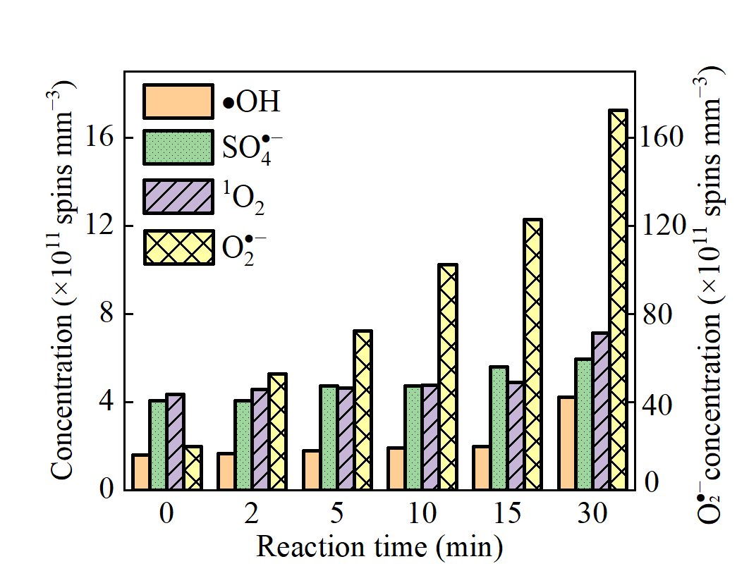
Fig. S13. Temporal variation of concentration of reactive species in the MB500/PMS catalytic system (initial pH = 7, aniline concentration = 10 mg L^{‒1}, PMS concentration = 0.2 g L^{‒1}, MB500 dosage = 0.7 g L^{‒1}).

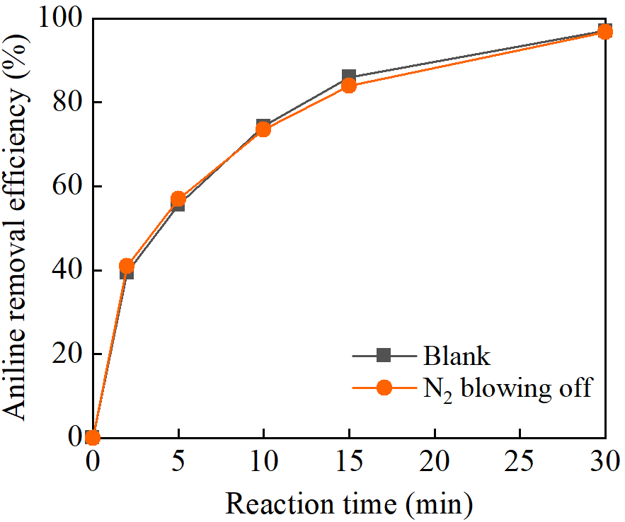
Fig. S14. Effect of N₂ purging on aniline removal by the MB500/PMS catalytic system (initial pH = 7, aniline concentration = 10 mg L^{‒1}, PMS concentration = 0.2 g L^{‒1}, MB500 dosage = 0.7 g L^{‒1}).

Table S1 Detailed analysis of ash composition in corncob after combustion at 550 ℃.
Compositions | SiO₂ | K₂O | CaO | Al₂O₃ | Fe₂O₃ | P₂O₅ | MgO | SO₃ | Na₂O | MnO | Cl | TiO₂ | ZnO | SrO
Relative contents (%) | 76.20 | 8.37 | 4.18 | 2.94 | 1.89 | 2.47 | 1.65 | 1.08 | 0.41 | 0.30 | 0.21 | 0.25 | 0.03 | 0.01

Table S2 Specific surface area, total pore volume, and average pore diameter of MBC at different pyrolysis temperatures.
Pyrolysis temperature (℃) | Specific surface area (m² g^{‒1}) | Pore volume (cm³ g^{‒1}) | Average pore size (nm)
300 | 10.81 | 0.11 | 41.52
400 | 9.84 | 0.05 | 18.88
500 | 48.74 | 0.10 | 8.46
600 | 253.70 | 0.23 | 3.60
700 | 899.14 | 0.54 | 2.40
900 | 1224.58 | 0.99 | 3.22

Table S3 Kinetic parameters for aniline adsorption onto MB500 at different initial pH values.
Initial pH | Pseudo-first order |  |  | Pseudo-second order
Initial pH | k₁  (min^{–1}) | q_{e} (mg g^{–1}) | R² | k₂  (min^{–1}) | q_{e} (mg g^{–1}) | R²
3 | 0.0516 | 3.974 | 0.904 | 0.0465 | 4.900 | 0.998
5 | 0.0439 | 4.137 | 0.924 | 0.0321 | 4.592 | 0.999
7 | 0.0419 | 3.969 | 0.947 | 0.0254 | 4.339 | 0.999
9 | 0.0494 | 3.564 | 0.956 | 0.0193 | 4.391 | 0.992
10 | 0.0476 | 3.376 | 0.961 | 0.0171 | 4.212 | 0.982

Corresponding author. E-mail: berthillon@hotmail.com (Z. Zhao); Full postal address: School of Civil and Environmental Engineering, Harbin Institute of Technology Shenzhen, Xili University Town, Nanshan District, Shenzhen, 518055, PR China

