Adsorptive-photocatalytic removal of tetracycline from wastewater by Fe₃O₄- and SnO₂-containing biochar nanocomposites
Chuchen Zhang^{1#}, Shuwen Zhao^{1#}, Qilan Huang¹, Jianqiao Liu^{2,} *, Qianru Zhang^{1,} *
1. State Key Laboratory of Efficient Utilization of Arid and Semi-arid Arable Land in Northern China, Institute of Agricultural Resources and Regional Planning, Chinese Academy of Agricultural Sciences, Beijing 100081, China
2. College of Information Science and Technology, Dalian Maritime University, Dalian 116026, China.
* Corresponding author, Qianru Zhang, E−mail: zhangqianru@caas.cn
* Corresponding author, Jianqiao Liu, E−mail: jqliu@dlmu.edu.cn
#Chuchen Zhang and Shuwen Zhao are co-first authors of the article.
Address: No. 12 Zhongguancun South Street, Beijing 100081, China.

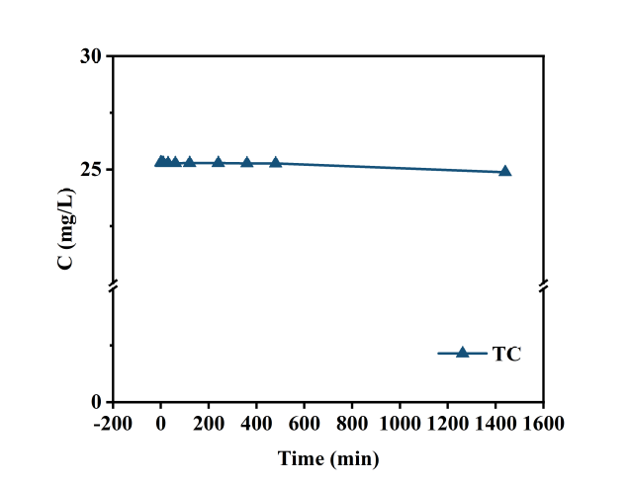
Fig. S1. The photolysis of TC.
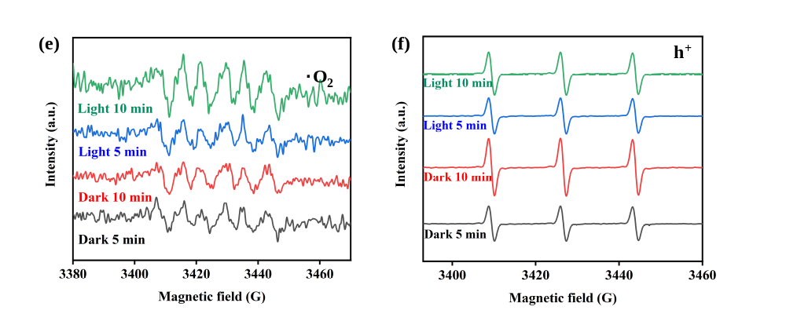
Fig. S2. UV-vis absorption spectra of (a) BC, (b) BC@Fe₃O₄@SnO₂-1:1:1 and (c) BC@Fe₃O₄@SnO₂-1:2:1.
Fig. S3. The EPR results about the generation of (a) ·OH, (b) ·O₂, (c) h⁺ of BC, (d) ·OH, (e) ·O₂ and (f) h⁺ of BC@Fe₃O₄@SnO₂-1:1:2.

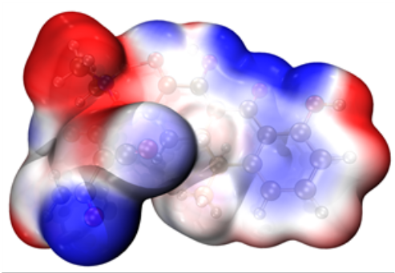
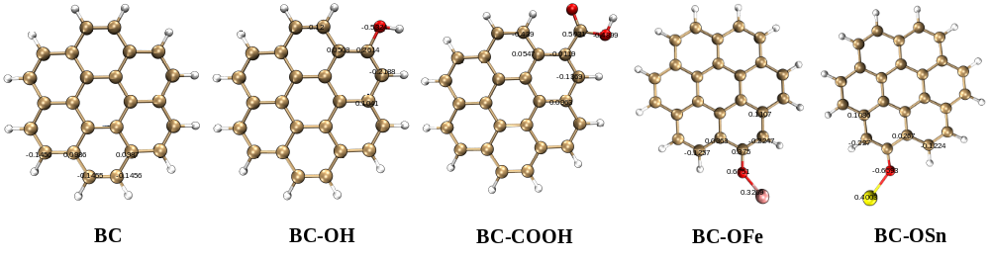
Fig. S4. Electrostatic Potential Surfaces of TC.
Fig. S5. Charge populations of carbon structures containing multiple functional groups.

Table S1. NPA charges and condensed Fukui functions of TC
Atom | q(N) | q(N+1) | q(N-1) | f ⁻ | f ⁺ | f ⁰
C1 | 0.36347 | 0.34579 | 0.39604 | 0.03257 | 0.01768 | 0.025125
C2 | -0.31799 | -0.33362 | -0.29272 | 0.02527 | 0.01563 | 0.02045
C3 | -0.20306 | -0.24681 | -0.16986 | 0.0332 | 0.04375 | 0.038475
C4 | -0.26228 | -0.26633 | -0.20781 | 0.05447 | 0.00405 | 0.02926
C5 | -0.00959 | -0.02124 | -0.00604 | 0.00355 | 0.01165 | 0.0076
C6 | -0.17795 | -0.17093 | -0.16209 | 0.01586 | -0.00702 | 0.00442
C7 | 0.2484 | 0.24721 | 0.25408 | 0.00568 | 0.00119 | 0.003435
C8 | -0.2791 | -0.27252 | -0.29123 | -0.01213 | -0.00658 | -0.009355
C9 | -0.24236 | -0.25846 | -0.14594 | 0.09642 | 0.0161 | 0.05626
C10 | 0.51548 | 0.47306 | 0.50989 | -0.00559 | 0.04242 | 0.018415
C11 | -0.46908 | -0.46642 | -0.47463 | -0.00555 | -0.00266 | -0.004105
C12 | -0.2867 | -0.28301 | -0.28817 | -0.00147 | -0.00369 | -0.00258
C13 | 0.14781 | 0.14567 | 0.14921 | 0.0014 | 0.00214 | 0.00177
C14 | 0.42755 | 0.42283 | 0.47257 | 0.04502 | 0.00472 | 0.02487
C15 | -0.10194 | -0.10006 | -0.10562 | -0.00368 | -0.00188 | -0.00278
C16 | 0.43236 | 0.27852 | 0.45287 | 0.02051 | 0.15384 | 0.087175
C17 | -0.29544 | -0.32282 | -0.29573 | -0.00029 | 0.02738 | 0.013545
C18 | 0.54701 | 0.4447 | 0.54511 | -0.0019 | 0.10231 | 0.050205
C19 | 0.6644 | 0.66868 | 0.66296 | -0.00144 | -0.00428 | -0.00286
O20 | -0.64427 | -0.69483 | -0.62809 | 0.01618 | 0.05056 | 0.03337
O21 | -0.67145 | -0.67759 | -0.63705 | 0.0344 | 0.00614 | 0.02027
N22 | -0.86614 | -0.88702 | -0.84293 | 0.02321 | 0.02088 | 0.022045
O23 | -0.62228 | -0.66736 | -0.53912 | 0.08316 | 0.04508 | 0.06412
O24 | -0.52673 | -0.58366 | -0.3834 | 0.14333 | 0.05693 | 0.10013
O25 | -0.6473 | -0.65961 | -0.59291 | 0.05439 | 0.01231 | 0.03335
O26 | -0.57317 | -0.68127 | -0.54539 | 0.02778 | 0.1081 | 0.06794
C27 | -0.69926 | -0.69507 | -0.70577 | -0.00651 | -0.00419 | -0.00535
N28 | -0.56878 | -0.58129 | -0.56851 | 0.00027 | 0.01251 | 0.00639
C29 | -0.48392 | -0.47977 | -0.48867 | -0.00475 | -0.00415 | -0.00445
C30 | -0.49605 | -0.48739 | -0.50117 | -0.00512 | -0.00866 | -0.00689
O31 | -0.79773 | -0.8231 | -0.77458 | 0.02315 | 0.02537 | 0.02426
O32 | -0.7747 | -0.78148 | -0.74682 | 0.02788 | 0.00678 | 0.01733
H33 | 0.23775 | 0.22124 | 0.26186 | 0.02411 | 0.01651 | 0.02031
H34 | 0.24864 | 0.23197 | 0.2731 | 0.02446 | 0.01667 | 0.020565
H35 | 0.24635 | 0.23597 | 0.26556 | 0.01921 | 0.01038 | 0.014795
H36 | 0.26105 | 0.24719 | 0.28596 | 0.02491 | 0.01386 | 0.019385
H37 | 0.26322 | 0.27107 | 0.26919 | 0.00597 | -0.00785 | -0.00094
H38 | 0.25235 | 0.23509 | 0.27022 | 0.01787 | 0.01726 | 0.017565
H39 | 0.26875 | 0.24806 | 0.27821 | 0.00946 | 0.02069 | 0.015075
H40 | 0.23375 | 0.20724 | 0.24616 | 0.01241 | 0.02651 | 0.01946
H41 | 0.5137 | 0.49254 | 0.52325 | 0.00955 | 0.02116 | 0.015355
H42  H43 | 0.50518  0.43005 | 0.49295 | 0.52649 | 0.02131 | 0.01223 | 0.01677
H42  H43 | 0.50518  0.43005 | 0.40708 | 0.4451 | 0.01505 | 0.02297 | 0.01901
H44 | 0.44962 | 0.45146 | 0.45157 | 0.00195 | -0.00184 | 5.5E-05
H45 | 0.53498 | 0.52966 | 0.55529 | 0.02031 | 0.00532 | 0.012815
H46 | 0.24428 | 0.23668 | 0.25345 | 0.00917 | 0.0076 | 0.008385
H47 | 0.25463 | 0.24236 | 0.26693 | 0.0123 | 0.01227 | 0.012285
H48 | 0.24999 | 0.25153 | 0.2612 | 0.01121 | -0.00154 | 0.004835
H49 | 0.25335 | 0.23544 | 0.2651 | 0.01175 | 0.01791 | 0.01483
H50 | 0.24347 | 0.23987 | 0.2392 | -0.00427 | 0.0036 | -0.000335
H51 | 0.21331 | 0.19861 | 0.2242 | 0.01089 | 0.0147 | 0.012795
H52 | 0.25291 | 0.23148 | 0.26518 | 0.01227 | 0.02143 | 0.01685
H53 | 0.26842 | 0.27643 | 0.26539 | -0.00303 | -0.00801 | -0.00552
H54 | 0.20624 | 0.19397 | 0.21651 | 0.01027 | 0.01227 | 0.01127
H55 | 0.5276 | 0.52187 | 0.53632 | 0.00872 | 0.00573 | 0.007225
H56 | 0.51121 | 0.51545 | 0.50604 | -0.00517 | -0.00424 | -0.004705

