Greenhouse gas removal in agricultural peatland via raised water levels and soil amendment

Peduruhewa H. Jeewani^{a,*}, Robert W. Brownª, Jennifer M. Rhymes^{b}, Niall P. McNamara^{c}, David R. Chadwickª, Davey L. Jonesª, Chris D. Evans^{b}
ª School of Environmental and Natural Sciences, Bangor University, Bangor, Gwynedd, LL57 2UW, UK
^{b} UK Centre for Ecology and Hydrology, Bangor, Gwynedd, LL57 2UW, UK
^{c} UK Centre for Ecology & Hydrology, Lancaster, LA1 4AP, UK

*Corresponding author: Peduruhewa H. Jeewani
Corresponding Author Address: School of Environmental and Natural Sciences, Bangor University, Bangor, Gwynedd, LL57 2UW, UK
Corresponding Author Email: j.hemamali@bangor.ac.uk

Table S1. Physicochemical properties of soil and applied amendments used in the experiments. Values represent means ± standard errors (n = 4). Abbreviation: C, carbon; N, nitrogen; SOM, Soil organic matter content; EC, electrical conductivity; BD, bulk density. Where applicable, the data is expressed on a dry weight basis.
Properties | Soil |  |  | Miscanthus  biochar | Miscanthus chip | Paper  waste | Barley  straw | Biosolids
 | 0-20 cm | 10-30 cm | 30-50 cm
Total C (%) | 27.6±2.6 | 27.6±1.7 | 24.7±0.9 | 79.3±0.9 | 47.4±0.5 | 46.8±0.81 | 43.7±0.5 | 36.45±30
Total N (%) | 1.81±0.45 | 1.81±0.13 | 1.80±0.08 | 0.41±0.01 | 0.49±0.07 | 0.75±0.07 | 0.68±0.02 | 3.66±6
C:N ratio | 16.0±4.8 | 15.2±1.3 | 13.7±0.9 | 259±14 | 97.9±16 | 62.8±7.3 | 63.5±2.0 | 9.95±0.03
SOM (%) | 45.22±2.6 | 33.05±5.6 | 20.79±1.9 | - | - | - | - | -
pH (H₂O) | 6.54±0.05 | 6.65±0.04 | 6.54±0.04 | 5.6± 0.61 | 6.9±0.85 | 5.19±0.52 | -
EC (μS cm⁻¹) | 193±4 | 186±4 | 199±9 | - | - | - | - | -
BD (g cm⁻³) | 0.52±0.05 | 0.55±0.03 | 0.53±0.03 | - | - | - | - | -
NO₃⁻ (mg N L⁻¹) | 4.05±0.29 | 3.52±0.36 | 3.54±0.29 | 0.15±0.01 | 0.11±0.02 | 0.3±0.03 | 5.84±0.98 | 1.7 ±0.2
NH₄⁺ (mg N L⁻¹) | 4.48±0.22 | 2.68±0.44 | 4.65±0.58 | 0.25±0.08 | 2.87±0.56 | 1.02±0.08 | 3.79±1.02 | 218±0.15.6
SO₄²⁻ (mg S L⁻¹) | 1.35±0.42 | 1.29±0.34 | 1.40±0.30 | - | - | - | - | -
PO₄³⁻ (mg P L⁻¹) | 1.05±0.11 | 1.23±0.34 | 0.98±0.19 | 3.33±0.98 | 2.26±0.8 | 3.57±0.9 | 4.03±0.89 | 2.32±0.23

Table S2. Characteristics of biochar. The biochar assessment for atomic H/C ratio and the fraction of stable polyaromatic carbon (SPAC) determined by hydropyrolysis (Hypy test)

Sample number | Carbon (%) | Hydrogen (%) | Nitrogen (%) | Atomic H/C | SPAC (%) | EC (µS cm⁻¹) | pH
Sample 1 | 73.57 | 4.08 | 0.44 | 0.66 | 25.18 | 51.53 | 5.65
Sample 2 | 72.7 | 4.27 | 0.39 | 0.69 | 22.08 | 52.01 | 6.21
Sample 3 | 73.66 | 3.86 | 0.22 | 0.62 | 24.21 | 50.13 | 5.85

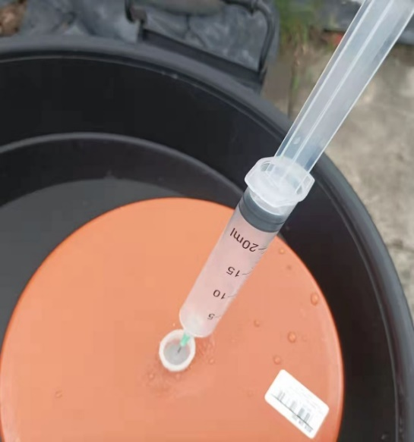
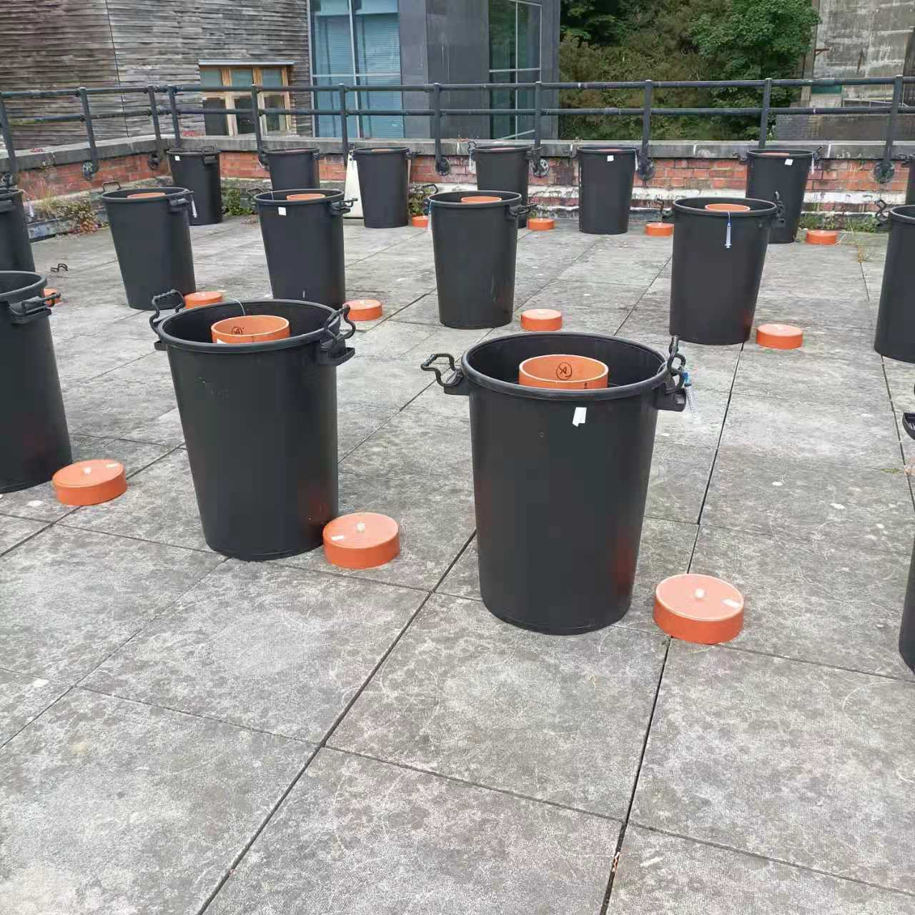
B
A
A

Fig. S1: Peat soil mesocosm setup. Intact peat soil mesocosm was placed into an outer container with drainage holes drilled to maintain the high or low water table level (A); headspace greenhouse gas sampling from the mesocosms after fitting a gas-tight lid (B).

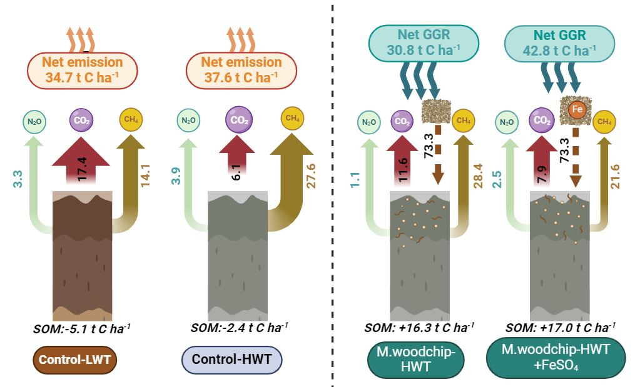
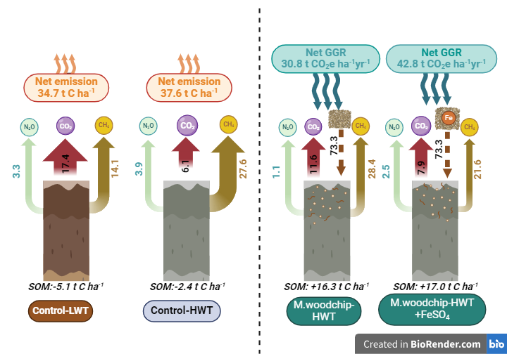
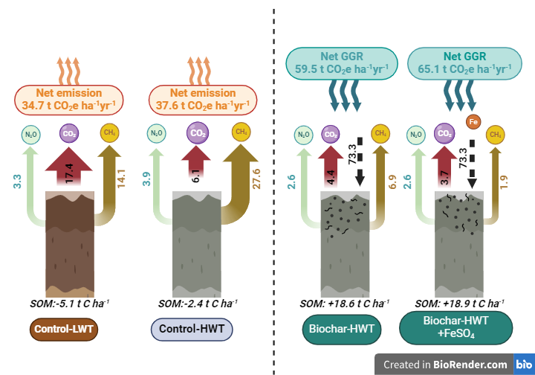
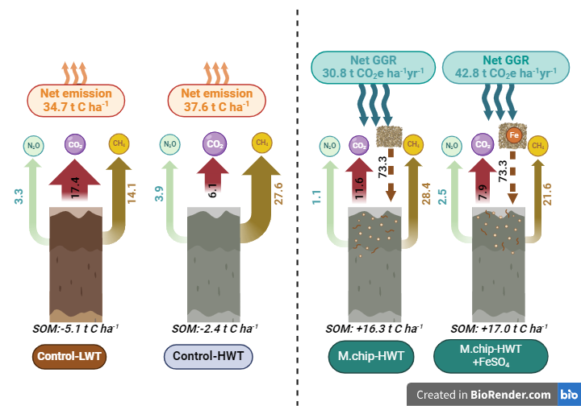
Net GGR effect of miscanthus chip amendment

Fig. S2: Estimated greenhouse gas and soil carbon balance for peat mesocosms (M.chip-HWT and M.chip-HWT+FeSO₄) treatments, compared to control mesocosms under two different water table levels (Control-LWT and Control-HWT). The C amendments included Miscanthus chips (M.chip). The experiment had two control consisting of a low water table (LWT) treatment and high water table (HWT) without C amendement with and without FeSO₄ addition. Values represent mean ± standard errors (n = 4).
(b)
(a)
(c)
(d)

(e)
(f)

Fig. S3. Effect of organic C amendments and FeSO₄ addition on daily soil CO₂ (a,b), CH₄ (c,d) and N₂O (e,f) fluxes from an agricultural peat soil under a high (0 cm) water table. The C amendments included Miscanthus biochar (Biochar), Miscanthus chips (M.chip), paper waste, biosolids and barley straw (B.straw). The experiment had two controls consisting of a low water table (LWT) treatment and high-water table (HWT) without C amendment with and without FeSO₄ addition. Values represent means ± standard errors (n = 4).

Fig. S4 Effect of organic amendment and FeSO₄ addition on the carbon balance in an agricultural peat soil (panels a and b). The organic amendments included Miscanthus biochar (Biochar), Miscanthus chips (M.chip), paper waste, biosolids and barley straw (B.straw). The experiment had two control consisting of a low water table (LWT) treatment and high water table (HWT) without organic amendement with and without FeSO₄ addition. Values represent mean ± standard errors (n = 4).

