Fig. S1. study protocol & design

Preliminary experimental study
A preliminary experiment was conducted to determine the optimal time, concentration, and ratios utilized in the inoculation reactor (Section 2.1.3). This experiment involved suspension of compost samples (Section 2.1.2) and various concentrations of 10%, 20%, and 30% biochar. Microbial inoculation took place in 500 mL containers, with nutrients and glucose being added every 24-48 hours to create favorable conditions for microbial growth. Following the preliminary experiment, biofilm formation on the biochar surface was confirmed using a scanning electron microscope (Fig. S2). The optimal conditions identified in this phase were employed to establish the inoculation reactor (Fig. S3), as detailed in section 2.1.3.

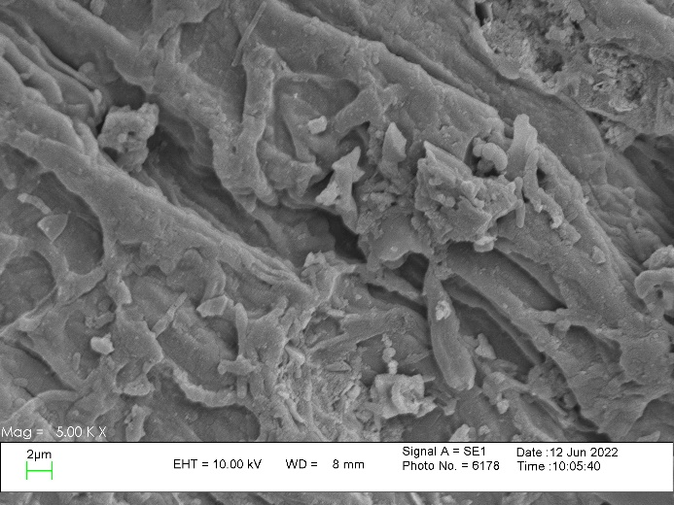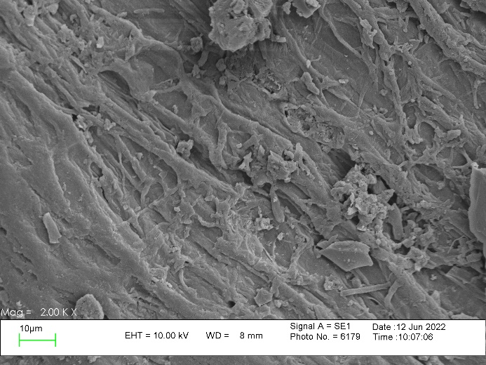
Fig. S2. Inoculated biochar
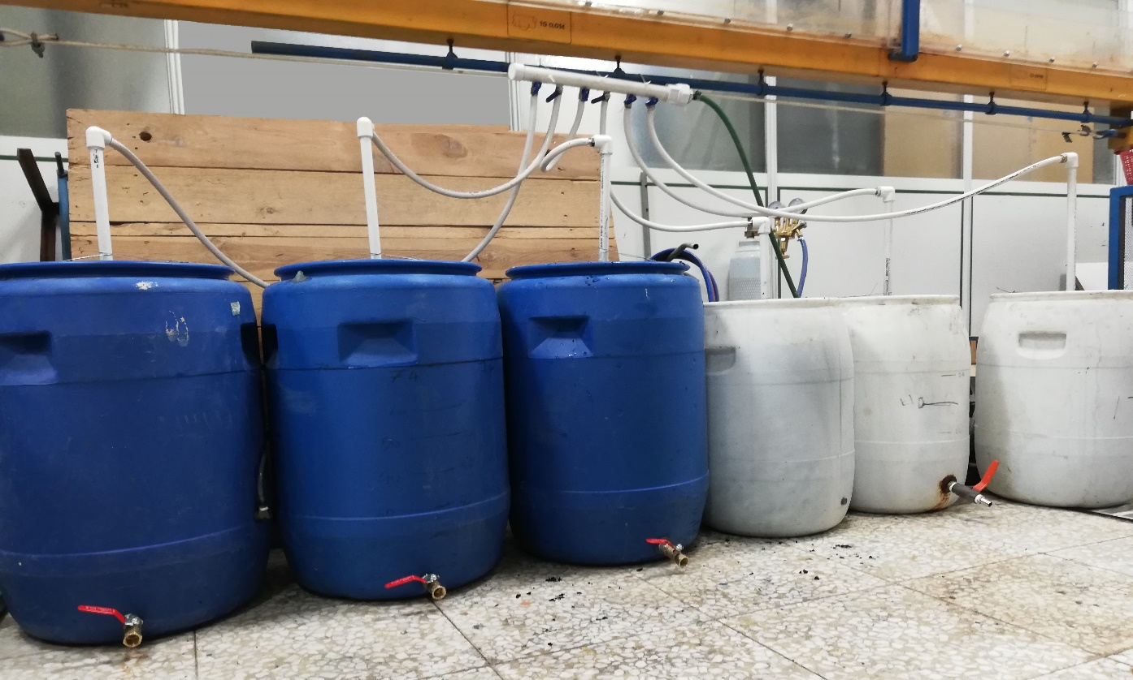
Fig. S3. Inoculation reactor detailed in Section 2.1.3

Table S1. The physicochemical characteristics of biochar
Parameter | Unit | Values
Organic Matters | % | 13.89
C/N Ratio | - | 10.20
Organic Carbon | % | 8.06
Mg | % | 5.77
pH | - | 8.2
Salinity | % | 0.2
N | % | 0.79
P | % | 0.14
K | % | 0.17
Ca | % | 4.26
Ash | % | 24.6

Table S2. Components of Casein starch culture medium
Substances | Value
Soluble starch | 10g
Casein | 0.3g
Potassium nitrate, KNO₃ | 2g
Sodium chloride, NaCl | 2g
Dipotassium hydrogen phosphate, K₂HPO₄ | 2g
Magnesium sulfate, hydrate, MgSO₄.7H₂O | 0.05g
Calcium carbonate, CaCO₃ | 0.02g
Ferrous sulfate, hydrate, FeSO₄.7H₂O | 0.01g
Agar | 15g
Reagent-grade water | 1L
Glycerol | 5g

Table S3. characteristics of raw MSW
Compostable Fraction % |  | Non-Compostable Fraction % |  |  | characteristics of Compostable Fraction
Green waste | Organic | Demolition & Construction | Special | Recyclable | Humidity % | C/N
0.46 | 64.5 | 0.27 | 7.25 | 27.52 | 65 | 24

