Supplementary Material

Soil organic carbon accumulation mechanisms in soil amended with straw and biochar: entombing effect or biochemical protection?

Yuhan Yuan^{1, 2†}, Yao Liang^{1†}, Hongguang Cai¹, Jingchao Yuan¹, Cuilan Li², Hang Liu², Chang Zhang¹, Lichun Wang^{1*} and Jinjing Zhang^{2*}
¹Institute of Agricultural Resources and Environments, Jilin Academy of Agricultural Sciences (Northeast Agricultural Research Center of China), Changchun 130033, People’s Republic of China
²Key Laboratory of Soil Resource Sustainable Utilization for Commodity Grain Bases of Jilin Province, College of Resource and Environmental Science, Jilin Agricultural University, Changchun 130118, People’s Republic of China
*Corresponding authors, E-mail: wlc1960@163.com, zhangjinjing@126.com

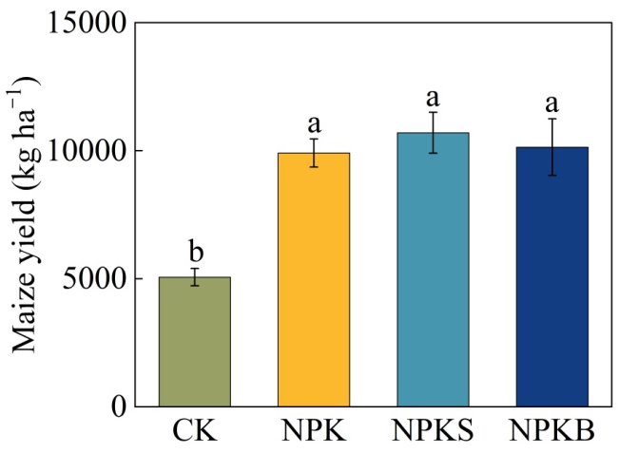

Fig. S1. Average maize grain yield during 2015−2023 under treatments receiving mineral fertilizers (NPK), mineral fertilizers plus maize straw (NPKS), mineral fertilizers plus maize straw-derived biochar (NPKB), and no fertilizers (CK). Bars represent standard deviations of mean (n = 3). Different lowercase letters indicate significant differences among treatments based on one-way ANOVA with LSD test at P < 0.05.

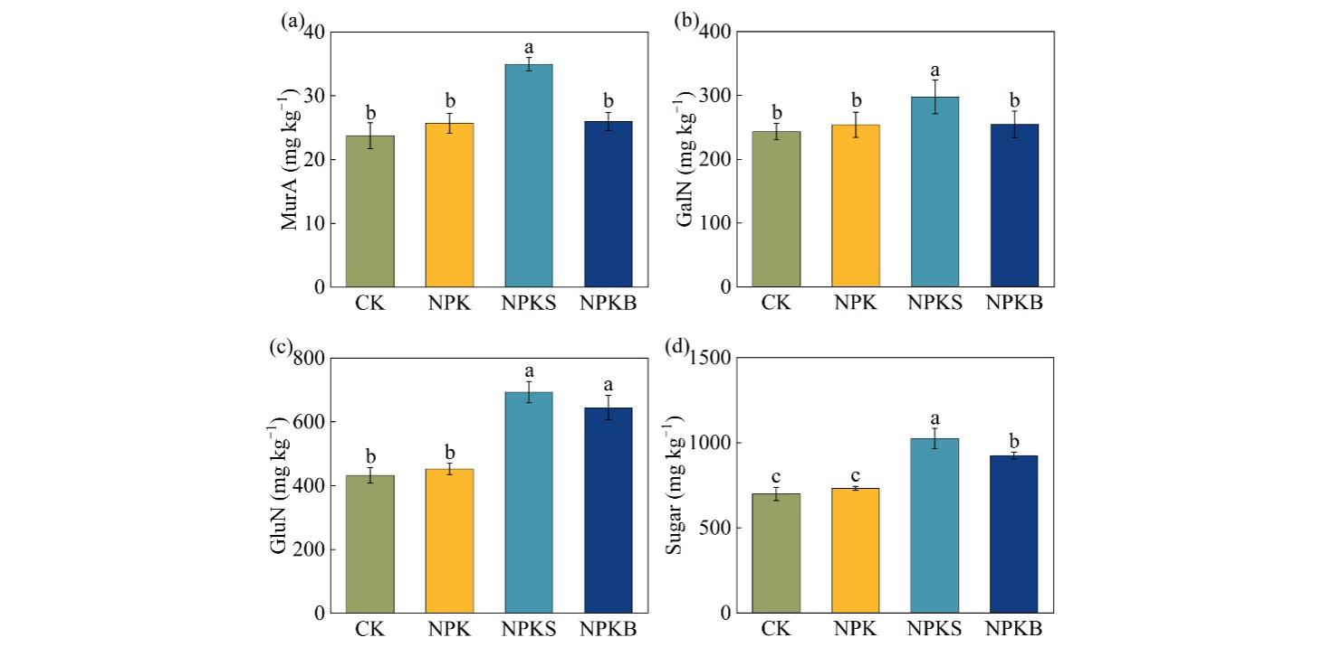

Fig. S2. Muramic acid (MurA) (a), galactosamine (GalN) (b), glucosamine (GluN) (c), and total amino sugar (d) contents in soil under treatments receiving mineral fertilizers (NPK), mineral fertilizers plus maize straw (NPKS), mineral fertilizers plus maize straw biochar (NPKB), and no fertilizers (CK). Bars represent standard deviations of mean (n = 3). Different lowercase letters indicate significant differences among treatments based on one-way ANOVA with LSD test at P < 0.05.



Fig. S3. FMNC to BMNC ratio under treatments receiving mineral fertilizers (NPK), mineral fertilizers plus maize straw (NPKS), mineral fertilizers plus maize straw biochar (NPKB), and no fertilizers (CK). Bars represent standard deviations of mean (n = 3). Different lowercase letters indicate significant differences among treatments based on one-way ANOVA with LSD test at P < 0.05.

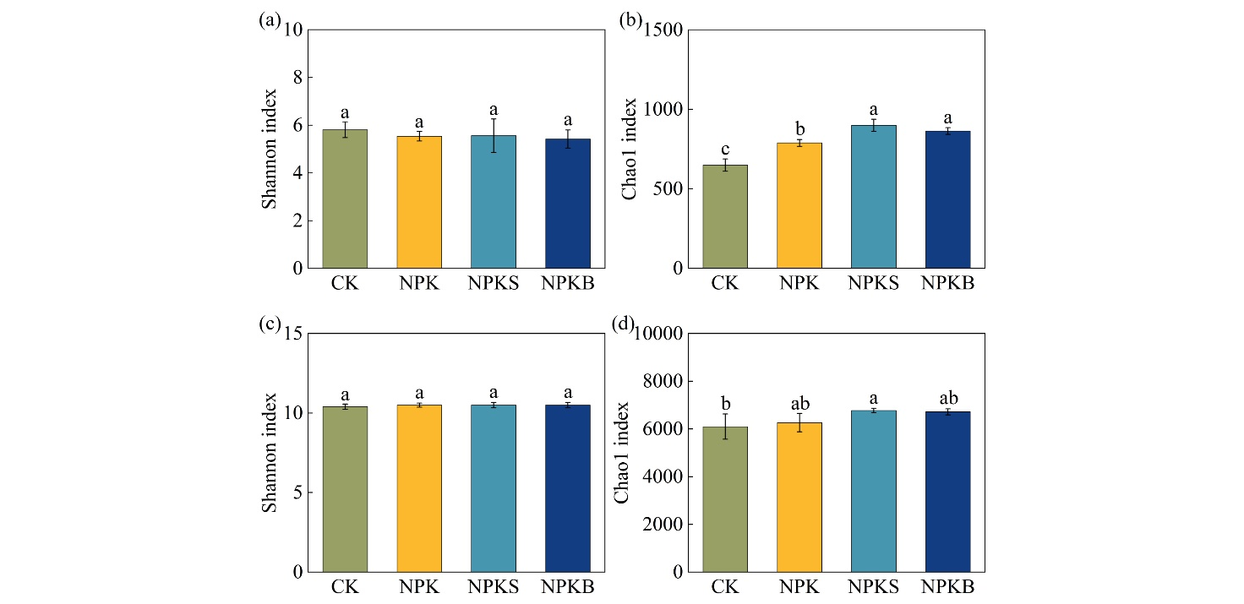

Fig. S4. Alpha-diversity (Shannon and Chao1 indices) of fungal (a–b) and bacterial (c–d) community in soil under treatments receiving mineral fertilizers (NPK), mineral fertilizers plus maize straw (NPKS), mineral fertilizers plus maize straw-derived biochar (NPKB), and no fertilizers (CK). Bars represent standard deviations of mean (n = 3). Different lowercase letters indicate significant differences among treatments based on one-way ANOVA with LSD test at P < 0.05.

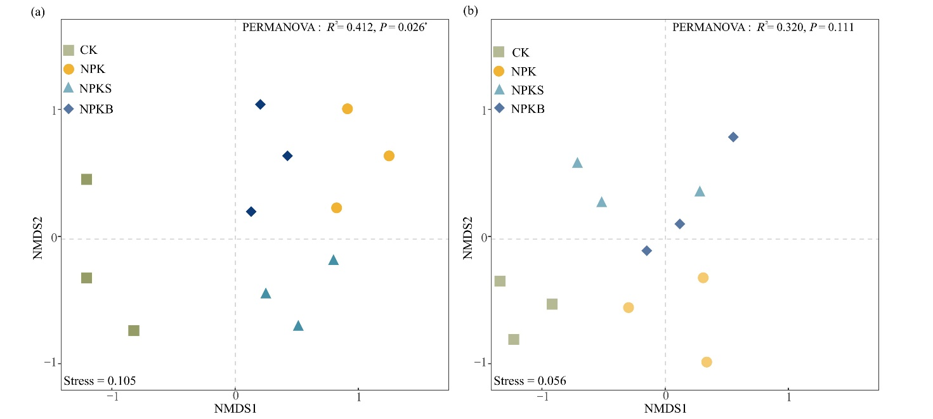

Fig. S5. Non-metric multidimensional scaling (NMDS) based on Bray-Curtis distance of fungal (a) and bacterial (b) community in soil under treatments receiving mineral fertilizers (NPK), mineral fertilizers plus maize straw (NPKS), mineral fertilizers plus maize straw-derived biochar (NPKB), and no fertilizers (CK). Significances are assessed based on Permutational multivariate analysis of variance (PERMANOVA) test at P < 0.05.

