Supporting information for Biochar selection for removal of per- and polyfluoroalkyl substances from reclaimed water for agricultural irrigation

Pia Ramos¹, Michael P. Schmidt¹, Richeng Xuan¹, Daniel J. Ashworth^{1*}
¹USDA-ARS
Figures: 6
Tables: 6

C
A

Figure S1: PFAS removal performance achieved by suspensions of biochars made from pine (A), manure (B), grass clippings (C), walnut shells (D) pyrolyzed at 600°C at different biochar suspension concentrations (of 0.05,0 .1, 0.5, 1, 3, 5, 10 g L⁻¹⁾. Notable differences between the biochars were observed at 1g/L

D
B

D
C
B
A

Figure S1B: PFAS removal performance achieved by suspensions of biochars made from pine (A), manure (B), grass clippings (C), walnut shells (D) pyrolyzed at 600°C at different biochar suspension concentrations (of 0.05,0 .1, 0.5, 1, 3, 5, 10 g L⁻¹⁾. Log-scale enhances the notable differences between the biochars were observed at 1g/L

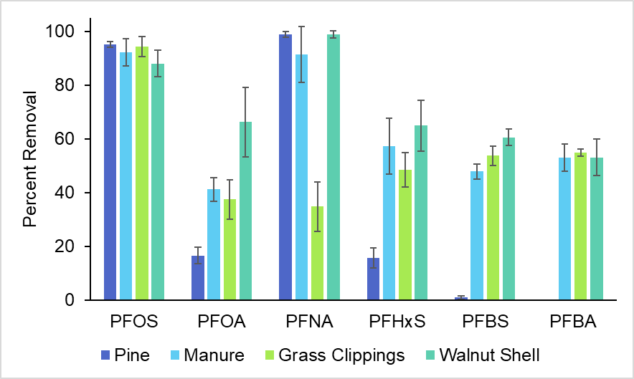

Figure S2: Removal of PFOS, PFOA, PFNA, PFHxS, PFBS, PFBA by biochar derived from pine needles, manure, grass clippings, and walnut shells prepared at 600°C. Different removal performances were observed for each PFAS for different biochars, with the greatest removal observed for PFOS by all biochars. C₀ for these studies was 50 μg L⁻¹.

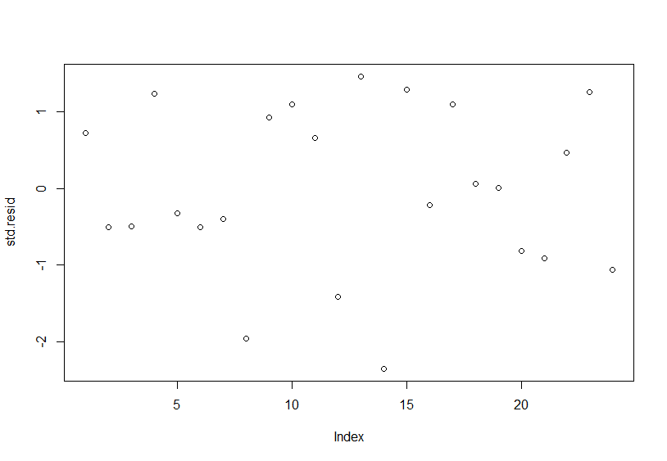
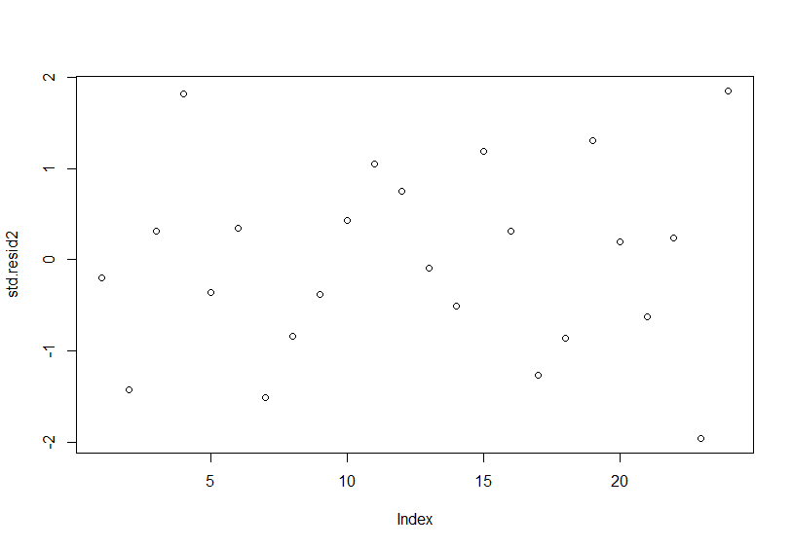
- (B)

Figure S3: Residuals plot for linear models for (A) PFBS and (B) PFOS

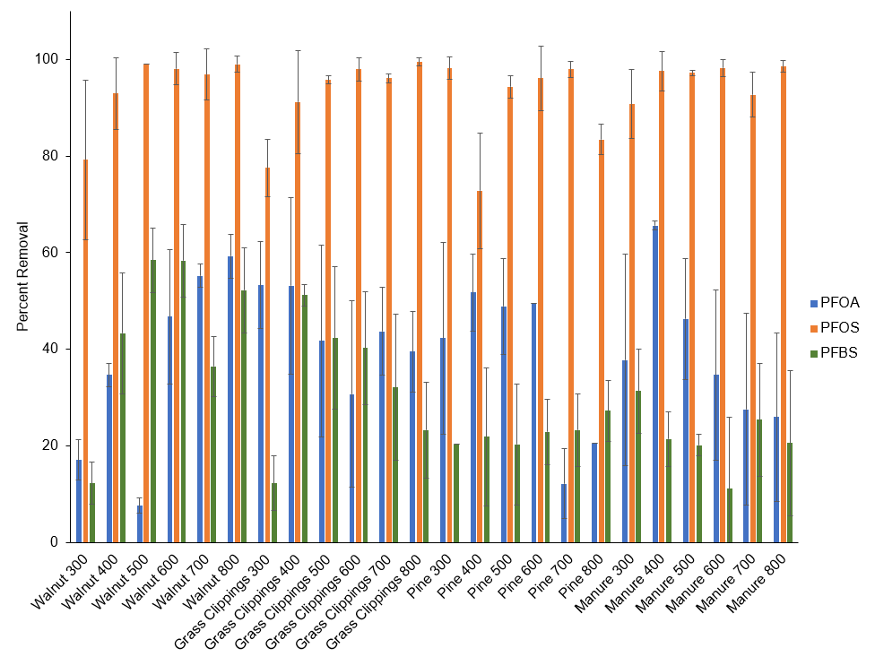

Figure S4: Removal efficiency for all biochars made from walnut shells, grass clippings, pine needles, manure, synthesized at temperatures 300-800 °C. Starting concentration was 50 μg L⁻¹. PFOA and PFOS were tested in the same experiment and PFBS was tested with PFBA (data not quantifiable so not shown here).

Figure S5: Removal of PFOS and PFBS by 24 biochars. Strating concentration was 50 μg L⁻¹ and experiments were run with individual PFAS.

Figure S6: Percentage of PFAS remaining after thermal treatment at 200 °C and 400 ° C as extracted from treated biochar. Relative values are compared to the amount of PFAS extracted from saturated biochars.

Table S2: Solid-liquid partitioning coefficients (Kd (L/mg))
 | PFOS | PFBS | PFOA
Pine | 0.35 | 0.38 | 0.12
Walnut | 0.11 | 0.17 | 0.18
Manure | 0.12 | 0.38 | 0.14
Grass Clippings | 0.13 | 0.19 | 0.14

Table S3: Treated Municipal Wastewater Characteristics
Characteristic | Value
Na (mg/L) | 105.5 ± 0.25
K (mg/L) | 16.5 ± 0.13
Mg (mg/L) | 13.1 ± 0.13
Ca (mg/L) | 69.7 ± 0.16
P (mg/L) | 0.74 ± 0.001
S (mg/L) | 23.9 ± 0.32
Cl (mg/L) | 150.6 ± 0.25
NO₃⁻ (mg N/L) | 6.3 ± 0.003
pH | 8.1
EC (mS) | 1.0

Table S5: Physicochemical properties of biochars used to validate linear models

Biochar | pH | CEC | %N | %C | %H | %O | SSA | PV | PD | Moisture | Volatile Content | Ash | Fixed C
Rogue (80% softwood, 15% hardwood, and 5% nutshells) >900°C | 8.22 | 135 | 0.81 | 84 | 0.83 | 5.43 | 553 | 0.26 | 1.89 | 5.72 | 10.63 | 3.2 | 86
Date (800°C) | 10.15 | 8.40 | 1.90 | 65 | 0.96 | 6.20 | 70 | - | - | 3.88 | 9.41 | 25.5 | 65
Pistachio (800°C) | 9.39 | 7.13 | 0.73 | 87 | 0.98 | 4.11 | 67 | - | - | 2.65 | 9.62 | 2.6 | 88
Rice | 8.91 | 11 | 2.23 | 57 | 3.72 | 18.8 | 5.72 | - | - | 3.29 | 12.17 | 28.3 | 60

Analytical Methods for Biochar Surface Characterization
Specific surface area of biochar was determined by a single-point BET N₂ adsorption isotherm. N₂ adsorption was measured on a Quantasorb Jr. surface area analyzer (Quantachrome Corp., Syosset, NY). Biochar moisture, ash, volatile and fixed carbon contents were determined by ASTM method D1762-84 (ASTM 2013) C and N concentrations were determined through combustion analysis. O and H concentrations were determined through pyrolysis on a Elementary Vario PYRO Cube (Elementar Americas Inc., Ronkonkoma, NY). Cation exchange capacity (CEC) was determined by the modified ammonium acetate compulsory displacement method (Lago et al. 2021)
Analytical Methods for Water Quality Measurement
ICP-OES Multi-Element Analysis
Sample Preparation, Preservation, and Storage
The water samples were filtered and acid stabilized with nitric acid. Samples were acidified to 1% nitric acid using concentrated nitric acid by combining 14.95 mL of sample with 0.15 mL of nitric acid. Samples were stored in 15 mL centrifuge tubes and refrigerated until analysis.
Standards
The standard solutions were prepared from single element high purity ICP 10,000 mg/L (for macroelements: Na, K, Mg, Ca, P, S) and 1,000 mg/L (for microelements/trace elements: Zn, Fe, Cu, Mn, Mo, B, etc.) stock standards.
Multi-element standard solutions were made in 1% nitric acid to matrix match the water samples.
Blank: 1% nitric acid
Standard 1: 1 ppm Na, K, Mg, Ca, P, S & 0.1 ppm Zn, Fe, Cu, Mn, Mo, B
Standard 2: 10 ppm Na, K, Mg, Ca, P, S & 0.5 ppm Zn, Fe, Cu, Mn, Mo, B
Standard 3: 50 ppm Na, K, Mg, Ca, P, S & 1 ppm Zn, Fe, Cu, Mn, Mo, B
Standard 4: 100 ppm Na, K, Mg, Ca, P, S & 10 ppm Zn, Fe, Cu, Mn, Mo, B
Analysis
Microelements were analyzed with an axial plasma observation for higher sensitivity to detect these trace elements. Macroelements were analyzed with a radial plasma observation which is better for higher concentrations of these elements in the samples.
Method detection limit: 0.001 mg/L

Analytical Methods for PFAS Quantification
PFAS LCMS Acquisition Parameters
Column: ZORBAX Eclopse Plus C18, Rapid Resolution HD 2.1x50mm 1.8-Micron
Mobile Phase A: 4 mM ammonium acetate and 0.1% acetic acid aqueous solution.
Mobile Phase B: Methanol.
Mobile Phase Gradient
Time | Mobile Phase A | Mobile Phase B
0 min | 90% | 10%
1 min | 70% | 30%
13 min | 20% | 80%
14 min | 5% | 95%
16 min | 5% | 95%
17 min | 90% | 10%
20 min | 90% | 10%
Injection volume: 0.50 µL
PFAS Full Name | Abbreviation | Internal Standard used for quantification | Linear Range (μg/L)
Perfluorooctanesulfonate | PFOS | sodium perfluoro-1-[1,2,3,4-13C4]octanesulfonate | 0.5-2000
Perfluorooctanoic acid | PFOA | perfluoro-n-[1,2,3,4-13C4]octanoic acid | 0.5-2000
Perfluorobutanesulfonate | PFBS | Sodium perfluoro-1-[2,3,4-13C3]butanesulfonate | 2-2000
Perfluorobutanoic acid | PFBA | Perfluoro-n-[1,2,3,4-13C4]butanoic acid | 2-2000
Perfluorohexanesulfonate | PFHxS | Sodium perfluoro-1-[1,2,3-13C3]hexanesulfonate | 1-2000
Perfluorononanoic acid | PFNA | Perfluoro-n-[1,2,3,4,5-13C5]nonanoic acid | 0.5-2000

Full Name | Abbreviation | Precursor Ion (m/z) | Product Ion (m/z) | Collision Energy (V) | Frag (V)
Perfluorooctanesulfonate | PFOS | 498.9 | 80 | 46 | 165
Perfluorooctanoic acid | PFOA | 413.0 | 168.9 | 10 | 76
Perfluorobutanesulfonate | PFBS | 298.9 | 79.9 | 42 | 135
Perfluorobutanoic acid | PFBA | 213.0 | 168.0 | 10 | 61
Perfluorohexanesulfonate | PFHxS | 389.9 | 79.9 | 46 | 155
Perfluorononanoic acid | PFNA | 463.0 | 218.9 | 10 | 89
Perfluoro-n-[1,2,3,4-13C4]octanoic acid | PFOA C-13 | 417.0 | 368.9 | 18 | 76
Sodium perfluoro-1-[1,2,3,4-13C4]octanesulfonate | PFOS C-13 | 502.9 | 98.9 | 50 | 125
Perfluoro-n-[1,2,3,4-13C4]butanoic acid | PFBA C-13 | 217.0 | 171.9 | 10 | 61
Sodium perfluoro-1-[2,3,4-13C3]butanesulfonate | PFBS C-13 | 301.9 | 78.9 | 38 | 125
Sodium perfluoro-1-[1,2,3-13C3]hexanesulfonate | PFHxS C-13 | 401.9 | 98.9 | 46 | 125
Perfluoro-n-[1,2,3,4,5-13C5]nonanoic acid | PFNA C-13 | 468 | 223 | 14 | 74
ASTM. 2013. "Standard Test Method for
Chemical Analysis of Wood Charcoal." In.
Lago, B. C., Azevedo Melo, L.C., Silva, C. A., and de Morais, E. G. . 2021. 'Predicting biochar cation exchange capacity using Fourier transform infrared spectroscopy combined with partial least square regression', Science of The Total Environment, 794: 148762.

