Supplementary Information
Synergistic multi-metal stabilization of contaminated lead-zinc smelting contaminated soil by Ochrobactrum EEELCW01-loaded iron-modified biochar: Performance and long-term efficacy
Yayuan Huangª, Yuxuan Luoª, Chuan Wu^{a,b,*}, Shengguo Xueª, Yahui Wuª, Waichin Li^{b,*}
ªSchool of Metallurgy and Environment, Central South University, Changsha 410083, China
^{b}Department of Science and Environmental Studies, the Education University of Hong Kong, Tai Po, Hong Kong Special Administrative Region, 999077, China

* Corresponding authors:
Prof, Chuan Wu.
Email: wuchuan@csu.edu.cn.

Name of the journal: Biochar
Date of the document prepared: November 1, 2024
Pages: 4
Figure: 2
Table: 3

1 Analysis of BET and XPS
  - BET analysis of Fe-BC and B-FeOB
We measured the specific surface area S_{BET} of iron-modified biochar (Fe-BC) and Ochrobactrum EEELCW01-loaded iron-modified biochar (B-FeOB) using the N₂-BET method. The specific surface area SBET of Fe-BC and B-FeOB were 183.64 m²/g and 158.26 m²/g, respectively. The decrease in specific surface area may be because the loading of Ochrobactrum EEELCW01 blocked some pores in Fe-BC, resulting in a decrease in S_{BET} and further confirming the successful loading of Ochrobactrum EEELCW01 onto the surface of biochar.
  - XPS analysis of FeOB
We conducted XPS analysis on the mineral precipitation formed by Ochrobactrum EEELCW01 after incubation for 7 days (Fig. S1). Fig. S1 presents the XPS full spectrum (a) and Fe 2p (b) of iron oxide precipitates from Ochrobactrum EEELCW01 incubated in Fe-containing medium for 7 days. In Fig. S1b, the photoelectron peaks at 711, 719, 725, and 732 eV represent the binding energies of 2p_{3/2}, shake-up satellite 2p_{3/2}, 2p_{1/2}, and shake-up satellite 2p_{1/2}, respectively. By comparing with the XPS characteristic spectrum library of Fe, it is indicated that the iron in the collected precipitates mainly exists in the form of Fe(II) and Fe(III) compounds. The peak at 711.5 eV is from the Fe 2p_{3/2} orbital of Fe(III) compounds, accounting for 79.99% of the total Fe content, while the peak at 710.3 eV is from the Fe 2p_{3/2} orbital of Fe(II) compounds, with a relative proportion of 20.01%. This result shows that the iron oxide precipitates obtained from Ochrobactrum EEELCW01 incubated in Fe-containing medium for 7 days are Fe(II)-Fe(III) compounds with an Fe(II):Fe(III) ratio of approximately 1:4. In the mineral precipitates, Fe(III) is the predominant form, which aligns with the oxidizing action of Ochrobactrum EEELCW01. Therefore, Ochrobactrum EEELCW01 primarily manifests as the oxidation of trivalent iron and the potential reduction of divalent iron during biomineralization, demonstrating its potential functions in iron cycling and heavy metal remediation.
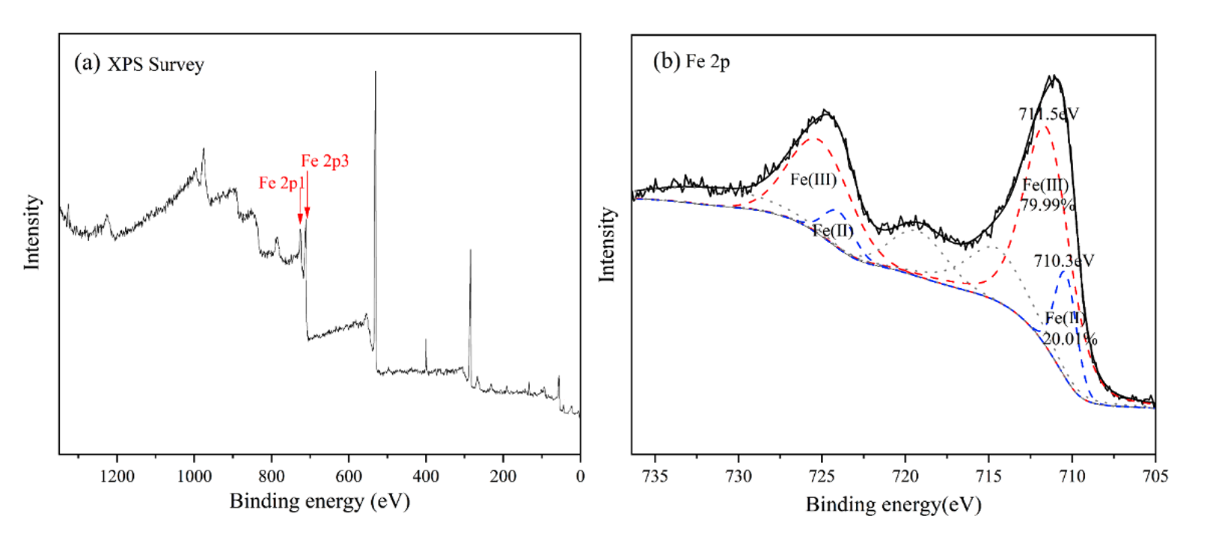
Fig. S1 XPS analysis of mineral precipitation after incubation of Ochrobactrum EEELCW01 for 7 days
2 Supplementary data
Table S1 Basic properties of iron-modified biochar (Fe-BC) and Ochrobactrum EEELCW01-loaded iron-modified biochar (B-FeOB)
 | pH | C (%) | H (%) | O (%) | N (%) | P (%) | BET (m²/g)
Fe-BC | 9.16 | 58.60 | 5.23 | 19.52 | 1.36 | 1.27 | 183.64
B-FeOB | 8.37 | 57.74 | 4.59 | 18.28 | 3.43 | 1.05 | 158.26

Table S2 The concentrations of heavy metals (Pb, Cd, As, and Zn) of soil (mg·kg⁻¹)
Total-Pb | Total-Cd | Total-As | Total-Zn | Available-Pb | Available-Cd | Available-As | Available-Zn
17175 | 177 | 4890 | 2481 | 0.316 | 0.312 | 3.901 | 5.525

Table S3 Fluorescence intensity of soil DOM components under different treatments
Treatment | Fluorescence intensity / a.u.
Treatment | total | component I | component II | component III | component IV
CK | 109224.372 | 9882.46124 | 20443.1368 | 20247.1861 | 58651.5883
FeOB | 151877.031 | 14745.8583 | 26781.543 | 29089.6179 | 81260.012
Biochar | 190930.8 | 17262.5012 | 39395.5804 | 30872.0974 | 103400.621
B-FeOB | 196339.128 | 17228.2841 | 37385.6063 | 33204.8029 | 108520.435
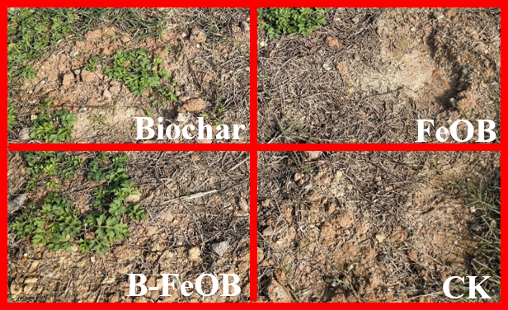

Fig. S2 Plant growth in different treatment groups

