The potential of biochar to mitigate soil acidification: a global meta-analysis
Nanhai Zhang^{a,b,c,1}, Jiamin Xing^{a,b,c,1}, Lianjun Wei^{a,b,c}, Chang Liu^{a,b,c}, Wenjing Zhao^{a,b}, Zihan Liu^{a,b}, Yuhao Wang^{a,b,c}, Enke Liu^{d}, Xiaolong Ren^{a,b}, Zhikuan Jia^{a,b}, Ting Wei^{a,b}, Kadambot H.M. Siddique^{e}, Peng Zhang^{a,b,c,*}
ªCollege of Agronomy, Northwest A&F University, Yangling 712100, Shaanxi, China
^{b}Key Laboratory of Crop Physiology, Ecology and Tillage Science in Northwestern Loess Plateau, Ministry of Agriculture and Rural Affairs, Northwest A&F University, Yangling 712100, Shaanxi, China
^{c}State Key Laboratory for Crop Stress Resistance and High-Efficiency Production, Northwest A&F University, Yangling 712100, Shaanxi, China
^{d}Institute of Environment and Sustainable Development in Agriculture, Chinese Academy of Agricultural Sciences, Beijing 100081, China
^{e}The UWA Institute of Agriculture, The University of Western Australia, Perth, WA 6001, Australia
The ORCID of Nanhai Zhang is: 0009-0008-8903-9097
¹These two authors contributed equally to this publication.
*Corresponding author: Peng Zhang (pengzhang121@hotmail.com)

Table S1 Publication bias test for different explanatory variables under biochar application
Explanatory variables | N | 5N + 10 | Fail-safe N | Explanatory variables | N | 5N + 10 | Fail-safe N
MAT | 721 | 3615 | 1932089 | Soil clay content | 613 | 3075 | 2950605
MAP | 842 | 4220 | 2619328 | Soil pH | 1313 | 6575 | 9974495
Biochar pH | 1319 | 6605 | 9851754 | Soil CEC | 420 | 2110 | 1308152
Pyrolysis temperature | 1266 | 6340 | 10714749 | Biochar returning time | 1313 | 6575 | 9636591
Raw material | 1421 | 7115 | 12733675 | Nitrogen application amount | 997 | 4995 | 5153211
Biochar C:N ratio | 1058 | 5300 | 4910085 | Nitrogen fertilizer application type | 711 | 3565 | 2918833
Biochar application amount | 1306 | 6540 | 8371828 | Irrigation or not | 577 | 2895 | 271676
Biochar ash | 482 | 2420 | 939405 | Experiment type | 1460 | 7310 | 13398967
Initial SOC | 1213 | 6075 | 6368589 | Crop type | 1259 | 6305 | 7517317
Initial STN | 957 | 4795 | 5222619 | Farmland utilization mode | 993 | 4975 | 2926305
Soil texture | 985 | 4935 | 5980983 | Soil pH assay method | 1460 | 7310 | 13398967
N is the number of samples for comparison. The meta-analysis results considered credible when Fail-safe N > 5N + 10.

Table S2 Effects of biochar on soil pH under different measurement methods
Class | N | 95% CI | Overall ln RR | Differences between grouping
H₂O solution | 1291 | 0.0414 to 0.0610 | 0.0512 | b
CaCl₂ solution | 16 | −0.1259 to 0.1334 | 0.0038 | b
KCI solution | 6 | 0.2674 to 0.5339 | 0.4007 | a
Not described in detail | 147 | 0.0390 to 0.0907 | 0.0649 | b
Overall | 1460 | 0.0447 to 0.0640 | 0.0544
The different lowercase letters indicate the significant differences between grouping of explanatory variables at P < 0.05 using the anova function in R.
Table S3 Description of explaining variables
Explaining variables | Unit | Key
Mean annual temperature | mm | MAT
Mean annual precipitation | ℃ | MAP
Biochar pH | - | B_pH
Biochar pyrolysis temperature | ℃ | PT
Biochar C: N ratio | - | B_CN
Biochar application amount | t ha⁻¹ | BAA
Biochar ash | % | B_ash
Initial SOC | g kg⁻¹ | I_SOC
Initial STN | g kg⁻¹ | I_STN
Soil clay content | % | SCC
Soil CEC | cmol kg⁻¹ | S_CEC
Nitrogen application amount | kg ha⁻¹ | NAA
Biochar returning time | d | BRT

The linear mixed-effects models uses the same data as the random forest model. The complete models were:
lmer (ln RR ~ MAT + MAP + B_pH + PT + B_CN + BAA + B_ash + I_SOC + I_STN + Soil_pH + SCC + S_CEC + NAA + BRT + (1|Site), data = data, REML ="TRUE")
See Table S3 for explaining variables. The best models selected for ln R are shown in Tables S4. The first row in Tables S4 suggested the best models with the lowest Akaike Information Criterion (AIC).
Tables S4 Model selection results for the effect of soil pH response ratio under biochar application
Models | Model selection table
Models | MAT | MAP | B_pH | PT | B_CN | BAA | B_ash | I_SOC | I_STN | Soil_pH | SCC | S_CEC | NAA | BRT | AIC
Model1 |  | 0.7243*** |  |  |  | 0.3694** |  |  |  |  | −0.7037*** |  |  |  | 182.6
Model2 |  |  | −112.8559 |  | 0.7386 | 0.5047** | 73.5751 | −197.6373 | 52.7353 | 66.0698 |  |  |  | −0.3277* | 183.8
Model3 |  |  | −0.6204* |  |  | 0.4028* | 0.4025* | −0.0109* | 0.2943* | 0.3594* |  |  |  |  | 183.8
Model4 |  |  | −103.0332 |  | 0.7581 | 0.5020** | 66.7201 | −179.9071 | 47.9560 | 60.0106 |  |  |  |  | 184.0
Model5 | 0.4972*** |  |  |  |  |  |  |  |  |  | −0.5263*** |  |  |  | 184.3
Model6 | 40.5197 | −42.7238 |  | −19.6351 | 0.7386 | 0.5047** |  |  | 11.6732 |  | −6.7579 |  |  | −0.3277* | 184.3

Table S5 Coefficients estimated in the linear mixed model for soil pH response ratio under biochar application
lmer (ln RR ~ MAP + BAA + SCC + (1|Site), data = data, REML ="TRUE")
Fixed effects:
 | Estimates | SE | df | t value | p value
(Intercept) | < 0.001 | 0.1025 | 62 | 0 | 1
BAA | 0.3694 | 0.1266 | 62 | 2.917 | 0.004
MAP | 0.7243 | 0.1472 | 62 | 4.921 | < 0.001
SCC | −0.7037 | 0.1343 | 62 | −5.239 | < 0.001
Conditional R²: 0.3284

Figure S1 The correlation analysis between the explanatory variable under different farmland utilization mode. And the data used were the same as PCA analysis. MAT, mean annual temperature; MAP, mean annual precipitation; B−pH, biochar pH; PT, pyrolysis temperature of biochar; B−C:N, biochar C:N ratio; BAA, biochar application amount; B−ash, biochar ash; I−SOC, initial SOC; I−STN, initial STN; SCC, soil clay content; S−CEC, soil CEC; NAA, nitrogen application amount; BRT, biochar returning time.

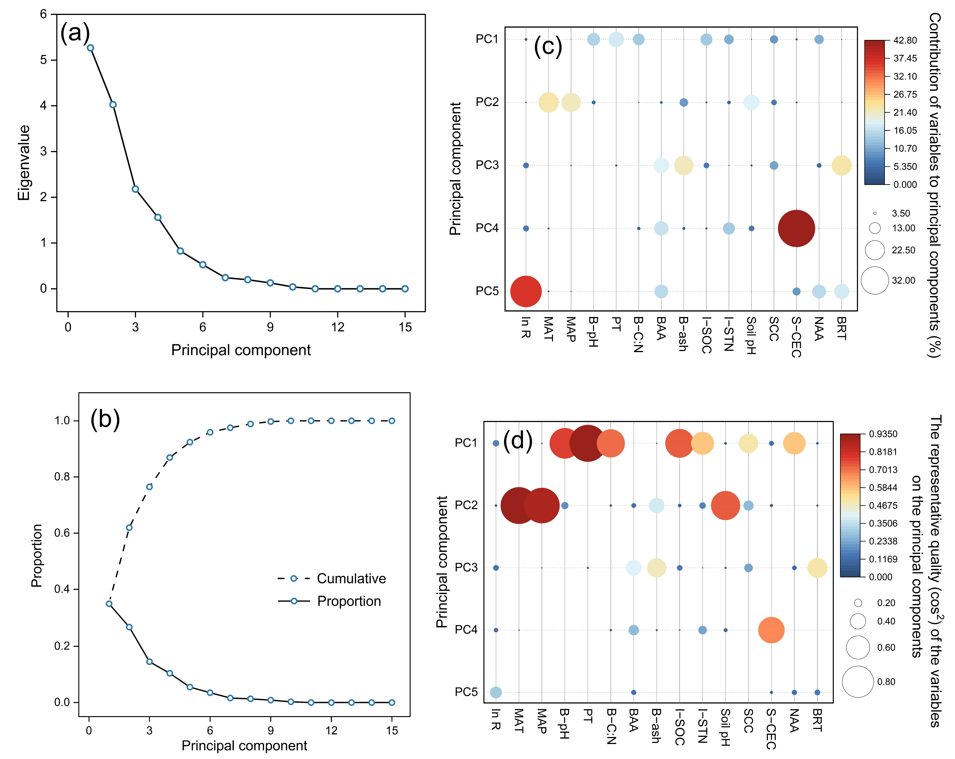
Figure S2 Scree plot of eigenvalues against the number of principal components for the effects of biochar on soil pH under different farmland utilization mode (a, b). Contribution and representative quality (cos²) of explanatory variables on different principal component axes (c, d). MAT, mean annual temperature; MAP, mean annual precipitation; B−pH, biochar pH; PT, pyrolysis temperature of biochar; B−C:N, biochar C:N ratio; BAA, biochar application amount; B−ash, biochar ash; I−SOC, initial SOC; I−STN, initial STN; SCC, soil clay content; S−CEC, soil CEC; NAA, nitrogen application amount; BRT, biochar returning time.

Figure S3 Preferred Reporting Items for Systematic Reviews and Meta-Analysis (PRISMA) flow chart showing the article search and selection of data for inclusion in this study.

Figure S4 Two-sample t-test of initial explanatory variable values for dryland and paddy fields (a). The responses of ln RR to biochar application across explanatory variables for dryland and paddy fields (b). The circles and error bars represent average parameter estimates and the 95% CI in the linear mixed-effects models. *, **, and *** indicate significant differences at P < 0.05, P < 0.01, and P <0.001, and NS denotes no significant difference at P = 0.05.
Figure S5 a Correlation analysis between mean annual precipitation (MAP) and mean annual temperature (MAT). b Correlation analysis between initial soil pH and MAP.

Figure S6 Correlation analysis between biochar pyrolysis temperature and biochar pH (a), C:N ratio (b), and ash content (c). pH (d), C:N ratio (e), and ash content (f) for biochar prepared from different raw materials. Each data point is represented by a dot with horizontal jitter for visibility, and shaded areas indicate kernel density smooth curve.

Figure S7 Correlation analysis between soil clay content and initial SOC (a) and soil CEC (b). c Correlation analysis between initial SOC and soil CEC.

