Table S1 Basic attributes of raw (BC) and sulphur (SBC) biochar.
 |  | BC | SBC
Yield percentage | Wt. % | 24.376 ± 1.322 | 32.711 ± 1.410
Ash Content | Wt. % | 19.245 ± 1.345 | 15.178 ± 0.567
Elemental Analysis | Wt. %
C |  | 68.234 ± 2.176 | 62.190 ± 2.786
H |  | 1.234 ± 0.099 | 1.789 ± 0.098
O |  | 7.876 ± 0.456 | 10.456 ± 0.345
N |  | 1.378 ± 0.050 | 0.754 ± 0.034
Atomic Ratio
C+H+O+N |  | 75.164 ± 3.567 | 76.45 ± 3.567
H/C |  | 0.045 ± 0.001 | 0.043 ± 0.003
O/C |  | 0.121 ± 0.004 | 0.158 ± 0.007
(N+O)/C |  | 0.131 ± 0.005 | 0.171 ± 0.013
pH |  | 8.987 ± 0.456 | 5.874 ± 0.378
IEC | Cmol kg⁻¹ | 94.245 ± 5.515 | 245.124 ± 14.45
BET surface area | m² g⁻¹ | 27.890 ± 1.332 | 95.672± 4.325

Table S2 Gene-specific primers sequences used in the present study.

Purpose | Name | Forward (5'-3') | Reverse (5'-3') | Full name of gene
Reference gene | OsUBQ | GACGGACGCACCCTGGCTGACTAC | TGCTGCCAATTACCATATACCACGAC | Ubiquitin
Target genes | OsCuZnSOD1 | ATGCGTCTGTGTTGCTTCTG | CCATCTCCCTCTTGGACAAA | Copper/zinc-superoxide dismutase 1
Target genes | OsCaTB | GTGAATGCACCAAAATGTGC | CCAGCCTGTTGGAAATTGTT | Catalase B
Target genes | OsGPX1 | TGAACCGGTCCCATATGAAT | AGCGGTGTAAGGTGAAATGG | Glutathione peroxidase 1
Target genes | OsGSTU37 | GCTGAGTCTGCCGGATAGAG | ATTTATTCCCAGGTGGCACA | Glutathione S-transferase 37
Target genes | OsAPX2 | TCAAGGACCAACTTCCCATC | AGGGTGTGACCACCAGAAAG | Ascorbate peroxidase 3
Target genes | OsGLYI-1 | AATTTTGTTCTTGGCGATGG | CTTATTGGGTGGCATGCTCT | Glyoxalase I
Target genes | OsGLYII-2 | CTCGCCAAGAGACCATAAGC | GCTCTCGTCCACGATTCTTC | Glyoxalase II
 | OsFSD1 | AACAACGGCAACCCATTACCA | CCTGGTGACCCACCACCTTC | Metal tolerant

Table S3 One-way analysis of variance (ANOVA) results for impact of sulfur modified (SBC) on different rice growth parameters under vanadium (V) stress.
Significance level of P < 0.05.
 |  |  |  |  |  | Leaf |  | Root
Variable |  | F | P | Variable |  | F | P | F | P
Agronomy attributes | Fresh weight shoot | 59.08 | 0.00 | Antioxidant enzymes | Superoxide Dismutase (SOD) | 153.67 | 0.00 | 83.95 | 0.00
 | Dry weight shoot | 659.81 | 0.00 |  | Catalase (CAT) | 96.03 | 0.00 | 38.32 | 0.00
 | Fresh weight root | 14.71 | 0.00 |  | Ascorbate peroxidase (APX) | 754 | 0.00 | 289.8 | 0.00
 | Dry weight root | 161.9 | 0.00 |  | Glutathione peroxidase (GPX) | 150.55 | 0.00 | 337.55 | 0.00
Root attributes | Root length | 279.67 | 0.00 |  | Glutathione reductase (Gr) | 105.38 | 0.00 | 283.75 | 0.00
 | Root volume | 149.79 | 0.00 |  | Glutathione S-transferases (GST) | 178.42 | 0.00 | 240.25 | 0.00
 | Root fork | 143.66 | 0.00 |  | Dehydroascorbate reductases (DHAR) | 167.35 | 0.00 | 330.15 | 0.00
 | Root tip | 1157.57 | 0.00 |  | Monodehydroasorbate reductase (MDHAR) | 169.37 | 0.00 | 121.24 | 0.00
 | Surface area | 98.62 | 0.00 |  | Glyoxalase I (GLY I) | 71.44 | 0.00 | 125.12 | 0.00
 | Root crossing | 322.9 | 0.00 |  | Glyoxalase II (GLY II) | 244.81 | 0.00 | 191.35 | 0.00
Photosynthesis attributes | Chlorophyll a | 202.76 | 0.00 |  | Methylglyoxal (MG) | 62.43 | 0.00 | 89.78 | 0.00
 | Chlorophyll b | 132.33 | 0.00 |  | Hydrogen peroxide (H₂O₂) | 623.2 | 0.00 | 233.51 | 0.00
 | Caroteniods | 725.45 | 0.00 |  | Superoxide radical (O₂^{•−}) | 239.34 | 0.00 | 97.08 | 0.00
 | SPAD INDEX | 218.74 | 0.00 |  | Malondialdehyde (MDA) | 245.13 | 0.00 | 176.22 | 0.00
 | Photosythetic assimilation | 144.88 | 0.00 |  | Electrolyte leakage (EL) | 513.74 | 0.00 | 556.15 | 0.00
 | Transpiration rate | 474.8 | 0.00 |  | Protein | 161.9 | 0.00 | 113.09 | 0.00
 | Stomatal conductance | 138.3 | 0.00 |  | V accumulation | 73019 | 0.00 | 61526.8 | 0.00
 | Intercellular CO2 | 216.2 | 0.00

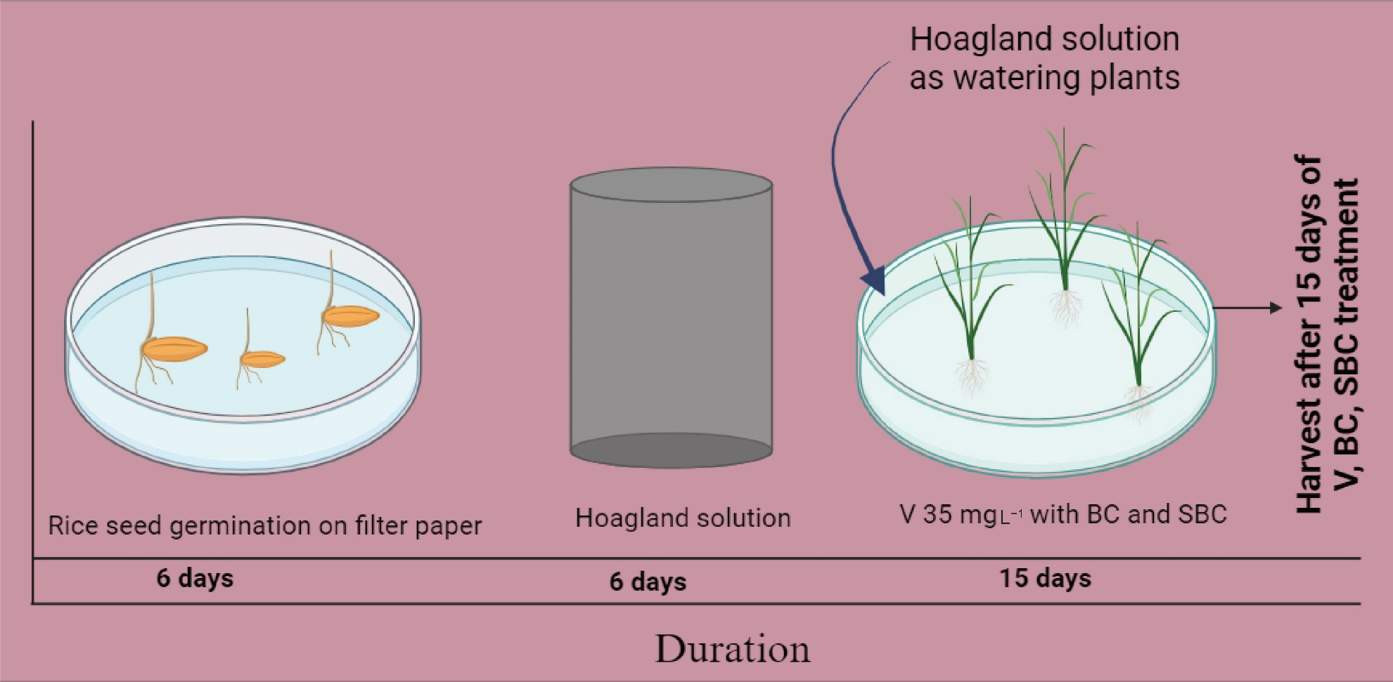
Fig. S1 Experimental setup of the current study; rice plants were treated with raw and sulphur modified biochar under vanadium (35 mg L⁻¹) stress treatments for 15 days under fully environment-controlled growth chamber.

