Development of hazelnut shell-derived biochar to support a bifunctional MoCo electrocatalyst for HER/OER in alkaline medium

Jaime Ñanculeo ª, Teresa Andreu ^{b}, Ignasi Sirés ^{b}, Andrés Ramírez ^{c}, Mara Cea ^{d,e}, Benjamín Nahuelcura ª, Gerson Valenzuela ^{d}, Karla Garrido-Miranda ^{e}, María Eugenia González ^{d,e,*}

ª Doctoral program in Engineering Sciences with Specialization in Bioprocesses, University of La Frontera, Av. Francisco Salazar 01145, Temuco-Chile.
^{b} Departament de Ciència de Materials i Química Física, Secció de Química Física, Facultat de Química, Universitat de Barcelona, Martí i Franquès, 1-11, 08028 Barcelona, Spain.
^{c} Department of Chemical Sciences and Natural Resources, Faculty of Engineering and Sciences, University of La Frontera, Av. Francisco Salazar 01145, Temuco 4780000, Chile.
^{d} Department of Chemical Engineering, University of La Frontera, Av. Francisco Salazar 01145, Temuco 4780000, Chile
^{e} Scientific and Technological Bioresource Nucleus (BIOREN-UFRO), Universidad de La Frontera, Av. Francisco Salazar 01145, Temuco 4780000, Chile
* Corresponding author, mariaeugenia.gonzalez@ufrontera.cl

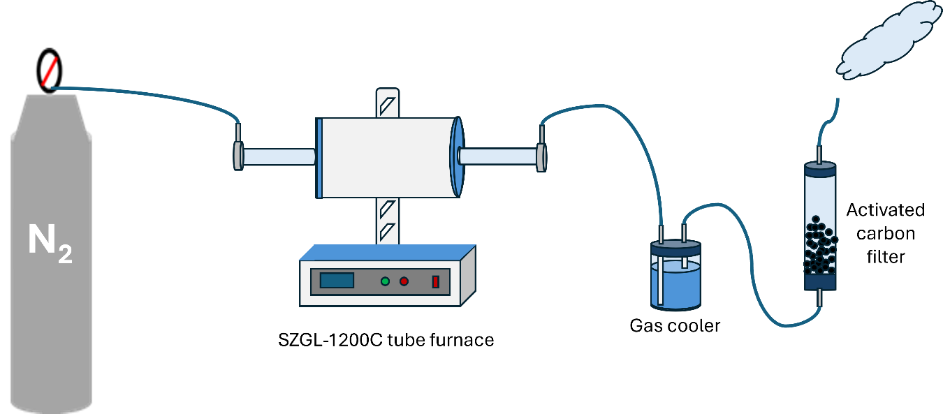
Fig. S1 Pyrolysis system used for this study.

Table S1. Elemental composition HS.
Element | Content (%)
C | 53.254
O | 40.779
H | 5.779
N | 0.535
Ash | 0.347

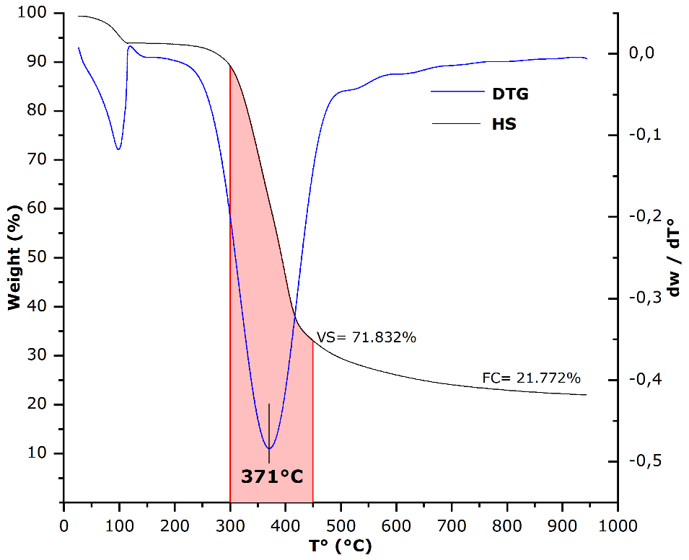
Fig. S2 Thermogravimetric analysis (TGA) and derivate thermogravimetric (DTG) of HS.

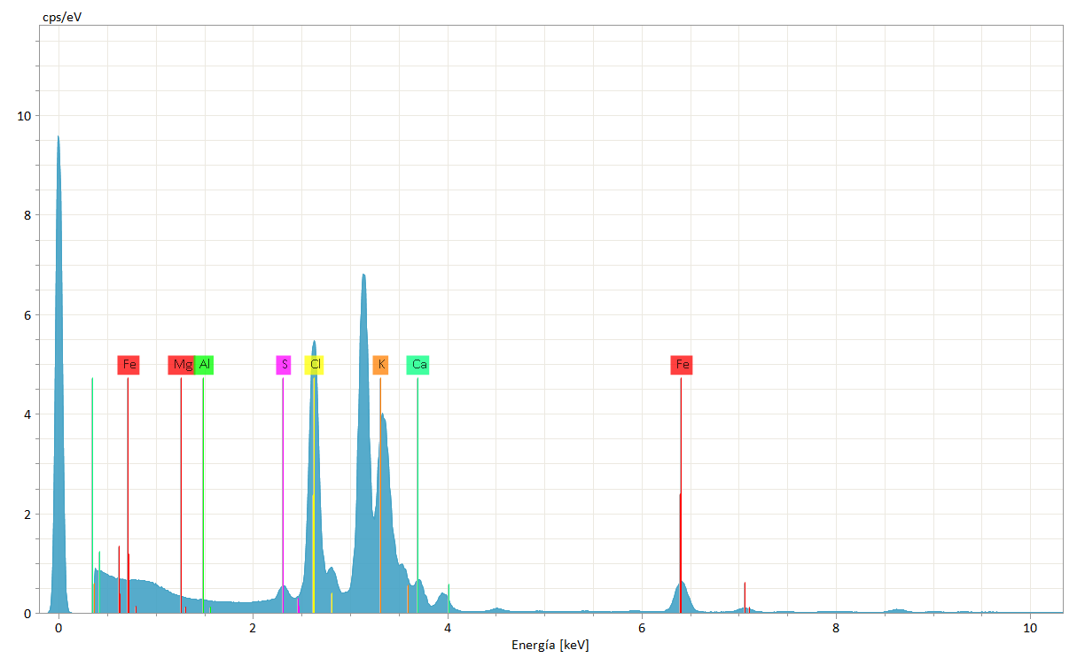
Fig. S3 Inorganic content of HS by Total reflection X-ray fluorescence (TXRF).

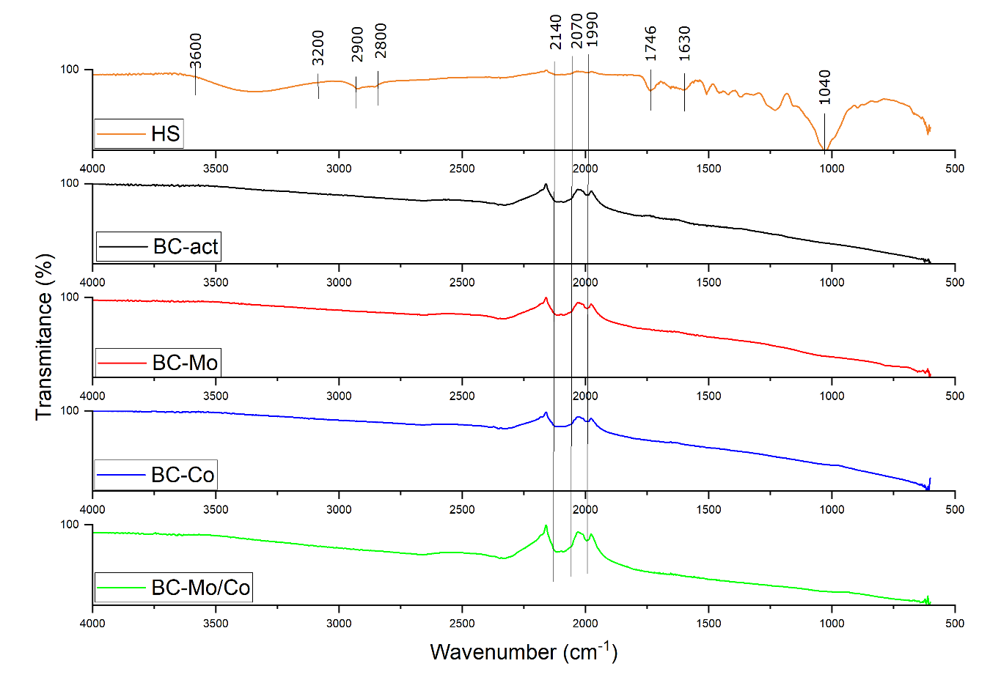
Fig. S4 FTIR spectrum of HS and electrocatalysts synthesized.

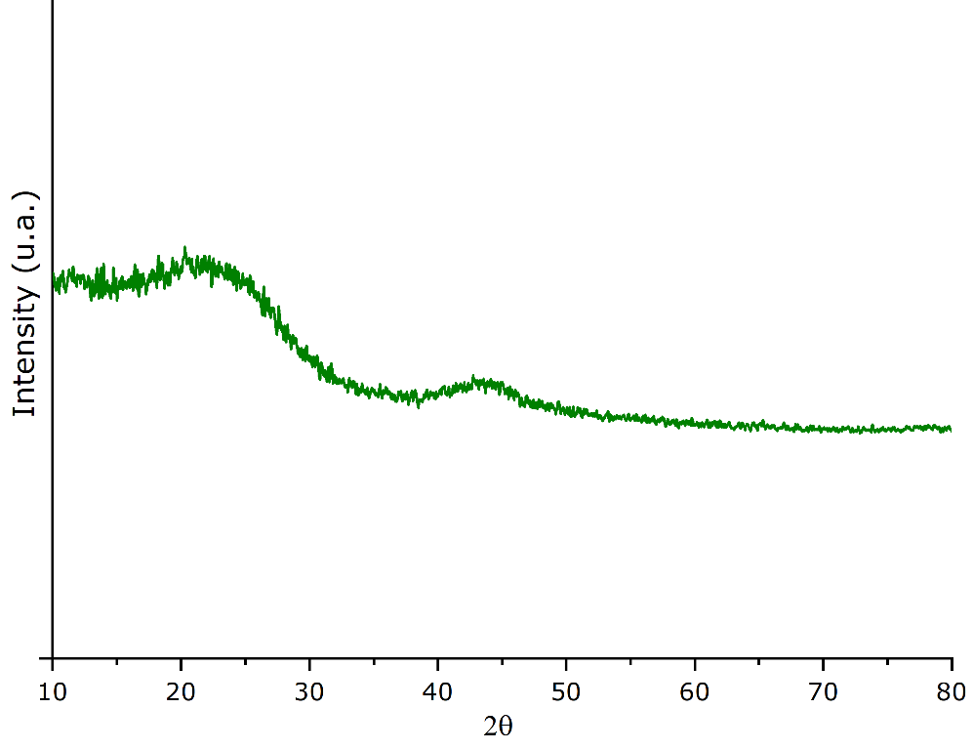
Fig. S5 X-ray diffraction (XRD) of biochar.

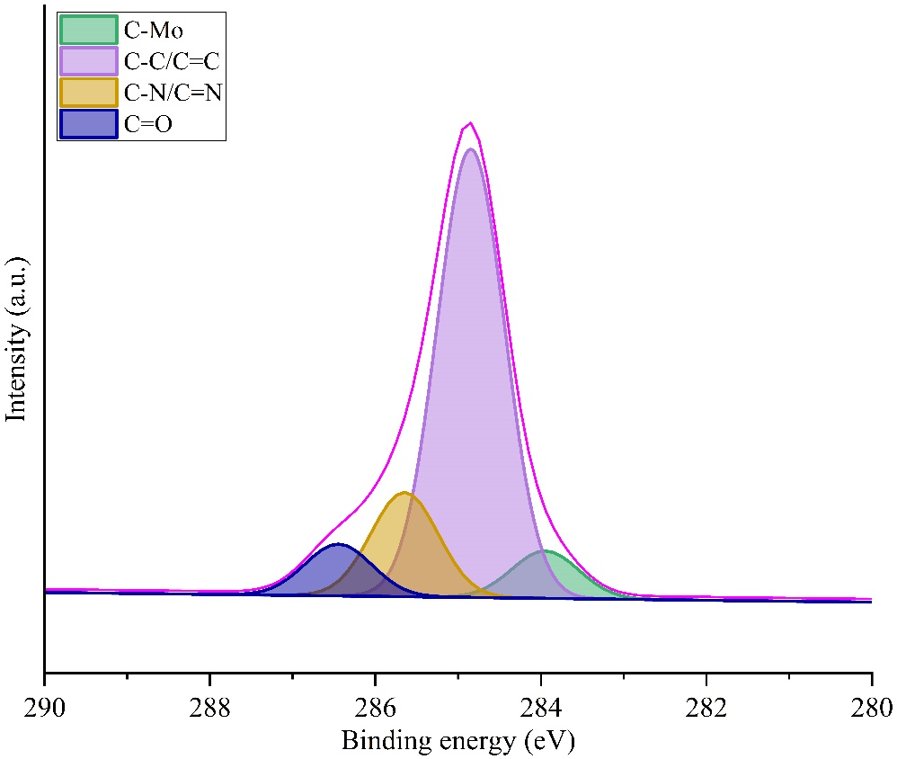
Fig. S6 High-resolution XPS spectra for C 1s in BC-Mo/Co.

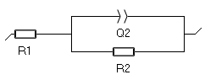
Fig. S7 Circuit equivalent of BC-Mo/Co for HER and OER.

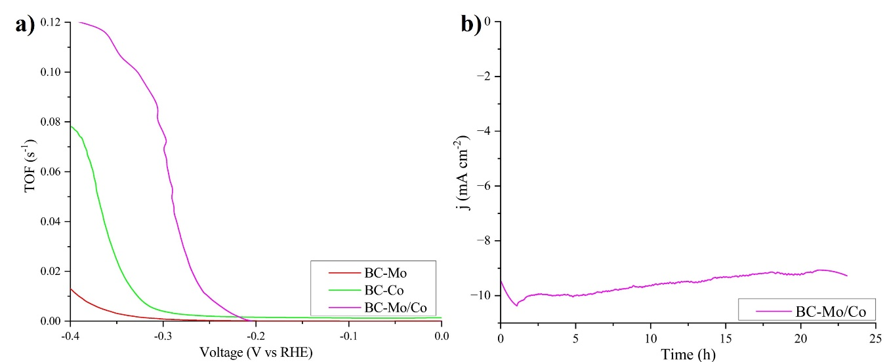
Fig. S8 HER performance: a) turnover frequency (TOF), and b) chronoamperometric at -0.257 V of BC-Mo/Co.

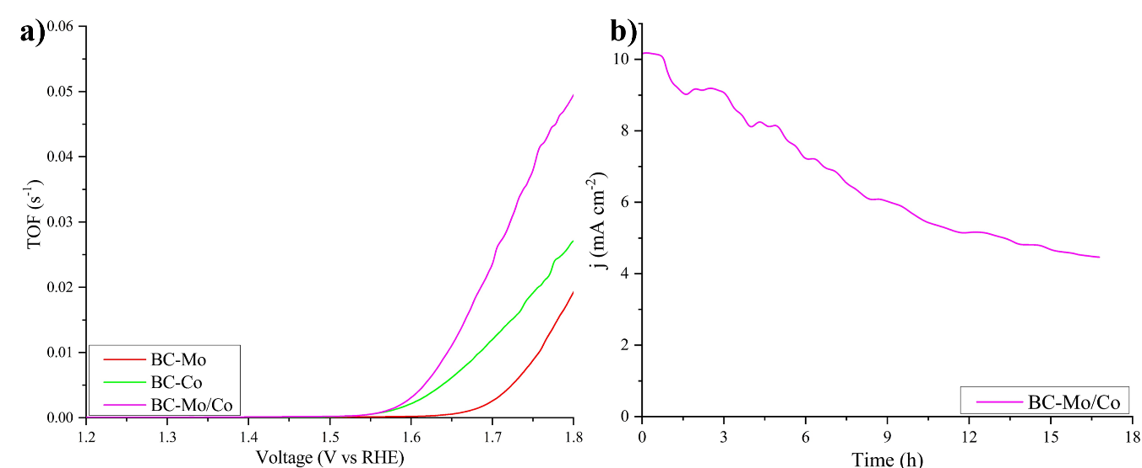
Fig. S9 OER performance: a) turnover frequency (TOF), and b) chronoamperometric at 1.6 V of BC-Mo/Co.

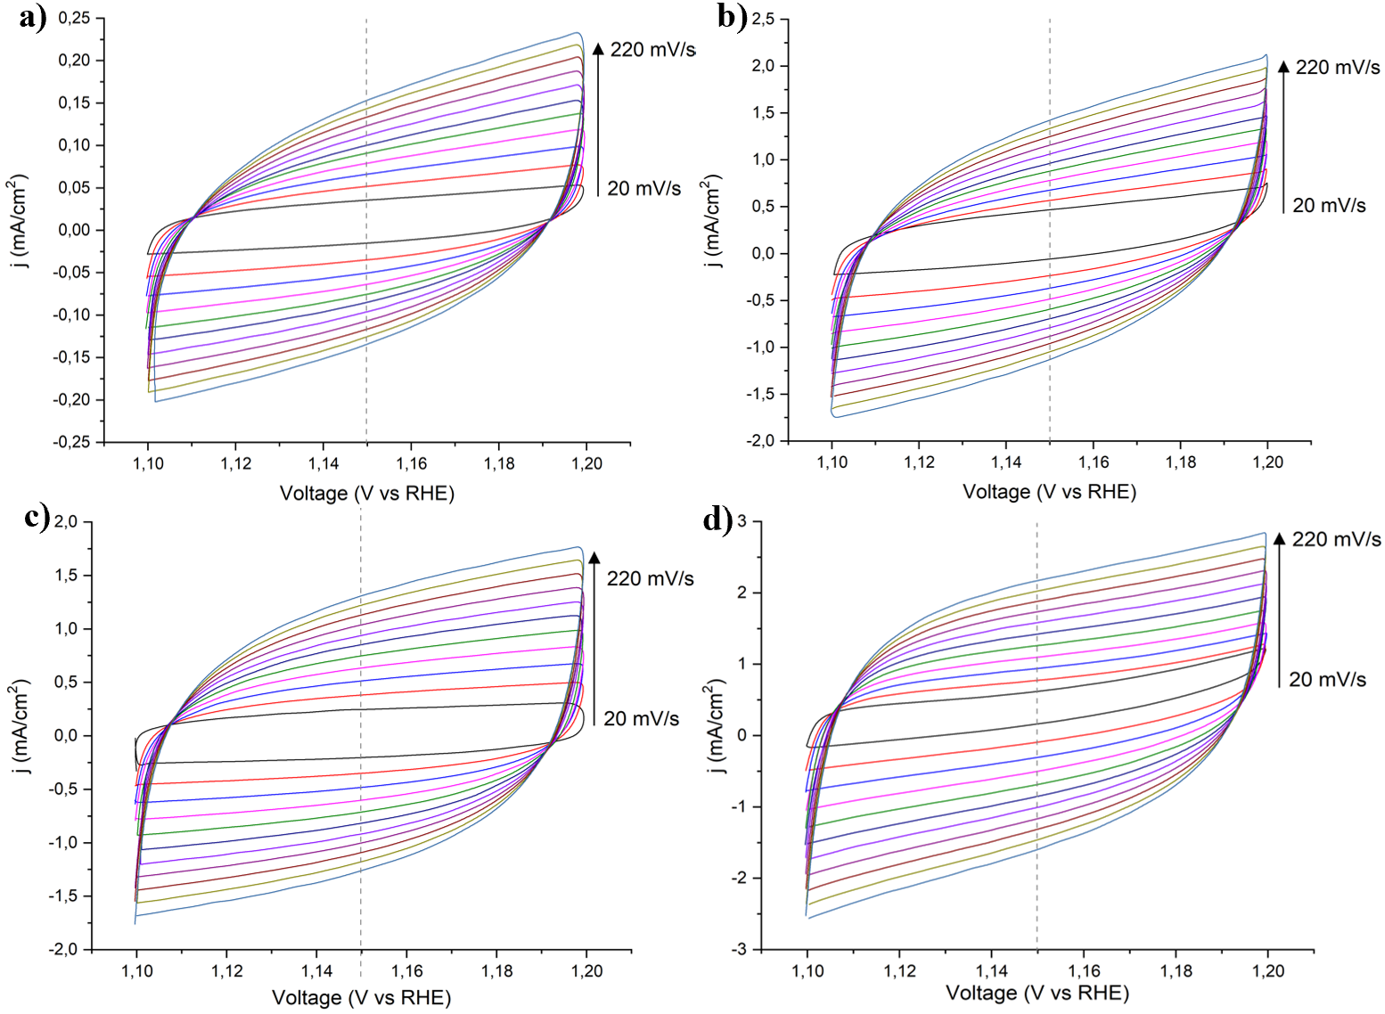
Fig. S10 Cyclic voltammetry for ECSA determination: a) BC, b) BC-Mo, c) BC-Co and d) BC-Mo/Co.

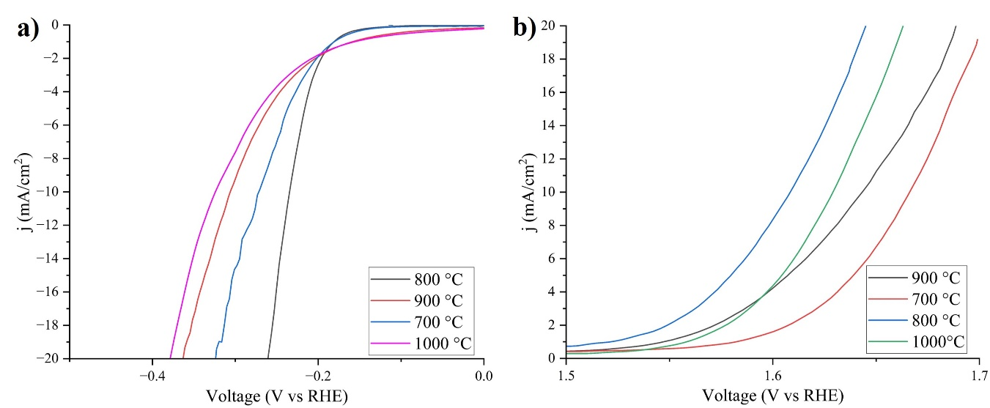
Fig. S11. Effect of BC-Mo/Co synthesis temperature on the overpotential of a) HER and b) OER.

