Supplementary Material

Conversation of pesticide residue into ammonium nitrogen (NH₄⁺-N) through AOPs and its fertilization effect on lettuce growth
Dong He ^{a, b,1}, Yujiao Wen ^{a, b,1}, Shangzhi Wei^{c}, Shikai Li ^{d}, Lide Liu ^{a, b}, Jinmeng Wu ^{a, b}, Zhi Zhou ^{a, b}, Nan Zhou ^{a, b, *}, Hongmei Liu ^{a, b, *}, Zhonghua Zhou ^{a, b, *}
a. Hunan Engineering Research Center for Biochar, Hunan Agricultural University, Changsha 410128, China;
b. College of Mechanical and Electrical Engineering, College of Agronomy, College of Chemistry and Material Science, Hunan Agricultural University, Changsha 410128. China;
c. Hunan Province Linxiang city Huanggai town agricultural comprehensive service center, Linxiang 414000, China;
d. Central South University Institute of Environmental Engineering School of Metallurgy and Environment 932 Lushan South Road, Changsha 410083, PR China.

1-These authors contributed equally to this work.
*Corresponding author: Nan Zhou, E-mail: zhounan@hunau.edu.cn;
Hongmei Liu, E-mail: liuhongmei@hunau.edu.cn;
Zhonghua Zhou, E-mail: zhouzhonghua1976@hotmail.com.

Number of pages: 35
Number of texts: 11
Number of figures: 12
Number of tables: 5

Contents:
Text S1. Chemicals reagents.
Text S2. Methods and means of material characterization.
Text S3. Electrochemical testing of BC@Fe₃S₄ and BC.
Text S4. iFIA7 detects ammonium nitrogen in the degradation system.
Text S5. Specific method for the determination of CTD residues in soil and lettuce.
Text S6. Catalytic degradation of CTD by BC@Fe₃S₄.
Text S7. Details of the CTD and intermediates extraction method.
Text S8. Analytical methods.
Text S9. Toxicity changes of intermediates involved in CTD degradation or nutrient conversion.
Text S10. Material characterization.
Text S11. Test method for fresh weight and dry weight of potted lettuce.
Fig.S1.SEM and EDS images of (a) BC and (b)BC@Fe₃S_{4,} (c)XRD spectra, (d)FTIR of BC@Fe₃S_{4,} BC@Fe₃S₄+CTD and BC samples.
Fig.S2. BET of BC and BC@Fe₃S₄ samples (a-b).
Fig.S3. Electrochemical performance analysis of BC and BC@Fe₃S₄: (a) CV curve, (b) EIS, (c) LSV curve.
Fig.S4. The TGA curves of BC and BC@Fe₃S₄ at: (a), the DTG curves of BC and BC@Fe₃S₄ at: (b).
Fig.S5. TOC removal performance of BC@Fe₃S₄+PMS for CTD, Tests conditions: Equilibrium time = 3 h, aqueous volume = 50 mL, catalyst dosage = 0.08 g L⁻¹, [CTD] = 20 mg L⁻¹, [PMS] = 1.6 mM, pH = No adjustment, T = 298.15 K.
Fig.S6. The effect of BC@Fe₃S₄ repeated degradation of CTD within 5 times. Test environment: The experiment was conducted in ultra-pure water. The reaction equilibrium time is 3h. [CTD] = 5 mg L⁻¹, aqueous volume = 50 mL, catalyst dosage = 0.08 g L⁻¹, [PMS] = 1.6 mM, pH = No adjustment, T = 298.15 K.
Fig.S7. SEM and EDS before and after BC@Fe₃S₄ degradation of CTD. (a) BC@Fe₃S₄, (b) BC@Fe₃S₄+PMS+CTD.
Fig.S8. Effect of BC@Fe₃S₄ on CTD degradation in polluted soils with different proportions of soil and water. Test environment: all the above experiments were carried out in CTD-contaminates the soil. The reaction equilibrium time is 3h. [CTD] = 50 mg kg⁻¹, CTD-contaminates soil = 5.00 g, aqueous volume = 5, 10, 25, 50 mL, catalyst dosage = 0.8 g kg⁻¹, [PMS] = 1.6 mM, pH = No adjustment, T = 298.15 K.
Fig.S9. High-definition photographs of growth morphology of lettuce on day 30th cultured under fresh soil (a1), fresh soil+BC@Fe₃S₄+PMS system (b1), CTD stress (a2-a6) and CTD+BC@Fe₃S₄+PMS system (b2-b6) detoxification.
Fig.S10. Using a scanner to obtain high-definition photos of lettuce under different treatments. Underground and ground biomass morphology of lettuce seedlings cultured on the 30th day under fresh soil (a1), fresh soil+BC@Fe₃S₄+PMS system (b1), under CTD stress (a2-a6) and CTD+BC@Fe₃S₄+PMS system (b2-b6) detoxification treatment.
Fig.S11. XPS high-resolution O1s and C1s spectra of (a,b) BC@Fe₃S₄ (before the reaction), and (c, d) BC@Fe₃S₄+CTD+PMS (after the reaction).
Fig.S12. LC-MS/MS of CTD and its degradation products.
Table S1. Analysis of metal components in CTD-contaminated soil and healthy soil.
Table S2. Analysis of nonmetallic components in CTD-contaminated soil and healthy soil.
Table S3. Specific surface area details of the BC, BC@Fe₃S₄.
Table S4. Summary on the second-order reaction rates of MeOH, TBA, FFA, L-histidine, and p-BQ with different ROS.
Table S5. T.E.S.T-QSAR evaluated the toxicity of CTD and its degradation intermediates to Fathead-minnow and T.pyriformis.

Text S1. Chemicals reagents.
Thiourea (CH₄N₂S), ferric chloride (FeCl₃), Sodium hydroxide (NaOH), Clothianidin (CTD, 97%), Peroxymonosulfate (KHSO₅, 99.5%, PMS), Sulfuric acid (H₂SO₄), Carbon black, Polytetrafluoroethylene (PTFE), Graphitized carbon black, P-propyl ethylenediamine, Sodium potassium tartrate (C₄H₄O₆KNa·4H₂O), Sodium citrate (C₆H₅O₇Na₃·2H₂O), Sodium salicylate (C₇H₅NaO₃), Sodium nitroprusside (Na[Fe(CN)₅NO]·2H₂O), Sodium dichloroisocyanurate (C₃Cl₂N₃NaO₃), L-histidine(C₆H₉N₃O₂), was purchased from Shanghai Aladdin Biochemical Technology Co., LTD., 5,5-dimethyl-1-pyrroline N-oxide (DMPO) and 2,2,6,6-tetramethylpiperidine oxide (TEMPO), purchased furfuryl alcohol (FFA), tert-butanol (TBA), p-benzoquinone (p-BQ), methanol (MeOH), Acetic acid, acetonitrile and ethanol from Sinopharm Group Chemical reagent Co., LTD. and other chemicals and reagents were all analytically pure. All the reagents were dissolved with ultra-pure water.

Text S2. Methods and means of material characterization.
X-ray diffraction (XRD-6,000, SHIMADZU, Japan) was used to record crystal patterns in the range of 2θ 10-80 degrees (Cu-Kα). Brunauer-Emmett-Teller (BET, 3H-2000PS1) was used to measure the specific surface area and pore size distribution of samples. Besides, the surface morphology of the catalysts was analyzed by scanning electron microscope (SEM, JSN-6380LV), and the distribution of elements in the sample was determined by energy dispersive spectrometer (EDS). Fourier transform infrared spectroscopy (FT-IR, VERTEX 80/80 v, Bruker, Germany) was used to measure the organic composition and functional groups. X-ray photoelectron spectroscopy (XPS, ESCA Lab 250Xi, Thermo Fischer) was utilized to analyze the surface elements, all peak positions were referenced to the C 1s peak of adventitious carbon at 284.8 eV. A thermogravimetric analyzer (TGA2, Mettler Toledo, Switzerland) was used to study the TGA of BC and BC@Fe₃S₄. Approximately 10 mg sample was added in corundum crucible and heated from 30 ℃ to 800 ℃ with the heating rates is 50 ℃/min.

Text S3. Electrochemical testing of BC@Fe₃S₄ and BC.
Mixing carbon black, Polytetrafluoroethylene (PTFE), and BC@Fe₃S₄/BC powder with a weight ratio of 1:1:8 and then wiped the mixture onto an aluminum foil paper. After the formation, the electrode is stripped from the aluminum foil, pressed into a round sheet using a mold, assembled on the conductive wire mesh, and pressed tightly using hydraulic pliers. After drying it in a vacuum oven (Shanghai qianjin scientific instrument co., LTD, DZ-2BCII, China) at 60 ℃ for 12 h to remove excess water.
Cyclic voltammetry (CV): The electrochemical measurements were conducted using CHI604E electrochemical workstation in an H-type electrolytic cell separated by a single-layer polyethylene film. The single-layer polyethylene film was washed several times using ultrapure water before tests. The electrode derived from BC@Fe₃S₄ and BC powder was used as the working electrode respectively, while saturated calomel electrode (SCE) and platinum foil were utilized as the reference electrode and counter electrode, respectively. The size of working electrode was tailored to 1×1 cm². The anode and cathode compartment were filled by 6 M H₂SO₄ solution (100 mL). The detection range was −0.2 - 0.8 V.
Electrochemical impedance spectroscopy (EIS): Electrochemical impedance spectroscopy (EIS) was measured at open circuit potential over a frequency range from 10 mHz to 100 kHz with an AC amplitude of 5 mV.
Linear sweep voltammetry (LSV): BC@Fe₃S₄ and BC were placed in 6 M H₂SO₄ solution and linear-sweep voltammetry (LSV) was performed at a potential window of −0.2 - 0.8 V.

Text S4. iFIA7 detects ammonium nitrogen in the degradation system.
The automatic multi-parameter flow injection analyzer (Model: iFIA7, Beijing Jitian Instruments Co.) was used in this experiment to measure ammonium nitrogen. Specific operation process: First, start the instrument to preheat for 30 min, and then clean the sample tube with ultra-pure water for about 10 min; Secondly, the infusion tube (C, R1, R2, R3) was placed in the corresponding detection reagent to moistening the pipeline, and then the baseline was observed. After the signal was stable, the standard sample was tested and the standard curve was drawn. Finally, the sample to be tested is detected and the results are derived.
Preparation of reagents: All reagents are prepared with ultra-pure water and degassed through an ultrasonic cleaner for 30 minutes to ensure no bubbles. The configuration process is as follows:
C: current-carrying: ultra-pure water.
R1 (Buffer solution): In an 1 L volumetric bottle, he dissolved 33 g of Sodium potassium tartrate (C₄H₄O₆KNa·4H₂O) and then added 24 g of sodium citrate (C₆H₅O₇Na₃·2H₂O). It was refilled to 1 L with ultra-pure water, mixed evenly, and degassed before use. Note: The pH of this solution should be 5.2 ± 0.1. If not, adjust with hydrochloric acid. This solution can be stable for one week, please store in the refrigerator at 4 ℃ when not in use.
R2 (Sodium salicylate - Nitroprusside solution): Dissolve 25 g sodium hydroxide (NaOH) in 500 mL ultra-pure water in a 1000 mL volumetric bottle and add 80 g sodium salicylate (C₇H₅NaO₃). Dissolve 5 g of Sodium nitroprusside (Na[Fe(CN)₅NO]·2H₂O) in 1 L of ultra-pure water. After thorough mixing, degas the solution to remove any dissolved gases before use. This solution can be stable for one week, please store in the refrigerator at 4 ℃ when not in use.
R3 (Sodium dichloroisocyanurate solution): Weigh and dissolve 4 g Sodium dichloroisocyanurate (C₃Cl₂N₃NaO₃) in 1 L volumetric bottle.

Text S5. Specific method for the determination of CTD residues in soil and lettuce.
First, the standard solution was prepared by using the original drug of CTD with purity of 97%. Then the following specific methods were used to extract and test CTD in soil and lettuce:
Soil CTD residue determination method: 5 g dry soil was taken, 10 mL extraction solution (acetonitrile-acetic acid) was added to the soil sample to be tested, and placed in a constant temperature generator. After the residual CTD in the soil was extracted, the tested solution was extracted using a water filter membrane. Finally, the samples to be tested were tested by HPLC (standard products were first tested and standard curves were made), and the residual concentration of CTD in the soil samples was calculated according to the standard curves.
Methods for the determination of CTD residues in lettuce: First, the roots and leaves of lettuce samples treated for 30 days in different treatment groups were separated, washed, chopped and ground, and the extraction solution (methanol) was added for extraction. After extraction, the mixture was centrifuged and the supernatant was separated. Then, an appropriate amount of graphitized carbon black and β-propyl ethylenediamine were added to remove the pigment in the extract solution (graphitized carbon black is not required to be added in the root system without pigment), and then use a magnetic stirrer to stir thoroughly, centrifuge, and take the supernatant. Finally, the sample to be tested is detected by HPLC.

Text S6. Catalytic degradation of CTD by BC@Fe₃S₄.
CTD removal experiments in contaminated soil were performed in 250 mL conical flasks, with 3 replicates per treatment and averaged. Firstly, 5.00 g CTD- contaminated soil and 50 mL of distilled water to a 250 mL conical flask and hold for 24 h at 298.15 K and 150 rpm to fully leach CTD in the soil, followed by 0.8 g kg⁻¹ BC/BC@Fe₃S₄ for further shaking. To clarify the adsorption and removal performance of BC@Fe₃S₄ on CTD. To further clarify the degradation performance of BC@Fe₃S₄ on CTD, PMS was added to the soil-water mixture 60min before experimental samples were taken, and then continued the reaction under the same environmental conditions. Within 0-60 min after the start of the degradation reaction, 2 mL of the mixture was taken every 10 min, and 1 mL of methanol was added to quench and stored. and extracted according to the method in text S4. Then the CTD concentration in the system was measured by HPLC.
According to the above experimental steps, the influence of different reaction parameters on the removal of CTD from the soil by biochar was explored through single-factor control experiments, to optimize the degradation conditions of pollutants. Firstly, different biochar amounts (BC, BC@Fe₃S₄), different biochar amounts (0.8, 1.6, 2.4, 3.2, 4.0 g kg⁻¹), different PMS amounts (0.8, 1.6, 2.4, 3.2, 4.0 mM), and different soil CTD-concentrations (50, 100, 150, 200 mg kg⁻¹) the concentration of CTD in soil-water mixture was 5, 10, 15, 20 mg L⁻¹, different pH values (2, 4, 6, 8, 10), different temperatures (288.15, 298.15, 308.15 K), and reaction time (-60, -40,-20, 0, 10, 20, 30, 40, 50, 60, 120 min) were systematically studied. The optimal removal efficiency degradation scheme was obtained. Within 0-180 min after the start of the degradation reaction, 2 mL of the mixture was taken every 10 min, and 1 mL of methanol was added to quench and stored.

Text S7. Details of the CTD and intermediates extraction method.
CTD was extracted with a mixture of acetonitrile and acetic acid. 10 mL acetonitrile solution containing 0.1% acetic acid was added to 5 g of soil and subjected to shock and ultrasound for 30 min. The extracted CTD was purified by nitrogen rotary evaporation method, and the samples were finally filtered by 0.22 µm microporous membrane. The content of residual CTD in the samples was determined by high performance liquid chromatography (HPLC).

Text S8. Analytical methods.
The quantitative analysis of CTD was performed by high performance liquid chromatography (HPLC) with organic phase (MeOH): aqueous phase (water)= (40:60, v/v) as the mobile phase. The chromatography was performed on C18 column (4.6 mm × 250 mm, 5 µL) with a flow rate of 1 mL/min and a wavelength of 265 nm. The column temperature was 35 ℃. UHPLC-QTOF/MS (Agilent1290–6530, USA) detected the intermediate products of CTD. The TOC content of different reaction systems was determined by TOC-2000 total organic carbon analyzer (Shanghai Meta-Analytical Instrument Co., LTD.) to determine the mineralization efficiency of CTD. The Fe leached from the soil the total Fe content in the soil was determined by flame atomic absorption spectrometry (FAAS). To identify the dominant reactive oxygen species (ROSs), TBA (0.1, 0.5, 1 M), MeOH (1 M), PBQ (2 mM), FFA (2 mM)), L-histidine (2 mM) were employed as radical scavengers. All the experimental conditions were set as the optimal degradation conditions and tested by high performance liquid chromatography. Using electron spin resonance (ESR, JEOL FA-200) to detect free radicals produced in the system. To further understand the formation of free radicals in the BC@Fe₃S₄+PMS system, ESR spectroscopy with 5,5-dimethyl-1-pyrroline N-oxide (DMPO) and 2,2,6,6-tetramethylpiperidine oxide (TEMPO), as the reactive species spin trapping agent, was also performed on a JEOL FA-200.

Text S9. Toxicity changes of intermediates involved in CTD degradation or nutrient conversion.
The toxicity prediction software used in this paper is T.E.S.T-QSAR 5.1(Toxicity Estimation Software Tool (TEST) Quantitative Structure Activity Relationships (QSAR). In order to analyze the toxicity change process of organic pesticide degradation, it is necessary to infer the degradation path of CTD and the chemical structure formula of each intermediate through the results of mass spectrometry. Then, the chemical formula of each intermediate is input into the software, and the prediction method and prediction object are selected (Fathead minnow and T.piriformis are selected in this study). The semi-lethal amounts of intermediates to Fathead minnow and T.piriformis during CTD degradation or nutrient conversion were simulated by T.E.S.T-QSAR 5.1. Then, based on the predicted results, we analyzed the toxicity changes of CTD and its degradation or nutrient conversion intermediates, compared the toxicity levels of different intermediates, and assessed their potential environmental and health risks. Finally, the trend of toxicity was plotted by the semi-lethal dose data obtained by T.E.S.T-QSAR 5.1.

Text S10. Material characterization.
Fig.S1c showed the analyzation of X-ray diffraction (XRD) toward BC and BC@Fe₃S₄, which could see several peaks corresponding to Fe₃S₄ (JCPDF#89-1999) (Li et al., 2022), indicating the successful load of Fe₃S₄ onto BC@Fe₃S₄. Meanwhile, scanning electron microscopy (SEM) and energy dispersion spectroscopy (EDS) were carried out to detect the surface morphology and element distribution of BC and BC@Fe₃S₄, and results were displayed in Fig.S1a and Fig.S1b clearly shows the morphology parameters of materials BC and BC@Fe₃S₄. In contrast, BC has uniform spherical particle shape, and the surface morphology of BC@Fe₃S₄ changes obviously after loading, forming an irregular and coarse massive structure(Gao et al., 2022a; Li et al., 2022). From the results of EDS analysis, it can be seen that the distribution of C, N, O, S and Fe elements on the surface of BC@Fe₃S₄ and BC is uniform, and the Fe and S elements were more significant than those of BC@Fe₃S₄ compared with BC, indicating that Fe and S elements were obviously loaded onto biochar, which again confirmed that Fe₃S₄ had been successfully loaded, which was basically consistent with XRD analysis results.
Subsequently, detecting the surface functional groups of BC and BC@Fe₃S₄ with Fourier transform infrared spectrum (FT-IR). As shown in Fig.S1d, there could be found a peak at 3440 cm⁻¹ assigned to the tensile vibration of O-H (Li et al., 2022), and the band at 1630 cm⁻¹ can be assigned to C=C or C=O tensile vibration, which may be caused by the transformation of lignin(Gao et al., 2022b). The peak at 1060 cm⁻¹ indicates the presence of C-O-Fe bonds(Manjuri Bhuyan et al., 2023), which are mainly due to the binding of oxygen-containing functional groups on the biochar surface to iron ions. The band 995 cm⁻¹ is C-O-C tensile vibration(de la Flor et al., 2022). It can be seen that biochar contains rich oxygen-containing groups, which on the one hand can promote the fixation of iron ions, and on the other hand can effectively promote PMS to produce free radicals, such as SO₄^{•−} and •OH(Gao et al., 2022b).
Later, the pore structure of materials BC and BC@Fe₃S₄ were measured by N₂ adsorption-desorption isotherm, as shown in Fig.S2 (a-b) and Table S3. The result shows that the specific surface area of BC@Fe₃S₄ is greater than that of BC. The results showed that the S_{BET} of BC and BC1 were 51.2072 m² g⁻¹ and 59.1355 m² g⁻¹, respectively, and the BJH desorption cumulative specific surface area of BC and BC@Fe₃S₄ were 76.4777 m² g⁻¹ and 84.9338 m² g⁻¹, respectively. It can be found from these results that after Fe₃S₄ modification, The BJH desorption cumulative specific surface area and S_{BET} of biochar materials increases, and these modifications may be one of the sources of BC@Fe₃S₄ excellent catalytic ability(Liang et al., 2017). At the same time, studies have shown that a larger BJH desorption cumulative specific surface area is conducive to the improvement of the catalytic capacity of the material and the surface electron transfer rate(Song et al., 2014; Ye et al., 2020).
In order to further verify the source of BC@Fe₃S₄ excellent properties, cyclic voltammetry (CV), electrochemical impedance spectroscopy (EIS) and linear sweep voltammetry (LSV) were used to test the electrochemical properties of BC@Fe₃S₄ and BC. The research results are shown in Fig.S3. The results of CV are shown in Fig.S3a, where BC@Fe₃S₄ has a greater specific capacitance and current density compared to BC, and has a stronger reduction capacity (minimum) and oxidation potential (maximum). The results of EIS are shown in Fig.S3b. By observing the resistance and diffusion in the high frequency region and the low frequency region, it can be found that BC@Fe₃S₄ has low charge transfer resistance, rapid surface ion diffusion, and fast electron transfer rate. The results of LSV are shown in Fig.S3c. It can be found that the current density of BC@Fe₃S₄ is significantly better than that of BC, indicating that BC@Fe₃S₄ has excellent electron transfer ability and strong catalytic activity. The possible reason for BC@Fe₃S₄ excellent electron transport ability is that iron and sulfur have strong in-situ modification ability on camellia shells during pyrolysis. It can be seen that BC@Fe₃S₄ has better electrochemical performance, which provides a possibility for BC@Fe₃S₄ to catalyze the degradation of CTD by PMS.
Finally, in order to evaluate the stability of the material in the actual application environment, the thermal stability analysis of BC and BC@Fe₃S₄ was further carried out. The TGA and DTG curves of the thermal decomposition of BC and BC@Fe₃S₄ under air atmosphere are shown in Fig.S4. The thermal decomposition behavior of the two catalysts is similar and can be mainly divided into three stages, 30-150 ℃ (water loss stage). 150-550 ℃ (main decomposition stage), 550-800 ℃ (quality stability stage). It can also be found that the thermal decomposition temperature of BC@Fe₃S₄ is low, which may be due to the catalytic action of Fe₃S₄ loaded on it, resulting in a decrease in the decomposition temperature of various components in biochar. BC@Fe₃S₄ is relatively stable under high temperature conditions, and the residual mass is much higher than that of BC, which may be due to the load of Fe₃S₄ on BC@Fe₃S₄, which still exists under high temperature conditions.

Text S11. Test method for fresh weight and dry weight of potted lettuce.
In this study, 3 lettuce seedlings were randomly selected in each group of 12 treatments, washed with ultrasonic cleaning machine and ultra-pure water, and the fresh weight of lettuce was obtained after absorbent cotton was used to absorb moisture, and then the green was dehydrated at 105 ℃ for 2 h and then dried at 60 ℃ to constant weight and dry weight was obtained.

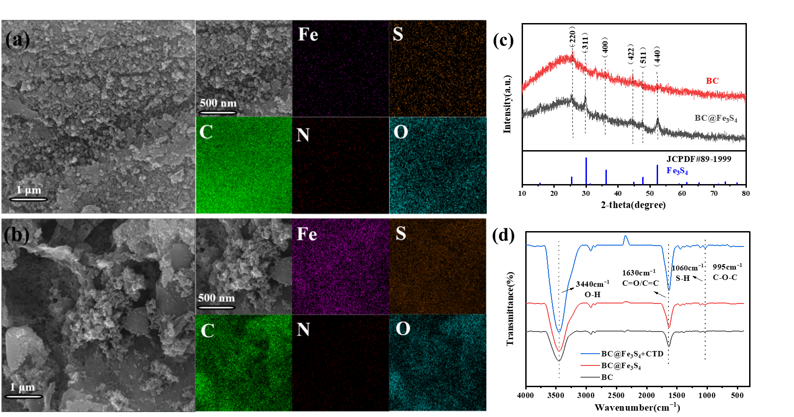
Fig.S1.SEM and EDS images of (a) BC and (b) BC@Fe₃S_{4,} (c) XRD spectra, (d) FT-IR of BC@Fe₃S_{4,} BC@Fe₃S₄+CTD and BC samples.

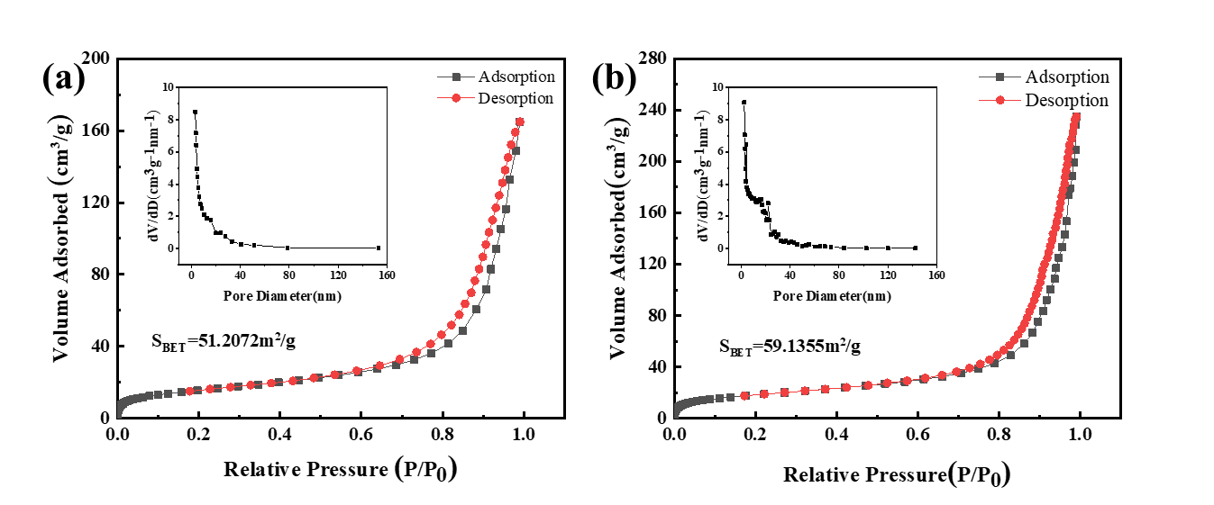
Fig.S2. BET of BC and BC@Fe₃S₄ samples (a-b).

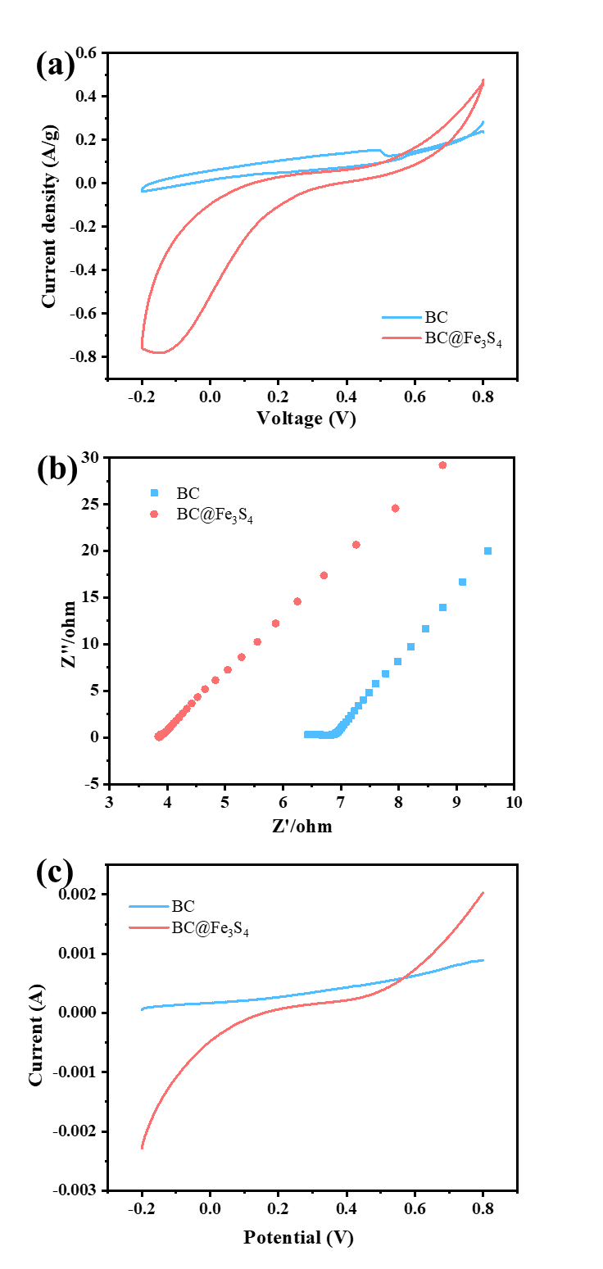
Fig.S3. Electrochemical performance analysis of BC and BC@Fe₃S₄: (a) CV curve, (b) EIS, (c) LSV curve.
Fig.S4. The TGA curves of BC and BC@Fe₃S₄ at: (a), the DTG curves of BC and BC@Fe₃S₄ at: (b).

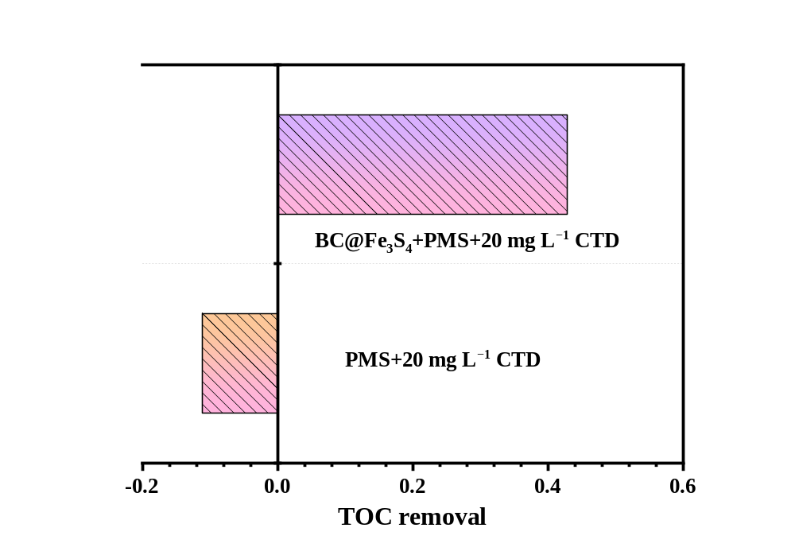
Fig.S5. TOC removal performance of BC@Fe₃S₄+PMS for CTD, Tests conditions: Equilibrium time = 3 h, aqueous volume = 50 mL, catalyst dosage = 0.08 g L⁻¹, [CTD] = 20 mg L⁻¹, [PMS] = 1.6 mM, pH = No adjustment, T = 298.15 K.

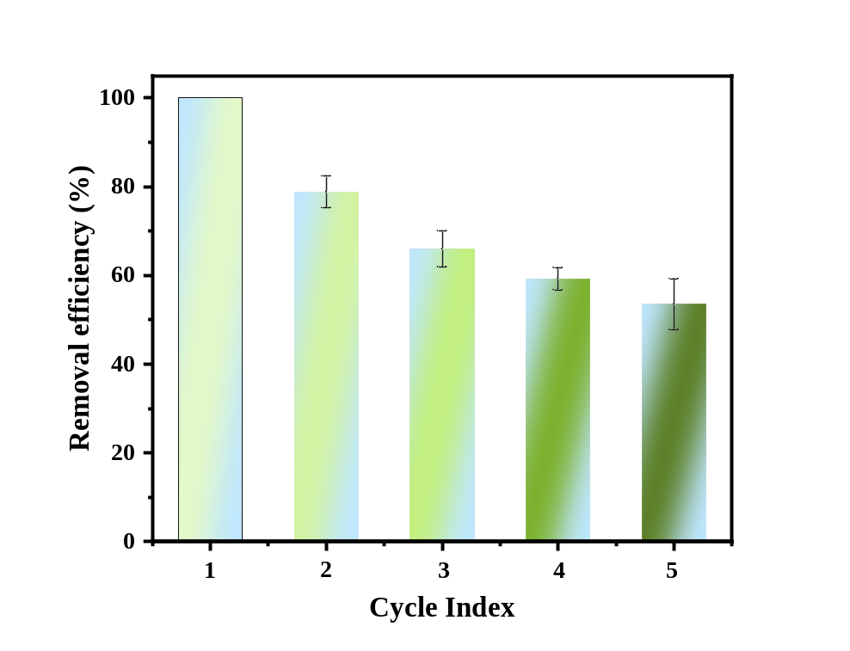
Fig.S6. The effect of BC@Fe₃S₄ repeated degradation of CTD within 5 times. Test environment: The experiment was conducted in ultra-pure water. The reaction equilibrium time is 3h. [CTD] = 5 mg L⁻¹, aqueous volume = 50 mL, catalyst dosage = 0.08 g L⁻¹, [PMS] =1.6 mM, pH = No adjustment, T = 298.15 K.

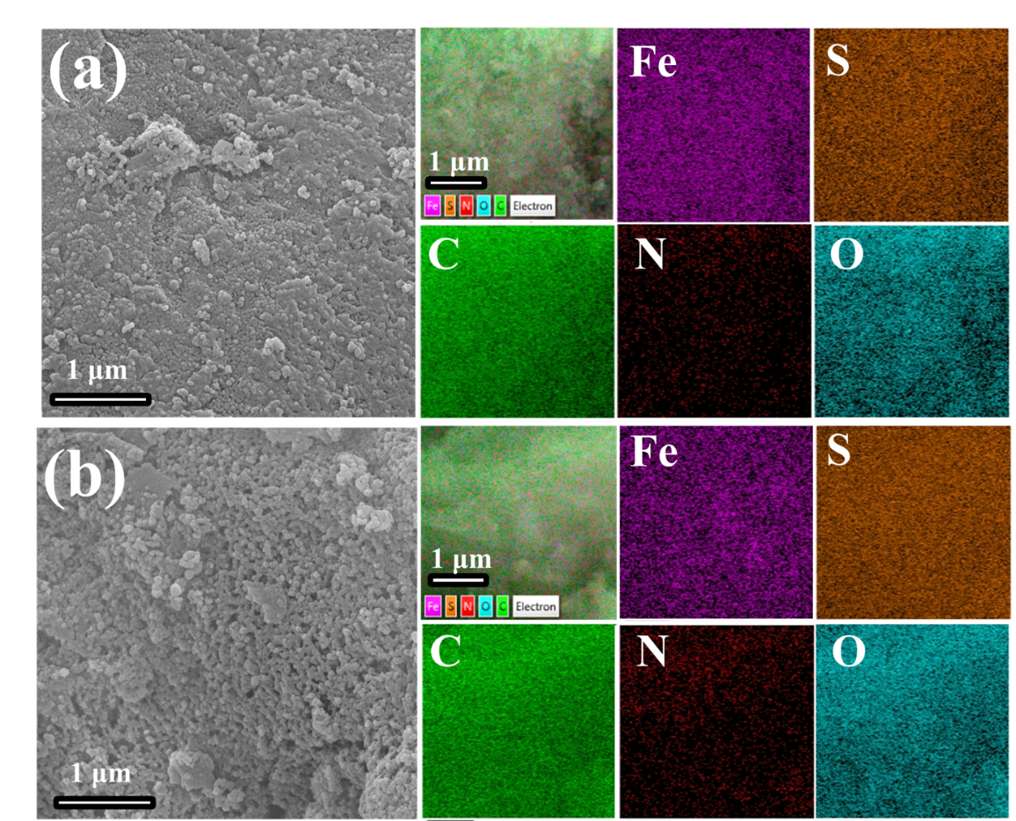
Fig.S7. SEM and EDS before and after BC@Fe₃S₄ degradation of CTD. (a) BC@Fe₃S₄, (b) BC@Fe₃S₄+PMS+CTD.

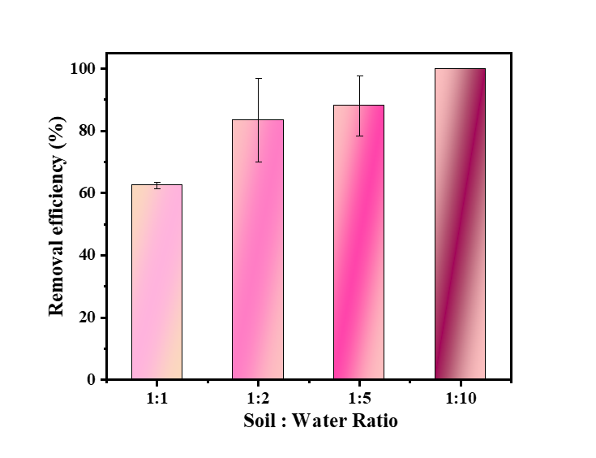
Fig.S8. Effect of BC@Fe₃S₄ on CTD degradation in polluted soils with different proportions of soil and water. Test environment: all the above experiments were carried out in CTD-contaminates the soil. The reaction equilibrium time is 3 h. [CTD] = 50 mg kg⁻¹, CTD-contaminates soil = 5.00 g, aqueous volume = 5, 10, 25, 50 mL, catalyst dosage = 0.8 g kg⁻¹, [PMS] = 1.6 mM, pH = No adjustment, T = 298.15 K.

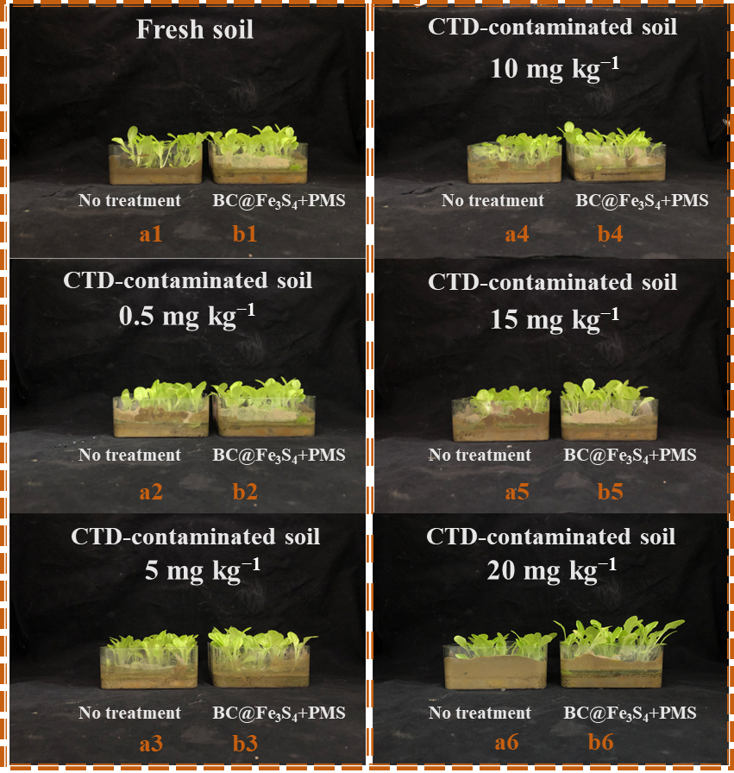
Fig.S9. High-definition photographs of growth morphology of lettuce on day 30th cultured under fresh soil (a1), fresh soil+BC@Fe₃S₄+PMS system (b1), CTD stress (a2-a6) and CTD+BC@Fe₃S₄+PMS system (b2-b6) detoxification.
Note: The CTD concentrations in a1-a6 treatment groups were 0, 0.5, 5, 10, 15, 20 mg kg⁻¹, respectively, and b1-b6 was treated by CTD+BC@Fe₃S₄+PMS system, corresponding to the initial CTD concentrations of 0, 0.5, 5, 10, 15, 20 mg kg⁻¹.

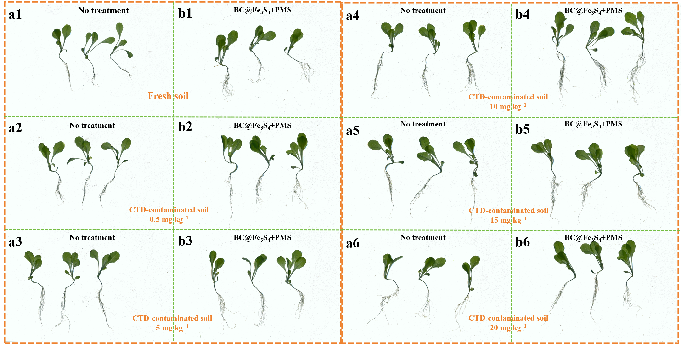
Fig.S10. Using a scanner to obtain high-definition photos of lettuce under different treatments. Underground and ground biomass morphology of lettuce seedlings cultured on the 30th day under fresh soil (a1), fresh soil+BC@Fe₃S₄+PMS system (b1), under CTD stress (a2-a6) and CTD+BC@Fe₃S₄+PMS system (b2-b6) detoxification treatment.
Note: The CTD concentrations in a1-a6 treatment groups were 0, 0.5, 5, 10, 15, 20 mg kg⁻¹, respectively, and b1-b6 was treated by CTD+BC@Fe₃S₄+PMS system, corresponding to the initial CTD concentrations of 0, 0.5, 5, 10, 15, 20 mg kg⁻¹.

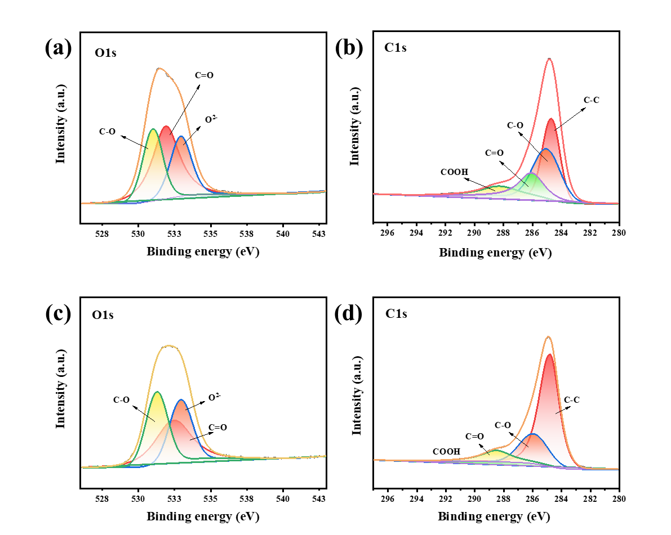
Fig.S11. XPS high-resolution O1s and C1s spectra of (a,b) BC@Fe₃S₄ (before the reaction), and (c, d) BC@Fe₃S₄+CTD+PMS (after the reaction).

Fig.S12. LC-MS/MS of CTD and its degradation products.

Table S1. Analysis of metal components in CTD-contaminated soil and healthy soil.
 | Leach (mg kg⁻¹) |  |  | Nitration (mg kg⁻¹)
 | Fe | Mn |  | Fe | Mn
CTD-contaminated soil | 2.9298 | 22.8259 |  | 5083.9300 | 934.7217
Healthy soil | 4.3292 | 2.4270 |  | 5002.4866 | 624.7233

Table S2. Analysis of nonmetallic components in CTD-contaminated soil and healthy soil.
 | Electric conductivity (μS/cm) | Organic carbon  (g kg⁻¹) | Organic matter | pH | Water content (%) | Dry weight (%)
CTD-contaminated soil | 73.5000 | 11.2928 | 19.4688 | 6.71 | 1.65 | 98.35
Healthy soil | 317.6667 | 11.4340 | 19.7122 | 5.70 | 1.00 | 99.00

Table S3. Specific surface area details of the BC, BC@Fe₃S₄.
Sample | S_{BET}  (m² g⁻¹) | BJH desorption cumulative specific surface area (d>2[nm])[m²/g] | Average pore radius size (nm) | BJH desorption mean pore radius (nm)
BC | 51.2072 | 76.4777 | 9.96 | 6.88
BC@Fe₃S₄ | 59.1355 | 84.9338 | 12.28 | 8.91

Table S4. Summary on the second-order reaction rates of MeOH, TBA, FFA, L-histidine, and p-BQ with different ROS.
Scavengers | Second-order reaction rate constants(M⁻¹·S⁻¹)(Bao et al., 2018; Liang et al., 2017; Qin et al., 2020; Wei et al., 2007; Zhao et al., 2020; Zhao et al., 2022; Zhou et al., 2021)
Scavengers | SO₄^{•−} | •OH | O₂^{•−} | ¹O₂
MeOH | (1.6-7.7) ×10⁷ | (1.2-2.8) ×10⁹ | - | -
TBA | (4.0-9.1) ×10⁵ | (3.8-7.6) ×10⁸ | <10³ | <10⁴
FFA | - | 1.5 × 10¹⁰ | - | 1.2 × 10⁸
L-histidine | - | - | - | 3.2 × 10⁸
p-BQ | 1.0 × 10⁸ | 1.2 × 10⁹ | (0.9-1.9) × 10⁹ | 6.6 × 10⁷

Table S5. T.E.S.T-QSAR evaluated the toxicity of CTD and its degradation intermediates to Fathead-minnow and T.pyriformis.
Symbol | Chemical Formula | T. pyriformis IGC₅₀ (48 hr) mg L⁻¹ | Fathead minnow LC₅₀ (96 hr)  mg L⁻¹ | m/z
CTD | C₆H₈ClN₅O₂S | 100.7 | 16 | 250
P1 | C₅H₇ClN₂O₄S | - | 131.45 | 228
P2 | C₅H₃ClN₂OS | 75.79 | 24.1 | 175
P3 | C₃H₃NO₂S | 495.71 | 80.86 | 118
P4 | C₂H₆N₄O₂ | 202.22 | 110 | 118
P5 | C₂H₇N₃ | 5843.69 | 116.83 | -
P6 | CH₄N₄O₂ | 584.77 | 62.04 | -
P7 | C₆H₉N₃O₂S | 1101.09 | 42.71 | 186
P8 | C₅H₇N₃O₂S | 834.35 | 194.45 | 172
P9 | C₃H₃NOS | 137.39 | 5.48 | 102
P10 | C₄H₆N₄O₃ | 585.63 | 99.1 | 158
P11 | C₃H₉N₃O | 893.47 | 516.37 | 103
P12 | C₂H₄O | 3372.77 | 36.99 | 43
P13 | C₂H₅NO | 12400.54 | 300.25 | 59

Reference:
Bao, Y., Lim, T.-T., Wang, R., Webster, R.D., Hu, X., 2018. Urea-assisted one-step synthesis of cobalt ferrite impregnated ceramic membrane for sulfamethoxazole degradation via peroxymonosulfate activation. Chemical Engineering Journal 343, 737-747. https://doi.org/10.1016/j.cej.2018.03.010.
de la Flor, M.P., Camarillo, R., Martínez, F., Jiménez, C., Quiles, R., Rincón, J., 2022. Synthesis and characterization of bimetallic TiO2/CNT/Pd-Cu for efficient remediation of endocrine disruptors under solar light. Journal of Environmental Chemical Engineering 10(2), 107245. https://doi.org/10.1016/j.jece.2022.107245.
Gao, W., Chen, Y., Rao, J., Hu, Z., Tan, Y., Wen, Y., Wang, Y., Zhou, Z., Zhu, Y., Zhou, N., 2022a. BCOFGs loaded with nano-FexSy for the catalytic degradation of QNC: Contribution and mechanism of OFGs for reductive iron regeneration. Journal of Hazardous Materials 440, 129741. https://doi.org/10.1016/j.jhazmat.2022.129741.
Gao, W., Tan, Y., Wu, B., Chen, Y., Hu, Z., Wang, Y., Wen, Y., Zhou, Z., Zhou, N., 2022b. Nano-Fe1−xS embedded BCAA/Fe3O4 as the stabilized catalyst for simultaneous quinclorac oxidation and Cr(VI) reduction. Separation and Purification Technology 297, 121422. https://doi.org/10.1016/j.seppur.2022.121422.
Li, H., Li, S., Jin, L., Lu, Z., Xiang, M., Wang, C., Wang, W., Zhang, J., Li, C., Xie, H., 2022. Activation of peroxymonosulfate by magnetic Fe3S4/biochar composites for the efficient degradation of 2,4,6-trichlorophenol: Synergistic effect and mechanism. Journal of Environmental Chemical Engineering 10(1), 107085. https://doi.org/10.1016/j.jece.2021.107085.
Liang, P., Zhang, C., Duan, X., Sun, H., Liu, S., Tade, M.O., Wang, S., 2017. An insight into metal organic framework derived N-doped graphene for the oxidative degradation of persistent contaminants: formation mechanism and generation of singlet oxygen from peroxymonosulfate. Environmental Science: Nano 4(2), 315-324. https://doi.org/10.1039/c6en00633g.
Manjuri Bhuyan, P., Borah, S., Kumar Bhuyan, B., Hazarika, S., Gogoi, N., Gogoi, A., Gogoi, P., 2023. Fe3S4/biochar catalysed heterogeneous Fenton oxidation of organic contaminants: Hydrogen peroxide activation and biochar enhanced reduction of Fe (III) to Fe (II). Separation and Purification Technology 312, 123387. https://doi.org/10.1016/j.seppur.2023.123387.
Qin, F., Peng, Y., Song, G., Fang, Q., Wang, R., Zhang, C., Zeng, G., Huang, D., Lai, C., Zhou, Y., Tan, X., Cheng, M., Liu, S., 2020. Degradation of sulfamethazine by biochar-supported bimetallic oxide/persulfate system in natural water: Performance and reaction mechanism. J Hazard Mater 398, 122816. https://doi.org/10.1016/j.jhazmat.2020.122816.
Song, P., Zhu, L., Bo, X., Wang, A., Wang, G., Guo, L., 2014. Pt nanoparticles incorporated into phosphorus-doped ordered mesoporous carbons: enhanced catalytic activity for methanol electrooxidation. Electrochimica Acta 127, 307-314. https://doi.org/10.1016/j.electacta.2014.02.068.
Wei, C., Song, B., Yuan, J., Feng, Z., Jia, G., Li, C., 2007. Luminescence and Raman spectroscopic studies on the damage of tryptophan, histidine and carnosine by singlet oxygen. Journal of Photochemistry and Photobiology A: Chemistry 189(1), 39-45. https://doi.org/10.1016/j.jphotochem.2007.01.005.
Ye, S., Zeng, G., Tan, X., Wu, H., Liang, J., Song, B., Tang, N., Zhang, P., Yang, Y., Chen, Q., Li, X., 2020. Nitrogen-doped biochar fiber with graphitization from Boehmeria nivea for promoted peroxymonosulfate activation and non-radical degradation pathways with enhancing electron transfer. Applied Catalysis B: Environmental 269. https://doi.org/10.1016/j.apcatb.2020.118850.
Zhao, Y., Song, M., Cao, Q., Sun, P., Chen, Y., Meng, F., 2020. The superoxide radicals' production via persulfate activated with CuFe2O4@Biochar composites to promote the redox pairs cycling for efficient degradation of o-nitrochlorobenzene in soil. J Hazard Mater 400, 122887. https://doi.org/10.1016/j.jhazmat.2020.122887.
Zhao, Y., Yu, L., Song, C., Chen, Z., Meng, F., Song, M., 2022. Selective Degradation of Electron-Rich Organic Pollutants Induced by CuO@Biochar: The Key Role of Outer-Sphere Interaction and Singlet Oxygen. Environ Sci Technol 56(15), 10710-10720. https://doi.org/10.1021/acs.est.2c01759.
Zhou, X., Luo, H., Sheng, B., Chen, X., Wang, Y., Chen, Q., Zhou, J., 2021. Cu(2+)/Cu(+) cycle promoted PMS decomposition with the assistance of Mo for the degradation of organic pollutant. J Hazard Mater 411, 125050. https://doi.org/10.1016/j.jhazmat.2021.125050.

