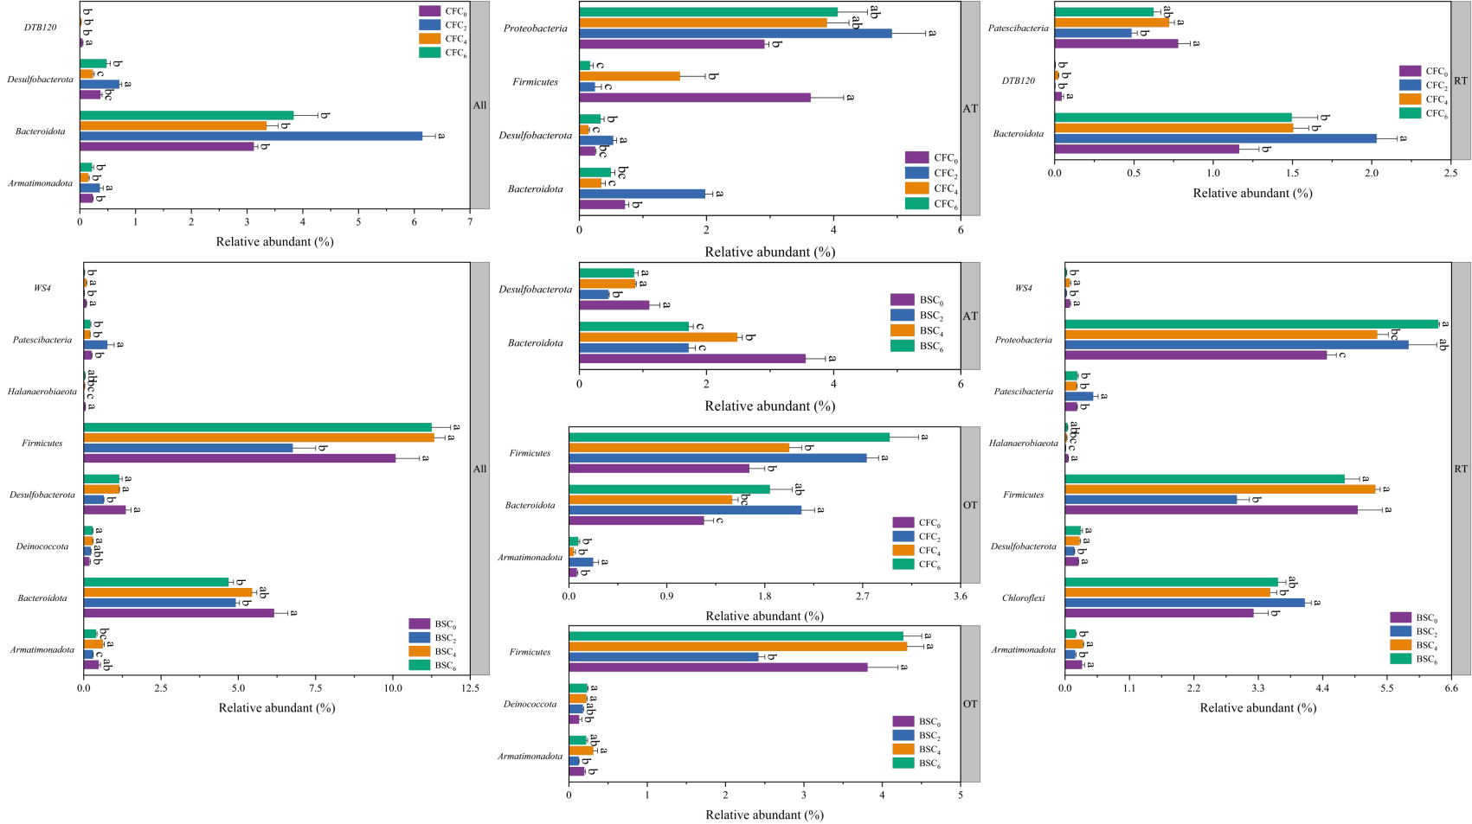
Fig.S1 Bacteria phylum with significant difference in biochar on each bacterial sub-communities under the same WFS.

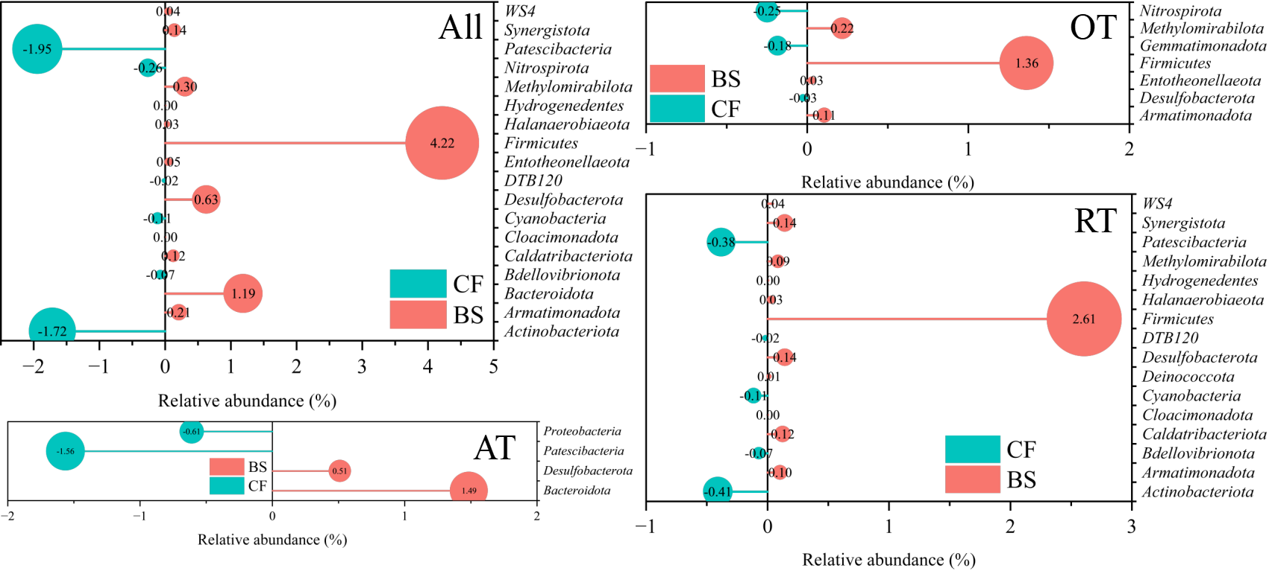
Fig. S2 The bacterial phylum with significant differences in each sub-bacterial community under the WFS, in which red and green represent the bacterial phylum significantly improved under the BSS and the CFS, respectively. The data size is the adjustment of the relative abundance of bacterial phylum by the BSS relative to the CFS.

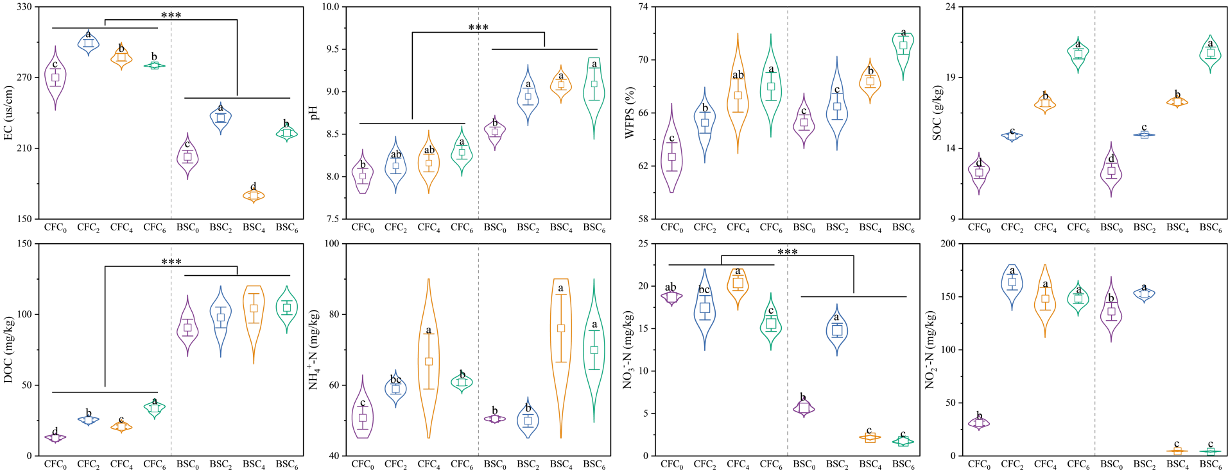
Fig. S3 Effects of different biochar echelons on soil EC, pH, WFPS, SOC, DOC, NH₄⁺-N, NO₃⁻-N and NO₂⁻-N under the same WFS.

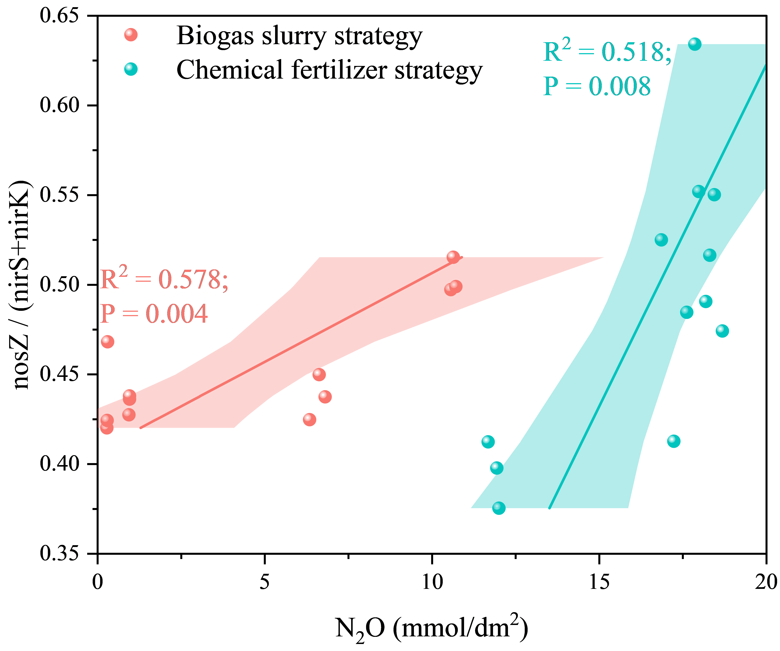
Fig. S4 Relationship between N₂O emission and nosZ / (nirS + nirK) under two WFS.

