Sustainable woody biochar application for improving net ecosystem carbon budget, yield and soil properties in red pepper cropping systems: A two-year field study
Sohee Yoon ª, Yeomyeong Lee ª, Hyerin An ª, Jasmin Melendez ª, Sang Yoon Kim ^{a,b *}

Supplementary information

Table S1 Total C of red pepper biomass under the different WB application levels for two years
Year | Treatment | Total C (g kg⁻¹)
(A) | (B) | Shoot | Fruit |  |  |  | Root
 |  | Shoot | 1st | 2nd | 3rd | 4th | Root
1st year | NPK+WB0 | 40.6^{1)a} | 42.9^{b} | 43.1^{ab} | 44.3ª | 45.0ª | 40.0ª
1st year | NPK+WB2.5 | 40.5ª | 43.4^{ab} | 43.7ª | 43.8^{b} | 44.8ª | 41.6ª
1st year | NPK+WB5 | 42.8ª | 43.7ª | 43.9ª | 43.8^{ab} | 44.9ª | 38.4ª
1st year | NPK+WB10 | 40.4ª | 43.8ª | 40.2^{b} | 44.2^{ab} | 44.8ª | 40.1ª
2nd year | NPK+WB0 | 39.7ª | 44.8^{b} | 44.9ª | 43.9ª | 45.6ª | 40.6ª
2nd year | NPK+WB2.5 | 39.7ª | 45.6ª | 43.8^{b} | 43.7ª | 44.9^{b} | 41.9ª
2nd year | NPK+WB5 | 39.5ª | 45.7ª | 44.1^{ab} | 43.8ª | 44.9^{b} | 41.0ª
2nd year | NPK+WB10 | 39.6ª | 44.7^{b} | 43.7^{b} | 44.0ª | 44.4^{b} | 41.6ª
Statistical analysis
A²⁾ |  | ³⁾* | *** | * | ns | ns | *
B |  | ns | *** | * | ns | *** | ns
A×B |  | ns | ns | ns | ns | ns | ns
Note) ¹⁾ Different letters indicate significant differences between the treatments (at p < 0.05, Tukey’s test). The same letter means there are no significant differences between the treatments. ²⁾ A and B denote year and treatment in 2 way ANOVA analysis. ³⁾ ns denotes not significant, and *, **, and *** denote significant differences at levels of p < 0.05, 0.01, and 0.001 respectively

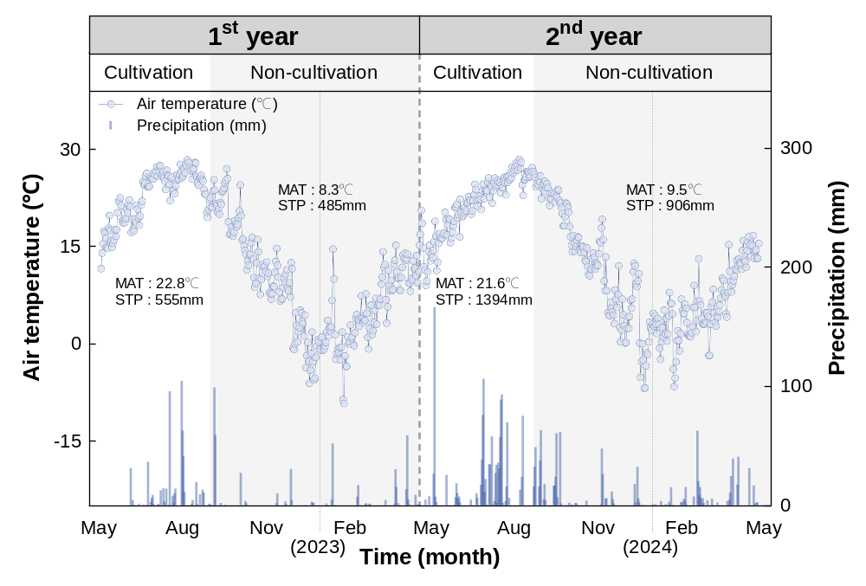
Fig. S1 Changes in air temperature and precipitation during the experiment period (MAT: Mean air temperature; STP: Seasonal total precipitation)

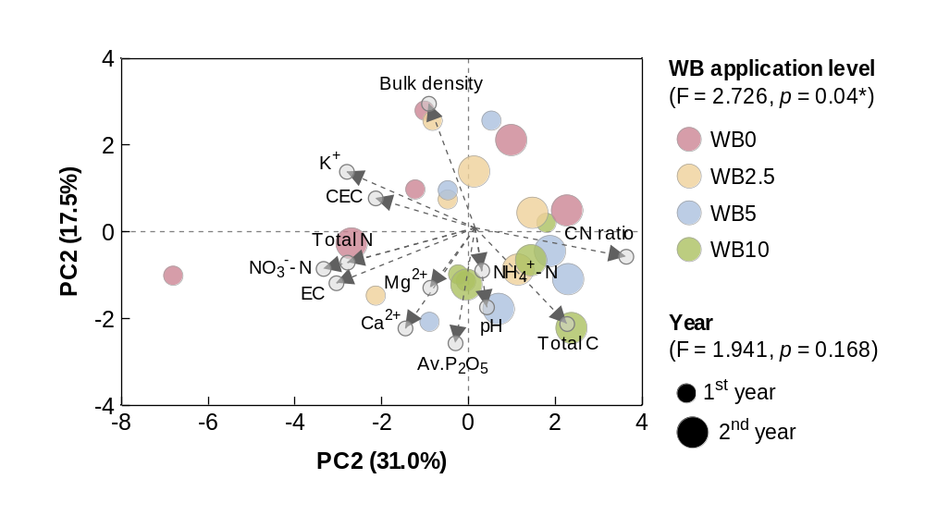
Fig. S2 Principal component analysis (PCA) of physicochemical properties under different WB application levels and red pepper cultivation years. Soil properties explained 31.0% and 17.5% of the total variability in the first and second principal components (PC1 and PC2) respectively. Permutational multivariate analysis of variance (PERMANOVA) was performed by using the "adonis" function of the package VEGAN in the R (http://cran.r-project.org)
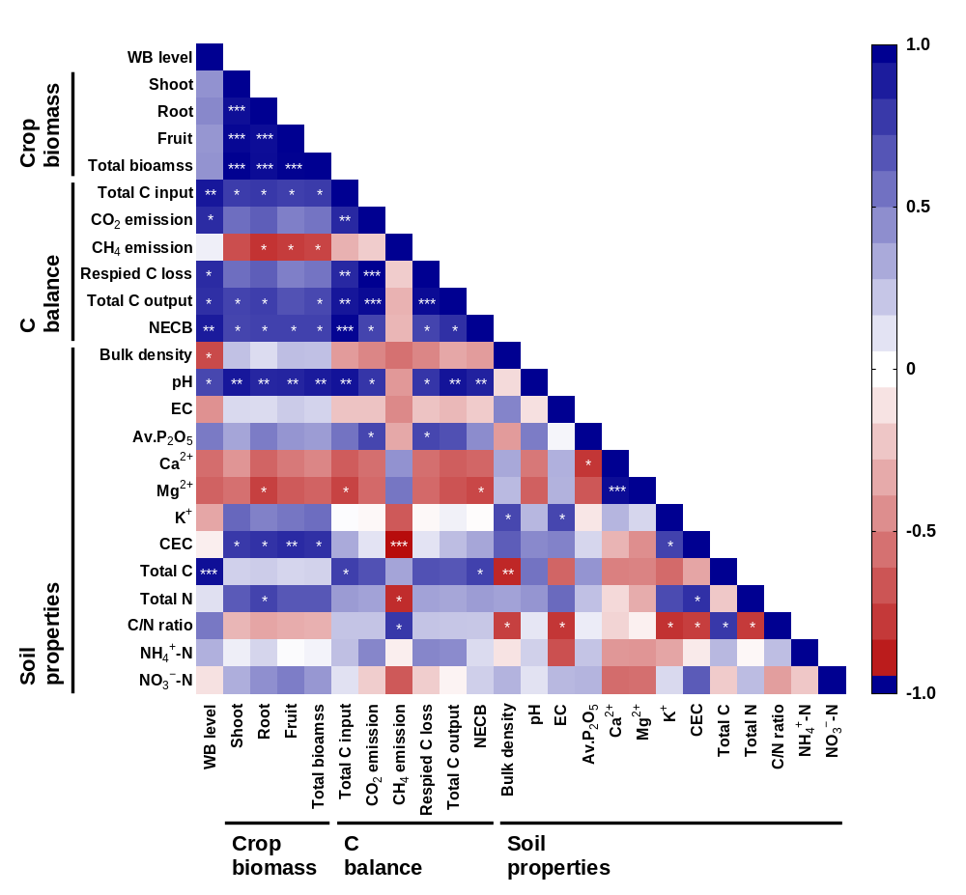
Fig. S3 Correlation between WB application level, red pepper biomass productivity, NECB parameters and soil physicochemical properties in red pepper cultivation soil

