Supplementary materials
2. Materials and methods
2.1. Materials
Row material The obtained residues were firstly washed with deionized water for three times to remove superficial impurities (mainly residual ashes), and then oven-dried (105℃) for 24 h before carbonization. Detailed characteristics of biogas residue (BR) are shown in Table S1.
Table S1 The properties of amendments, control and amended soils
Sample | TOC (g kg⁻¹) | TN (g kg⁻¹) | C/N | SSA (m² g⁻¹) | pH | VM (%)
BR | 418.2 | 17.8 | 23.5 | 15.8 | 4.7 | 65.6
BR: biogas residue; TOC: total organic carbon; TN: total nitrogen; SSA: specific surface area; VM: volatile matter
Row biochar preparation The oven-dried BR samples were placed inside capped porcelain crucibles and loaded into a muffle furnace (KSL-1200X, Kejing Materials Tec., China) under N₂ (99.999%) saturated atmosphere (0.5 dm³ min⁻¹ of flowing rate). The final furnace temperature was set at 600°C, respectively, with heating rate and final residence time of 5 °C min⁻¹ and 60 min, respectively. Subsequently, after the reactor temperature cooled to below 100°C, the biochar sample was collected. The biochars were crushed using a ceramic mortar and pestle, filtered through a 2 mm sieve.
2.4 Influencing factors of ammonia nitrogen adsorption
The pH value of NH₄⁺-N solution The 0.4 g of biochar and its modified biochar were weighed in turn and placed in a 50 mL centrifuge tube, and 100 mg L⁻¹ NH₄⁺ solution was 40 mL, the pH value was adjusted to 4.0 to 10.0, sealed at 25°C 140 rpm shaking for 120 h, centrifugation at 1400 rpm for 10 mins, filtered by 0.45 μm filter membrane. Other experimental conditions and calculation methods were consistent with those described in Section 2.3.
Competitive ions in the adsorption solution In a 100 mg L⁻¹ NH₄⁺-N solution, 100 mg L⁻¹ solutions of K⁺, Na⁺, Ca²⁺, and Mg²⁺ were prepared using KCl, NaCl, CaCl₂, and MgCl₂ reagents, respectively. Subsequently, 40 mL of each of the aforementioned solutions was mixed with 0.4 g of biochar derived from anaerobic digestate in a 50 mL centrifuge tube. The pH of the mixture was adjusted to 7.0, and the tubes were sealed and subjected to shaking at 25°C for 120 h at 140 rpm. After shaking, the samples were centrifuged at 1400 rpm for 10 min and filtered through a 0.45 μm filter membrane. Other experimental conditions and calculation methods were consistent with those described in Section 2.3.
The initial NH₄⁺-N concentration in the adsorption solution In 50 mL centrifuge tubes, 40 mL of NH₄⁺ solutions with concentrations of 5, 10, 20, 50, 100, and 150 mg L⁻¹ were added, along with 0.4 g of biochar. The pH of each mixture was adjusted to 7.0, and the tubes were sealed and subjected to shaking at 25°C for 120 h at 140 rpm. After shaking, the samples were centrifuged at 1400 rpm for 10 min and filtered through a 0.45 μm filter membrane. The determination of absorbance and the calculation of NH₄⁺-N adsorption were performed as described in Section 2.4.
3. Results and discussion
3.2 Factors affecting NH₄⁺-N Adsorption
The pH of the adsorption solution The pH of the solution significantly influences the surface charge distribution of biochar. As shown in Figure S1, the NH₄⁺-N adsorption capacity of both unmodified and modified biochars rapidly increased with the pH value in the range of 4 to 7. The maximum adsorption capacities were observed at pH = 7 for RB, RB-KMnO₄, and RB-NaOH, with values of 20.92 mg g⁻¹, 27.68 mg g⁻¹, and 35.10 mg g⁻¹, respectively. In contrast, the maximum adsorption capacity of RB-H₂O₂ was achieved at pH = 8, with a value of 22.56 mg g⁻¹. This phenomenon can be attributed to the competition between H⁺ and NH₄⁺ for active adsorption sites on the surface of biochar under acidic conditions. As the concentration of H⁺ in the solution decreases, competitive adsorption weakens, resulting in poorer adsorption performance of biochar for NH₄⁺-N at low pH values. Additionally, acidic conditions are unfavorable for the dissociation of surface functional groups on biochar (Mukherjee et al., 2011), reducing the number of active sites available for adsorption and thereby decreasing the chemical adsorption capacity of biochar.
It was also found that the adsorption capacity of unmodified biochar, which primarily relies on physical adsorption, was less affected by solution pH. When the pH value exceeded 8, the adsorption capacity of both unmodified and modified biochars began to decline. This decline is likely due to the fact that under alkaline conditions, NH₄⁺ predominantly exists as NH₃·H₂O (Kasera et al., 2022), and the proportion of NH₃·H₂O increases while that of NH₄⁺ decreases with rising pH. Since NH₃·H₂O is uncharged and has weaker electrostatic interactions, the physical adsorption capacity of biochar decreases. Simultaneously, the binding efficiency between the functional groups on the biochar surface and NH₄⁺ is reduced, leading to a decrease in the chemical adsorption capacity of biochar (Nayak et al., 2024).
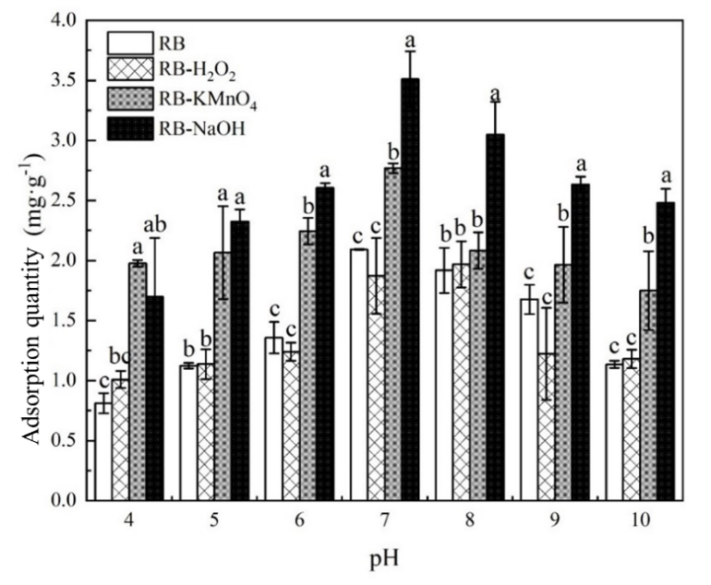
Figure S1 Effect of solution pH on NH₄⁺-N adsorption by modified biochars. The lowercase letters marked on the columns in the figure indicate the significance of differences among different biochars at the same pH. Columns sharing the same letter indicate no significant difference (P > 0.05), while those without the same letter indicate significant differences (P < 0.05).

Influence of competitive ions on NH₄⁺-N adsorption The impact of competitive ions on the NH₄⁺-N adsorption performance of biochar before and after modification was shown in Figure S2. The presence of Na⁺, K⁺, Ca²⁺, and Mg²⁺ in the solution all led to a reduction in the NH₄⁺-N adsorption capacity of biochar derived from anaerobic digestate. Notably, the adsorption capacities of RB-KMnO₄ and RB-NaOH were most significantly affected by Ca²⁺ and Mg²⁺. Specifically, the NH₄⁺-N adsorption capacities decreased from 2.65 mg g⁻¹ (RB-KMnO₄ control) and 2.79 mg g⁻¹ (RB-NaOH control) to 1.38 mg g⁻¹ (RB-KMnO4 with Ca²⁺), 1.32 mg g⁻¹ (RB-KMnO₄ with Mg²⁺), 1.26 mg g⁻¹ (RB-NaOH with Ca²⁺), and 1.08 mg g⁻¹ (RB-NaOH with Mg²⁺). These values correspond to 52.02% (RB-KMnO₄ with Ca²⁺), 49.66% (RB-KMnO₄ with Mg²⁺), 45.28% (RB-NaOH with Ca²⁺), and 38.51% (RB-NaOH with Mg²⁺) of the NH₄⁺-N adsorption capacities of the respective control groups.
This reduction is likely due to the competitive adsorption between metal cations and NH₄⁺. As the concentration of metal cations in the solution increases, these cations enter the adsorption layer, reducing the negative charge on the biochar surface and compressing the electrical double layer. Consequently, the adsorption capacity of biochar for NH₄⁺-N decreases (Huang et al., 2024). Additionally, compared to monovalent cations, divalent cations are more likely to bind to the adsorption sites on the biochar surface. Moreover, multivalent ions typically occupy more adsorption sites, making the impact of divalent cations on the NH₄⁺-N adsorption capacity of biochar more pronounced (Karthik et al., 2020). Overall, the presence of competitive metal cations significantly diminished the NH₄⁺-N adsorption capacity of both unmodified and modified biochar derived from anaerobic digestate.
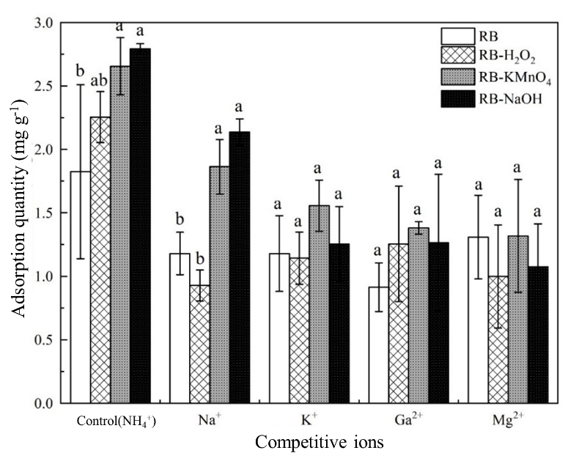
Figure S2 Influence of competitive ions on NH₄⁺-N Adsorption by modified biochars. The lowercase letters marked on the columns in the figure indicate the significance of differences among different biochars under the same solution conditions. Columns sharing the same letter indicate no significant difference (P > 0.05), while those without the same letter indicate significant differences (P < 0.05).

Effect of initial NH₄⁺-N concentration on the adsorption Figure S3 illustrated the impact of initial NH₄⁺-N concentration on the adsorption of NH₄⁺-N by unmodified and modified biochar derived from anaerobic digestate. The results showed that the adsorption capacity of biochar for NH₄⁺-N gradually increased with the rise in initial NH₄⁺-N concentration. In solutions with higher NH₄⁺-N concentrations (> 20 mg L⁻¹), the modified biochar exhibited superior adsorption performance compared to the unmodified biochar. The higher the initial NH₄⁺-N concentration, the greater the difference in adsorption capacity between the modified and unmodified biochar, particularly for RB-KMnO₄. In a 150 mg L⁻¹ NH₄⁺-N solution, the NH₄⁺-N adsorption capacities of RB-H₂O₂, RB-KMnO₄, and RB-NaOH were 5.79 mg g⁻¹, 7.74 mg g⁻¹, and 6.24 mg g⁻¹, respectively, which were 2.99, 3.99, and 3.21 times higher than that of RB (1.94 mg g⁻¹). This enhancement in adsorption capacity is likely due to the increased number of NH₄⁺ ions available for interaction with the biochar surface active sites as the NH₄⁺-N concentration increases, while the biochar dosage remains constant. Consequently, the adsorption capacity of NH₄⁺-N per unit surface area of biochar increases (Chen et al., 2024).
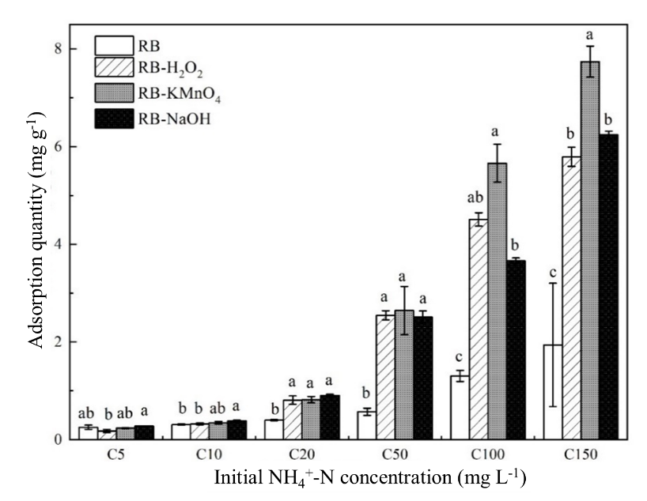
Figure S3 Effect of initial NH₄⁺-N concentration on NH₄⁺-N Adsorption by modified biochars. The lowercase letters marked on the columns in the figure indicate the significance of differences among different biochars at the same initial NH₄⁺-N concentration. Columns sharing the same letter indicate no significant difference (P > 0.05), while those without the same letter indicate significant differences (P < 0.05).

References
Chen Z, Jiang X, Boyjoo Y, Zhang L, Li W, Zhao L, Liu Y, Zhang Y, Liu J, Li X (2024) Nanoporous Carbon Materials Derived from Biomass Precursors: Sustainable Materials for Energy Conversion and Storage. Electrochemical Energy Reviews 7(1). https://doi.org/10.1007/s41918-024-00223-y
Huang F, Dong F, Chen L, Zeng Y, Zhou L, Sun S, Wang Z, Lai J, Fang L (2024) Biochar-mediated remediation of uranium-contaminated soils: evidence, mechanisms, and perspectives. Biochar 6(1). https://doi.org/10.1007/s42773-024-00308-3
Karthik V, Kumar PS, Vo DVN, Sindhu J, Sneka D, Subhashini B, Saravanan K, Jeyanthi J (2020) Hydrothermal production of algal biochar for environmental and fertilizer applications: a review. Environmental Chemistry Letters 19(2): 1025–1042. https://doi.org/10.1007/s10311-020-01139-x
Kasera N, Kolar P, Hall SG (2022) Nitrogen-doped biochars as adsorbents for mitigation of heavy metals and organics from water: a review. Biochar 4(1). https://doi.org/10.1007/s42773-022-00145-2
Mukherjee A, Zimmerman AR, Harris W (2011) Surface chemistry variations among a series of laboratory-produced biochars. Geoderma 163(3–4): 247–255. https://doi.org/10.1016/j.geoderma.2011.04.021
Nayak P, Nandipamu TMK, Chaturvedi S, Dhyani VC, Chandra S (2024) Synthesis, Properties, and Mechanistic Release-Kinetics Modeling of Biochar-Based Slow-Release Nitrogen Fertilizers and Their Field Efficacy. Journal of Soil Science and Plant Nutrition 24(4): 7460–7479. https://doi.org/10.1007/s42729-024-02052-w

