Machine learning–aided design of La-based composite modified biochar: Efficient materials and cost optimization for low-phosphorus water treatment
Weilin Fuª, Xia Yao^{a,c}, Xueyan Zhangª, Tian Yuanª, Shiyu Lvª, Yi An^{a,*}, Feng Wang^{a,b}
ª Agro-Environmental Protection Institute, Ministry of Agriculture and Rural Affairs, Tianjin 300191, China.
^{b} College of Resources and Environment, Xinjiang Agricultural University, Urumqi 830052, China.
^{c} Institute of Ecological and Environmental Sciences, Sichuan Agricultural University, Chengdu 611130, China.

List of contents
Text S1 Detailed description of data collection
Text S2 Model interpretability methods
Text S3 Material preparation and adsorption experiment
Fig. S1 Histogram of input numerical features before and after Yeo–Johnson transformation.
Table S1 List of literature information about data in all dataset.
Table S2 Cost statistics and calculation methods of raw materials required for material preparation.
Table S3 Data distribution and statistical analysis of input features.
Table S4 The parameter space, optimization objective, and best parameters for Bayesian optimization of the RF, GBR, and XGB models.

Text S1 Detailed description of data collection
Text S1.1 Feature selection
Feature selection is a critical prerequisite for building robust machine learning models. All features in this study were selected based on the physicochemical mechanisms underlying the adsorbent preparation and adsorption processes, aiming to comprehensively cover the key controllable factors that determine the phosphate adsorption performance of La-based biochars. The ten features finally included in the model can be divided into two major categories:
Adsorbent Synthesis Parameters
Biomass type (B): Determines the initial pore structure and surface functional groups of the biochar, representing the source of the material.
Pyrolysis temperature (T) and pyrolysis time (t): Jointly regulate the carbonization degree, specific surface area, and pore structure of the biochar, serving as core process parameters that influence the fundamental physicochemical properties of the adsorbent.
Composite metal type (M): Different doped metals exhibit synergistic effects with La, significantly affecting the affinity and selectivity for phosphate by altering the surface charge, forming specific oxide/hydroxide precipitates, etc.
Metal loading method (LM): The specific technique used to load metals onto the biochar directly affects the distribution morphology, particle size, and binding strength between the metals and the carbon matrix, thereby influencing the accessibility of active sites.
Total metal loading capacity (TLC): Directly determines the number of active sites on the adsorbent surface and is a dominant factor controlling the maximum adsorption capacity.
Metal loading ratio (LR): Reflects the relative proportion of La in the composite metal. A higher LR enhances the capture capacity for phosphate due to an increased number of specific complexation sites provided by La³⁺.
Adsorption Conditions
Initial phosphate concentration (C₀): Represents the initial driving force of the adsorption process and is a key external factor influencing adsorption equilibrium and capacity.
Dosage (WV): Determines the ratio of adsorbent mass to pollutant mass, which is an essential operational parameter for controlling treatment efficiency and cost in practical applications.
Solution pH: Affects the speciation of phosphate, the surface zeta potential of the adsorbent, and the stability of metal active sites, making it a critical condition governing both adsorbate and adsorbent surface charge.
These features were included in the dataset for the following reasons: (1) They have been extensively demonstrated in previous experimental studies and theoretical analyses as dominant factors influencing adsorption performance; (2) They possess clear physical interpretations, facilitating mechanism understanding and guiding practical material design; (3) Within the compiled dataset of this study, these features are completely reported and exhibit sufficient variability for the model to learn both their individual effects and interaction effects.
Text S1.2 Data missing and unit conversion
No missing values were found in the final dataset compiled for this study. All 240 collected data entries completely contain the full set of features and label values required for model training. For certain features that were missing in some of the literature, if the missing rate was high and reliable imputation was not feasible, the corresponding data were excluded from the final dataset. All numerical values extracted from the literature underwent rigorous unit standardization and were converted to the International System of Units (SI). Specifically, the total metal loading content was uniformly expressed in mmol/g, following the conversion rules below:
If the original data were provided in mass units (mg/g or wt%), TLC (mmol/g) = [metal mass loading (mg/g)] / [atomic weight of the metal (g/mol)]. For weight percentage (wt%), it was first converted to mg/g before applying the above formula. If the original data were already in molar units (mmol/g), the values were directly adopted. For composite metal systems, the total metal loading content was calculated as the sum of the molar quantities of all loaded metals. If only the dosage of metal salt precursors was provided in the literature, the final molar amount of metal loaded onto the biochar was estimated based on the described stoichiometric relationships. Data with unclear loading amounts or that could not be reliably converted were excluded from the final dataset to ensure the quality of the training data.

Text S2 Model interpretability methods
Within the interpretability framework adopted in this study, feature importance analysis methods can be categorized into model-intrinsic methods and post-hoc methods. Model-intrinsic methods directly assess feature importance based on the internal structure of the model. Among these, Embedded Feature Importance (EFI) is an inherent global metric for tree-based models, which quantifies the importance of a feature by calculating the total reduction in impurity it brings during node splitting. Permutation Feature Importance (PFI), on the other hand, evaluates the contribution of a feature by randomly shuffling its values and observing the resulting decline in model performance, also offering a global perspective (Azodi et al., 2020).
As a post-hoc interpretation method, SHAP (SHapley Additive exPlanations) is grounded in the concept of Shapley values from cooperative game theory. Its core strength lies in its ability to provide both global feature importance and local, instance-level explanations. SHAP values allocate the prediction outcome using Equation (S1):
$ϕ_{i}​=\sum_{S⊆F∖\{i\}}{\frac{\left|S\right|!(\left|F\right|-\left|S\right|-1)!}{\left|F\right|!}​}​[f(S∪\{i\})-f(S)]$ (S1)
where F denotes the complete set of features, S represents a subset excluding feature i, and f(S) denotes the model output using the feature subset S.
Unlike EFI and PFI, SHAP quantifies the influence of a feature by systematically perturbing the input and observing changes in the output, rigorously satisfying the fairness axiom from game theory. To further dissect the heterogeneity in feature effects, this study supplements the analysis with Individual Conditional Expectation (ICE) curves. ICE curves visualize the prediction response of individual instances by varying a target feature while keeping all other features fixed. This method effectively reveals interaction effects between features and individual differences in model predictions, serving as a valuable visual complement to local interpretation methods like SHAP.

Text S3 Material preparation and adsorption experiment
Corn straw was placed in a muffle furnace and pyrolyzed at 540 °C for 1.9 h with a heating rate of 5 °C/min. After cooling to room temperature, the resulting material was ground, passed through a 60-mesh nylon sieve, washed with deionized water, and dried at 105 °C for 6 h to obtain biochar BC₁. Then, 1.5844 g of LaCl₃·7H₂O and 1.4511 g of FeCl₃·6H₂O were separately dissolved in 100 mL of deionized water. Subsequently, 5 g of BC₁ was added to the mixed solution under continuous stirring. An excess amount of NaOH solution was slowly introduced, and the mixture was magnetically stirred at room temperature for 12 h. The resulting product was washed three times with deionized water and dried at 105 °C to obtain La/FeBC.
Corn straw was pyrolyzed at 692 °C for 2.9 h under the same heating rate and post-treatment conditions to produce BC₂. Then, 5.7508 g of LaCl₃·7H₂O and 3.1389 g of anhydrous CaCl₂ were dissolved in 100 mL of deionized water. The solution was added to 5 g of BC₂ under stirring, and the mixture was magnetically stirred at room temperature for 24 h. After standing, the solid was washed three times with deionized water and dried at 105 °C to obtain La/CaBC₁.
Cypress sawdust was pyrolyzed at 773 °C for 2.5 h under identical heating and processing conditions to obtain BC₃. Then, 0.6675 g of LaCl₃·7H₂O and 0.2573 g of anhydrous CaCl₂ were separately dissolved in 100 mL of deionized water. The solution was introduced to 5 g of BC₃ with continuous mixing. An excess amount of NaOH solution was slowly added, and the mixture was magnetically stirred at room temperature for 12 h. The final product was washed three times with deionized water and dried at 105 °C to obtain La/CaBC₂.
For the adsorption experiments, 13.5 mg of La/FeBC, 7.0 mg of La/CaBC₁, and 20.0 mg of La/CaBC₂ were separately weighed into 100 mL conical flasks. Each flask received 50 mL of a KH₂PO₄ solution with initial phosphorus concentrations of 10 mg/L, 5 mg/L, and 24 mg/L, respectively. The pH of each solution was adjusted to 5.05, 3.37, and 3.58 using HCl or NaOH solutions. The flasks were then placed in a thermostatic shaker at 25 ± 0.5 °C and 180 rpm for 24 h. After reaction, the solutions were filtered through a 0.22 μm membrane filter, and the residual phosphorus concentration was determined using the ammonium molybdate spectrophotometric method at a wavelength of 700 nm. All experiments were performed in triplicate.

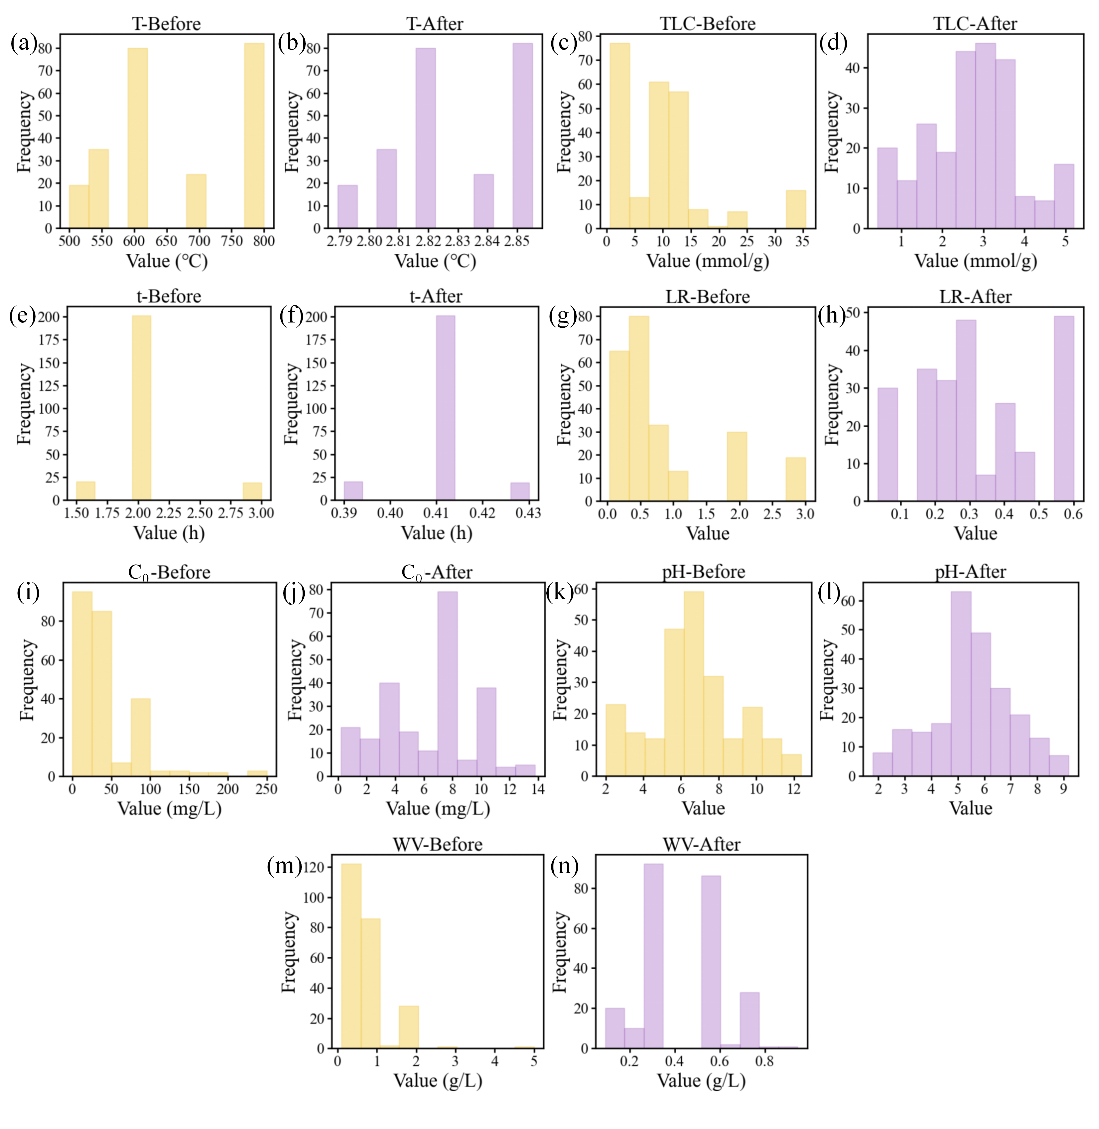
Fig. S1 Histogram of input numerical features before and after Yeo–Johnson transformation.

Table S1 List of literature information about data in all dataset.
Number | Title | DOI
1 | Lanthanum ferrite nanoparticles modification onto biochar: Derivation from four different methods and high performance for phosphate adsorption | 10.1007/s11356-019-04553-z
2 | Development of rare earth element doped magnetic biochars with enhanced phosphate adsorption performance | 10.1016/j.colsurfa.2018.10.082
3 | One-pot hydrothermal synthesis of NaLa(CO₃)₂ decorated magnetic biochar for eﬃcient phosphate removal from water: Kinetics, isotherms, thermodynamics, mechanisms and reusability exploration | 10.1016/j.cej.2020.124915
4 | Performance and mechanism of a biochar-based Ca-La composite for the adsorption of phosphate from water | 10.1016/j.jece.2021.105267
5 | Enhanced phosphate scavenging with effective recovery by magnetic porous biochar supported La(OH)₃: Kinetics, isotherms, mechanisms and applications for water and real wastewater | 10.1016/j.biortech.2020.124232
6 | Formable porous biochar loaded with La-Fe(hydr)oxides/montmorillonite for efficient removal of phosphorus in wastewater: Process and mechanisms | 10.1007/s42773-022-00177-8
7 | Lanthanum carbonate hydroxide/magnetite nanoparticles functionalized porous biochar for phosphate adsorption and recovery: Advanced capacity and mechanisms study | 10.1016/j.envres.2022.113783
8 | Efficient removal of phosphate from aqueous media using magnetic bimetallic lanthanum-iron-modified sulfonylmethylated lignin biochar | 10.1016/j.ijbiomac.2023.125809
9 | Optimized Ca-Al-La modiﬁed biochar with rapid and eﬃcient phosphate removal performance and excellent pH stability | 10.1016/j.arabjc.2023.104880
10 | Magnetic biochar with Mg/La modification for highly effective phosphate adsorption and its potential application as an algaecide and fertilizer | 10.1016/j.envres.2023.116252
11 | Rapid and eﬃcient removal of phosphate by La-doped layered double hydroxide/biochar from aqueous solution | 10.1039/d3nj05213c
12 | Lanthanum/iron co-modified biochar for highly efficient adsorption of low-concentration phosphate from aqueous solution | 10.1016/j.jece.2024.111876
Table S2 Cost statistics and calculation methods of raw materials required for material preparation.
Cost statistics | Raw material |  | Unit price ($) | Price reference source
Cost statistics | LaCl₃·7H₂O |  | 2.7571/kg | https://b2b.baidu.com/
Cost statistics | FeCl₃·6H₂O |  | 0.2757/kg | https://b2b.baidu.com/
Cost statistics | CaCl₂ |  | 0.2068/kg | https://b2b.baidu.com/
Cost statistics | NaOH |  | 0.1379/kg | https://b2b.baidu.com/
Cost statistics | General industrial and commercial electricity consumption |  | 0.1144/KWh | The electricity price table for agency power purchase of State Grid Tianjin Electric Power Company in February 2025
Cost calculation |  | Cost types ($) | Calculation method
 |  | Metal reagents | The amount of metal reagent required for preparing each kilogram of biochar (kg)× the unit price of metal reagent
 |  | Other reagents | Dipping：0；coprecipitation：0.1379$ (Calculated in excess NaOH)
 |  | Electricity consumption | Pyrolysis temperature /100 (approximately equal to power) × pyrolysis time × unit price of electricity
 |  | Unit quality cost | Unit price of metal reagents + other reagents + electricity consumption
 |  | Per ton cost | Unit quality cost ($/kg)×dosage (kg/t)
 |  | Whole-lake cost | Per ton cost ($/t)×pondage (t)

Table S3 Data distribution and statistical analysis of input features.
Feature | Min | Max | Mean±SD | 25% | 50% | 75% | Mean±SD (Transformed)
T (℃) | 500.00 | 800.00 | 663.13±109.03 | 600.00 | 600.00 | 800.00 | 2.82±0.02
t (h) | 1.50 | 3.00 | 2.04±0.31 | 2.00 | 2.00 | 2.00 | 0.41±0.01
TLC (mmol/g) | 0.50 | 35.51 | 10.07±8.66 | 4.00 | 8.00 | 13.09 | 2.69±1.22
LR | 0.04 | 3.00 | 0.81±0.86 | 0.27 | 0.40 | 1.00 | 0.31±0.16
C₀ (mg/L) | 0.19 | 250.00 | 47.73±44.84 | 10.00 | 50.00 | 50.64 | 6.20±3.05
WV (g/L) | 0.10 | 5.00 | 0.84±0.61 | 0.50 | 0.50 | 1.00 | 0.43±0.17
pH | 2.00 | 12.39 | 6.85±2.33 | 6.00 | 6.91 | 8.00 | 5.41±1.65
C_{e} (mg/L) | 0.00 | 99.35 | 19.79±24.65 | 0.830 | 7.89 | 30.94 | /

Table S4 The parameter space, optimization objective, and best parameters for Bayesian optimization of the RF, GBR, and XGB models.
Parameters | Parameter space |  |  | Best parameter
Parameters | RF | GBR | XGB | RF | GBR | XGB
n_estimators | 50-200 | 50-200 | 50-200 | 72 | 149 | 85
max_depth | 1-20 | 1-20 | 1-20 | 12 | 14 | 17
min_samples_leaf | 2-40 | 2-40 | / | 2 | 6 | /
min_samples_split | 1-20 | 1-20 | / | 4 | 32 | /
learning_rate | / | 0.01-1 | 0.01-1 | / | 0.55 | 0.24
subsample | / | / | 0.5-1 | / | / | 0.72
optimal object—R² | >0.95 | >0.95 | >0.95 | / | / | /

References
Azodi, C.B., Tang, J., Shiu, S.-H., 2020. Opening the black box: interpretable machine learning for geneticists. Trends Genet. 36, 442–455. https://doi.org/10.1016/j.tig.2020.03.005

Corresponding author E-mail address: simon8601@126.com (Y. An); wangfeng_530@163.com (F. Wang).

