Supplementary Information for
Coffee grounds derived porous nitrogen-rich biochar as a metal-free catalyst for efficient selective oxidation of hydrogen sulfide to sulfur
Fei Zhao^{§a}, Zibin Pan^{§a}, Fang Wangª, Suo Cuiª, Rui Caoª, Jiayu Feng*ª, Ping Ning*^{b}, Lijuan Jia*ª
School of Chemistry and Environment, Yunnan Minzu University, Kunming, Yunnan 650504, PR China.
^{b}Faculty of Environmental Science and Engineering, Kunming University of Science and Technology, Kunming, Yunnan 650500, PR China.
§ These authors contributed equally to this work (joint first authors)
*Email: FJY_DX3906@163.com (Jiayu Feng)
*Email: ningping86@163.com (Ping Ning)
*Email: leegyerkm@163.com (Lijuan Jia)
Submitted to
Biochar
Number of Pages:32
Number of appendices:4
Several figures:16
Several tables:8

Table of contnets

Appendix S1: Reaction gas cylinders, raw materials, and preparation process of catalysts 3

Appendix S2: Characterization methods 5

Appendix S3: Selectivity catalytic oxidation process of H₂S. 7

Appendix S4: DFT theoretical computational methods 8

Supplementary Figures 9
Figure S1. Reaction flow diagram for the use of CGNrC-T for H₂S-SCO. 9
Figure S2. (a, b) SEM images of CGNrC-500 and (c) elemental mapping images of CGNrC-500. (d, e) SEM images of CGNrC-900 and (f) elemental mapping images of CGNrC-900. 10
Figure S3. The energy spectrum of CGNrC-500 (a) and CGNrC-900 (b), respectively. 11
Figure S4. Pore size distribution of as-prepared samples. 12
Figure S5. The XPS survey spectra of all the samples. 13
Figure S6. Systematically illustrates the different types of C and O species. a. C 1s and b. O 1s XPS spectra. 14
Figure S7. Antioxidant performance test. Reaction conditions: T=180 ℃, O₂/H₂S=8, WHSV=60000 mL/h/g. 15
Figure S8. a, b. show H₂S conversion and sulfur selectivity of CGNrC-700 at different WHSV (T=180 ℃, O₂/H₂S=0.5). 16
Figure S9. Depicts catalytic activity of CGNrC-700 at high H₂S concentrations (0.5 vol%), reaction condition: WHSV=30000 mL/h/g, T=180 ℃, O₂/H₂S=0.5). 17
Figure S10. The EDS energy spectrum of CGNrC-700-S. 18
Figure S11. a, b. showed the SEM images of the CGNrC-700-S catalyst. 19
Figure S12. FT-IR spectra of fresh and spent catalysts. 20
Figure S13. The pore size distributions of CGNrC-700-S and CGNrC-700-R. 21
Figure S14. Optimized structural model for CGNrC-700 catalysts. 22
Figure S15. Frontier orbital distribution of CGNrC-700. 23
Figure S16. Structural optimization of CGNrC-700 for H₂S and O₂ adsorption using B3LYP/6-31G 24

Supplementary Tables 25
Table S1. CCG-700 and CGNrC-T defect structures and defect density. 25
Table S2. Porosity parameters of catalysts obtained from BET analysis. 26
Table S3. C 1s high-resolution XPS spectra of all samples. 27
Table S4. O 1s high-resolution XPS spectra of all samples. 28
Table S5. Element content and atomic content of C, N, and O, and the ratio of O and N to C for all samples. 29
Table S6. N species content from XPS analysis of all samples. The atomic percentage of (a)pyridine-N, (b) pyrrole-N, (c) graphite-N, and (d) oxidized-N. 30
Table S7. Different carbon catalysts are used in the selective oxidation of H₂S to S. 31
Table S8. S2p high-resolution XPS spectra of fresh and deactivated catalysts. 32

Reference 33

Appendix S1: Reaction gas cylinders, raw materials, and preparation process of catalysts
Reaction gas cylinders
Experimental gas: Hydrogen sulfide (2% H₂S/N₂) was purchased from Dalian Specialty Gas Co. Ltd., and oxygen (1% O₂/N₂), nitrogen (99.99 vol%), and sulfur dioxide (99.99 vol%) were purchased from Kunming Guangruida Specialty Gas Co. Ltd.
Raw materials of catalysts
Coffee grounds from a cafe in Kunming, Yunnan Province. Potassium hydroxide (AR, 99%) and Melamine cyanurate (AR, 99%) were purchased from Shanghai Macklin Biochemical Co. Ltd. and used directly without further purification.
Preparation process of catalysts
The dried coffee grounds of 8.0 g were weighed and placed in a reactor liner containing 40 mL of deionized water and hydrothermally reacted at 180 °C for 12 h. The obtained hydrothermally carbonized coffee grounds (HCG) were dried in an oven at 105 °C for 12 h to reduce the volatile, water-soluble impurities (e.g., alkaloids and carbons) in the coffee grounds, lower the ash content, and leach out some of the metal salts to reduce the interference of these impurities on the physicochemical properties of the target materials. The dried carbonized coffee grounds were added to a beaker with MCA and KOH in a certain ratio (HCG: MCA: KOH=1:2:1/2), then 40 mL of distilled water followed by ultrasonic impregnation for 1h. The obtained mixed slurry was dried in an oven at 105 °C for 12 h. The dried mixture of 6 g was taken and placed in a tube furnace under the atmosphere of N₂ and heated at a heating rate of 10 °C/min to the design temperature for 2 h of pyrolysis, the black solids obtained were washed repeatedly with deionized water until neutral, and then dried, broken and sieved. Collecting the 40-60 mesh product CGNrC-T (T=500, 700, 900 °C). Similarly, the carbon material obtained by pyrolysis HCG without activation treatment at 700 °C for 2 h was named CGC-700.

Appendix S2: Characterization methods
The surface morphology and elemental composition of the samples were investigated using a ZEISS Sigma 360 scanning electron microscope (SEM) and energy dispersive X-ray spectroscopy (EDS). The microstructure of the catalysts was observed on a transmission electron microscope (TEM, JEM-2100). The X-ray diffraction (XRD) patterns were performed in a Bruker Advance D8 ADVANCE A25X diffractometer with Cu Kα radiation (λ=1.5406 Å, 40 kV, 40 mA) in the scanning range of 10-80°(2θ) at a scanning rate of 1°/min. Raman spectroscopy was characterized by Thermo Fisher Scientific in a Via Raman microscope (excitation wavelength of 532 nm and power of 5 mW). Fourier transform infrared (FT-IR) spectra were collected on a 670 FT-IR spectrophotometer (Thermo Nicolet, USA; 600-4000 cm⁻¹). The surface area and pore size distribution were determined using the Brunauer-Emmett-Teller (BET) method and the BJH model. N₂ adsorption-desorption isotherms were performed on a model Quantachrome Autosorb IQ BET analyzer, USA, and all samples were degassed at 150℃ for 12 h before the measurement. X-ray photoelectron spectroscopy (XPS) was analyzed by an aluminum-containing spectrometer equipped with an Al Kα X-ray source (hν = 1486.6 eV) (Thermo Scientific K-Alpha, USA). The CO₂ temperature-programmed desorption (CO₂-TPD) experiment was performed on a BelCata II instrument manufactured by Micro. During the experiment. Firstly, 0.1 g of catalyst (40-60 mesh) was purged with high-purity helium gas at 250 ℃ for 1 h to remove the impurity gas adsorbed in the catalyst. The impurity gas is adsorbed on the surface of the sample. After cooling to room temperature, the catalyst was purged with high-purity CO₂ for 1 h. Next, it is purged with high-purity helium at 30 ℃. Next, it is purged with high-purity helium for 30 minutes to remove the physically adsorbed CO₂. Finally, the catalyst is heated to the desired temperature at a rate of 10 °C/min, and the gas composition signal is recorded and analyzed. The gas composition signal is recorded and analyzed by TCD. The O₂ temperature-programmed desorption (O₂-TPD). The O₂ temperature-programmed desorption (O₂-TPD). Thermogravimetric (TG-DTG) analysis was determined using a STA Instrument 44gF3 thermogravimetric analyzer. The samples were heated to 1000 °C at a heating rate of 10 °C/min in an N₂ flow rate of 10 mL/min.

Appendix S3: Selectivity catalytic oxidation process of H₂S.
The catalysts, with a mesh size of 40-60, were placed in quartz reaction tubes with an inner diameter of 6 mm and subsequently positioned in a fixed-bed reactor where thermocouples controlled the temperature. The catalyst was purged with N₂ for 30 minutes before the reaction to remove possible impurities. The total flow rate of the feed gas (containing 0.1 vol.% H₂S, 0.05 vol.% O_{2,} and balance N₂) was controlled at 100 mL/min by a mass flow meter. The reaction temperature is controlled by a thermocouple with a range of 60 to 210 °C. Hydrogen sulfide (H₂S) concentrations at the inlet and outlet are measured using a fixed hydrogen sulfide detector (DR70C-H₂S). The possible presence of the product sulfur dioxide (SO₂) in the tail gas is detected utilizing a stationary SO₂ detector, thus calculating the sulfur selectivity, and this tail gas is treated with KMnO₄ (0.25 mol/L) solution and NaOH (0.5 mol/L) solution, and then discharged. The point at which the outlet concentration of H₂S reaches 100 ppm is defined as the breakthrough time. A condenser was installed at the reactor outlet to trap gaseous sulfur before venting.
Furthermore, calculated H₂S conversion (X_{H2S}), sulfur selectivity (S_{S}), and sulfur yield (Y_{S}) according to the following equations (1)-(3).
$${\text{X}}_{{\text{H}}_{\text{2}}\text{S}}\text{(\%)=}\frac{\text{[}{\text{H}}_{\text{2}}\text{S}{\text{]}}_{\text{in}}\text{-}\text{[}{\text{H}}_{\text{2}}\text{S}{\text{]}}_{\text{out}}}{\text{[}{\text{H}}_{\text{2}}\text{S}{\text{]}}_{\text{in}}}\text{×100\% } \text{ (1)}$$
$${\text{S}}_{\text{S}}\text{(\%)=}\frac{\text{[}{\text{H}}_{\text{2}}\text{S}{\text{]}}_{\text{in}}\text{-}\text{[}{\text{H}}_{\text{2}}\text{S}{\text{]}}_{\text{out}}\text{-}\text{[S}{\text{O}}_{\text{2}}{\text{]}}_{\text{out}}}{\text{[}{\text{H}}_{\text{2}}\text{S}{\text{]}}_{\text{in}}\text{-}\text{[}{\text{H}}_{\text{2}}\text{S}{\text{]}}_{\text{out}}}\text{×100\% } \text{(2) }$$
${\text{Y}}_{\text{S}}\text{=}{\text{X}}_{{\text{H}}_{\text{2}}\text{S}}{\text{S}}_{\text{S}} \text{ (3)}$
Where [H₂S]_{in} and [H₂S]_{out} denote the concentrations of H₂S in the inlet gas and outlet gas (ppm), respectively. And [SO₂]_{out} is the outlet concentration of SO₂ (ppm).

Appendix S4: DFT theoretical computational methods
All density functional theory calculations (DFT) involved in this paper were performed using Gaussian 16.0 and Gaussian View software, and all molecular structures were optimized using the B3LYP method. A model of monolayer graphene containing defects and nitrogen doping was constructed using monolayer graphene (001) with all atoms fully relaxed. To prevent periodic interaction, a vacuum space of 18 Å was included in the orthogonal orientation. Convergence criteria for structure selection were set to ensure that the maximum force on each atom was less than 0.02 eV/Å and its energy variation was less than 10⁻⁵ eV. Subsequently, the electrostatic surface potential (ESP) of the nitrogen-enriched carbon material was calculated, the difference between the lowest unoccupied molecular orbital (LUMO) and the highest occupied molecular orbital (HOMO) is known as the energy gap (E_{g}), and the adsorption energies (E_{ads}) of H₂S and O₂ were evaluated according to the following equations:${\text{E}}_{\text{ads}}\text{=}{\text{E}}_{\text{slab+A}}\text{-}{\text{E}}_{\text{slab}}\text{-}{\text{E}}_{\text{A}}\text{ (4)}$
$${\text{E}}_{\text{g}}\text{=}{\text{E}}_{\left(\text{LUMO}\right)}\text{-}{\text{E}}_{\left(\text{HOMO}\right)}\text{ (5)}$$
Where E_{slab+A}, E_{slab}, and E_{A} are the total energy after adsorption of the molecules, the energy of the pure N-doped biomass carbon slab, and the total energy of the isolated H₂S or O₂ molecules, respectively.

Supplementary Figures
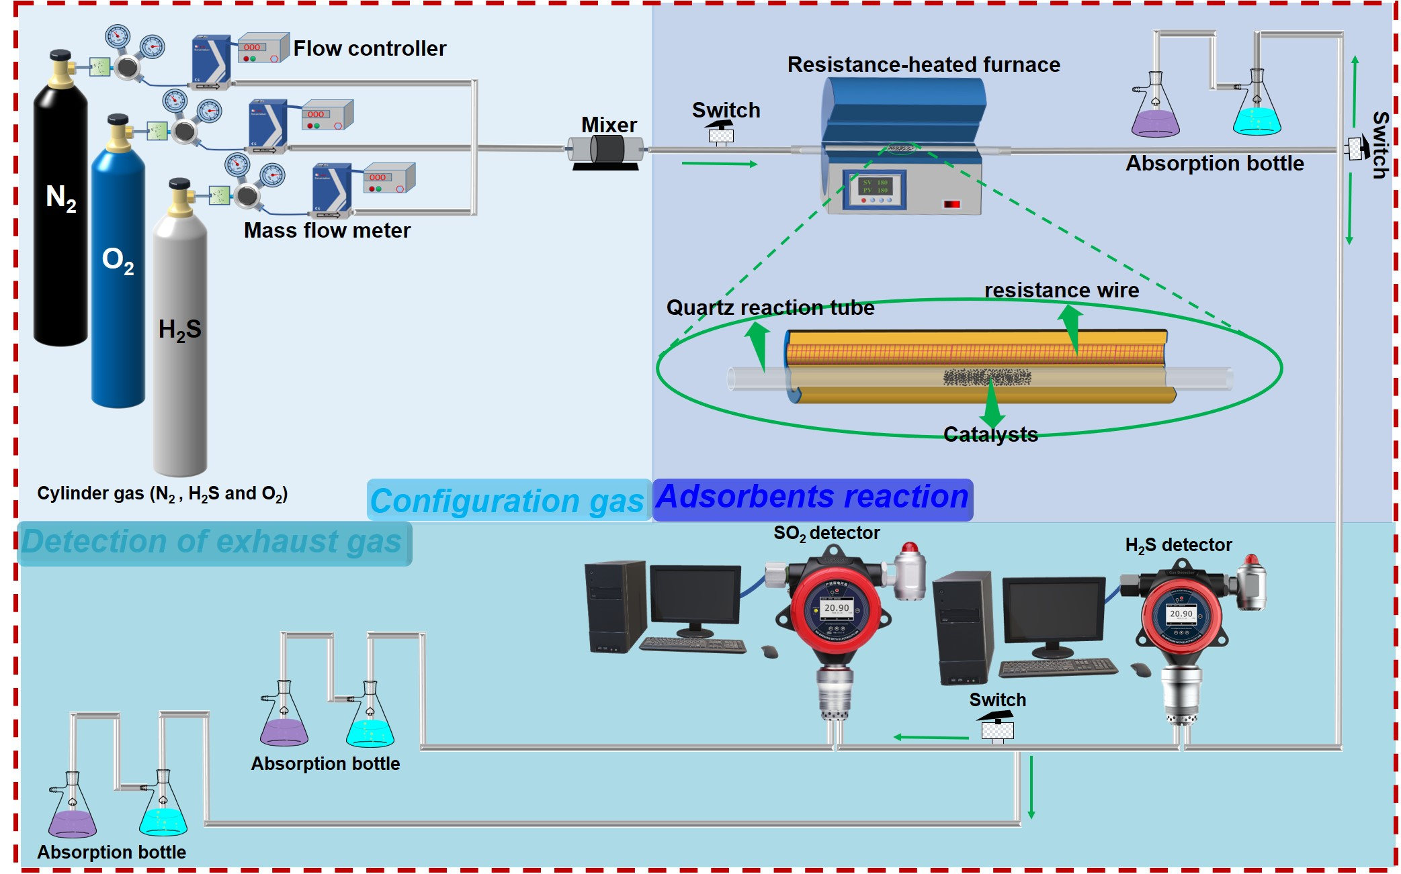

Figure S1. Reaction flow diagram for the use of CGNrC-T for H₂S-SCO.
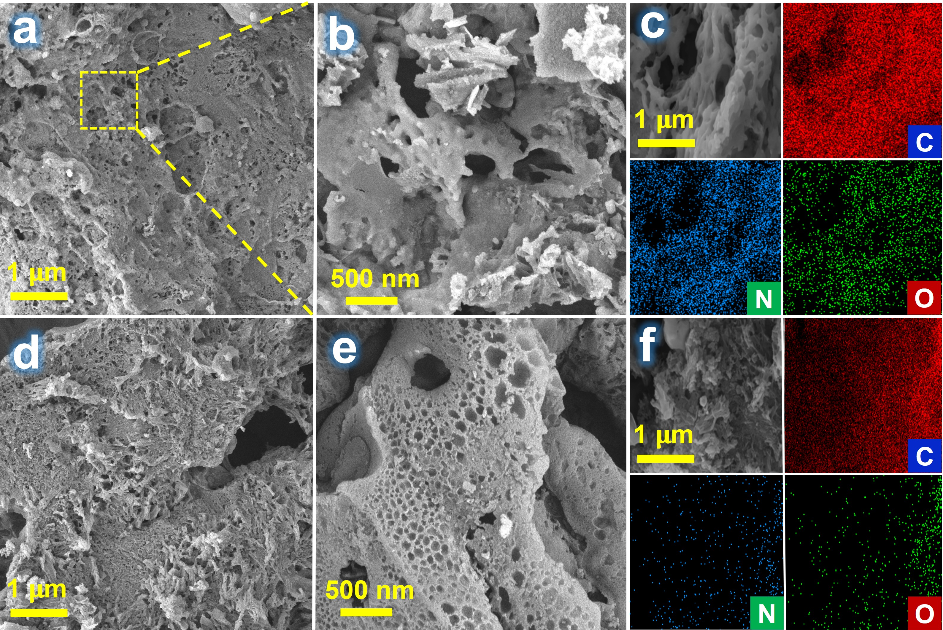

Figure S2. a, b. SEM images of CGNrC-500 and c. elemental mapping images of CGNrC-500. d, e. SEM images of CGNrC-900 and f. elemental mapping images of CGNrC-900.
The SEM images of the samples obtained after the pyrolysis of the materials treated with the same activation method at different reaction temperatures still show large differences; the pyrolysis temperature significantly affects the structure of carbon materials.
During the temperature increase from 500 to 900 °C, only a few micropores were observed to form in the carbon matrix at 500 °C due to the lower temperature without fully utilizing the etching effect of KOH, and as the temperature increased to 900 °C, highly developed hierarchical pore formation occurred.
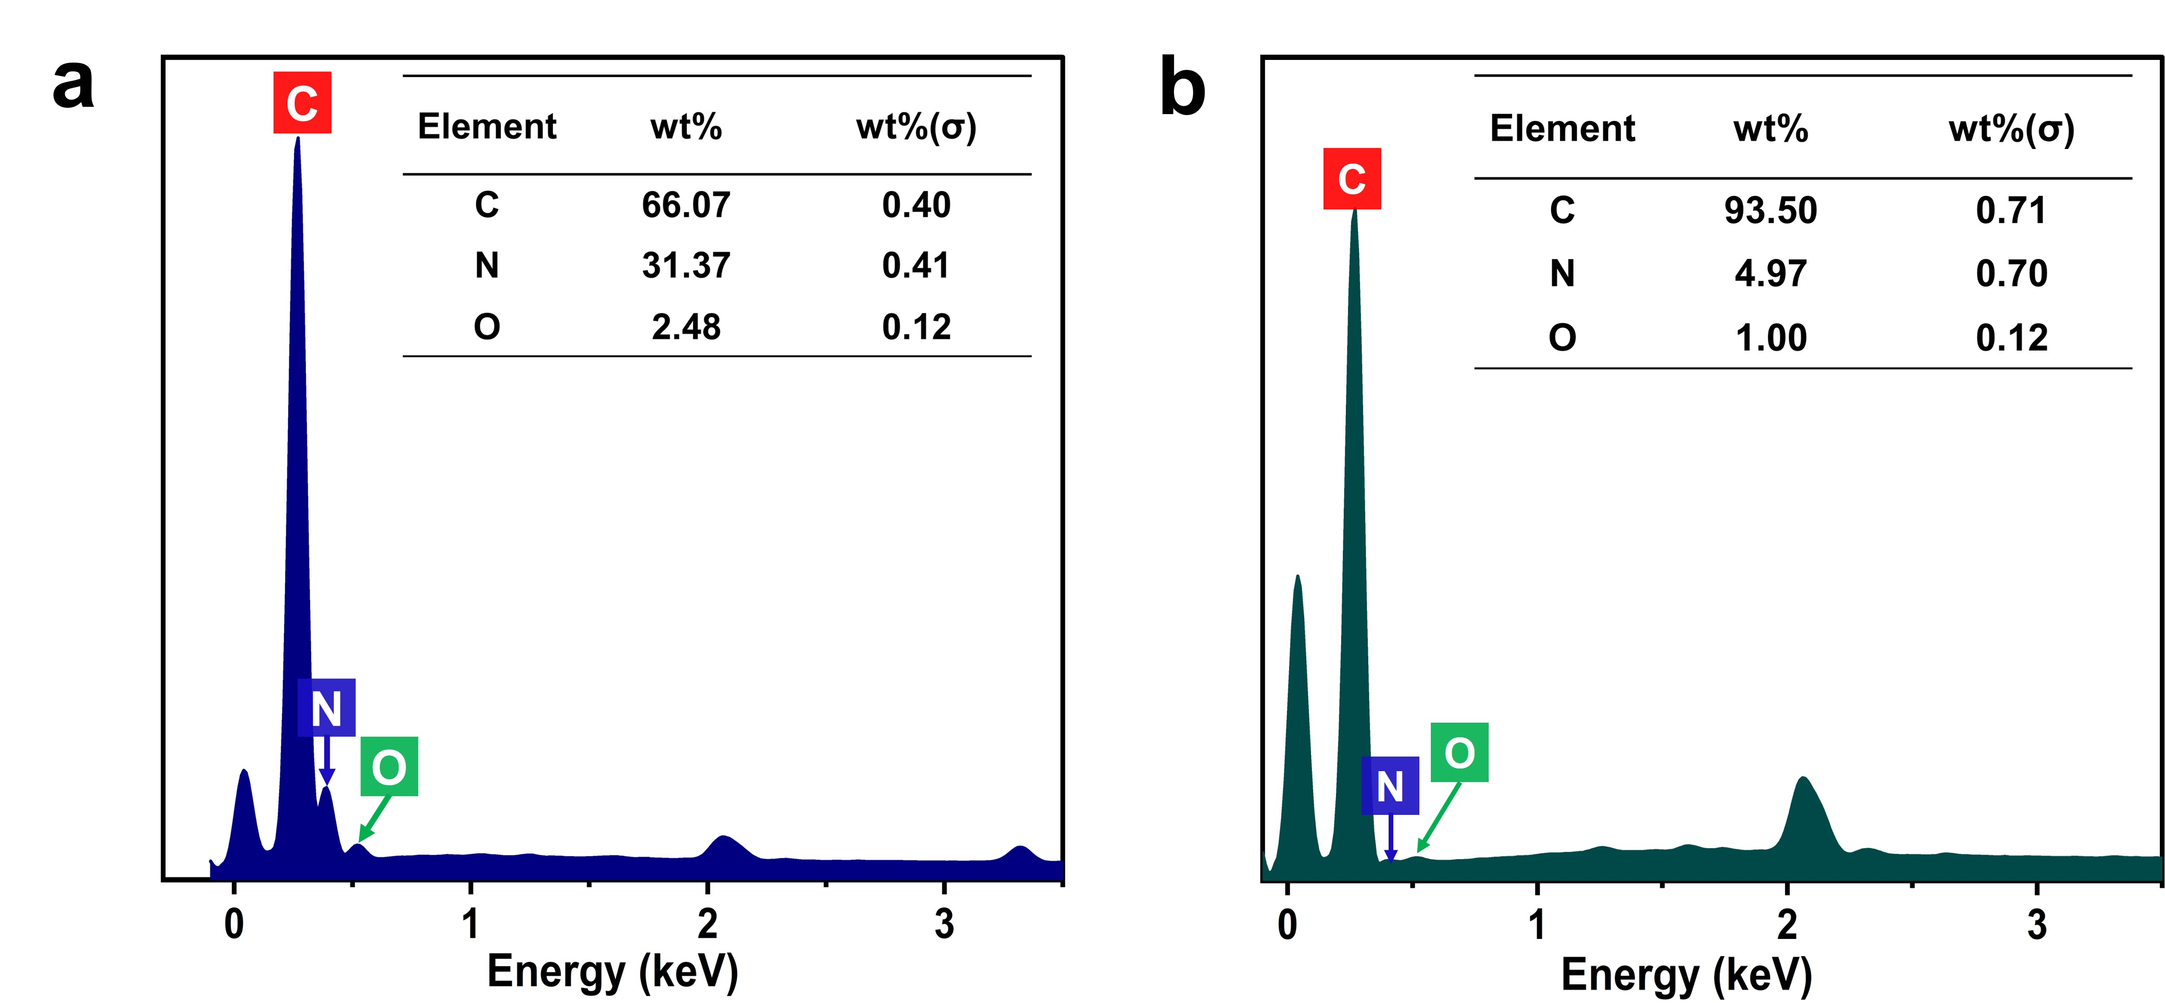

Figure S3. The energy spectrum of a. CGNrC-500 and b. CGNrC-900, respectively.
The energy spectrum further indicates that the pyrolysis temperature significantly affects the content of nitrogen species in carbon materials. The higher temperature aggravates the sublimation of nitrogen species or the generation of graphite phase carbon nitride, causing a dramatic decrease in the content of surface nitrogen species. This reduces the number of nitrogen-active sites and, thus, the catalytic activity.

Figure S4. Pore size distribution of as-prepared samples.
Based on the pore size distributions of all the samples, it was further demonstrated that the samples prepared after activation and nitrogen doping treatments and at optimal temperatures have rich pore structures that are conducive to the adsorption of H₂S molecules and the transport of oxidation products, thus facilitating the catalytic oxidation of H₂S and prolonging the life of the catalysts.

Figure S5. The XPS survey spectra of all the samples.
The chemical state and component composition of all samples were explored by X-ray photoelectron spectroscopy (XPS). From the XPS survey spectra, it can be observed that all the samples are mainly composed of three elements, C, N, and O.

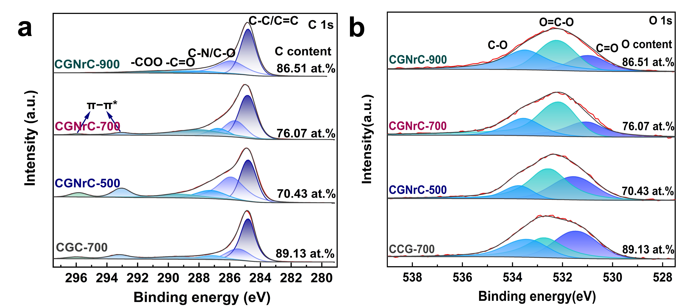

Figure S6. Systematically illustrates the different types of C and O species. a. C 1s and b. O 1s XPS spectra.

Figure S7. Antioxidant performance test (reaction conditions: T=180 ℃, C_{O2}/C_{H2S}=8, WHSV=60000 mL/h/g).

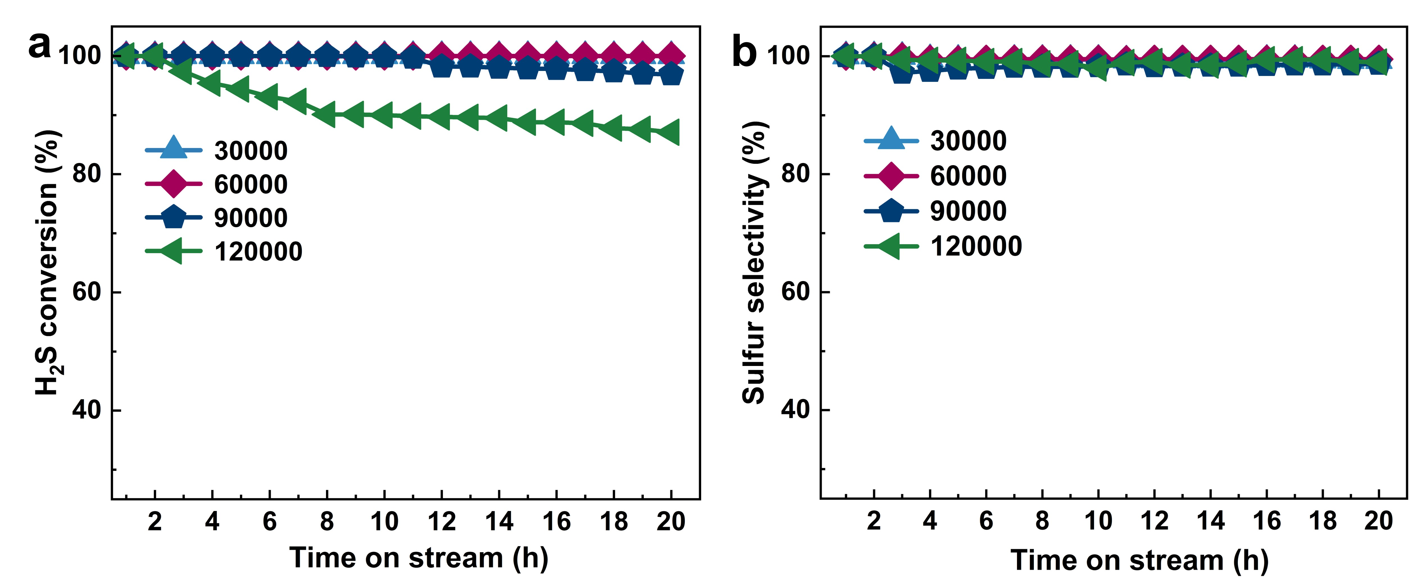

Figure S8. a, b. show H₂S conversion and sulfur selectivity of CGNrC-700 at different WHSV (T=180 ℃, C_{O2}/C_{H2S}=0.5).

Figure S9. Depicts catalytic activity of CGNrC-700 at high H₂S concentrations (0.5 vol%) (reaction condition: WHSV=30000 mL/h/g, T=180 ℃, C_{O2}/C_{H2S}=0.5).
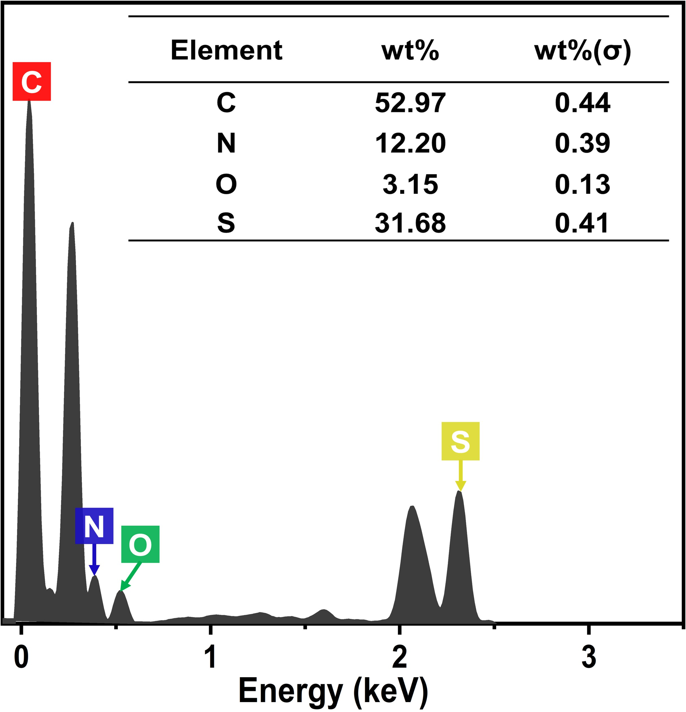

Figure S10. The EDS energy spectrum of CGNrC-700-S.
The increase in the weight percentage of elemental sulfur from 0.31 to 31.68 wt% by analysis of the corresponding EDS spectra further demonstrated the elemental sulfur increase in elemental sulfur after the reaction.
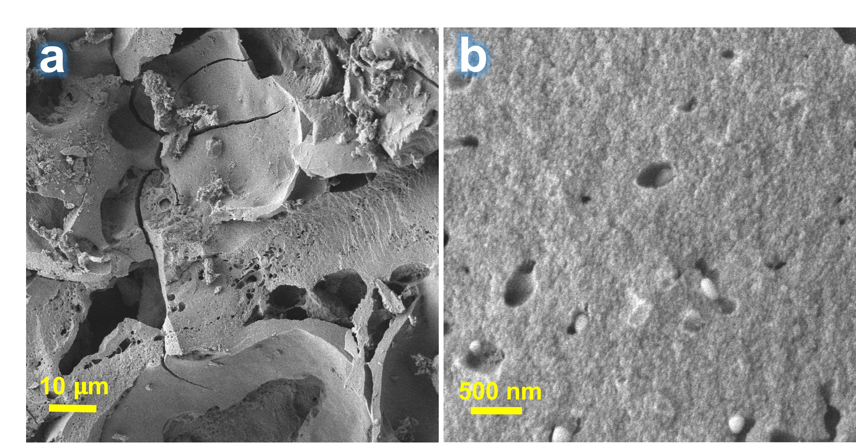

Figure S11. a, b. showed the SEM images of the CGNrC-700-S catalyst.

Figure S12. FT-IR spectra of fresh and spent catalysts.
The peak positions and intensities of CGNrC-700-S were essentially unchanged compared to CGNrC-700, except for the obvious weakening of the intensity of the C≡N peaks, which suggested that desulfurization did not destroy the chemical structure of the catalyst, only resulting in a slight decrease in nitrogen content.

Figure S13. The pore size distributions of CGNrC-700-S and CGNrC-700-R.
Regeneration at 500 °C removes most of the elemental sulfur present on the surface of the look catalyst and in the pore channels, allowing the pore channels to be released. This explains that the regenerated catalyst still has a good catalytic oxidation performance.

Figure S14. Optimized structural model for CGNrC-700 catalysts.

Figure S15. Frontier orbital distribution of CGNrC-700.

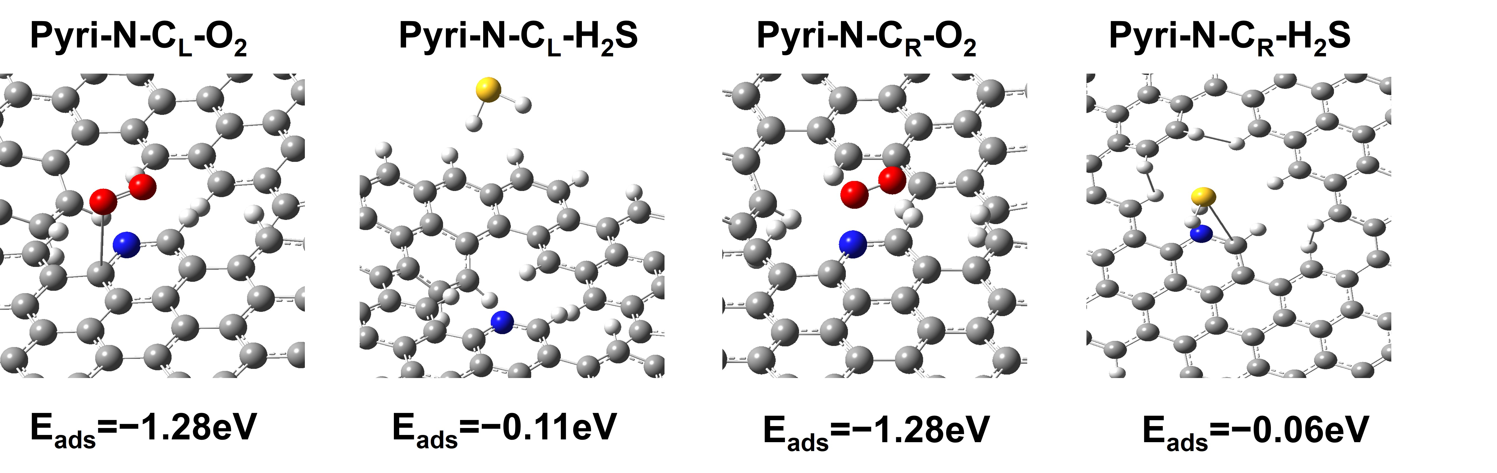

Figure S16. Structural optimization of CGNrC-700 for H₂S and O₂ adsorption using B3LYP/6-31G

Supplementary Tables

Table S1. CCG-700 and CGNrC-T defect structures and defect density.
Sample | I_{D}/I_{G} | n_{D} ( ×10¹¹ cm⁻²)
CCG-700 | 0.88 | 2.82
CGNrC-500 | 1.07 | 3.43
CGNrC-700 | 1.1 | 3.52
CGNrC-900 | 0.99 | 3.17
The defect density (n_{D}) of CGNrC-T and CCG-700 was calculated by Eq. (6). According to Cançado's work from the Raman spectra (Cançado, et al. 2011), where E_{L} is expressed as the excitation energy and the value is fixed around 2.41 eV.${\text{n}}_{\text{D}}\left({\text{cm}}^{\text{-1}}\right)\text{= (7.3±2.2) ×}{\text{10}}^{\text{9}}{\text{E}}_{\text{L}}^{\text{4}}\text{(}\frac{\text{ID}}{\text{IG}}\text{) (6)}$

Sample | $${\text{S}}_{\text{BET}}^{\text{a}}$$  m²/g | $${\text{D}}_{\text{meso}}^{\text{b}}$$  $$\text{(nm)}$$ | $${\text{V}}_{\text{micro }}^{\text{c}}$$  cm³/g | $${\text{V}}_{\text{total}}^{\text{d}}$$  cm³/g | $${\text{D}}_{\text{e}}$$  (nm)
CCG-700 | 26.70 | 3.41 | 0.032 | 0.035 | 5.30
CGNrC-500 | 21.26 | 3.41 | 0.029 | 0.038 | 7.15
CGNrC-700 | 787.78 | 3.82 | 0.421 | 0.46 | 2.36
CGNrC-900 | 1195.11 | 3.82 | 0.648 | 0.72 | 2.41
CGNrC-700-S | 24.3 | 3.82 | 0.039 | 0.041 | 6.82
CGNrC-700-R | 793.7 | 3.82 | 0.32 | 0.45 | 2.26

Table S2. Porosity parameters of catalysts obtained from BET analysis.
a) BET surface; b) Average pore size of mesopores was obtained by BJH method; c) Micropores volume from the DFT method; d) Total pore volume d); e) Average pore width.

Sample | C (at%) | C-C/C=C (at%) | C-N/C=O  (at%) | C=O  (at%) | -COO  (at%) | carbon π-π* transition groups  (at%)
CCG-700 | 89.13 | 45.27 | 17.75 | 7.55 | 6.79 | 11.77
CGNrC-500 | 70.43 | 25.80 | 21.27 | 8.45 | 5.44 | 9.47
CGNrC-700 | 76.07 | 34.10 | 15.42 | 6.92 | 15.42 | 4.21
CGNrC-900 | 86.51 | 46.44 | 27.28 | 6.92 | 5.87 | 0
CGNrC-700-S | 55.44 | 23.71 | 18.05 | 4.56 | 2.09 | 7.01
CGNrC-700-R | 64.86 | 31.47 | 23.44 | 3.62 | 6.33 | -

Table S3. C 1s high-resolution XPS spectra of all samples.

Sample | O (at%) | C=O (at%) | O=C-O (at%) | C-O(at%)
CCG-700 | 7.54 | 2.25 | 2.63 | 1.90
CGNrC-500 | 6.24 | 2.91 | 2.19 | 1.00
CGNrC-700 | 6.41 | 3.34 | 1.27 | 1.43
CGNrC-900 | 6.53 | 1.49 | 2.53 | 2.08
CGNrC-700-S | 21.08 | 12.21 | 5.98 | 2.89
CGNrC-700-R | 16.56 | 4.77 | 3.49 | 8.3

Table S4. O 1s high-resolution XPS spectra of all samples.
The atomic percentages of oxygen in the carbon materials prepared by carbonization at different temperatures were essentially the same, indicating that the oxygen functional group did not have much effect on the desulphurization performance. The oxygen content of the deactivated catalyst increased sharply, which may be due to the formation of sulfate material during the desulfurization reaction.

Sample | C (at. %) | N (at. %) | O (at. %) | O/C (at. %) | N/C (at. %)
CCG-700 | 89.13 | 3.33 | 7.54 | 0.085 | 0.037
CGNrC-500 | 70.43 | 23.33 | 6.24 | 0.089 | 0.33
CGNrC-700 | 76.07 | 17.33 | 6.41 | 0.084 | 0.23
CGNrC-900 | 86.51 | 6.97 | 6.53 | 0.075 | 0.081

Table S5. Element content and atomic content of C, N, and O, and the ratio of O and N to C for all samples.
The N and O groups in biomass-derived carbon materials play an important role in many catalytic processes. However, in the present study, all the samples have a close content of oxygen groups, suggesting that N species play a key role in catalytic oxidation. The ratio of O and C to N can further indicate that N species are crucial for the catalytic oxidation of H₂S.
Sample | N(at%) | Pyri-N (%)ª | Pyrr-N (%)^{b} | Grap-N (%)^{c} |  | Oxid-N (%)^{d}
CCG-700 | 3.33 | 1.36 | 0.97 | 0.57 |  | 0.43
CGNrC-500 | 23.33 | 13.59 | 4.73 | 3.75 |  | 1.26
CGNrC-700 | 17.33 | 8.11 | 3.58 | 3.41 |  | 2.23
CGNrC-900 | 6.97 | 2.44 | 1.23 | 2.79 |  | 0.51
CGNrC-700-S | 16.97 | 5.29 | 6.00 | 3.82 |  | 1.86
CGNrC-700-R | 17.19 | 7.45 | 3.68 |  | 4.03 | 2.03

Table S6. N species content from XPS analysis of all samples. The atomic percentage of (a)pyridine-N, (b) pyrrole-N, (c) graphite-N, and (d) oxidized-N.
The N content of the samples obtained by N-doping before pyrolysis is significantly higher than that of the samples without any treatment, indicating the successful incorporation of N into the carbon framework. Furthermore, it can be observed that pyrolysis temperatures higher than 700 °C leading to a significant decrease in the N content, which is not favorable for H₂S-SCO.
Entry | Simulate gas | catalysts | WHSV/GHSV | Temp, ℃ | Conv % | Sel % | Ref
1 | H₂S/O₂=1/50 with N₂ as the balance gas | 30Fe5Ag-MCM41 | 120,000 mL/h/g | 120 | 100 | 81.1 | (Gu, et al. 2023)
2 | H₂S/O₂=2/5 with 30vol % water, and balance gas (He) | N-C/CNT-6%P | 0.6/h | 210 | 99.2 | 82 | (Xu, et al. 2021)
3 | H₂S/O₂/N₂ = 0.5/0.25/99.25 | N-OMCS-700 | 12000 mL/h/g | 200 | 100 | 88 | (Kan, et al. 2019)
4 | H₂S/O₂/N₂ = 0.5/0.25/99.25 | NrC-450 | 6000 mL/h/g | 180 | 99.6 | 94 | (Yang, et al. 2020)
5 | H₂S/O₂/N₂ = 0.5/0.25/99.25 | HNMC-800 | 6000 mL/h/g | 150 | 100 | 95 | (Lei, et al. 2023)
6 | H₂S/O₂/N₂ = 0.5/0.25/99.25 | PCN | 12000 mL/h/g | 200 | 99 | 95 | (Lyu, et al. 2022)
7 | H₂S/O₂/N₂ = 0.5/0.25/99.25 | 2D-NHPC-10 | 12000 mL/h/g | 180 | 100 | 99 | (Kan, et al. 2022)
8 | H₂S/O₂/N₂=  0.1/0.05/99.85 | CGNrC-700 | 60000 mL/h/g | 180 | 100 | 99% | This work

Table S7. Different carbon catalysts are used in the selective oxidation of H₂S to S.

Sample | S (at%) | S 2p1/2 (at%) | S 2p3/2 (at%) | Sulfate (at%)
CGNrC-700 | - | - | - | -
CGNrC-700-S | 6.46 | 0.72 | 0.81 | 4.93
CGNrC-700-R | 1.4 | 0.2 | 0.20 | 1.00

Table S8. S2p high-resolution XPS spectra of fresh and deactivated catalysts.
A significant increase in the sulfur content of the deactivated catalyst can be observed by XPS analysis. Fortunately, after the deactivated catalyst was washed several times with hot water and heat-treated at 500°C for 2h under N₂ atmosphere, most of the sulfur-containing substances accumulated on the surface and in the pores of the catalyst were removed. This explains why the catalyst still has good catalytic activity after regeneration and also proves that CGNrC-700 has good regenerative properties.

Reference
Cançado L G, Jorio A, Ferreira E H M, Stavale F, Achete C A, Capaz R B, Moutinho M V O, Lombardo A, Kulmala T S, Ferrari A C (2011) Quantifying Defects in Graphene via Raman Spectroscopy at Different Excitation Energies. Nano Letters 11(8): 3190-3196. http://dx.doi.org/10.1021/nl201432g
Gu J-n, Liang J, Xue Y, Yu C, Li X, Li K, Guo M, Jia J, Sun T (2023) Highly Dispersed FeAg-MCM41 Catalyst for Medium-Temperature Hydrogen Sulfide Oxidation in Coke Oven Gas. Environmental Science & Technology 57(36): 13579-13587. http://dx.doi.org/10.1021/acs.est.3c04112
Xu C, Gu Q, Li S, Ma J, Zhou Y, Zhang X, Jiang C, Pham-Huu C, Liu Y (2021) Heteroatom-Doped Monolithic Carbocatalysts with Improved Sulfur Selectivity and Impurity Tolerance for H₂S Selective Oxidation. ACS Catalysis 11(14): 8591-8604. http://dx.doi.org/10.1021/acscatal.1c01252
Kan X, Chen X, Chen W, Mi J, Zhang J-Y, Liu F, Zheng A, Huang K, Shen L, Au C, Jiang L (2019) Nitrogen-Decorated, Ordered Mesoporous Carbon Spheres as High-Efficient Catalysts for Selective Capture and Oxidation of H₂S. ACS Sustainable Chemistry & Engineering 7(8): 7609-7618. http: //dx. doi. org/10. 1021/acssuschemeng.8b05852
Yang C, Ye H, Byun J, Hou Y, Wang X (2020) N-Rich Carbon Catalysts with Economic Feasibility for the Selective Oxidation of Hydrogen Sulfide to Sulfur. Environmental Science & Technology 54(19): 12621-12630. http: //dx. doi. org/10. 1021/acs.est.0c02967
Lei G, Fan Z, Hou Y, Liu F, Wang S, Shen L, Zhan Y, Jiang L (2023) Facile template-free synthesis of 3D cluster-like nitrogen-doped mesoporous carbon as metal-free catalyst for selective oxidation of H₂S. Journal of Environmental Chemical Engineering 11(1): 109095. http://dx.doi.org/10.1016/j.jece.2022.109095
Lyu S, Wu W, Xiong R, Yang C, Sa B, Zhang J, Hou Y, Wang X (2022) Carbon-Rich carbon nitride nanocatalysts for H₂S selective oxidation. J. Catal. 413: 992-1004. http://dx.doi.org/10.1016/j.jcat.2022.08.011
Kan X, Zhang G, Luo Y, Liu F, Zheng Y, Xiao Y, Cao Y, Au C-t, Liang S, Jiang L (2022) Efficient catalytic removal of COS and H₂S over graphitized 2D micro-meso-macroporous carbons endowed with ample nitrogen sites synthesized via mechanochemical carbonization. Green Energy & Environment 7(5): 983-995. http://dx.doi.org/10.1016/j.gee.2020.12.016

