Supplementary materials:
Hydrochar as a superior amendment for soil aggregation and carbon sequestration: evidence from comparative studies
Liyang Sunª, Jim J. Wang^{b}, Sun Wei^{c}, Pingping Yeª, Yue Dengª, Xiangtian Meng^{c}, Ronghua Li^{c}, Zongsheng Zhang^{d}, Xiaoxuan Su^{a*}, Ran Xiao^{a*}
ª Interdisciplinary Research Center for Agriculture Green Development in Yangtze River Basin, College of Resources and Environment, Southwest University, Beibei, 400715, Chongqing, PR China
^{b} School of Plant, Environment and Soil Sciences, Louisiana State University Agricultural Center, Banton Rouge, LA, 70803, PR China
^{c} Key Laboratory of Ecosystem Network Observation and Modeling, Institute of Geographic Sciences and National Resources Research, Chinese Academy of Sciences, Beijing 100101, China
^{c} College of Natural Resources and Environment, Northwest A&F University, Yangling, Shaanxi 712100, China
^{d} State Key Laboratory of Black Soils Conservation and Utilization, Institute of Northeast Geography and Agroecology, Chinese Academy of Sciences, Changchun, Jilin 130012, China

Corresponding author:
Prof. Xiaoxuan Su
Interdisciplinary Research Center for Agriculture Green Development in Yangtze River Basin, College of Resources and Environment,
Southwest University,
Chongqing 400715, China
E-mail address: xuangood@swu.edu.cn
Dr. Ran Xiao
Interdisciplinary Research Center for Agriculture Green Development in Yangtze River Basin, College of Resources and Environment,
Southwest University,
Chongqing 400715, China
E-mail address: xiaoran0012@swu.edu.cn, xiaoran0012@gmail.com

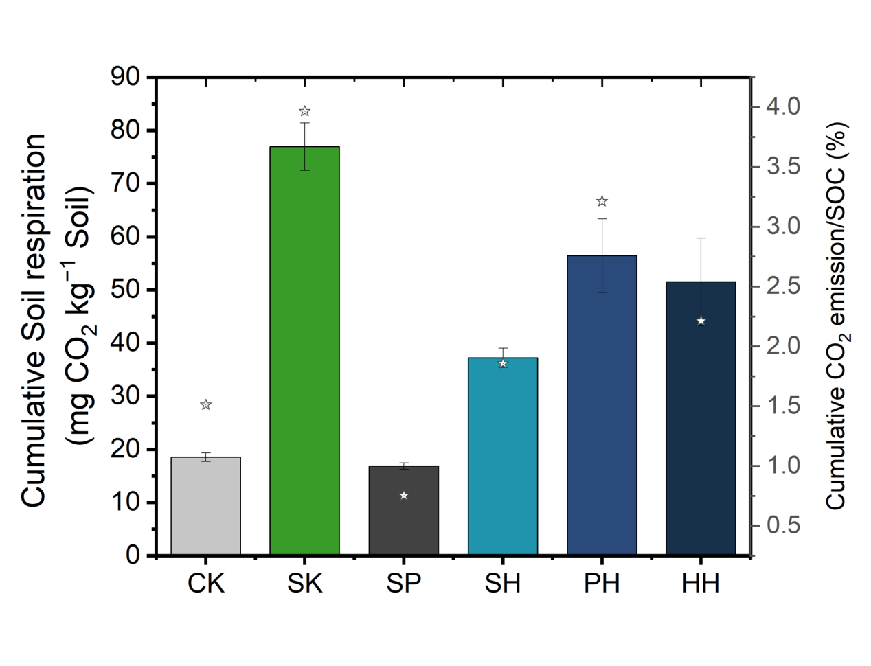
Fig. S1 Cumulative CO₂ emission within 3 days for soils collected after incubation experiment, and its proportion in the bulk SOC.

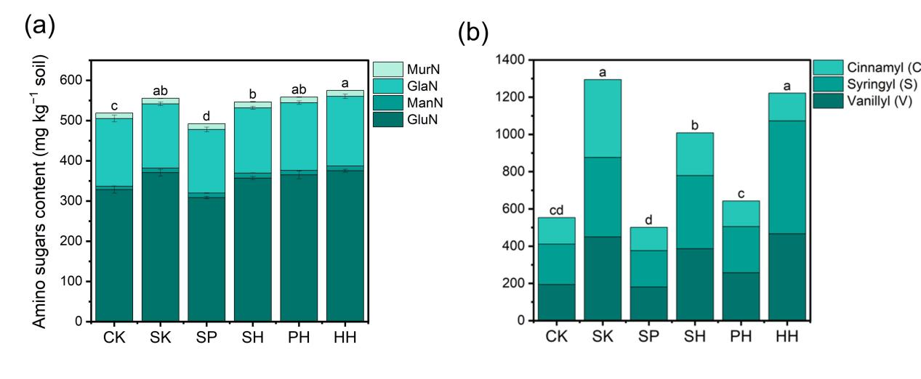
Fig. S2. The total amino sugar (a) and lignin phenols (b) in soils among different treatments.
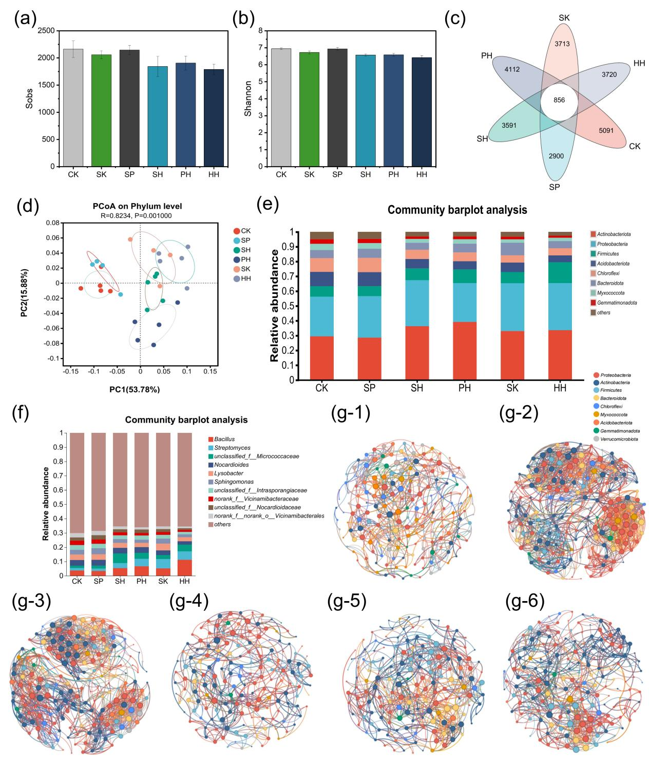
Fig. S3 Difference in the bacterial communities in soils among treatments with different organic inputs. (a) Sobs indices for the bacterial community, (b) Shannon indices for bacterial community, (c) Venn diagram of bacterial communities, (d) principal co-ordinates analysis (PCoA) of the bacterial community, (e) the relative abundance of the top 10 bacteria at the phylum levels, (f) relative abundance of bacterial community at the genus level, (g) The co-occurrence network patterns of bacterial communities with keystone taxa among different treatments (g-1) CK, (g-2) SK, (g-3) SP, (g-4) SH, (g-5) PH, and (g-6) HH.
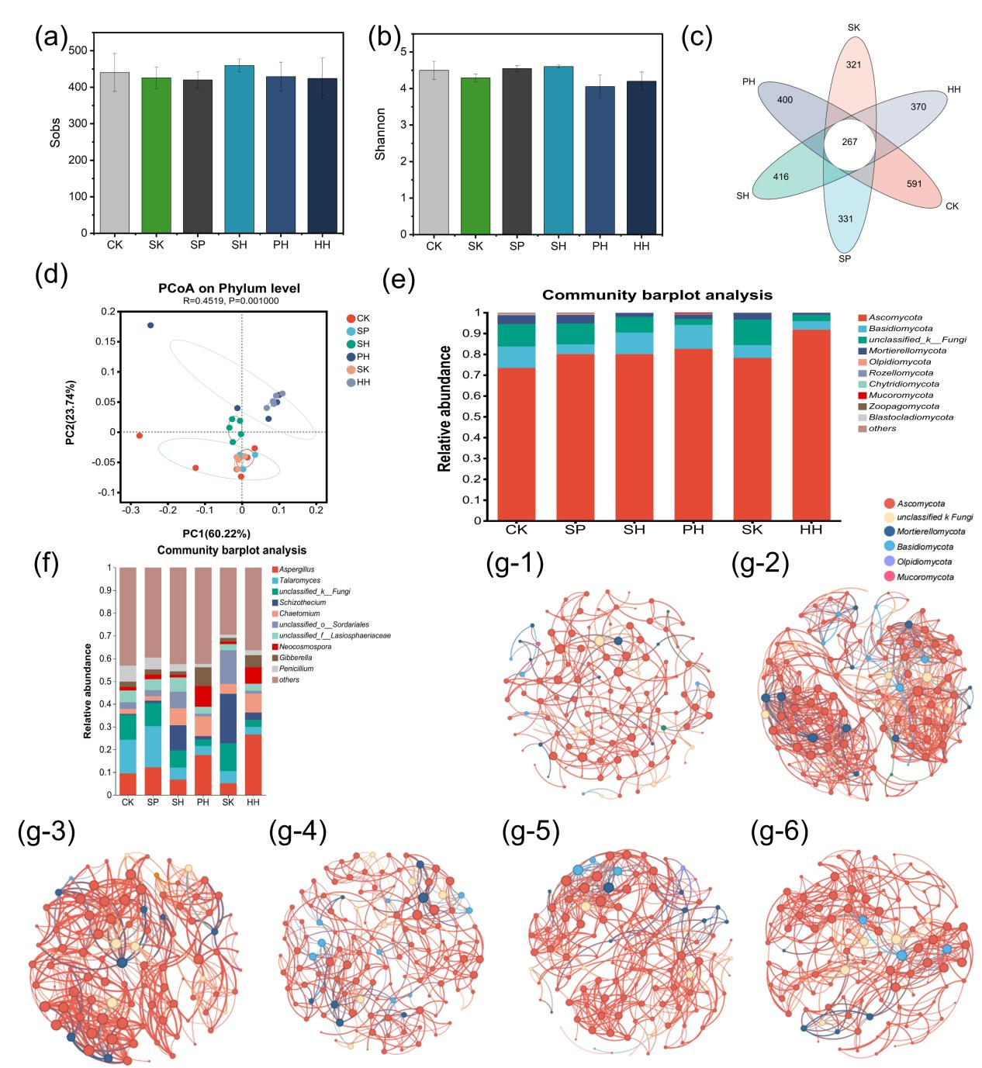
Fig. S4 Difference in the fungal communities in soils among treatments with different organic inputs. (a) Sobs indices for fungal community, (b) Shannon indices for fungal community, (c) Venn diagram of fungal communities, (d) principal co-ordinates analysis (PCoA) of the fungal community, (e) the relative abundance of the top 10 fungi at the phylum levels, (f) relative abundance of fungal community at the genus level, (g) The co-occurrence network patterns of fungal communities with keystone taxa among different treatments (g-1) CK, (g-2) SK, (g-3) SP, (g-4) SH, (g-5) PH, and (g-6) HH.
Table S1. Carbon-normalized cumulative CO₂ emission and SOC increase through the 28-day incubation period.
Treatment | Normalized cumulative CO₂ emission  (mg CO₂ kg⁻¹ soil %⁻¹Carbon in the organic amendments) | Carbon efficiencies (%)
SK | 67.3 ± 0.35a | 0.204
SP | 4.54 ± 0.07d | 0.204
SH | 36.0 ± 0.60c | 0.186
PH | 56.7 ± 1.32b | 0.208
HH | 51.8 ± 2.53b | 0.230
Note: carbon efficiencies were calculated by dividing the changes of SOC by the carbon input with organic amendment inputs (Li et al., 2024; Journal of Environmental Management, 351, 119745).

Table S2 A comprehensive carbon efficiencies for organic amendments by taking the carbon loss in both organic amendment production and incubation.
Treatment | Carbon loss during organic amendment production (%) | Carbon loss during incubation period (%) | Overall carbon loss (%)
SK | 0.00 | 18.5 | 18.5
SP | 31.0 | 18.6 | 43.9
SH | 6.40 | 25.5 | 30.3
PH | 29.4 | 16.7 | 41.3
HH | 4.23 | 8.08 | 12.3
Note: Priming effects attributed to organic input was not considered.

Table S3. The ratio of GluN/MurN, cinnamyl to vanillyl (C/V) and syringyls to vanillyl (S/V), and the acid-to-aldehyde ratios for vanillyl units [(Ac/Al)v] and syringyls units [(Ac/Al)s] in soils among different treatments.
Treatment | GlcN/MurN | C/V | S/V | C/V v.s S/V | (Ad/Al)V | (Ad/Al)S | (Ad/Al)S v.s (Ad/Al)V
CK | 24.5 ± 0.86bc | 0.73 ± 0.01b | 1.11 ± 0.02b | 1.52 ± 0.03c | 0.41 ± 0.01b | 0.44 ± 0.01b | 1.06 ± 0.02c
SK | 27.2 ± 0.77a | 0.94 ± 0.10a | 0.95 ± 0.06c | 1.02 ± 0.05d | 0.44 ± 0.01e | 0.49 ± 0.00a | 1.78 ± 0.04a
SP | 21.5 ± 0.31d | 0.69 ± 0.03bc | 1.08 ± 0.03bc | 1.55 ± 0.03c | 0.20 ± 0.00a | 0.35 ± 0.01c | 1.10 ± 0.02c
SH | 24.2 ± 1.36c | 0.60 ± 0.06c | 1.02 ± 0.03c | 1.71 ± 0.14b | 0.32 ± 0.01d | 0.47 ± 0.02a | 1.45 ± 0.15b
PH | 26.3 ± 1.63ab | 0.54 ± 0.09c | 0.97 ± 0.07c | 1.81 ± 0.18b | 0.37 ± 0.01c | 0.43 ± 0.01b | 1.16 ± 0.10c
HH | 25.6 ± 0.46bc | 0.33 ± 0.08d | 1.30 ± 0.04a | 4.14 ± 0.91a | 0.31 ±0.01d | 0.35 ± 0.00c | 1.13 ± 0.07c

Table S4. The concentration of alkaline-N, available P and available K in soils among different treatments.
Treatment | Alkaine-N  (g kg⁻¹ soil) | Available P  (g kg⁻¹ soil) | Available K  (g kg⁻¹ soil) | TN  (g kg⁻¹ soil) | C/N
CK | 77.17 ± 1.51d | 25.94 ± 1.10c | 337 ± 48.7d | 1.21 ± 0.03b | 10.14
SK | 75.30 ± 1.88d | 46.24 ± 2.57a | 874 ± 25.8a | 1.48 ± 0.19ab | 13.06
SP | 113.2 ± 3.28a | 26.03 ± 1.21c | 366 ± 6.03d | 1.36 ± 0.07ab | 16.46
SH | 96.82 ± 0.73c | 42.67 ± 2.92a | 435 ± 17.5c | 1.58 ± 0.11b | 12.63
PH | 91.73 ± 2.76b | 32.21 ± 0.77b | 544 ± 18.6b | 1.47 ± 0.11a | 11.95
HH | 117.8 ± 14.2a | 25.60 ± 0.16c | 408 ± 6.0c | 1.55 ± 0.04ab | 15.05

Table S5. Network indices corresponding to each treatment are presented in Fig. S1.
 | CK | SK | SP | SH | PH | HH
Nodes | 108 | 126 | 102 | 128 | 118 | 108
Edges | 376 | 756 | 459 | 373 | 451 | 376
Positive rate (%) | 100 | 88.1 | 83.88 | 81.23 | 93.79 | 90.69
Negative rate (%) | 0 | 11.9 | 16.12 | 18.77 | 6.21 | 9.31
Average degree | 3.748 | 12 | 9 | 5.828 | 7.644 | 6.963
Average weighted degree | 0.079 | 0.236 | 0.18 | 0.12 | 0.171 | 0.162
Diameter | 20 | 11 | 11 | 9 | 9 | 10
Density | 0.032 | 0.096 | 0.089 | 0.046 | 0.065 | 0.065
Modularity | 0.754 | 0.694 | 0.76 | 0.735 | 0.615 | 0.633
Average clustering coefficient | 0.443 | 0.647 | 0.594 | 0.441 | 0.549 | 0.503

Table S6. Network indices corresponding to each treatment are presented in Fig. S2.
 | CK | SK | SP | SH | PH | HH
Nodes | 184 | 182 | 180 | 161 | 163 | 170
Edges | 596 | 1474 | 1289 | 512 | 649 | 678
Positive rate (%) |  | 88.13 | 84.64 | 87.5 | 88.6 | 86.58
Negative rate (%) |  | 11.87 | 15.36 | 12.5 | 11.4 | 13.42
Average degree | 6.48 | 16.20 | 14.32 | 6.36 | 7.96 | 7.98
Average weighted degree | 0.14 | 0.31 | 0.27 | 0.13 | 0.17 | 0.17
Diameter | 11 | 8 | 10 | 13 | 10 | 10
Density | 0.03 | 0.09 | 0.08 | 0.04 | 0.05 | 0.05
Modularity | 0.69 | 0.71 | 0.77 | 0.71 | 0.67 | 0.65
Average clustering coefficient | 0.44 | 0.59 | 0.54 | 0.44 | 0.55 | 0.44

