Supporting information (SI)
For
Synergistic Enhancement of Biochar in TiO₂/g-C₃N₄ Z-Scheme Heterojunction Photocatalysts: Mechanistic Insights into the Degradation Pathways of Sulfonamide Antibiotics
The Supporting Information includes:
Supplementary Text S1.Material preparation
Supplementary Text S2. Uniform experimental parameters for photocatalytic degradation
Supplementary Text S3.Analysis methods
Supplementary Text S4.Details for quantum chemistry calculations
Supplementary Text S5.Details for Density Functional Theory (DFT) calculations
Fig. S1. (a)(b) SEM and TEM image of TiO₂; (c)(d) SEM and TEM image of g-C₃N₄; (e) (f) SEM and TEM image of TiO₂/g-C₃N₄
Fig. S2 EDS mapping of MBC-500
Fig. S3 TGA plot
Fig. S4 Mott–Schottky plots
Fig. S5 (a) Transient photocurrent results of Material;(b) EIS Nyquist plots
Fig. S6 A Study of SDZ Adsorption Equilibrium on MBC-500
Fig S7. ICP-MS standard curve of Ti ions
Fig. S8 EPR spectra of DMPO-h⁺
Fig. S9-S16 Degradation pathways of SDZ
Fig. S17 The total density of MBC-500 and TiO₂/g-C₃N₄
Fig S18. (a) Fermi levels of TiO₂ and (b) g-C₃N₄
Fig S19. SDZ degradation pathway Ⅰ-Ⅳ free energy step diagram
Table S1. Determination of titanium (Ti) content in the sample by ICP-MS
Table S2 Accurate mass of the intermediates for SDZ in MBC-500 photocatalytic system by HPLC mass spectrometry analysis.
Table S3. SDZ degradation pathway Ⅰ-Ⅳ free energy
Table S4. The atomic natural charge and Fukui function values of atoms in SDZ molecules.
Table S5. Mulliken charge of SDZ atom

Text S1. Material preparation
The corn cobs were thoroughly washed three to four times with distilled water and subsequently dried in an oven at a controlled temperature of 80 ℃. The dried corn cob material was then ground, and particles were sieved to obtain an 80-mesh size. The corn cob powder, after sieving, was placed in a crucible and underwent calcination in a muffle furnace with restricted oxygen availability.
Preparation of TiO₂: The sol-gel method was used, tetrabutyl titanate was utilized as the source of titanium, and glacial acetic acid functioned as the chelating agent, and ethanol as the solvent. Preparation of Solution A: Measure 17 mL of tetrabutyl titanate and place it in 55 mL of ethanol solution, then add 4.5 mL of glacial acetic acid. Stir the solution using a six-position magnetic stirrer until fully mixed, and label it as Solution A. Preparation of Solution B: Measure 27.6 mL of ethanol, add 0.9 mL of distilled water, and adjust the pH to 4 using nitric acid. Mix thoroughly and label as Solution B. After stirring Solutions A and B separately for 30 minutes, pour Solution B into a burette and add it to Solution A at a rate of 10 drops per minute. The resulting mixture is the titanium dioxide precursor. Once the sol dries to form a gel, dry it completely, then calcine it at 500 ℃ under oxygen-deficient conditions, followed by grinding to finally form TiO₂.
Preparation of TiO₂/g-C₃N₄ composite material: Weigh 0.5 g of urea material on an electronic balance, add 10 mL of titanium dioxide precursor to a beaker, then add 20 mL of anhydrous ethanol and stir. After stirring until dry, dry it in an oven at 80 ℃. Once cooled to room temperature, grind it and place it in a crucible. Heat the mixture in a muffle furnace by gradually increasing the temperature at a rate of 5 ℃ per minute until reaching 500 ℃, and then maintain this temperature for a duration of two hours to complete the calcination process to produce the TiO₂/g-C₃N₄ composite material.
Preparation of BC/TiO₂/g-C₃N₄ composite material: The composite, consisting of biochar, TiO₂, and carbon nitride, was prepared by mixing and subjecting it to calcination at six distinct temperatures: 300 ℃, 400 ℃, 500 ℃, 600 ℃, 700 ℃, and 800 ℃. The preparation process is as follows: Weigh 1g of BC, 10mL of TiO₂ precursor, and 0.5 g of urea into a beaker. Afterwards, stir on a magnetic stirrer. After thorough mixing, dry in an electric blast drying oven at 80 ℃. Once cooled to room temperature, grind the mixture and place the powdered sample into a crucible for calcination in a muffle furnace. Once the material has cooled to ambient temperature, remove the crucible to obtain the 300 ℃ BC/TiO₂/C₃N₄ composite, designated as MBC-300. Store in bags and label accordingly. Modify the temperature settings to 400 ℃, 500 ℃, 600 ℃, 700 ℃, and 800 ℃ in sequence to respectively acquire MBC-400, MBC-500, MBC-600, MBC-700, and MBC-800.

Text S2. Uniform experimental parameters for photocatalytic degradation
All degradation experiments (including BC, TiO₂, g-C₃N₄, TiO₂/g-C₃N₄, and MBC series samples) strictly maintained consistent core parameters: initial SDZ concentration (20 mg/L, prepared by precise pipetting of the stock solution), catalyst dosage (0.03 g, weighed using an electronic analytical balance with an accuracy of 0.0001 g), reaction solution volume (50 mL, adjusted to the mark of a volumetric flask), and initial pH (6.8, adjusted using 0.1 M HNO₃/NaOH solutions and measured with a pH meter with an accuracy of ±0.01). Each set of experiments was conducted in triplicate, with all relative standard deviations (RSD) below 5%, effectively eliminating randomness caused by operational errors. In addition, the simulated visible light source (λ > 420 nm) was calibrated with a standard radiometer before each experiment, and the distance between the light source and the reaction solution was fixed at 10 cm. The temperature was monitored throughout the reaction to maintain consistent conditions, thereby minimizing the influence of temperature fluctuations on both SDZ solubility and reaction kinetics. To enable a clear comparative analysis of photocatalytic performance across single-component, binary composite, and ternary MBC-series materials, the performance of BC, TiO₂, g-C₃N₄, TiO₂/g-C₃N₄, and MBC samples (MBC-300 to MBC-800) was also examined under the same experimental conditions.

Text S3. Analysis methods
The SDZ were quantified using a high-performance liquid chromatography (HPLC) system (Thermo Scientific™ UltiMate™ 3000, USA) equipped with a Thermo Scientific™ Acclaim™ C18 column (150 mm × 4.6 mm, 5 μm) and a diode array detector (DAD). The mobile phase consisted of a mixture of acetonitrile and 0.1% formic acid (20:80, v/v) with a detection wavelength set at 256 nm. The column temperature was maintained at 35 ℃, and the flow rate was set to 1.0 mL/min.
The surface morphology and elemental distribution of the samples were evaluated and examined using a scanning electron microscope (SEM/EDS, Zeiss Sigma300, Germany). The morphology and lattice of the materials were examined using a high-resolution transmission electron microscope (HRTEM, JEOL JEM-2100, Japan). Surface roughness of the material was characterized using atomic force microscopy (AFM) (Shimadzu SPM-9700, Japan).The crystal structure of the photocatalyst was determined by X-ray diffraction (XRD, Rigaku-SmartLab SE, Japan) using Cu Kα radiation. The functional groups of the catalyst were analyzed using Fourier-transform infrared spectroscopy (FT-IR, Thermo Fisher-iS5, USA). The elemental composition of the samples was characterized using X-ray photoelectron spectroscopy (XPS, ThermoFisher Nexsa, USA). The specific surface area and pore volume of the catalyst were measured using a surface area and porosity analyzer (BET, Micromeritics ASAP 2460, USA). The thermal stability of the material was evaluated by measuring its mass loss using thermogravimetric analysis (TGA) (Hitachi, TG/DTA7300, Japan).UV-vis diffuse reflectance spectroscopy (UV-vis DRS) was recorded in the wavelength range of 200-800 nm using a UV-vis diffuse reflectance spectrophotometer (Agilent Cary7000, China). The surface charge of the solid samples was measured using a zeta potential meter (zeta, Nano-ZS90 Zetasizer). The photoluminescence (PL) lifetime of the material was measured using time-resolved fluorescence spectroscopy (Edinburgh FLS1000, UK).The dissolution of Ti ions in the solution after the reaction was measured using ICP-MS (Agilent 7900, USA).Electron spin resonance (ESR) signals were measured under simulated sunlight (λ>420 nm) using an electron paramagnetic resonance spectrometer (Bruker-EmxPlus, Germany).Analyzing the degradation pathway of SDZ using LC-MS (Agilent 1290II-6460).
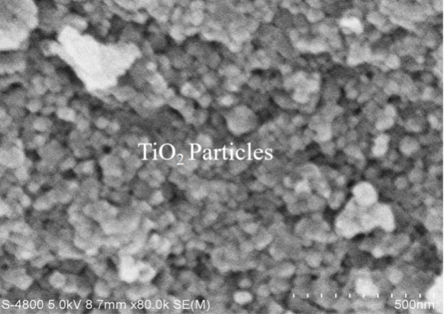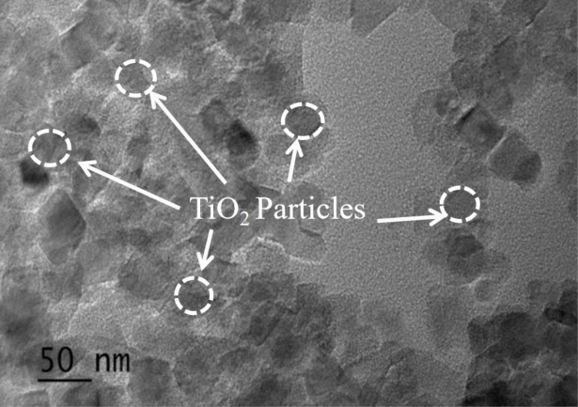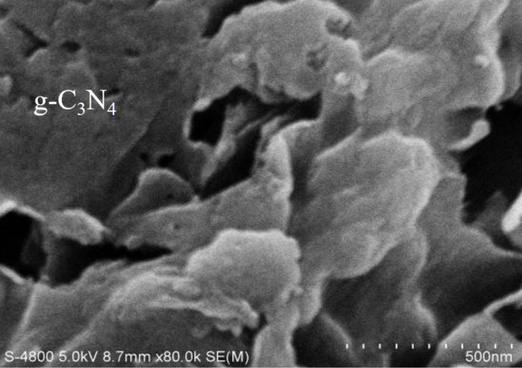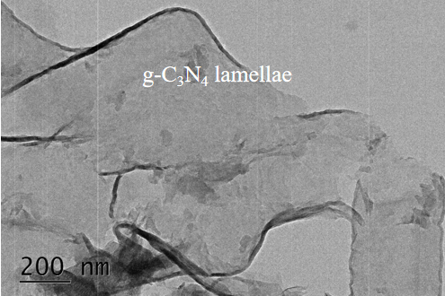
(a)
(d)

(c)

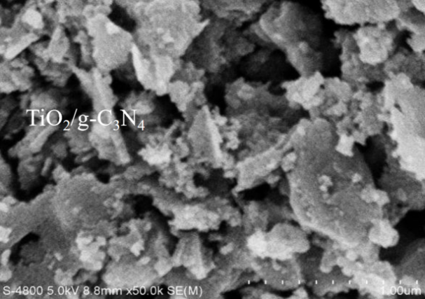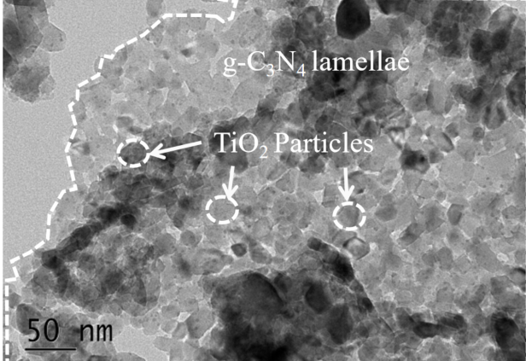
(f)

(e)

Fig. S1. (a)(b) SEM and TEM image of TiO₂; (c)(d) SEM and TEM image of g-C₃N₄; (e) (f) SEM and TEM image of TiO₂/g-C₃N₄

Text S4. Details for quantum chemistry calculations
The Gaussian 09 program with B3LYP/6-311+G** level with minimum energy was applied for calculating the molecular orbital of SDZ. Electron populations of the HOMO and LUMO were obtained from the Gaussian output files, where the HOMO is the highest occupied molecular orbital and the LUMO is the lowest unoccupied molecular orbital.
Fukui functions were used to predict the reactive sites of nucleophilic, electrophilic, and radical attack. When the value of the Fukui function was larger, reactivity of the corresponding position was higher; the Fukui function is defined as:Nucleophilic attack: f_{A}⁺ = q_{A}^{N} − q_{A}^{N+1} ；Electrophilic attack: f_{A}⁻ = q_{A}^{N-1} − q_{A}^{N} ；
Radical attack: f_{A}⁰ = (q_{A}^{N-1} − q_{AN+1})/2 .where A, q, N, and f represent an atom A, the charge of atom A, and the number of electrons in the SDZ molecule. f_{A}⁺, f_{A}⁻, and f_{A}⁰ are the Fukui function values of atom A; these are susceptible to reduction by a nucleophilic reagent, oxidation by an electrophilic agent, and addition by radicals, respectively.

Text S5. Details for Density Functional Theory (DFT) calculations
We performed density functional theory (DFT) calculations (Kohn & Sham, 1965) using the Vienna Ab initio Simulation Package (VASP) (Hafner, 2008; Kresse & Furthmüller, 1996) to obtain relaxed geometries and total energies. The projector augmented wave (PAW) method (Blochl et al., 1994; Blöchl, 1994) was employed to describe electron–ion interactions. The exchange–correlation energy was treated within the generalized gradient approximation (GGA) using the Perdew–Burke–Ernzerhof (PBE) functional (Perdew et al., 1992; Perdew et al., 1996; Perdew & Wang, 1992). A plane-wave kinetic energy cutoff of 420 eV was used. The electronic self-consistent field (SCF) iteration was converged to a threshold of 1×10⁻⁵ eV per atom. Atomic structures were optimized until the maximum residual force on each atom was less than 0.04 eV/Å. Difference charge density analysis was performed using the VESTA software.
All geometric and energy calculations were carried out within the DFT framework as implemented in VASP (Hafner, 2007). The exchange–correlation potential was approximated by the GGA-PBE functional (Kresse & Furthmüller, 1996). Core–valence electron interactions were described using the PAW method (Perdew et al., 1992). A kinetic energy cutoff of 450 eV was adopted for the plane-wave basis set. The DFT-D3 dispersion correction and dipole corrections were included in all computations (Huang et al., 2019; Neugebauer & Scheffler, 1992). The energy convergence criterion for solving the Kohn–Sham equations was set to 10⁻⁶ eV. All atomic configurations were fully relaxed until the forces on all atoms were below 0.02 eV/Å. Brillouin zone sampling was performed using a 4×4×1 Monkhorst–Pack k-point mesh. A vacuum layer of 15 Å was applied along the perpendicular direction to avoid spurious interactions between periodic images.
Within this model, the change in Gibbs free energy (ΔG) for each reaction step was defined as:
ΔG = ΔE + ΔEZPE − TΔS
where ΔE is the reaction energy obtained directly from DFT total energy differences. The zero-point energy correction (ΔEZPE) was derived from vibrational frequency calculations. ΔS denotes the entropy change between products and reactants at room temperature (T = 298.15 K).
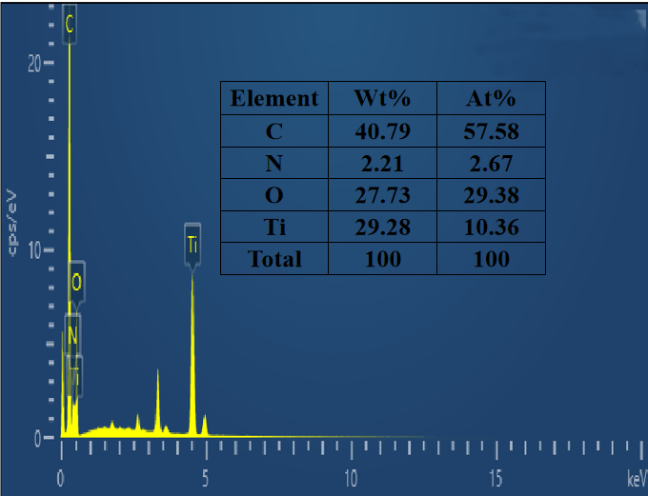
Fig. S2. EDS mapping of MBC-500.
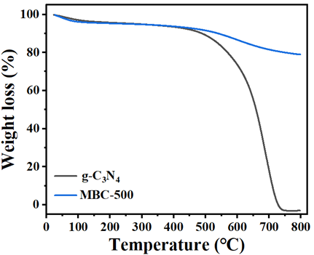
Fig. S3 TGA plot

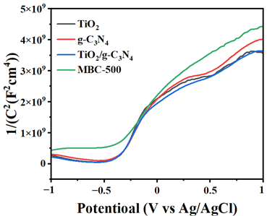
Fig. S4 Mott–Schottky plots

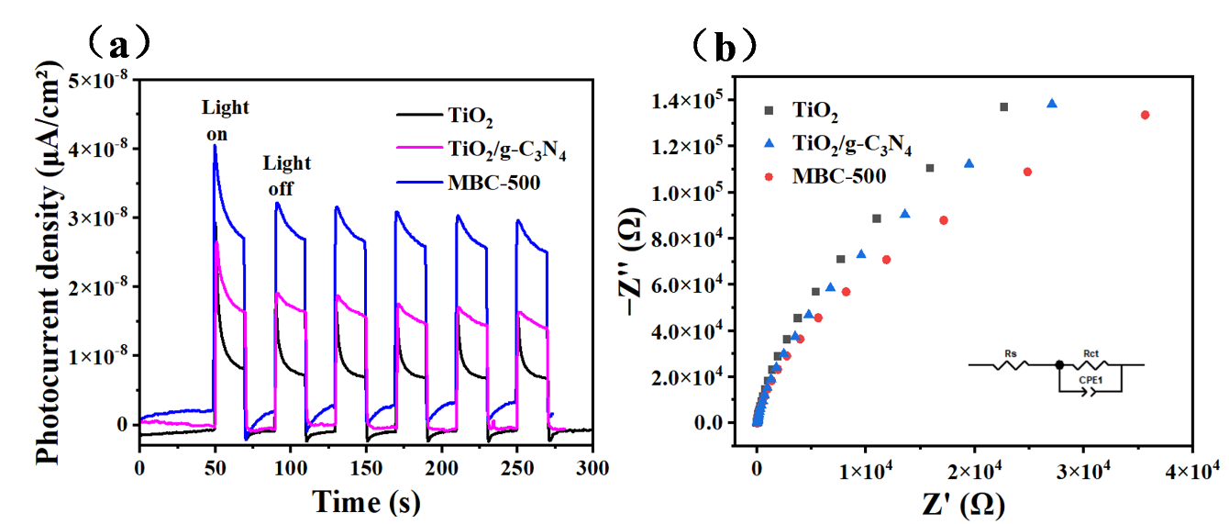
Fig. S5 (a) Transient photocurrent results of Material;(b) EIS Nyquist plots

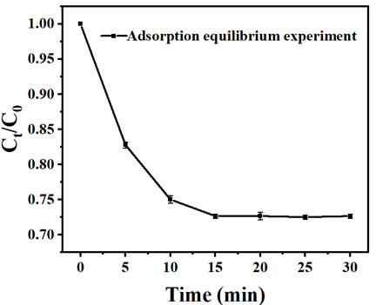
Fig. S6 A Study of SDZ Adsorption Equilibrium on MBC-500

Table S1. Determination of titanium (Ti) content in the sample by ICP-MS
 | Concentration (PPB ) | Concentration (RSD)
Blank | 0.161770769 | 13.05327599
Sample | 77.25640227 | 3.386224568

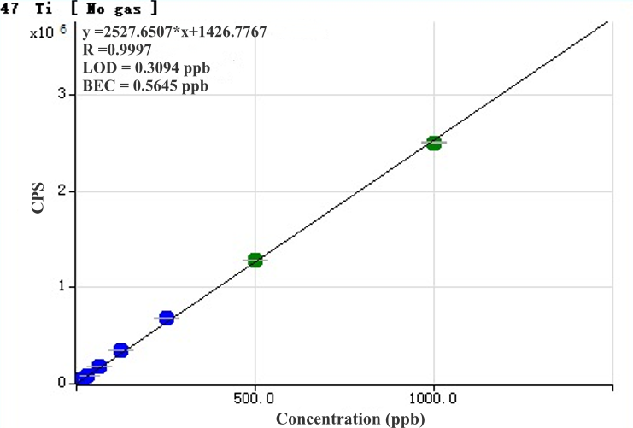
Fig S7. ICP-MS standard curve of Ti ions

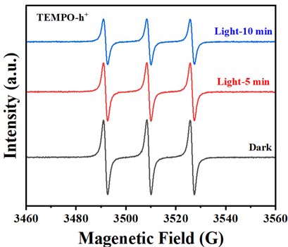
Fig. S8. EPR spectra of DMPO-h⁺
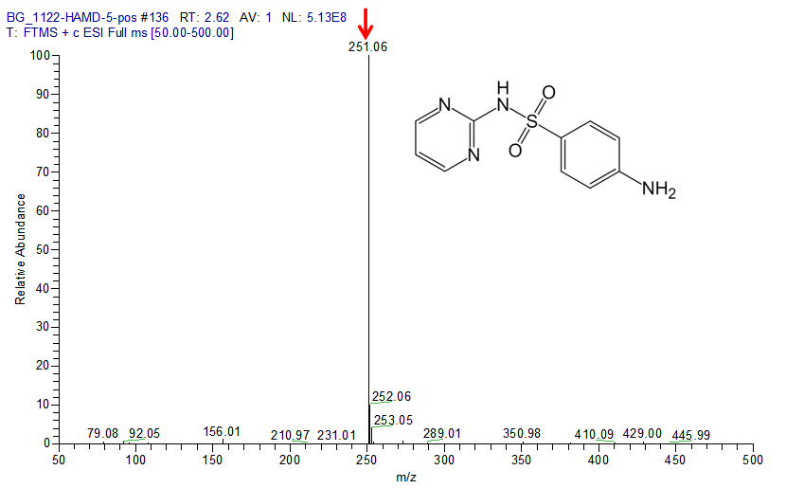
Fig. S9. Identification of parent SDZ (m/z 251.06)
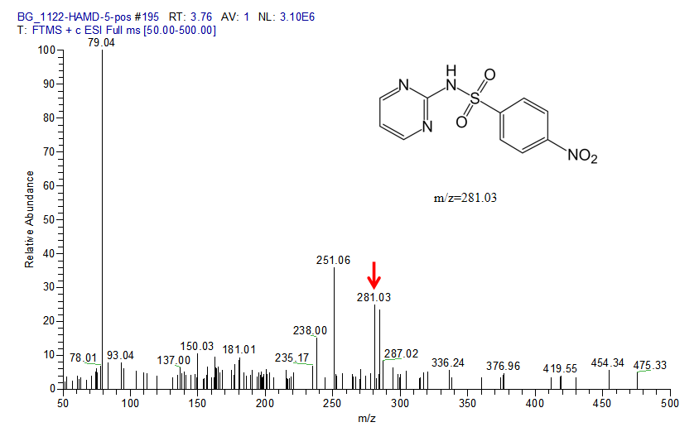
Fig. S10. Identification of P2 (m/z 281.03)
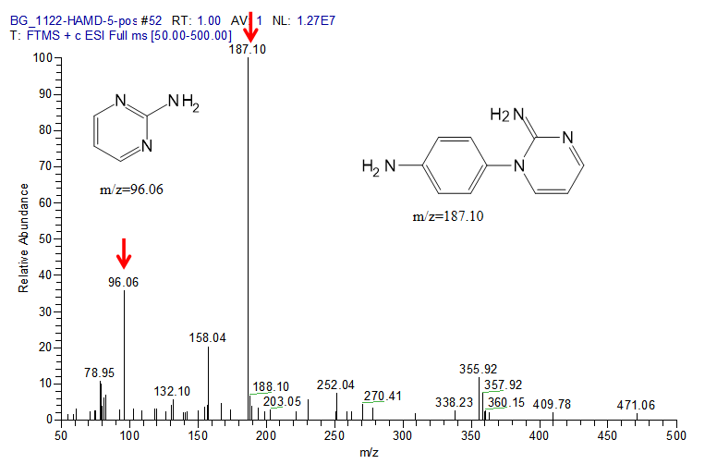
Fig. S11. Identification of P3 (m/z 96.06) and P5 (m/z 187.10)
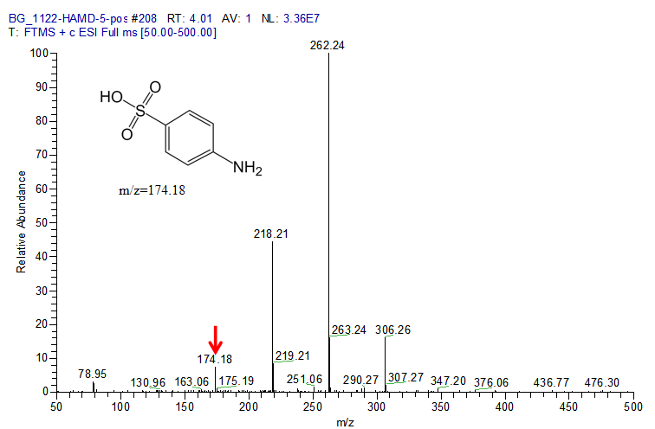
Fig. S12. Identification of P4 (m/z 174.18)
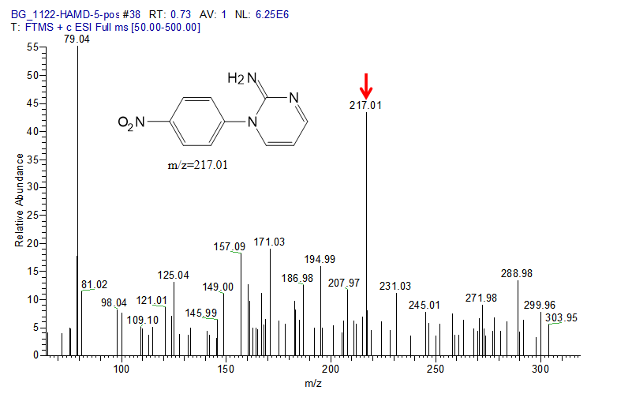
Fig. S13. Identification of P6 (m/z 217.01)
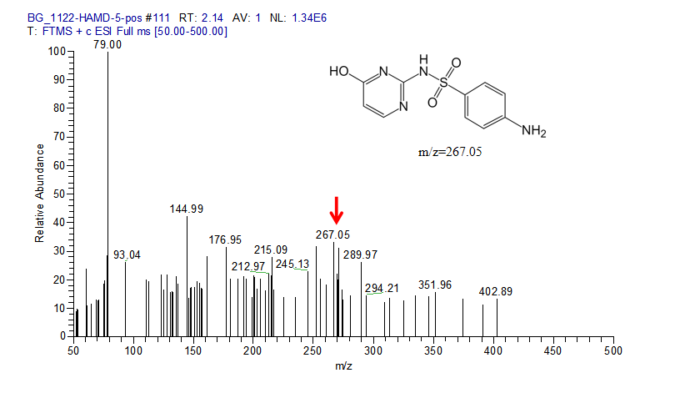
Fig. S14. Identification of P7 (m/z 267.05)
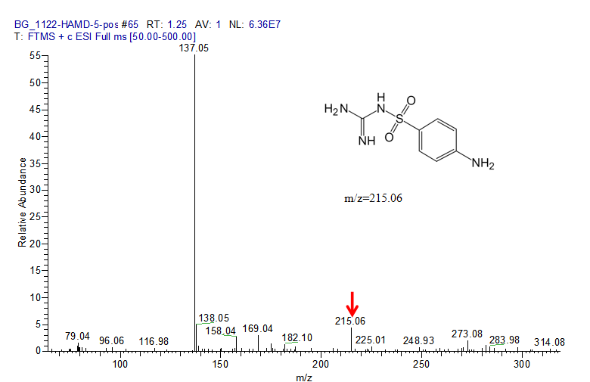
Fig. S15. Identification of P8 (m/z 215.06)
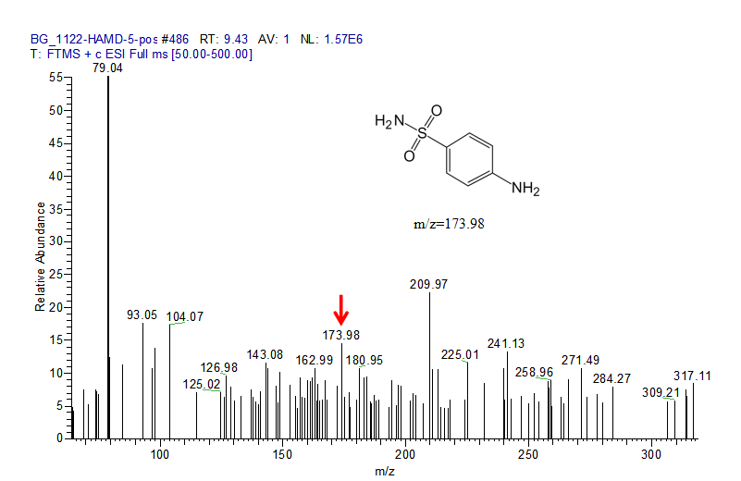
Fig. S16. Identification of P9 (m/z 173.98)
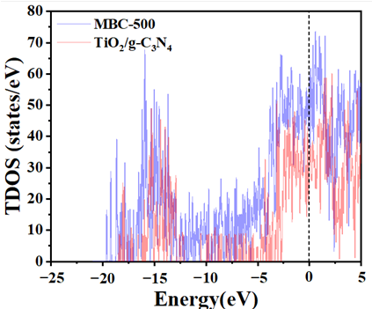
Fig S17. The total density of MBC-500 and TiO₂/g-C₃N₄
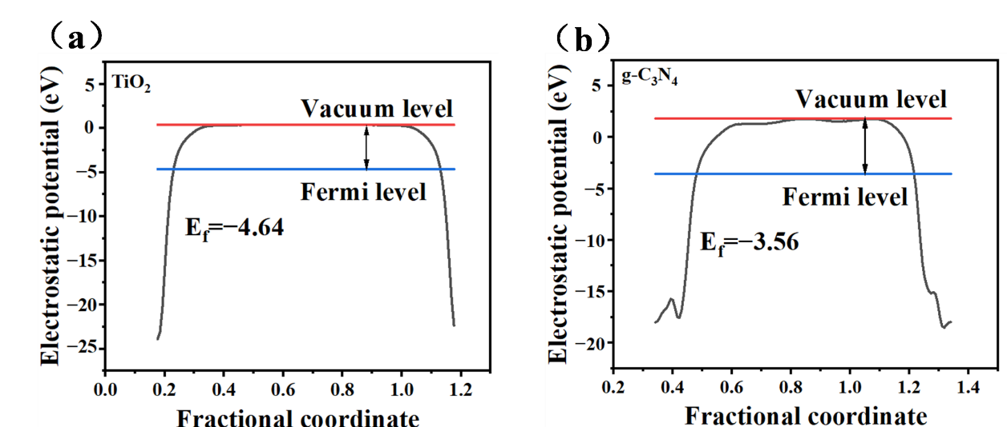
Fig S18. (a) Fermi levels of TiO₂ and (b) g-C₃N₄

Table S2. Accurate mass of the intermediates for SDZ in MBC-500 photocatalytic system by HPLC mass spectrometry analysis.
Compounds | Structure | Proposed Formula | Rt (s) | Experimental mass | Calculated mass |  | Error (mg L⁻¹)
Compounds | Structure | [M+H]⁺ | Rt (s) | (m/z) | (m/z) |  | Error (mg L⁻¹)
P251 | 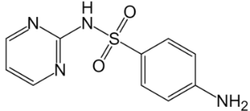 | C₁₀H₁₁N₄O₂S | 157.2 | 251.0589 | 251.0597 | -0.743
P281 | 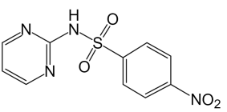 | C₁₀H₉N₄O₄S | 224.4 | 281.0331 | 281.0331 | -0.852
P96 | 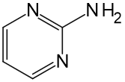 | C₄H₆N₃ | 60 | 96.0559 | 96.0556 | 3.084
P174 | 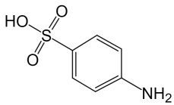 | C₆H₈NO₃S | 240.6 | 174.1850 | 174.0219 | -1.5
P187 | 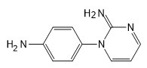 | C₁₀H₁₁N₄ | 60 | 187.0974 | 187.0978 | -2.1
P217 | 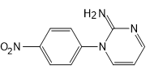 | C₁₀H₉N₄O₂ | 45.6 | 217.0718 | 217.0720 | 0.93
P267 | 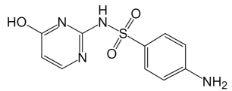 | C₁₀H₁₁N₄O₃S | 128.4 | 231.0534 | 231.0546 | -1.167
P215 | 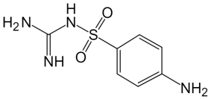 | C₇H₁₁N₄O₂S | 73.8 | 215.0592 | 215.0597 | -0.563
P173 | 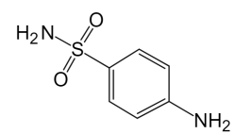 | C₆H₉N₂O₂S | 565.8 | 173.9769 | 173.0379 | 2.2

Table S3. SDZ degradation pathway Ⅰ-Ⅳ free energy
Degradation pathway of sulfamethoxazole | total energy (eV) | Relative free energy variation (ΔG, eV)
Initial | -1615.1530
Pathway Ⅰ | -1610.8559 | -4.3
Pathway Ⅱ | -1607.3537 | -7.79
Pathway Ⅲ | -1604.2472 | -10.91
Pathway Ⅳ | -1612.2332 | -2.92

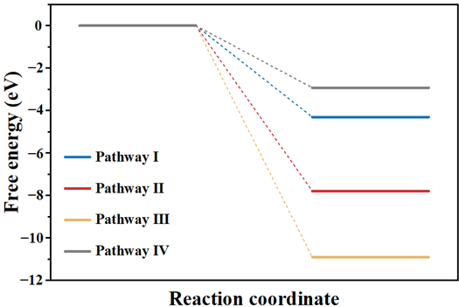
Fig S19. SDZ degradation pathway Ⅰ-Ⅳ free energy step diagram

Table S4. The atomic natural charge and Fukui function values of atoms in SDZ molecules.
Atom | Atomic natural charge | fA- | fA+ | fA0
C1 | -0.39659 | 0.12291 | 0.05735 | 0.02895
C2 | -0.19423 | 0.00055 | 0.018 | 0.04857
C3 | -0.28106 | 0.07914 | 0.035 | 0.02727
C4 | 0.195 | 0.01954 | 0.08556 | 0.080925
C5 | -0.27982 | 0.07629 | 0.00164 | 0.001055
C6 | -0.18714 | 0.00047 | 0.07116 | 0.048195
H7 | 0.26628 | 0.02523 | 0.01737 | 0.022035
H8 | 0.23747 | 0.0267 | 0.02397 | 0.025325
H9 | 0.2377 | 0.02668 | 0.02475 | 0.02503
H10 | 0.2663 | 0.02531 | 0.01822 | 0.092835
N11 | -0.81719 | 0.16745 | 0.03245 | 0.031085
H12 | 0.40564 | 0.02972 | 0.02381 | 0.02672
H13 | 0.40554 | 0.02963 | 0.0255 | 0.00463
S14 | 2.35192 | -0.01624 | 0.00438 | 0.02523
O15 | -0.92113 | 0.04608 | 0.03359 | 0.03645
O16 | -0.93364 | 0.03931 | 0.03236 | 0.01758
N17 | -0.87582 | 0.0028 | 0.00985 | 0.00637
H18 | 0.44142 | 0.00289 | 0.00918 | 0.010125
C19 | 0.0733 | 0.01107 | 0.12756 | 0.104135
N20 | -0.49627 | 0.08071 | 0.05585 | 0.045095
C21 | -0.34932 | 0.03434 | 0.00446 | -0.001265
C22 | 0.59434 | -0.00699 | 0.0023 | 0.00879
C23 | 0.06567 | 0.01528 | 0.10016 | 0.06184
H24 | 0.24702 | 0.02352 | 0.03201 | 0.05424
N25 | -0.51547 | 0.07647 | 0.09021 | 0.059785
H26 | 0.22824 | 0.02936 | 0.03163 | 0.03172
H27 | 0.23185 | 0.03181 | 0.03167 | 0.03167

Table S5. Mulliken charge of SDZ atom
Atom | Mulliken
C1 | -0.233156
C2 | -0.075934
C3 | -0.028394
C4 | 0.021175
C5 | -0.047878
C6 | -0.032872
H7 | 0.155465
H8 | 0.119486
H9 | 0.102176
H10 | 0.123163
N11 | -0.488802
H12 | 0.212904
H13 | 0.209985
S14 | 0.689651
O15 | 0.002549
O16 | -0.526367
N17 | -0.449242
H18 | 0.156684
C19 | 0.186545
N20 | -0.236272
C21 | -0.223356
C22 | 0.204839
C23 | 0.067094
H24 | 0.118031
N25 | -0.276441
H26 | 0.12643
H27 | 0.122537

References
Blochl, Jepsen, & Andersen (1994). Improved tetrahedron method for brillouin-zone integrations. Physical Review B. https://doi.org/10.1103/physrevb.49.16223
Blöchl, P. E. (1994). Projector augmented-wave method. Physical Review B. https://doi.org/10.1103/physrevb.50.17953
Hafner, J. (2007). Materials simulations using VASP—a quantum perspective to materials science. Computer Physics Communications. https://doi.org/10.1016/j.cpc.2007.02.045
Hafner, J. (2008). Ab-initiosimulations of materials using VASP: density-functional theory and beyond. Journal of Computational Chemistry. https://doi.org/10.1002/jcc.21057
Huang, J., Li, D., Li, R., Chen, P., Zhang, Q., Liu, H., Lv, W., Liu, G., & Feng, Y. (2019). One-step synthesis of phosphorus/oxygen Co-doped g-C₃N₄/anatase TiO₂ Z-scheme photocatalyst for significantly enhanced visible-light photocatalysis degradation of enrofloxacin. Journal of Hazardous Materials. https://doi.org/10.1016/j.jhazmat.2019.121634
Kohn, W., & Sham, L. J. (1965). Self-consistent equations including exchange and correlation effects. Physical Review. https://doi.org/10.1103/physrev.140.a1133
Kresse, G., & Furthmüller, J. (1996). Efficient iterative schemes for ab initio total-energy calculations using a plane-wave basis set. Physical Review B. https://doi.org/10.1103/physrevb.54.11169
Neugebauer, J., & Scheffler, M. (1992). Adsorbate-substrate and adsorbate-adsorbate interactions of na and k adlayers on al(111). Physical Review B. https://doi.org/10.1103/physrevb.46.16067
Perdew, J. P., Burke, K., & Ernzerhof, M. (1996). Generalized gradient approximation made simple. Physical Review Letters. https://doi.org/10.1103/physrevlett.77.3865
Perdew, J. P., Chevary, J. A., Vosko, S. H., Jackson, K. A., Pederson, M. R., Singh, D. J., & Fiolhais, C. (1992). Atoms, molecules, solids, and surfaces: applications of the generalized gradient approximation for exchange and correlation. Physical Review B. https://doi.org/10.1103/physrevb.46.6671
Perdew, J. P., & Wang, Y. (1992). Accurate and simple analytic representation of the electron-gas correlation energy. Physical Review B. https://doi.org/10.1103/physrevb.45.13244

