Supporting Information

Contrasting microbial carbon transformation pathways drive differential SOC sequestration in long-term biochar-amended paddy and upland soils
Xin Yang^{a,b}, Lingying Xu^{a,c} and Xu Zhao^{a,c*}
ªState Key Laboratory of Soil and Sustainable Agriculture, Changshu National Agro-Ecosystem Observation and Research Station, Institute of Soil Science, Chinese Academy of Sciences, Nanjing 211135, China
^{b}University of Chinese Academy of Sciences, Beijing 100049, China
^{c}University of Chinese Academy of Sciences, Nanjing 211135, China
*Corresponding author: Xu Zhao E-mail: zhaoxu@issas.ac.cn

Table S1 Basic information on the six test soils
Soils | Rotation | Sampling site | Location and climate | Parent material
QP | Rice-Wheat | Yujiang County, Jiangxi Province | 28°5′30′′N, 116°5′30′′E;  Subtropical humid monsoon climate | Quaternary red clay
QU | Millet-Wheat | Yujiang County, Jiangxi Province | 28°5′30′′N, 116°5′30′′E;  Subtropical humid monsoon climate | Quaternary red clay
TP | Rice-Wheat | Yujiang County, Jiangxi Province | 28°13′11′′N, 116°55′20′′E; Subtropics humid monsoon climate | Tertiary red sandstone
TU | Millet-Wheat | Yujiang County, Jiangxi Province | 28°13′11′′N, 116°55′20′′E; Subtropics humid monsoon climate | Tertiary red sandstone
YP | Rice-Wheat | Yuanyang County, Henan Province | 35°3′54′′N, 113°56′5′′E;  Temperate monsoon climate | Yellow River alluvium
YU | Millet-Wheat | Fengqiu County, Henan Province | 35°3′54′′N, 113°56′5′′E  Temperate monsoon climate | Yellow River alluvium
Note: QP, TP, and YP represent paddy soils derived from Quaternary red clay, Tertiary red sandstone, and Yellow River alluvium, respectively. QU, TU, and YU represent upland soils developed from the same parent materials, respectively.

Table S2 Results of three-way ANOVA showing the effects of Biochar treatment (B), Land use practices (LU), Parent material (PM), and their interactions on soil properties.
Source | SOC | pH | SWC | BD | TP | Sand | Silt | Clay
B | 465.144 | 9.517 | 0.803 | 36.857 | 28.337 | 49.441 | 3.158 | 1.308
LU | 340.474 | 140.9 | 8.369 | 3.334 | 11.76 | 70.052 | 110.469 | 4.742
PM | 16.271 | 465.6 | 1.732 | 0.269 | 1.574 | 1895.88 | 1389.21 | 388.04
B×LU | 13.316 | 9.476 | 0.351 | 1.145 | 4.159 | 0.14 | 1.573 | 0.506
B×PM | 3.209 | 10.56 | 0.612 | 3.262 | 1.895 | 7.075 | 1.8 | 9.775
LU×PM | 1.747 | 36.06 | 1.795 | 1.663 | 0.341 | 3.73 | 26.686 | 42.48
B×LU×PM | 1.852 | 4.635 | 0.723 | 0.614 | 0.945 | 10.173 | 1.421 | 0.783
Note: Values in the table are F-values from the three-way ANOVA. Bold values indicate significant effects at p < 0.05. SOC, soil organic carbon; SWC, soil water content; BD, soil bulk density; TP, soil total porosity.

Table S3 Results of three-way ANOVA examining the effects of Biochar treatment (B), Land use practices (LU), Parent material (PM), and their interactions on soil organic carbon (SOC) sequestration.
Source | DF | Sum of squares (SS) | F | P
B | 1 | 326646 | 175.9 | <0.001
LU | 1 | 185879 | 100.1 | <0.001
PM | 2 | 19410 | 5.3 | 0.013
B×LU | 1 | 74861 | 40.3 | <0.001
B×PM | 2 | 12623 | 3.4 | 0.05
LU×PM | 2 | 21453 | 5.8 | 0.009
B×LU×PM | 2 | 14950 | 4.0 | 0.031

Table S4 Proportion of ΔC functional groups relative to total ΔSOC content following long-term biochar application across different soils
Soil | Alkyl C | O-alkyl C | Aromatic C | Carbonyl C | Recalcitrant C | Labile C
QP | 9.41% | 19.17% | 61.90% | 9.52% | 71.31% | 28.69%
QU | 10.95% | 18.68% | 59.69% | 10.68% | 70.64% | 29.36%
TP | 10.31% | 18.86% | 61.60% | 9.22% | 71.91% | 28.08%
TU | 9.80% | 18.27% | 61.24% | 10.69% | 71.04% | 28.96%
YP | 9.96% | 16.00% | 62.61% | 11.42% | 72.58% | 27.42%
YU | 13.57% | 21.69% | 53.51% | 11.23% | 67.08% | 32.92%
Note: ΔC functional group content = BC11.3 C functional group content − BC0 C functional group content, △SOC content = BC11.3 SOC content − BC0 content

Table S5 Results of three-way ANOVA examining the effects of Biochar treatment (B), Land use practices (LU), Parent material (PM), and their interactions on SOC chemical composition (%) and the contents of C functional groups (g kg⁻¹).
Source | C functional groups | BC | LU | PM | B×LU | B×PM | LU×PM | B×LU×PM
Percentages (%) | Alkyl C | 343.115 | 10.531 | 0.911 | 0.678 | 0.47 | 13.588 | 2.99
Percentages (%) | O-alkyl C | 753.795 | 14.958 | 6.356 | 0.215 | 0.663 | 4.89 | 14.499
Percentages (%) | Aromatic C | 1793.465 | 8.841 | 5.085 | 0.106 | 1.006 | 7.24 | 11.635
Percentages (%) | Carbonyl C | 37.295 | 10.731 | 0.967 | 3.541 | 0.534 | 1.739 | 1.012
Content (g kg ⁻¹) | Alkyl C | 161.2 | 316.388 | 14.785 | 12.843 | 3.437 | 0.097 | 0.472
Content (g kg ⁻¹) | O-alkyl C | 179.337 | 330.025 | 19.062 | 12.383 | 2.383 | 0.555 | 0.805
Content (g kg ⁻¹) | Aromatic C | 1103.146 | 276.567 | 11.007 | 8.739 | 1.052 | 2.925 | 3.711
Content (g kg ⁻¹) | Carbonyl C | 382.128 | 325.087 | 14.219 | 7.503 | 5.047 | 4.511 | 1.327
Stability index | A/O-A | 0.479 | 0.426 | 1.007 | 0.273 | 1.086 | 4.109 | 0.935

Note: Values represent F-values from three-way ANOVA. Bold values indicate statistical significance at p < 0.05. A/O-A, alkyl C/O-alkyl C.

Table S6 Results of three-way ANOVA examining the effects of Biochar treatment (B), Land use practices (LU), Parent material (PM), and their interactions on soil microbial community composition.
Source | Bacteria | Fungi | AMF | Actinomycetes | G⁺ | G⁻ | Total PLFAs | F/B | G⁺/G⁻
BC | 6.958 | 3.508 | 21.714 | 2.628 | 77.736 | 11.968 | 11.354 | 2.269 | 70.716
LU | 32.597 | 30.532 | 2.292 | 57.271 | 70.533 | 26.824 | 37.658 | 5.907 | 1.182
PM | 7.631 | 8.144 | 29.797 | 2.286 | 41.742 | 17.303 | 10.970 | 2.536 | 86.534
BC×LU | 0.007 | 1.808 | 2.377 | 3.906 | 1.635 | 1.122 | 0.018 | 7.559 | 97.944
BC×PM | 7.056 | 10.668 | 8.549 | 11.276 | 14.283 | 4.225 | 8.793 | 3.381 | 42.675
LU×PM | 4.967 | 13.207 | 2.554 | 0.444 | 3.831 | 7.491 | 6.170 | 22.234 | 43.631
BC×LU×PM | 4.189 | 1.699 | 4.819 | 8.961 | 4.829 | 2.357 | 3.779 | 7.785 | 40.045
Note: Values represent F-values from the three-way ANOVA. Bold values indicate statistical significance at p < 0.05. AMF, arbuscular mycorrhizal fungi; G⁺, gram-positive bacteria; G⁻, gram-negative bacteria; Total PLFAs, total phospholipid fatty acids; F/B, fungi/bacteria.

Table S7 Results of three-way ANOVA examining the effects of Biochar treatment (B), Land use practices (LU), Parent material (PM), and their interactions on microbial necromass carbon (C) and its contribution to soil organic carbon (SOC).
Source | BNC | FNC | MNC | BNC/SOC | FNC/SOC | MNC/SOC
BC | 3.232 | 7.189 | 7.795 | 284.937 | 30.937 | 63.462
LU | 0.532 | 0.087 | 0.000 | 290.610 | 48.359 | 88.995
PM | 2.005 | 18.871 | 17.717 | 18.025 | 10.13 | 6.621
BC×LU | 0.491 | 0.283 | 0.21 | 5.34 | 0.73 | 1.86
BC×PM | 0.244 | 12.716 | 9.631 | 0.47 | 12.384 | 8.882
LU×PM | 0.565 | 2.332 | 2.596 | 2.537 | 4.273 | 5.105
BC×LU×PM | 0.972 | 0.949 | 1.16 | 2.124 | 0.454 | 0.442
Note: Values represent F-values from the three-way ANOVA. Bold values indicate statistical significance at p < 0.05. BNC, bacterial necromass C; FNC, fungal necromass C; MNC, microbial necromass C; BNC/SOC, bacterial necromass C/soil organic C; FNC/SOC, fungal necromass C/soil organic C; MNC/SOC, microbial necromass C/soil organic C.

Table S8 Outer model of the partial least squares path model.
Name | Block | Weight | Loading | Communality | Redundancy
Biochar application | Biochar application | 1.00 | 1.00 | 1.00 | 0.00
pH | Soil properties | 0.51 | 0.93 | 0.87 | 0.06
TP | Soil properties | 0.38 | 0.62 | 0.39 | 0.03
Silt | Soil properties | 0.33 | 0.86 | 0.74 | 0.05
AMF | Microbial biomass | 0.29 | 0.93 | 0.86 | 0.48
Actinomycete | Microbial biomass | 0.35 | 0.98 | 0.96 | 0.54
G⁺ | Microbial biomass | 0.17 | 0.81 | 0.65 | 0.37
G⁻ | Microbial biomass | 0.26 | 0.96 | 0.92 | 0.52
G+/G⁻ | Microbial structure | 1.01 | −1.00 | 1.00 | 0.38
F/B | Microbial structure | 0.03 | 0.44 | 0.19 | 0.07
Fungal necromass C | Fungal necromass C | 1.00 | 1.00 | 1.00 | 0.18
O-alkyl C | Labile C | 0.62 | 0.86 | 0.73 | 0.29
Carbonyl C | Labile C | 0.57 | 0.82 | 0.68 | 0.27
Alkyl C | Recalcitrant C | 0.41 | −0.98 | 0.96 | 0.23
Aromatic C | Recalcitrant C | -0.60 | 0.99 | 0.98 | 0.24
Note: TP, Soil total porosity; SWC, soil water content; AMF, arbuscular mycorrhizal fungi; G⁺, gram-positive bacteria; G⁻, gram-negative bacteria; F/B, fungi/bacteria; G⁺/G⁻, G⁺ bacteria/G⁻ bacteria.

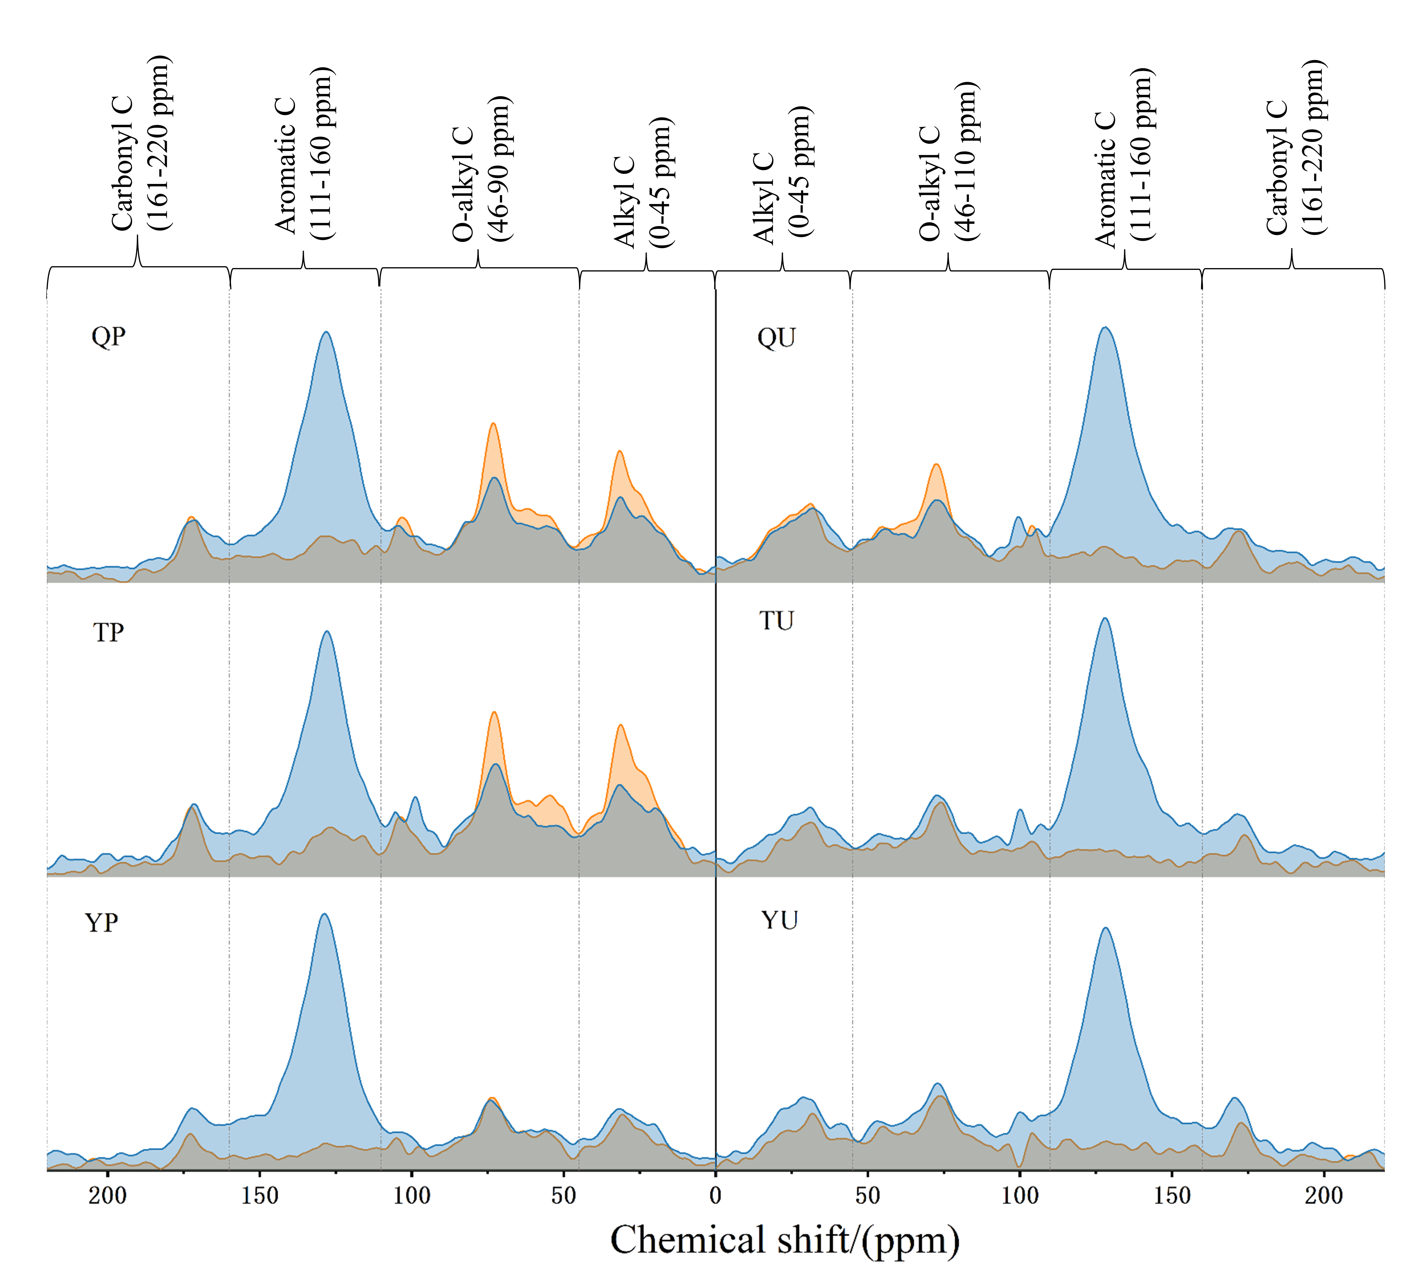
Figure S1. ¹³C solid-state NMR spectra of soil organic carbon under different treatments. QP, Quaternary red clay paddy soil; TP, Tertiary red sandstone paddy soil; YP, Yellow River alluvium paddy soil; QU, Quaternary red clay upland soil; TU, Tertiary red sandstone upland soil; YU, Yellow River alluvium upland soil.

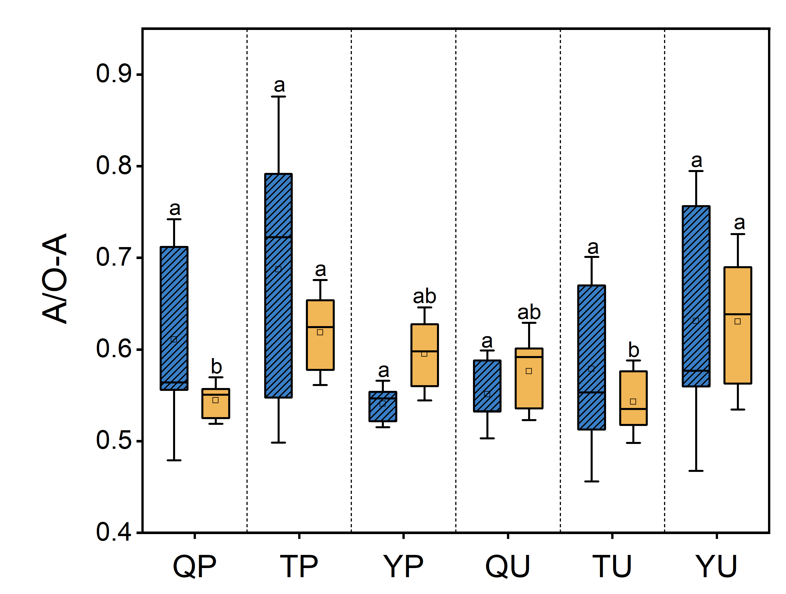
Figure S2. A/O-A. A/O-A, alkyl C/O-alkyl C. Bars represent the standard deviation (n = 3). Different letters indicate significant differences between different soils at the same BC application rate at p < 0.05.

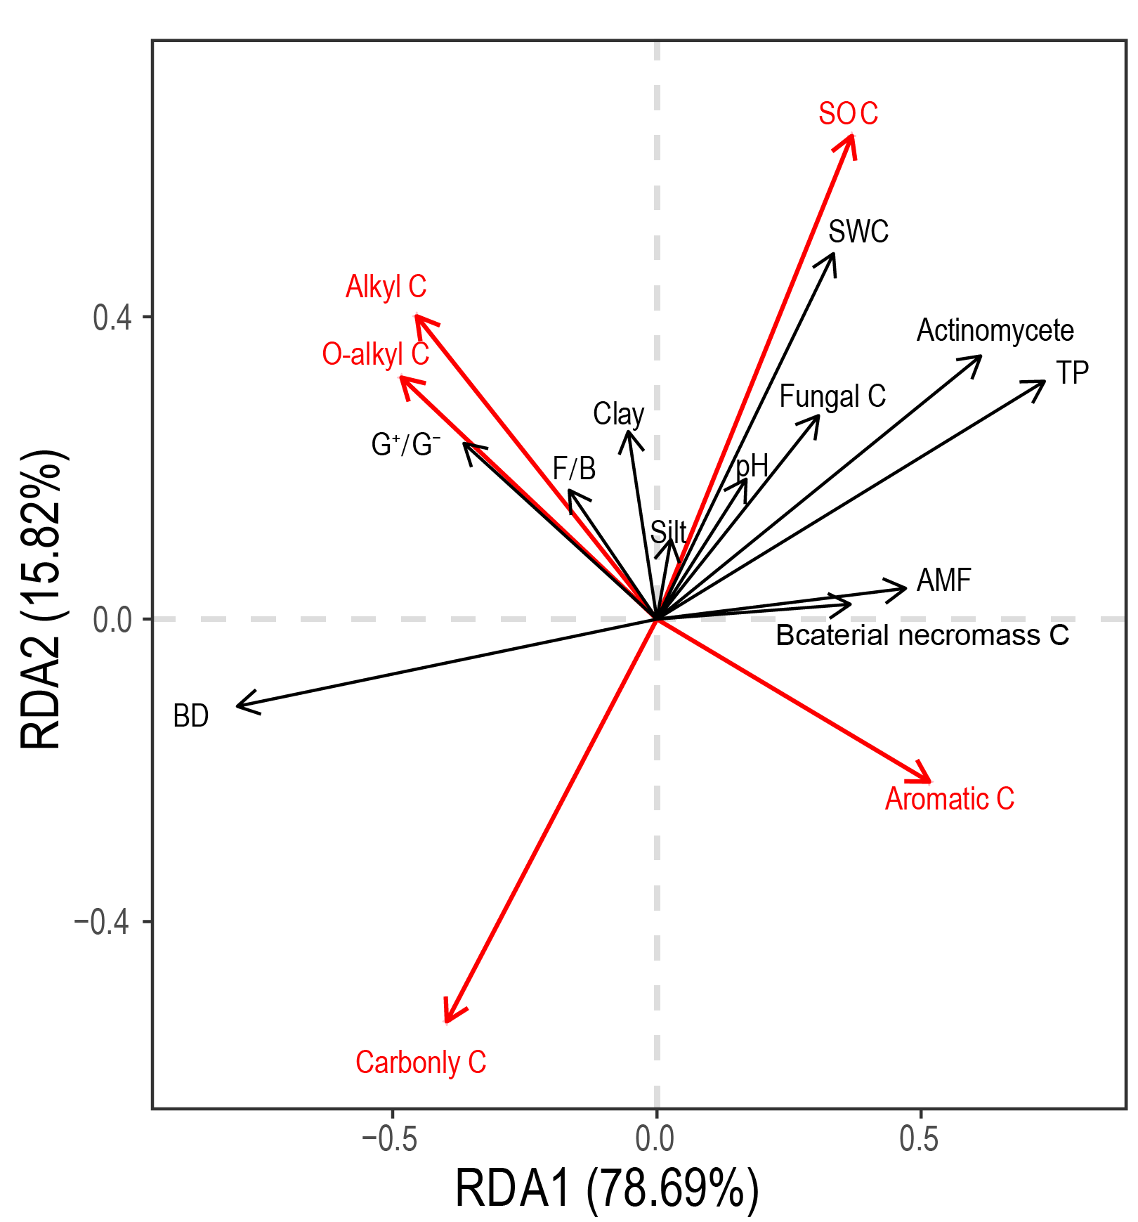
Figure S3. Redundancy analysis (RDA) of soil microbial activity, community structure, microbial necromass C and SOC chemical composition (%) under control and biochar treatments.

