Supplementary Information for
Microbial Regulation Mechanisms of Soil Organic Carbon Sequestration by Biochar Application
Gehao Zhangª, Lei Deng^{a,b,c*}, Yang Liao^{a,c}, Jianzhao Wuª, Xining Zhao^{ac}, Zhouping Shangguan^{ac}

ªState Key Laboratory of Soil and Water Conservation and Desertification Control, College of Soil and Water Conservation Science and Engineering (Institute of Soil and Water Conservation), Northwest A&F University, Yangling 712100, Shaanxi, China.
^{b}Key Laboratory of Applied Ecology of Loess Plateau, College of Life Science, Yan’an University, Yan’an 716000, Shaanxi, China
^{c}Institute of Soil and Water Conservation, Chinese Academy of Science and Ministry of Water Resources, Yangling 712100, Shaanxi,China.
*Corresponding author. E-mail: leideng@ms.iswc.ac.cn

The following Supplementary Information is available for this article:
Table S1–S3
Figures S1–S10

Table S1 Fixed-effect estimates from the linear mixed-effects model explaining SOC response ratio (SOC_RR). Estimates, standard errors (S.E.), degrees of freedom (df), t-values, p-values, and 95% confidence intervals (CIs) are shown. Marginal R² (0.262) represents the variance explained by fixed effects; Significant effects (p < 0.05) are in bold.
 | Estimate | S.E. | df | t | P | 95% CIs |  | M_R²
 |  |  |  |  |  | Lower | Upper | M_R²
(Intercept) | 1.299 | 0.651 | 1.888 | 2.0 | 0.192 | −1.670 | 4.268 | 0.262
MBC_RR | 0.538 | 0.205 | 169.156 | 2.6 | 0.009 | 0.134 | 0.942
C/N_Soil | 0.093 | 0.165 | 169.776 | 0.6 | 0.572 | −0.232 | 0.419
pH_Soil | 0.487 | 0.197 | 168.118 | 2.5 | 0.015 | 0.097 | 0.876
TN_Soil | −0.329 | 0.169 | 168.368 | −1.9 | 0.054 | −0.662 | 0.005
BC_w/w | 0.596 | 0.215 | 167.336 | 2.8 | 0.006 | 0.172 | 1.020
Duration (days) | −0.079 | 0.203 | 168.409 | −0.4 | 0.698 | −0.481 | 0.323
MAP | −0.901 | 0.200 | 169.292 | −4.5 | 0.000 | −1.296 | −0.506
MAT | 0.072 | 0.233 | 169.667 | 0.3 | 0.759 | −0.388 | 0.532
bacteria_Chao1_RR | −0.812 | 0.215 | 168.109 | −3.8 | 0.000 | −1.236 | −0.388
bacteria_Shannon_RR | −0.052 | 0.222 | 168.073 | −0.2 | 0.814 | −0.490 | 0.386
bacteria_Simpson_RR | −0.710 | 0.235 | 168.348 | −3.0 | 0.003 | −1.173 | −0.247
Proteobacteria_RR | 0.305 | 0.151 | 168.464 | 2.0 | 0.045 | 0.007 | 0.602
Verrucomicrobia_RR | 0.459 | 0.204 | 168.424 | 2.2 | 0.026 | 0.056 | 0.863
Nitrospirae_RR | −0.085 | 0.143 | 168.299 | −0.6 | 0.552 | −0.368 | 0.198
Acidobacteria_RR | −0.593 | 0.162 | 168.631 | −3.7 | 0.000 | −0.913 | −0.273
Actinobacteria_RR | 1.195 | 0.156 | 168.661 | 7.6 | 0.000 | 0.886 | 1.503
Bacteroidota_RR | 0.458 | 0.194 | 168.753 | 2.4 | 0.019 | 0.075 | 0.840
Chloroflexi_RR | −0.612 | 0.206 | 168.722 | −3.0 | 0.003 | −1.018 | −0.205
Firmicutes_RR | 0.241 | 0.177 | 169.503 | 1.4 | 0.176 | −0.109 | 0.591
Gemmatimonadota_RR | 0.289 | 0.196 | 169.156 | 1.5 | 0.143 | −0.099 | 0.677
Ascomycota_RR | −0.104 | 0.169 | 169.541 | −0.6 | 0.540 | −0.437 | 0.229
Basidiomycota_RR | −0.086 | 0.173 | 168.809 | −0.5 | 0.618 | −0.428 | 0.255
pH_BC | 0.155 | 0.180 | 168.360 | 0.9 | 0.392 | −0.201 | 0.511
C/N_BC | −0.398 | 0.202 | 168.429 | −2.0 | 0.051 | −0.797 | 0.002
Notes：Marginal R² of mixed−effects models is 0.262, whereas Conditional R² is 0.316.

Table S2 Test for publication bias for the response of different indicator to experimental conditions using Egger’s regression test and Fail‐Safe Analysis with Rosenberg method.
Type | Indicator | n | Egger_Z | Egger_p | Fail−safe coefficient
Field | SOC | 110 | −1.52244851 | 0.12789674 | 1681241.63 | >5n+10
Field | TN | 87 | 2.7940445 | 0.00520533 | 61029.5793 | >5n+10
Field | pH | 113 | −0.39663532 | 0.6916364 | 119724.663 | >5n+10
Field | MBC | 27 | −0.89835063 | 0.36899865 | 362142.779 | >5n+10
Field | Bacteria_chao1 | 66 | 0.90175357 | 0.36718779 | 6109.98854 | >5n+10
Field | Bacteria_shannon | 81 | 0.48941833 | 0.62454556 | 3709.9798 | >5n+10
Field | Acidobacteria | 108 | 2.4719275 | 0.01343868 | 6902.40174 | >5n+10
Field | Actinobacteria | 109 | −1.3953307 | 0.16291614 | 6886.19907 | >5n+10
Field | Bacteroidota | 98 | 1.58307165 | 0.11340514 | 1436.05523 | >5n+10
Field | Chloroflexi | 89 | 0.94281571 | 0.34577517 | 103.269478 | 103
Field | Firmicutes | 88 | −0.54092367 | 0.58856019 | 4321.50464 | >5n+10
Field | Gemmatimonadota | 98 | 1.71917042 | 0.08558335 | 51635.4018 | >5n+10
Field | Nitrospirae | 51 | −1.54217978 | 0.12302991 | 67701.5781 | >5n+10
Field | Proteobacteria | 111 | −2.62480461 | 0.00866987 | 430.023555 | 430
Field | Verrucomicrobia | 70 | −2.74912965 | 0.00597537 | 12253.0882 | >5n+10
Field | Ascomycota | 55 | −2.08363673 | 0.03719322 | 11136.366 | >5n+10
Field | Basidiomycota | 42 | −0.00390461 | 0.99688458 | 564.634008 | >5n+10

Type | Indicator | n | Egger_Z | Egger_p | Fail−safe coefficient
Incubation | SOC | 32 | 3.41310598 | 0.00064227 | 237950.1 | >5n+10
Incubation | TN | 22 | 0.41216884 | 0.68021568 | 44617.2932 | >5n+10
Incubation | pH | 36 | −0.18626908 | 0.85223375 | NA | NA
Incubation | MBC | 18 | −5.65916369 | 1.5211E−08 | 4139339.34 | >5n+10
Incubation | Bacteria_chao1 | 14 | 2.11942016 | 0.03405497 | 300.265145 | >5n+10
Incubation | Bacteria_shannon | 24 | 0.01336018 | 0.98934043 | 25.2444317 | 25
Incubation | Acidobacteria | 38 | −0.40143508 | 0.68809983 | NA | NA
Incubation | Actinobacteria | 38 | 0.99688985 | 0.31881798 | 35651.3205 | >5n+10
Incubation | Bacteroidota | 32 | −0.11967809 | 0.90473816 | NA | NA
Incubation | Chloroflexi | 38 | 2.05499619 | 0.03987937 | NA | NA
Incubation | Firmicutes | 17 | −0.55450137 | 0.57923577 | 46455.8075 | >5n+10
Incubation | Gemmatimonadota | 31 | −1.30040972 | 0.19346058 | 4197.9741 | >5n+10
Incubation | Nitrospirae | 14 | −2.27942191 | 0.022642 | 238.616477 | >5n+10
Incubation | Proteobacteria | 34 | −1.09078354 | 0.27536814 | 2472.1617 | >5n+10
Incubation | Verrucomicrobia | 13 | 1.37920645 | 0.16783111 | 6305.05161 | >5n+10
Incubation | Ascomycota | 14 | −2.44314823 | 0.01455976 | NA | NA
Incubation | Basidiomycota | 13 | −2.13470576 | 0.03278505 | 36037.1132 | >5n+10

Type | Indicator | n | Egger_Z | Egger_p | Fail−safe coefficient
Pot | SOC | 58 | −2.09889113 | 0.0358265 | 9871460.27 | >5n+10
Pot | TN | 40 | 1.49840409 | 0.13402829 | 177908.771 | >5n+10
Pot | pH | 41 | −1.08773136 | 0.27671372 | 168859.439 | >5n+10
Pot | MBC | 16 | −4.52274137 | 6.1044E−06 | 230279.762 | >5n+10
Pot | Bacteria_chao1 | 41 | −0.01502204 | 0.98801459 | 2415.86457 | >5n+10
Pot | Bacteria_shannon | 40 | −0.04853056 | 0.96129341 | 18954.0326 | >5n+10
Pot | Acidobacteria | 41 | 3.75101175 | 0.00017612 | 76601.6527 | >5n+10
Pot | Actinobacteria | 46 | −0.84444838 | 0.3984189 | 42468.4911 | >5n+10
Pot | Bacteroidota | 38 | 0.11264903 | 0.91030882 | NA | NA
Pot | Chloroflexi | 44 | 2.87372508 | 0.00405662 | 118395.538 | >5n+10
Pot | Firmicutes | 24 | −1.72529901 | 0.0844736 | NA | NA
Pot | Gemmatimonadota | 21 | −4.08925587 | 4.3276E−05 | 72454.6344 | >5n+10
Pot | Nitrospirae | 23 | −2.85047295 | 0.00436543 | 32305.2147 | >5n+10
Pot | Proteobacteria | 52 | −1.82047574 | 0.06868659 | 12564.8385 | >5n+10
Pot | Verrucomicrobia | 21 | −0.35167846 | 0.72507942 | 3171.1684 | >5n+10
Pot | Ascomycota | 15 | −1.24915408 | 0.21160872 | 794.848457 | >5n+10
Pot | Basidiomycota | 15 | 0.72411107 | 0.46899755 | 14764.2568 | >5n+10
Note: n is sample size. For Egger's regression test, Z is the egger regression intercept, p values > 0.05 indicates the absence of publication bias. For Fail−Safe Analysis, coefficients >5n+10 indicate the effect sizes of variables are statistically significant, and there was no potential publication bias in the dataset. NA indicates that the fail-safe N is not applicable because the overall effect was not statistically significant or the estimator yielded a non-interpretable (e.g., negative) value.
Table S3 Crop type classification.
Crop type | Description of treatment
Paddy rice | Japonica rice, rice paddy, rice, paddy
Upland cereals | Wheat, Winter wheat, maize, corn, potato
Legumes | Peanuts, soybean, T. repens, alfalfa, nuts, black locust
Industrial crops | Cotton, rapeseed, tobacco, pomelo, roses
Vegetables | Tomato, Vegetable, grape, apple, tea
Forestry | Bamboo, Cunninghamia lanceolata, Pinus massoniana, Cyclobalanopsis gilva
Cereal rotation | wheat−maize, Rice−wheat
Else | Without botany or incubation

To ensure consistency across studies, all cropping systems were categorized into eight groups: Paddy rice (e.g., japonica rice, rice paddies), Upland cereals (e.g., wheat, maize, corn, potato), Legumes (e.g., soybean, peanut, alfalfa), Industrial crops (e.g., cotton, rapeseed, tobacco), Vegetables or fruits (e.g., tomato, grape, apple, tea), Forestry (e.g., bamboo, Cunninghamia lanceolata, Pinus massoniana), Cereal rotation (e.g., wheat−maize, rice−wheat), and Else, which included studies without specified botanical information or incubation−only experiments.
Identification of studies via databases and registers
Identification of studies via databases and registers

Records removed before screening:
Duplicate records removed
(n = 2324)

Records identified from*:
Web of Science (n = 4939)

Identification

Records excluded
Base on their title and abstract
(n = 2524 )

Records screened
(n = 2615)

Screening

Full-test papers excluded:
(1)Only one type of soil physicochemical properties and microbial phylum were reported
(n =15 )
Reports sought for retrieval
(n = 91)

Reports assessed for eligibility
(n =76 )

Included
Studies included in review
(n =76 )

Fig. S1 PRISMA flow diagram showing the selection process of studies included in the analysis.

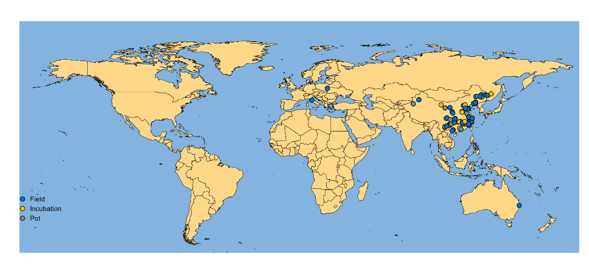
Fig. S2 The 76 study sites and experimental types included in the meta-analysis.

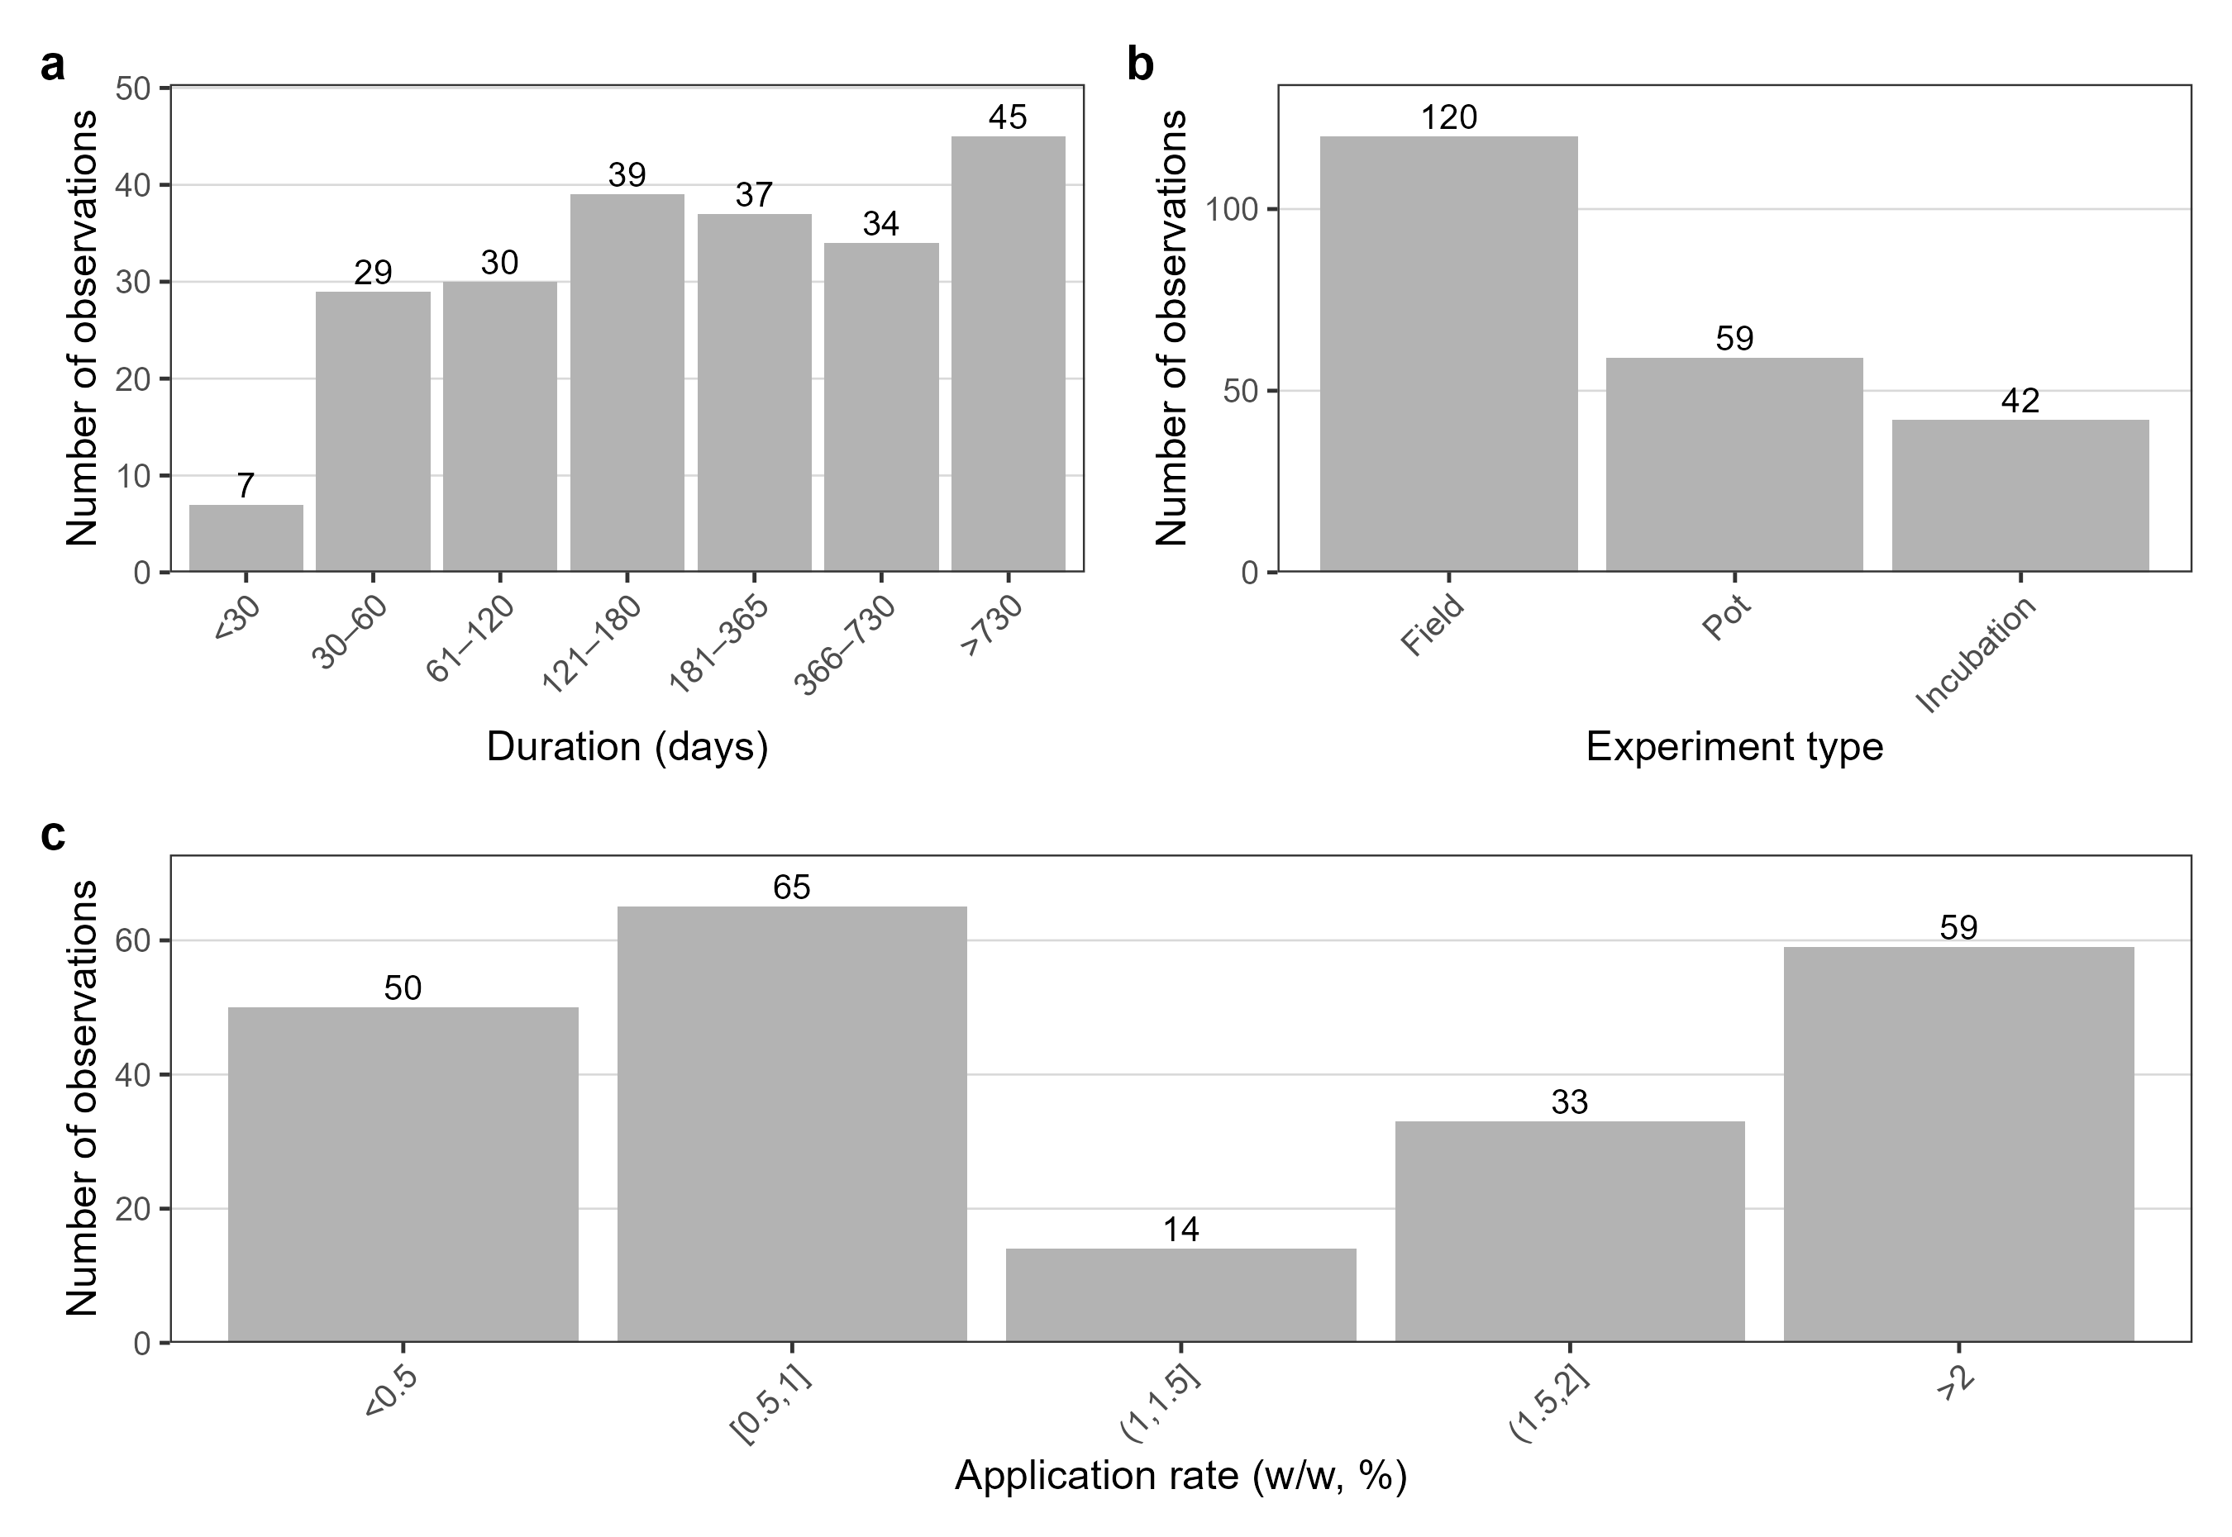
Fig. S3 Dataset composition. a: Study duration bins; b: experiment type (Field/Pot/Incubation); c: biochar application rates (< 0.5, 0.5 – 21, 1 – 1.5, 1.5 – 2, >2%; counts above bars).

Fig. S4 Biochar properties. Raincloud plots of a pH and b C/N (dots=observations; box=median/IQR; violin=distribution).

Fig. S5 Soil and climate overview. Raincloud plots of pH, TN (g kg⁻¹), SOC (g kg⁻¹), MAT (°C), and MAP (mm) a–e. (dots=observations; box=median/IQR; violin=distribution).
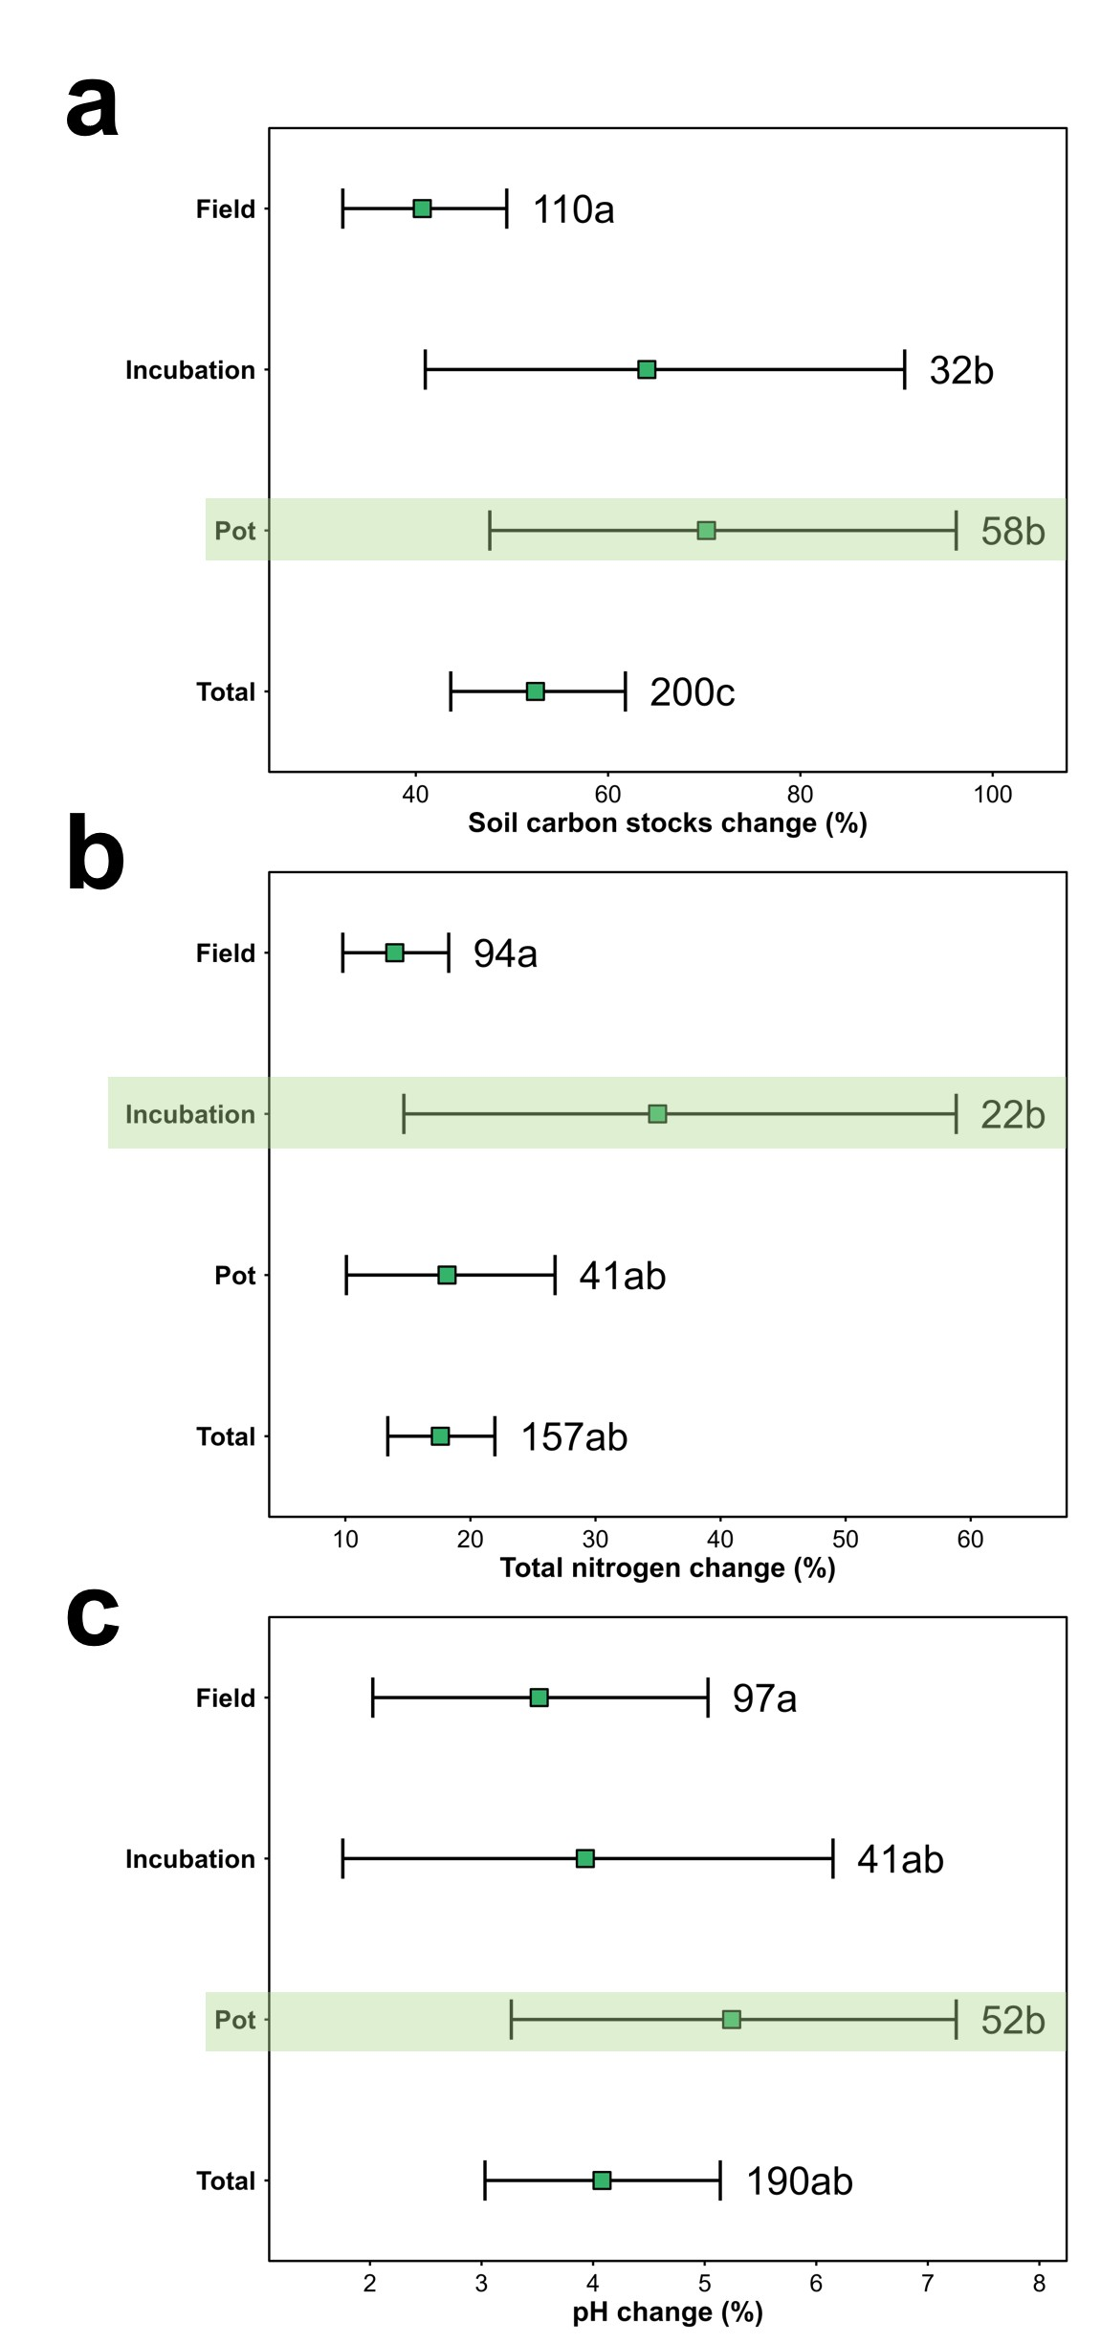
Fig. S6 Weighted mean effect sizes based on maximum likelihood estimation under different experimental types. Error bars indicate mean ± 95% confidence interval. Numbers represent the sample size for each experimental type. Panels a, b, and c represent the changes in SOC content, soil pH, and total nitrogen content, respectively, under different experimental types following biochar application. The letters is significant differences among treatment types (p < 0.05). The light-green shading highlights the subgroup with the highest mean SOC increase within each panel.
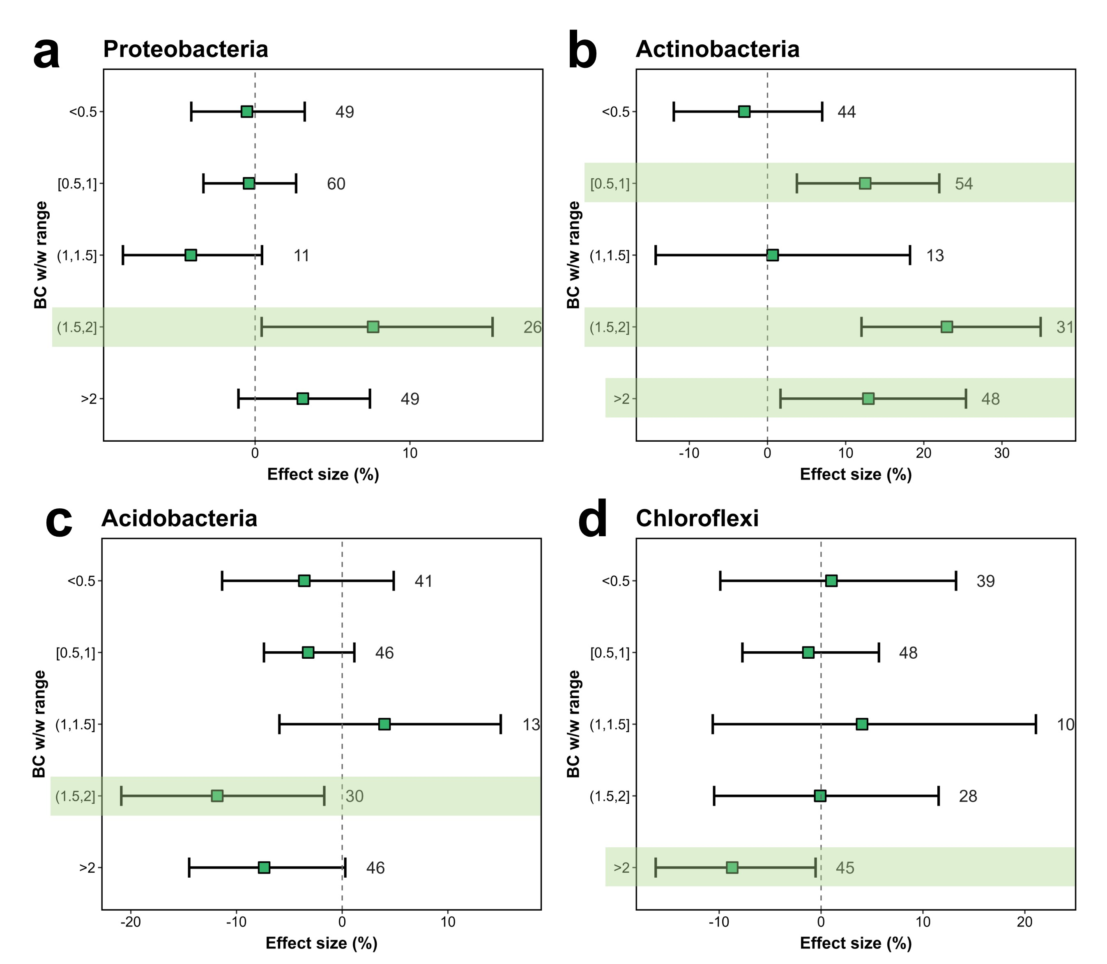
Fig. S7 Weighted mean effect sizes based on maximum likelihood estimation across different biochar application rates (BC w/w). Error bars indicate mean ± 95% confidence interval, and numbers represent subgroup sample sizes. Panels a, b, c, and d show the responses of Proteobacteria, Actinobacteria, Acidobacteria, and Chloroflexi, respectively. The light-green background highlights subgroups exhibiting significant differences within each classification (p < 0.05).
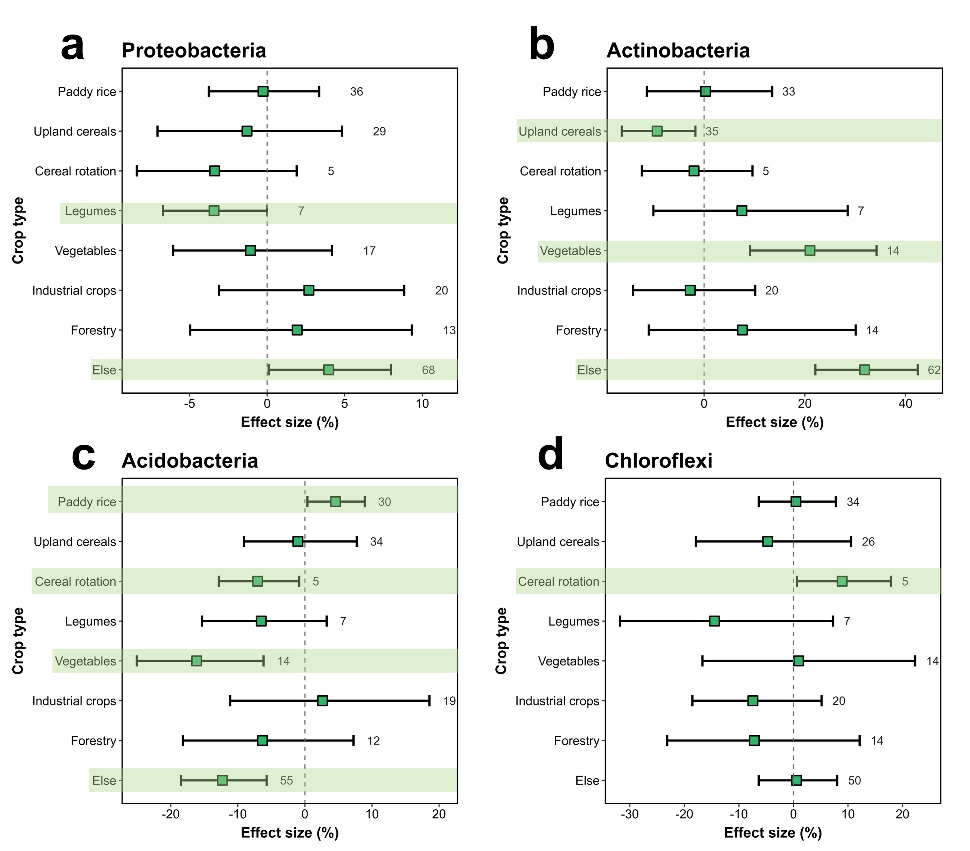
Fig. S8 Weighted mean effect sizes based on maximum likelihood estimation across different crop systems. Error bars indicate mean ± 95% confidence interval, and numbers represent sample sizes for each crop type. Panels a, b, c, and d show the responses of Proteobacteria, Actinobacteria, Acidobacteria, and Chloroflexi, respectively. The light-green background highlights subgroups exhibiting significant differences within each classification (p < 0.05).
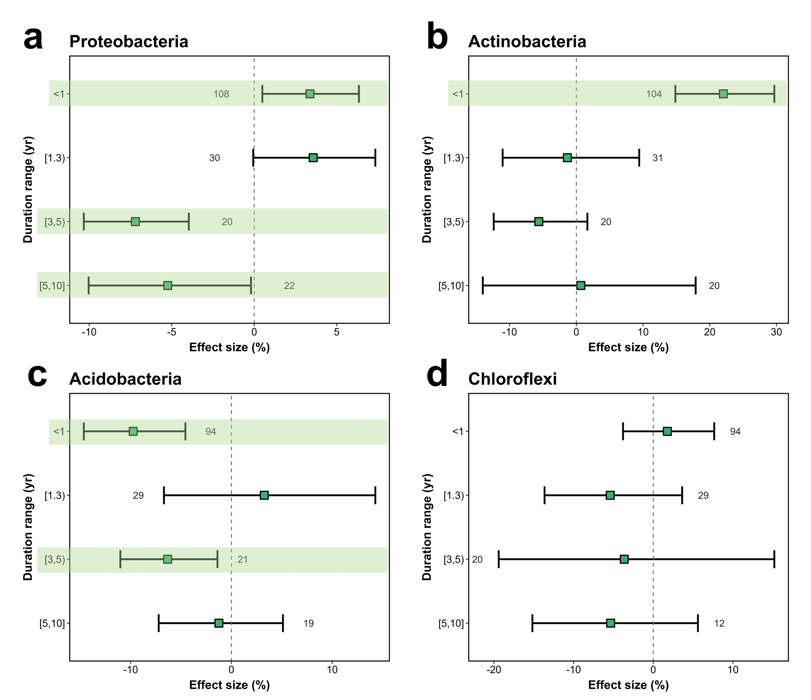
Fig. S9 Weighted mean effect sizes based on maximum likelihood estimation across biochar application durations. Error bars indicate mean ± 95% confidence interval, and numbers represent sample sizes for each duration range. Panels a, b, c, and d show the responses of Proteobacteria, Actinobacteria, Acidobacteria, and Chloroflexi, respectively. The light-green background highlights subgroups exhibiting significant differences within each classification (p < 0.05).

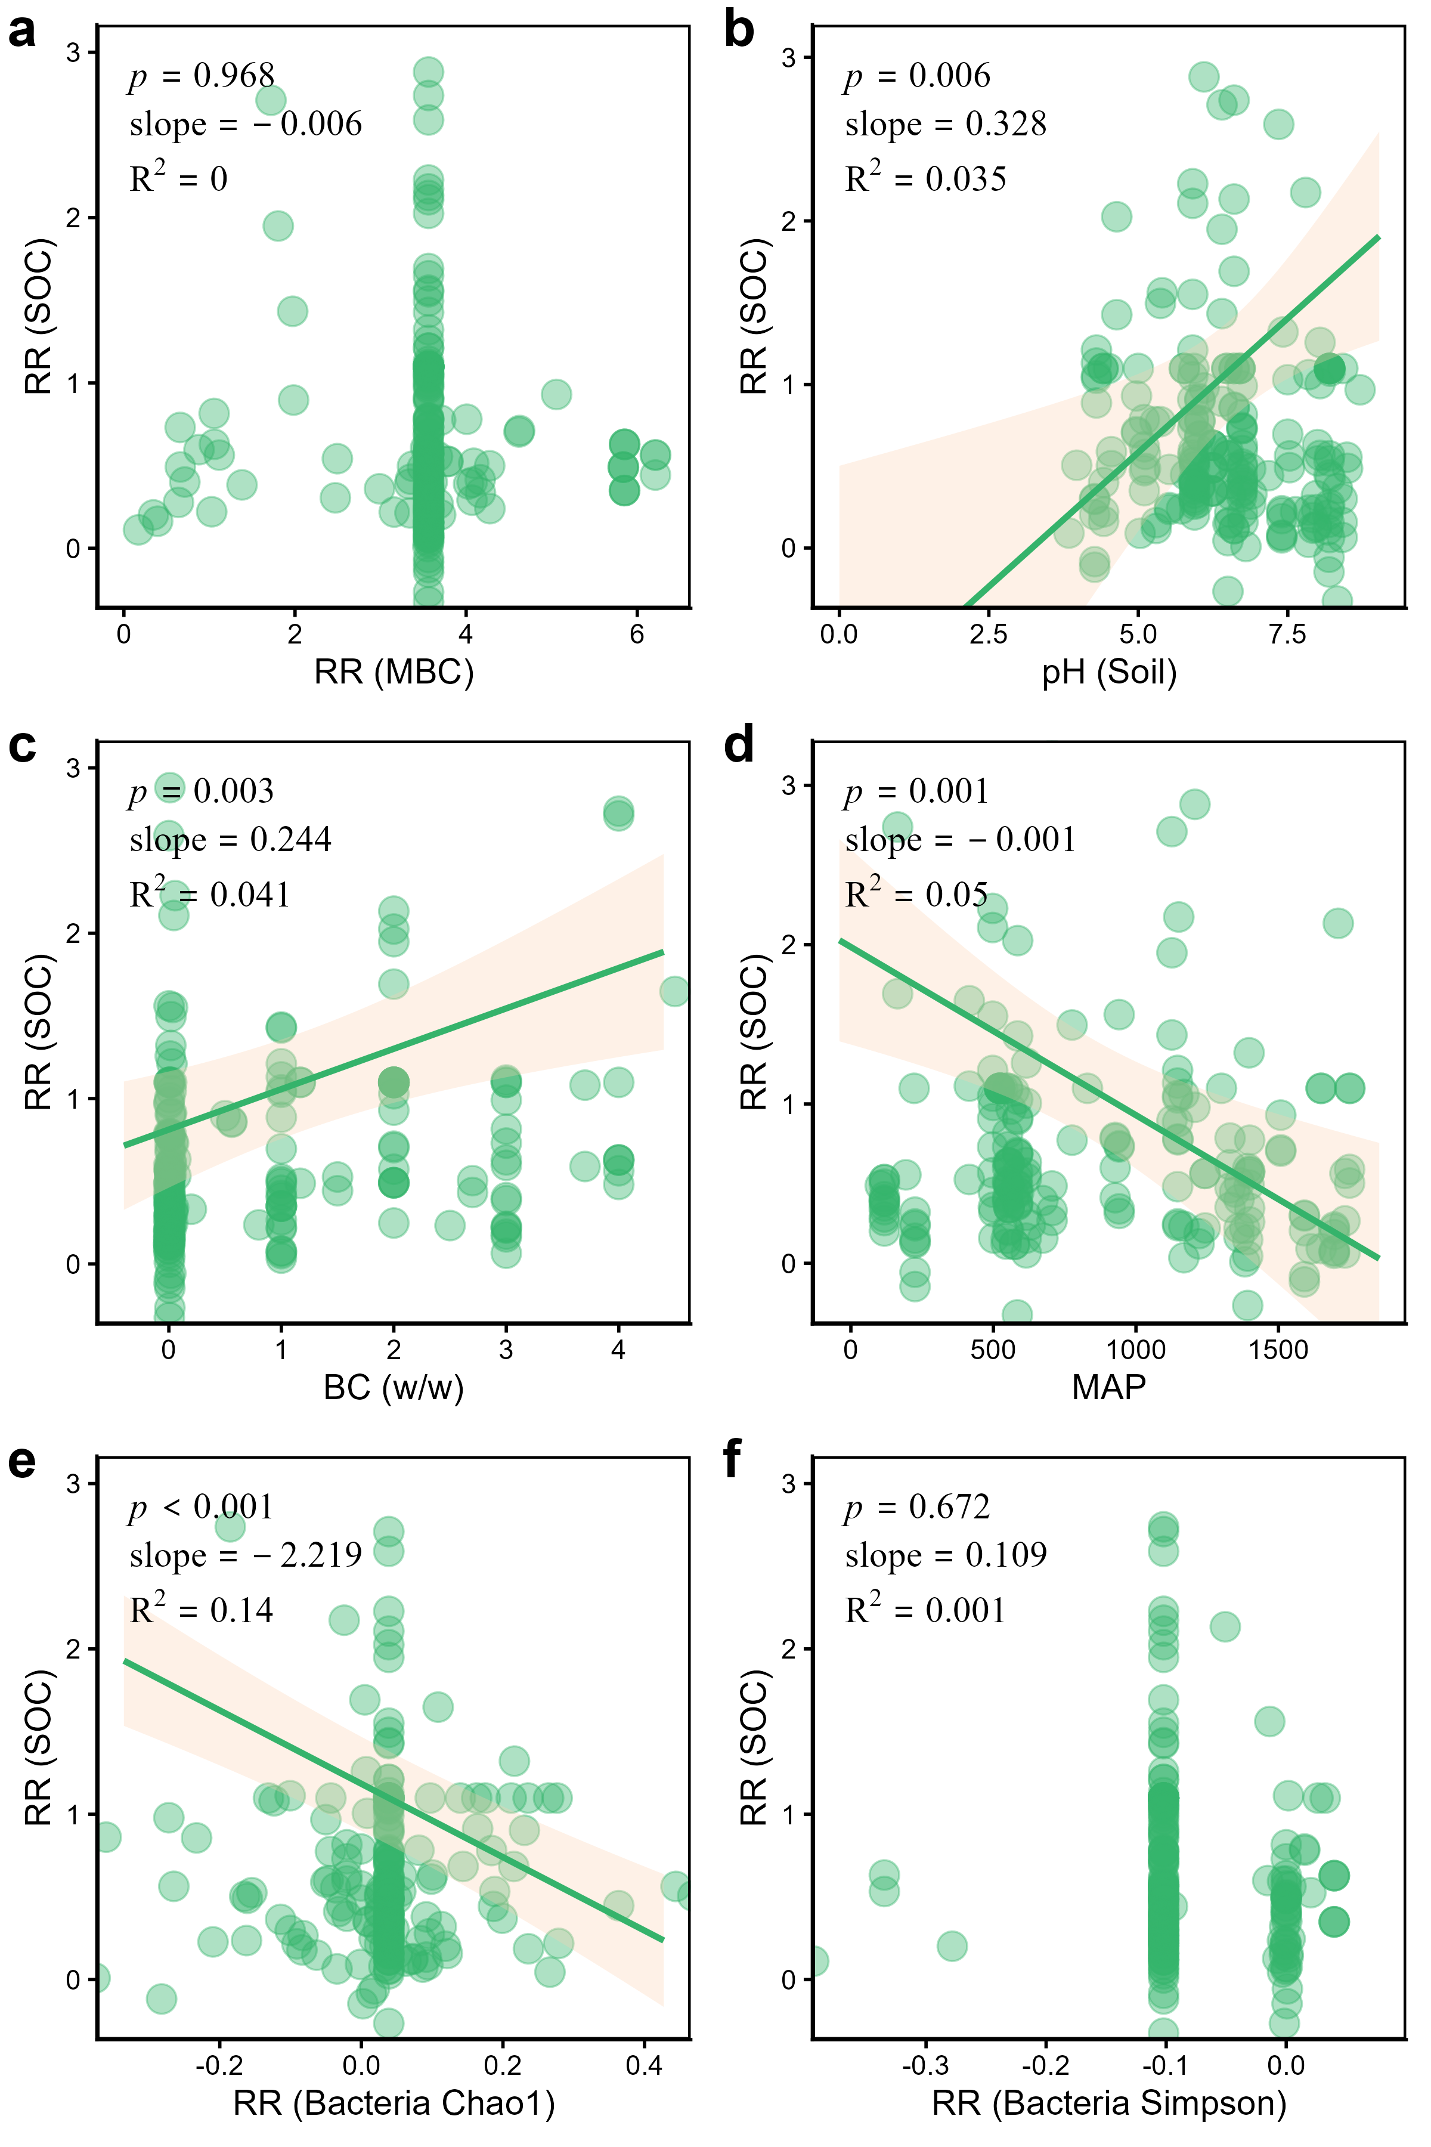
Fig. S10 Regression with SOC as response fitted to each predictor identified as significant in the mixed-effects model. Points represent weighted effect sizes estimated using a mixed-effects mode and sample size of each observation. The solid line and shaded area indicate the fitted line and corresponding 95% confidence interval, respectively. a, b, c, d, e, and f correspond to RR (MBC), pH (Soil), BC (w/w), (d) MAP, RR (Bacteria Chao1), and RR (Bacteria Simpson) , respectively.

