Supplementary Information
Text S1. Removal of total bacteria from municipal wastewater
Municipal wastewater feed and permeate samples were collected to measure the presence of bacteria. The total bacterial count (TBC) in the samples was determined by the plate count method reported in the literature (Ibrahim et al., 2020). The serial dilutions for each sample were made using 15 mL sterile tubes containing 9 mL of 0.1% peptone in water. Then, 1 mL of the well-mixed original sample was transferred into the first tube to obtain a 10⁻¹ dilution. Subsequently, tenfold serial dilutions were prepared up to 10⁻⁴ by transferring 1 mL from each preceding dilution into the next tube. A 50 µL aliquot from each dilution was aseptically inoculated onto the surface of Mueller–Hinton Agar (MHA) plates. The inoculated plates were incubated at 37 °C for 24 h under aerobic conditions. Following the incubation, bacterial colonies were observed and counted. The bacterial concentration or TBC (CFU/mL) was calculated using Eq. S1:
$$TBC= \frac{N_{c}}{V×F_{d}}$$ | $$(S1)$$
where $N_{c}$ is the number of colonies, $V$ is the volume plated (mL), and $F_{d}$ is the dilution factor. All procedures were performed under sterile conditions to avoid contamination, and the waste was autoclaved before disposal.

Table S1. The characteristics of the pretreated municipal wastewater feed solution.
Component | Concentration (mg/L)
COD | 276
Sulfate (SO₄²⁻) | 88
Phosphate (PO₄³⁻) | 29
Nitrate (NH₃⁺) | 0.45
Ammonium (NH₄⁺) | 108
Chloride (Cl⁻) | 13.3
Magnesium (Mg⁺) | 94.5
pH | 7.41

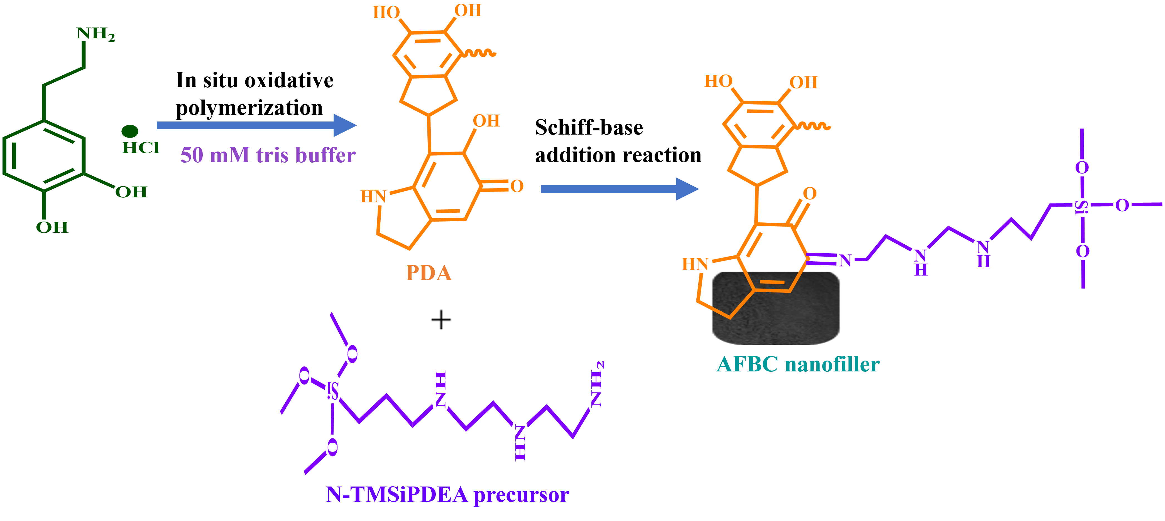
Scheme S1. Reaction route for synthesis of AFBC via one-pot mussel-inspired oxidative polymerization and Schiff-base addition reaction.

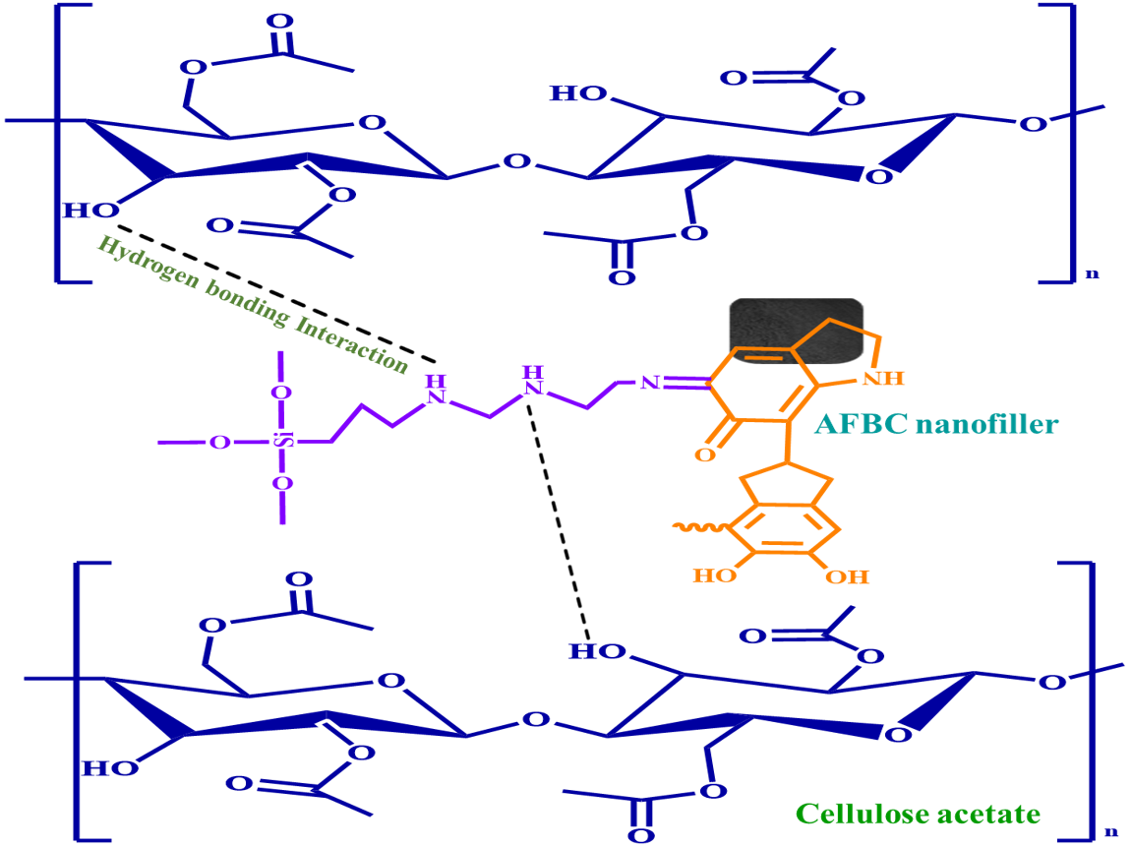
Fig. S1. Schematic representation of the interaction between AFBC nanofiller and CA within the matrix of the hybrid membrane.
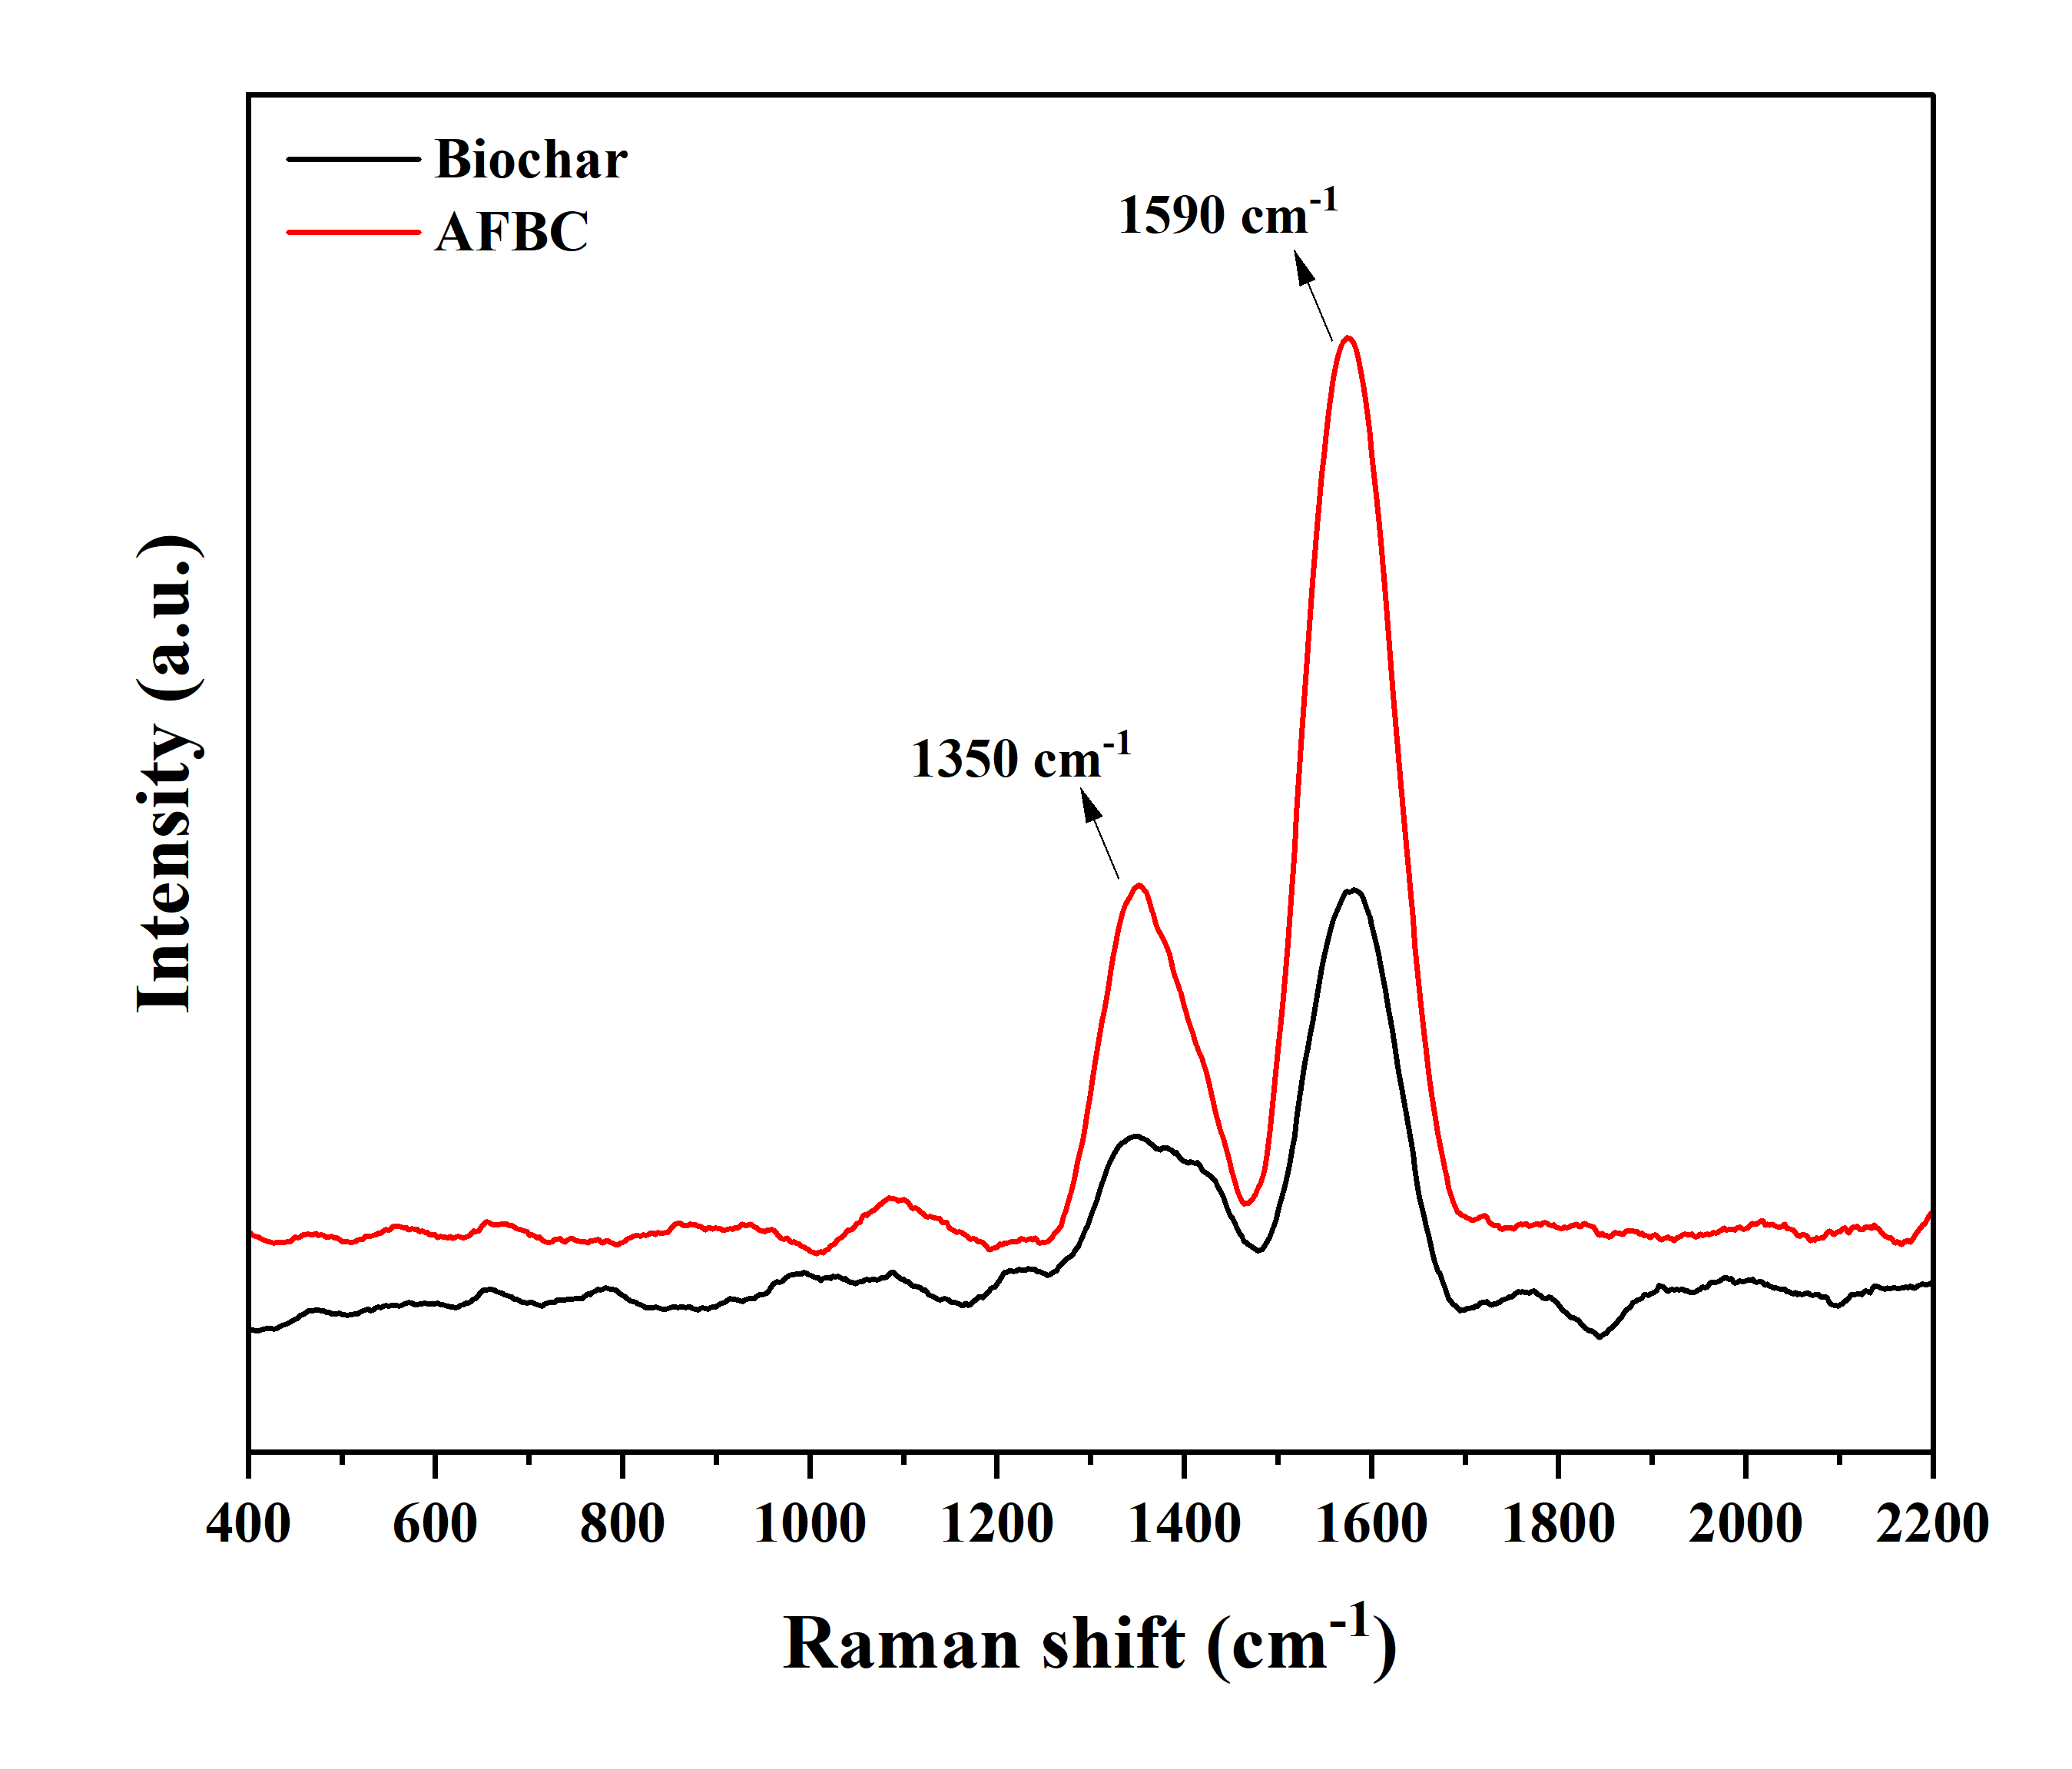
Fig. S2. Raman spectra of biochar and amine-functionalized biochar.
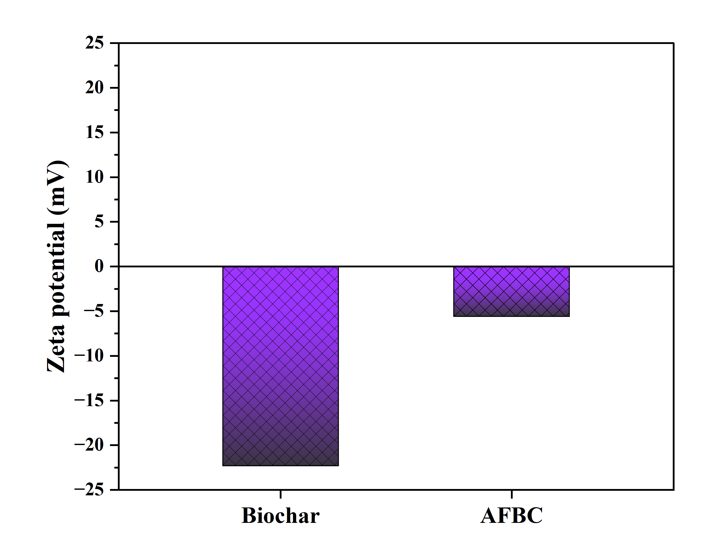
Fig. S3. The zeta potential (ζ, mV) of biochar and amine-functionalized biochar.

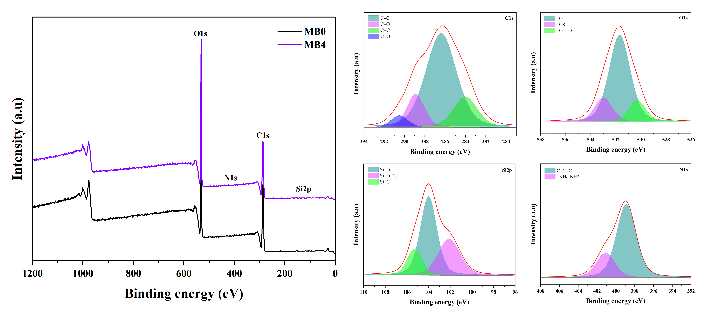
Fig. S4. XPS survey spectra of pristine membrane MB0 and hybrid MB4, along with the deconvoluted XPS spectra of C, O, Si, and N for the hybrid membrane MB4.
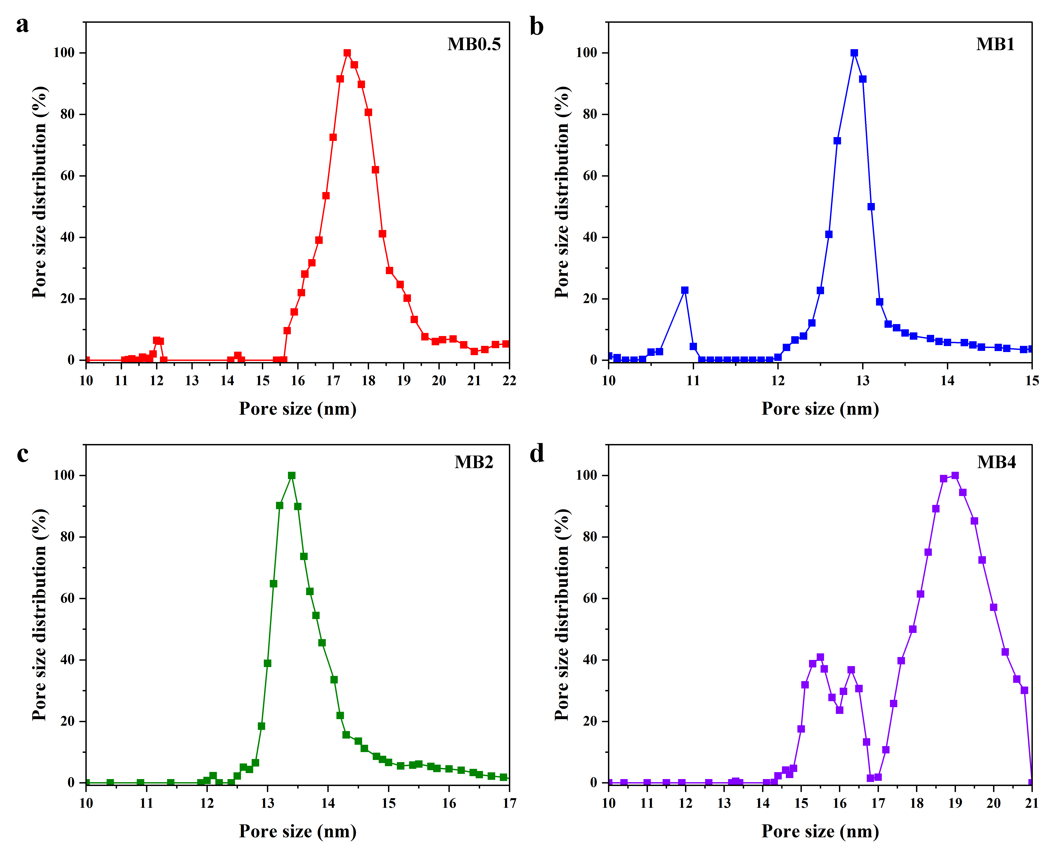
Fig. S5. Pore size distribution of amine-functionalized biochar infused hybrid membranes MB0.5, MB1, MB2, and MB4, respectively.
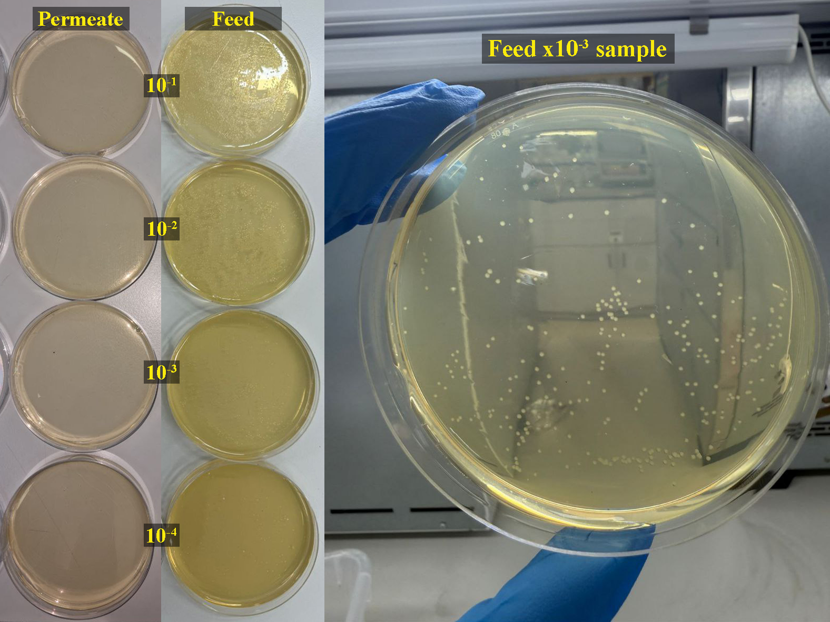
Fig. S6. TBC test for municipal wastewater feed and permeate samples at different dilutions.
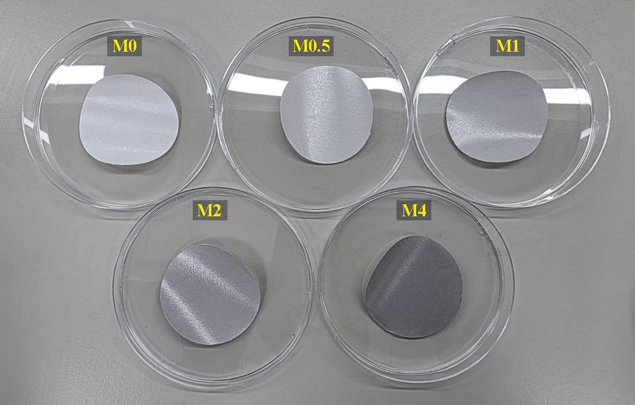
Fig. S7. Digital image of cuts from the fabricated membranes.

References
Ibrahim, Y., Banat, F., Yousef, A. F., Bahamon, D., Vega, L. F., & Hasan, S. W., 2020. Surface modification of anti-fouling novel cellulose/graphene oxide (GO) nanosheets (NS) microfiltration membranes for seawater desalination applications. Journal of Chemical Technology & Biotechnology, 95(7), 1915-1925. doi:https://doi.org/10.1002/jctb.6341

