Supplementary Material
In-situ and long-enduring oxidation of SMX by Fe-modified biochar activated O₂ in soil: bridging Fe-redox cycling and electron transfer modulation

Hongying Duª, Lei Zhang ^{a,}*, Wenbo Liuª, Yuyang Xieª, Xueyan Houª, Junkang Guoª, Qixing Zhou^{b},

ª School of Environmental Science and Engineering, Shaanxi University of Science ＆ Technology, Xi’ an, 710021, PR China.
^{b}Key Laboratory of Pollution Processes and Environmental Criteria (Ministry of Education)/Tianjin Key Laboratory of Environmental Remediation and Pollution Control, College of Environmental Science and Engineering, Nankai University, Tianjin 300071, PR China.

*Corresponding author:
Lei Zhang, School of Environmental Science and Engineering, Shaanxi University of Science ＆ Technology, Xi’ an, 710021, PR China
Email: zhanglei0954@126.com
This document contains 9 texts (S1-9), 16 figures (S1-16), 4 tables (S1-4)

List of Texts
Text S1. Chemicals.
Text S2. The characterization for physico-chemical properties of BC-Fex.
Text S3. Electrochemical Analysis.
Text S4. Preparation of contaminated soil.
Text S5. Method for extraction and determination of SMX in soils.
Text S6. Measurements of p-HBA.
Text S7. ⁵⁷Fe Mössbauer spectroscopy (13 K) analysis.
Text S8. Toxicological experiments.
Text S9. Structural equation model.

List of Figures
Fig. S1. Flow chart of preparation of iron-carrying biochar materials.
Fig. S2. The total iron content in the soil extracted by hydrochloric acid.
Fig. S3. XPS spectra of low-temperature biochar with gradient iron loading.
Fig. S4. XRD patterns of low-temperature biochar with gradient iron loading.
Fig. S5. Physico-chemical properties of BC-Fex.
Fig. S6. Cyclic Voltammetry (CV) curves.
Fig. S7. Quantitative and qualitative analysis of free radicals.
Fig. S8. Correlation analyses between cumulative •OH and consumed Fe(II).
Fig. S9. The content of HF-Fe(II) during oxygenation of soils with/without gradient iron loading BC-Fe400 during 30 days oxygenation.
Fig. S10. Evolution of Mössbauer and XPS spectra for HBC-Fe400 before and after soil amendment.
Fig. S11. The changes of pH and Eh during oxygenation of soils with/without gradient iron loading BC-Fe400 during 30 days oxygenation.
Fig. S12. Van Krevelen diagram of DOM formulas detected in soils with HBC-Fe400 after 10d incubation.
Fig. S13. Radar plots of links detected of DOM with HBC-Fe400 after oxygenation. (a)10d. (b)30d.
Fig. S14. Mass spectra of SMX degradation products detected by LC-MS.
Fig. S15. The intensities of detected degradation products of SMX with LC-MS after the incubation period of 30 days.
Fig. S16. Oral rat LD50 of SMX degradation intermediates.

List of Tables
Table S1. Physicochemical properties of farmland soils used in this study.
Table S2. The total Fe contents of the BC-Fex.
Table S3. Molecular characteristics of DOM measured by FT-ICR MS analysis.
Table S4. General information on identified transformation products of SMX.

Text S1. Chemicals
Ultrapure water (UW, 18.2 MΩ cm) obtained from a Millipore Milli-Q water purification system (Milford, USA) was adopted to configure all aqueous solutions. Sulfamethoxazole (SMX, C₁₀H₁₁N₃O₃S, 98.0%), Sodium benzoate (BA, 99.5%), p-hydroxybenzoic acid (p-HBA, 99%), phosphoric acid (85% w/v in H2O) were purchased from Aladdin Chemistry Co., Ltd. (Shanghai, China). Hydroxylamine hydrochloride (98%), ammonium acetate (98%), dimethyl sulfoxide (DMSO, 99.5%), hydrochloric acid (GR), hydrofluoric acid (GR), sulfuric acid (AR), and acetic acid (GR) were obtained from the Sinopharm Chemical Reagent Co., Ltd. (Shanghai, China). Methanol (HPLC grade) was obtained from Macklin Biochemical Co., Ltd. (Shanghai, China).

Text S2. The characterization for physico-chemical properties of BC-Fex
The morphologies characteristics of BC-Fex, were analyzed using scanning electron microscopy (SEM, Thermo Fisher Scientific Inc., USA). Meanwhile, the carbon structures were evaluated through Raman spectroscopy analysis. Fourier transform infrared spectroscopy (FT-IR, VERTEX 80, Bruker, Germany) was adopted for analyzing the surface functional groups (FGs). Furthermore, X-ray diffractometry (XRD, Ultima IV, Rigaku, Japan) was employed to examine the structure and crystallinity of BC-Fex. The valence state of Fe in the BC-Fex was determined by X-ray photoelectron spectroscopy (XPS) using an ESCALAB 250Xi XPS spectrometer (Thermo Fisher, USA). Persistent free radicals (PFRs) were characterized for their species and concentrations via electron paramagnetic resonance spectroscopy (EMX nano, Bruker, Germany). Gaussian function fitting was applied to EPR signals to verify the g-value.

Text S3. Electrochemical Analysis
Cyclic voltammetry (CV) and electrochemical impedance spectroscopy (EIS) were employed to test and evaluate the electrochemical performance of the prepared electrodes in a three-electrode system, where a platinum sheet electrode as the counter electrode, the prepared electrodes as working electrodes, and Ag/AgCl functioned as the reference electrode. Furthermore, the electron exchange capacities (EEC) of BC-Fex were quantitatively determined using the mediated electrochemical reduction (MER) and oxidation (MEO) method. The N, N-bis(3-sulfonatopropyl)-4-4’-bipyridinium (ZiV) and 2, 2’-azino-bis (3-ethylben- zothiazoline-6-sulfonic acid) (ABTS), respectively, are used as a redox mediator in phosphate buffer (pH 7) [1]. The ABTS and Ziv mediators, respectively, could be reduced or oxidized at applied potential are +0.61V and －0.49V vs SHE in MER and MEO, which fulfilled the measurement requirement of the potential range reported for redox functional groups of biochar. During the MER/MEO experiment, adding ZiV (in MER) or ABTS (in MEO) into reaction cells would result in reductive and oxidative current peaks, respectively. When the background current value stabilizes, the iron-based biochar suspension is added. The integrated current responses were normalized to the added BC-Fex, to obtain electron accepting capacities (EAC) and donating capacities (EDC) values (Eqs. S1, s2) [2]. The electron exchange capacity (EEC = EAC + EDC) describes the total capacity to accept and donate electrons.
$EAC=\frac{\int{\frac{I_{red}}{F}dt}}{m_{char}}$ （S1）
$EDC=\frac{\int{\frac{I_{ox}}{F}dt}}{m_{char}}$ （S2）
where Ired and Iox are the baseline-corrected reductive and oxidative currents in MER and MEO, respectively, and F is the Faraday constant (96,485 sA/mole).

Text S4. Preparation of contaminated soil
One kilogram of the soil samples was spiked with 10 mg SMX dissolved in methanol (10 mg kg⁻¹ SMX in soil) [3]. After being thoroughly mixed, the spiked soils were placed under the fume hood until the complete volatilization of methanol. In addition, the contaminated soil should be kept for aging at room temperature (25°C) for at least two weeks and then the dry soil was passed through a 60 mesh sieve. The prepared soil was stored in a brown glass bottle under a dark condition in a refrigerator (4°C) waiting for upcoming treatment.

Text S5. Method for extraction and determination of SMX in soils
Determination of SMX concentration in soil was based on the following method. Soil samples (1.5 g) were extracted with buffer solution (15 mL) consisting of methanol (7.5 mL), Na₂EDTA (2.5 mL, 0.1 M), and citrated buffer (5 mL, pH = 4). The mixture was shaken at 250 r min⁻ ¹ for 1 h, sonicated for 15 min, and centrifuged at 4000 r min⁻¹ for 5 min, and then the supernatant was collected. This extraction procedure was repeated three times.

Text S6. Measurements of p-HBA
The concentrations of p-HBA were analyzed by an LC 2030 Plus high performance liquid chromatography (HPLC, Agilent, USA) equipped with a C18 chromatography column (250 × 4.6 mm, 5 μm, Agilent). Mobile phase for analysis of p-HBA a mixture of 65% 1‰ (v/v) phosphate phosphoric acid and 35% methanol, with an injection volume of 10 μL and a flow rate at 1 mL min⁻¹. The UV detector was set at 254 nm for p-HBA analysis. Cumulative •OH concentration was estimated from 5.87 times of p-HBA concentration, respectively [4,5].

Text S7. ⁵⁷Fe Mössbauer spectroscopy (13 K) analysis
Soil samples were analyzed using a conventional spectrometer (WiSSEL MS-500, Germany) equipped with a closed-cycle cryostat SHI-850 and an Ar-Kr proportional counter detector (LND, Inc. NY) in transmission geometry with constant acceleration mode. A 57Co (Rh) source with an activity of 25 mCi was used and the velocity was calibrated from −10 to 10 mm s⁻¹ with a 13 K a-Fe absorber. The fitting of Mössbauer spectra was performed using the Voigt-based fitting (VBF) method for quadrupole splitting distributions (QSD) and combined hyperfine field distributions (HFD), in the RecoilTM software. The relative abundance of each Fe site population (i.e., mineral phases) was extracted from the spectral fitting as a fraction of the total Fe spectral area. The Mössbauer recoilless fractions of all detected Fe phases were assumed to be equal, which is expected to be valid at cryogenic temperatures.

Text S8. Toxicological experiments
In the present study, cherry radish seeds were chosen for germination and cultivation tests to monitor plant growth in various soil samples. The treatment components were uncontaminated soil (CK), High BC-Fe400-remediated soil (HBC-Fe400), and SMX-contaminated soil (SMX). Soils from each treatment group were weighed 10.00 g into 50 ml Teflon bottles and 30 ml ultrapure water was added as an extractant. After shaking, the samples were centrifuged at 5000 rpm for 10 min, and the supernatant was extracted and set aside. Cherry Radish seeds were sterilized with 2% NaClO for 15 min and then rinsed at least five times with ultrapure water [6]. After complete soaking with soil extract for 4 h at room temperature, the seeds were transferred to transparent observation boxes (10.5 cm in diameter at the top, 10 cm in height and 10.5 cm at the bottom) containing different treatment soils with more than 1 cm between seeds. The transparent observation boxes were then placed in the dark at 25°C for germination and sprayed with water, maintaining a soil-to-water ratio of about 60% throughout the planting period. Transparent observation boxes were randomly placed in the growth chamber. Water loss was compensated daily to keep the soil moist. After 5 and 15 days, whole plants were gently removed from the seedling pots and rinsed with ultrapure water. Three parallel replicates were established for each treatment group. The germination rate, stem length, and fresh weight of harvested plants were measured and recorded for each treatment group separately.

Text S9. Structural equation model.
Based on the results of BC-Fe properties, soil properties, and •OH formation in our experiments, a conceptual structural equation model was constructed to quantify the multivariate causal network in which BC-Fe and soil properties are involved (Fig. 5b). First, SEM contains five composite variables, which potentially represent the collections of variables in terms of BC-Fe and soil properties. Random forest analysis was also used to select indices (i.e., PFRs, I_{D}/I_{G}, Eh, Fe-reduction microbes, Fe(II), and SOC) that exhibited significant correlations with •OH formation. Then SEM was developed from the fully conceptual model using χ2 tests with maximum likelihood estimation. The model assumption that the sample covariance matrix is not different from the assumed model's expected covariance matrix, should not be true (p>0.05). Additionally, the relative contribution of BC-Fe and soil properties on •OH formation was also evaluated by SEM.

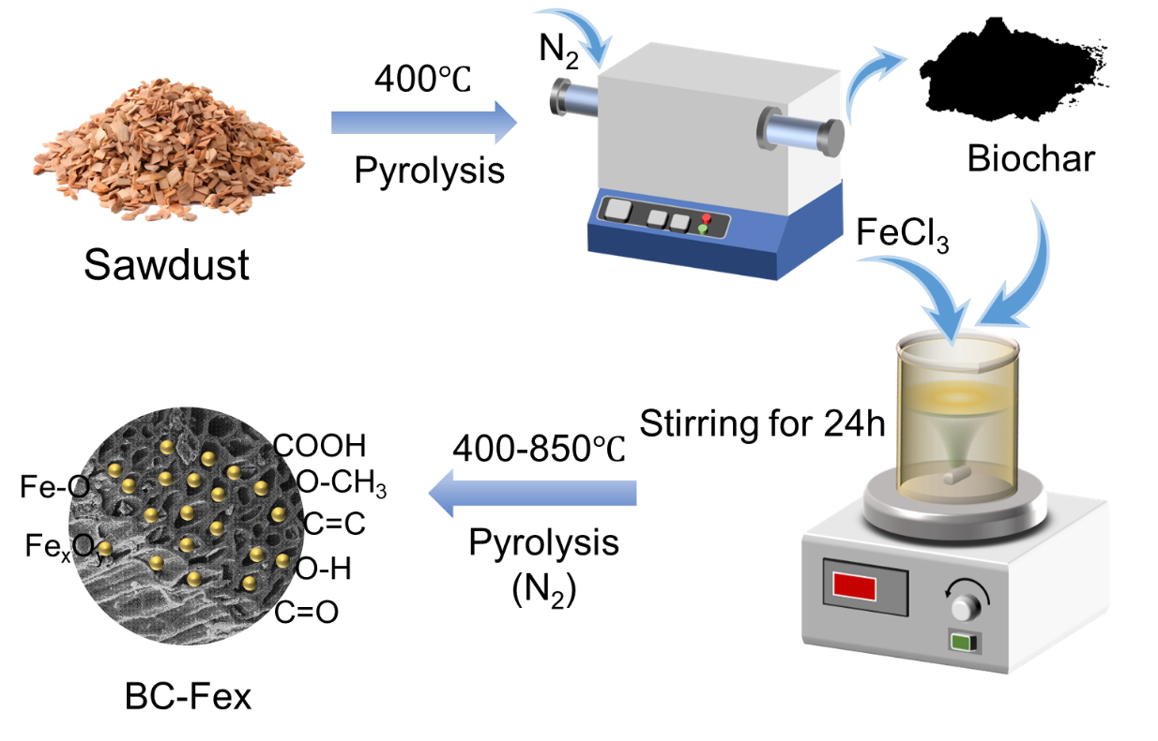
Fig. S1. Flow chart of preparation of iron-carrying biochar materials.
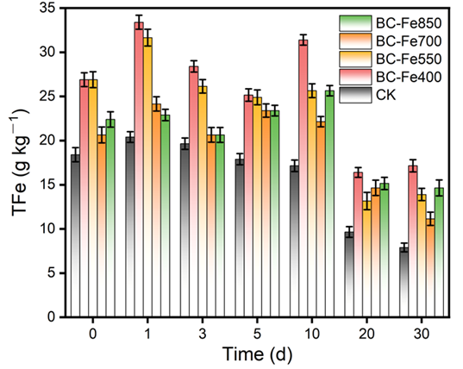
Fig. S2. The total iron content in the soil extracted by hydrochloric acid.

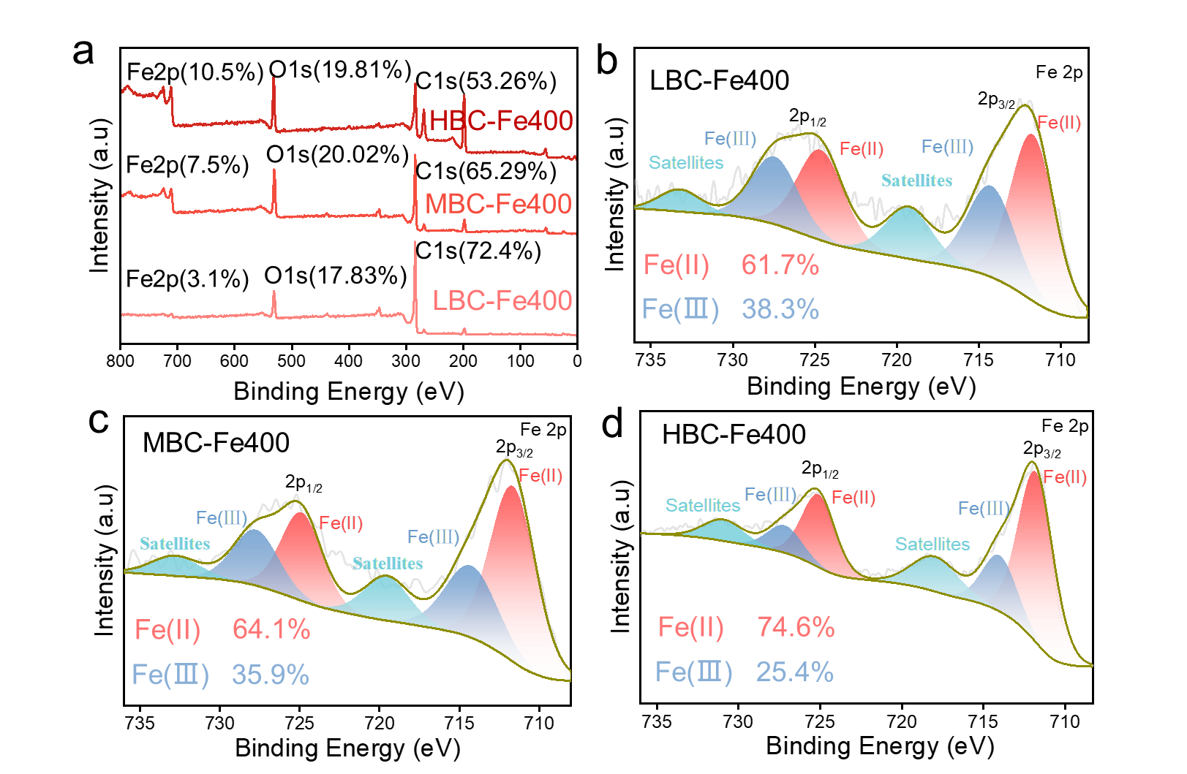
Fig. S3. XPS spectra of low-temperature biochar with gradient iron loading. a XPS survey spectra. b-d Fe2p. (LBC-Fe400, BC:Fe=10:1; MBC-Fe400, BC:Fe=5:1; HBC-Fe400. BC:Fe=1:1).

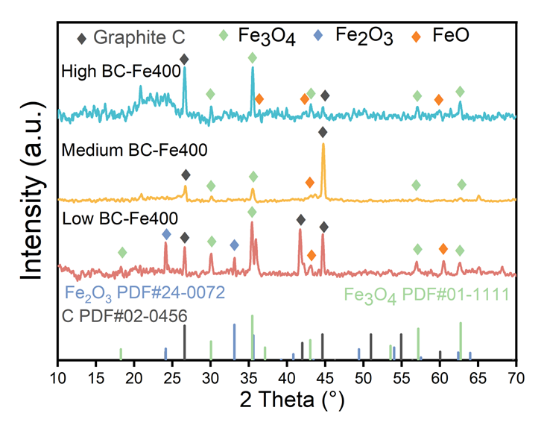
Fig. S4. XRD patterns of low-temperature biochar with gradient iron loading.

The influence of pyrolysis temperature on the functional groups on the Fe/BC is significant, as illustrated in Fig. S5a. A broad peak appeared at 3440 cm⁻¹, which was attributed to the characteristic O-H vibration peak, can directly participate in electron transfer [7,8]. The peaks at 2924 cm⁻¹ and 2850 cm⁻¹ correspond to the stretching vibrations of -CH₂/-CH₃. The characteristic absorption peak around 1635 cm⁻¹ originates from the stretching vibrations of C=C and C=O, which can serve as active sites to promote the generation of reactive oxygen species (ROS) [9]. Furthermore, the vibration intensity of -OH and C-O decreased with increasing pyrolysis temperature of the BC-Fex. Hence, it is reasonable to speculate that the O atoms may be replaced from their original positions in the biochar by the Fe-doped structures in the Fe-doping process. The peak at 1043 cm⁻¹ corresponds to Fe-OH, and the stretching peak around 557 cm⁻¹ corresponds to Fe-O vibration [10], suggesting the presence of Fe-O complexes or iron oxides on its surface, which is consistent with the XRD results. In addition, BC-Fe-400 has more abundant oxygen-containing functional groups. This indicates that the cleavage of chemical bonds in the biochar raw materials is relatively limited at low temperatures, allowing these functional groups to exist stably. High temperatures, however, cause the removal of oxygen-containing functional groups through reactions such as decarboxylation, resulting in a decrease in their content. Previous studies have also shown that an increase in the pyrolysis temperature of biochar inhibits the formation of oxygen - containing functional groups.
The full spectra of iron - loaded biochar prepared at different temperatures are shown in Fig. S5c. Characteristic peaks at around 284.84 eV, 531.2 eV, 711.2 eV, and 725.2 eV are observed respectively, indicating the simultaneous presence of C, O, and Fe elements on the surface of the four iron-loaded biochar materials, with C element being dominant.
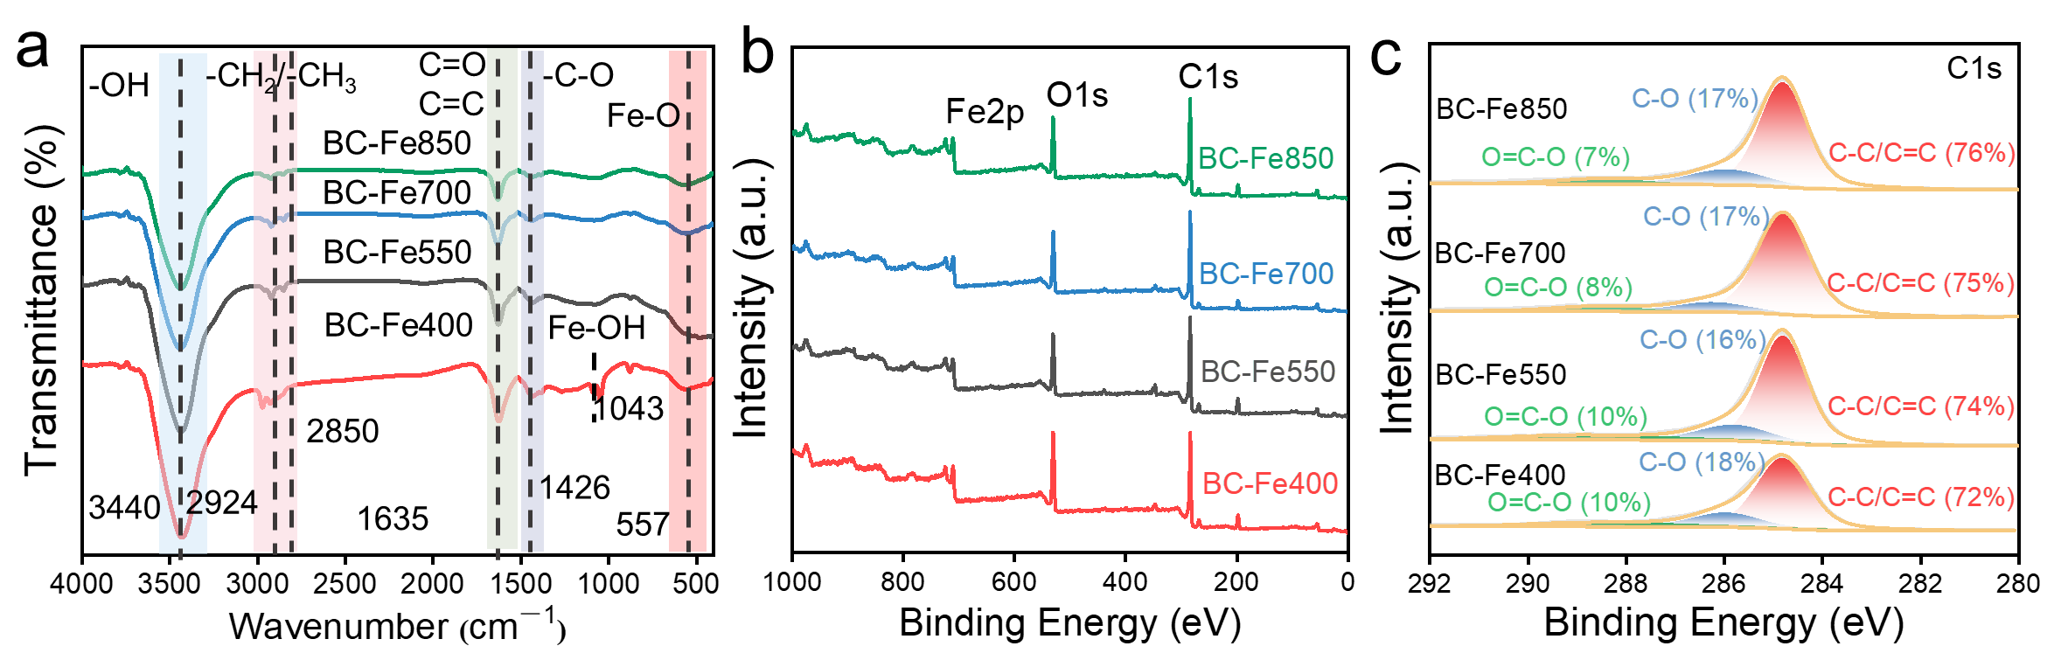
Fig. S5. Physico-chemical properties of BC-Fex. a FT-IR spectra. b The XPS survey spectra. c XPS spectrum of C1s.

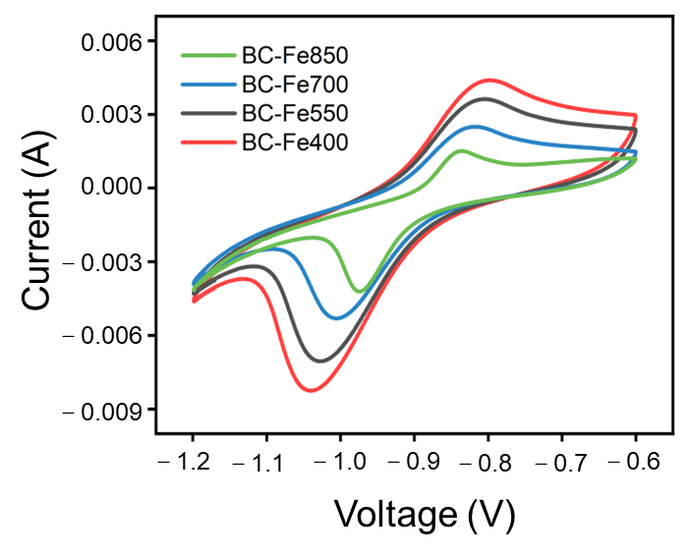
Fig. S6. Cyclic Voltammetry (CV) curves.

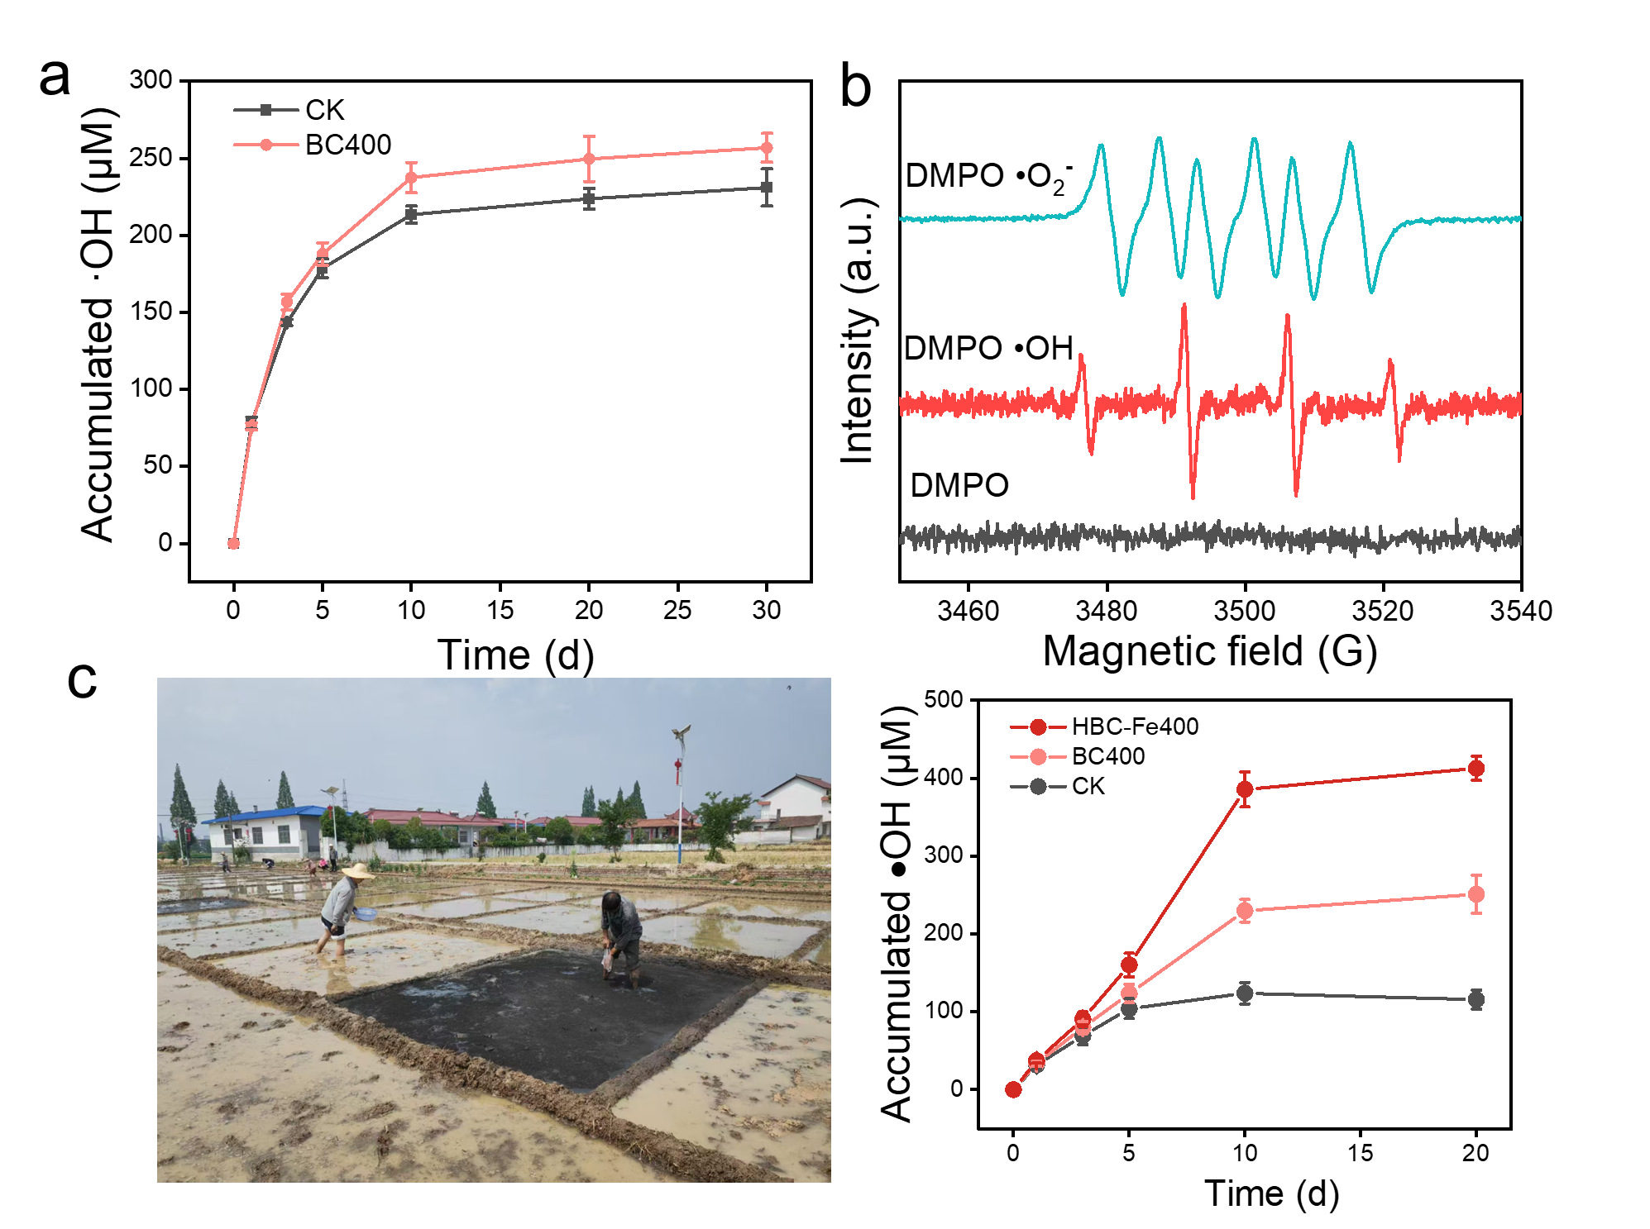
Fig. S7. Quantitative and qualitative analysis of free radicals. a ·OH production in soil without (CK) and with pristine biochar (BC400). b Results of EPR analysis. c ·OH production in field soil without (CK), with pristine biochar (BC400), and with Fe-based biochar (HBC-Fe400).
We conducted a complementary field experiment in Weiyang District, Xi'an, Shaanxi Province, which represents a typical agricultural soil environment in the region. We applied both the pristine biochar (BC400) and our iron-modified biochar (HBC-Fe400) to two representative soil plots, respectively. We then monitored the generation of •OH over a period of 3 weeks. The soil amended with HBC-Fe400 exhibited a marked, sustained elevation in •OH production, reaching 3.58-fold that of the control. This confirms that the key mechanism of sustainable Fe(III)/Fe(II) cycling and enhanced •OH generation, which we identified in the laboratory, remains operative and effective in the complex field environment.
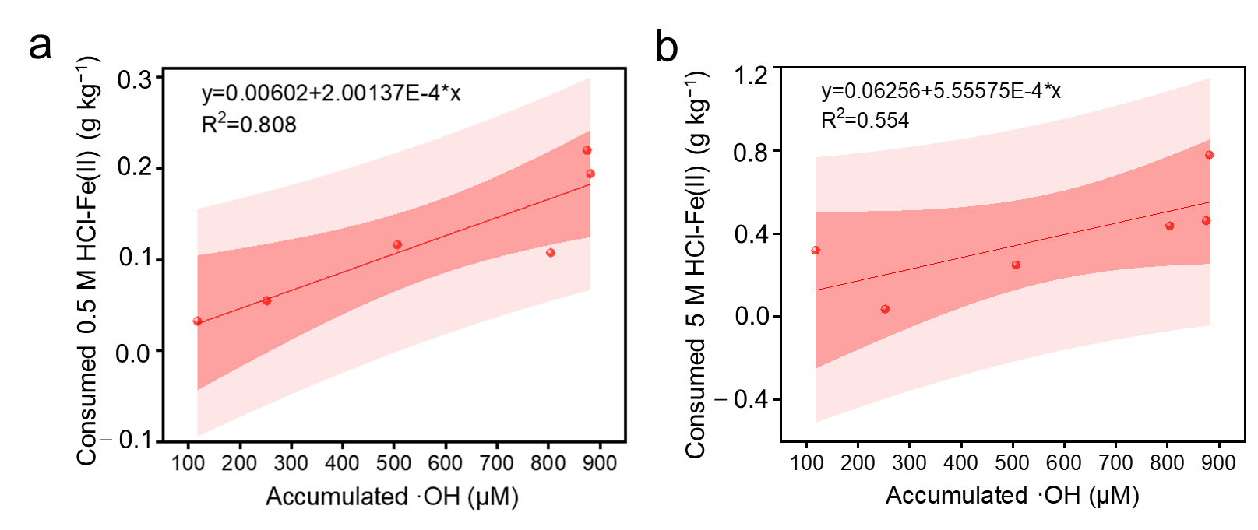
Fig. S8. Correlation analyses between cumulative •OH and consumed Fe(II). a 0.5 M HCl-Fe(II). b 5 M HCl-Fe(II) of High BC400Fe soil during 30-days oxygenation.

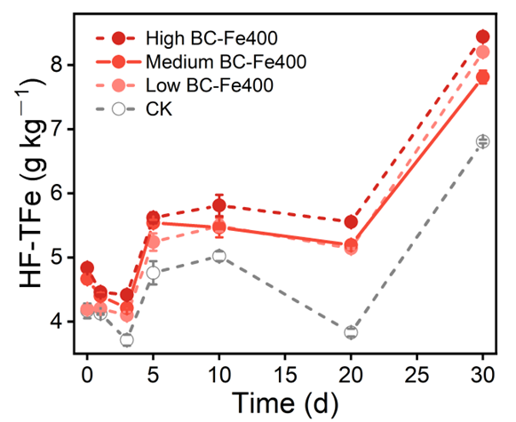
Fig. S9. The content of HF-Fe(II) during oxygenation of soils with/without gradient iron loading BC-Fe400 during 30 days oxygenation.

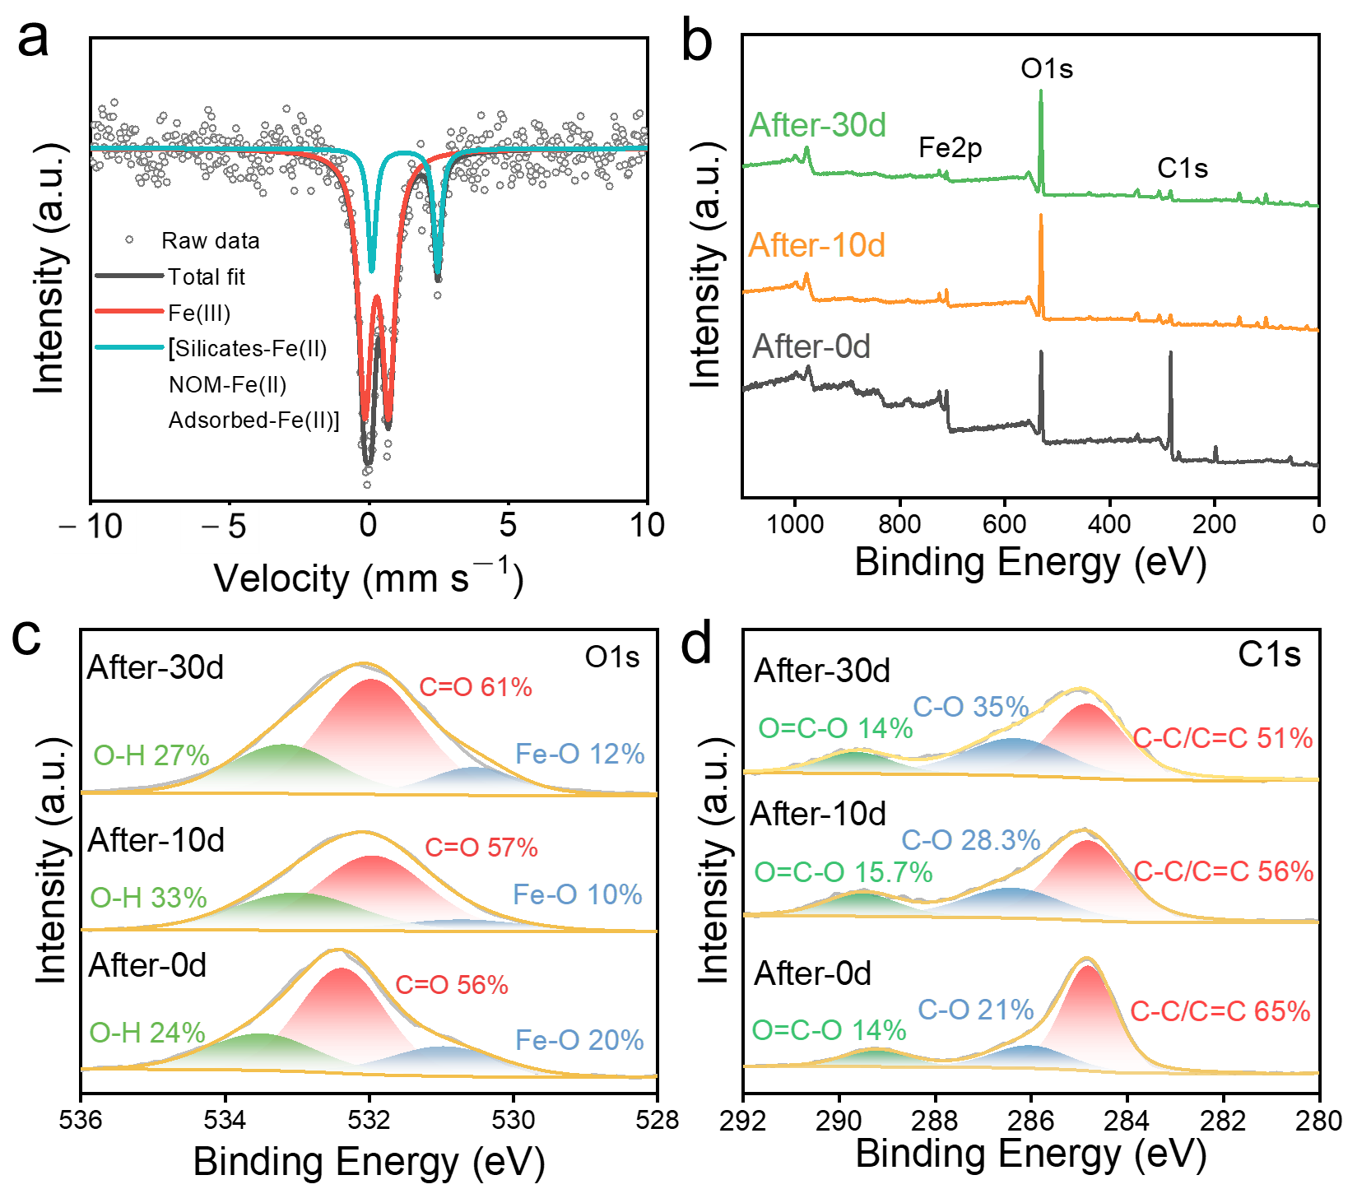
Fig. S10. a Mössbauer spectra of HBC-Fe400 after oxygenation 10d. b-d Evolution of XPS spectra for HBC-Fe400 after soil amendment.

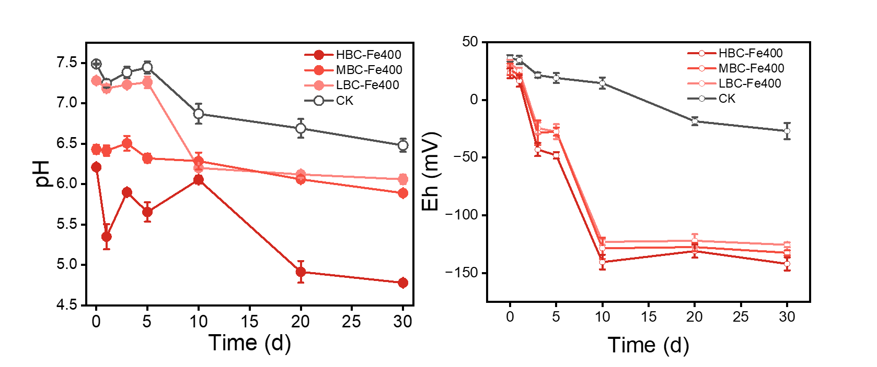
Fig. S11. The changes of pH and Eh during oxygenation of soils with/without gradient iron loading BC-Fe400 during 30 days oxygenation.

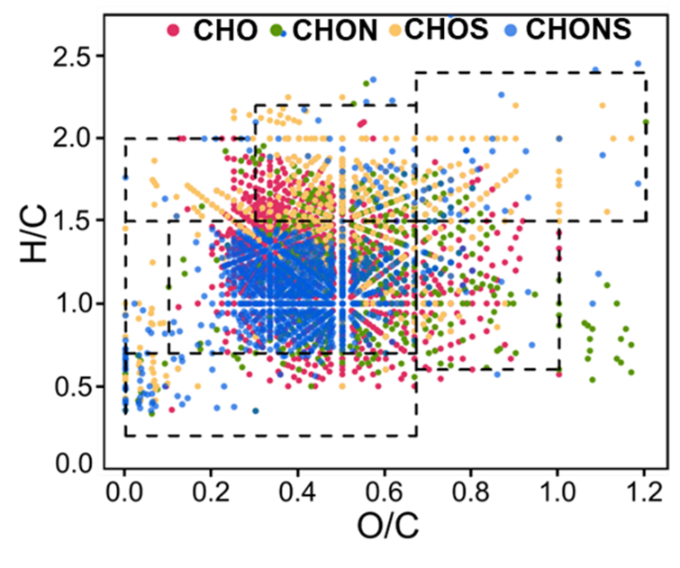
Fig. S12. Van Krevelen diagram of DOM formulas detected in soils with HBC-Fe400 after 10d incubation.

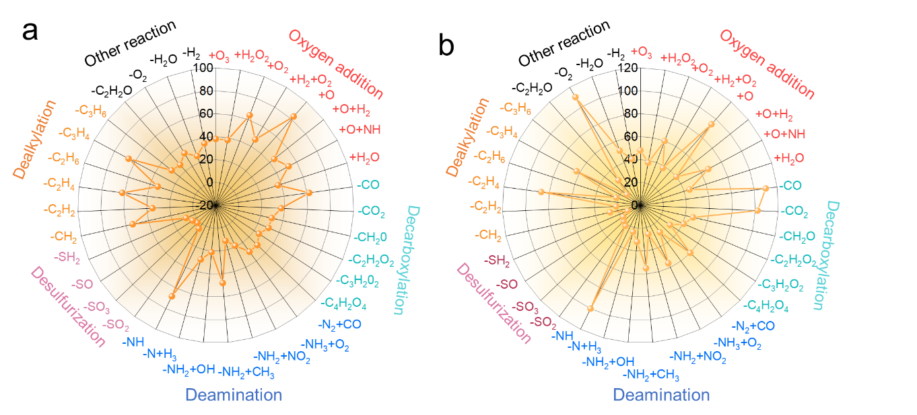
Fig. S13. Radar plots of links detected of DOM with HBC-Fe400 after oxygenation. a 10d. b 30d.

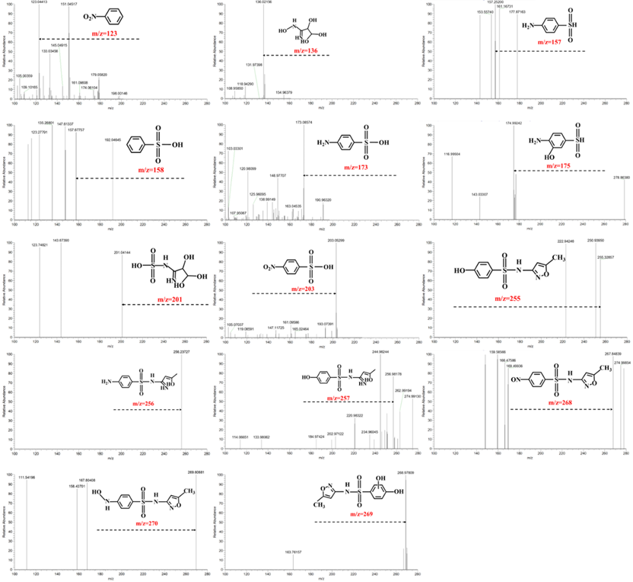
Fig. S14. Mass spectra of SMX degradation products detected by LC-MS.
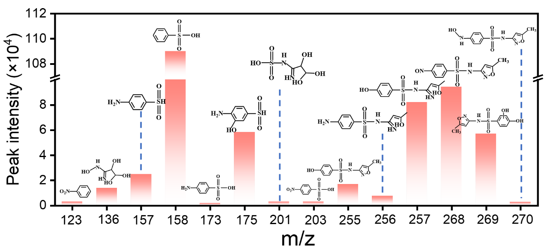
Fig. S15. The intensities of detected degradation products of SMX with LC-MS after the incubation period of 30 days.

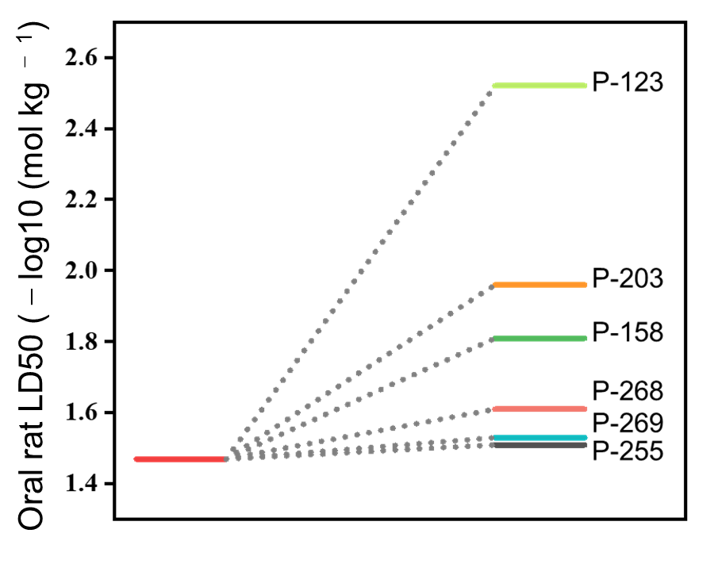
Fig. S16. Oral rat LD50 of SMX degradation intermediates.

Table S1. Physicochemical properties of farmland soils used in this study.
Properties | Index | Content
Soil texture | Sand (%) | 10.71
Soil texture | Silt (%) | 83.10
Soil texture | Clay (%) | 6.19
General properties | pH | 8.27
General properties | SOC (g kg⁻¹) | 12.562
General properties | TN (%) | 1.415
General properties | CEC (cmol kg⁻¹) | 16.972
General properties | Total Mn (g kg⁻¹) | 0.523
General properties | Total Fe (g kg⁻¹) | 26.403

Table S2. The total Fe contents of the BC-Fex.
Sample | BC-Fe400 | BC-Fe550 | BC-Fe700 | BC-Fe850
The total Fe contents (mg g⁻¹) | 101.4 | 70.81 | 77.4 | 79.89

Table S3. Molecular characteristics of DOM measured by FT-ICR MS analysis.
Time | Count | m/Zw | O/Cwa | H/Cwa | N/Cwa | DBEwa | Aimod,wa | NOSCw
0 | 2517 | 348.51 | 0.395 | 1.261 | 0.105 | 7.54 | 0.20 | 0.019
10 | 3497 | 358.35 | 0.408 | 1.231 | 0.093 | 7.92 | 0.22 | 0.015
30 | 4270 | 370.32 | 0.412 | 1.290 | 0.058 | 7.60 | 0.19 | －0.176

Table S4. General information on identified transformation products of SMX.
Product name | m/z | Ionospheric model | Molecular formula | Structural formula
SMX | 254 | [M+H]⁺ | C₁₀H₁₁N₃O₃S
P-256 | 256 | [M+H]⁺ | C₁₀H₁₃N₃O₃S
P-257 | 257 | [M+H]⁺ | C₁₀H₁₂N₂O₄S
P-201 | 201 | [M+H]⁺ | C₃H₆N₂O₆S
P-136 | 136 | [M+H]⁺ | C₃H₆N₂O₄
P-255 | 255 | [M+H]⁺ | C₁₀H₁₀N₂O₄S
P-269 | 269 | [M+H]⁺ | C₁₀H₉N₂O₅S
P-270 | 270 | [M+H]⁺ | C₁₀H₁₁N₃O₄S
P-268 | 268 | [M+H]⁺ | C₁₀H₉N₃O₄S
P-157 | 157 | [M+H]⁺ | C₆H₇NO₂S
P-175 | 175 | [M+H]⁺ | C₆H₇NO₃S
P-173 | 173 | [M+H]⁺ | C₆H₇NO₃S
P-203 | 203 | [M+H]⁺ | C₆H₅NO₅S
P-123 | 123 | [M+H]⁺ | C₆H₅NO₂
P-158 | 158 | [M+H]⁺ | C₆H₆O₃S

References
- Zhao, G., Wu, B., Zheng, X., Chen, B., Kappler, A., Chu, C., 2022. Tide-triggered production of reactive oxygen species in coastal soils. Environ Sci Technol 56, 11888-11896. https://doi.org/10.1021/acs.est.2c03142.
- Zhu, H., Ma, H., Zhao, Z., Xu, L., Li, M., Liu, W., Lai, B., Vithanage, M., Pu, S., 2025. Electron transfer tuning for persulfate activation via the radical and non-radical pathways with biochar mediator. J Hazard Mater 486, 136825. https://doi.org/10.1016/j.jhazmat.2024.136825.
- Zhao, R., Wang, T., Wang, Z., Cheng, W., Li, L., Wang, Y., Xie, X., 2024. Activation of peroxymonosulfate with natural pyrite-biochar composite for sulfamethoxazole degradation in soil: Organic matter effects and free radical conversion. J Hazard Mater 469, 133895. https://doi.org/10.1016/j.jhazmat.2024.133895.
- Xie, W., Zhang, P., Liao, W., Tong, M., Yuan, S., 2021. Ligand-enhanced electron utilization for trichloroethylene degradation by· OH during sediment oxygenation. Environ Sci Technol 55, 7044-7051. https://doi.org/10.1021/acs.est.1c00136.
- Mopper, K., Zhou, X., 1990. Hydroxyl radical photoproduction in the sea and its potential impact on marine processes. Science 250, 661-664. https://doi.org/10.1126/science.250.4981.661.
- Lin, H., Liu, C., Li, B., Dong, Y., 2021. Trifolium repens L. regulatedphytoremediation of heavy metal contaminated soil by promoting soil enzyme activities and beneficial rhizosphere associated microorganisms. J Hazard Mater 402, 123829. https://doi.org/10.1016/j.jhazmat.2020.123829.
- Fu, J., Li, Q., Dzakpasu, M., He, Y., Zhou, P., Chen, R., Li, Y.-Y., 2024. Biochar’s role to achieve multi-pathway nitrogen removal in anammox systems: Insights from electron donation and selective microbial enrichment. Chem Eng J 482, 148824. https://doi.org/10.1016/j.cej.2024.148824.
- Zeng, H., Li, J., Xu, J., Qi, W., Hao, R., Lin, D., Li, D., Zhang, J., 2022. Magnetic biochar based on platanus leaves and iron sludge for persulfate activation and catalytic degradation of tetracycline. J Clean Prod 370, 133336. https://doi.org/10.1016/j.jclepro.2022.133336.
- Xia, W., Li, S., Wu, G., Ma, J., 2023. Recycling waste iron-rich algal flocs as cost-effective biochar activator for heterogeneous Fenton-like reaction towards tetracycline degradation: Important role of iron species and moderately defective structures. J Hazard Mater 460, 132377. https://doi.org/10.1016/j.jhazmat.2023.132377.
- Huang, Q., Xia, G.-J., Huang, B., Xie, D., Wang, J., Wen, D., Lin, D., Xu, C., Gao, L., Wu, Z., 2024. Activating lattice oxygen by a defect-engineered Fe₂O₃–CeO₂ nano-heterojunction for efficient electrochemical water oxidation. Energy Environ Sci 17, 5260-5272. https://doi.org/10.1039/D4EE01588F.

