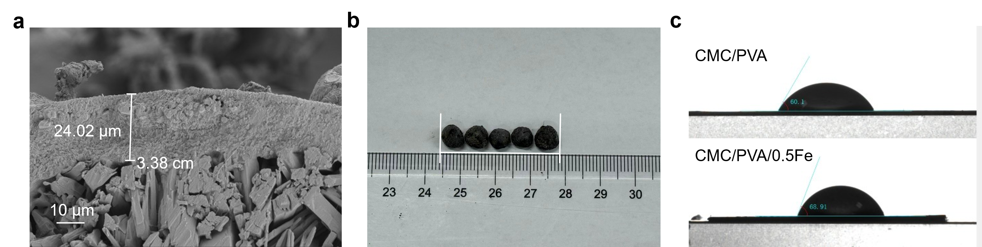
Fig. S1. a SEM images of the fertilizer cross-section, b macro photographs of the fertilizer, and c water contact angles of CMC/PVA and CMC/PVA/0.5Fe composite films.
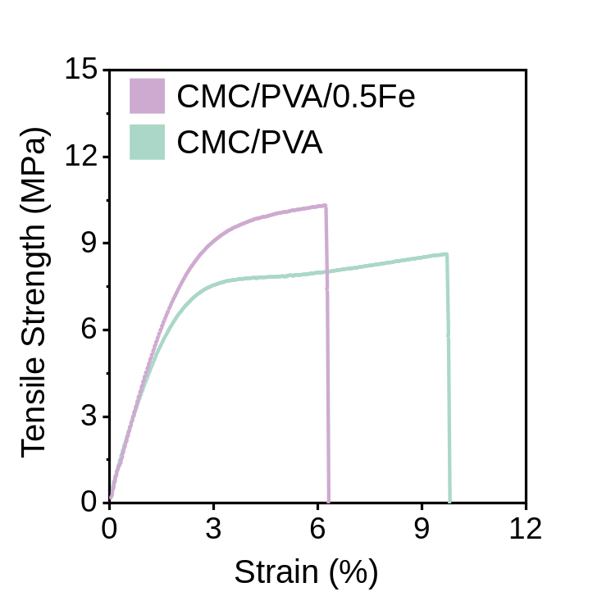
Fig. S2. Deformation curves of various hydrogel membranes. (Room temperature: 25 ◦C, relative humidity: 40 %).
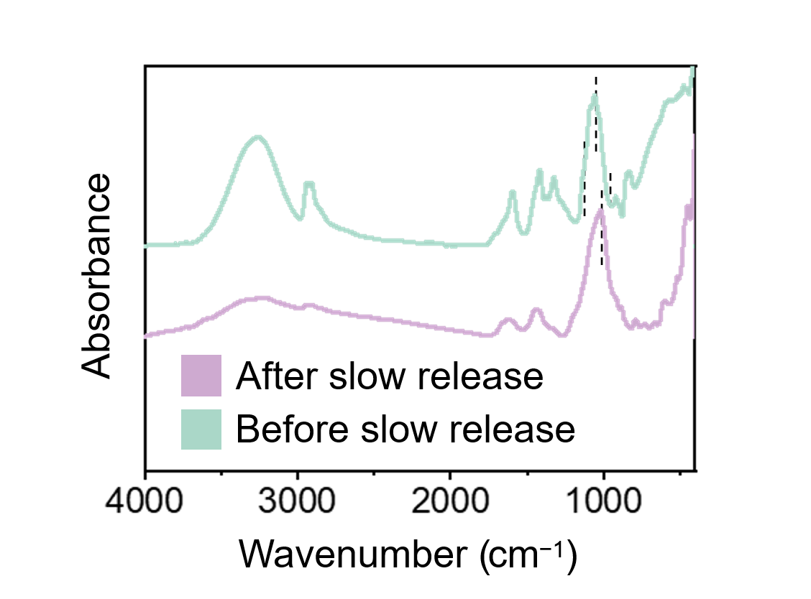
Fig. S3. FTIR spectra of membranes before and after slow release

Table S1 The physicochemical properties of potting mixtures.
Soil species | pH | CEC (cmol⁺ kg⁻¹) | Total N (g kg⁻¹) | Total P (g kg⁻¹) | Total K (g kg⁻¹)
Composite soil | 5.83 | 47.22 | 5.42 | 0.39 | 10.27

Table. S2 Comparison with the slow-release properties of fertilizers studied in the past.
Materials | Slow-release performance | Article
Greenly synthesized tea extract-derived nano-iron enhances CMC/PVA composite materials, coating zeolite-biochar-NPK composite fertilizer cores. | At 31 days, the release rates of nitrogen (N) and phosphorus (P) are 58.48% and 15.82%, respectively. | This article
All-cellulose hydrogel formulation was applied as waterborne and swellable coating material of monoammonium phosphate fertilizer (MAP) | At 20 days, the release rates of nitrogen (N) and phosphorus (P) are essentially 100% | Biodegradable all-cellulose composite hydrogel as eco-friendly and efffcient coating material for slow-release MAP fertilizer(Kassem et al., 2022)
Chitosan-kaolinite composite film (CS-Gl-K) for the coating of nitrogen-phosphorus-potassium (NPK) particles. | On the thirtieth day, the release amount of phosphorus is 30% | Chitosan-kaolinite clay composite as durable coating material for slow release NPK fertilizer(Eddarai et al., 2022)
Hydro-soluble diammonium phosphates (DAP) fertilizer was double coated following the dip-coating process by chitosan-clay composites as inner coating and paraffin wax as an outer coating. | 40% of phosphorus was released during the first 30 days | Sustainable coating material based on chitosan-clay composite and paraffin wax for slow-release DAP fertilizer(El Assimi et al., 2020)
Polyester and urea prepared by one-step blending | released 96.23%, 95.48% and 96.31% of K, P and N, respectively afterone-month incubation in soil medium. | Cellulose nanocrystals-filled poly (vinyl alcohol) nanocomposites as waterborne coating materials of NPK fertilizer with slow release and water retention properties (Kassem et al., 2021)
Sulfonated carboxymethyl cellulose-g Poly (AA)/Polyvinylpyrrolidone/ Silica SCMC-g-PAA/ PVP/Silica | SCMC-g-PAA coated NPK: 83.6% in a month SCMC-g-PAA/PVP coated NPK: 72.3% in a month | Slow-release NPK fertilizer encapsulated by carboxymethyl cellulose-based nanocomposite with the function of water retention in soil(Olad et al., 2018)

Table S3 The reduction in applied nitrogen demand across each region under the fertilizer substitution scenario.
Region | NPK compound (Mt N) | Demand rudection (Mt N)
Africa | 0.38 | 0.06
Central Europe | 0.40 | 0.07
E. Europe & C. Asia | 0.50 | 0.09
East Asia | 15.55 | 2.66
Latin America | 0.47 | 0.08
North America | 0.47 | 0.08
Oceania | 0.03 | 0.00
South Asia | 0.45 | 0.08
West Asia | 0.10 | 0.02
West Europe | 0.67 | 0.12
Total | 19.02 | 3.25
Reference
Eddarai, E., El Mouzahim, M., Boussen, R., Bellaouchou, A., Guenbour, A. and Zarrouk, A. (2022) Chitosan-kaolinite clay composite as durable coating material for slow release NPK fertilizer. Int J Biol Macromol 195, 424-432.
El Assimi, T., Lakbita, O., El Meziane, A., Khouloud, M., Dahchour, A., Beniazza, R., Boulif, R., Raihane, M. and Lahcini, M. (2020) Sustainable coating material based on chitosan-clay composite and paraffin wax for slow-release DAP fertilizer. Int J Biol Macromol 161, 492-502.
Kassem, I., Ablouh, E.-H., El Bouchtaoui, F.-Z., Kassab, Z., Hannache, H., Sehaqui, H. and El Achaby, M. (2022) Biodegradable all-cellulose composite hydrogel as eco-friendly and efficient coating material for slow-release MAP fertilizer. Prog Org Coat 162, 106575.
Kassem, I., Ablouh, E.-H., El Bouchtaoui, F.-Z., Kassab, Z., Khouloud, M., Sehaqui, H., Ghalfi, H., Alami, J. and El Achaby, M. (2021) Cellulose nanocrystals-filled poly (vinyl alcohol) nanocomposites as waterborne coating materials of NPK fertilizer with slow release and water retention properties. Int J Biol Macromol 189, 1029-1042.
Olad, A., Zebhi, H., Salari, D., Mirmohseni, A. and Tabar, A.R. (2018) Slow-release NPK fertilizer encapsulated by carboxymethyl cellulose-based nanocomposite with the function of water retention in soil. Mater Sci Eng C 90, 333-340.

