SUPPORTING INFORMATION FOR
Biochar application enhances ant (Formica japonica) ecological functions as indicated by their social behaviors

Sha Liu^{1, 2}, Danling Xiong¹, Liang Zeng¹, Wei Du¹, Yang Liu¹, Christian E.W. Steinberg^{1, 3}, Bo Pan^{1, 2 *}, Shu Tao^{2, 4}, Baoshan Xing⁵

¹ Yunnan Provincial Key Laboratory of Soil Carbon Sequestration and Pollution Control, Faculty of Environmental Science & Engineering, Kunming University of Science & Technology, Kunming, 650500, China.
² Southwest United Graduate School. Kunming, People's Republic of China.
³ Faculty of Life Sciences, former Freshwater and Stress Ecology Group, Humboldt Universität zu Berlin, 12437 Berlin, Germany.
⁴ College of Urban and Environmental Sciences, Peking University, 100871, Beijing, China.
⁵ Stockbridge School of Agriculture, University of Massachusetts, Amherst, MA 01003, USA.

* Corresponding Author, email: panbocai@gmail.com (Bo Pan)
Figure numbers: 4
Table number: 2
Page numbers: 5

Supporting Information

Supporting Information 1: Figure
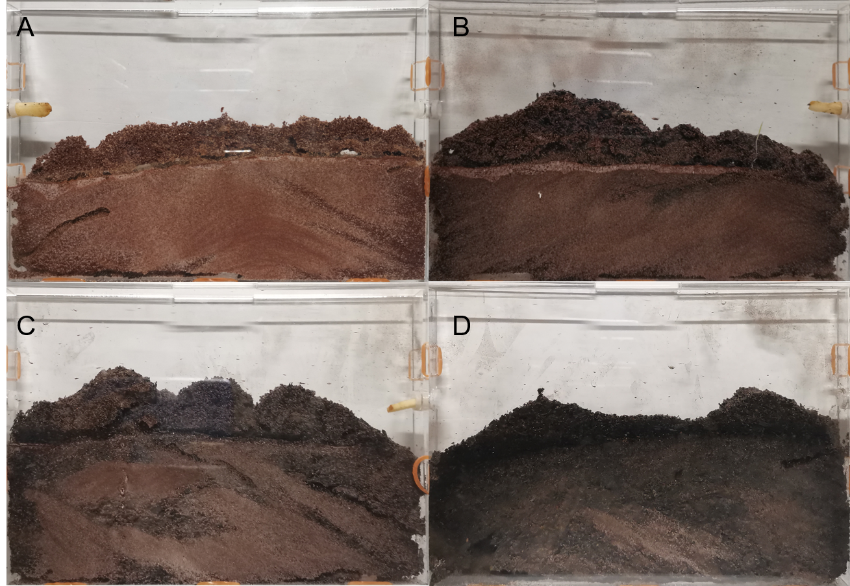
Figure S1. Biochar concentrations affect ant nest architecture complexity: (A) CO, (B) 2.5%, (C) 5%, and (D) 10% biochar treatments.

Figure S2. Selective apparatus for assessing Formica japonica preference among CO and three biochar application.
Figure S3. Behavioral quantification methods evaluate ant social complexity using foraging “T” maze schematic (A), food discovery arena (B), foraging confirmation (C), intraspecific recognition (D), and interspecific aggression (E).
Figure S4. The time required for the fastest ants to find food in each treatment.

Supporting Information 2: Table
Table S1. Scoring scales, meaning, and description of the behaviors observed.
Score | Meaning | Description
-4 | Trophallaxis | Exchange of food or fluids between workers
-3 | Allogrooming | Cleaning of another worker
-2 | Antennation | Touching of other workers with the antennae
-1 | Being next to each other | Being next to each other without touching
0 | Ignoring | Lack of interactions
1 | Avoiding | The workers try to avoid each other, often walking backward
2 | Mandible threatening | Opening the mandibles to show potential aggression
3 | Biting without gaster flexion | Fighting/Biting
4 | Biting with gaster flexion | Fighting/Biting plus gaster flexion
5 | Killing | Killing is the end of behavior observation
Note: The scores from -4 to - 1 were considered as peaceful, while the scores from 1 to 5 were considered as aggressive. 0 was considered as neutral behavior.

Table S2. Summary of Two-way ANOVA results for nest architecture, foraging behavior, and social interactions. The model included biochar dose (Treatment) as a fixed effect and experimental replicate (Block) as a random effect.
Category | Endpoint | Block Effect  (P-value) | Treatment Effect  (P-value)
Nest Architecture | Tunnel Area | 0.79 | < 0.01
Nest Architecture | Tunnel Diameter | 0.18 | < 0.001
Foraging Behavior | Maze Success Rate | 1.00 | < 0.01
Foraging Behavior | Maze Transit Time | 0.25 | < 0.001
Foraging Behavior | Food Success Rate | 0.42 | < 0.01
Foraging Behavior | Food Retrieval Time | 0.39 | < 0.001
Social Behaviors | Aggressive Duration | 0.25 | < 0.01
Social Behaviors | Aggressive Frequency | 0.54 | < 0.01
Social Behaviors | Peaceful Duration | 0.46 | < 0.05
Social Behaviors | Peaceful Frequency | 0.25 | < 0.05
Note: Significance was set at p < 0.05. Post-hoc comparisons were performed using Tukey’s HSD test.

