SUPPLEMENTARY MATERIAL for

Fungi enhance biochar and compost effects on carbon accrual in nutrient-deficient urban greenspace soils

Sihang Deng¹, Qun Gao²*, Ling Han³*, Xin Tong⁴, Wenrui Shen³, Anqi Liu³, Hongkuan Lee³, Zhencheng Ye¹, Suo Liu¹, Ke Sun², Xinghui Xia², Yunfeng Yang⁵

¹School of Environment, Tsinghua University, Beijing 100084, China
²Key Laboratory of Water and Sediment Sciences of Ministry of Education, State Key Laboratory of Water Environment Simulation, School of Environment, Beijing Normal University, Beijing 100875, China
³College of Environmental Sciences and Engineering, Peking University, Beijing, 100871, China
⁴College of Urban and Environmental Sciences, Peking University, Beijing, 100871, China
⁵Institute of Environment and Ecology, Tsinghua Shenzhen International Graduate School, Tsinghua University, Shenzhen 518055, China

*To whom correspondence may be addressed. E-mail: gaoqun@bnu.edu.cn; Phone: +86-15321066905; or E-mail: hanling@pku.edu.cn; Phone: +86-13810856471

The Supplementary Information contains 34 pages with 5 supplementary methods, 11 supplementary figures, and 13 supplementary tables.

Supplementary Method S1 Estimation of bacterial rrn copy number
The rRNA operon (rrn) copy numbers for bacterial zOTUs were estimated using the rrnDB database (Lee et al. 2009) (version 5.9, https://rrndb.umms.med.umich.edu/downloads/, detailed in Supplementary Method S1). Each zOTU was matched to the database, starting from the lowest taxonomic rank. When matches were found at the child taxon level, the mean rrn copy number of all corresponding child taxa was assigned, otherwise, higher taxonomic ranks were examined, and the mean rrn copy number of the parent taxa was assigned to that zOTU. The community-level rrn copy number for each sample, an aggregate trait value, was calculated as the weighted mean of the estimated rrn copy numbers for each zOTU, with weights corresponding to the relative abundance of each zOTU (Dai et al. 2022), as described in Eq. (1) below:
$community−level rrn copy number= \frac{\sum_{i=1}^{N}{S_{i}}}{\sum_{i=1}^{N}{\frac{S_{i}}{n_{i}}}}$ (1)
where N is the total number of zOTUs in a sample, S_{i} is the sequence relative abundance of zOTUi, and n_{i} is the estimated rrn copy number of zOTUi.

Supplementary Method S2 Niche breadth calculation and classification of ecological strategies
The niche breadth was used to quantify habitat specialization (Levins 1968). The formula is described in Eq. (2) below:
$B_{i}=\frac{1}{\sum_{k=1}^{N}{\sum_{t=1}^{T}{P_{ijkt}^{2}}}}$ (2)
where B_{i} represents the niche breadth of zOTUi, P_{ijkt} represents the relative abundance of zOTUi in a given urban greenspace j under treatment k at sampling time t, N is the total number of treatments (which was 4 in our study), and T is the total number of sampling times (which was 7 in our study). Given the heterogeneity among urban greenspace (Fig. S3) and the research’s focus on the impacts of treatments on microbial functional traits within an urban greenspace, we separately calculated the niche breadth for bacterial and fungal zOTUs within each urban greenspace. A higher B_{i} value corresponding to zOTUi indicates a more even and broader distribution across different treatments at different sampling times, while a smaller B_{i} value indicates a more patchy and narrower distribution (Pandit et al. 2009). Community-level niche breadth was calculated by averaging the abundance of unweighted niche breadth of each microbial species appearing in a given sample.
To classify microbial ecological strategies, we identified microbial generalists and specialists by calculating zOTU occurrences through 1,000 simulated permutations using the quasiswap permutation algorithm implemented in the EcolUtils R package (Salazar 2015). Given that generalist species exhibit broader fundamental niches than specialists, zOTUs with observed occurrences exceeding the upper 95% confidence interval were classified as generalists, while those falling below the lower 95% confidence interval were classified as specialists. zOTUs within the 95% confidence interval range were categorized as neutral species (Zhang et al. 2018). The relative abundance of a generalist, specialist, and neutral species within bacterial and fungal communities in each sample was quantified as the proportion of zOTU richness corresponding to each category, divided by the total observed richness in the sample.

Supplementary Method S3 Network construction and topological property calculation
Microbial co-occurrence networks were constructed using relative abundance datasets of bacterial and fungal zOTUs. Given the temporal nature of the dataset, local similarity analysis (LSA) was used to identify time-dependent associations among microbial taxa (Ruan et al. 2006), based on a method in a previous study (Weiss et al. 2016). LSA is a robust analytical technique that captures complex temporal dependency among species without requiring significant data reduction (Ruan et al. 2006). Separate bacterial and fungal networks were constructed for each treatment at each urban greenspace, resulting in a total of 12 bacterial and 12 fungal networks. To enhance the statistical power of correlation calculations, only bacterial zOTUs detected in at least 4 out of 7 samples and fungal zOTUs present in at least 3 out of 7 samples were included in network construction. The LSA preprocessing involved normal transformation, computation of local similarity scores, and retention of significant pairwise associations (p < 0.05) (Ruan et al. 2006; Xia et al. 2011). Time delay (D) was set to 0, with significance determined using parametric tests and all other parameters set to default values in LSA pipeline.
Using the igraph package in R software (Csardi and Nepusz 2006; Deng et al. 2012), we calculated the topological properties of microbial networks: total number of nodes (n), total number of links (L), proportion of negative links within network, power-law fitting of node degrees (γ, r², and P), average connectivity (average K), average clustering coefficient (average CC), average path length (Geodesic Distance, GD), network density (D), and connectance (Con). Network modules and modularity were identified using the fast-greedy optimization method, which quantifies the extent to which a network is partitioned into distinct modules or communities. To evaluate the significant differences between the constructed empirical networks and random networks, 100 random networks were generated for each empirical network by randomly rewiring the links among nodes while maintaining the same number of nodes and edges, following the Maslov-Sneppen procedure (Maslov and Sneppen 2002). The same set of network topological properties was calculated for each random network. The means and standard deviations of these properties from the 100 random networks were then compared with those of the corresponding empirical networks, confirming significant differences (p < 0.05; Table S8 and S9).
The stability of each microbial network was assessed through simulated random species removal (Montesinos-Navarro et al. 2017). For each network, we calculated network robustness based on the abundance-weighted mean interaction strength of nodes, following methods proposed in a previous study (Yuan et al. 2021). Moreover, we quantified network natural connectivity after random node removal (Wu et al. 2010), which serves as a complementary metric for assessing the robustness of complex networks. Network robustness and natural connectivity were measured after the random removal of 10% of nodes, with each simulation repeated 100 times for both bacterial and fungal networks to obtain mean values and standard deviations.

Supplementary Method S4 Microbial community assembly analyses
To quantify the relative importance of stochasticity, we calculated the modified stochasticity ratio (MST) based on a standard null-model algorithm using Bray-Curtis taxonomic metrics. The null-model algorithm maintained proportional taxa frequencies while fixing species richness. A threshold of 50% was used to distinguish between more deterministic (< 50%) and more stochastic (> 50%) assembly, ensuring that their combined contributions summed to 100% (Liang et al. 2020; Ning et al. 2019). Assuming that microbial communities within each urban greenspace shared a common regional species pool (Guo et al. 2018), the MST value was calculated independently for each greenspace under each sampling time. The MST values were calculated using the NST package in R software (https://github.com/DaliangNing/NST) (Ning et al. 2019).

Supplementary Method S5 Partial least squares path modeling (PLS-PM) analysis
To investigate the relationships between background soil physicochemical properties, microbial community responses, and changes in environmental factors across three urban greenspaces, Partial least squares path modeling (PLS-PM) analysis was performed using the plspm package in R software (Sanchez 2013) as PLS-PM is well-suited for estimating cause-effect relationships with small sample sizes (Sanchez 2013). To correct for potential temporal autocorrelation, background environmental factor values were averaged across different sampling time points under different treatment conditions within each urban greenspace. Eight latent variables were defined: (1) Soil fertility (SOC, TC, TN) and functioning (CO₂ flux), (2) Δ Bacterial diversity (effect size of treatment on bacterial richness), (3) Δ Bacterial functional traits (effect size of treatment on rrn copy number and unweighted mean niche width of the bacterial community), (4) Δ Bacterial network (effect size of treatment on the proportion of negative links and robustness in the bacterial network), (5) Δ Fungal diversity (effect size of treatment on fungal richness), (6) Δ Fungal functional traits (effect size of treatment on the species richness of plant pathogenic fungi and unweighted mean niche width of the fungal community), (7) Δ Fungal network (effect size of treatment on the proportion of negative links and robustness in the fungal network), and (8) Δ Soil fertility (effect size of treatment on SOC, TC, TN) and functioning (effect size of treatment on CO₂ flux). The assumed relationships among latent variables were based on existing biological and biogeochemical literature (Fig. S11). Observed variables were selected based on low collinearity and high predictive power for the effect size of treatment on environmental factors, with most loadings exceeding 0.7 as recommended (Sanchez 2013) (Table S12). PLS-PM was conducted using 1,000 bootstraps to validate the estimates of path coefficients and the coefficients of determination (Sanchez 2013). Path coefficients represent the direction and strength of linear relationships between latent variables (i.e., direct effects) (Sanchez 2013). Direct effects were represented by path coefficients between latent variables, while indirect effects were calculated as the product of path coefficients between a predictor and response variable, summing across all possible paths excluding the direct effect. The total effect was computed as the sum of direct and indirect effects. The final model was determined based on the model goodness-of-fit (> 0.7) (Sanchez 2013), with explanatory power provided for each latent variable.
Supplementary Figures
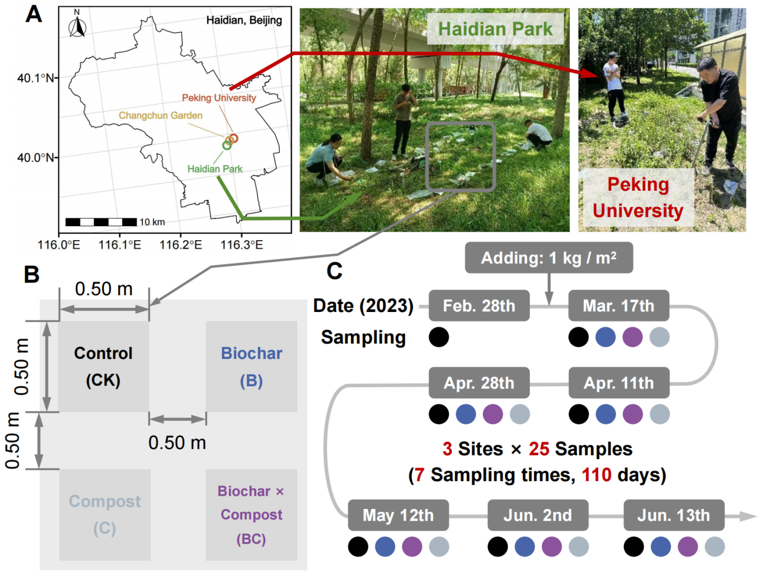

Fig. S1 Overview of the experimental design. (A) Locations of the biochar and/or compost addition experiments, along with representative photos from the field trials. The three selected urban greenspaces, including Peking University, Haidian Park, and Changchun Garden, in Beijing. (B) Plots and corresponding treatment assignments within each urban greenspace. (C) Duration of the experiment and sampling schedule.
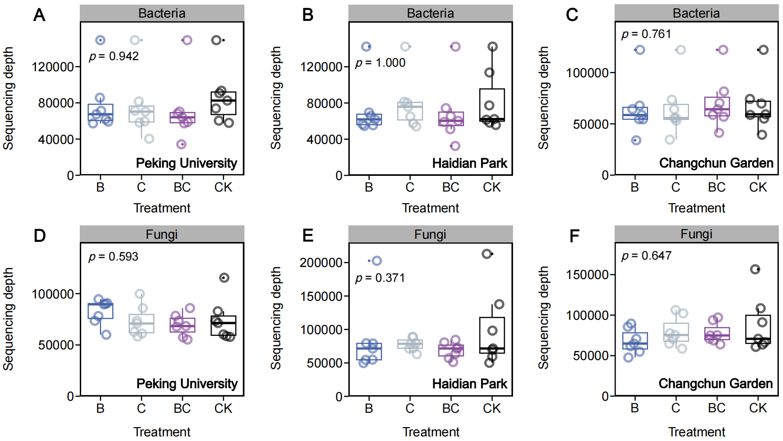

Fig. S2 Sequencing depths among different treatments for soil bacterial and fungal communities across three urban greenspaces. All soil samples collected over 110 days were analyzed using 16S rRNA genes for bacteria, and ITS regions (between the 5.8S and 28S rRNA genes) for fungi. On average, 73,811 ± 29,675 bacterial (A−C), and 78,623 ± 27,404 fungal (D−F) sequence reads were obtained. No significant differences in sequencing depth were observed among treatments or sampling sites for bacterial and fungal communities in Peking University, Haidian Park, and Changchun Garden. Box plots display the distribution of sequencing depth, with hinges representing the 25, 50 (median), and 75 percentiles, while whiskers extend to the largest or smallest values within 1.5 × IQR from the hinges.
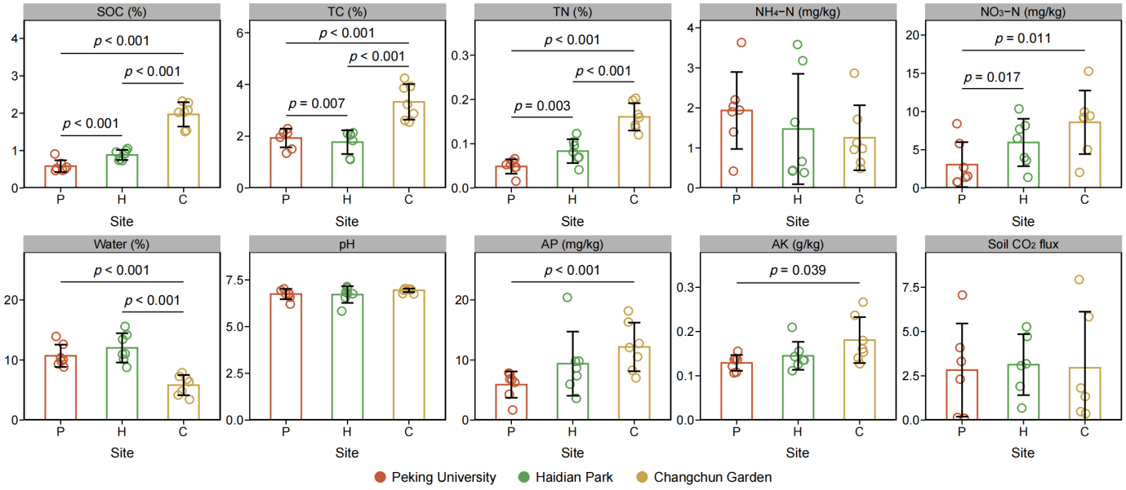

Fig. S3 Comparison of physicochemical properties and CO₂ flux across three urban greenspace soils under control conditions. Bars represent mean values, with error bars indicating standard deviations. Data points for each sampling time are shown as open circles. Soil physicochemical properties include surface soil SOC, TC, TN, ammonium nitrogen (NH₄⁺), nitrate (NO₃⁻), water content, pH, available phosphorus (AP), and available potassium (AK). Statistical significance was assessed using Wald type II χ² tests with false discovery rate adjustment (n = 14, for CO₂ flux n = 12) in linear mixed-effects models (sampling time set as a random factor). P-values are provided only for significant differences between urban greenspaces. P: Peking University; H: Haidian Park; C: Changchun Garden.
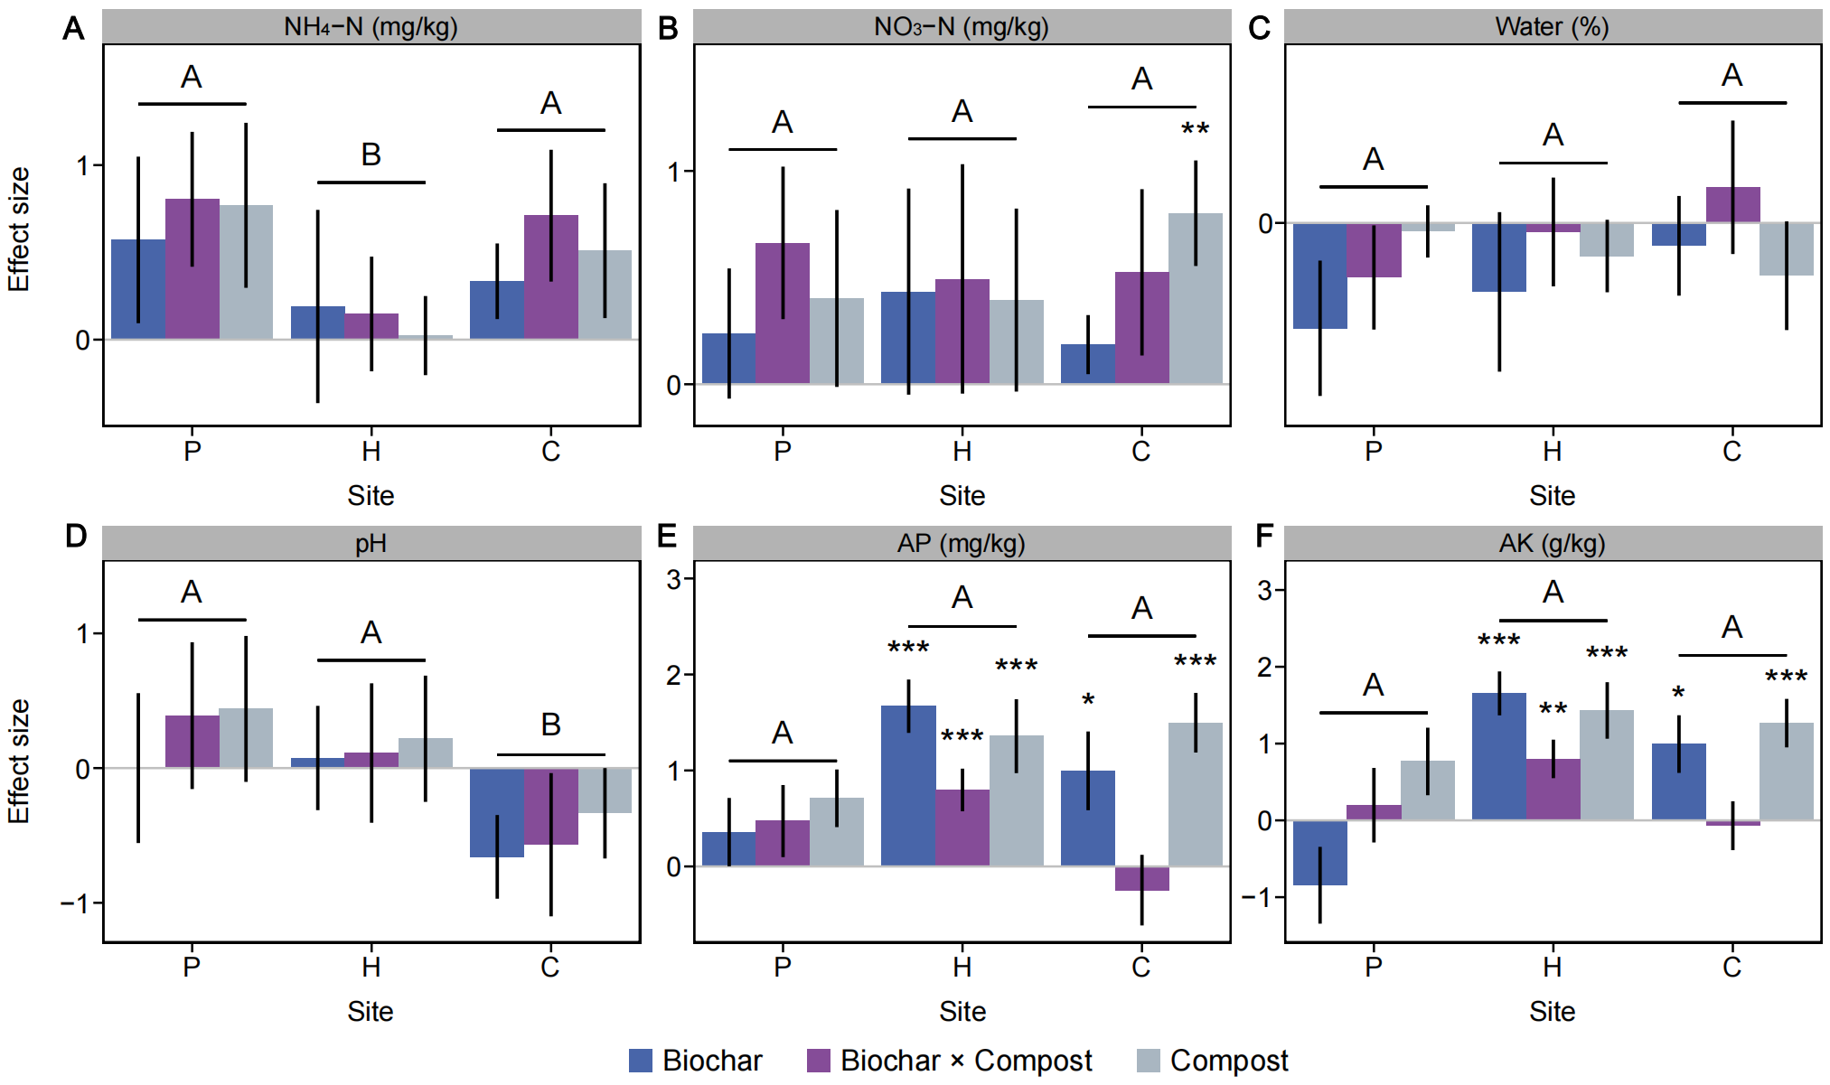

Fig. S4 Effects of single and combined treatments of biochar and compost on soil physicochemical variables. (A) Soil ammonium nitrogen (NH₄⁺). (B) Soil nitrate (NO₃⁻). (C) Soil water content. (D) Soil pH. (E) Soil available phosphorus (AP). (F) Soil available potassium (AK). Effect sizes are represented as regression coefficients derived from rescaled response variables (mean = 0, standard deviation = 1) in linear mixed-effects models. Bars indicate the mean ± s.e.m. of the effect sizes. Statistical significance was determined using Wald type II χ² tests with false discovery rate adjustment (n = 14). Significance levels are denoted as: ***p < 0.001, ** p < 0.01, * p < 0.05. Differences in effect sizes among the three urban greenspaces were assessed using a post-hoc LSD test following one-way ANOVA (n = 9), and are indicated by uppercase letters. P: Peking University; H: Haidian Park; C: Changchun Garden.
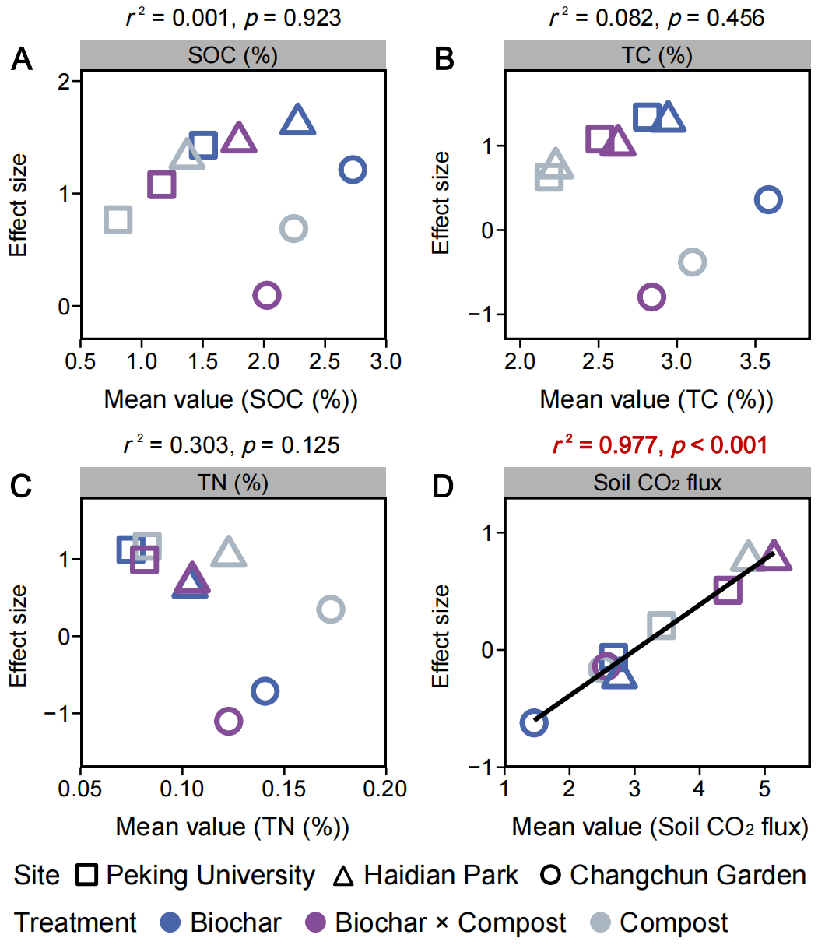

Fig. S5 Relationships between the effect size of the treatment on key environmental factors and the mean value of the corresponding environmental factors under treatment conditions. (A) Soil organic carbon (SOC). (B) Soil total carbon (TC). (C) Soil total nitrogen (TN). (D) Soil CO₂ flux. Pearson correlation coefficients (r²) and p values were calculated (n = 9), with significant relationships (p < 0.05) highlighted in red bold text and the corresponding fitting lines are provided. Different shapes represent different urban greenspaces, while different colors represent different treatments.
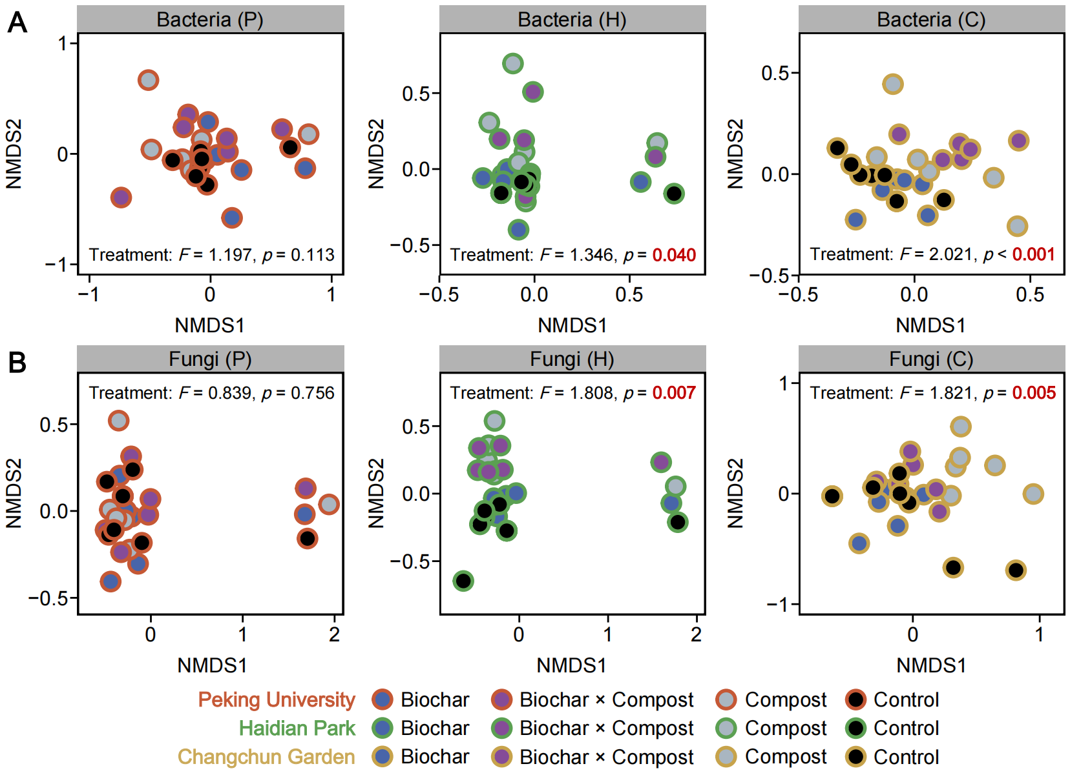

Fig. S6 Non-metric multidimensional scaling (NMDS) ordination of bacterial (A) and fungal (B) community changes under different treatments in three urban greenspaces. Analyses were performed using Bray-Curtis dissimilarity matrices, with F-values and p-values derived from permutational multivariate analysis of variance (Adonis). A two-way repeated-measures ANOVA model (‘dissimilarity ~ treatment + time’) was applied using the adonis2 function in the R package vegan. Significant effects (p < 0.05) are highlighted in red bold text. The outer circle color represents different urban greenspaces (P: Peking University; H: Haidian Park; C: Changchun Garden), while the inner color indicates different treatments.
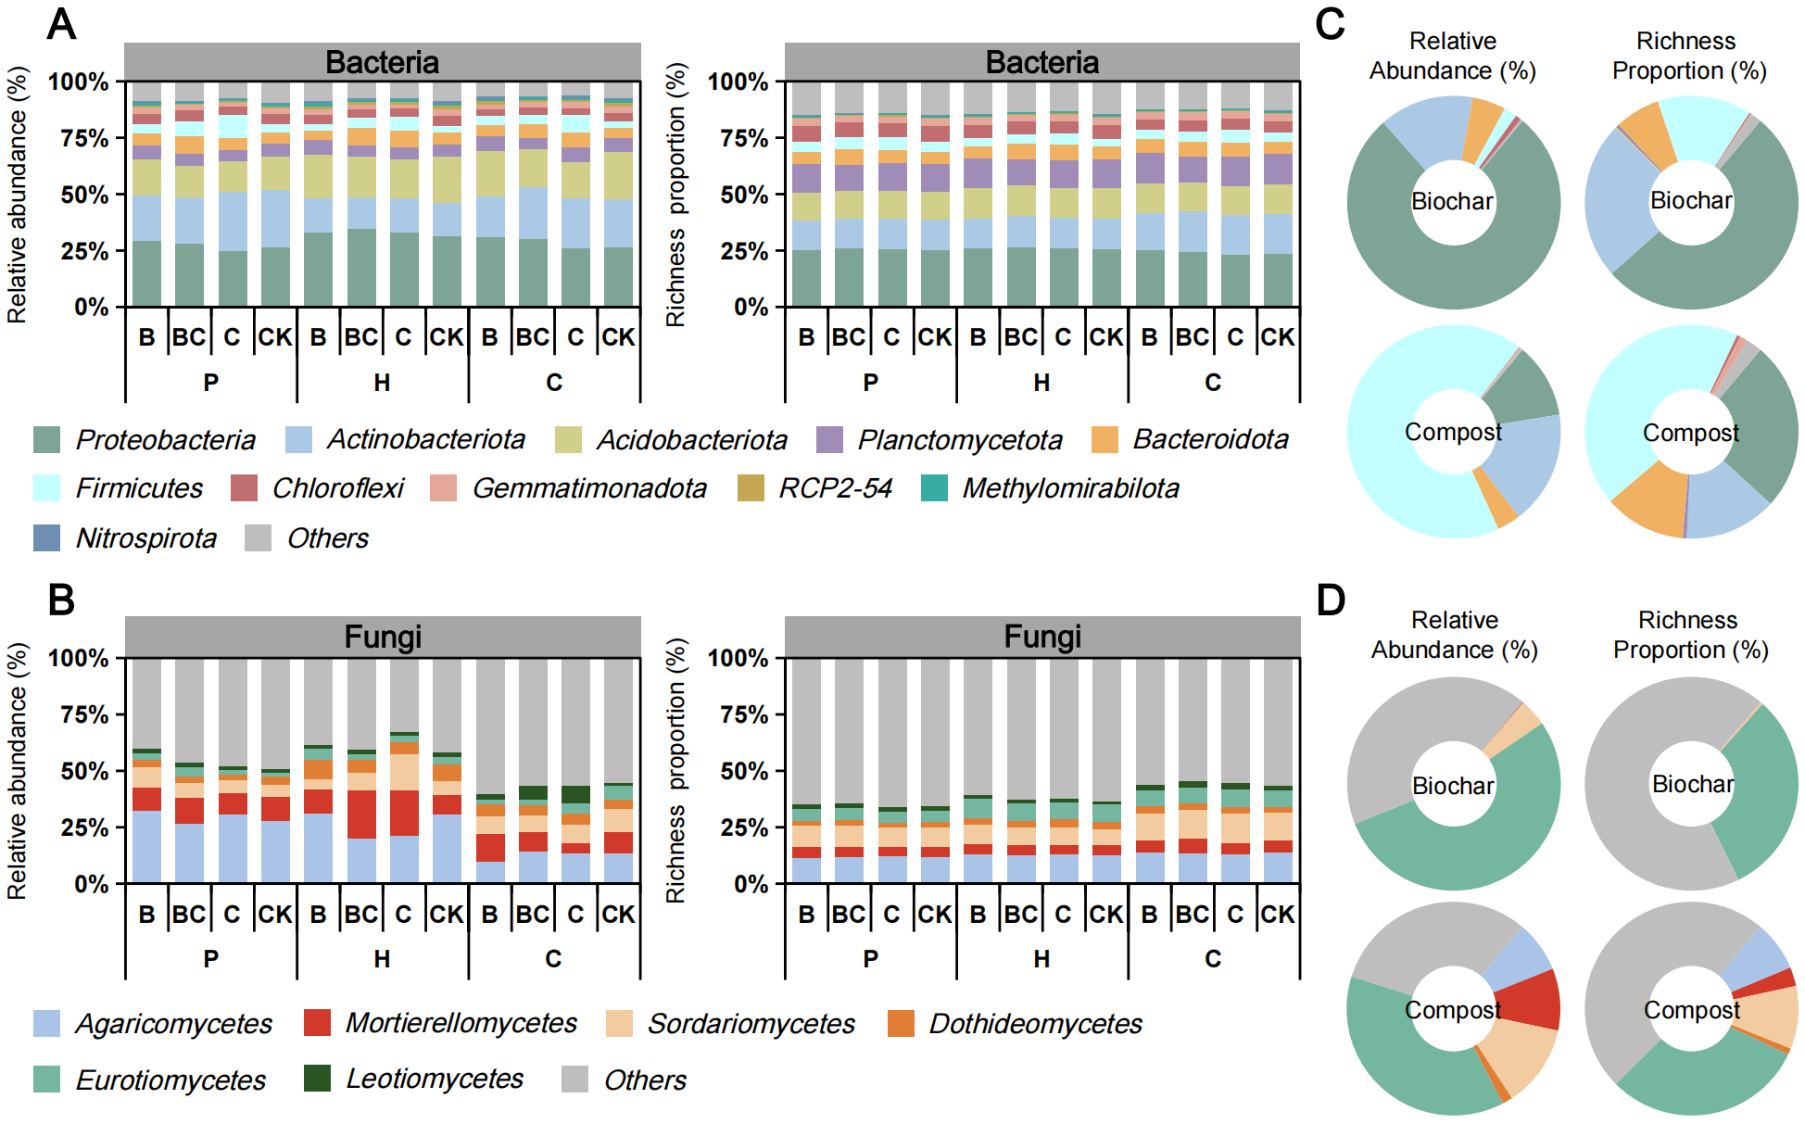

Fig. S7 Taxonomic composition and species richness proportion of bacterial (phylum level) and fungal (class level) communities across different treatments in three urban greenspaces, and added biochar and compost. (A) Bacterial community composition in urban greenspaces. At the phylum level, Proteobacteria, Actinobacteriota, and Acidobacteriota dominate the bacterial communities, collectively accounting for > 60% of relative abundance and ~ 50% of species richness. (B) Fungal community composition in urban greenspaces. At the class level, the fungal communities are primarily composed of Agaricomycetes, Mortierellomycetes, and Sordariomycetes, contributing to > 25% of both relative abundance and species richness. (C) Bacterial community composition in added biochar, and compost. (D) Fungal community composition in added biochar and compost. The horizontal axis of the bar plots follows a two-row labeling format (A, B): the first row indicates treatment conditions: biochar (B), biochar × compost (BC), compost (C), and control (CK); the second row denotes the sampling sites: P: Peking University, H: Haidian Park, and C: Changchun Garden. All bar plots are plotted using the mean values of different sampling times for each phylum/class under different treatments in urban greenspaces.
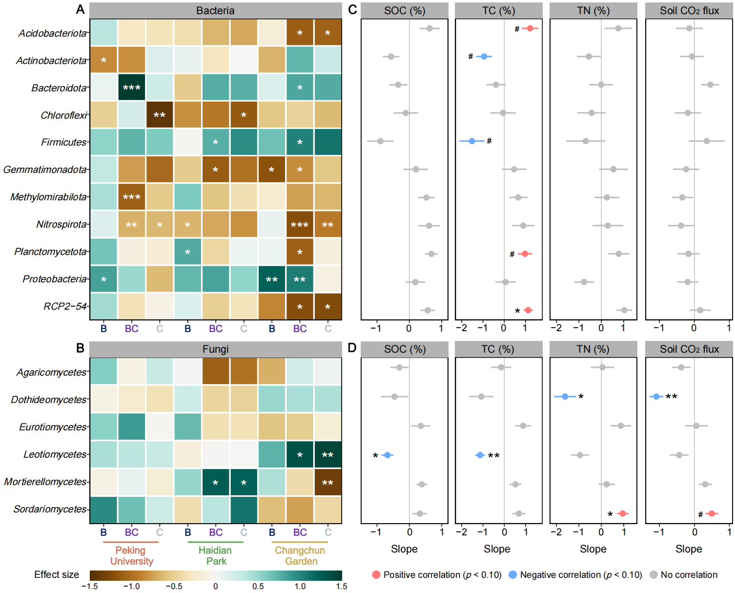

Fig. S8 Divergent responses of various microbial groups to different treatments in three urban greenspaces, and the correlation between these responses and the degree of changes in key environmental factors. (A, B) Treatment effect sizes on the relative abundance of bacterial (phylum level) and fungal (class level) communities in three urban greenspaces. Effect sizes are represented as regression coefficients derived from rescaled response variables (mean = 0, standard deviation = 1) in linear mixed-effects models. The color gradient of each box corresponds to the effect size. Statistical significance is determined using Wald type II χ² tests with false discovery rate adjustment (n = 14). (C, D) Relationships between the effect size of the treatment on key environmental factors (SOC, TC, TN, and soil CO₂ flux), and the relative abundance of bacterial and fungal lineages. Slopes and p-values with false discovery rate adjustment were calculated based on Pearson correlation (n = 9). The red circle indicates a positive correlation, the blue circle indicates a negative correlation, and the gray circle indicates no correlation. Significance levels are denoted as *** p < 0.001, ** p < 0.01, * p < 0.05, # p < 0.1. B: Biochar; BC: Biochar × Compost; C: Compost.
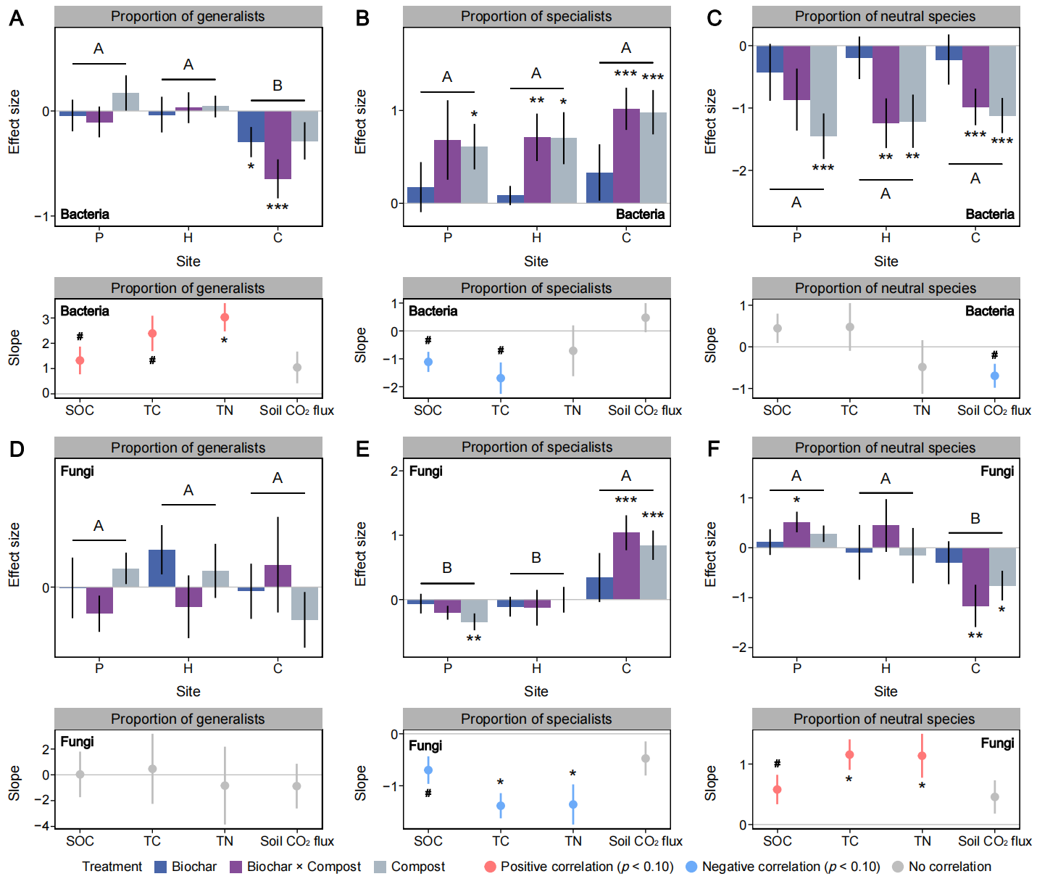

Fig. S9 Effects of single and combined treatments of biochar and compost on the unweighted proportions of generalists, specialists, and neutral species within soil microbial communities. Treatment effect sizes on the unweighted proportions of generalists, specialists, and neutral species within soil bacterial (A−C), and fungal (D−F) communities across three urban greenspaces. Microbial functional groups were classified using the permutation method in EcolUtils package in R. Effect sizes are represented as regression coefficients derived from rescaled response variables (mean = 0, standard deviation = 1) in linear mixed-effects models. Bars indicate the mean ± s.e.m. of the effect sizes. Statistical significance was determined using Wald type II χ² tests (n = 14). Differences in effect sizes among the three urban greenspaces were assessed using a post-hoc LSD test following one-way ANOVA (n = 9), and are indicated by uppercase letters. Relationships between the effect size of the treatment on key environmental factors (SOC, TC, TN, and soil CO₂ flux), and the above bacterial (A−C), and fungal (D−F) functional groups. Slopes and p-values with false discovery rate adjustment were calculated based on Pearson correlation (n = 9). The red circle indicates a positive correlation, the blue circle indicates a negative correlation, and the gray circle indicates no correlation. Significance levels are denoted as *** p < 0.001, ** p < 0.01, * p < 0.05, # p < 0.1. P: Peking University; H: Haidian Park; C: Changchun Garden.
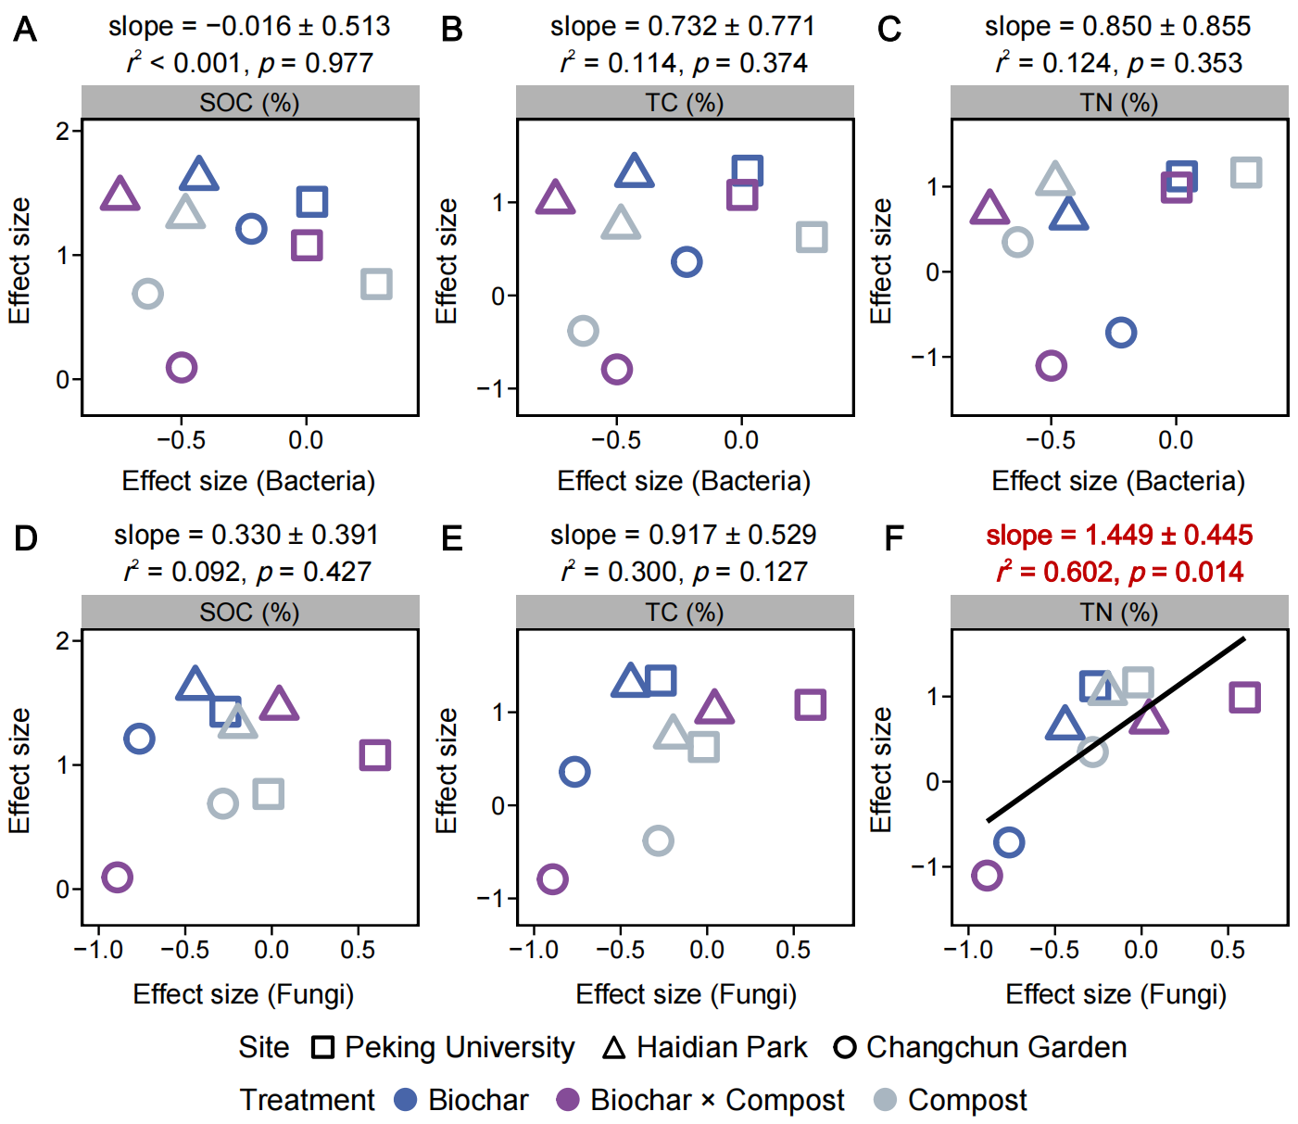

Fig. S10 Relationships between the effect size of the treatment on deterministic processes in microbial community assembly and their effect sizes on SOC, TC, and TN across three urban greenspaces. (A−C) Bacterial community. (D−F) Fungal community. Pearson correlation coefficients (r²) and p values were calculated (n = 9), with significant relationships (p < 0.05) highlighted in red bold text and the corresponding fitting lines are provided. Different shapes represent different urban greenspaces, while different colors represent different treatments. The x-axis represents the effect size of treatments on deterministic processes in microbial community assembly, while the y-axis represents the effect size of treatments on SOC, TC, and TN.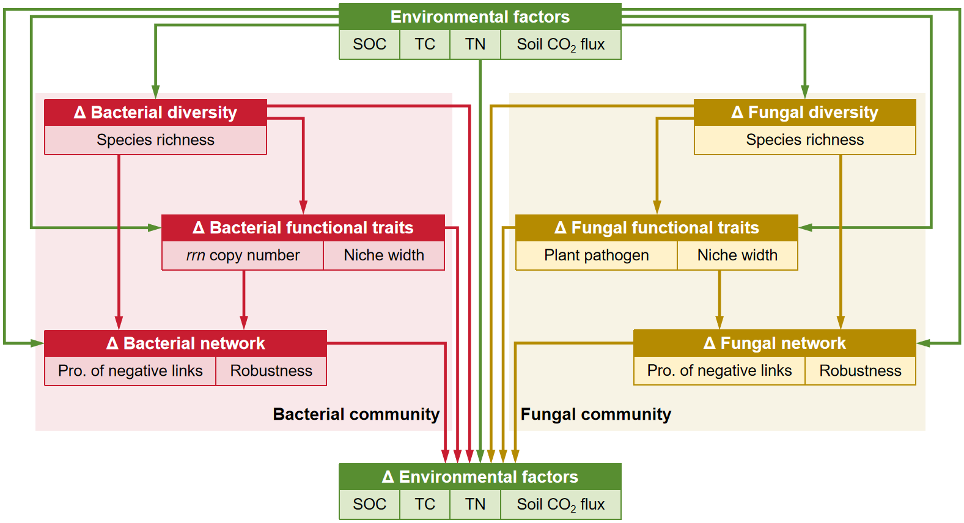

Fig. S11 A hypothetical conceptual model for PLS-PM analysis to investigate the relationships between the background values of environmental factors, and the effect sizes of treatments on microbial communities and environmental factors across three urban greenspaces. We hypothesized that the background values of environmental factors in urban greenspaces not only directly influence the effect size of treatment on environmental factors, but also indirectly affect it by modulating the effect sizes of microbial community diversity, functional traits, and network properties. These microbial variables, in turn, shape the treatment effects on environmental factors. Moreover, we assumed that treatment-induced changes in microbial community diversity could influence corresponding changes in functional traits and network properties. Additionally, changes in microbial functional traits under treatments may further regulate the effect size of treatment on microbial network properties. Δ represents the effect sizes of biochar and compost additions on the selected variables.
Supplementary Tables

Table S1 Physicochemical properties of the added biochar and compost
Physicochemical properties | Biochar^{[1]} | Compost
TOC (%) | 63.82 | 18.61
TC (%) | 64.65 | 18.67
TN (%) | 0.72 | 1.58
NH₄⁺-N (mg/kg) | 9.86 | 137.14
NO₃⁻-N (mg/kg) | 0.07 | 54.13
Water (%) | 0.86 | 0.71
AP (mg/kg) | 11.30 | 134.40
AK (g/kg) | 0.75 | 4.93
[1] The added biochar exhibited a higher C/N ratio compared to the compost. Both the added biochar and compost contained higher TOC, TC, and TN levels compared to urban greenspace soil (Fig. S3).

Table S2 Summary of permutational multivariate analysis of treatment, sampling site, and time on soil microbial community compositions
Microbial Taxa  /Variables | Bacteria |  |  | Fungi
Microbial Taxa  /Variables | F^{[1]} | r² | p | F | r² | p
Treatment | 2.063 | 0.049 | 0.001 | 1.734 | 0.038 | 0.014
Site | 16.978 | 0.271 | 0.001 | 21.642 | 0.318 | 0.001
Time | 3.182 | 0.025 | 0.003 | 4.155 | 0.030 | 0.001
Site × Time | 3.578 | 0.057 | 0.001 | 4.303 | 0.063 | 0.001
[1] Permutational multivariate analysis of variance (Adonis) was used on the basis of Bray-Curtis dissimilarity matrices. The one-way repeated-measures ANOVA model was set as ‘dissimilarity ~ treatment + site × time’ using the function adonis2 in the R package vegan. Significant effects (p < 0.050) are shown in bold text.

Table S3 Relationships between the effect sizes of the treatment on key environmental factors and soil microbial diversity across three urban greenspaces
Soil microbial diversity indices | Key environmental factors | slope^{[1]} | r² | p
Bacterial richness | SOC | − 0.365 ± 0.386 | 0.113 | 0.375
Bacterial richness | TC | − 0.843 ± 0.546 | 0.254 | 0.166
Bacterial richness | TN | − 1.529 ± 0.403 | 0.672 | 0.007
Bacterial richness | Soil CO₂ flux | − 0.939 ± 0.205 | 0.751 | 0.003
Fungal richness | SOC | 0.384 ± 0.281 | 0.210 | 0.214
Fungal richness | TC | 0.967 ± 0.324 | 0.560 | 0.020
Fungal richness | TN | 1.108 ± 0.348 | 0.592 | 0.015
Fungal richness | Soil CO₂ flux | 0.532 ± 0.244 | 0.404 | 0.066
F/B richness ratio | SOC | 0.263 ± 0.234 | 0.153 | 0.297
F/B richness ratio | TC | 0.699 ± 0.289 | 0.455 | 0.046
F/B richness ratio | TN | 0.918 ± 0.265 | 0.632 | 0.010
F/B richness ratio | Soil CO₂ flux | 0.486 ± 0.175 | 0.525 | 0.027
[1] Pearson correlation coefficients (r²), slopes, and p-values were calculated (n = 9), with significant relationships (p < 0.05) highlighted in bold text.

Table S4 Differences in effect sizes of treatment on species richness and relative abundance of different microbial lineages in three urban greenspaces
Microbial lineages | Species richness |  |  | Relative abundance
Microbial lineages | P^{[1]} | H | C | P | H | C
Acidobacteriota | A | A | A | A | A | A
Actinobacteriota | A | A | A | A | A | A
Bacteroidota | A | A | A | A | A | A
Chloroflexi^{[2]} | B | B | A | A | A | A
Firmicutes | A | A | A | A | A | A
Gemmatimonadota | A | A | A | A | A | A
Methylomirabilota | A | A | A | A | A | A
Nitrospirota | B | AB | A | A | A | A
Planctomycetota | A | A | A | A | A | A
Proteobacteria | A | A | A | A | A | A
RCP2-54 | A | A | A | A | A | B
Agaricomycetes | A | A | B | A | A | A
Dothideomycetes | A | A | A | B | B | A
Eurotiomycetes | A | AB | B | A | A | A
Leotiomycetes | B | B | A | B | B | A
Mortierellomycetes | AB | A | B | AB | A | B
Sordariomycetes | A | A | B | A | AB | B
[1] Differences in effect sizes among the three urban greenspaces were evaluated using a post-hoc LSD test following one-way ANOVA (n = 9), and are denoted by uppercase letters. P: Peking University, H: Haidian Park, and C: Changchun Garden.
[2] Larger letters correspond to higher effect sizes for the treatments. Significant differences (p < 0.05) in effect sizes between different urban greenspaces are indicated by different letters. Microbial lineages exhibiting significant differences in treatment effects are highlighted in bold.

Table S5 Relationships between the treatment effect size on key environmental factors and the species richness of various microbial lineages
Microbial lineages | SOC |  |  | TC |  |  | TN |  |  | Soil CO₂ flux
Microbial lineages | slope^{[1]} | r² | p | slope | r² | p | slope | r² | p | slope | r² | p
Acidobacteriota | − 0.224 ± 0.403 | 0.042 | 0.799 | − 0.411 ± 0.616 | 0.060 | 0.643 | − 1.194 ± 0.546 | 0.406 | 0.179 | − 0.838 ± 0.263 | 0.591 | 0.057
Actinobacteriota | − 0.725 ± 0.416 | 0.302 | 0.361 | − 1.390 ± 0.561 | 0.468 | 0.232 | − 1.338 ± 0.692 | 0.349 | 0.207 | − 0.357 ± 0.480 | 0.073 | 0.525
Bacteroidota | − 0.468 ± 0.301 | 0.257 | 0.361 | − 0.581 ± 0.491 | 0.167 | 0.456 | − 0.467 ± 0.573 | 0.086 | 0.695 | 0.226 ± 0.338 | 0.060 | 0.525
Chloroflexi | − 0.497 ± 0.302 | 0.279 | 0.361 | − 1.037 ± 0.384 | 0.510 | 0.232 | − 1.443 ± 0.277 | 0.795 | 0.013 | − 0.767 ± 0.206 | 0.664 | 0.057
Firmicutes | − 0.482 ± 0.365 | 0.200 | 0.417 | − 0.992 ± 0.505 | 0.356 | 0.331 | − 0.196 ± 0.697 | 0.011 | 0.863 | 0.402 ± 0.378 | 0.139 | 0.445
Gemmatimonadota | − 0.550 ± 0.341 | 0.270 | 0.361 | − 0.824 ± 0.531 | 0.256 | 0.453 | − 0.789 ± 0.619 | 0.188 | 0.446 | − 0.653 ± 0.314 | 0.381 | 0.168
Methylomirabilota | 0.107 ± 0.303 | 0.017 | 0.799 | 0.113 ± 0.470 | 0.008 | 0.817 | − 0.142 ± 0.523 | 0.010 | 0.863 | − 0.393 ± 0.267 | 0.236 | 0.291
Nitrospirota | − 0.066 ± 0.250 | 0.010 | 0.799 | − 0.415 ± 0.354 | 0.164 | 0.456 | − 0.805 ± 0.307 | 0.496 | 0.126 | − 0.521 ± 0.156 | 0.615 | 0.057
Planctomycetota | 0.687 ± 0.352 | 0.353 | 0.361 | 0.654 ± 0.627 | 0.134 | 0.456 | 0.134 ± 0.750 | 0.005 | 0.863 | − 0.667 ± 0.357 | 0.333 | 0.190
Proteobacteria | − 0.145 ± 0.315 | 0.029 | 0.799 | − 0.483 ± 0.458 | 0.137 | 0.456 | − 1.263 ± 0.273 | 0.753 | 0.013 | − 0.592 ± 0.229 | 0.489 | 0.099
RCP2-54 | 0.148 ± 0.279 | 0.039 | 0.799 | 0.126 ± 0.436 | 0.012 | 0.817 | − 0.205 ± 0.483 | 0.025 | 0.863 | − 0.243 ± 0.269 | 0.104 | 0.486
Agaricomycetes | 0.334 ± 0.238 | 0.220 | 0.243 | 0.838 ± 0.268 | 0.582 | 0.035 | 0.860 ± 0.330 | 0.493 | 0.052 | 0.424 ± 0.216 | 0.355 | 0.161
Dothideomycetes | 0.022 ± 0.584 | < 0.001 | 0.971 | 0.373 ± 0.889 | 0.025 | 0.688 | 0.429 ± 0.991 | 0.026 | 0.678 | 1.005 ± 0.443 | 0.424 | 0.161
Eurotiomycetes | 0.611 ± 0.349 | 0.305 | 0.243 | 1.296 ± 0.419 | 0.578 | 0.035 | 1.446 ± 0.467 | 0.578 | 0.035 | 0.561 ± 0.360 | 0.258 | 0.166
Leotiomycetes | − 0.515 ± 0.357 | 0.229 | 0.243 | − 1.178 ± 0.442 | 0.504 | 0.044 | − 1.500 ± 0.410 | 0.657 | 0.033 | − 0.646 ± 0.325 | 0.360 | 0.161
Mortierellomycetes | 0.473 ± 0.273 | 0.300 | 0.243 | 0.929 ± 0.360 | 0.488 | 0.044 | 0.556 ± 0.520 | 0.141 | 0.384 | 0.493 ± 0.267 | 0.327 | 0.161
Sordariomycetes | 0.429 ± 0.257 | 0.285 | 0.243 | 1.011 ± 0.270 | 0.667 | 0.035 | 1.093 ± 0.319 | 0.626 | 0.033 | 0.405 ± 0.262 | 0.255 | 0.166
[1] Pearson correlation coefficients (r²), slopes, and p-values with false discovery rate adjustment were calculated (n = 9), with significant relationships (p < 0.1) highlighted in bold text.

Table S6 Relationships between the treatment effect size on key environmental factors and the relative abundance of various microbial lineages
Microbial lineages | SOC |  |  | TC |  |  | TN |  |  | Soil CO₂ flux
Microbial lineages | slope^{[1]} | r² | p | slope | r² | p | slope | r² | p | slope | r² | p
Acidobacteriota | 0.626 ± 0.312 | 0.365 | 0.155 | 1.212 ± 0.393 | 0.576 | 0.081 | 0.759 ± 0.609 | 0.182 | 0.694 | − 0.146 ± 0.387 | 0.020 | 0.789
Actinobacteriota | − 0.568 ± 0.255 | 0.415 | 0.155 | − 0.946 ± 0.368 | 0.486 | 0.081 | − 0.556 ± 0.532 | 0.135 | 0.710 | − 0.070 ± 0.332 | 0.006 | 0.839
Bacteroidota | − 0.342 ± 0.285 | 0.171 | 0.370 | − 0.386 ± 0.459 | 0.092 | 0.553 | − 0.006 ± 0.537 | < 0.001 | 0.991 | 0.458 ± 0.260 | 0.306 | 0.773
Chloroflexi | − 0.112 ± 0.383 | 0.012 | 0.778 | − 0.059 ± 0.593 | 0.001 | 0.924 | − 0.436 ± 0.641 | 0.062 | 0.713 | − 0.189 ± 0.378 | 0.035 | 0.773
Firmicutes | − 0.892 ± 0.412 | 0.401 | 0.155 | − 1.518 ± 0.587 | 0.488 | 0.081 | − 0.698 ± 0.876 | 0.083 | 0.710 | 0.354 ± 0.515 | 0.063 | 0.773
Gemmatimonadota | 0.199 ± 0.382 | 0.037 | 0.680 | 0.457 ± 0.575 | 0.083 | 0.553 | 0.542 ± 0.638 | 0.093 | 0.710 | − 0.239 ± 0.379 | 0.054 | 0.773
Methylomirabilota | 0.526 ± 0.260 | 0.369 | 0.155 | 0.653 ± 0.440 | 0.240 | 0.284 | 0.249 ± 0.554 | 0.028 | 0.752 | − 0.344 ± 0.300 | 0.158 | 0.773
Nitrospirota | 0.608 ± 0.333 | 0.323 | 0.174 | 0.891 ± 0.525 | 0.292 | 0.245 | 0.292 ± 0.687 | 0.025 | 0.752 | − 0.383 ± 0.377 | 0.128 | 0.773
Planctomycetota | 0.680 ± 0.196 | 0.632 | 0.115 | 0.971 ± 0.338 | 0.541 | 0.081 | 0.777 ± 0.472 | 0.279 | 0.527 | − 0.170 ± 0.317 | 0.039 | 0.773
Proteobacteria | 0.185 ± 0.302 | 0.051 | 0.680 | 0.055 ± 0.477 | 0.002 | 0.924 | − 0.769 ± 0.446 | 0.298 | 0.527 | − 0.191 ± 0.301 | 0.054 | 0.773
RCP2-54 | 0.565 ± 0.221 | 0.483 | 0.155 | 1.121 ± 0.212 | 0.800 | 0.012 | 1.029 ± 0.358 | 0.541 | 0.262 | 0.169 ± 0.300 | 0.043 | 0.773
Agaricomycetes | − 0.308 ± 0.283 | 0.145 | 0.312 | − 0.147 ± 0.468 | 0.014 | 0.763 | 0.050 ± 0.525 | 0.001 | 0.927 | − 0.376 ± 0.271 | 0.216 | 0.249
Dothideomycetes | − 0.458 ± 0.421 | 0.145 | 0.312 | − 1.078 ± 0.571 | 0.337 | 0.121 | − 1.620 ± 0.487 | 0.613 | 0.038 | − 1.087 ± 0.196 | 0.815 | 0.005
Eurotiomycetes | 0.355 ± 0.298 | 0.168 | 0.312 | 0.882 ± 0.379 | 0.436 | 0.116 | 0.874 ± 0.455 | 0.345 | 0.144 | 0.058 ± 0.326 | 0.004 | 0.865
Leotiomycetes | − 0.677 ± 0.184 | 0.658 | 0.048 | − 1.136 ± 0.228 | 0.780 | 0.010 | − 0.948 ± 0.407 | 0.437 | 0.105 | − 0.433 ± 0.269 | 0.270 | 0.228
Mortierellomycetes | 0.384 ± 0.168 | 0.429 | 0.167 | 0.527 ± 0.278 | 0.339 | 0.121 | 0.237 ± 0.370 | 0.055 | 0.651 | 0.311 ± 0.188 | 0.282 | 0.228
Sordariomycetes | 0.324 ± 0.228 | 0.224 | 0.312 | 0.687 ± 0.303 | 0.423 | 0.116 | 0.958 ± 0.259 | 0.661 | 0.038 | 0.498 ± 0.177 | 0.530 | 0.079
[1] Pearson correlation coefficients (r²), slopes, and p-values with false discovery rate adjustment were calculated (n = 9), with significant relationships (p < 0.1) highlighted in bold text.

Table S7 Relationships between the treatment effect size on key environmental factors and microbial functional traits
Microbial  functional traits | SOC |  |  | TC |  |  | TN |  |  | Soil CO₂ flux
Microbial  functional traits | slope^{[1]} | r² | p | slope | r² | p | slope | r² | p | slope | r² | p
rrn copy number | − 0.653 ± 0.249 | 0.495 | 0.034 | − 1.257 ± 0.258 | 0.772 | 0.002 | − 0.992 ± 0.472 | 0.387 | 0.074 | − 0.060 ± 0.350 | 0.004 | 0.869
Bacterial niche width^{[2]} | 0.737 ± 0.336 | 0.407 | 0.065 | 1.446 ± 0.393 | 0.659 | 0.008 | 1.684 ± 0.397 | 0.720 | 0.004 | 0.658 ± 0.358 | 0.325 | 0.109
Plant pathogenic fungi | 0.359 ± 0.290 | 0.179 | 0.256 | 0.905 ± 0.357 | 0.479 | 0.039 | 1.151 ± 0.338 | 0.623 | 0.011 | 0.495 ± 0.260 | 0.341 | 0.099
Fungal niche width | − 0.927 ± 0.548 | 0.290 | 0.135 | − 1.968 ± 0.672 | 0.550 | 0.022 | − 2.464 ± 0.619 | 0.694 | 0.005 | − 1.027 ± 0.521 | 0.357 | 0.090
Bacterial generalists^{[3]} | 1.320 ± 0.548 | 0.453 | 0.094 | 2.390 ± 0.700 | 0.625 | 0.059 | 3.029 ± 0.559 | 0.807 | 0.012 | 1.044 ± 0.627 | 0.284 | 0.239
Bacterial specialists | − 1.109 ± 0.360 | 0.575 | 0.059 | − 1.692 ± 0.563 | 0.563 | 0.059 | − 0.712 ± 0.911 | 0.080 | 0.477 | 0.475 ± 0.522 | 0.106 | 0.477
Bacterial neutral species | 0.445 ± 0.352 | 0.186 | 0.370 | 0.477 ± 0.574 | 0.090 | 0.477 | − 0.485 ± 0.645 | 0.075 | 0.477 | − 0.696 ± 0.288 | 0.455 | 0.094
Fungal generalists | 0.032 ± 1.766 | < 0.001 | 0.986 | 0.464 ± 2.716 | 0.004 | 0.948 | − 0.837 ± 3.018 | 0.011 | 0.948 | − 0.876 ± 1.733 | 0.035 | 0.838
Fungal specialists | − 0.699 ± 0.265 | 0.498 | 0.081 | − 1.385 ± 0.242 | 0.823 | 0.009 | − 1.360 ± 0.387 | 0.639 | 0.039 | − 0.475 ± 0.328 | 0.230 | 0.287
Fungal neutral species | 0.579 ± 0.243 | 0.447 | 0.098 | 1.155 ± 0.252 | 0.750 | 0.015 | 1.137 ± 0.363 | 0.584 | 0.050 | 0.468 ± 0.275 | 0.293 | 0.227
- Pearson correlation coefficients (r²), slopes, and p-values were calculated (n = 9), with significant relationships (p < 0.05) highlighted in bold text. To account for multiple comparisons, false discovery rate adjustment was applied to p-values driven by the associations between effect sizes of generalist, specialist, and neutral species, and those of environmental factors.
- The niche width of microbial community was determined by calculating the niche width of each microbial species and taking the arithmetic mean (unweighted).
- Generalists, specialists, and neutral species within microbial communities were classified using the permutation method in EcolUtils package in R, and their unweighted proportions within the overall community were subsequently calculated.

Table S8 Topological properties of the constructed bacterial networks under different treatments across three urban greenspaces
Site |  | Peking University |  |  |  | Haidian Park |  |  |  | Changchun Garden
Treatment/Indices^{[1]} |  | B^{[4]} | BC | C | CK | B | BC | C | CK | B | BC | C | CK
Numbers of zOTUs^{[2]} |  | 5,181 | 4,982 | 4,692 | 5,432 | 5,312 | 4,893 | 4,956 | 5,394 | 6,003 | 5,714 | 5,736 | 5,854
Empirical network | Total nodes | 5,155 | 4,952 | 4,657 | 5,401 | 5,275 | 4,857 | 4,927 | 5,361 | 5,975 | 5,683 | 5,708 | 5,829
Empirical network | Total links | 38,020 | 33,625 | 32,008 | 38,792 | 35,596 | 31,199 | 36,789 | 37,528 | 37,437 | 34,196 | 36,122 | 36,114
Empirical network | Pro. of neg. links | 0.301 | 0.195 | 0.215 | 0.328 | 0.322 | 0.294 | 0.270 | 0.301 | 0.378 | 0.362 | 0.334 | 0.374
Empirical network | γ (Power law) | 1.393 | 1.444 | 1.361 | 1.308 | 1.026 | 1.426 | 1.524 | 1.280 | 1.394 | 1.155 | 0.873 | 1.112
Empirical network | Average K | 14.751 | 13.580 | 13.746 | 14.365 | 13.496 | 12.847 | 14.934 | 14.000 | 12.531 | 12.034 | 12.657 | 12.391
Empirical network | Average CC | 0.513 | 0.522 | 0.530 | 0.527 | 0.501 | 0.501 | 0.507 | 0.501 | 0.520 | 0.520 | 0.517 | 0.511
Empirical network | GD | 6.252 | 6.347 | 6.449 | 6.264 | 6.263 | 6.368 | 6.253 | 6.179 | 6.296 | 6.403 | 6.313 | 6.303
Empirical network | Density | 0.0029 | 0.0027 | 0.0030 | 0.0027 | 0.0026 | 0.0026 | 0.0030 | 0.0026 | 0.0021 | 0.0021 | 0.0022 | 0.0021
Empirical network | Con | 0.941 | 0.912 | 0.914 | 0.924 | 0.946 | 0.928 | 0.933 | 0.925 | 0.908 | 0.908 | 0.916 | 0.918
Empirical network | No. of modules | 70 | 87 | 81 | 77 | 74 | 76 | 77 | 90 | 90 | 97 | 82 | 91
Empirical network | Modularity (M) | 0.680 | 0.700 | 0.693 | 0.683 | 0.668 | 0.683 | 0.652 | 0.660 | 0.671 | 0.692 | 0.689 | 0.682
Empirical network | RM | 2.116 | 2.056 | 2.051 | 2.089 | 1.897 | 1.869 | 2.007 | 1.932 | 1.783 | 1.798 | 1.872 | 1.806
Random networks^{[3]} | Average CC ± SD | 0.005 ± 0.003 | 0.005 ± 0.003 | 0.006 ± 0.003 | 0.004 ± 0.002 | 0.004 ± 0.002 | 0.005 ± 0.003 | 0.007 ± 0.003 | 0.004 ± 0.002 | 0.003 ± 0.002 | 0.003 ± 0.002 | 0.003 ± 0.002 | 0.003 ± 0.002
Random networks^{[3]} | GD ± SD | 3.284 ± 0.018 | 3.351 ± 0.021 | 3.309 ± 0.020 | 3.330 ± 0.014 | 3.394 ± 0.016 | 3.399 ± 0.016 | 3.227 ± 0.022 | 3.369 ± 0.017 | 3.538 ± 0.010 | 3.556 ± 0.011 | 3.496 ± 0.010 | 3.529 ± 0.010
Random networks^{[3]} | Con ± SD | 0.999 ± 0.006 | 0.999 ± 0.010 | 0.999 ± 0.009 | 0.999 ± 0.006 | 0.999 ± 0.007 | 0.999 ± 0.008 | 0.999 ± 0.010 | 0.999 ± 0.010 | 1.000 ± 0.006 | 0.999 ± 0.007 | 1.000 ± 0.005 | 1.000 ± 0.003
Random networks^{[3]} | M ± SD | 0.218 ± 0.016 | 0.229 ± 0.016 | 0.227 ± 0.019 | 0.221 ± 0.014 | 0.230 ± 0.016 | 0.238 ± 0.017 | 0.217 ± 0.016 | 0.225 ± 0.016 | 0.241 ± 0.016 | 0.247 ± 0.016 | 0.240 ± 0.016 | 0.243 ± 0.015
- The total number of zOTUs with non-zero sequence numbers in at least 4 of the 7 samples used for each network.
- Pro. of neg. links: Proportion of negative links; Average K: Average connectivity; Average CC: Average clustering coefficient; GD: Average path distance; Con: Connectance; RM: Relative modularity.
- 100 random networks were generated by randomly rewiring all links of the corresponding empirical network while maintaining the same number of nodes and links. The reported values represent the mean and standard error derived from these 100 random networks. When significant differences (p < 0.05) were observed between the empirical and random network properties, the values were highlighted in bold.
- Treatment: B: Biochar, BC: Biochar × Compost, C: Compost, CK: Control.

Table S9 Topological properties of the constructed fungal networks under different treatments across three urban greenspaces
Site |  | Peking University |  |  |  | Haidian Park |  |  |  | Changchun Garden
Treatment/Indices^{[1]} |  | B^{[4]} | BC | C | CK | B | BC | C | CK | B | BC | C | CK
Numbers of zOTUs^{[2]} |  | 703 | 853 | 727 | 662 | 812 | 857 | 789 | 818 | 765 | 686 | 721 | 834
Empirical network | Total nodes | 603 | 730 | 617 | 547 | 703 | 747 | 669 | 738 | 597 | 520 | 577 | 694
Empirical network | Total links | 1,792 | 1,664 | 1,097 | 1,070 | 1,642 | 1,769 | 1,698 | 1,950 | 829 | 679 | 984 | 1,728
Empirical network | Pro. of neg. links | 0.040 | 0.053 | 0.078 | 0.096 | 0.055 | 0.072 | 0.067 | 0.066 | 0.174 | 0.224 | 0.133 | 0.115
Empirical network | γ (Power law) | 1.440 | 1.394 | 1.900 | 1.441 | 1.492 | 1.510 | 1.476 | 1.594 | 1.883 | 1.772 | 1.681 | 1.644
Empirical network | Average K | 5.944 | 4.559 | 3.556 | 3.912 | 4.671 | 4.736 | 5.076 | 5.285 | 2.777 | 2.612 | 3.411 | 4.980
Empirical network | Average CC | 0.594 | 0.587 | 0.618 | 0.552 | 0.630 | 0.587 | 0.622 | 0.602 | 0.555 | 0.556 | 0.568 | 0.582
Empirical network | GD | 8.475 | 9.079 | 9.765 | 15.677 | 16.839 | 10.230 | 18.009 | 10.075 | 5.844 | 6.870 | 8.175 | 6.805
Empirical network | Density | 0.010 | 0.006 | 0.006 | 0.007 | 0.007 | 0.006 | 0.008 | 0.007 | 0.005 | 0.005 | 0.006 | 0.007
Empirical network | Con | 0.493 | 0.372 | 0.117 | 0.438 | 0.287 | 0.322 | 0.566 | 0.353 | 0.041 | 0.074 | 0.199 | 0.313
Empirical network | No. of modules | 54 | 83 | 94 | 66 | 78 | 92 | 68 | 72 | 103 | 96 | 100 | 95
Empirical network | Modularity (M) | 0.840 | 0.880 | 0.939 | 0.912 | 0.924 | 0.836 | 0.881 | 0.867 | 0.956 | 0.948 | 0.864 | 0.800
Empirical network | RM | 1.186 | 0.874 | 0.664 | 0.738 | 1.009 | 0.845 | 1.048 | 1.066 | 0.404 | 0.332 | 0.499 | 0.841
Random networks^{[3]} | Average CC ± SD | 0.025 ± 0.004 | 0.013 ± 0.003 | 0.010 ± 0.003 | 0.013 ± 0.004 | 0.015 ± 0.003 | 0.021 ± 0.004 | 0.023 ± 0.004 | 0.018 ± 0.003 | 0.006 ± 0.004 | 0.004 ± 0.003 | 0.016 ± 0.005 | 0.020 ± 0.004
Random networks^{[3]} | GD ± SD | 3.504 ± 0.018 | 4.077 ± 0.020 | 4.634 ± 0.038 | 4.323 ± 0.035 | 3.998 ± 0.021 | 3.887 ± 0.024 | 3.748 ± 0.022 | 3.755 ± 0.017 | 5.682 ± 0.073 | 6.321 ± 0.083 | 4.459 ± 0.046 | 3.806 ± 0.022
Random networks^{[3]} | Con ± SD | 0.992 ± 0.007 | 0.983 ± 0.010 | 0.959 ± 0.016 | 0.977 ± 0.012 | 0.982 ± 0.010 | 0.980 ± 0.011 | 0.987 ± 0.009 | 0.989 ± 0.007 | 0.901 ± 0.026 | 0.894 ± 0.026 | 0.941 ± 0.017 | 0.977 ± 0.012
Random networks^{[3]} | M ± SD | 0.384 ± 0.004 | 0.470 ± 0.004 | 0.564 ± 0.005 | 0.525 ± 0.005 | 0.460 ± 0.005 | 0.453 ± 0.004 | 0.430 ± 0.004 | 0.420 ± 0.004 | 0.681 ± 0.005 | 0.712 ± 0.005 | 0.576 ± 0.005 | 0.435 ± 0.004
- The total number of zOTUs with non-zero sequence numbers in at least 4 of the 7 samples used for each network.
- Pro. of neg. links: Proportion of negative links; Average K: Average connectivity; Average CC: Average clustering coefficient; GD: Average path distance; Con: Connectance; RM: Relative modularity.
- 100 random networks were generated by randomly rewiring all links of the corresponding empirical network while maintaining the same number of nodes and links. The reported values represent the mean and standard deviation derived from these 100 random networks. When significant differences (p < 0.05) were observed between the empirical and random network properties, the values were highlighted in bold.
- Treatment: B: Biochar, BC: Biochar × Compost, C: Compost, CK: Control.

Table S10 Stability indices of the constructed microbial networks under different treatments across three urban greenspaces
Site |  | Peking University |  |  |  | Haidian Park |  |  |  | Changchun Garden
Treatment/Indices |  | B^{[1]} | BC | C | CK | B | BC | C | CK | B | BC | C | CK
Bacterial network | Robustness^{[2]} | 0.639 ± 0.004 | 0.711 ± 0.003 | 0.697 ± 0.004 | 0.626 ± 0.004 | 0.629 ± 0.004 | 0.644 ± 0.003 | 0.672 ± 0.004 | 0.642 ± 0.003 | 0.553 ± 0.004 | 0.576 ± 0.004 | 0.609 ± 0.004 | 0.570 ± 0.004
Bacterial network | Natural connectivity^{[3]} | 22.949 ± 1.021 | 24.509 ± 1.535 | 23.817 ± 0.860 | 22.132 ± 1.225 | 15.628 ± 0.412 | 21.249 ± 1.110 | 30.518 ± 1.121 | 15.682 ± 0.368 | 14.391 ± 0.804 | 13.671 ± 0.465 | 16.629 ± 1.023 | 15.459 ± 0.643
Fungal network | Robustness | 0.812 ± 0.006 | 0.805 ± 0.006 | 0.769 ± 0.008 | 0.745 ± 0.009 | 0.793 ± 0.006 | 0.774 ± 0.007 | 0.782 ± 0.006 | 0.762 ± 0.007 | 0.704 ± 0.008 | 0.672 ± 0.011 | 0.715 ± 0.010 | 0.728 ± 0.008
Fungal network | Natural connectivity | 11.942 ± 1.107 | 6.801 ± 0.663 | 4.774 ± 0.510 | 6.020 ± 0.801 | 8.536 ± 0.861 | 11.192 ± 1.178 | 11.134 ± 1.008 | 11.905 ± 1.366 | 2.436 ± 0.228 | 1.594 ± 0.067 | 7.522 ± 0.940 | 7.549 ± 0.634
- Treatment: B: Biochar, BC: Biochar × Compost, C: Compost, CK: Control.
- Robustness was measured as the weighted proportion of taxa that remained following the random removal of 10% of taxa from each empirical network. The reported values represent the mean and standard deviation derived from 100 repetitions of the simulation.
- Natural connectivity was calculated after the random removal of 10% of taxa from each empirical network. The reported values represent the mean and standard deviation derived from 100 repetitions of the simulation.

Table S11 Relationships between the treatment effect size on key environmental factors and microbial network properties
Microbial  network properties^{[1]} | SOC |  |  | TC |  |  | TN |  |  | Soil CO₂ flux
Microbial  network properties^{[1]} | slope^{[2]} | r² | p | slope | r² | p | slope | r² | p | slope | r² | p
Bacterial networks
Total nodes | − 0.146 ± 3.651 | < 0.001 | 0.996 | − 4.807 ± 5.327 | 0.104 | 0.781 | − 11.547 ± 4.510 | 0.484 | 0.300 | − 7.671 ± 2.215 | 0.631 | 0.276
Total links | 0.103 ± 2.389 | < 0.001 | 0.996 | − 2.884 ± 3.517 | 0.088 | 0.781 | − 4.862 ± 3.672 | 0.200 | 0.590 | − 3.967 ± 1.857 | 0.395 | 0.374
Pro. of neg. links | 0.749 ± 1.109 | 0.061 | 0.833 | − 0.535 ± 1.753 | 0.013 | 0.947 | − 2.522 ± 1.721 | 0.235 | 0.590 | − 1.264 ± 1.039 | 0.174 | 0.602
Average K | 0.470 ± 3.841 | 0.002 | 0.996 | − 2.352 ± 5.859 | 0.022 | 0.906 | 0.032 ± 6.608 | < 0.001 | 0.996 | − 1.975 ± 3.769 | 0.038 | 0.897
Average CC | − 16.459 ± 11.203 | 0.236 | 0.590 | − 37.760 ± 13.654 | 0.522 | 0.297 | − 37.590 ± 16.830 | 0.416 | 0.374 | − 7.272 ± 12.506 | 0.046 | 0.883
Modularity (M) | − 4.230 ± 10.840 | 0.021 | 0.906 | 1.712 ± 16.876 | 0.001 | 0.996 | 7.749 ± 18.604 | 0.024 | 0.906 | 12.655 ± 9.849 | 0.191 | 0.590
Robustness | − 2.580 ± 3.012 | 0.095 | 0.781 | 0.165 ± 4.880 | < 0.001 | 0.996 | 7.377 ± 4.673 | 0.263 | 0.590 | 3.745 ± 2.829 | 0.200 | 0.590
Natural connectivity | 0.508 ± 0.527 | 0.117 | 0.781 | 0.569 ± 0.837 | 0.062 | 0.833 | 1.208 ± 0.849 | 0.224 | 0.590 | 1.128 ± 0.363 | 0.579 | 0.276
Fungal networks
Total nodes | 0.950 ± 0.946 | 0.126 | 0.398 | 2.877 ± 1.118 | 0.486 | 0.084 | 3.285 ± 1.218 | 0.510 | 0.076 | 1.168 ± 0.909 | 0.191 | 0.320
Total links | 0.485 ± 0.365 | 0.201 | 0.314 | 1.250 ± 0.417 | 0.563 | 0.063 | 1.414 ± 0.456 | 0.578 | 0.062 | 0.421 ± 0.376 | 0.152 | 0.369
Pro. of neg. links | − 0.627 ± 0.304 | 0.378 | 0.146 | − 1.300 ± 0.335 | 0.683 | 0.039 | − 1.596 ± 0.275 | 0.828 | 0.014 | − 0.344 ± 0.363 | 0.114 | 0.413
Average K | 0.822 ± 0.501 | 0.277 | 0.221 | 1.834 ± 0.588 | 0.581 | 0.062 | 2.100 ± 0.631 | 0.613 | 0.058 | 0.584 ± 0.546 | 0.140 | 0.380
Average CC | 2.109 ± 2.954 | 0.068 | 0.498 | 7.588 ± 3.744 | 0.370 | 0.146 | 11.090 ± 3.177 | 0.635 | 0.054 | 2.214 ± 2.941 | 0.075 | 0.491
Modularity (M) | − 2.694 ± 1.613 | 0.285 | 0.221 | − 5.732 ± 1.987 | 0.543 | 0.063 | − 7.771 ± 1.456 | 0.803 | 0.014 | − 3.370 ± 1.418 | 0.447 | 0.105
Robustness | 5.940 ± 2.597 | 0.428 | 0.112 | 12.325 ± 2.509 | 0.775 | 0.014 | 13.758 ± 2.788 | 0.777 | 0.014 | 3.581 ± 3.152 | 0.156 | 0.369
Natural connectivity | 0.431 ± 0.317 | 0.209 | 0.314 | 0.864 ± 0.441 | 0.354 | 0.153 | 1.197 ± 0.412 | 0.547 | 0.063 | 0.274 ± 0.340 | 0.085 | 0.476
- Pro. of neg. links: Proportion of negative links; Average K: Average connectivity; Average CC: Average clustering coefficient.
- Pearson correlation coefficients (r²), slopes, and p-values with false discovery rate adjustment were calculated (n = 9), with significant relationships (p < 0.1) highlighted in bold text.

Table S12 Loadings of observed variables for latent variables in the PLS-PM analysis
Latent variables^{[1]} | Observed variables | Weight | Loading^{[2]}
Environmental factors | SOC | 0.335 | 0.946
Environmental factors | TC | 0.303 | 0.955
Environmental factors | TN | 0.228 | 0.731
Environmental factors | Soil CO₂ flux | 0.280 | 0.812
Δ Bacterial diversity | Δ Bacterial richness | 1.000 | 1.000
Δ Bacterial functional traits | Δ Bacterial rrn copy number | 0.201 | 0.689
Δ Bacterial functional traits | Δ Bacterial niche width | 0.874 | 0.986
Δ Bacterial network | Δ proportion of negative links | 0.533 | 0.992
Δ Bacterial network | Δ network robustness | 0.476 | 0.990
Δ Fungal diversity | Δ Fungal richness | 1.000 | 1.000
Δ Fungal functional traits | Δ species richness of  plant pathogenic fungi | 0.500 | 0.975
Δ Fungal functional traits | Δ Fungal niche width | 0.525 | 0.977
Δ Fungal network | Δ proportion of negative links | 0.497 | 0.995
Δ Fungal network | Δ network robustness | 0.508 | 0.996
Δ Environmental factors | Δ SOC | 0.165 | 0.732
Δ Environmental factors | Δ TC | 0.300 | 0.869
Δ Environmental factors | Δ TN | 0.424 | 0.929
Δ Environmental factors | Δ Soil CO₂ flux | 0.316 | 0.710
- Δ represents the effect sizes of biochar and compost additions on selected variables.
- Most selected observed variables had loadings larger than 0.7.

Table S13 Standardized path coefficients of selected variables in PLS-PM analysis
Predictor | Response^{[1]} | Standardized path coefficients, b^{[2]} | t | p^{[3]} | R^{2[4]}
Environmental factors | Δ Bacterial diversity | 0.861 ± 0.192 | 4.476 | 0.003 | 0.741
Environmental factors | Δ Bacterial network | 0.757 ± 0.425 | 1.782 | 0.125 | 0.432
Environmental factors | Δ Fungal diversity | − 0.784 ± 0.235 | − 3.342 | 0.012 | 0.615
Δ Bacterial diversity | Δ Bacterial functional traits | 0.773 ± 0.240 | 3.226 | 0.015 | 0.598
Δ Bacterial diversity | Δ Environmental factors | − 0.541 ± 0.098 | − 5.507 | 0.005 | 0.980
Δ Bacterial functional traits | Δ Bacterial network | − 0.160 ± 0.425 | − 0.377 | 0.719 | 0.432
Δ Bacterial network | Δ Environmental factors | 0.314 ± 0.094 | 3.349 | 0.029 | 0.980
Δ Fungal diversity | Δ Fungal functional traits | 0.935 ± 0.134 | 6.995 | < 0.001 | 0.875
Δ Fungal functional traits | Δ Fungal network | 0.855 ± 0.196 | 4.368 | 0.003 | 0.732
Δ Fungal functional traits | Δ Environmental factors | 0.271 ± 0.175 | 1.548 | 0.197 | 0.980
Δ Fungal network | Δ Environmental factors | 0.469 ± 0.142 | 3.308 | 0.030 | 0.980
- Δ represents the effect sizes of biochar and compost additions on selected variables. Bacterial and fungal diversity are represented by species richness. Bacterial functional traits include rrn copy number and unweighted mean niche width, while fungal functional traits include the species richness of plant pathogenic fungi and unweighted mean niche width. Bacterial and fungal network properties are represented by the proportion of negative links (topological properties) and robustness (stability index).
- Path coefficients were estimated using 1,000 bootstraps and then standardized, and presented as mean ± standard error.
- Significant paths (p < 0.05) are highlighted in bold.
- The proportion of variance explained (R²) by all predictors for each response variable.

Table S14 The significance of the influence of different sampling times on the treatment effect
Type | Index | Peking University |  |  | Haidian Park |  |  | Changchun Garden
Type | Index | B^{[1][2]} | BC | C | B | BC | C | B | BC | C
Environment | SOC | 0.392 | 0.943 | 0.045 | 0.857 | 0.857 | 0.857 | 0.972 | 0.972 | 0.972
Environment | TC | 0.591 | 0.794 | 0.676 | 0.991 | 0.991 | 0.991 | 0.968 | 0.968 | 0.968
Environment | TN | 0.007 | 0.746 | 0.001 | 0.828 | 0.828 | 0.828 | 0.701 | 0.473 | 0.815
Environment | Soil CO₂ flux | 0.502 | 0.403 | 0.946 | 0.901 | 0.034 | 0.901 | 0.316 | 0.231 | 0.166
Environment | NH₄⁺ | 0.493 | 0.509 | 0.398 | 0.645 | 0.980 | 0.645 | 0.817 | 0.817 | 0.817
Environment | NO₃⁻ | 0.510 | 0.242 | 0.242 | 0.619 | 0.619 | 0.619 | 0.887 | 0.195 | 0.195
Environment | Moisture | 0.303 | 0.277 | 0.204 | 0.469 | 0.469 | 0.469 | 0.777 | 0.736 | 0.736
Environment | pH | 0.306 | 0.306 | 0.268 | 0.842 | 0.839 | 0.839 | 0.931 | 0.931 | 0.931
Environment | AP | 0.492 | 0.561 | 0.492 | 0.026 | 0.153 | 0.091 | 0.582 | 0.236 | 0.236
Environment | AK | 0.926 | 0.926 | 0.926 | 0.089 | 0.750 | 0.750 | 0.808 | 0.808 | 0.123
Bacteria | Richness | 0.899 | 0.899 | 0.494 | 0.597 | 0.557 | 0.557 | 0.890 | 0.890 | 0.890
Bacteria | rrn Copy number | 0.267 | 0.267 | 0.267 | 0.617 | 0.617 | 0.617 | 0.894 | 0.813 | 0.813
Bacteria | Niche width | 0.504 | 0.504 | 0.696 | 0.967 | 0.882 | 0.790 | 0.848 | 0.722 | 0.416
Bacteria | Pro. generalists | 0.724 | 0.899 | 0.724 | 0.930 | 0.930 | 0.930 | 0.216 | 0.231 | 0.216
Bacteria | Pro. specialists | 0.273 | 0.636 | 0.273 | 0.882 | 0.882 | 0.882 | 0.851 | 0.301 | 0.301
Bacteria | Pro. neutral species | 0.318 | 0.590 | 0.410 | 0.893 | 0.893 | 0.893 | 0.568 | 0.568 | 0.568
Bacteria | Deterministic  processes | 0.644 | 0.090 | 0.345 | 0.873 | 0.873 | 0.873 | 0.114 | 0.294 | 0.078
Fungi | Richness | 0.968 | 0.968 | 0.968 | 0.790 | 0.650 | 0.650 | 0.930 | 0.930 | 0.929
Fungi | Plant pathogenic | 0.889 | 0.889 | 0.889 | 0.843 | 0.843 | 0.843 | 0.730 | 0.952 | 0.730
Fungi | Niche width | 0.836 | 0.836 | 0.585 | 0.752 | 0.752 | 0.752 | 0.978 | 0.978 | 0.806
Fungi | Pro. generalists | 0.901 | 0.901 | 0.901 | 0.946 | 0.946 | 0.946 | 0.782 | 0.782 | 0.782
Fungi | Pro. specialists | 0.810 | 0.299 | 0.299 | 0.346 | 0.346 | 0.346 | 0.975 | 0.975 | 0.397
Fungi | Pro. neutral species | 0.695 | 0.695 | 0.041 | 0.366 | 0.324 | 0.324 | 0.987 | 0.987 | 0.637
Fungi | Deterministic  processes | 0.673 | 0.277 | 0.673 | 0.966 | 0.966 | 0.966 | 0.798 | 0.836 | 0.255
Bacteria/Fungi richness |  | 0.899 | 0.899 | 0.009 | 0.750 | 0.750 | 0.750 | 0.731 | 0.766 | 0.167
[1] The significance of the influence of sampling time on the treatment effect was assessed by the p-value for the Treatment × Sampling Time interaction in linear mixed-effects models (Index ~ Treatment × Sampling Time + (1|Sampling Time)) (n = 14, soil CO₂ flux: n = 12). All p-values were adjusted for the false discovery rate. Significant effects (p < 0.05) highlighted in bold text.
[2] Treatments: B: Biochar; BC: Biochar × Compost; C: Compost.

References
Csardi, G., Nepusz, T., 2006. The igraph software package for complex network research. InterJournal, complex systems 1695(5), 1-9.
Dai, T.J., Wen, D.H., Bates, C.T., Wu, L.W., Guo, X., Liu, S., Su, Y.F., Lei, J.S., Zhou, J.Z., Yang, Y.F., 2022. Nutrient supply controls the linkage between species abundance and ecological interactions in marine bacterial communities. Nat. Commun. 13(1), 1-9.
Deng, Y., Jiang, Y.H., Yang, Y.F., He, Z.L., Luo, F., Zhou, J.Z., 2012. Molecular ecological network analyses. BMC Bioinformatics 13, 113.
Guo, X., Feng, J.J., Shi, Z., Zhou, X.S., Yuan, M.T., Tao, X.Y., Hale, L., Yuan, T., Wang, J.J., Qin, Y.J., Zhou, A.F., Fu, Y., Wu, L.Y., He, Z.L., Van Nostrand, J.D., Ning, D.L., Liu, X.D., Luo, Y.Q., Tiedje, J.M., Yang, Y.F., Zhou, J.Z., 2018. Climate warming leads to divergent succession of grassland microbial communities. Nat. Clim. Chang. 8(9), 813-818.
Lee, Z.M.P., Bussema, C., Schmidt, T.M., 2009. rrnDB: documenting the number of rRNA and tRNA genes in bacteria and archaea. Nucleic Acids Res. 37, D489-D493.
Levins, R., 1968. Evolution in Changing Environments: Some Theoretical Explorations. Princeton University Press. https://doi.org/10.2307/j.ctvx5wbbh.
Liang, Y., Ning, D., Lu, Z., Zhang, N., Hale, L., Wu, L., Clark, I.M., McGrath, S.P., Storkey, J., Hirsch, P.R., Sun, B., Zhou, J., 2020. Century long fertilization reduces stochasticity controlling grassland microbial community succession. Soil Biol. Biochem. 151, 108023.
Maslov, S., Sneppen, K., 2002. Specificity and stability in topology of protein networks. Science 296(5569), 910-913.
Montesinos-Navarro, A., Hiraldo, F., Tella, J.L., Blanco, G., 2017. Network structure embracing mutualism-antagonism continuums increases community robustness. Nat. Ecol. Evol. 1(11), 1661-1669.
Ning, D.L., Deng, Y., Tiedje, J.M., Zhou, J.Z., 2019. A general framework for quantitatively assessing ecological stochasticity. Proc. Natl. Acad. Sci. U.S.A. 116(34), 16892-16898.
Pandit, S.N., Kolasa, J., Cottenie, K., 2009. Contrasts between habitat generalists and specialists: an empirical extension to the basic metacommunity framework. Ecology 90(8), 2253-2262.
Ruan, Q., Dutta, D., Schwalbach, M.S., Steele, J.A., Fuhrman, J.A., Sun, F., 2006. Local similarity analysis reveals unique associations among marine bacterioplankton species and environmental factors. Bioinformatics 22(20), 2532-2538.
Salazar, G., 2015. EcolUtils: utilities for community ecology analysis.
Sanchez, G., 2013. PLS path modeling with R. Berkeley: Trowchez Editions 383(2013), 551.
Weiss, S., Van Treuren, W., Lozupone, C., Faust, K., Friedman, J., Deng, Y., Xia, L.C., Xu, Z.Z., Ursell, L., Alm, E.J., Birmingham, A., Cram, J.A., Fuhrman, J.A., Raes, J., Sun, F.Z., Zhou, J.Z., Knight, R., 2016. Correlation detection strategies in microbial data sets vary widely in sensitivity and precision. ISME J. 10(7), 1669-1681.
Wu, J., Barahona, M., Tan, Y.J., Deng, H.Z., 2010. Natural connectivity of complex networks. Chinese Physics Letters 27(7).
Xia, L.C., Steele, J.A., Cram, J.A., Cardon, Z.G., Simmons, S.L., Vallino, J.J., Fuhrman, J.A., Sun, F., 2011. Extended local similarity analysis (eLSA) of microbial community and other time series data with replicates. BMC Systems Biology 5(2), S15.
Yuan, M.M., Guo, X., Wu, L.W., Zhang, Y., Xiao, N.J., Ning, D.L., Shi, Z., Zhou, X.S., Wu, L.Y., Yang, Y.F., Tiedje, J.M., Zhou, J.Z., 2021. Climate warming enhances microbial network complexity and stability. Nat. Clim. Chang. 11(4), 343-348.
Zhang, J., Zhang, B., Liu, Y., Guo, Y., Shi, P., Wei, G., 2018. Distinct large-scale biogeographic patterns of fungal communities in bulk soil and soybean rhizosphere in China. Sci. Total Environ. 644, 791-800.

