Supplementary Materials

Conventional and Microwave-Assisted Pyrolysis Biochars: Comparative Mechanistic Insights, Structural Evolution, and Environmental Remediation Applications
Atta Rasool^{1,*}, Kateřina Brožová¹, Jitka Chromíková¹, Eva Pertile¹, Jan Halfar¹, Petra Malíková¹, Oldřich Motyka¹, Silvie Drabinová¹, Kristina Čabanová¹, Silvie Heviánková¹

¹Faculty of Mining and Geology, VSB – Technical University of Ostrava, 17. listopadu 2172/15, Ostrava-Poruba, 708 00, Czech Republic
*Corresponding author
Name: Atta Rasool
Email: atta.rasool@vsb.cz

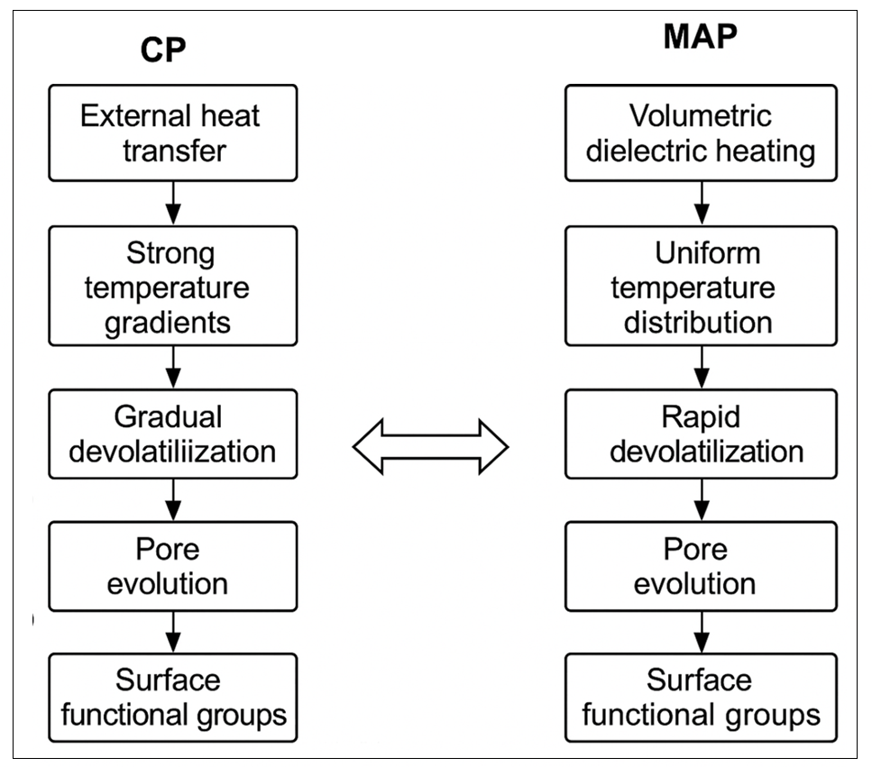
Fig. S1 shows a comparative schematic of the mechanisms of pore structure evolution and surface functional group synthesis during CP and MAP

Table S1. Quantitative Benchmarking of CP vs. MAP Biochars (Typical Literature Ranges).
Property |  | Conventional Pyrolysis (CP) Biochar | Microwave-Assisted Pyrolysis (MAP) Biochar | Notes & Interpretation | Representative References
BET Surface Area (m² g⁻¹) |  | 10–350 | 150–850 | MAP often produces higher SA due to rapid heating and better pore development | Shadi et al. 2023
Pore Volume (cm³ g⁻¹) |  | 0.01–0.20 | 0.10–0.60 | Greater mesoporosity in MAP char improves the diffusion of larger molecules | Tomczyk et al., 2020
Dominant Pore Type |  | Microporous | Mesoporous + microporous | MAP favors mesopore formation via internal dielectric heating | Meyer et al., 2024; Ellison et al. 2017
pH |  | 6–9 (feedstock dependent) | 7–11 | Higher pH is often due to the concentration of basic functional groups in MAP chars | Dennison et al. 2025
Elemental C (%) |  | 50–75 | 60–85 | MAP enhances carbonization and aromaticity | Nizamuddin et al. 2019
Elemental H (%) |  | 2–4 | 1–3 | Lower H indicates greater aromatic condensation in MAP | Wijitkosum and Jiwnok 2019
Elemental O (%) |  | 10–25 | 5–20 | Controlled MAP heating reduces oxygen loss, preserving OFGs at moderate temperatures | Yu et al. 2023
C/O Ratio |  | 2–8 | 4–12 | Higher C/O ratio indicates stronger graphitization in MAP | Ahmad et al., 2014; Zuo et al. 2023
Ash Content (%) |  | 5–20 | 1–10 | MAP typically generates lower ash because mineral migration is limited | Chen et al. 2023
Surface Functional Groups |  | Moderate; decreases sharply at high T | Often higher abundance at equivalent T | MAP preserves OFGs due to rapid heat exposure | Chen et al. 2017
Heating Rate (°C s⁻¹) |  | 5–50 | 50–500+ | Rapid MAP heating drives unique pore and carbon structures | Lei et al. 2023; Chaubey et al. 2024

Table S2. Comparative mechanistic matrix linking CP vs. MAP structural characteristics to adsorption mechanisms, thermodynamic signatures, kinetic behavior, and key findings.
Structural Feature | CP Biochar Characteristics | MAP Biochar Characteristics | Effect on Adsorption Mechanisms | Thermodynamic Implications | Kinetic Implications | Key Findings / Conclusions | Supporting References
Surface area & pore structure | Moderate SA; micropore-dominant; slower devolatilization | Higher SA; mesopore-rich due to rapid internal heating | MAP enhances pore filling, intraparticle diffusion, accessibility for bulky organics & emerging contaminants | Higher q_max; often endothermic due to increased surface accessibility | Faster intraparticle diffusion; pseudo-second-order best fit | MAP biochars provide faster sorption and higher capacities due to mesoporosity and improved accessibility | Tomczyk et al., 2020; Puteri et al. 2025
Graphitization/aromaticity | Lower aromatic order | Higher graphitization, π-rich domains | Stronger π–π and hydrophobic interactions for aromatic organics | Spontaneous (ΔG < 0), endothermic for aromatic compounds | Enhanced film diffusion; rapid uptake | MAP graphitization significantly improves organic pollutant adsorption | Mohona et al. 2023
Surface oxygen functional groups (OFGs) | Reduced at high CP temperature | Often higher OFGs due to controlled MAP heating | Enhanced H-bonding, electrostatic attraction, surface complexation | Exothermic chemisorption for metals; improved affinity | Faster initial sorption; chemisorption dominates (PSO kinetics) | MAP chars show stronger metal sorption due to abundant OFGs | Suliman et al. 2017; Ahmad et al., 2014
Mineral/ash content | Higher ash (depending on feedstock) | Lower mineral residues | CP favors ion exchange, precipitation, and co-precipitation | Multi-step isotherms; increased heterogeneity | Slower overall kinetics; mineral-dependent reactions | CP biochars are more suitable for precipitation-driven metal immobilization | (Bedia et al. 2018
Surface charge (pHₚzc) | Often lower; varies widely | Often higher due to lower ash and higher OFGs | MAP enhances anion adsorption; CP supports cation exchange | pH-sensitive ΔG; MAP improves anion affinity | Faster equilibrium for anions in MAP systems | MAP biochars outperform CP in removal of oxyanions (As(V), Cr(VI)) | Haider et al. 2022
Chemical stability / recalcitrance | Moderate structural stability | Higher aromatic stability | Maintains active sites during reuse; improved catalytic performance | Higher entropy (ΔS) contributions | Improved regeneration kinetics | MAP chars exhibit superior regenerability and reusability | Priyanka et al. 2024; Portillo et al. 2024
Surface defects / active sites | Fewer defect sites | Higher defect density due to rapid MAP heating | Improved redox reactions and catalysis | Higher ΔH in redox-mediated adsorptions | Faster electron transfer kinetics | MAP potentially superior for emerging contaminants requiring redox pathways | Bongosia et al. 2024; Zhang et al., 2024

