Supplementary Information

Deep Learning-Aided Prediction and Mechanistic Analysis of Reaction Kinetics in Biochar-Catalyzed Antibiotic Degradation
Junaid Latif^{a,b}, Na Chen^{a,b*}, Jia Xie^{a,b}, Zheng Ni^{a,b}, Lang Zhu^{a,b}, Azka Saleem^{c}, Kai Li^{a,b}, and Hanzhong Jia^{a,b*}

ª State Key Laboratory of Soil and Water Conservation and Desertification Control, College of Natural Resources and Environment, Northwest A and F University, 3# Taicheng Road, Yangling 712100, China.
^{b} Key Laboratory of Low-Carbon Green Agriculture in Northwestern China, Ministry of Agriculture and Rural Affairs, Yangling 712100, China.
^{c} College of Life Sciences, Northwest A and F University, Yangling 712100, China.

* To whom correspondence should be addressed
College of Resources and Environment
Northwest A & F university
3# Taicheng Road, Yangling 712100, China
Hanzhong Jia and Na Chen
Emails: jiahz@nwafu.edu.cn and nachen@nwafu.edu.cn
Phone: +86-029-87080055

Text S1. Introduction of missing values imputation
To handle the missing values in our data set, the feature prediction imputation method was employed to estimate and fill in the missing values. The column with the fewest missing values was selected as the target variable, and then the RF regression model was employed to train and predict using the remaining feature columns. The predicted values were then filled back into the original feature matrix. This iterative process was repeated until all missing values had been gradually filled in.
Text S2. Application of K-means Clustering to Categorize PFRs
K-means clustering was employed to classify PFR observations into four distinct groups based on PT and PFR spin concentrations (spins g⁻¹). Our prior research indicated a positive correlation between PT and PFR levels in the 200–500 °C range, followed by a sharp decline beyond 500 °C (Latif et al. 2024). Electron paramagnetic resonance (EPR) spectra further pinpointed 400–500 °C as the optimal temperature window for maximum PFR formation (Bi et al. 2022).
While PFRs play a critical role in pollutant degradation, their substantial variability complicates the identification of patterns associated with antibiotic removal efficiency using BCSs. To address this, K-means clustering was utilized to stratify the dataset into four meaningful categories: low, medium, high, and diminished PFR levels. This classification enabled a more systematic analysis of how PFR abundance influences degradation performance. K-means is an unsupervised ML algorithm well-suited for continuous numerical data. It partitions data into K clusters by minimizing intra-cluster variance. The algorithm initiates with random centroids, assigns samples based on Euclidean distance to the nearest centroid, recalculates cluster centres, and iterates until convergence. In this study, K was set to 4, corresponding to the four PFRs categories.
Cluster quality was assessed using the silhouette coefficient, calculated as:
$$s\left(i\right)=\frac{b\left(i\right)-a\left(i\right)}{\max\left(a\left(i\right),b\left(i\right)\right)}$$
where a(i) is the average intra-cluster distance and b(i) is the average distance to the nearest cluster. Higher values of s(i) indicate well-separated and cohesive clusters, supporting the suitability of the chosen clustering approach.
The clustering analysis identified four distinct clusters based on PT and PFR levels. Cluster 1 (Low, n = 60) is characterized by PT values primarily around 300 °C and 650 °C, with PFR concentrations ranging from 1.2×10¹⁸ to 2.2×10¹⁸ spins g⁻¹. Cluster 2 (Medium, n = 62) corresponds to PT values around 350 °C, 400 °C, and 600 °C, with PFRs ranging from 2.5×10¹⁸ to 4.5×10¹⁸ spins g⁻¹. Cluster 3 (High, n = 163) includes PT values of 450 °C, 500 °C, and 550 °C, exhibiting elevated PFR levels ranging from 5.0×10¹⁸ to 9.8×10¹⁸ spins g⁻¹. Cluster 4 (Diminished, n = 98) is defined by the highest PT values between 700 °C and 900 °C, with PFR concentrations below 1.0×10¹⁸ spinsg⁻¹. In total, these four clusters comprise 383 samples. The remaining six samples (n = 6) correspond to systems without detectable PFRs and were treated as a separate “PFR-absent” category excluded from the clustering analysis. A scatter plot (Fig. 1b) visualized the distribution of PFRs against PT across the four clusters, showing distinct separation along the temperature axis. Additionally, a histogram (Fig. 1c) illustrated the sample frequency within each cluster, emphasizing the distribution of observations across PFR categories.
Text S3. Transformation techniques and their impact on model performances
Transforming only the target variable is commonly done to address skewness and improve the performance of regression models, particularly those that assume normally distributed residuals, such as linear regression or generalized linear models. Transforming the target can help achieve homoscedasticity, stabilize variance, and improve the accuracy of predictions, confidence intervals, and p-values. Most ensemble ML models like RF or XGBoost do not require normality of either the target or features; however, target transformation can still enhance performance when the distribution is highly skewed. Feature transformations are generally applied when skewness, outliers, or non-linearity adversely affect model performance or interpretability. As the target variable has a direct impact on residual distribution and model accuracy, it is often prioritized for transformation. The transformation parameters and corresponding skewness and λ values are summarized in Table S4, highlighting that the Yeo-Johnson transformation, with a λ value of –12.9708, most effectively reduced skewness to 0.228, compared to the original skewness of 3.2.
Among the evaluated techniques, log transformation resulted in a high coefficient of determination on the training set (R² = 0.967), but its generalization performance was comparatively weaker, with a test R² of 0.861, a training RMSE of 0.265, and a test RMSE of 0.488. In contrast, the square root transformation demonstrated more balanced performance, achieving R² values of 0.960 (train) and 0.867 (test), along with notably lower RMSE values (0.025 for training and 0.039 for testing), suggesting a well-generalized model with minimal overfitting. Among all transformations, the Yeo-Johnson method yielded the highest predictive accuracy, with a test R² of 0.870 and a training R² of 0.926. Furthermore, it recorded the lowest error levels, with a training RMSE of 0.018 and a test RMSE of 0.028, indicating strong model generalization and reliable predictive performance.
Text S4. Distribution Analysis of predicted variable (k)
To validate the data preprocessing phase, we assessed the normality of the target variable (k) using both visual and statistical methods. The original dataset exhibited significant skewness, as evidenced by the points deviating from the diagonal reference line and a Shapiro–Wilk test statistic of 0.6358 (p = 6.4×10⁻²⁸). After applying the Yeo-Johnson transformation, the distribution improved substantially; the data points in the transformed plot align much more closely with the y=x red line. This improvement is further supported by the increase in the Shapiro–Wilk statistic to 0.9503. While the p-value (3.8×10⁻¹⁰) reflects the inherent variability of an experimental dataset, the transformation successfully mitigated extreme values and stabilized the distribution. This ensures that the dataset meets the requirements for the machine learning algorithms used in this study, reducing the risk of bias during model training.
Text S5. Introduction of ML models, training and development of GUI
ML models differ in their algorithmic structures, underlying assumptions, and learning capabilities, leading to variations in their predictive performance when applied to the same dataset. In this study, a dataset comprising 389 data points was analyzed, where the potential risk of overfitting remained a consideration despite the dataset's relatively large size in the context of reaction rate constants (k). To determine the most suitable predictive model, both conventional and advanced ML techniques were employed, including transformer-based deep learning model TabPFN (Tabular Prior-data Fitted Network), XGBoost (XGB), random forest regression (RFR), Light Gradient Boosting Machines (LGBM), support vector regression (SVR), and neural networks (NN). These models have been extensively utilized for addressing complex predictive challenges in environmental research. To facilitate understanding, a concise overview of these ML techniques and their hyperparameter tuning is provided below.
TabPFN (Tabular Prior-data Fitted Network) is a transformer-based deep learning foundation model designed for tabular data, excelling in supervised classification and regression tasks, particularly on small datasets (up to 10,000 samples and 500 features) (Hollmann et al. 2025). Unlike traditional ML models like XGB or RF, TabPFN requires no hyperparameter tuning and delivers predictions in a single forward pass, making it significantly faster than AutoML systems (up to 230× speedup). It’s pretrained on 130 millions of synthetic datasets generated from structural causal models (SCMs), incorporating principles like simplicity and causality, allowing it to approximate Bayesian inference through in-context learning (ICL). This means it processes training and test data together without further training, producing smooth, interpretable predictions. While TabPFN’s speed and performance are impressive, its reliance on synthetic data raises questions about generalizability to complex real-world datasets. The model’s inductive biases, explored in studies like, show both brilliant (e.g., resembling 1-nearest-neighbour in sparse settings) and baffling behaviors (e.g., non-monotonic probability outputs without ensembling). Its scalability to larger datasets remains a challenge, and reproducibility concerns persist due to the proprietary aspects of its development.
XGB is an optimized gradient boosting algorithm that enhances the performance of traditional gradient boosting by integrating multiple weak learners (decision trees) into a robust predictive framework (Sibindi et al. 2023). To prevent overfitting, XGB incorporates regularization techniques, thereby controlling model complexity. RFR, on the other hand, constructs an ensemble of decision trees, aggregating their predictions to improve accuracy and robustness (Shehadeh et al. 2021). By employing bootstrap sampling, RFR randomly selects subsets of features for individual trees, introducing variability and reducing overfitting risks. SVR operates by identifying an optimal hyperplane that maximizes the margin around training samples, thereby enhancing generalization capabilities (Cervantes et al. 2020). Unlike conventional regression methods, SVR relies on kernel functions to map data into higher-dimensional spaces, improving its ability to capture complex relationships. NNs, inspired by the architecture of biological neural systems, consist of multiple layers of interconnected artificial neurons (Yang and Wang 2020). These networks are adept at learning intricate patterns from input data and are widely applied in classification and regression tasks. However, their effectiveness is contingent on factors such as network architecture, parameter selection, and the availability of extensive computational resources. Given their complexity, NNs are particularly prone to overfitting when trained on limited datasets.
Hyperparameter tuning is a critical process that involves selecting appropriate model parameters before training to optimize performance and enhance generalization (Elgeldawi et al. 2021). Various approaches exist for hyperparameter tuning, including grid search, random search, Bayesian optimization, and evolutionary algorithms. In this study, the grid search method was employed due to its interpretability, systematic exploration of parameter combinations, and reproducibility, particularly when working with smaller datasets.
In developing the web-based graphical user interface (GUI) for our predictive model, we chose to deploy only the RFR model, despite exploring integration with the TabPFN. This decision was based on practical, technical, and research-driven factors that favored robustness, efficiency, and ease of deployment. RFR, being a lightweight and tree-based model, requires minimal computational resources, making it ideal for integration into a Flask-based web application. In contrast, TabPFN model depends heavily on PyTorch and CUDA for optimal performance, which introduces significant dependency and hardware constraints. Particularly for servers lacking GPU support, TabPFN’s inference becomes considerably slower for datasets exceeding 1,000 samples, as reported in its documentation (Liu and Ye 2025). For a user-facing application requiring real-time predictions, RFR provided a more suitable balance between performance and usability.

Table S1. Article information.
No. | year | DOI
1 | 2014 | https://doi.org/10.1021/es4048126
2 | 2015 | https://pubs.acs.org/doi/10.1021/es5061512
3 | 2017 | https://doi.org/10.1016/j.apcatb.2017.05.036
4 | 2017 | https://doi.org/10.1021/acs.est.7b01087
5 | 2017 | https://doi.org/10.1016/j.cej.2017.08.013
6 | 2017 | https://doi.org/10.1021/acsami.7b03310
7 | 2018 | https://doi.org/10.1016/j.carbon.2018.01.036
8 | 2018 | https://doi.org/10.1016/j.cej.2018.06.147
9 | 2019 | https://doi.org/10.1016/j.cej.2018.12.098
10 | 2019 | https://doi.org/10.1016/j.jhazmat.2019.03.024
11 | 2019 | https://doi.org/10.1016/j.cej.2019.121908
12 | 2019 | https://doi.org/10.1016/j.cej.2019.04.135
13 | 2019 | https://doi.org/10.1016/j.cej.2019.03.179
14 | 2019 | https://doi.org/10.1016/j.cej.2019.01.053
15 | 2019 | https://doi.org/10.1016/j.cej.2019.06.006
16 | 2019 | https://doi.org/10.1016/j.scitotenv.2019.07.043
17 | 2019 | https://doi.org/10.1016/j.cej.2019.05.204
18 | 2019 | https://doi.org/10.1016/j.cej.2019.03.235
19 | 2020 | https://doi.org/10.1016/j.cej.2019.123921
20 | 2020 | https://doi.org/10.1016/j.chemosphere.2020.126975
21 | 2020 | https://doi.org/10.1016/j.jhazmat.2020.122783
22 | 2020 | https://doi.org/10.1016/j.cej.2020.125377
23 | 2020 | https://doi.org/10.1016/j.cej.2020.126039
24 | 2020 | https://doi.org/10.1016/j.jhazmat.2019.121258
25 | 2020 | https://doi.org/10.1016/j.jhazmat.2020.123039
26 | 2020 | https://doi.org/10.1016/j.envpol.2020.114020
27 | 2020 | https://doi.org/10.1016/j.jhazmat.2020.122764
28 | 2021 | https://doi.org/10.1016/j.biortech.2021.124780
29 | 2021 | https://doi.org/10.1016/j.scitotenv.2021.148707
30 | 2021 | https://doi.org/10.1016/j.scitotenv.2020.144630
31 | 2021 | https://doi.org/10.1021/acs.est.1c01974
32 | 2021 | https://doi.org/10.1016/j.chemosphere.2020.129213
33 | 2021 | https://doi.org/10.1016/j.jhazmat.2020.124454
34 | 2021 | https://doi.org/10.1016/j.chemosphere.2021.130456
35 | 2021 | https://doi.org/10.1016/j.chemosphere.2021.131399
36 | 2021 | https://doi.org/10.1016/j.scitotenv.2021.146807
37 | 2022 | https://doi.org/10.1016/j.chemosphere.2022.133737
38 | 2022 | https://doi.org/10.1016/j.jwpe.2022.102626
39 | 2022 | https://doi.org/10.1016/j.cej.2022.135669
40 | 2022 | https://doi.org/10.1016/j.chemosphere.2022.136442
41 | 2022 | https://doi.org/10.1016/j.jhazmat.2022.129514
42 | 2022 | https://doi.org/10.1016/j.jaap.2022.105770
43 | 2022 | https://doi.org/10.1016/j.scitotenv.2022.153536
44 | 2022 | https://doi.org/10.1016/j.chemosphere.2022.135308
45 | 2022 | https://doi.org/10.1007/s42773-022-00188-5
46 | 2022 | https://doi.org/10.1016/j.scitotenv.2022.153453
47 | 2022 | https://doi.org/10.1016/j.jhazmat.2021.126805
48 | 2022 | https://doi.org/10.1016/j.jhazmat.2021.127225
49 | 2022 | https://doi.org/10.1016/j.watres.2022.119013
50 | 2023 | https://doi.org/10.1021/acs.est.3c03370
51 | 2023 | https://doi.org/10.1016/j.cej.2023.142908
52 | 2023 | https://doi.org/10.1016/j.scitotenv.2023.163740
53 | 2023 | https://doi.org/10.1016/j.cej.2022.138560
54 | 2023 | https://doi.org/10.1016/j.scitotenv.2022.159940
55 | 2023 | https://doi.org/10.1016/j.watres.2023.120368
56 | 2023 | https://doi.org/10.1016/j.envres.2022.114724
57 | 2023 | https://doi.org/10.1016/j.jece.2023.110747
58 | 2023 | https://doi.org/10.1016/j.apcatb.2023.122647
59 | 2023 | https://doi.org/10.1016/j.watres.2023.119977
60 | 2023 | https://doi.org/10.1016/j.chemosphere.2023.140362
61 | 2023 | https://doi.org/10.1016/j.cej.2023.147274
62 | 2023 | https://doi.org/10.1016/j.chemosphere.2023.138409
63 | 2023 | https://doi.org/10.1016/j.envpol.2022.120669
64 | 2024 | https://doi.org/10.1016/j.envpol.2024.123827
65 | 2024 | https://doi.org/10.1016/j.envpol.2024.124499
66 | 2024 | https://doi.org/10.1016/j.jhazmat.2023.132652
67 | 2024 | https://doi.org/10.1016/j.seppur.2024.127499
68 | 2024 | https://doi.org/10.1016/j.watres.2024.122267
69 | 2024 | https://doi.org/10.1016/j.jenvman.2023.119930
70 | 2024 | https://doi.org/10.1016/j.cej.2024.155025
71 | 2024 | https://doi.org/10.1016/j.biortech.2024.131103
72 | 2024 | https://doi.org/10.1016/j.seppur.2023.125725
73 | 2024 | https://doi.org/10.1016/j.jhazmat.2023.132960
74 | 2024 | https://doi.org/10.1016/j.seppur.2023.125444
75 | 2024 | https://doi.org/10.1016/j.cej.2024.152080

Table S2. The chemical names and structures.
No. | Chemical Structure | Chemical Structure Depiction
1 | Chlortetracycline | 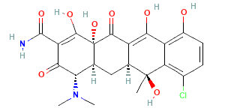
2 | Ciprofloxacin | 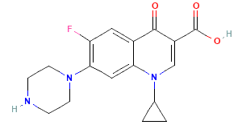
3 | Doxycycline | 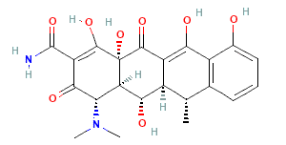
4 | Enrofloxacin | 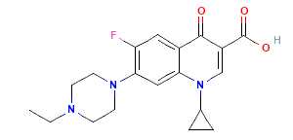
5 | Fleroxacin | 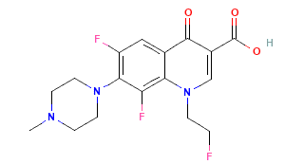
6 | Levofloxacin | 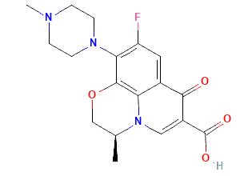
7 | Norfloxacin | 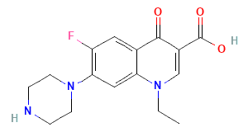
8 | Ofloxacin | 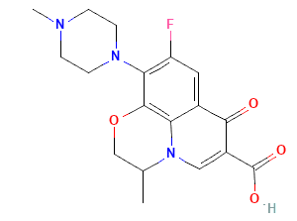
9 | Oxytetracycline | 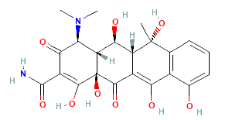
10 | Pefloxacin | 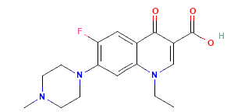
11 | Sulfadiazine | 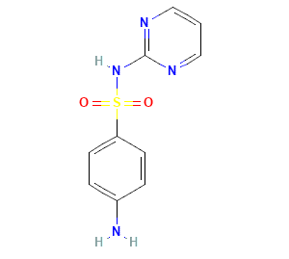
12 | Sulfamethazine | 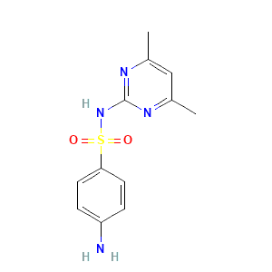
13 | Sulfamethoxazole | 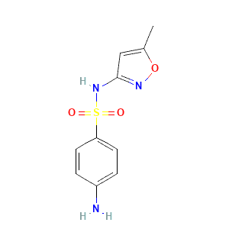
14 | Tetracycline | 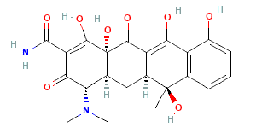

Table S3. Input features used to predict k of antibiotic.
Empirical categories | Input features | Unit | Abbreviation | Data range
1.Catalyst properties | 1. Doping | Yes/No | Doping | 2 types
1.Catalyst properties | 2. Graphitic structure | Yes/No | GS | 2 types
1.Catalyst properties | 3. Specific surface area | m² g⁻¹ | SSA | 0.9–756
1.Catalyst properties | 4. Average pore size | nm | APS | 0.0002–0.06
1.Catalyst properties | 5. Total pore volume | cm³ g⁻¹ | TPV | 0.002–2.23
1.Catalyst properties | 6. Raman intensity ratio | I_{D}/I_{G} | I_{D}/I_{G} | 0.13–1.9
1.Catalyst properties | 7. Pyrolysis temperature | ℃ | PT | 160–900
1.Catalyst properties | 8. Persistent free radicals | Spins g⁻¹ (10¹⁷) | PFRs | 10¹⁶–10¹⁸
2.Elemental composition | 9. Carbon | % | C | 15–96
2.Elemental composition | 10. Hydrogen | % | H | 0.19–13.5
2.Elemental composition | 11. Oxygen | % | O | 1.96–38.7
2.Elemental composition | 12. Nitrogen | % | N | 0.05 –3
2.Elemental composition | 13. pH | _ | pH | 3–12
3.Reaction conditions | 14. Oxidant concentration | mg L⁻¹ | C_{oxi} | 0–8
3.Reaction conditions | 15. Biochar concentration | mg L⁻¹ | C_{bio} | 0.05–4
3.Reaction conditions | 16. Pollutant concentration | mg L⁻¹ | C_{pol} | 1–50
Target variable | 1. Reaction rate constant | k | k | 0.0003–0.48

Table S4. The Skewness and lambda value of the target variable of different transformation.
Transformation | Skewness
Original (Before Transformation) | 3.2
Log Transformation | -0.965
Square Root Transformation | 1.145
Yeo-Johnson Transformation | 0.228
Yeo-Johnson Lambda | -12.9708

Table S5. Descriptive statistical analysis on the raw, transformed, and scaled dataset.
Feature | SSA | APS | TPV | PT | I_{D}/I_{G} | PFRs | C | H | O | N | pH | C_{oxi} | C_{bio} | C_{pol} | Dope | GS
Min_Raw | 0.99 | 0.00 | 0.00 | 160.00 | 0.13 | 0.03 | 15.10 | 0.20 | 1.96 | 0.05 | 3.00 | 0.00 | 0.05 | 1.00 | 0.00 | 0.00
Max_Raw | 756.10 | 0.06 | 2.23 | 900.00 | 2.00 | 0.06 | 96.00 | 13.55 | 38.70 | 3.02 | 12.00 | 8.00 | 4.00 | 50.00 | 1.00 | 1.00
Mean_Raw | 163.38 | 0.01 | 0.17 | 572.99 | 0.94 | 0.05 | 65.02 | 3.07 | 15.25 | 1.39 | 6.75 | 3.43 | 1.86 | 22.26 | 0.33 | 0.79
Std_Raw | 179.01 | 0.01 | 0.33 | 165.31 | 0.39 | 0.01 | 20.61 | 2.12 | 6.90 | 0.92 | 1.71 | 2.36 | 1.31 | 13.29 | 0.47 | 0.41
Skew_Raw | 1.32 | 2.69 | 3.97 | 0.27 | 0.50 | -1.70 | -1.16 | 1.54 | 0.92 | 0.00 | 0.09 | 0.08 | -0.12 | 0.42 | 0.72 | -1.41
Min_Yeo-Johnson | -1.81 | -1.58 | -1.44 | -2.82 | -2.29 | 0.03 | -1.90 | -2.61 | -2.73 | -1.57 | -2.19 | -1.60 | -1.45 | -1.96 | 0.00 | 0.00
Max_Yeo-Johnson | 1.84 | 2.08 | 2.26 | 1.88 | 2.45 | 0.06 | 2.19 | 2.58 | 2.70 | 1.63 | 3.09 | 1.73 | 1.51 | 1.82 | 1.00 | 1.00
Mean_Yeo-Johnson | 0.00 | 0.00 | 0.00 | 0.00 | 0.00 | 0.05 | 0.00 | 0.00 | 0.00 | 0.00 | 0.00 | 0.00 | 0.00 | 0.00 | 0.33 | 0.79
Std_Yeo-Johnson | 1.00 | 1.00 | 1.00 | 1.00 | 1.00 | 0.01 | 1.00 | 1.00 | 1.00 | 1.00 | 1.00 | 1.00 | 1.00 | 1.00 | 0.47 | 0.41
Skew_Yeo-Johnson | -0.12 | 0.72 | 0.57 | 0.02 | 0.03 | -1.70 | -0.48 | 0.02 | 0.04 | -0.13 | 0.10 | -0.19 | -0.21 | -0.12 | 0.72 | -1.41
Min_MinMax Scaled | 0.00 | 0.00 | 0.00 | 0.00 | 0.00 | 0.00 | 0.00 | 0.00 | 0.00 | 0.00 | 0.00 | 0.00 | 0.00 | 0.00 | 0.00 | 0.00
Max_MinMax Scaled | 1.00 | 1.00 | 1.00 | 1.00 | 1.00 | 1.00 | 1.00 | 1.00 | 1.00 | 1.00 | 1.00 | 1.00 | 1.00 | 1.00 | 1.00 | 1.00
Mean_MinMax Scaled | 0.50 | 0.43 | 0.39 | 0.60 | 0.48 | 0.74 | 0.46 | 0.50 | 0.50 | 0.49 | 0.41 | 0.48 | 0.49 | 0.52 | 0.33 | 0.79
Std_MinMax Scaled | 0.27 | 0.27 | 0.27 | 0.21 | 0.21 | 0.31 | 0.24 | 0.19 | 0.18 | 0.31 | 0.19 | 0.30 | 0.34 | 0.26 | 0.47 | 0.41
Skew_MinMax Scaled | -0.12 | 0.72 | 0.57 | 0.02 | 0.03 | -1.70 | -0.48 | 0.02 | 0.04 | -0.13 | 0.10 | -0.19 | -0.21 | -0.12 | 0.72 | -1.41

Table S6. The tuned hyperparameters of RFR, XGB, LGBM, SVR, and NN models for the prediction of the k trained with the BCSs data set.
Prediction target | ML models | Hyperparameters (three vital parameters)
reaction rate constant (k) | 1. TabPFN | device  CPU | inference_mode  Default | ---
reaction rate constant (k) | 2. Random Forest regression (RFR) | n_estimators  100 | max_depth  20 | max_features  sqrt
reaction rate constant (k) | 3. XGBoost regression (XGB) | n_estimators  100 | max_depth  6 | learning_rate  0.03
reaction rate constant (k) | 4. Light Gradient Boosting LGBM | n_estimators  100 | max_depth  -1 | learning_rate  0.01
reaction rate constant (k) | 5. Supporting vector regression (SVM) | C  1 | Epsilon  0.1 | Gamma  scale
 | 6. Neural network (MLP) | hidden_layer_sizes  (100,100) | max_iter  500 | learning_rate_init = 0.001

Table S7. Experimental data used to predict k in BCS system
Doping | GS | SSA | APS | TPV | I_{D}/I_{G} | PT | PFRs | C | H | O | N | pH | C_{oxi} | C_{bio} | C_{pol} | k
No | Yes | 53.2 | 0.0061 | 0.081 | 1.01 | 900 | Dim | 17.21 | 0.22 | 3.24 | 0.52 | 7 | 0 | 4 | 20 | 0.048
No | No | 6.5 | 0.0185 | 0.030 | 0.96 | 300 | Low | 34.29 | 3.31 | 34.00 | 2.55 | 8.48 | 0 | 0.5 | 2.5 | 0.009
No | No | 14 | 0.0171 | 0.060 | 1.02 | 500 | High | 37.51 | 1.99 | 13.00 | 2.53 | 9.36 | 0 | 0.5 | 2.5 | 0.055
No | Yes | 121.1 | 0.0033 | 0.100 | 1.08 | 700 | Dim | 36.97 | 1.09 | 10.00 | 1.45 | 10.4 | 0 | 0.5 | 2.5 | 0.034
No | No | 1.89 | 0.0110 | 0.005 | 0.81 | 400 | Med | 54.70 | 2.87 | 17.00 | 0.96 | 7.4 | 0 | 0.5 | 2.5 | 0.010
No | No | 9.15 | 0.0092 | 0.021 | 0.85 | 600 | Med | 33.36 | 1.45 | 14.21 | 2.34 | 7.4 | 0 | 0.5 | 40 | 0.015
No | No | 202.3 | 0.0035 | 0.177 | 0.97 | 800 | No | 78.74 | 5.00 | 12.08 | 2.58 | 3 | 0 | 0.2 | 20 | 0.011
No | No | 202.3 | 0.0035 | 0.177 | 0.97 | 500 | High | 78.74 | 5.00 | 12.08 | 2.58 | 3 | 0 | 0.2 | 20 | 0.010
No | No | 14 | 0.0171 | 0.060 | 1.02 | 700 | Dim | 37.51 | 1.99 | 13.00 | 2.53 | 9.36 | 0 | 1 | 2.5 | 0.061
Yes | No | 28.32 | 0.0593 | 0.420 | 0.82 | 400 | Med | 43.56 | 9.06 | 31.61 | 2.62 | 6 | 0 | 0.05 | 5 | 0.013
Yes | Yes | 484.4 | 0.0062 | 0.750 | 0.98 | 500 | High | 52.46 | 13.55 | 30.80 | 1.96 | 6 | 0 | 0.05 | 5 | 0.014
Yes | Yes | 656.1 | 0.0067 | 1.100 | 0.99 | 600 | Med | 60.24 | 10.84 | 23.79 | 1.62 | 6 | 0 | 0.05 | 5 | 0.016
Yes | Yes | 641.3 | 0.0139 | 2.230 | 1.04 | 700 | Dim | 71.33 | 8.64 | 17.92 | 1.46 | 6 | 0 | 0.05 | 5 | 0.017
Yes | Yes | 679.9 | 0.0086 | 1.470 | 1.08 | 900 | Dim | 72.44 | 6.84 | 16.37 | 1.78 | 6 | 0 | 0.05 | 5 | 0.0261
Yes | Yes | 362.5 | 0.0033 | 0.297 | 0.49 | 800 | Dim | 78.74 | 5.00 | 12.08 | 2.58 | 3 | 0 | 0.2 | 20 | 0.014
Yes | Yes | 69.79 | 0.0077 | 0.135 | 1.60 | 500 | High | 29.50 | 1.94 | 16.85 | 3.01 | 7 | 0 | 0.4 | 10 | 0.149
Yes | Yes | 27.29 | 0.0114 | 0.078 | 1.40 | 500 | High | 17.20 | 1.79 | 15.62 | 2.42 | 7 | 0 | 0.4 | 10 | 0.050
Yes | Yes | 362.5 | 0.0033 | 0.297 | 0.49 | 500 | High | 78.74 | 5.00 | 12.08 | 2.58 | 3 | 0 | 0.2 | 20 | 0.012
No | No | 4.64 | 0.0018 | 0.0021 | 0.471 | 300 | Low | 54.8 | 6.5 | 38.7 | 0.05 | 7 | 3 | 3 | 20 | 0.0116
No | Yes | 3.7 | 0.0432 | 0.04 | 0.959 | 700 | Dim | 75.98 | 1.62 | 6.27 | 1.37 | 7 | 0.1 | 1 | 50 | 0.11
No | No | 36.9 | 0.0015 | 0.0145 | 0.625 | 400 | Med | 74.1 | 4.95 | 20.9 | 0.06 | 7 | 5.5 | 3 | 20 | 0.0443
No | No | 330.33 | 0.0017 | 0.140 | 0.72 | 500 | High | 77.53 | 2.08 | 15.24 | 0.65 | 7 | 5 | 3 | 20 | 0.0489
No | No | 9.15 | 0.00918 | 0.021 | 0.85 | 600 | Med | 33.36 | 1.45 | 14.21 | 2.34 | 7.4 | 8 | 0.5 | 40 | 0.055
No | Yes | 3.7 | 0.0432 | 0.04 | 0.959 | 700 | Dim | 75.98 | 1.62 | 6.27 | 1.37 | 7 | 0.5 | 3 | 1 | 0.48
No | No | 9.15 | 0.00918 | 0.021 | 0.85 | 600 | Med | 33.36 | 1.45 | 14.21 | 2.34 | 7.4 | 8 | 1 | 40 | 0.057
No | Yes | 6.5 | 0.0084 | 0.0138 | 1.621 | 650 | Low | 66.32 | 1.45 | 11.45 | 1.79 | 12 | 7 | 1.8 | 40 | 0.0058
No | Yes | 393.05 | 0.0019 | 0.1864 | 0.988 | 800 | Dim | 94 | 1.5 | 5.5 | 0.07 | 7 | 3 | 3 | 20 | 0.062
No | Yes | 54.5 | 0.0064 | 0.087 | 0.99 | 900 | No | 17.17 | 0.195 | 1.96 | 0.459 | 7 | 4 | 4 | 20 | 0.0698
No | Yes | 45.11 | 0.00165 | 0.0191 | 0.64 | 500 | High | 83.2 | 2.37 | 10.8 | 0.19 | 7.4 | 6 | 3 | 50 | 0.0205
Yes | No | 13.71 | 0.0146 | 0.0501 | 0.78 | 160 | No | 16.14 | 2.64 | 15.75 | 2.103 | 7 | 4 | 4 | 20 | 0.0069
Yes | Yes | 362.5 | 0.0033 | 0.297 | 1.02 | 800 | Dim | 78.74 | 5 | 12.08 | 2.58 | 7 | 0.5 | 0.2 | 20 | 0.0177
Yes | No | 18.4 | 0.0018 | 0.0085 | 0.825 | 350 | Med | 63.37 | 2.87 | 28 | 1.249 | 5 | 3 | 1 | 10 | 0.0267
Yes | No | 210 | 0.0017 | 0.09 | 0.7 | 400 | Med | 74.23 | 3.19 | 16.85 | 0.77 | 7 | 5 | 3 | 20 | 0.0488
Yes | Yes | 362.5 | 0.0033 | 0.297 | 1.02 | 800 | Dim | 78.74 | 5 | 12.08 | 2.58 | 7 | 1.5 | 0.2 | 20 | 0.0685
Yes | Yes | 362.5 | 0.0033 | 0.297 | 1.02 | 500 | High | 78.74 | 5 | 12.08 | 2.58 | 7 | 1 | 0.2 | 20 | 0.0649
Yes | Yes | 220 | 0.0018 | 0.1 | 0.87 | 600 | Med | 87.4 | 1.19 | 10.96 | 0.45 | 7 | 5 | 3 | 20 | 0.0365
Yes | Yes | 679.89 | 0.0086 | 1.47 | 1.08 | 900 | Dim | 72.44 | 6.84 | 16.48 | 1.78 | 6 | 2 | 0.05 | 5 | 0.0337
Yes | Yes | 679.89 | 0.0086 | 1.47 | 1.08 | 900 | Dim | 72.44 | 6.84 | 16.08 | 1.78 | 6 | 6 | 0.05 | 5 | 0.0764
Yes | Yes | 362.5 | 0.0033 | 0.297 | 1.02 | 800 | Dim | 78.74 | 5 | 12.08 | 2.58 | 7 | 1 | 0.1 | 20 | 0.0237
Yes | Yes | 362.5 | 0.0032 | 0.297 | 1.02 | 800 | Dim | 78.74 | 5 | 12.08 | 2.58 | 7 | 2 | 0.2 | 20 | 0.1644
Note: All variables listed in this table are numerical unless otherwise specified. Doping and GS are binary categorical variables indicating the absence (“No”) or presence (“Yes”) of heteroatom doping and graphitic structure, respectively. PFRs is a categorical variable classified into four levels (Low, Medium, High, and Diminished) based on clustering analysis; “No” indicates control or reference samples in which persistent free radicals were not generated or were not detectable. C_{oxi} represents oxidant concentration; a value of 0 mg L⁻¹ denotes systems without any oxidant addition.

Fig. S1. Flowchart outlining the steps of the machine learning framework for determining the reaction rate constant of antibiotics in biochar-based catalysts. The process begins with data collection from literature, including input and output features. Data preprocessing follows, which includes wrangling, imputation of missing values, feature selection, and scaling. The model is trained using 80% and then evaluated with 20% test data, with hyperparameter tuning and retraining through 7-fold cross-validation. The final model is used for feature exploration to study the impact of input features on the reaction rate constants.
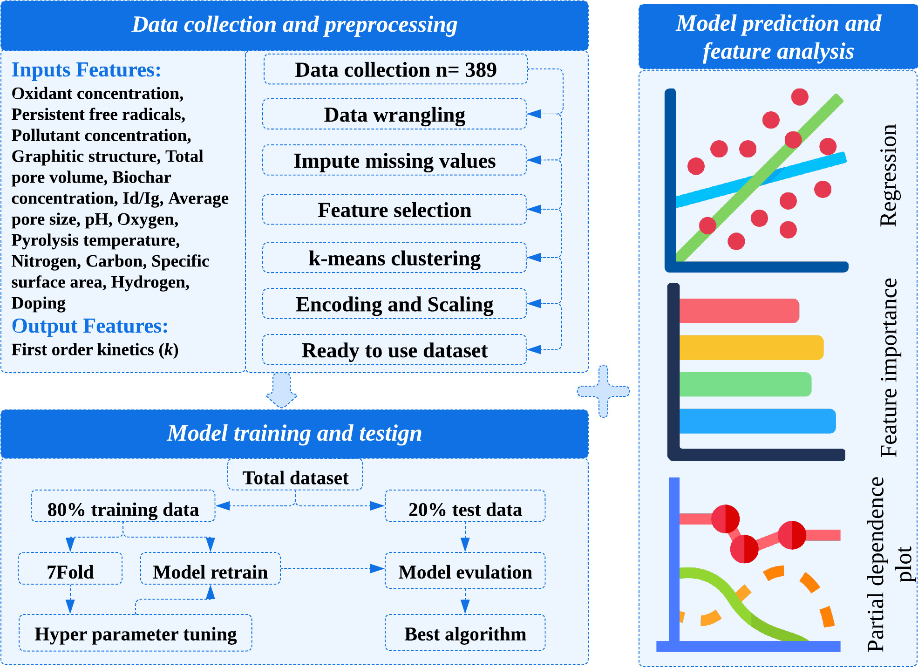

Fig. S2. Q–Q plots of the prediction variable (k) before and after transformation. The red line represents the y=x ideal normal distribution.
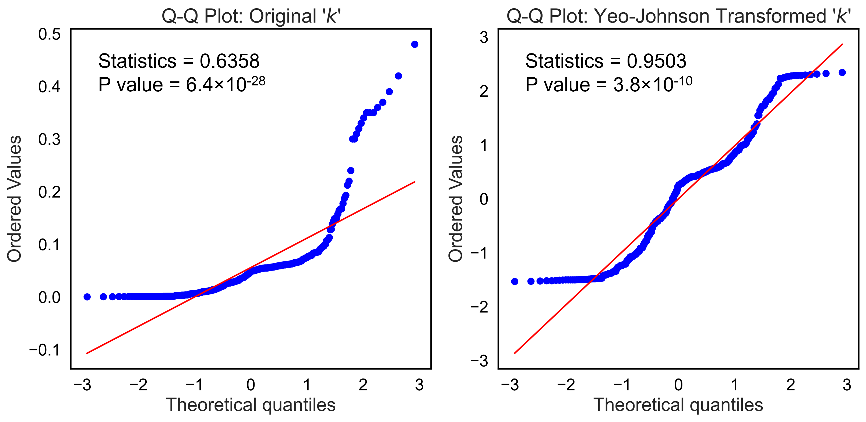

Fig. S3. (a) The model’s coefficient of determination across different training set sizes. (b) The model’s cross-validation score for different cross-validation folds. (c) Schematic of the model selection workflow.
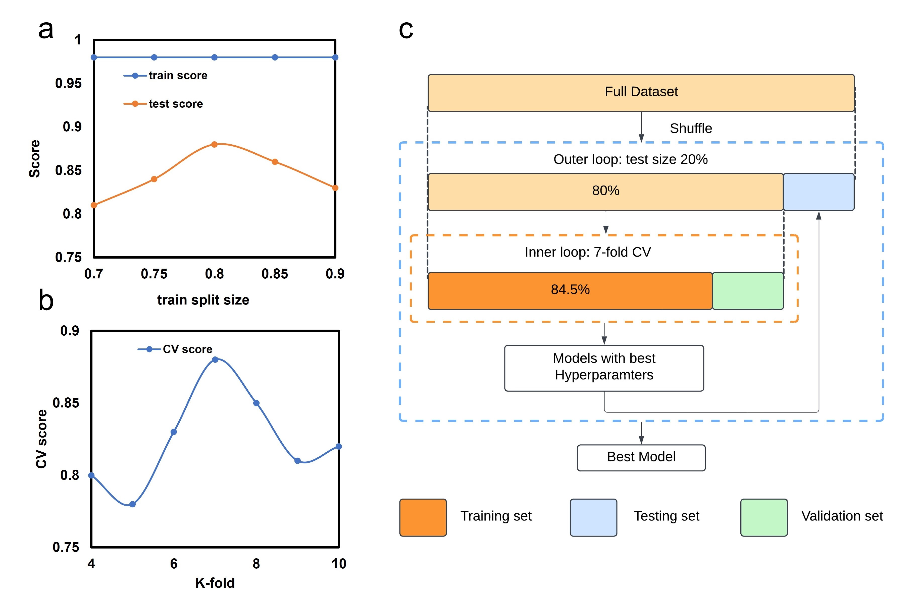

Fig. S4. Distribution of input features before and after data preprocessing. For each feature, the left panels show the raw data distribution, the middle panels represent the transformed data (Yeo–Johnson transformation for continuous variables and label or target encoding for categorical variables), and the right panels show the Min–Max scaled values used for model training. Histograms are overlaid with kernel density estimation (KDE) curves to illustrate changes in distribution shape. This figure demonstrates the effectiveness of preprocessing in reducing skewness, handling categorical variables (e.g., GS and PFRs), and normalizing feature ranges prior to machine learning analysis.

Fig. S5. Pearson Correlation Heatmap.
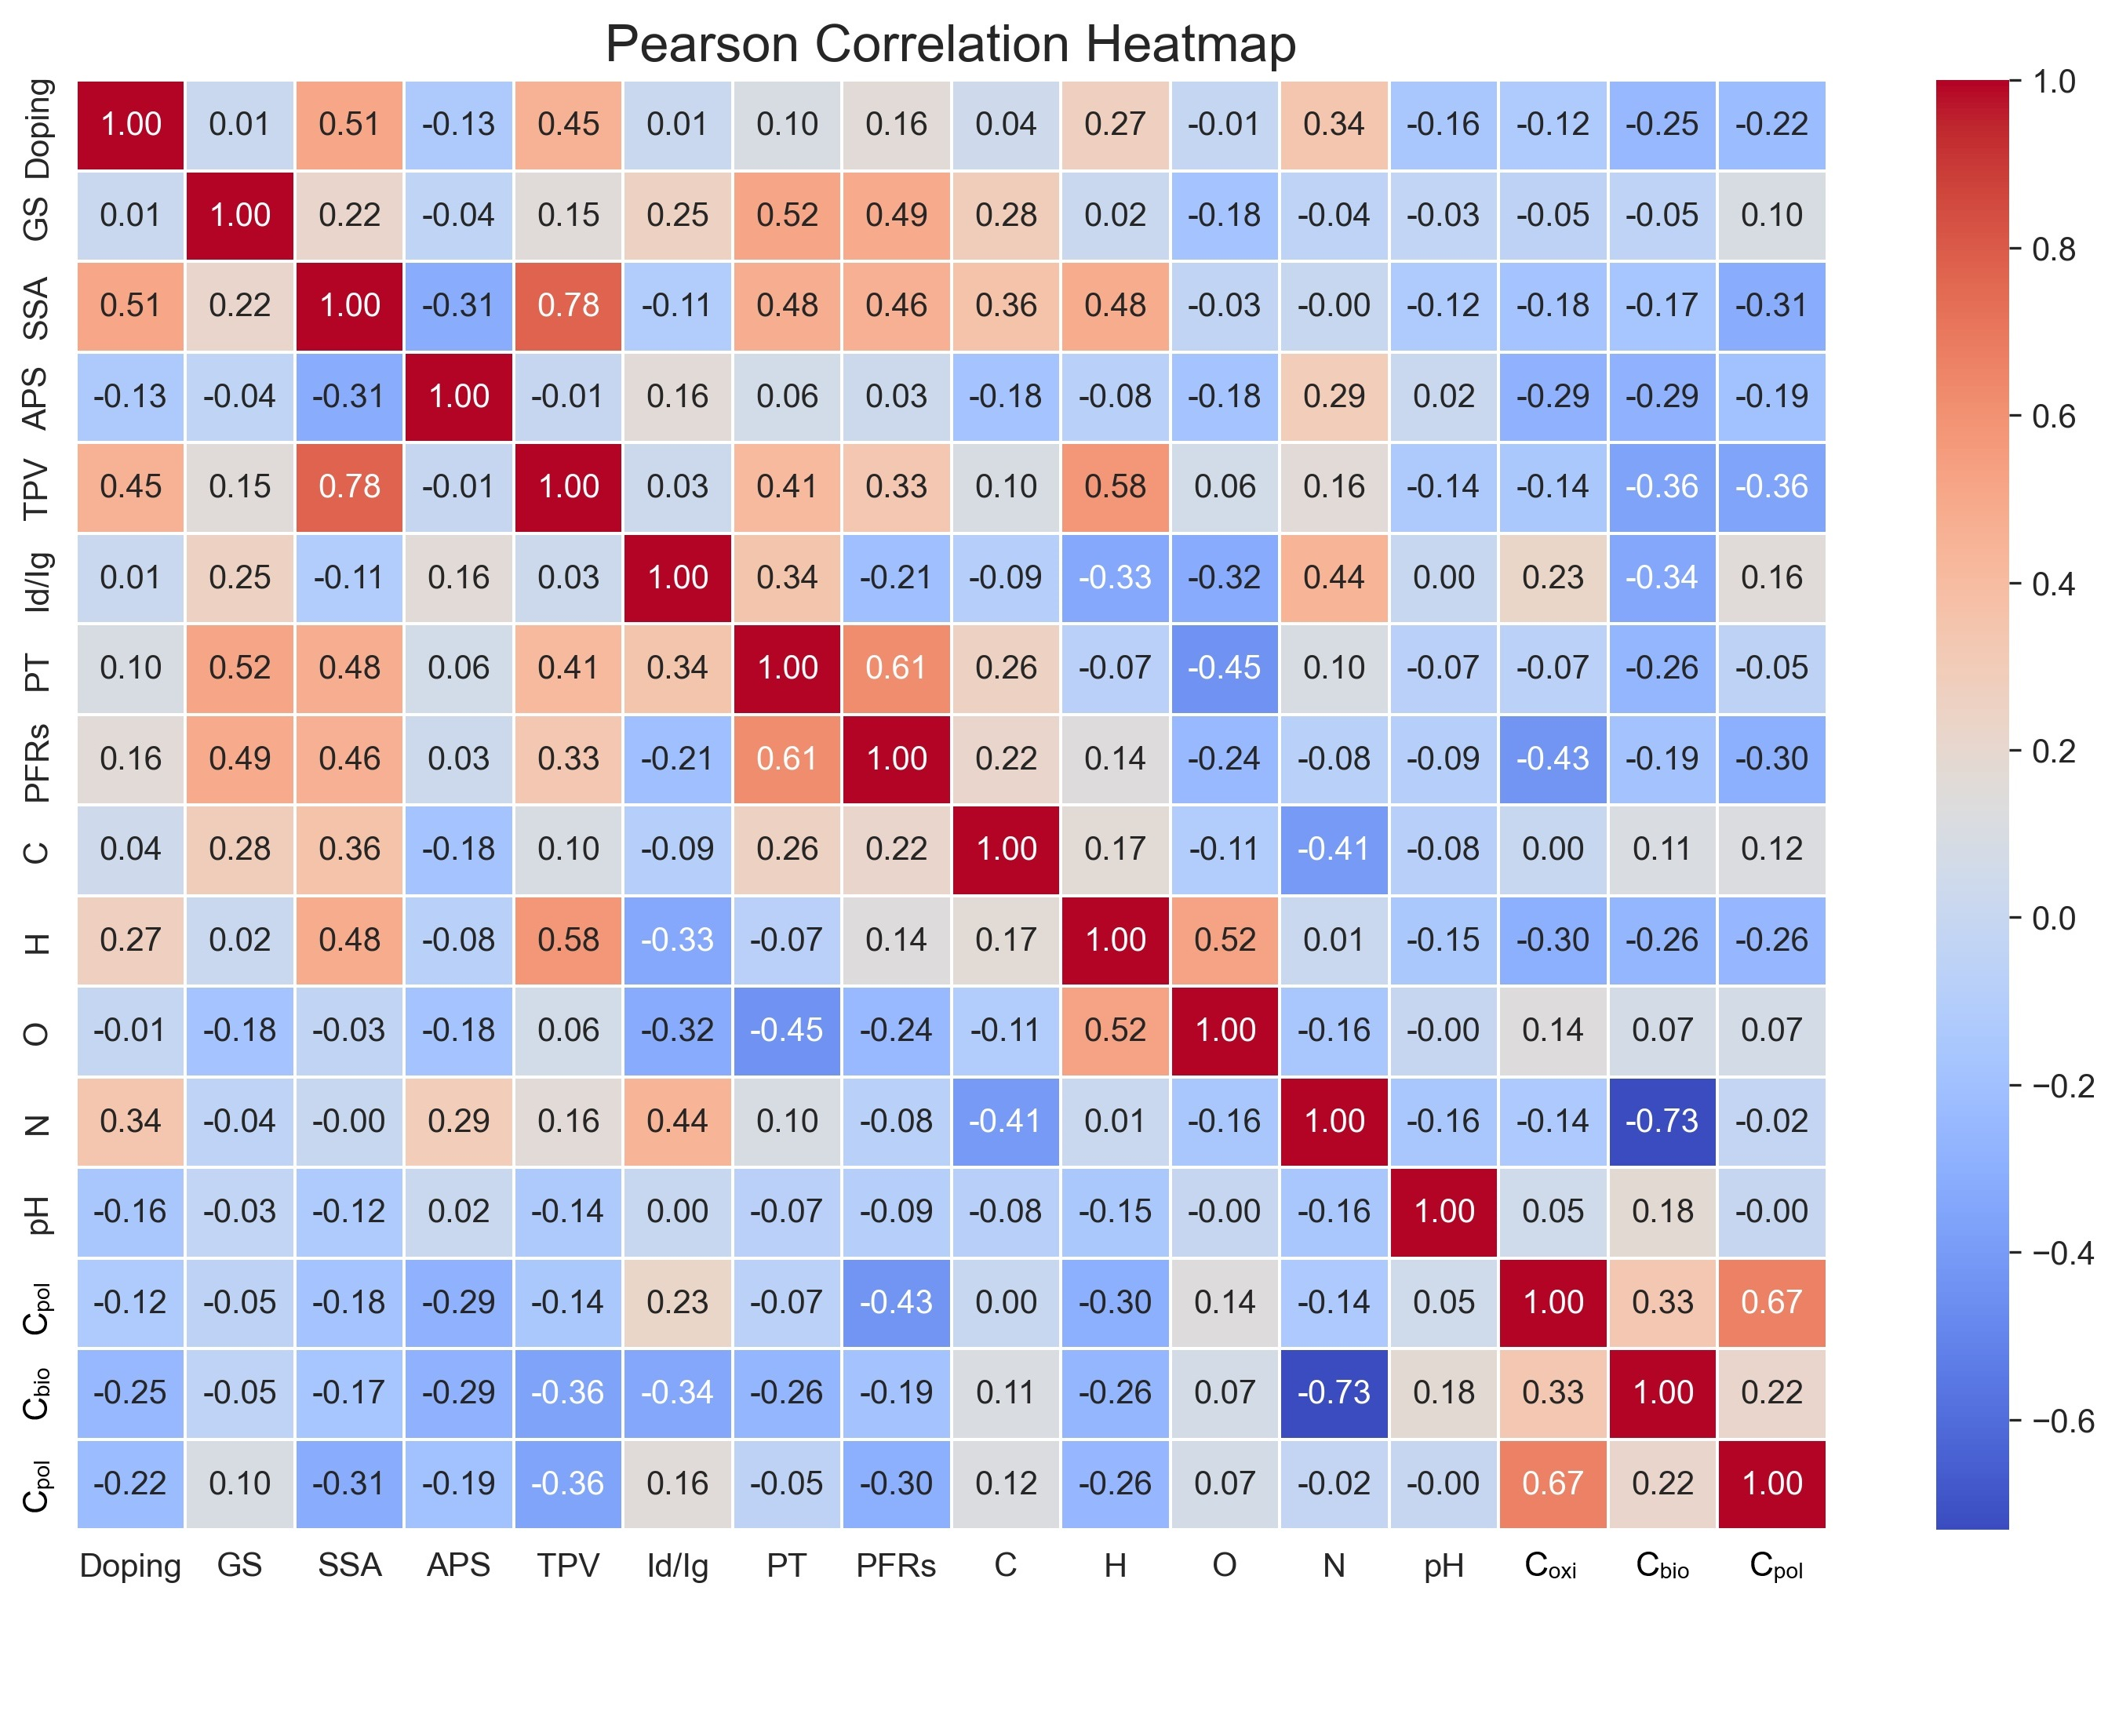

Fig. S6. SHAP partial dependence plots (SPDP) for representative variables.
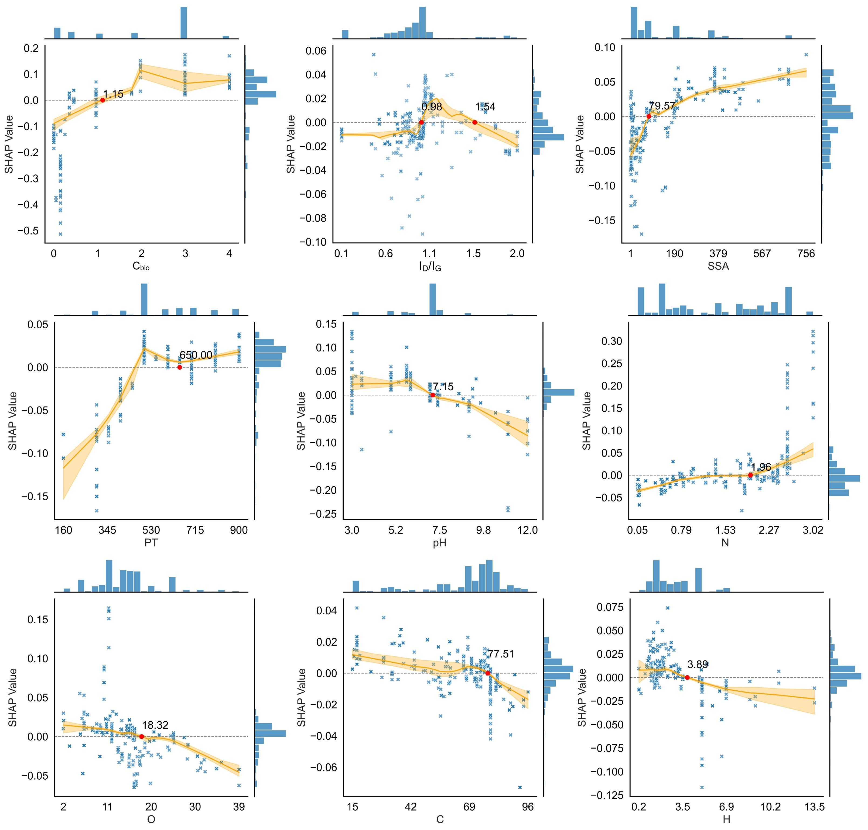

Fig. S7. Individual Conditional Expectation (IPDP) plots for the representative variables.
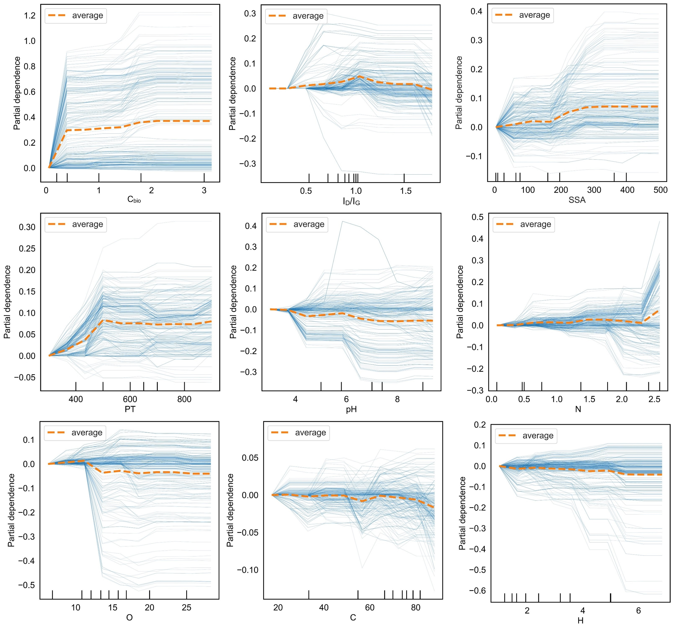

Fig. S8. Graphic user interface (GUI) development in the webpage through the integration of Python (version 3.12) and Flask (version 2.3.3). This was based on the well-trained regressor model to predict k in BCSs system (online address: https://github.com/junaid1990/antibiotic-k-prediction Method: Run the app.py file in Python, follow the prompts to enter the data, and click the "Predict" button.
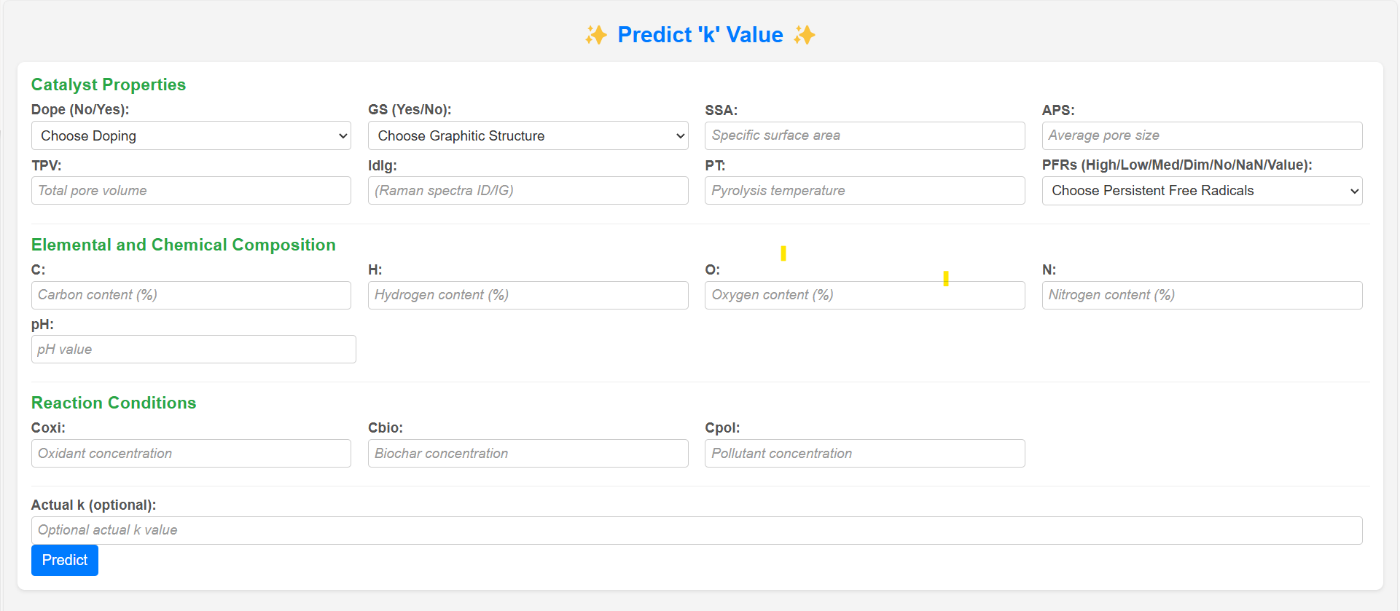

Fig. S9. Comparison of actual and predicted k and prediction errors across different experimental conditions. The left y-axis represents the k×10², while the right y-axis shows the prediction error (%). The x-axis represents the number of samples. (a) No oxidant, no doping. (b) No oxidant, doped. (c) Oxidant, no doping. (d) Oxidant, doped.
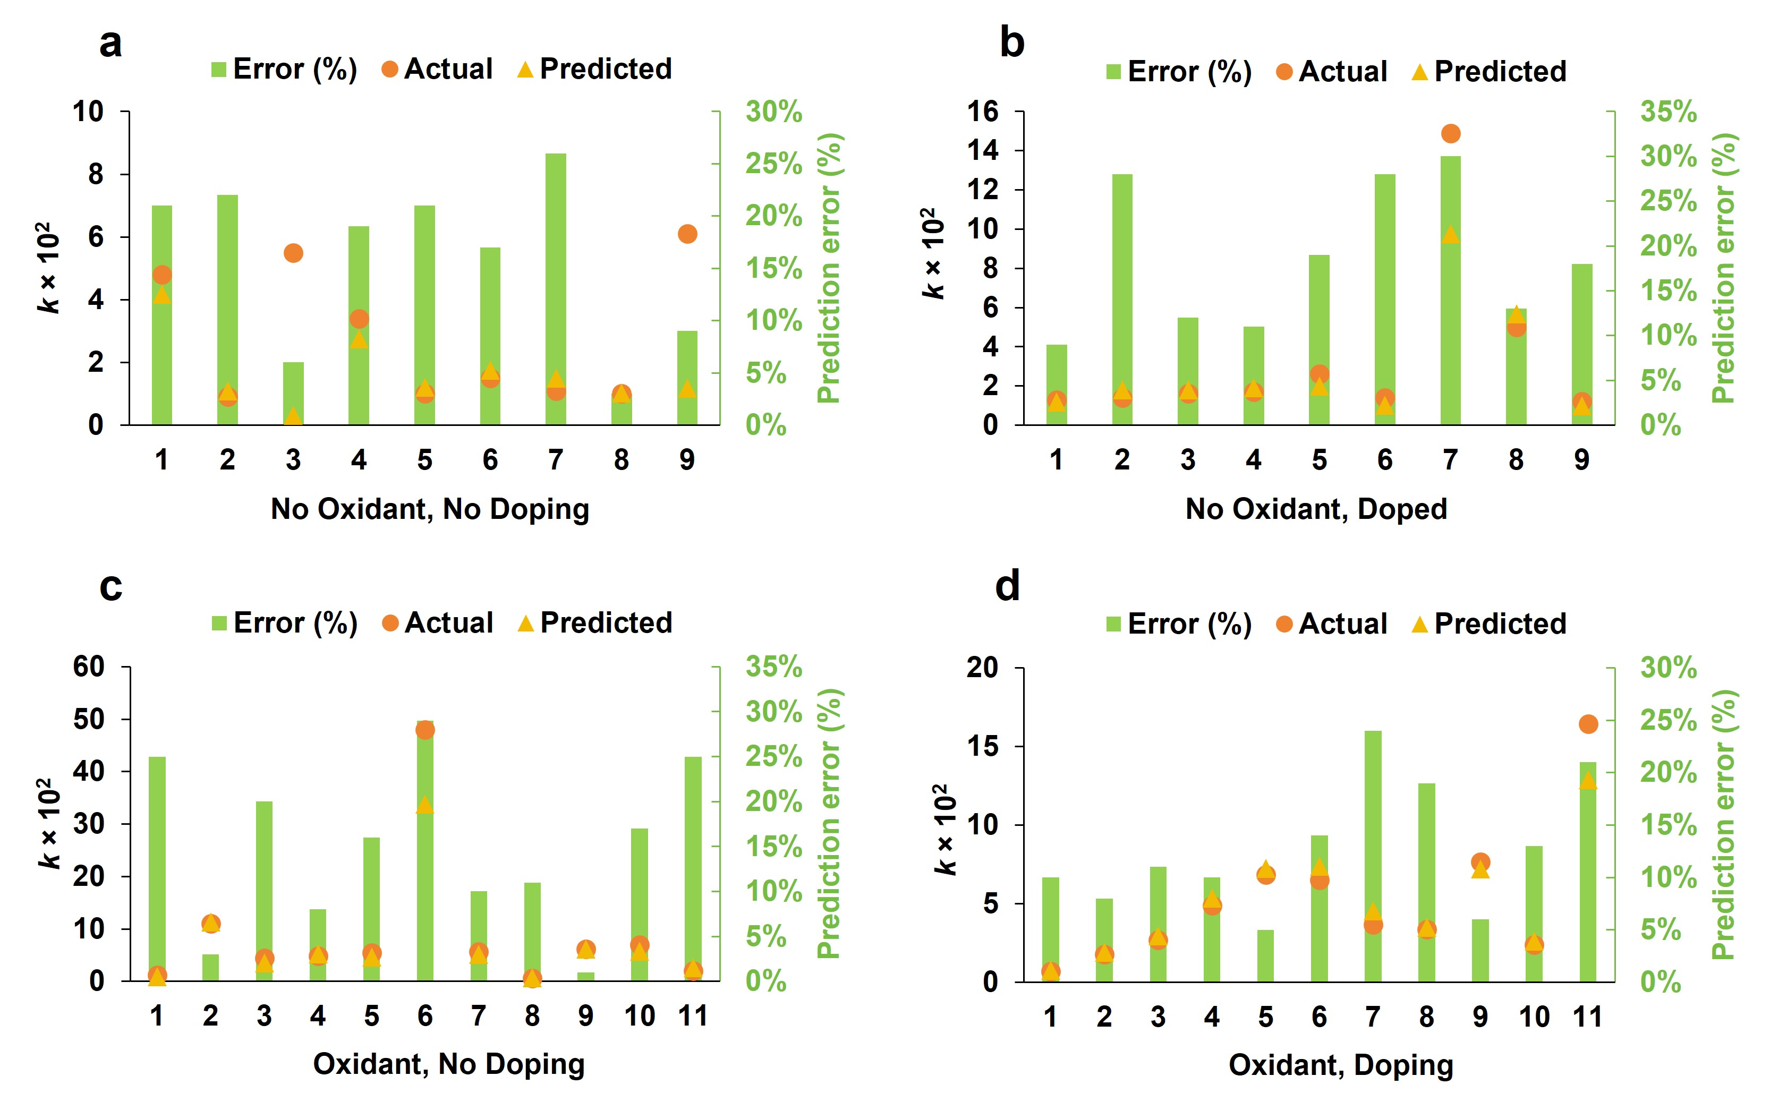
References.
Bi D, Huang F, Jiang M, et al (2022) Effect of pyrolysis conditions on environmentally persistent free radicals (EPFRs) in biochar from co-pyrolysis of urea and cellulose. Sci Total Environ 805:150339. https://doi.org/10.1016/j.scitotenv.2021.150339
Cervantes J, Garcia-Lamont F, Rodríguez-Mazahua L, Lopez A (2020) A comprehensive survey on support vector machine classification: Applications, challenges and trends. Neurocomputing 408:189–215. https://doi.org/10.1016/j.neucom.2019.10.118
Elgeldawi E, Sayed A, Galal AR, Zaki AM (2021) Hyperparameter tuning for machine learning algorithms used for arabic sentiment analysis. MDPI, p 79
Hollmann N, Müller S, Purucker L, et al (2025) Accurate predictions on small data with a tabular foundation model. Nature 637:319–326. https://doi.org/10.1038/s41586-024-08328-6
Latif J, Chen N, Saleem A, et al (2024) Machine learning for persistent free radicals in biochar: dual prediction of contents and types using regression and classification models. Carbon Res 3:39. https://doi.org/10.1007/s44246-024-00125-0
Liu S-Y, Ye H-J (2025) TabPFN Unleashed: A Scalable and Effective Solution to Tabular Classification Problems. ArXiv Prepr ArXiv250202527. https://doi.org/10.48550/arXiv.2502.02527
Shehadeh A, Alshboul O, Al Mamlook RE, Hamedat O (2021) Machine learning models for predicting the residual value of heavy construction equipment: An evaluation of modified decision tree, LightGBM, and XGBoost regression. Autom Constr 129:103827. https://doi.org/10.1016/j.autcon.2021.103827
Sibindi R, Mwangi RW, Waititu AG (2023) A boosting ensemble learning based hybrid light gradient boosting machine and extreme gradient boosting model for predicting house prices. Eng Rep 5:e12599. https://doi.org/10.1002/eng2.12599
Yang GR, Wang X-J (2020) Artificial neural networks for neuroscientists: a primer. Neuron 107:1048–1070. https://doi.org/10.1016/j.neuron.2020.09.005

