Supplementary Information
Global Evaluation of a New Biochar Model for Supporting Climate-Smart Agriculture
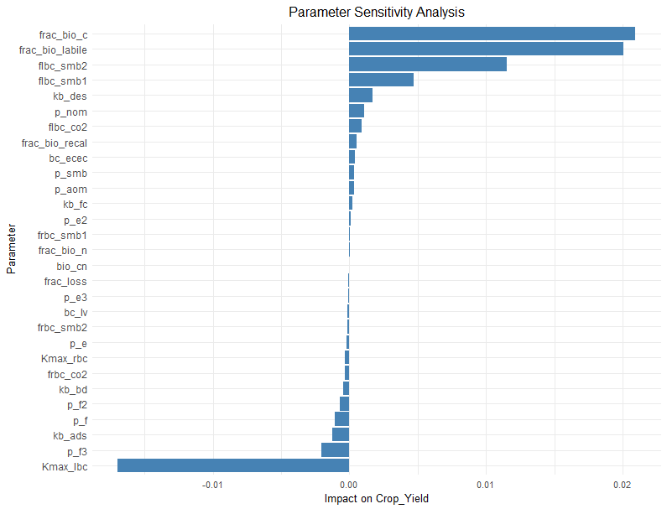
Wei Ren¹, Yogesh Kumar¹, and Yawen Huang^{1,2}
Fig. S1 Total-order sensitivity indices for crop yield in response to biochar-related parameters. Bars represent the magnitude of each parameter’s total effect on crop yield variability in the DLEM-Ag-Biochar model.

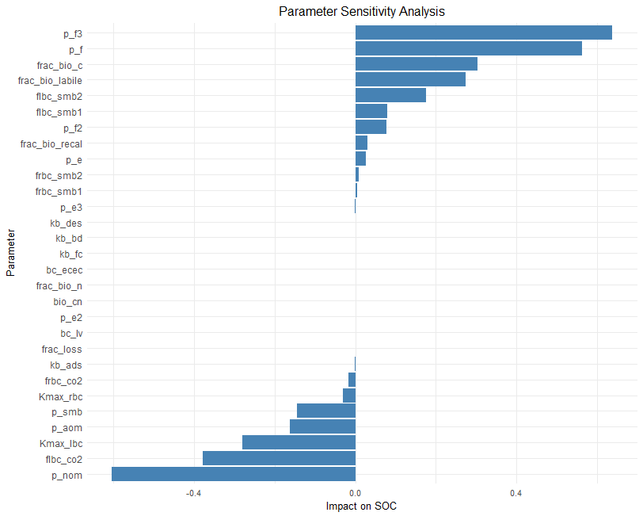
Fig. S2 Total-order sensitivity indices for SOC in response to biochar-related parameters. Bars represent the magnitude of each parameter’s total effect on SOC variability in the DLEM-Ag-Biochar model.
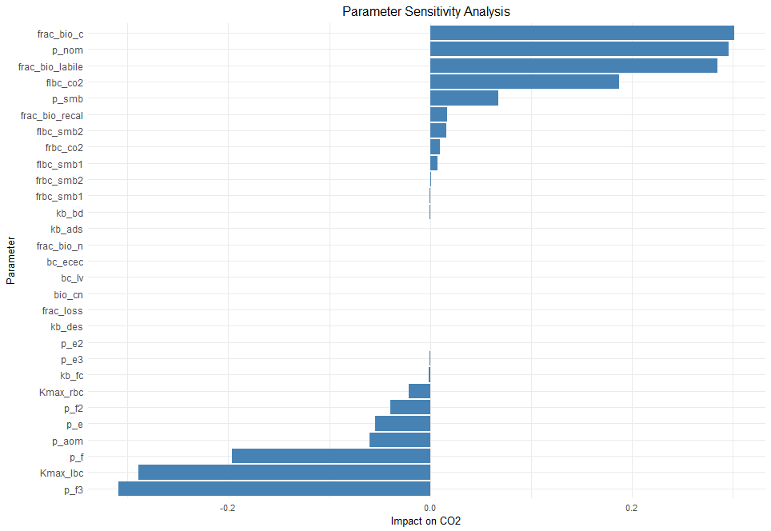
Fig. S3 Total-order sensitivity indices for CO₂ in response to biochar-related parameters. Bars represent the magnitude of each parameter’s total effect on CO₂ variability in the DLEM-Ag-Biochar model.

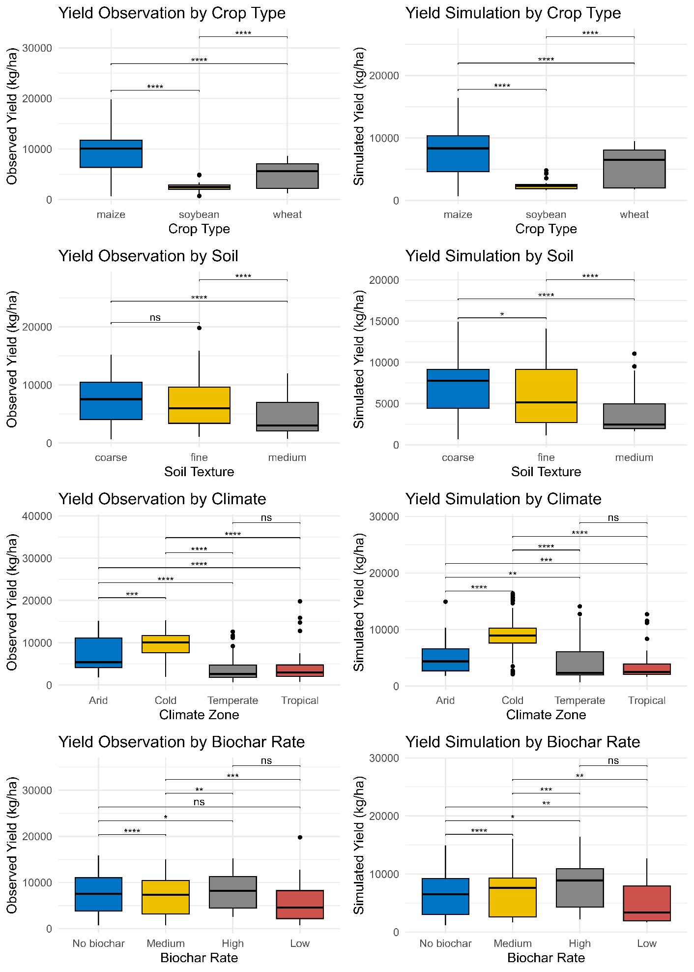
Fig. S4 Comparison of observed and simulated Yield (kg/ha) across different categories: (a) crop type, (b) soil texture, (c) climate zone, and (d) biochar application rate. Boxplots display group-wise distributions with pairwise significance annotations based on Tukey HSD or Dunn’s test (depending on normality and homogeneity assumptions). Asterisks denote statistical significance (*p < 0.05, **p < 0.01, ***p < 0.001; ns = not significant), highlighting agreement or divergence in modeled performance relative to observed variability.
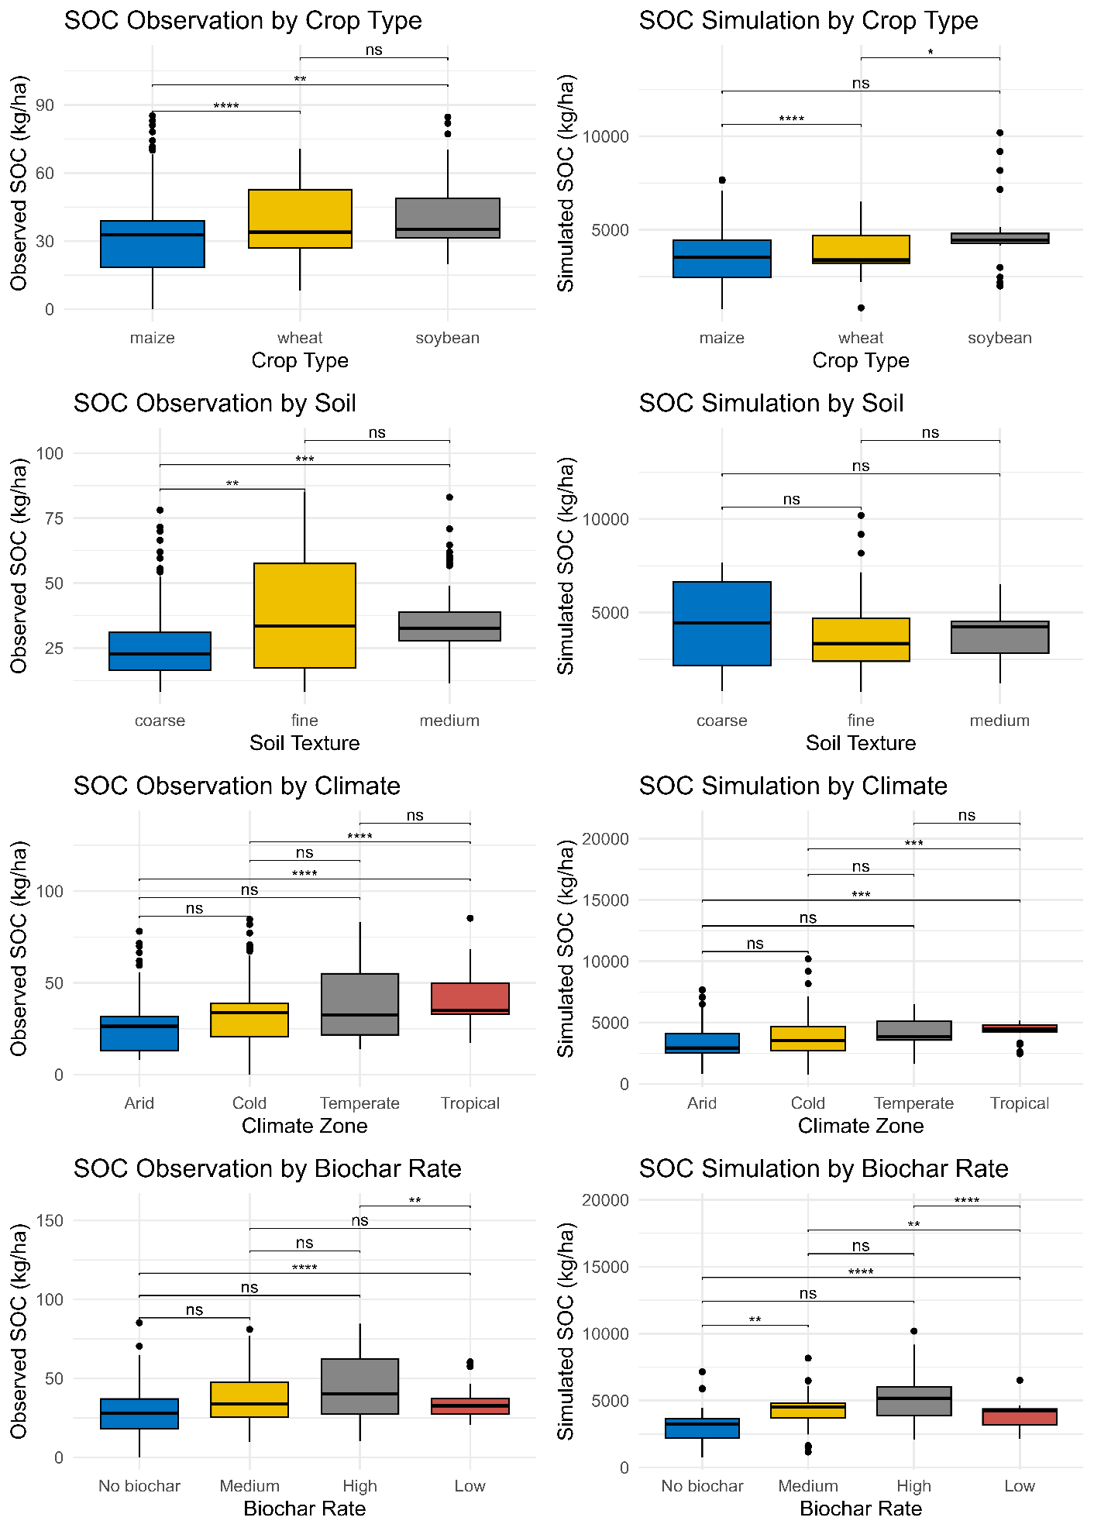
Fig. S5 Comparison of observed and simulated SOC (kg/ha) across different categories: (a) crop type, (b) soil texture, (c) climate zone, and (d) biochar application rate. Boxplots display group-wise distributions with pairwise significance annotations based on Tukey HSD or Dunn’s test. Asterisks denote statistical significance (*p < 0.05, **p < 0.01, ***p < 0.001; ns = not significant), highlighting agreement or divergence in modeled performance relative to observed variability.
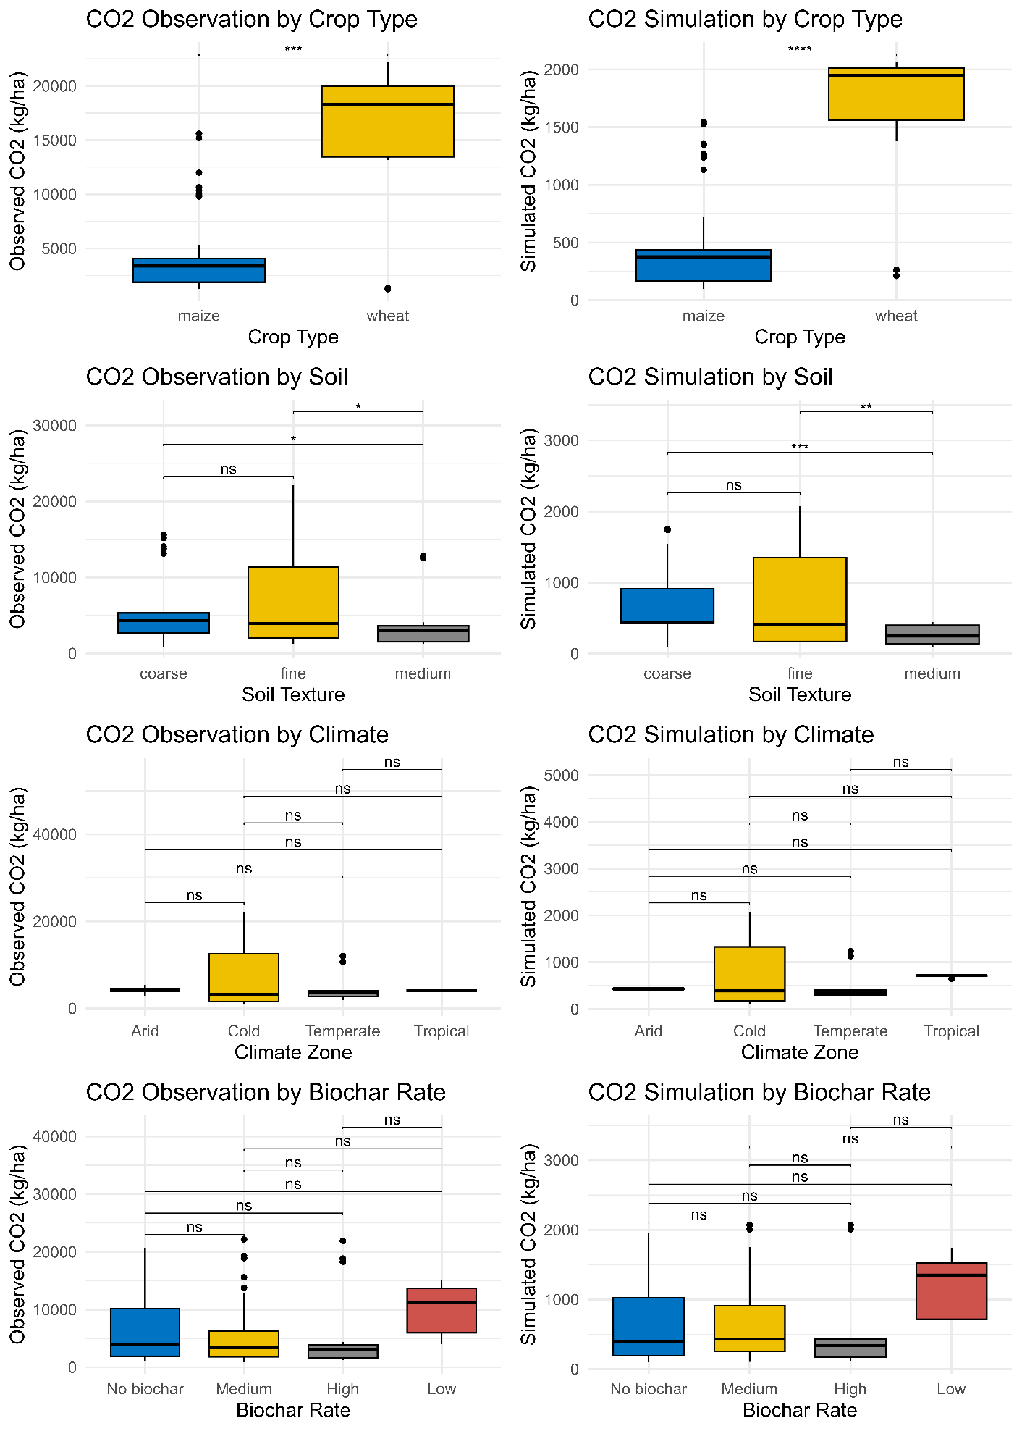
Fig. S6 Comparison of observed and simulated CO₂ (kg/ha) across different categories: (a) crop type, (b) soil texture, (c) climate zone, and (d) biochar application rate. Boxplots display group-wise distributions with pairwise significance annotations based on Tukey HSD or Dunn’s test (depending on normality and homogeneity assumptions). Asterisks denote statistical significance (*p < 0.05, **p < 0.01, ***p < 0.001; ns = not significant), highlighting agreement or divergence in modeled performance relative to observed variability.

Table S2 Sites information
Site number | Paper | Country | Latitude | Longitude | Cropping system | Crop yield | SOC | GHG
 | Yang W. et al., 2020 | China | 40.68333 | 107.30000 | maize | * | * | *
 | Wang Z.H. et al., 2020 | China | 46.61667 | 125.18330 | Maize | * | * | -
 | Omara et al., 2020 | USA | 36.13683 | -97.10720 | maize | * | - | -
 | Omara et al., 2020 | USA | 36.14944 | -97.28869 | maize | * | - | -
 | Obia et al., 2020 | Zambia | -13.75750 | 29.06517 | maize-soybean | * | - | -
 | Munera-Echeverri I. et al., 2020 | Zambia | -13.75750 | 29.06517 | maize-soybean-maize | * | * | -
 | Liu Y.J. et al., 2020 | China | 35.00000 | 114.40000 | wheat-maize | * | * | *
 | Liu X.D. et al., 2020 | China | 33.13333 | 112.96670 | wheat-maize | * | * | -
 | Liao X. et al., 2020 | China | 35.00000 | 114.40000 | wheat-maize | * | * | *
 | Li S.L. et al., 2020 | China | 34.30417 | 108.04167 | Wheat | - | * | *
 | Li N. et al., 2020 | China | 34.30000 | 108.08330 | maize-wheat | * | * | *
 | Kan et al., 2020 | China | 37.60000 | 116.35000 | wheat-maize | - | * | -
 | Jin L. et al., 2020 | China | 45.83472 | 126.85140 | soybean-maize | * | * | -
 | Faloye et al., 2020 | Nigeria | 7.26667 | 5.21667 | maize | * | * | -
 | Wu Y. et al., 2019 | China | 40.43333 | 107.83330 | maize-maize-spring wheat | * | - | *
 | Sistani et al., 2019 | USA | 36.93864 | -86.48090 | maize | * | - | *
 | Ma H. et al., 2019 | Germany | 52.52000 | 14.11000 | soybean | * | * | -
 | Liu X.Y. et al., 2019b | China | 34.06667 | 116.93330 | wheat-soybean | - | * | -
 | Abagandura, Gandura Omar et al., 2019 | USA | 44.21000 | -96.74000 | Corn–soybean-soybean | - | * | *
 | Ali K. et al., 2018 | Pakistan | 34.02250 | 71.46806 | wheat-maize-wheat | * | * | -
 | Ali K. et al., 2019 | Pakistan | 34.02250 | 71.46806 | wheat-maize-wheat | * | * | -
 | Bassouny Mohamed and Abbas Mohamed, 2019 | Egypt | 30.60056 | 31.37389 | maize | * | * | *
 | Clark M. et al., 2019 | USA | 40.71694 | -77.94111 | maize | - | * | -
 | Clark M. et al., 2019 | USA | 38.63389 | -75.45861 | maize | - | * | -
 | Dong X.L. et al., 2018 | China | 40.13917 | 116.18111 | wheat | - | * | -
 | Dong X.L. et al., 2019 | China | 40.13917 | 116.18111 | wheat | * | - | -
 | Faloye et al., 2019 | Nigeria | 7.26667 | 5.21667 | maize | * | * | -
 | Ibrahim M. et al., 2019 | Egypt | 30.78333 | 31.11667 | maize-wheat | * | - | -
 | Jin L. et al., 2019 | China | 45.83417 | 126.85140 | soybean | * | * | -
 | Katterer T. et al., 2019 | Kenya | -0.50000 | 37.50000 | maize-soybean | - | * | -
 | Katterer T. et al., 2019 | Kenya | 0.13361 | 34.00000 | maize-soybean | - | * | -
 | Niu Y.H. et al., 2017 | China | 35.00000 | 114.40000 | maize | * | - | -
 | Shen Y.F. et al., 2017 | China | 35.28000 | 107.88000 | maize or wheat | - | - | *
 | Vitkova J. et al., 2017 | Slovakia | 48.31667 | 18.15000 | maize-wheat | * | - | -
 | Zhang A.F. et al., 2017 | China | 34.33333 | 108.44440 | maize | * | - | -
 | Agegnehu G. et al., 2016a | Australia | -17.21910 | 145.47100 | maize | * | * | *
 | Fungo B. et al., 2017 | Kenya | 0.15944 | 34.96028 | maize | * | * | *
 | He X.H. et al., 2016 | China | 36.95000 | 117.96667 | maize-wheat | * | * | *
 | Liu, X. Y. et al., (2014) | China | 34.53333 | 115.50000 | maize | * | * | *
 | Madari B.E. et al., 2017 | Brazil | -14.59330 | -52.40110 | soybean | * | * | -
 | Zhang D. et al., 2016 | China | 38.49670 | 113.20000 | maize | * | * | *
 | Zhang A. et al., 2012a | China | 34.53330 | 115.50000 | maize | * | * | *
 | Major et al., 2010 | Colombia | 4.17089 | -72.60360 | maize-soybean | * | * | -
 | Blackwell et al., 2010 | South Africa | -28.81667 | 114.88333 | wheat | * | - | -
 | Blackwell et al., 2010 | South Africa | -30.53333 | 115.81667 | wheat | * | - | -
 | Blackwell et al., 2010 | South Africa | -34.48889 | 138.84639 | wheat | * | - | -
 | Blackwell et al., 2010 | South Africa | -34.50830 | 138.74780 | wheat | * | - | -
 | Phillips et al., 2023 | USA | 42.01758 | -93.76448 | maize | * | * | -

Table S2. Biochar Model Parameters and Ranges
Parameter Name | Explanation | Parameter Range
frac_loss | Fraction of biochar lost during application | 0 to 1
frac_bio_c | Carbon fraction in biochar | From article
frac_bio_n | Nitrogen fraction in biochar | From article
bio_cn | Biochar C to N ratio | From article
frac_bio_labile | Fraction of labile C in biochar | 0.03 to 0.3
frac_bio_recal | Fraction of recalcitrant C in biochar | 0.7 to 0.97
Kmax_lbc | Maximum decay rate for labile biochar | 0.1 to 30
Kmax_rbc | Maximum decay rate for recalcitrant biochar | 50 to 50000
bc_ecec | Biochar effective cation exchange capacity | 0 to 253 cmolc kg⁻¹
kb_ads | Langmuir adsorption coefficient | 0 to 0.125 mg L⁻¹
kb_des | Langmuir desorption coefficient | 0 to 0.125 mg L⁻¹
bc_lv | Biochar liming value | 20 to 200
flbc_smb1 | Fraction of labile biochar C to SMB1 pool | 0.312 to 0.600
flbc_smb2 | Fraction of labile biochar C to SMB2 pool | 0.300 to 0.688
frbc_smb1 | Fraction of recalcitrant biochar C to SMB1 pool | 0.01 to 0.312
frbc_smb2 | Fraction of recalcitrant biochar C to SMB2 pool | 0.01 to 0.688
flbc_co2 | Respiration fraction of labile biochar C pool | 0.33 to 0.86
frbc_co2 | Respiration fraction of recalcitrant biochar C pool | 0.1 to 0.6
prime_aom | Positive priming effect coefficient for AOM1 and AOM2 | 0 to 0.138
prime_e | Negative priming effect coefficient 1 for AOM | 0 to 0.15
prime_f | Negative priming effect coefficient 2 for AOM | -0.30 to 0
prime_smb | Positive priming effect for SMB1/2 and SMR | 0 to 0.15
prime_nom | Positive priming effect for NOM | 0 to 0.15
prime_e2 | Negative priming coefficient 1 for SMB/SMR | -0.15 to 0
prime_f2 | Negative priming coefficient 2 for SMB/SMR | -0.15 to 0
prime_e3 | Negative priming coefficient 1 for NOM | -0.15 to 0
prime_f3 | Negative priming coefficient 2 for NOM | -0.15 to 0
kb_fc | Slope parameter in field capacity modifier | -1 to 0
kb_bd | Slope parameter in bulk density modifier | -1 to 0

