Supplementary Material
Synergistic effects of Fe–Mn modified biochar and water management on remediation of Cd and Hg co–contaminated soils
Tong Sun^{a,b,1}, Wenhao Yang^{b,c,1}, Yuebing Sun^{b*}, Lin Wang^{b}, Xuefeng Liang^{b}
ªKey Laboratory of Agro–Ecological Processes in Subtropical Region, Institute of Subtropical Agriculture, Chinese Academy of Sciences, Changsha 410125, China;
^{b}Key Laboratory of Original Environmental Pollution Control of MARA, Agro-Environmental Protection Institute, Ministry of Agriculture and Rural Affairs, Tianjin 300191, China;
^{c}College of Resources and Environment, Northeast Agricultural University, Harbin 150030, China

¹ Tong Sun and Wenhao Yang contributed equally to this work.

∗ Corresponding author. Tel: +86–22–23618061; Fax: +86–22–23618060
E–mail address: sunyuebing2008@126.com (Y. –B. Sun)

Text S1. The details of high–throughput sequencing analysis
The total microbial genomic DNA was extracted from soil samples using the E.Z.N.A.® soil DNA Kit (Omega Bio–tek, Norcross, GA, U.S.). Next, the hypervariable region V3–V4 of the bacterial 16S rRNA gene were amplified with primer pairs 338F (5’–ACTCCTACGGGAGGCAGCAG–3’) and 806R (5’–GGACTACHVGGGTWTCTAAT–3’) by an ABI GeneAmp® 9700 PCR thermocycler (ABI, CA, USA). All samples were amplified in triplicate. The PCR product was extracted from 2% agarose gel and purified using the AxyPrep DNA Gel Extraction Kit (Axygen Biosciences, Union City, CA, USA) and quantified using Quantus™ Fluorometer (Promega, USA). Purified amplicons were pooled in equimolar amounts and paired–end sequenced on an Illumina MiSeq PE300 platform (Illumina, San Diego,USA) according to the standard protocols by Majorbio Bio–Pharm Technology Co. Ltd. (Shanghai, China).
Moreover, the raw fastq files were quality-filtered by Trimmomatic and merged by FLASH with the following criteria: (1) The reads were truncated at any site receiving an average quality score <20 over a 50 bp sliding window; (2) Sequences whose overlap being longer than 10 bp were merged according to their overlap with mismatch no more than 2 bp; (3) Sequences of each sample were separated according to barcodes (exactly matching) and Primers (allowing 2 nucleotide mismatching), and reads containing ambiguous bases were removed. Operational taxonomic units (OTUs) were clustered with 97% similarity cutoff using UPARSE (version 7.1 http://drive5.com/uparse/) with a novel “greedy” algorithm that performs chimera filtering and OTU clustering simultaneously. The taxonomy of each 16S rRNA gene sequence was analyzed by RDP Classifier algorithm (http://rdp.cme.msu.edu/) against the Silva (SSU123) 16S rRNA database using confidence threshold of 70%.

Table S1 The basic properties of paddy soil
pH | EC  (µs cm^{–1}) | CEC  (cmol⁺ kg^{–1}) | TOC  (g kg^{–1}) | TN  (g kg^{–1}) | TP  (g kg^{–1}) | TK  (g kg^{–1}) | Heavy metal
 |  |  |  |  |  |  | Hg  (mg kg^{–1}) | Cd  (mg kg^{–1})
6.19 | 13.64 | 12.13 | 31.63 | 1.42 | 1.00 | 16.67 | 5.40 | 0.76

Table S2 The physiochemical properties of BC and FMBC
Adsorbents | pH | ABET (m² g⁻¹) | Vtot （cm³ g⁻¹) | Average pore diameter (nm) | Bulk elemental composition (wt%) |  |  |  | Ash（%）
 |  |  |  |  | C | H | N | S | Ash（%）
BC | 10.06 ± 0.01 | 6.17 | 0.0356 | 23.07 | 70.66 | 2.18 | 0.96 | 0.47 | 17%
FMBC | 10.24 ± 0.01 | 4.65 | 0.0430 | 37.03 | 47.38 | 1.53 | 0.81 | 0.13 | 39%

Table S3 Topological properties of bacterial community co-occurrence network
Network Parameters | FCK | FBC | FFM | ACK | ABC | AFM
Nodes | 288 | 324 | 335 | 136 | 318 | 324
Edges (positive) | 1586 | 2088 | 2076 | 418 | 1721 | 1794
Edges (negative) | 1272 | 1117 | 1069 | 208 | 819 | 1178
Average degree | 18.032 | 20.42 | 19.968 | 9.206 | 16.577 | 16.734
Clustering coefficients | 0.804 | 0.791 | 0.768 | 0.807 | 0.799 | 0.789
Modularity | 2.09 | 2.086 | 2.518 | 2.979 | 4.708 | 6.09

Table S4 The classification information for each keystone taxa
Treatments | Genus | Phylum | Degree
ACK | Solirubrobacter | Actinobacteriota | 14
ACK | WCHB1-32 | Bacteroidota | 14
ACK | Archangium | Myxococcota | 14
ACK | Lysobacter | Proteobacteria | 14
ACK | Propionicicella | Actinobacteriota | 14
ACK | RB41 | Acidobacteriota | 14
ACK | Thermoanaerobaculum | Acidobacteriota | 14
ACK | Deferrisoma | Deferrisomatota | 14
ACK | Adhaeribacter | Bacteroidota | 14
ACK | Luedemannella | Actinobacteriota | 13
ABC | unclassified_f__Gallionellaceae | Proteobacteria | 28
ABC | Thermomonas | Proteobacteria | 28
ABC | Sporacetigenium | Firmicutes | 28
ABC | norank_f__norank_o__Syntrophales | Desulfobacterota | 28
ABC | norank_f__norank_o__norank_c__Thermodesulfovibrionia | Nitrospirota | 28
ABC | norank_f__norank_o__Candidatus_Falkowbacteria | Patescibacteria | 28
ABC | norank_f__Lentimicrobiaceae | Bacteroidota | 28
ABC | norank_f__Geobacteraceae | Desulfobacterota | 28
ABC | Endomicrobium | Elusimicrobiota | 28
ABC | Defluviicoccus | Proteobacteria | 28
AFM | norank_f__norank_o__norank_c__Alphaproteobacteria | Proteobacteria | 31
AFM | norank_f__Rhodocyclaceae | Proteobacteria | 30
AFM | norank_f__Isosphaeraceae | Planctomycetota | 30
AFM | norank_f__norank_o__Candidatus_Moranbacteria | Patescibacteria | 30
AFM | norank_f__Blrii41 | Myxococcota | 30
AFM | norank_f__norank_o__Clostridia_UCG-014 | Firmicutes | 30
AFM | norank_f__Planococcaceae | Firmicutes | 30
AFM | Geobacter | Desulfobacterota | 30
AFM | norank_f__norank_o__norank_c__KD4-96 | Chloroflexi | 30
AFM | unclassified_f__Anaerolineaceae | Chloroflexi | 30
FCK | norank_f__norank_o__Candidatus_Moranbacteria | Patescibacteria | 35
FCK | Ellin6067 | Proteobacteria | 35
FCK | unclassified_f__Beijerinckiaceae | Proteobacteria | 32
FCK | norank_f__Caulobacteraceae | Proteobacteria | 30
FCK | norank_f__norank_o__SJA-15 | Chloroflexi | 28
FCK | norank_f__norank_o__norank_c__Dojkabacteria | Patescibacteria | 28
FCK | norank_f__Methyloligellaceae | Proteobacteria | 28
FCK | norank_f__Heliobacteriaceae | Firmicutes | 28
FCK | Flavisolibacter | Bacteroidota | 28
FCK | unclassified_o__Fimbrimonadales | Armatimonadota | 27
FBC | unclassified_f__Myxococcaceae | Myxococcota | 51
FBC | norank_f__TRA3-20 | Proteobacteria | 50
FBC | Monoglobus | Firmicutes | 48
FBC | unclassified_c__Clostridia | Firmicutes | 48
FBC | unclassified_f__Thermomonosporaceae | Actinobacteriota | 48
FBC | Adhaeribacter | Bacteroidota | 46
FBC | Archangium | Myxococcota | 46
FBC | Arenimonas | Proteobacteria | 46
FBC | Asticcacaulis | Proteobacteria | 46
FBC | Bosea | Proteobacteria | 46
FFM | Novosphingobium | Proteobacteria | 48
FFM | Deinococcus | Deinococcota | 47
FFM | Edaphobaculum | Bacteroidota | 47
FFM | Herbaspirillum | Proteobacteria | 47
FFM | Lactobacillus | Firmicutes | 47
FFM | norank_f__Beggiatoaceae | Proteobacteria | 47
FFM | norank_f__Chitinophagaceae | Bacteroidota | 47
FFM | norank_f__env.OPS_17 | Bacteroidota | 47
FFM | norank_f__unclassified_o__Oxyphotobacteria_Incertae_Sedis | Cyanobacteria | 47
FFM | Sideroxydans | Proteobacteria | 47

Fig. S1 Effects of FMBC combined with water management on soil physicochemical properties (a) pH; (b) CEC; (c) TOC; (d) DOC

Fig. S2 Effects of FMBC combined with water management on the iron-manganese plaques of rice roots (a) DCB-Fe; (b) DCB-Mn

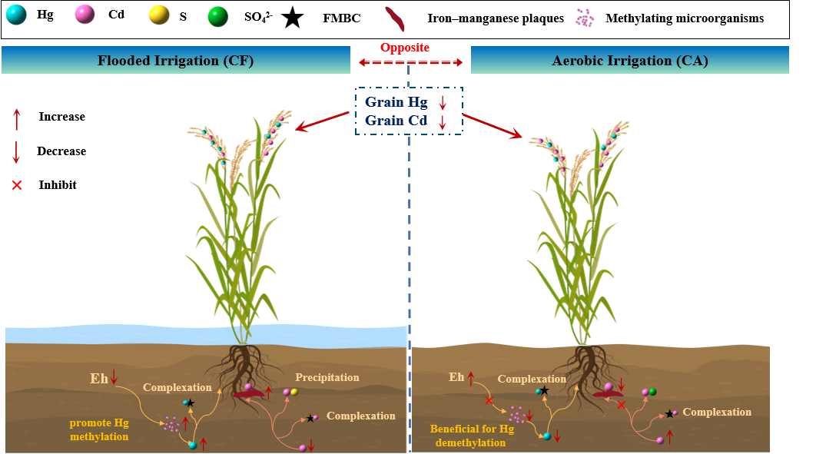
Fig. S3 Key pathways for the synergistic reduction of Cd and Hg accumulation by combined FMBC application and water management

