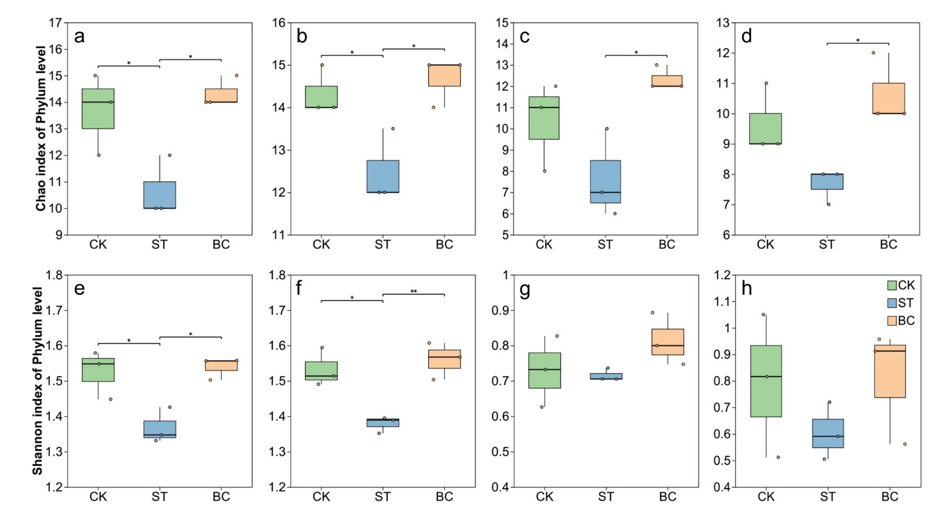
Fig. S1 Effects of rice straw (ST) and straw-derived biochar (BC) on α diversity indices. (a) and (b) show the bacterial Chao index at the phylum level on day 10 and day 65, respectively; (c) and (d) show the fungal Chao index at the phylum level on day 10 and day 65, respectively; (e) and (f) show the bacterial Shannon index at the phylum level on day 10 and day 65, respectively; (g) and (h) show the fungal Shannon index at the phylum level on day 10 and day 65, respectively. The symbols * and ** indicate significant differences at p < 0.05 and p < 0.01, respectively. Values are the means ± standard deviation (n = 3).

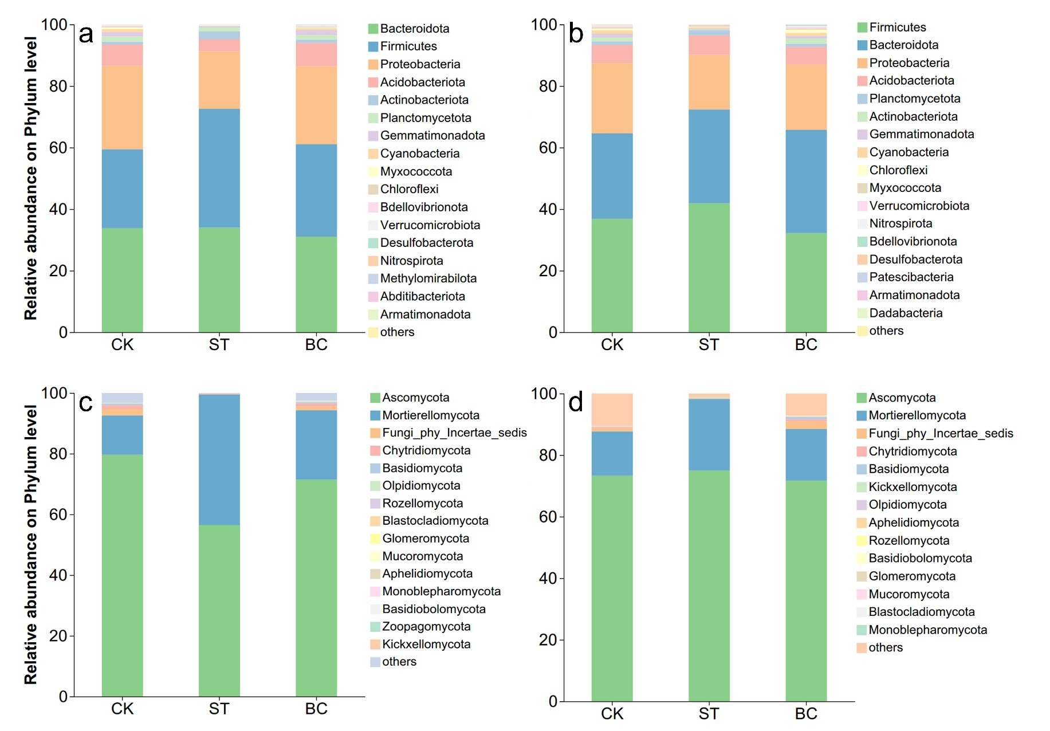
Fig. S2 Effects of straw and biochar on microbial community composition. (a) and (b) depict the bacterial community composition at the phylum level on day 10 and day 65, respectively; (c) and (d) depict the fungal community composition at the phylum level on day 10 and day 65, respectively.

