Text S1. Comparison between microwave-assisted and water-bath-heated grafting
A comparative experiment was carried out to evaluate the effect of heating mode during the β-CD grafting step. The same batch of Ca@CBC was used as a precursor. In both cases, β-CD (2.0 g) and NaOH (3.5 g) were dissolved in 50 mL of water, followed by the addition of Ca@CBC (0.30 g) and glutaraldehyde (1 mL). One suspension was treated by microwave irradiation (350 W, 15 min), whereas the other was heated in a water bath (80 °C, 120 min) under stirring. The products were filtered, washed, dried, and ground under identical conditions. The two samples were then compared in terms of reaction time, electricity consumption, and TC adsorption performance under the standard condition (pH 6.0, C₀ = 50 mg L⁻¹, dosage = 0.5 g L⁻¹, 25 °C, 3 h).

Table S1. Adsorption kinetics and thermodynamics parameters, equations, and related information
Model | Expression
Pseudo-first-order kinetic | $$q_{t}=q_{e}(1-e^{-k_{1}t})$$
Pseudo-second-order kinetic | $$q_{t}=\frac{k_{2}q_{e}^{2}t}{1+k_{2}q_{e}t}$$
Intra-particle diffusion model | q_{t}= k_{n}t^{1/2} + C
Langmuir | $$q_{e}=\frac{q_{m}k_{L}C_{e}}{1+k_{L}C_{e}}$$
Freundlich | $$q_{e}=k_{F}C_{e}^{1/n}$$

Table S2. ML models for TC adsorption by Ca@CBC/β-CD: principles, hyperparameters, and optimal settings
ML model | ML principle | Hyperparameters | Best Hyperparameters
RF | The RF model is an ensemble learning method that builds multiple decision trees on random subsets of data and features, then combines their outputs to improve prediction accuracy and reduce overfitting. | 'n_estimators': (100, 1000)  'max_depth': (1, 50)  'min_samples_split': (2, 20)  'min_samples_leaf': (1, 20)  'max_features': (0.1, 1.0) | 'max_depth': 39,  'max_features': 0.5077,  'min_samples_leaf': 1,  'min_samples_split': 2,  'n_estimators': 930
GBDT | GBDT is a powerful machine learning algorithm used for both classification and regression tasks. It is an ensemble method, meaning it combines the predictions of multiple simpler models, in this case, decision trees, to create a more robust and accurate final model. | 'learning_rate': Real(0.01, 0.3, prior='log-uniform')  'max_depth': Integer(3, 10)  'n_estimators': Integer(100, 300)  'min_samples_split': Integer(2, 10)  'min_samples_leaf': Integer(1, 10)  'subsample': Real(0.5, 1.0, prior='uniform') | 'learning_rate': 0.1220,  'max_depth': 3,  'min_samples_leaf': 1,  'min_samples_split': 10,  'n_estimators': 300,  'subsample': 0.5784
LGBM | The LGBM model is a gradient boosting framework that uses tree-based learning with a leaf-wise growth strategy, offering high speed, low memory usage, and excellent performance on large-scale and high-dimensional datasets. | 'learning_rate': Real(0.01, 0.3, prior='log-uniform')  'max_depth': Integer(-1, 15)  'num_leaves': Integer(20, 255)  'n_estimators': Integer(100, 500)  'min_child_samples': Integer(5, 30)  'subsample': Real(0.5, 1.0, prior='uniform')  'colsample_bytree': Real(0.5, 1.0, prior='uniform')  'reg_alpha': Real(0.0, 5.0, prior='uniform')  'reg_lambda': Real(0.0, 5.0, prior='uniform') | 'colsample_bytree': 0.5,  'learning_rate': 0.1591,  'max_depth': 15,  'min_child_samples': 5,  'n_estimators': 100,  'num_leaves': 255,  'reg_alpha': 5.0,  'reg_lambda': 5.0,  'subsample': 1.0
CatBoost | The CatBoost model is a gradient boosting algorithm developed by Yandex that handles categorical features natively and efficiently, offering high accuracy, fast training, and strong performance on a variety of structured data tasks. | ' 'learning_rate': Real(0.01, 0.3, prior='log-uniform')  'depth': Integer(3, 10)  'l2_leaf_reg': Real(1.0, 10.0, prior='uniform')  'iterations': Integer(100, 300) | ''bagging_temperature': 0.0,  'depth': 10,  'iterations': 609,  'l2_leaf_reg': 9.9543,  'learning_rate': 0.0879
EN | The EN model is a regularized regression method that combines L1 (lasso) and L2 (ridge) penalties to handle multicollinearity, encourage sparsity, and improve predictive accuracy. | l1_ratio = [0.1, 0.3, 0.5, 0.7, 0.9, 0.99, 1.0]  alphas = np.logspace(-4, 2, 50) | 'alpha': 1.9307,  'l1_ratio': 0.9900
TabPFN | The TabPFN model is a transformer-based prior-fitting network that directly predicts posterior distributions for tabular data, enabling fast and accurate classification without iterative training. | None | None

Table S3. Kinetics and isotherm parameters for TC uptake on Ca@CBC/β-CD
Kinetics / Isotherm | Parameters | Units | Value
Pseudo-first-order (PFO) | qe | mg·g⁻¹ | 87.8189
 | k1 | min⁻¹ | 0.4403
 | R² | – | 0.9514
 | Reduced Chi-Sqr | (mg·g⁻¹)² | 35.4026
 | RMSE | mg·g⁻¹ | 5.95
Pseudo-second-order (PSO) | qe | mg·g⁻¹ | 91.6951
 | k² | g·mg⁻¹·min⁻¹ | 0.0071
 | R² | – | 0.9755
 | Reduced Chi-Sqr | (mg·g⁻¹)² | 17.8649
 | RMSE | mg·g⁻¹ | 4.2267
Intra-particle diffusion (Weber–Morris) | Stage I K₁ | mg·g⁻¹·min⁻¹⁄² | 25.6197
 | Stage I C | mg·g⁻¹ | 7.9168
 | Stage I R² | – | 0.9227
 | Stage II K₂ | mg·g⁻¹·min⁻¹⁄² | 1.1384
 | Stage II C | mg·g⁻¹ | 77.0364
 | Stage II R² | – | 0.7892
 | Stage III K₃ | mg·g⁻¹·min⁻¹/² | 0.6731
 | Stage III C | mg·g⁻¹ | 87.1914
 | Stage III R² | – | 0.9668
Langmuir (25 ℃) | Qmax | mg·g⁻¹ | 142.3642
 | K_{L} | L·mg⁻¹ | 0.5839
 | R² | – | 0.9605
 | Reduced Chi-Sqr | (mg·g⁻¹)² | 80.8956
 | RMSE | mg·g⁻¹ | 8.9942
Freundlich (25 ℃) | K_{F} | (mg·g⁻¹)·(L·mg⁻¹)^{1/n} | 57.2914
 | n | – | 4.7014
 | R² | – | 0.8506
 | Reduced Chi-Sqr | (mg·g⁻¹)² | 306.2088
 | RMSE | mg·g⁻¹ | 17.4988
Langmuir (35 ℃) | Qmax | mg·g⁻¹ | 153.1092
 | K_{L} | L·mg⁻¹ | 0.6732
 | R² | – | 0.9753
 | Reduced Chi-Sqr | (mg·g⁻¹)² | 61.0251
 | RMSE | mg·g⁻¹ | 7.8119
Freundlich (35 ℃) | K_{F} | (mg·g⁻¹)·(L·mg⁻¹)^{1/n} | 63.5902
 | n | – | 4.768
 | R² | – | 0.8907
 | Reduced Chi-Sqr | (mg·g⁻¹)² | 270.1461
 | RMSE | mg·g⁻¹ | 16.4361
Langmuir (45 ℃) | Qmax | mg·g⁻¹ | 161.9135
 | K_{L} | L·mg⁻¹ | 0.643
 | R² | – | 0.9788
 | Reduced Chi-Sqr | (mg·g⁻¹)² | 59.8049
 | RMSE | mg·g⁻¹ | 7.7334
Freundlich (45 ℃) | K_{F} | (mg·g⁻¹)·(L·mg⁻¹)^{1/n} | 65.3718
 | n | – | 4.5862
 | R² | – | 0.9006
 | Reduced Chi-Sqr | (mg·g⁻¹)² | 279.9778
 | RMSE | mg·g⁻¹ | 16.7325

Table S4. Life cycle inventory data of consumables used in the preparation of Ca@CBC/β-CD adsorbent
Item (Input/Output) | Quantity | Unit | Source/Description | Destination/Treatment Method
1. Cotton-stalk powder (biomass raw material) | ~1.0 | kg | Agricultural residue (renewable biomass), dried and sieved. | Pyrolyzed at 600 °C for 3 h to form carbonaceous biochar (CBC).
2. Waste eggshells (Ca source) | ~1.0 | kg | Post-consumer biowaste (≈95% CaCO₃). | Co-pyrolyzed; CaCO₃ → CaO + CO₂; CaO embedded in biochar matrix.
3. β-Cyclodextrin (β-CD) | ~0.30 | kg | Industrial product; typically from starch via enzymatic cyclization (overall yield 70–85%). If dataset is missing, model with maize starch + enzyme proxy and ethanol recovery. | Mixed with biochar and grafted through crosslinking.
4. Glutaraldehyde | ~0.05 | kg | Petrochemical-based crosslinker; but dataset is missing, use proxy (petrochemical intermediate + H₂O₂, with heat/electricity and wastewater). | Crosslinks β-CD to CBC; residuals removed by washing (to wastewater).
5. Sodium hydroxide (NaOH) | ~0.05 | kg | Industrial caustic soda (chlor-alkali). | Used for pH control/surface activation; ends as dissolved salts in wastewater.
6. Deionized water | ~10 | kg | Laboratory-grade water for solution preparation and washing. | Becomes process wastewater; sent to treatment.
7. Nitrogen gas (purge/protection) | 0.066–0.072 | m³ | Protective inert atmosphere during pyrolysis (≈200 mL·min⁻¹ for 5.5–6 h). | Used during pyrolysis; released to the atmosphere after use.
8. Electricity (process energy) | ~8–12 | kWh | Grid electricity for furnace heating/holding, mixing, and microwave step. | Used to operate equipment; no direct material output.
9. Emission: CO₂ (from CaCO₃ decomposition) | ~0.42 | kg | Reaction gas from eggshell CaCO₃ decomposition (geogenic CO₂). | Released to air.
10. Emission: CO₂ (from biomass pyrolysis) | ~0.50 | kg | Gaseous products of biomass pyrolysis (biogenic CO₂). | Released to air.
11. Emission/Wastewater: wastewater, average | 0.005–0.010 | m³ | From washing/filtration; contains dilute organics/inorganics. | Sent to municipal/industrial wastewater treatment.
12. Intermediate: Prepared Ca@CBC/β-CD adsorbent | ~1.0 | kg | Final composite (Ca-modified CBC with grafted β-CD). | Proceeds to application phase (tetracycline adsorption).

Table S5. Direct operating costs (DOC) breakdown for Ca@CBC/β-CD production
Item | Unit | Consumption (per 1 kg adsorbent) | Unit price ($/unit) | Notes | Subtotal ($)
Cotton stalk powder (waste feedstock) | kg | 1.5 | 0 | Waste biomass; collection cost ignored | 0
Eggshells (waste Ca source) | kg | 1.5 | 0 | Biowaste; calcined to CaO/CaCO3 | 0
β-Cyclodextrin (β-CD) | kg | 0.15 | 6 | Low technical grade; optimized dosage | 0.9
Glutaraldehyde (aqueous) | kg | 0.01 | 2 | Crosslinker, minimized use | 0.02
NaOH (activation/neutralization) | kg | 0.02 | 0.3 |  | 0.006
Nitrogen (N₂) purge | Nm³ | 0.2 | 0.1 | Tight system, low flow | 0.02
Electricity -pyrolysis | kWh | 3.5 | 0.06 | Insulated furnace + heat recovery | 0.21
Electricity - drying/microwave/stirring | kWh | 0.8 | 0.06 | Low-temp drying + short microwave | 0.048
Process water | t | 0.02 | 0.3 | Includes washing; partial recycle | 0.006

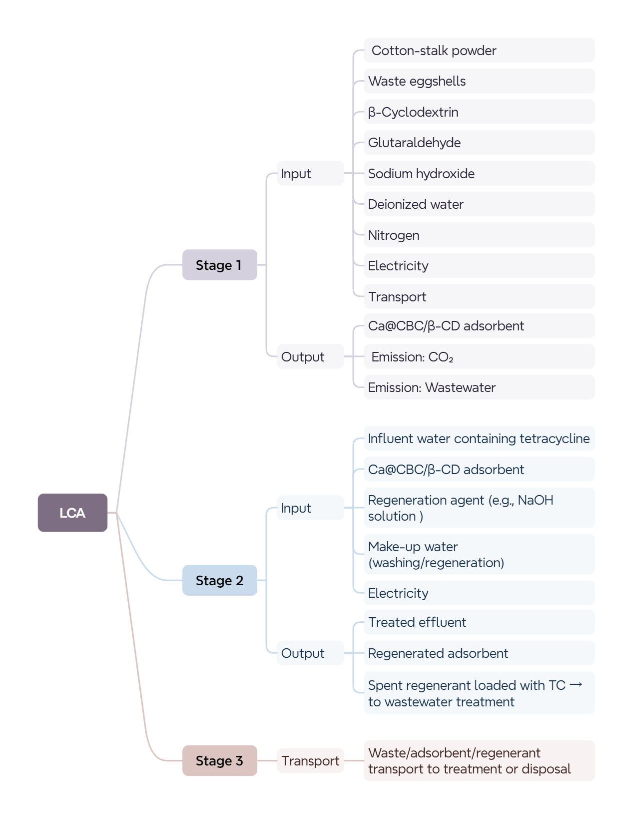
Fig. S1. LCA flow of Ca@CBC/β-CD adsorbent for TC removal.

Fig. S2. N₂ adsorption–desorption isotherms and BJH pore-size distribution of Ca@CBC/β-CD. The inset shows the pore-size-distribution profile in the 0–50 nm range for clearer visualization of the dominant micro/mesopore region.

Fig. S3. SEM image, elemental mapping, and EDS spectrum of Ca@CBC.

Fig. S4. Comparison of the microwave-assisted and water-bath-heated β-CD grafting routes using the same Ca@CBC precursor: (a) reaction time, (b) electricity consumption per batch, and (c) adsorption capacity under the standard condition (pH 6.0, C₀ = 50 mg L⁻¹, dosage = 0.5 g L⁻¹, 25 °C, 3 h).

Fig. S5. (a) Adsorption isotherm models (pH = 6.0, dosage = 0.5 g L⁻¹, 35 °C); (b) Adsorption isotherms models (pH = 6.0, dosage = 0.5 g L⁻¹, 45 °C)

Fig. S6. Effects of humic acid (HA) and trivalent cations (Fe³⁺ and Al³⁺) on TC adsorption by Ca@CBC/β-CD under the baseline conditions (pH = 6.0, dosage = 0.5 g L⁻¹, C₀ = 50 mg L⁻¹, 25 °C, 3 h).

Fig. S7. Time-dependent Ca leaching from Ca@CBC/β-CD under the optimum adsorption condition (pH 6.0, 0.5 g L⁻¹, 25 ± 1 °C).

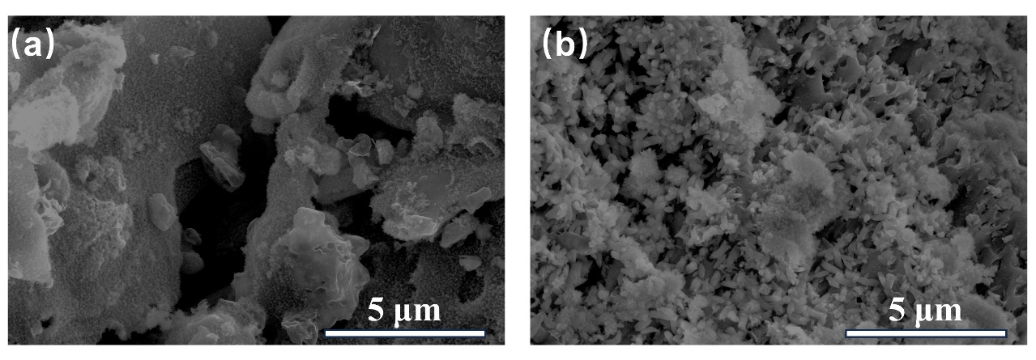
Fig. S8. TC adsorption by Ca@CBC-β-CD: (a) before adsorption; (b) after adsorption.

