Supporting Information
Promoted sequestration and photo-induced destruction of perfluorooctane sulfonate using photoregenerable β-Ga₂O₃-functionalized biochar: Superior defluorination and mechanistic insights
Yanyan Gong^{a,}*, Dongjiao Linª, Ying Liuª, Shuai Gao^{b}, Haodong Ji^{b}, Lianjun Baoª, Zuhui Wuª, Honghong Lyu^{c}, Dongye Zhao^{d, *}
ª College of Environment and Climate, Guangdong Provincial Key Laboratory of Environmental Pollution and Health, Jinan University, Guangzhou 511443, China
^{b} Eco-environment and Resource Efficiency Research Laboratory, School of Environment and Energy, Peking University Shenzhen Graduate School, Shenzhen 518055, PR China
^{c} Tianjin Key Laboratory of Clean Energy and Pollution Control, School of Energy and Environmental Engineering, Hebei University of Technology, Tianjin 300401, China
^{d} Department of Civil, Construction and Environmental Engineering, San Diego State University, San Diego, CA 92182-1324, USA

*Corresponding authors. E-mail addresses: yanyangong@jnu.edu.cn (Y. Gong), dzhao2@sdsu.edu (D. Zhao)
29 Pages
10 Tables
8 Figures
Contents
Text S1. Materials and chemicals
Text S2. Material characterization
Text S3. Analytical methods
Text S4. Adsorption kinetic models
Text S5. Adsorption isotherm models
Text S6. Photodegradation kinetic models
Table S1. Specific surface area, micropore area, external surface area, total pore volume, micropore volume, mesopore volume, and average pore diameter of 0%Ga₂O₃@biochar and 1%Ga₂O₃@biochar.
Table S2. The corresponding fitting parameters of adsorption kinetic models (Errors given as standard deviation).
Table S3. Regression parameters of adsorption isotherm data of PFOS onto Ga₂O₃@biochar by Langmuir and Freundlich isotherm models (Errors given as standard deviation).
Table S4. Special surface area and pore structure for 1%Ga₂O₃@biochar before and after PFOS adsorption.
Table S5. Pseudo-first-order and retarded first-order kinetic models applied for simulating POFS degradation kinetics and the corresponding fitting parameters (Errors given as standard deviation).
Table S6. PFOS photodegradation and defluorination by different catalysts.
Table S7. Pseudo-first-order kinetic model applied for simulating POFS degradation kinetics via 1%Ga₂O₃@biochar in the presence of BQ, AgNO₃ and FFA and the corresponding fitting parameters (Errors given as standard deviation).
Table S8. LC-QTOF-MS detection of PFOS and its intermediate products.
Table S9. Predicted acute and chronic toxicity levels of PFOS and the detected degradation products by ECOSAR software.
Table S10. Basic physicochemical properties of groundwater.
Fig. S1. SEM-EDS of 0%Ga₂O₃@biochar.
Fig. S2. (a) N₂ adsorption-desorption curves and (b) pore size distribution of 0%Ga₂O₃@biochar and 1%Ga₂O₃@biochar.
Fig. S3. (a) Full survey, (b) C 1s, and (c) O 1s XPS depth profiling spectra of 1%Ga₂O₃@biochar. Fractions of various (d) carbon and (e) oxygen species in different depths of 1%Ga₂O₃@biochar which were calculated from XPS depth spectra.
Fig. S4. Pseudo-first-order kinetic model applied for fitting pre-concentrated PFOS onto 1%Ga₂O₃@biochar with various scavengers.
Fig. S5. Ion current of PFOS and its intermediate products.
Fig. S6. Adsorption and photodegradation of PFOS by 1%Ga₂O₃@biochar during four consecutive adsorption-photodegradation cycles.
Fig. S7. (a) XRD and (b) FTIR of 1%Ga₂O₃@biochar after adsorption and photodegradation.
Fig. S8. (a) Concentration and (b) destroy of PFOS by 1%Ga₂O₃@biochar in deionized water and real groundwater.

Text S1. Materials and chemicals
Wheat straw (1.6-2.0 mm) was acquired from a farm in Donghai, Jiangsu Province, China. PFOS was purchased from CATO Research Chemical Inc. (Guangzhou, China). Sodium perfluoro-1-[¹³C₈] octanesulfonate (M8PFOS) was supplied by Wellington Laboratories Inc. (Guelph, Ontario, Canada). Ethylenediaminetetraacetic acid disodium salt (EDTA-2Na), silver nitrate (AgNO₃), gallium chloride (GaCl₃), and 2,2,6,6-tetramethylpiperidine (TEMP) were purchased from Macklin Biochemical Technology Co., Ltd. (Shanghai, China). A fluoride standard solution was obtained from ANPEL Laboratory Technologies Inc. (Shanghai, China). Isopropyl alcohol (IPA) was supplied by Guangdong Guanghua Sci-Tech Co., Ltd. (Shantou, China). Dimethyl sulfoxide (DMSO) was procured from J&K Scientific Ltd. (Shanghai, China). 5,5-Dimethyl-1-pyrroline-N-oxide (DMPO) was acquired from TCI Development Co., Ltd. (Shanghai, China). Ethanol was sourced from Guangzhou Chemical Reagent Factory (Guangzhou, China).

Text S2. Material characterization
The microstructure and elemental composition and distribution were examined using scanning electron microscopy (SEM) and energy disperse spectroscopy (EDS) (Sigma 300, Carl Zeiss Company, Germany), high-resolution transmission electron microscopy (HRTEM) (JEM-2100F, JEOL, Japan), and elemental mapping. The crystallographic structure was determined using X-ray diffraction (XRD 6100, SHIMADZU, Japan). The surface functional groups were identified using Fourier transform infrared spectroscopy (FTIR) (Nicolet iN10, Thermo Fisher Scientific, Waltham, MA, USA). The hydrophobicity was assessed via water contact angle measurement (ST200KB, KINO Industry Co., Boston, MA, USA). The zeta potential was measured via a Zetasizer Nano ZSE instrument (Malvern Instruments, UK). Specific surface area and pore size distribution were derived from N₂-adsorption/desorption isotherms using a Micromeritics ASAP 2460 analyzer (Micromeritics Instruments Corporation., Norcross, GA, USA). The elemental composition and valence states were analyzed via X-ray photoelectron spectroscopy (XPS, EA, Euro EA3000, Euro Vector, Milan, Italy) with depth profiling technique. The optical properties were assessed via UV-vis diffuse reflectance spectra (UV-vis DRS) (UV-2700, Shimadzu, Tokyo, Japan) and photoluminescence (PL) spectrophotometer (F-7100, Hatachi, Japan). The electrochemical properties were performed with an electrochemical workstation (CHI 770, Shanghai Chenhua Instrument Co., Shanghai, China). Cyclic voltammetry (CV) was performed from -2 to 2 V at a scan rate of 100 mV/s and electrochemical impedance spectroscopy (EIS) was recorded over a frequency range of 0.1 Hz to 100 kHz.

Text S3. Analytical methods
PFOS and M8PFOS were analyzed using an ultra-high-performance liquid chromatography system (UHPLC, Shimadzu Corporation Inc., Kyoto, Japan) equipped with an AB-Sciex 5500 triple quadrupole mass spectrometry system (Applied Biosystems, Foster City, CA, USA). 1 μL of the sample was injected into a Waters XBridge BEH C18 column (3 mm × 100 mm, 2.5 μm). A gradient mobile phase of ultrapure water and 4 mmol/L ammonium acetate in methanol were applied as the mobile phase at a flow rate of 300 μL/min. The mobile phase gradient expressed as the ratio of methanol to total solution was as follows: 0-1.0 min, 20%; 1.0-2.5 min, a linear increase from 20% to 95%; 2.5-6.0 min, 95%; 6.0-6.5 min, a linear decrease from 95% to 20%; and 6.5-8.5 min, 20%. The column temperature was 40 °C. The total run time of each injection was 8.5 min. Mass spectra data were collected in a negative electrospray ionization mode and chromatograms were recorded by a multiple reaction monitoring (MRM) mode. The compounds monitoring transition were 499, 99 m/z⁺ for PFOS and 503, 80 m/z⁺ for M8PFOS. The detection limits of PFOS and M8PFOS were 300 ng/L and 0.4 ng/L, respectively.

Text S4. Adsorption kinetic models
The pseudo-first-order (Eq. S1) (Corbett. 1972), pseudo-second-order (Eq. S2) (Ho and McKay. 1999), intraparticle diffusion (Eq. S3) (Wu et al. 2009), and external mass transfer models (Eq. S4) (Luo et al. 2015) were used to fit the PFOS adsorption kinetic data:
Pseudo-first-order: $ln(q_{e}-q_{t})=lnq_{e}-K_{1}t$ (S1)
Pseudo-first-order: $\frac{t}{q_{t}}=\frac{1}{K_{2}q_{e}^{2}}+\frac{t}{q_{e}}$ (S2)
Internal diffusion model: $q_{t}=k_{i}t^{0.5}+C_{i}$ (S3)
External mass transfer model: $\frac{-dC}{d_{t}}=k_{f}a(C-C_{s})$ (S4)
where q_{t} and q_{e} (μg/g) represent the adsorption capacity at t (h) and equilibrium, respectively, K₁ (h^{–1}) is the pseudo-first-order adsorption rate constant, K₂ (g/(μg·h)) is the pseudo-second-order adsorption rate constant, k_{i} (μg/(g·h^{0.5}) is the intraparticle diffusion rate constant, C_{i} (μg/g) is the intercept related to the thickness of the boundary layer, C and Cs are the concentrations of PFOS in bulk solution and at the interface, respectively (μg/L), k_{f} is the mass transfer coefficient (cm/s), and a (m²/m³ ) is the specific area available for mass transfer per unit volume of the contactor.
For the external mass transfer model (Eq. S4), assume the PFOS sorption fits Langmuir isotherm (Eq. S5)
${\text{q}}_{\text{e}}\text{ = }\frac{{\text{q}}_{\text{m}}\text{k}{\text{C}}_{\text{S}}}{\text{1+}{\text{C}}_{\text{S}}}$ (S5)
where k is the sorption equilibrium coefficient; and q_{m} (μg/g) is the maximum sorption capacity. q_{e} (μg/g) can be calculated by the following Eq. S6:
${\text{q}}_{\text{e}}\text{ = }\frac{\text{V}}{\text{m}}\text{ (}{\text{C}}_{\text{0}}\text{ –}{ \text{C}}_{\text{s}}\text{)}$ (S6)
Where V (L) is the contactor volume, m (g) is the mass of NBCC, and C₀ (μg/L) is the initial PFOS concentration in bulk solution. Combine Eq. S3, S5, and S6 yielding Eq. S7:
$\text{–}\frac{\text{d}\text{c}}{\text{d}\text{t}}\text{ = }{\text{k}}_{\text{f}}\text{a}\text{[}\text{C}\text{ – }\frac{\text{1}}{\text{2}}\text{(}\sqrt{\text{(}\frac{{\text{q}}_{\text{m}}\text{m}}{\text{V}}\text{ –}{ \text{C}}_{\text{0}}\text{ + }\frac{\text{1}}{\text{k}}{\text{)}}^{\text{2}}\text{ + }\frac{\text{4}{\text{C}}_{\text{0}}}{\text{k}}}\text{) – }\frac{{\text{q}}_{\text{m}}\text{m}}{\text{V}}\text{ + }{\text{C}}_{\text{0}}\text{ – }\frac{\text{1}}{\text{k}}\text{)]}$ (S7)
To describe the sorption data with the model, the concentration of PFOS in the bulk
solution (C) is derived as a function of time (t) with Eq. S8:
$\text{C}\text{ = }\text{b}\text{exp}\left[\text{–}\text{ht}\right]\text{ + }{\text{C}}_{\text{0}}\text{ – }\text{b}$ (S8)
where h (1/h) and b (μg/L) are the fitting parameters of the external mass transfer
model, respectively.
$\text{h}\text{ = }{\text{k}}_{\text{f}}\text{a}$ (S9)
$\text{b}\text{ = }{\text{C}}_{\text{0}}\text{ – }\frac{\text{1}}{\text{2}}\text{(}\sqrt{\text{(}\frac{{\text{q}}_{\text{m}}\text{m}}{\text{V}}\text{ –}{ \text{C}}_{\text{0}}\text{ + }\frac{\text{1}}{\text{k}}{\text{)}}^{\text{2}}\text{ + }\frac{\text{4}{\text{C}}_{\text{0}}}{\text{k}}}\text{) – }\frac{{\text{q}}_{\text{m}}\text{m}}{\text{V}}\text{ +}{ \text{C}}_{\text{0}}\text{ – }\frac{\text{1}}{\text{k}}\text{)}$ (S10)
Eq. S8 is applied to fit the experimental results with h (Eq. S9) and b (Eq. S10) as fitting parameters.

Text S5. Adsorption isotherm models
The Langmuir (Eq. S11) (Kano et al. 2000) and Freundlich (Eq. S12) (Kano et al. 2000) isotherm models were applied to fit the adsorption isotherm data:
Langmuir model:${ q}_{e}=\frac{q_{m}×K_{L}×C_{e}}{1+K_{L}×C_{e}}$ (S11)
Freundlich model:${ q}_{e}=K_{F}×C_{e}^{\frac{1}{n}}$ (S12)
where q_{e} (mg/g) stands for the equilibrium PFOS uptake, C_{e} (mg/L) represents the equilibrium PFOS concentration in the solution, K_{L} (mg/L) is the Langmuir sorption constant, q_{m} (mg/g) is the maximum Langmuir adsorption capacity; K_{F} [(mg/g)/(mg/L)^{n}] is the Freundlich affinity coefficient, and n is the exponential coefficient.

Text S6. Photodegradation kinetic models
The pseudo-first-order (Eq. S13) and retarded first-order kinetic models (Eq. S14) were applied to simulate the PFOS degradation rate data:
Pseudo-first-order kinetic model: $\text{ln}\left(\frac{{\text{M}}_{\text{t}}}{{\text{M}}_{\text{0}}}\right) \text{= –}{\text{K}}_{\text{P}}\text{t}$ (S13)
Retarded first-order kinetic model: $\frac{{\text{M}}_{\text{0}}}{{\text{M}}_{\text{t}}}\text{ = }\frac{\text{1}}{{\left(\text{1 + }\text{αt}\right)}^{{\text{–}\text{K}}_{\text{α}}\text{/}\text{α}}}$ (S14)
where M₀ (g) and M_{t} (g) are the mass of PFOS at time 0 and t h, respectively, K_{p} (h^{–1}) is the first-order rate constant, K_{α} (h^{–1}) is the retarded first-order rate constant, and α is the retardation factor indicating the degree of deviation from pseudo-first-order behavior (Watanabe et al. 2018).

Table S1. Specific surface area, micropore area, external surface area, total pore volume, micropore volume, mesopore volume, and average pore diameter of 0%Ga₂O₃@biochar and 1%Ga₂O₃@biochar.
Sample | S_{BET}ª  (m²/g) | Micropore  areaª  (m²/g) | External surface area  (m²/g) | Total pore volume^{b}  (cm³/g) | Micropore volume  (cm³/g) | Mesopore volume  (cm³/g) | Average pore diameter^{c}  (nm)
0%Ga₂O₃@biochar | 409.06 | 334.95 | 74.11 | 0.2422 | 0.1318 | 0.1104 | 5.366
1%Ga₂O₃@biochar | 276.71 | 182.56 | 94.15 | 0.2305 | 0.0766 | 0.1539 | 5.749
Note: a: BET surface area and micropore area calculated in the relative pressure region P/P₀ = 0.300.
b: Pore volume determined at P/P₀ = 0.991.
c: Average pore diameter obtained from BJH (mesopore) and Horvath-Kawazoe (micropore) models using N₂ adsorption-desorption isotherms.

Table S2. The corresponding fitting parameters of adsorption kinetic models (Errors given as standard deviation).
Adsorption kinetic models | Material | Parameters
Pseudo-first-order |  | K₁ (h^{–1}) |  | q_{e} (μg/g) |  | R²
Pseudo-first-order | 0%Ga₂O₃@biochar | 8.22±1.13 |  | 946.19±164.91 |  | 0.946
Pseudo-first-order | 1%Ga₂O₃@biochar | 9.75±1.29 |  | 1928.29±383.23 |  | 0.950
Pseudo-second-order |  | K₂ (g/(μg·h)) |  | q_{e} (μg/g) |  | R²
Pseudo-second-order | 0%Ga₂O₃@biochar | 2.81±0.0002 |  | 3175.20±548.09 |  | 0.919
Pseudo-second-order | 1%Ga₂O₃@biochar | 0.0011±0.0003 |  | 2811.72±296.35 |  | 0.968
Intraparticle diffusion |  | k_{i} (μg/(g·h^{0.5})) |  | C_{i} (μg/g) |  | R²
Intraparticle diffusion | 0%Ga₂O₃@biochar | 1140.30±234.67 |  | 0 |  | 0.844
Intraparticle diffusion | 1%Ga₂O₃@biochar | 2477.74±279.80 |  | 0 |  | 0.953
Film diffusion |  | k_{f} (cm/s) | h (1/h) |  | b (μg/L) | R²
Film diffusion | 0%Ga₂O₃@biochar | 1.34*10⁻⁴±3.23*10⁻⁵ | 1.54±0.37 |  | 91.52±18.82 | 0.999
Film diffusion | 1%Ga₂O₃@biochar | 3.80*10⁻⁴±4.28*10⁻⁵ | 3.52±2.27 |  | 95.45±8.66 | 0.997
Note: K₁ (h^{–1}) is the pseudo-first-order sorption rate constant, q_{e} (μg/g) is PFOS uptake at equilibrium time, K₂ (g/(μg·h)) is the pseudo-second-order sorption rate constant, k_{i} (μg/(g·h^{0.5})) is the intraparticle diffusion rate constant, C_{i} (μg/g) is the intercept related to the thickness of the boundary layer, k_{f} (cm/s) is the mass transfer coefficient (cm/s), and h (1/h) and b (μg/L) are the fitting parameters of the external mass transfer model.

Table S3. Regression parameters of adsorption isotherm data of PFOS onto Ga₂O₃@biochar by Langmuir and Freundlich isotherm models (Errors given as standard deviation).
Adsorption isotherm models |  | Material |  | Parameters
Langmuir |  | q_{m} (mg/g) | K_{L} (mg/L) |  | R²
Langmuir | 0%Ga₂O₃@biochar | 3.67±0.64 | 6.48±3.95 |  | 0.796
Langmuir | 1%Ga₂O₃@biochar | 4.01±0.36 | 40.84±20.10 |  | 0.870
Freundlich |  | K_{F} (mg/g)/(mg/L)^{n} | 1/n |  | R²
Freundlich | 0%Ga₂O₃@biochar | 3.39±0.16 | 0.31±0.037 |  | 0.956
Freundlich | 1%Ga₂O₃@biochar | 4.52±022 | 0.24±0.026 |  | 0.962
Note: q_{m} (mg/g) is the maximum Langmuir adsorption capacity of Ga₂O₃@biochar, K_{L} (mg/L) is the Langmuir sorption constant, K_{F} [(mg/g)/(mg/L)^{n}] is the Freundlich affinity coefficient, and n is the exponential coefficient.

Table S4. Special surface area and pore structure for 1%Ga₂O₃@biochar before and after PFOS adsorption.
Sample | Specific surface area  (m²/g) | Micropore  area  (m²/g) | External surface area  (m²/g) | Total pore volume  (cm³/g) | Micropore volume  (cm³/g) | Mesopore volume  (cm³/g) | Average pore diameter  (nm)
1%Ga₂O₃@biochar | 276.7 | 182.6 | 94.15 | 0.2305 | 0.0766 | 0.1539 | 5.749
PFOS-laden 1%Ga₂O₃@biochar | 43.83 | 12.40 | 31.43 | 0.1011 | 0.0134 | 0.0877 | 5.473

Table S5. Pseudo-first-order and retarded first-order kinetic models applied for simulating POFS degradation kinetics and the corresponding fitting parameters (Errors given as standard deviation).
Photodegradation  kinetic models | Material | Parameters
Pseudo-first-order |  | K_{P} (h^{‒1}) |  | R²
Pseudo-first-order | 0%Ga₂O₃@biochar | 0.1418 ± 0.0038 |  | 0.981
Pseudo-first-order | 1%Ga₂O₃@biochar | 0.2326 ± 0.0117 |  | 0.980
Retarded-first-order |  | K_{α} (h^{‒1}) | α (h^{‒1}) | R²
Retarded-first-order | 0%Ga@NBCC | 0.1829 ± 0.0148 | 0.1148 ± 0.0428 | 0.994
Retarded-first-order | 1%Ga@NBCC | 0.4932± 0.0312 | 0.4717 ± 0.0714 | 0.998
Note: K_{p} (h^{–1}) is the first-order rate constant, K_{α} (h^{–1}) is the retarded first-order rate constant, and α is the retardation factor indicating the degree of deviation from pseudo-first-order behavior.

Table S6. PFOS photodegradation and defluorination by different catalysts.
Material | Initial PFOS mass | Material mass | Degradation effiency (%) | Defluorination effiency (%) | Reference
2%Ga/TNTs@AC | 4 μg | 0.1200 g | 75.0% | 66.2% | (Zhu et al. 2021)
Fe-BiOCl/CS | 4 μg | 0.0100 g | 80.5% | 65.3% | (Rather et al. 2024)
BN/BiOI | 1000 μg | 0.0500 g | 36.8% | 23.3% | (Duan et al. 2025)
ChPCN | 100 μg | 0.0100 g | - | 1.75% | (Sun et al. 2025)
1%Ga₂O₃@biochar | 4 μg | 0.0060 g | 80.8% | 70.5% | This study

Table S7. Pseudo-first-order kinetic model applied for simulating POFS degradation kinetics via 1%Ga₂O₃@biochar in the presence of BQ, AgNO₃ and FFA and the corresponding fitting parameters (Errors given as standard deviation).
Photodegradation kinetic model | Scavengers | Parameters
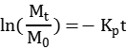 |  | K_{P} (h^{‒1}) | R²
 | Control | 0.233 ± 0.012 | 0.980
 | BQ | 0.089 ± 0.003 | 0.997
 | AgNO₃ | 0.104 ± 0.004 | 0.995
 | FFA | 0.138 ± 0.003 | 0.998
Note: K_{p} (h^{–1}) is the first-order rate constant.

Table S8. LC-QTOF-MS detection of PFOS and its intermediate products.
Compounds | Chemical formula | CAS | Retention time (min)
PFOS | C₈HF₁₇O₃S | 1763-23-1 | 10.13
PFOA | C₈HF₁₅O2 | 335-67-1 | 9.82
PFHpA | C₇HF₁₃O2 | 375-85-9 | 9.46
PFHxA | C₆HF₁₁O₂ | 307-24-4 | 8.96
PFPeA | C₅HF₉O₂ | 2706-90-3 | 8.21
PFBA | C₄HF₇O₂ | 375-22-4 | 6.49

Table S9. Predicted acute and chronic toxicity levels of PFOS and the detected degradation products by ECOSAR software.
Compounds | Acute toxicity (mg/L) |  |  | Chronic toxicity (ChV)  (mg/L)
Compounds | Fish  (LC₅₀)/96 h | Daphnid  (EC₅₀)/48 h | Green angle  (EC₅₀)/96 h | Fish | Daphnid | Green angle
PFOS | 23.66 | 16.92 | 32.65 | 3.04 | 3.13 | 14.28
PFOA | 10.10 | 7.44 | 16.22 | 1.34 | 1.50 | 7.58
PFHpA | 35.43 | 24.52 | 41.43 | 4.37 | 4.15 | 16.86
PFHxA | 121.93 | 79.34 | 103.8 | 13.40 | 11.31 | 36.83
PFPeA | 408.97 | 250.18 | 253.6 | 43.65 | 30.02 | 78.39
PFBA | 1322 | 760.6 | 597.1 | 131.23 | 76.85 | 160.9

Table S10. Basic physicochemical properties of groundwater.
pH | 5.98 | HCO₃⁻ (mg/L) | 42.1
TOC (mg/L) | 1.90 | K (mg/L) | 10.4
F⁻ (mg/L) | 0.043 | Ca (mg/L) | 14.4
Cl⁻ (mg/L) | 38.5 | Na (mg/L) | 41.0
NO₃⁻ (mg/L) | 27.1 | Mg (mg/L) | 4.17
NO₂⁻ (mg/L) | ＜0.01 | Fe (mg/L) | 0.003
SO₄²⁻ (mg/L) | 26.4 | Mn (mg/L) | 0.052

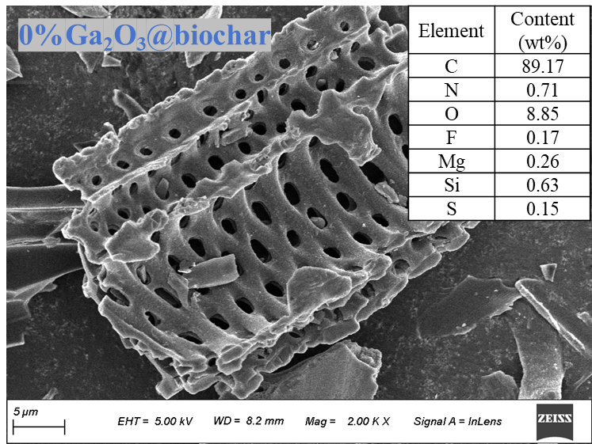
Fig. S1. SEM-EDS of 0%Ga₂O₃@biochar.

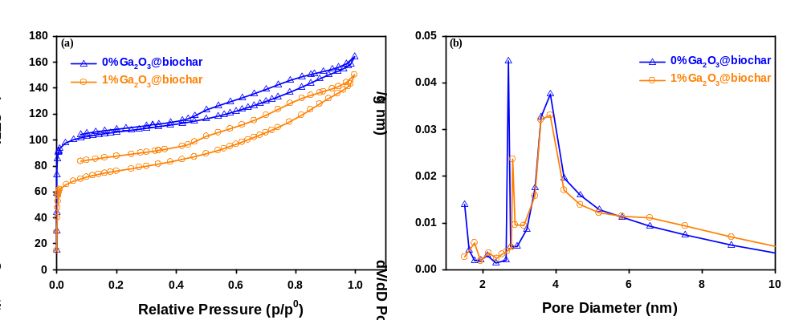
Fig. S2. (a) N₂ adsorption-desorption curves and (b) pore size distribution of 0%Ga₂O₃@biochar and 1%Ga₂O₃@biochar.

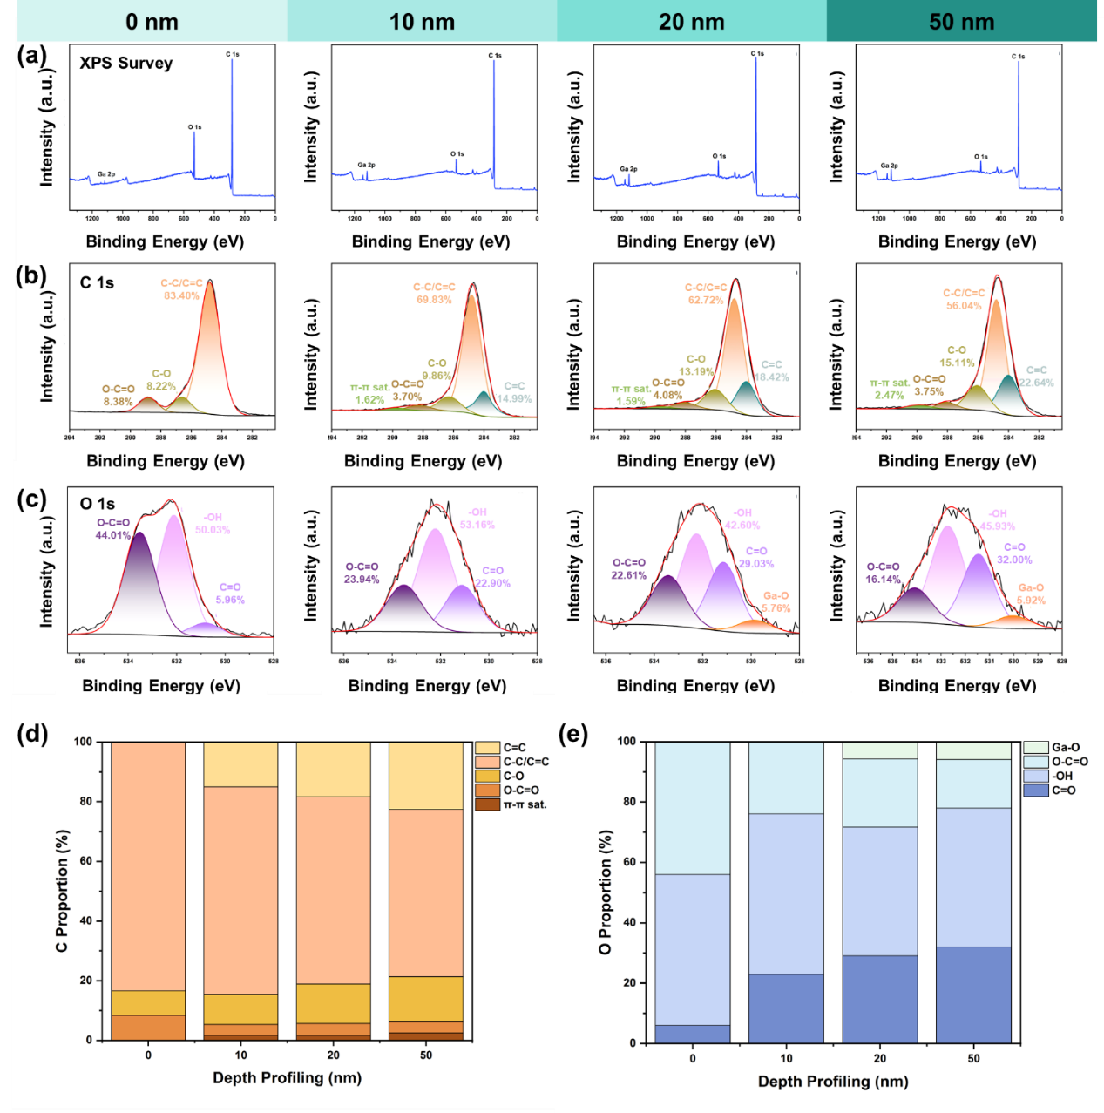
Fig. S3. (a) Full survey, (b) C 1s, and (c) O 1s XPS depth profiling spectra of 1%Ga₂O₃@biochar. Fractions of various (d) carbon and (e) oxygen species in different depths of 1%Ga₂O₃@biochar which were calculated from XPS depth spectra.

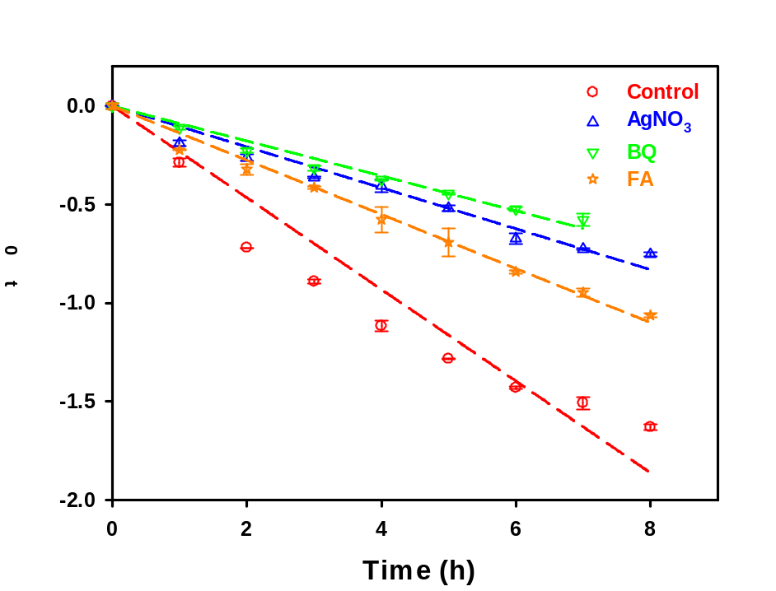
Fig. S4. Pseudo-first-order kinetic model applied for fitting pre-concentrated PFOS onto 1%Ga₂O₃@biochar with various scavengers.
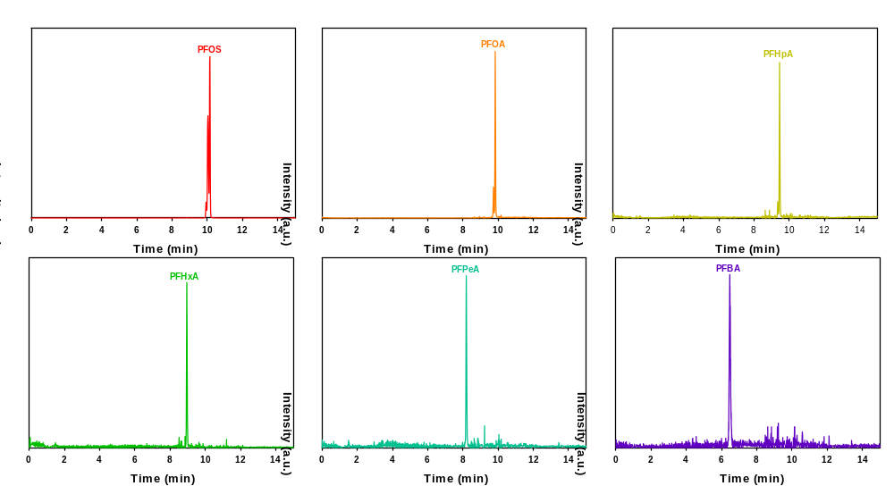
Fig. S5. Ion current of PFOS and its intermediate products.

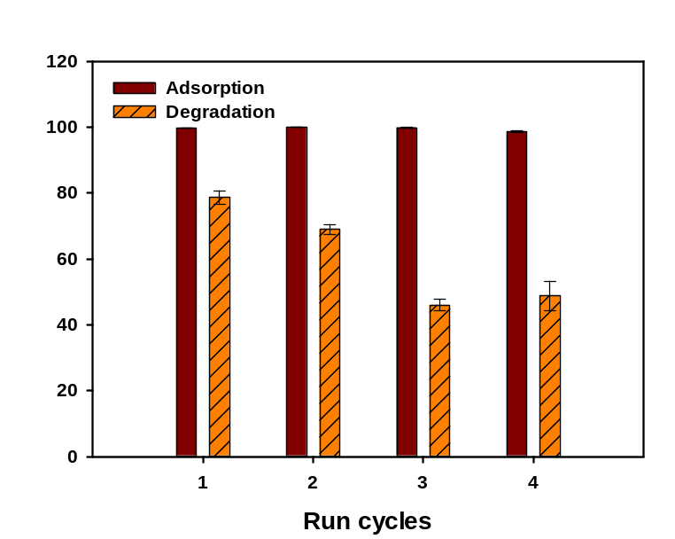

Fig. S6. Adsorption and photodegradation of PFOS by 1%Ga₂O₃@biochar during four consecutive adsorption-photodegradation cycles. Experimental conditions: for each adsorption cycle, initial PFOS concentration = 100 µg/L, material dosage = 0.80 g/L, solution volume = 40 mL, adsorption time = 24 h, and pH = 7.0±0.3. For each photodegradation cycle, intensity = 30 mW/cm², solution volume = 10 mL, pH = 7.0±0.3, and reaction time = 8 h. Data plotted as the mean of triplicates and error bars refer to the standard deviation.

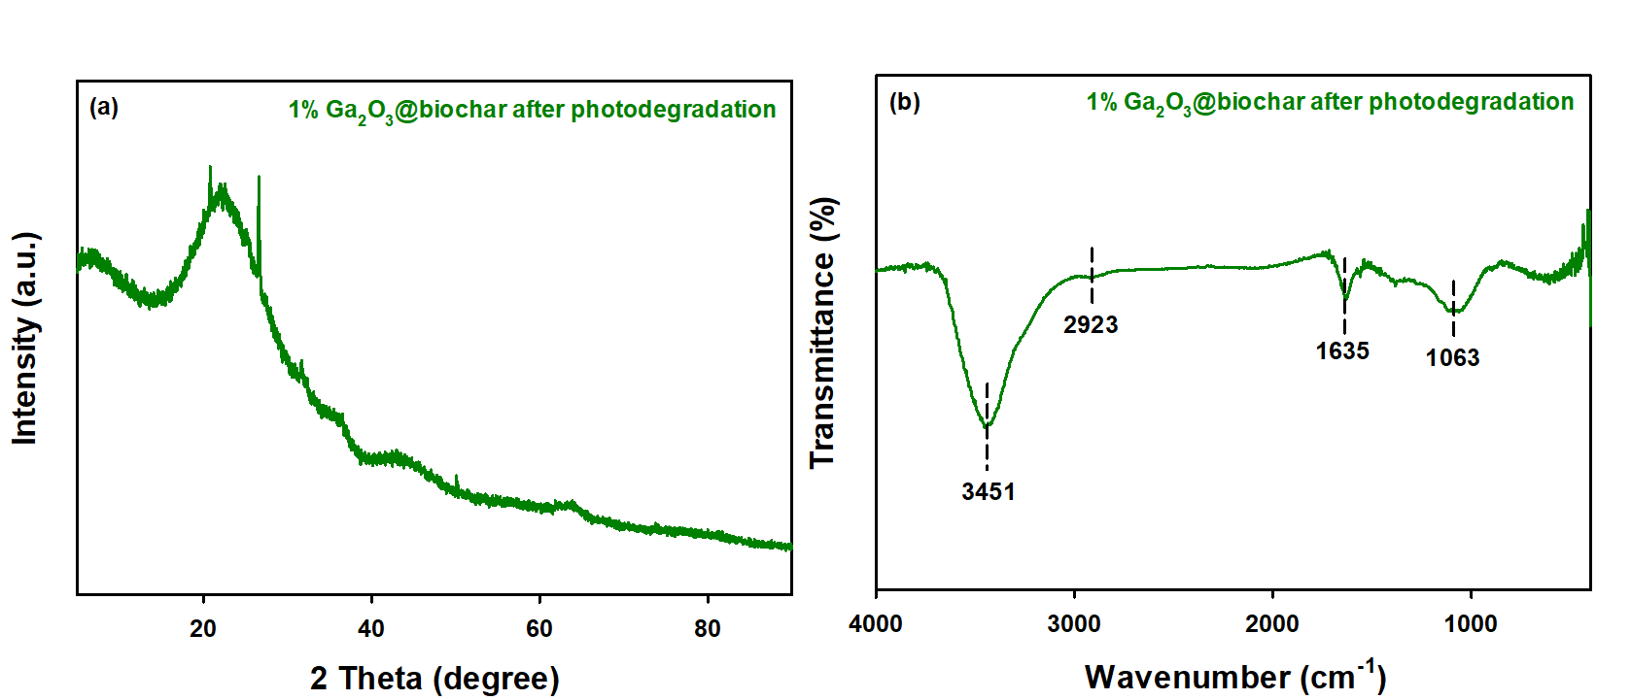

Fig. S7. (a) XRD and (b) FTIR of 1%Ga₂O₃@biochar after adsorption and photodegradation.

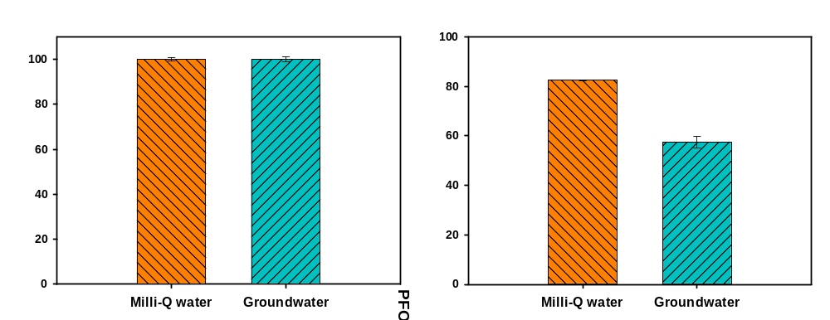
Fig. S8. (a) Concentration and (b) destroy of PFOS by 1%Ga₂O₃@biochar in deionized water and real groundwater.

References
Corbett JF (1972) Pseudo first-order kinetics. J Chem Educ 49(10):663.
Duan L, Gu M, Wang M, Liu L, Cheng X,Huang J (2025) Mechanism of Z-scheme BN/BiOI heterojunction for efficient photodegradation of perfluorooctane sulfonate (PFOS). Sep Purif Technol 360:131229.
Ho YS, McKay G (1999) Pseudo-second order model for sorption processes. Process Biochem 34(5):451-465.
Kano F, Abe I, Kamaya H, Ueda I (2000) Fractal model for adsorption on activated carbon surfaces: Langmuir and Freundlich adsorption. Surface Science 467(1-3):131-138.
Luo J, Luo X, Crittenden J, Qu J, Bai Y, Peng Y, Li J (2015) Removal of antimonite (Sb(III)) and antimonate (Sb(V)) from aqueous solution using carbon nanofibers that are decorated with zirconium oxide (ZrO₂). Environ Sci Technol 49(18):11115-11124.
Rather R, Xu, T, Leary RN, Zhao D (2024) Aqueous and solid phase photocatalytic degradation of perfluorooctane sulfonate by carbon- and Fe-modified bismuth oxychloride. Chemosphere 346:140585.
Sun C, Wang Z, Li X, Luo Y, Zheng H, Li X, Chen L, Li F (2025) Adsorption–photocatalysis synergistic removal of perfluoroalkyl/polyfluoroalkyl substances by reusable chitin/polyethylene imine/O-g-C₃N₄ sponges in water environments. Chem Eng J 511:162006.
Watanabe N, Takata M, Takemine S, Yamamoto K (2018) Thermal mineralization behavior of PFOA, PFHxA, and PFOS during reactivation of granular activated carbon (GAC) in nitrogen atmosphere. Environ Sci Pollut Res 25(8):200-7205.
Wu F, Tseng R, Juang R (2009) Initial behavior of intraparticle diffusion model used in the description of adsorption kinetics. Chem Eng J 153(1-3):1-8.
Zhu Y, Xu T, Zhao D, Li F, Liu W, Wang B, An B (2021) Adsorption and solid-phase photocatalytic degradation of perfluorooctane sulfonate in water using gallium-doped carbon-modified titanate nanotubes. Chem Eng J 421:129676.

