Supplementary Material
Long-term biochar amendment increased dissimilatory nitrate reduction to ammonium concomitantly suppressing denitrification and anaerobic ammonium oxidation in deep alkaline paddy soil
Qiannan Yang¹, Guilong Zhang¹, Jie Li¹, Hu Li², Lukas Van Zwieten³ and Lili Wang^{1,*}
¹ Agro-Environmental Protection Institute, Ministry of Agriculture and Rural Affairs, Tianjin, China
² State Key Laboratory of Efficient Utilization of Arable Land in China, Institute of Agricultural Resources and Regional Planning, Chinese Academy of Agricultural Sciences, Beijing, China
³ NSW Department of Primary Industries, Wollongbar Primary Industries Institute, Wollongbar, NSW, Australia
*Corresponding authors: Lili Wang
E-mail address: lili0229ok@126.com (Lili Wang)
Number of Pages: 9
Number of Figures: 4
Number of Tables: 3

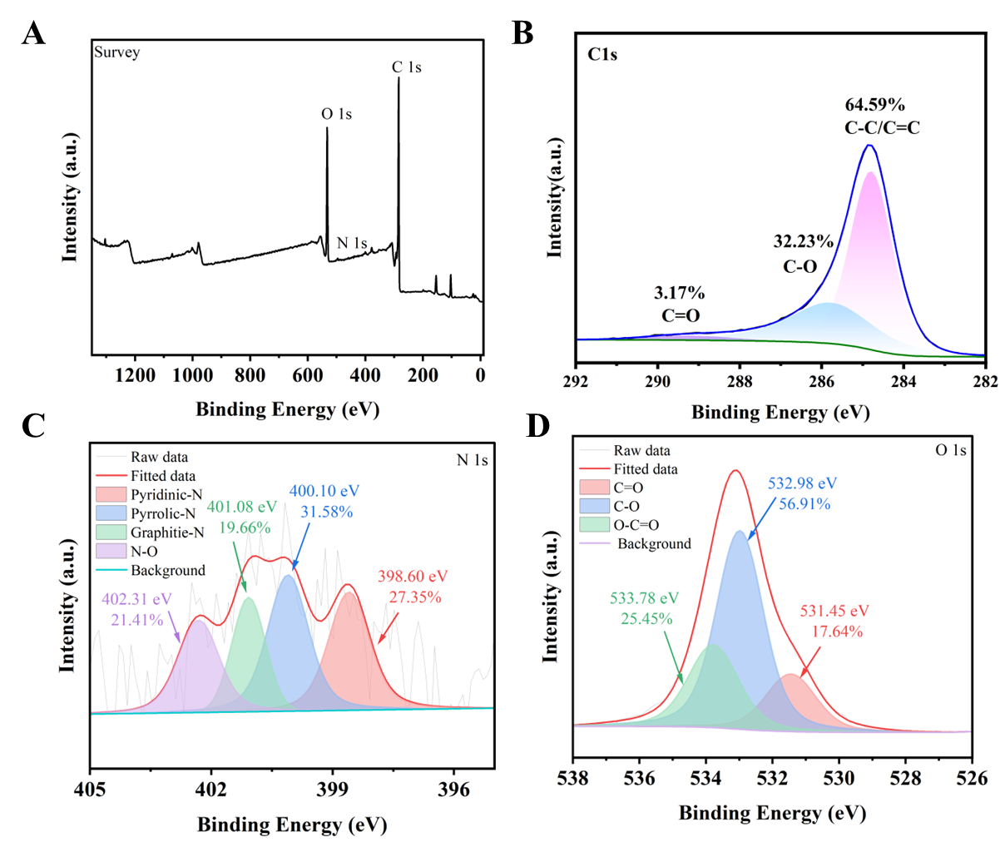

Fig. S1 Results of full (A), C 1s (B), N 1s (C) and O 1s (D) spectrum of the rice biochar.

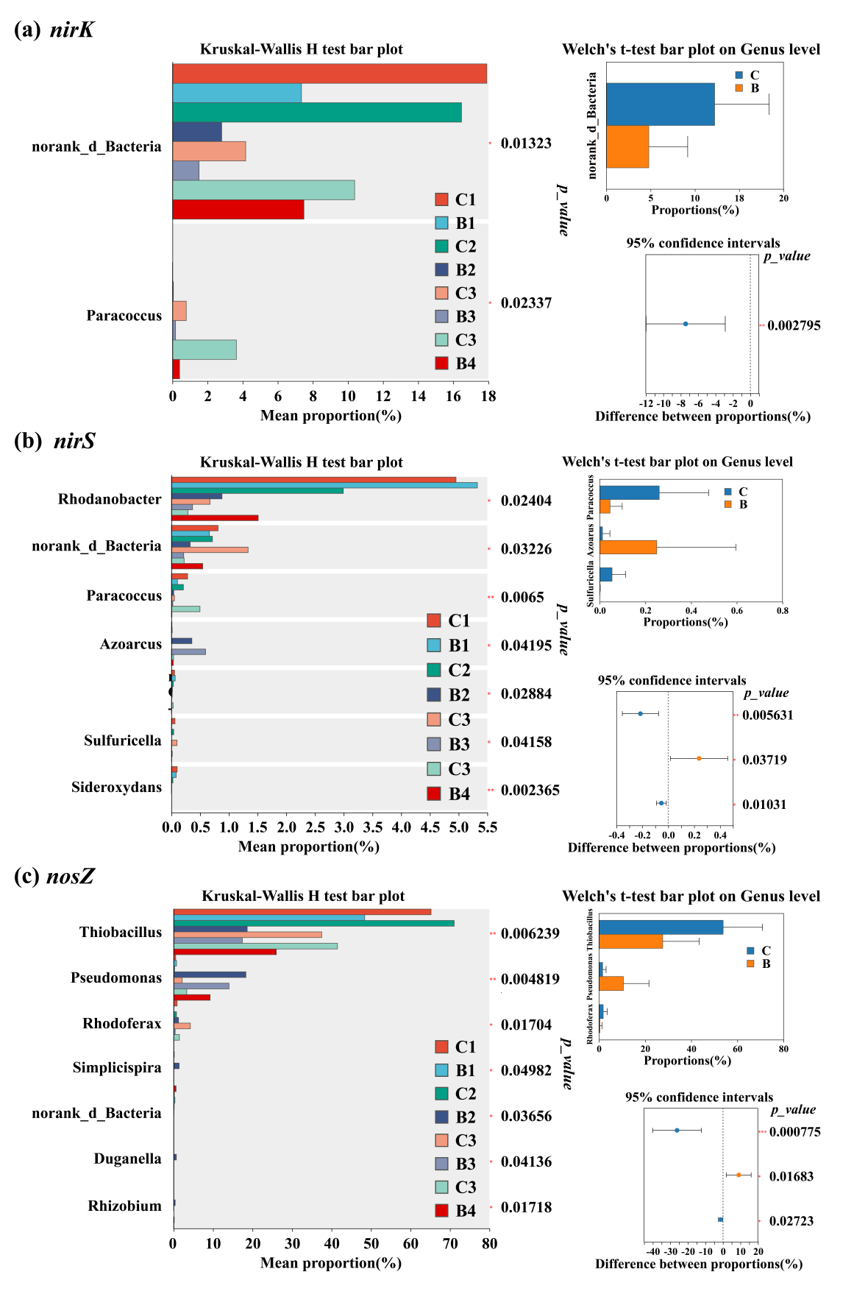
Fig. S2 Differences in the denitrification microbial community. The significant genera of the nirK (a), nirS (b) and nosZ (c) phyla under CK and biochar treatment in different depths as determined by Welch’s t-test at 95% confidence interval (P < 0.05, n = 3) , and the significant genera relative to CK and BC treatment with merged depths. C: CK of 0- 80 cm; B: Biochar amendment of 0-80 cm.
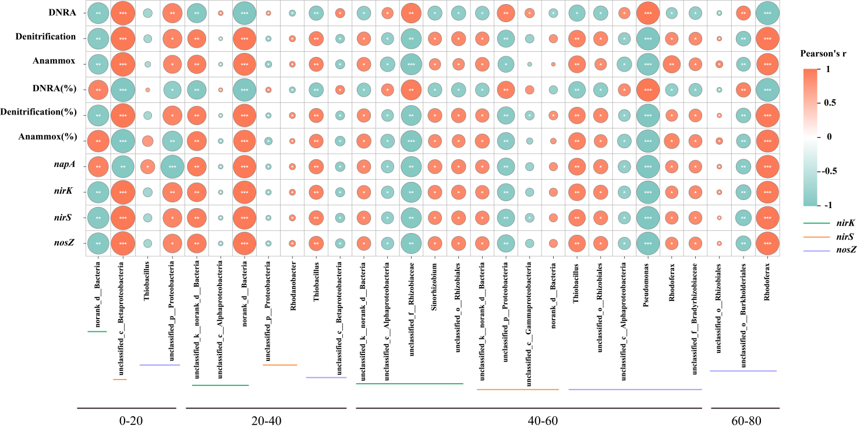

Fig. S3 Correlations between the relative abundance of keystone orders encoded by nirS, nirK and nosZ genes and N transformation rates [DNRA, denitrification, anammox rate, relative contribution (%) and related gene abundances] in different depths of paddy soil. The color gradient and square denote correlation coefficients. Statistical significance with significance levels represent the significance at P < 0.001 (***) , P < 0.01 (**), and P < 0.05 (*).
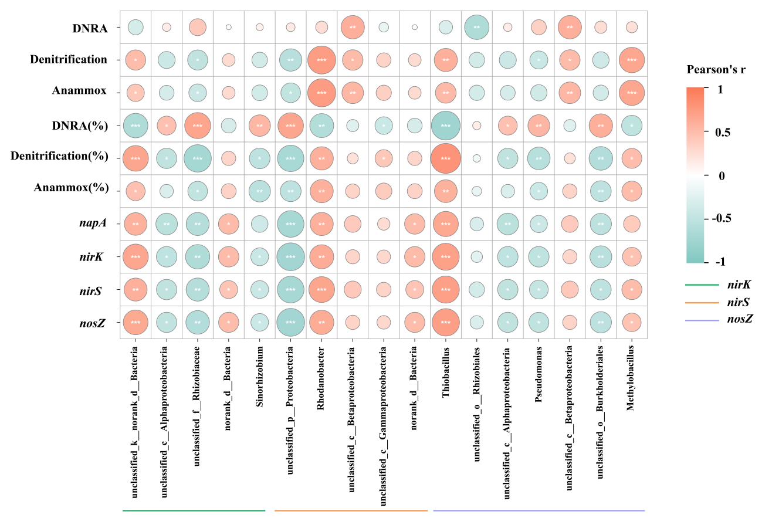

Fig. S4 Pearson’s correlations between the relative abundance of keystone orders encoded by nirS, nirK and nosZ genes and N transformation rates [DNRA, denitrification, anammox rate, relative contribution (%) and related gene abundances] in different depths combined (0-80 cm) of paddy soil. The color gradient and square denote Pearson’s correlation coefficients. Statistical significance with significance levels represent the significance at P < 0.001 (***) , P < 0.01 (**), and P < 0.05 (*).

Table S1 Basic properties of the biochar added in the field
Treatments | pH | EC (µs/cm) | C (%) | H (%) | molar H/C ratio | O  (%) | N (%) | Specific  surface area^{[a]}  (m²/g) | Total pore volume^{[b]}  (cm³/g) | Micropore volume^{[c]}  (cm³/g) | Mesopore volume^{[d]}  (cm³/g)
Biochar | 10.72 | 1067 | 50.07 | 0.88 | 0.018 | 7.17 | 0.43 | 226.30 | 0.12 | 0.07 | 0.04
ª Specific surface area calculated by BET method
^{b} Total pore volume at P/P₀=0.99
^{c} Micropore volume is calculated by using the t-plot method
^{d} Mesopore volume is calculated by subtracting the micropore volume from the total pore volume

Table S2 Calculations of denitrification, anammox and DNRA rates using slurry-based ¹⁵N tracer pairing technique and membrane inlet mass spectrometry (MIMS)
(1) | $$D_{30}=Y_{30}$$
(2) | $${\text{D}}_{\text{29}}\text{=2×}{\text{Y}}_{\text{30}}\text{×}{\text{F}}_{\text{N}}^{\text{-1}}\text{×(1-}{\text{F}}_{\text{N}}^{\text{-1}}\text{)}$$
(3) | $${\text{D}}_{\text{p}}\text{=}{\text{Y}}_{\text{30}}\text{×}{\text{F}}_{\text{N}}^{\text{-2}}$$
(4) | $${\text{A}}_{\text{p}}\text{=}{\text{Y}}_{\text{29}}\text{-}{\text{D}}_{\text{29}}\text{=}{\text{Y}}_{\text{29}}\text{-2×}{\text{Y}}_{\text{30}}\text{×(1-}{\text{F}}_{\text{N}}^{\text{-1}}\text{)×}{\text{F}}_{\text{N}}^{\text{-1}}$$
(5) | $$R_{DNRA}{=\left(C_{2}{−C}_{1}\right)×V×W}^{−1}{×T}^{−1}$$
For the above equations, D_{p} (nmol N g^{–1} h^{–1}) represents the potential denitrification rate; D₃₀ (nmol N g^{–1} h^{–1}) is the ³⁰N₂ production rate based denitrification during the incubation; D₂₉ (nmol N g^{–1} h^{–1}) is the ²⁹N₂ production rate based denitrification during the incubation; A_{p} (nmol N g^{–1} h^{–1}) represents the potential anammox rate; Y₂₉ (nmol N g^{–1} h^{–1}) and Y₃₀ represent (nmol N g^{–1} h^{–1}) represent the ²⁹N₂ and ³⁰N₂ production rates during the incubation, respectively. R_{DNRA} (nmol N g^{–1} h^{–1}) represents the potential DNRA rate; C₂ and C₁ are the concentrations of ¹⁵NH₄⁺ at the end and start of the slurry experiments, V is the volume of the vial, W is the dry weight of the soil, T is the incubation time.

Table S3 Primers and PCR conditions used in this study
Target gene | Primers | Primer sequence (5'-3') | PCR conditions | Reference
napA | 3F | CCCAATGCTCGCCACTG | 5 min of denaturation at 94 °C, 30 cycles of 30 s at 94 °C, 45 s of annealing at 60 °C, and 1.5 min of elongation at 72 °C | Smith Cindy et al. 2007
napA | 3R | CATGTTKGAGCCCCACAG |  | Smith Cindy et al. 2007
nirK | F_{1a}CuF | ATCATGGTSCTGCCGCG | 5 min of denaturation at 95 °C, 35 cycles of 30 s at 94 °C, 1 min of annealing at 51 °C, and 1 min of elongation at 72 °C | Throbäck et al. 2004
nirK | R₃CuR | GCCTCGATCAGGTTGTGGTT |  | Throbäck et al. 2004
nirS | cd3aF | GTSAACGTSAAGGARACSGG | 2 min of denaturation at 94 °C, 6 cycles of 30 s at 94 °C, 30 s of annealing at 57 °C, and 45 s of elongation at 72 °C; 30 cycles of 30 s at 94 °C, 30 s of annealing at 52 °C, and 45 s of elongation at 72 °C | Michotey et al. 2000
nirS | R3cd | GASTTCGGRTGSGTCTTGA |  | Michotey et al. 2000
nosZ | ZF | CGCRACGGCAASAAGGTSMSSGT | 10 min of denaturation at 95 °C, 50 cycles of 30 s at 95 °C, 15 s of annealing at 62 °C, and 30 s of elongation at 72 °C | Mohan et al. 2004
nosZ | ZR | CAKRTGCAKSGCRTGGCAGAA |  | Mohan et al. 2004

References
Smith Cindy J, Nedwell David B, Dong Liang F, Osborn AM (2007) Diversity and abundance of nitrate reductase genes (narG and napA), nitrite reductase genes (nirS and nrfA), and their transcripts in estuarine sediments. Appl Environ Microbiol 73:3612–3622. https://doi.org/10.1128/AEM.02894-06
Throbäck IN, Enwall K, Jarvis Å, Hallin S (2004) Reassessing PCR primers targeting nirS, nirK and nosZ genes for community surveys of denitrifying bacteria with DGGE. FEMS Microbiol Ecol 49:401–417. https://doi.org/10.1016/j.femsec.2004.04.011
Michotey V, Méjean V, Bonin P (2000) Comparison of methods for quantification of cytochrome cd1-denitrifying bacteria in environmental marine samples. Appl Environ Microbiol 66:1564–1571. https://doi.org/10.1128/AEM.66.4.1564-1571.2000
Mohan SB, Schmid M, Jetten M, Cole J (2004) Detection and widespread distribution of the nrfA gene encoding nitrite reduction to ammonia, a short circuit in the biological nitrogen cycle that competes with denitrification. FEMS Microbiol Ecol 49:433–443. https://doi.org/10.1016/j.femsec.2004.04.012

