Supplementary Information
for

Sorption and transport of Escherichia coli CN-13 in saturated sand columns amended with biochar derived from malt spent rootlets

Christos P. Giannopoulos ª, Christos A. Kolotouros ª, Ioannis D. Manariotis ª
ª Department of Civil Engineering, Environmental Engineering Laboratory, University of Patras, Patras 26504, Greece

Table S1. Parameter values and $r_{adj}^{2}$ of inactivation models fitted to observed data.
Inactivation model | Ionic strength, [KCl] | Parameters* |  |  | $$r_{adj}^{2}$$
First-order |  |  |  | $$k_{d}$$
First-order | 1 mM |  |  | 9.166·10⁻⁴ | 0.72
First-order | 150 mM |  |  | 7.272·10⁻³ | 0.75
Log-logistic |  | $$A$$ | $$σ$$ | $$τ$$
Log-logistic | 1 mM | 1000 | 303.913 | 9.461 | 0.80
Log-logistic | 150 mM | 1000 | 164.663 | 13.948 | 0.86
Modified Gompertz |  | $$A$$ | $$B$$ | $$T$$
Modified Gompertz | 1 mM | 1.165 | 1.771·10⁻³ | 0 | 0.73
Modified Gompertz | 150 mM | 1.166 | 1.002·10⁻² | 0 | 0.85
*Inactivation model formulations and parameter units are given in the manuscript

Table S2. Key fixed parameter values for 1D-ADE and 1D-BTE model simulations.
Column | C1 | C2 | C3
Biochar content (% w/w MSRB) | 0 | 5 | 10
Biochar content (% v/v MSRB) | 0 | 28.8 | 38.0
Column diameter (cm) | 1 | 1 | 1
Column height (cm) | 30 | 30 | 30
Flow rate (mL min⁻¹) | 1 | 1 | 1
Mixture bulk density (g cm⁻³) | 1.651 | 1.238 | 1.137
Mixture median particle size (μm)* | 505.0 | 381.2 | 341.6
Porosity (-) | 0.335 | 0.399 | 0.407
Straining function shape parameter, $β$ | 0.432 | 0.432 | 0.432
Pulse duration (min) | 41.080 | 48.932 | 49.868
Initial cell concentration (CFU mL⁻¹) | 1.05·10⁵ | 1.45·10⁵ | 1.01·10⁵
Weibull inactivation constant, $k_{d}$ (min^{-α}) | 0.02329 | 0.02329 | 0.02329
Weibull shape factor, $α$ | 0.52778 | 0.52778 | 0.52778
Mean pH value | 6.6 | 7.5 | 7.6
*Considering the volumetrically weighted average of the median particle sizes of sand ($d_{50}$ = 505 μm) and biochar ($d_{50}$ = 75 μm) for each mixture.

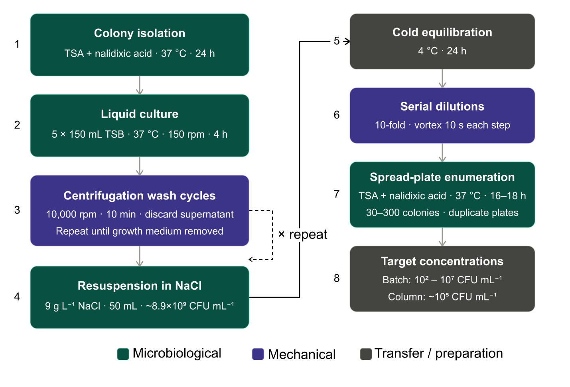
Figure S1. Schematic flow diagram of stepwise bacterial stock preparation, including isolation, cultivation, centrifugation, storage, and dilution, with additional operational parameters.

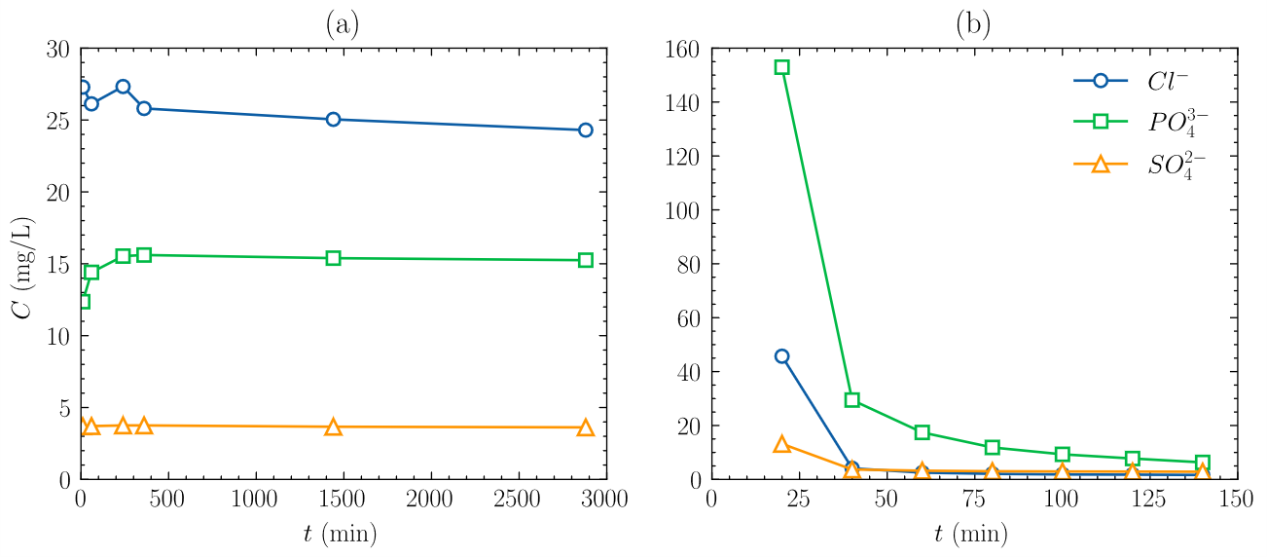
Figure S2. Measured Cl⁻, PO₄³⁻, and SO₄²⁻ anion concentration time series (a) throughout a batch experiment ([KCl] = 1 mM, Solution volume = 10 mL, MSRB mass = 10 mg) and (b) during washing prior to C2 column tracer experiment (MSRB content = 5% w/w, $Q =$ 1 mL/min).

