pH-regulated surface chemistry of nano-biochar for selective silver ion reduction: the pivotal role of superoxide radicals
Shiguo Gu ª, Dandan Wang ª, Tongtong Wang ^{b}, Wei Zhu ª*
ª College of Civil and Architecture Engineering, Chuzhou University, Chuzhou, 239000, China
^{b} Institute for Interdisciplinary and Innovation Research, Xi'an University of Architecture and Technology, Xi'an 710055, China
*Corresponding authors. wzhu@issas.ac.cn

Text S1. Modified Boehm titration
The Boehm titration methodology was utilized to classify acidic groups in biochar into carboxylic, lactonic, and phenolic acids. These acids exhibit specific interactions with different bases: NaHCO₃ neutralizes only carboxylic acid groups, Na₂CO₃ neutralizes mainly lactonic and carboxylic acid groups (excluding strong acids), and NaOH neutralizes all organic acids, e.g., phenolic, lactonic, and carboxylic acids (Boehm). A refined Boehm method was employed to quantify phenolic–OH content of biochar by exploiting the consumption differential between NaOH and Na₂CO₃ (Uchimiya et al., 2010). This involved dispersing 2.5 g of biochar in 250 mL of deionized water (10 g/L), adjusting the pH to 5.0 with 0.1 M HCl, stirring for 24 h, filtering through a 0.45-μm membrane, drying at 60°C for 24 h, and then mixing the dried sample with 20 mL of 0.1 M base solution (NaOH, Na₂CO₃, or NaHCO₃) to form a 10 g/L biochar suspension for another 24 h incubation. After incubation, the suspension was filtered (0.45-μm) again, and 20 mL of 0.1 M HCl were added to 10 mL of the filtrate, followed by titration with 0.1 M NaOH to determine the phenolic–OH content. A set of control experiments, replicating all previous conditions except for the absence of biochar, was also conducted.
Text S2: Electrochemical measurements of nano-BC
Electrochemical assays were conducted in 0.1 mol/L phosphate buffer (pH 7, KCl as supporting electrolyte, 9 mL) using a three-electrode system: a glassy carbon working electrode (3 mm diameter), a platinum spiral wire counter electrode, and an Ag/AgCl reference electrode saturated with 3 mol/L KCl. After equilibrating to the target redox potential, electron transfer capacities were assessed by adding 100 μL of either 10 mmol/L zwitterionic viologen 4,4'-bipyridinium-1,1'-bis(2-ethylsulfonate) (for reductive MER measurements) or 2,2'-azino-bis(3-ethylbenzothiazoline-6-sulfonic acid) diammonium salt (for oxidative MEO measurements). Following background current stabilization, 200 μL of nano-BC suspension (10 mg/L) was introduced, with electron accepting (EAC) and donating capacities (EDC) (mmol e-/g) determined by integrating the resulting current peaks, with all measurements performed in triplicate.
Text S3 SP-ICP-MS analysis
SP-ICP-MS analysis was performed in single-particle mode on the same instrument with the Syngistix Nano-Application module to quantify AgNPs formation and concentrations (Schwertfeger et al., 2017). Briefly, aqueous reaction aliquots were ultrasonicated (600 W) for 30 min, centrifuged at 6000 × g for 20 min to isolate AgNPs, and the resulting supernatant was filtered through a 0.22 μm nylon syringe filter (Millex Millipore) and 50-fold diluted with ultrapure water prior to SP-ICP-MS measurement (Schwertfeger et al., 2017).
Text S4 Determination of XTT formazan, TPA, and FFA
After 10 min of reaction of silver ions in different systems, 0.05 mM XTT, 1.00 mM TPA, and 0.45 mM FFA were added to the resulting reaction solution, respectively. This mixture solution was shaken for 24 h under dark condition. Subsequently, the mixture solution was centrifuged at 7000 (g) for 5 min to collect the supernatant fraction, and then filtered through a nylon organic membrane with 0.45 μm. Finally, the concentration of XTT formazan in the filtrate was measured using UV-visible spectroscopy (UV-1800, Shimadzu, Japan) at 475 nm. TPA stock solution was prepared in 2 mmol/L NaOH and filtered through a 0.45-μm membrane, and the initial concentration of TPA in dissolved BC solutions was adjusted to 0.5 mM. The TPA concentration was measured using an Agilent 1100 HPLC system equipped with a Zorbax Eclipse SB-C18 column (Agilent). For the HPLC analysis, the mobile phase comprised 30% acetonitrile and 70% of a solution containing 0.1 wt% phosphoric acid, while the detection wavelength was set at 254 nm. The residue concentration of FFA in the suspensions was quantified by HPLC at a wavelength of 220 nm, using a mixture of acetonitrile (30%) and 0.1 wt % phosphoric acid (70%). The steady-state concentration of ¹O₂ ([¹O₂]_{ss}) was calculated from the FFA degradation rate constant and the second-order rate constant for the reaction between ¹O₂ and FFA using Equation (1) (Li et al., 2019).
[¹O₂]_{ss} = k_{ex}/k_{FFA} (1)
where k_{ex} denotes the pseudo-first-order rate constant for FFA degradation, and k_{FFA} represents the bimolecular rate constant for the reaction of ¹O₂ with FFA.
The formation rate of ¹O₂ (R_{p}, M/s) was calculated using Equation (2), assuming that quenching by water constitutes the primary decay pathway of singlet oxygen, with k_{d} = 2.4 × 10⁵ s⁻¹.
R_{p} = [¹O₂]_{ss}*k_{d} (2)
The apparent quantum yield of ¹O₂ (Ф_{single oxygen}) was calculated from Equation 3 and 4:
Ф_{single oxygen} = R_{p}/R_{a} (3)
$R_{a}= R_{p,λ}^{0}(1-{10}^{\frac{A_{λ}}{t}z})/z$ (4)
Where R_{a}​ represents the light absorption rate (einsteins L⁻¹ s⁻¹), $R_{p,λ}^{0}$​ denotes the spectral photon irradiance (einsteins cm⁻² s⁻¹) at the solution surface, λ is the corresponding wavelength (nm), z stands for the solution depth (cm), A_{λ}​ is the solution absorbance determined by UV–Vis spectroscopy, and ι (cm) refers to the optical path length of the cuvette.
Text S5 EPR measurement for O₂^{·−}
For EPR detection of O₂^{·−}, DMPO was adopted as the spin-trapping reagent to capture O₂^{·−} produced in nano-BC aqueous suspensions. The reaction system consisted of 10 mg/L nano-BC and 100 mM DMPO, and the pH was tuned to target gradients (6.5–9.5) using dilute NaOH or HCl. After sampling, the mixture was manually shaken for 60 s and filtered through a 0.45 μm syringe filter. A 50 μL aliquot of the filtrate was transferred into an EPR capillary tube, with one end sealed using vacuum grease. The capillary was then placed into a standard EPR tube for spectrum recording. EPR spectra were recorded on an X‑band spectrometer with a microwave frequency of 9.85 GHz and microwave power of 1.92 mW. Detailed instrument settings were as follows: center field 3510 G, modulation amplitude 1.00 G, receiver gain 1.00 × 10³, sweep width 200 G, sweep time 30.72 s, and time constant 10.24 ms.

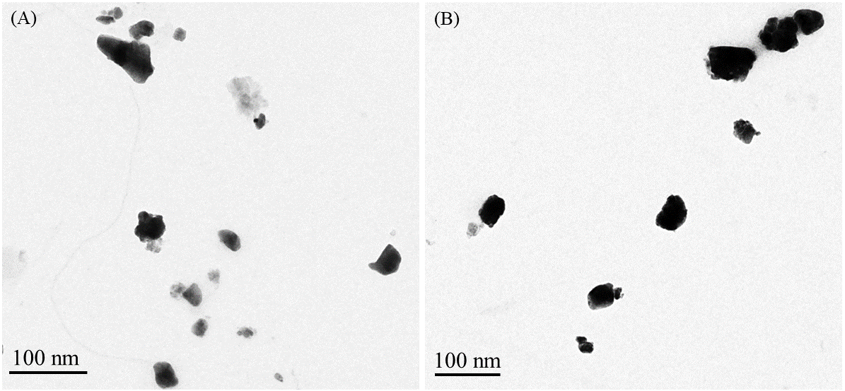
Fig. S1 Representative HR-TEM images of (a) nano400 and (b) nano700, respectively.
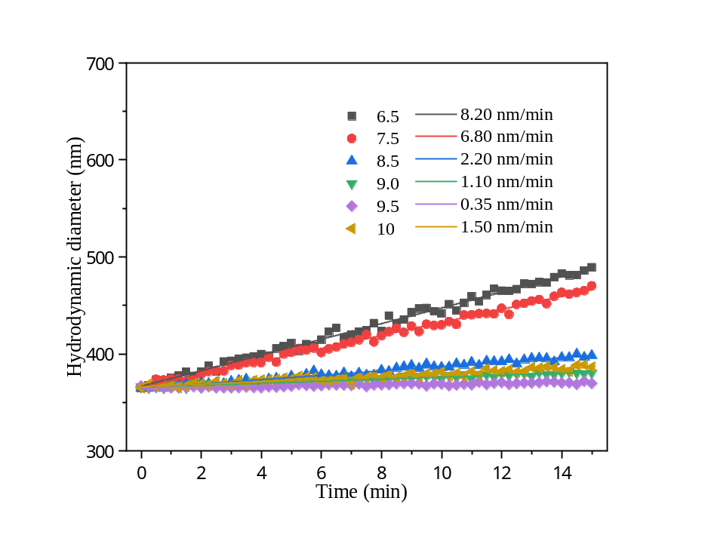
Fig. S2 Hydrodynamic diameter of nano400 (10 mg/L) under various pH conditions.

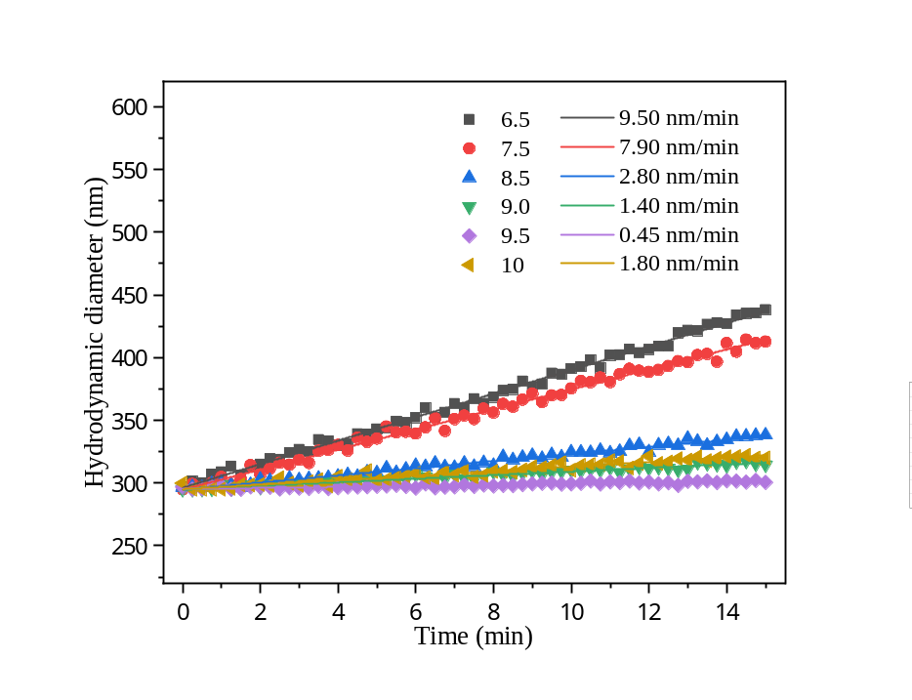
Fig. S3 Hydrodynamic diameter of nano700 (10 mg/L) under various pH conditions.

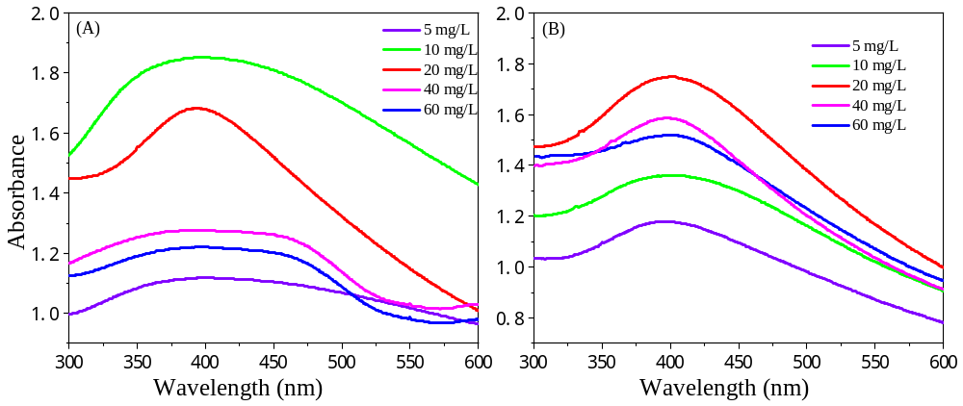
Fig. S4 Determination of AgNPs formation using UV-vis in the presence of nano400 (A) and nano700 (B) at varying concentrations, with a fixed Ag⁺ concentration of 0.5 mM and pH 9.5.

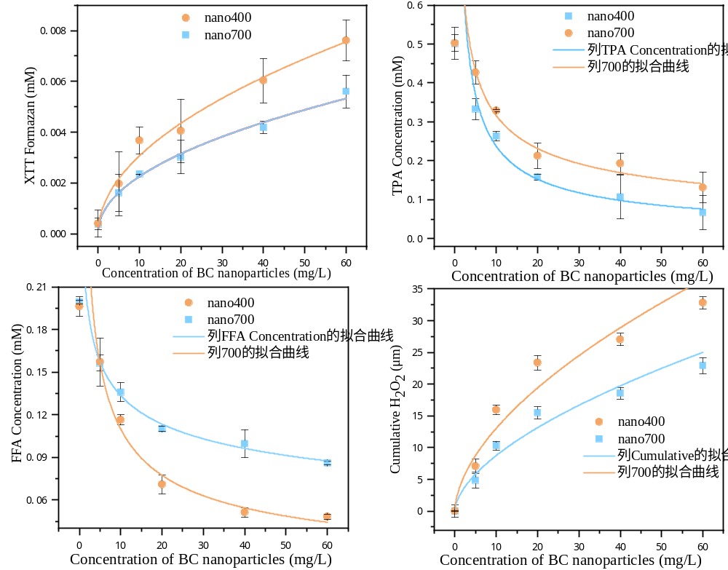
Fig. S5 Generations of O₂^{·−} by the production of XTT formazan in the suspensions of nano-BC under 0.5 mM Ag⁺ and pH 9.5 conditions.

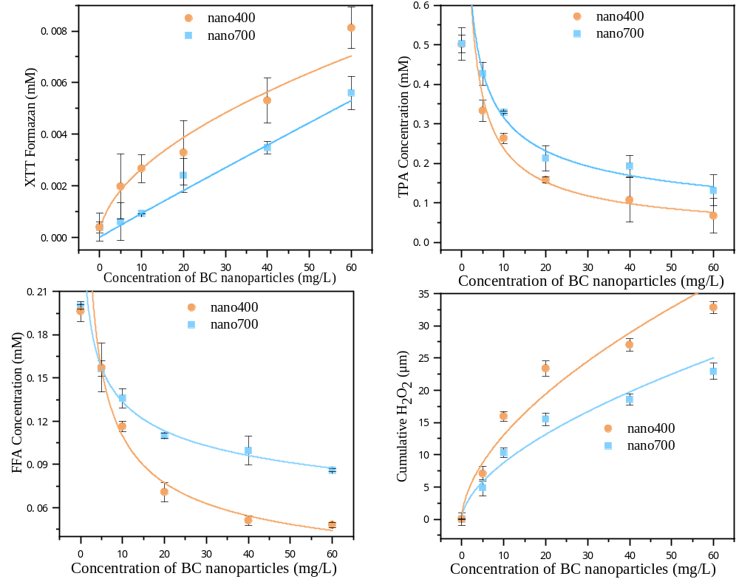
Fig. S6 Generations of ¹O₂ by the reduction of FFA formazan in the suspensions of nano-BC under 0.5 mM Ag⁺ and pH 9.5 conditions.

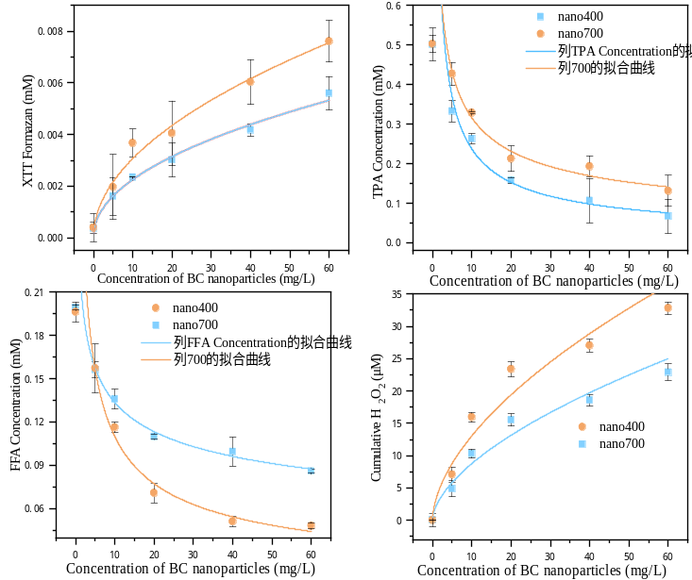
Fig. S7 Effect of concentration of nano-BC on cumulative H₂O₂ generation under 0.5 mM Ag⁺ and pH 9.5 conditions.

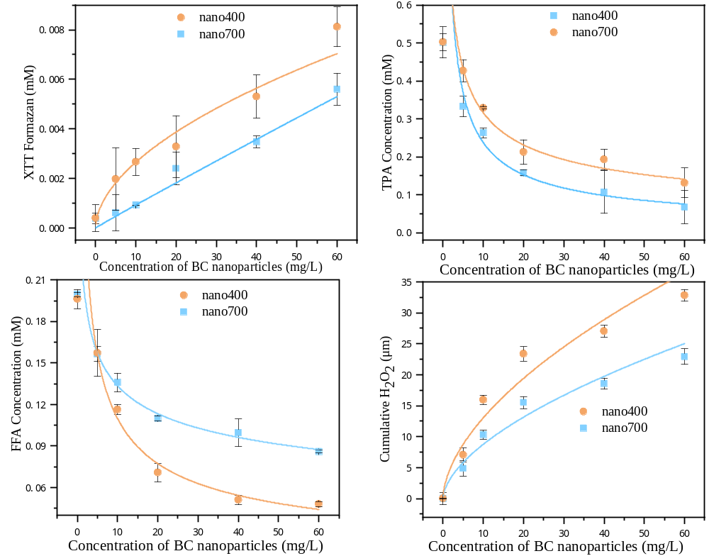
Fig. S8 Generations of •OH by the loss of TPA formazan in the suspensions of nano-BC under 0.5 mM Ag⁺ and pH 9.5 conditions.

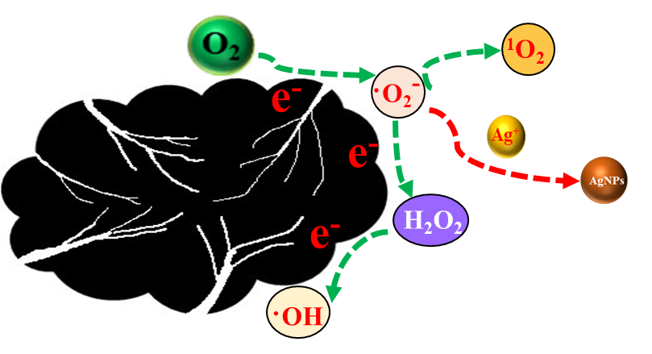
Fig. S9 ROS formation mechanism of Ag⁺ reduction to AgNPs in the presence of excess nano-BC

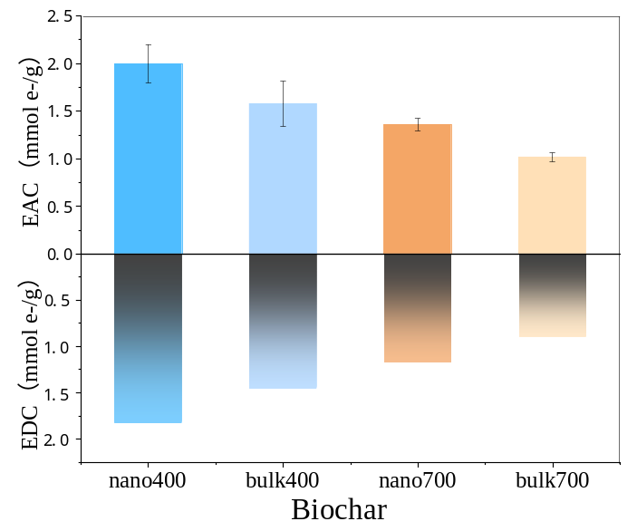
Fig. S10 Electron accepting and donating capacity (EAC and EDC) of nano-BCs and bulk-BCs derived from wood chips. Abbreviations: nano400: nano-sized biochar pyrolyzed at 400 °C; bulk400: bulk biochar pyrolyzed at 400 °C; nano700: nano-sized biochar pyrolyzed at 700 °C; bulk700: bulk biochar pyrolyzed at 700 °C. Different letters represent different statistical groups suggested by the Tukey-HSD multiple comparisons at P < 0.05.

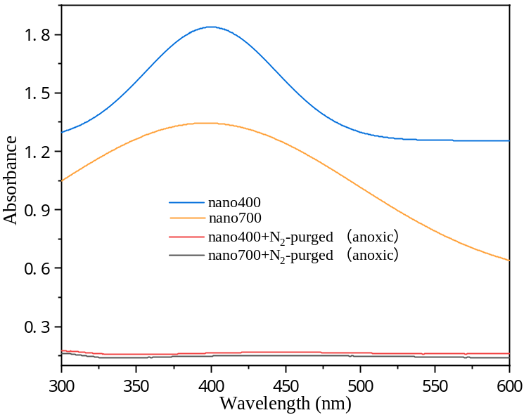
Fig. S11 UV-Vis absorption spectra of AgNPs synthesized by nano-BC (nano400 and nano700) under aerobic and anoxic (N₂-purged) conditions

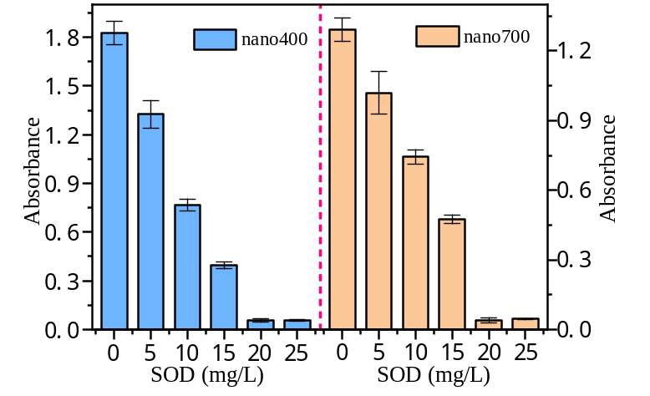
Fig. S12 UV–Vis spectra at 410 nm of AgNPs suspensions incubated with various SOD concentrations for 10 min, prepared via reduction of 0.5 mM Ag⁺ by 10 mg/L nano-BC at pH 9.5.

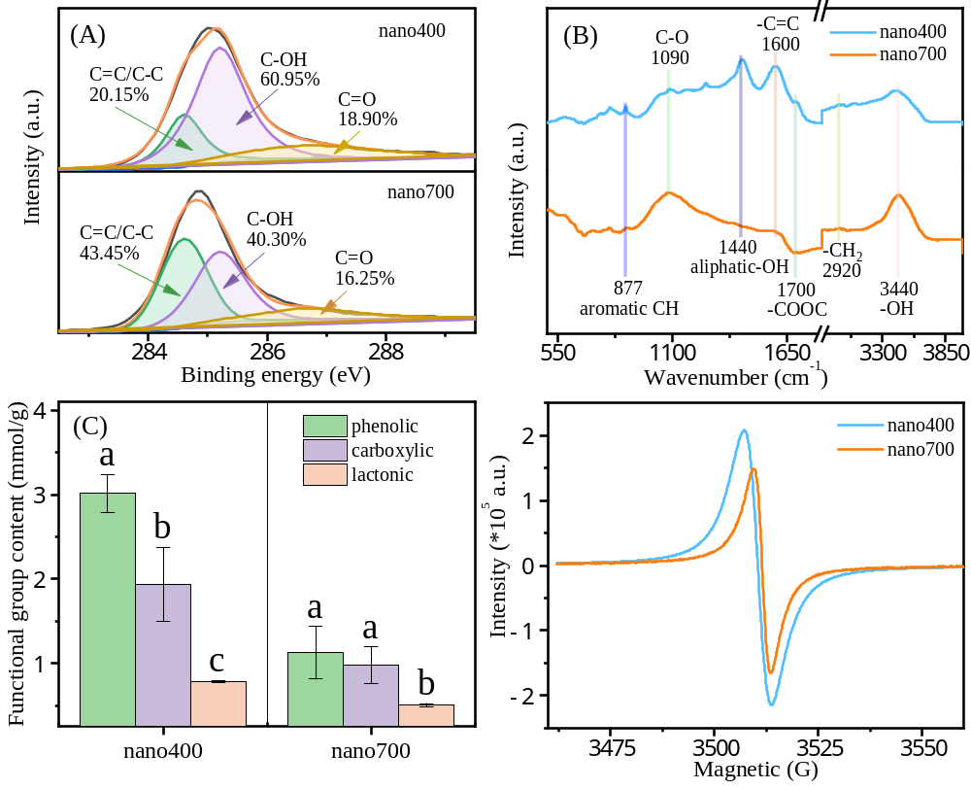
Fig. S13 EPR spectra of nano400 and nano700.

Table S1. Elemental composition, atomic ratio, and polar index of nano-BCs by elemental analysis (EA). Data were the average of triplicates.
Sample |  |  |  | EA
Sample | Ash (%) |  | C (wt%) |  | N (wt%) | H (wt%) | O (wt%) | S (wt%) | O/C | (O+N)/C
nano400 | 4.26 |  | 62.85 |  | 4.35 | 4.63 | 22.65 | 1.26 | 0.27 | 0.33
nano700 | 12.65 |  | 70.72 |  | 2.06 | 2.16 | 12.02 | 0.39 | 0.13 | 0.15

Table S2. Elemental composition, atomic ratio, and polar index of nano-BCs fractions by XPS.
Sample
 |  | C (wt%) | N (wt%) | O (wt%) | Si (wt%) | O/C | (O+N)/C
nano400 | 58.26 |  | 3.10 | 36.67 | 1.97 | 0.47 | 0.52
nano700 | 75.11 |  | 1.95 | 20.25 | 2.69 | 0.20 | 0.22

Table S3. EPR spectral characteristics of PFRs from nano-BCs.
sample | g-factor | Signal value of EPR (spins/g)
nano400 | 2.00213 | 2.30×10¹⁸
nano700 | 2.00271 | 2.80×10¹⁷

References
Boehm HP, Diehl E, Heck W, Sappok R (1964) Surface oxides of carbon. Angew Chem Int Ed Engl 3(10):669–677
Li M, Bao F, Zhang Y, Sheng H, Chen C, Zhao J (2019) Photochemical Aging of soot in the aqueous phase: release of dissolved black carbon and the formation of ¹O₂. Environ Sci Technol 53(21):12311–12319
Schwertfeger DM, Velicogna JR, Jesmer AH, Saatcioglu S, McShane H, Scroggins RP, Princz JI (2017) Extracting metallic nanoparticles from soils for quantitative analysis: Method development using engineered silver nanoparticles and SP-ICP-MS. Anal Chem 89:2505–2513
Uchimiya M, Lima IM, Thomas Klasson K, Chang S, Wartelle LH, Rodgers JE (2010) Immobilization of heavy metal ions (Cu^{II}, Cd^{II}, Ni^{II}, and Pb^{II}) by broiler litter-derived biochars in water and soil. J Agric Food Chem 58:5538–5544

