Application and prospect of artificial intelligence in biochar for acidic soil amelioration

Linyu Guo^{1,2}, Kewei Li ¹, Ren-kou Xu^{1,2}*

¹ State Key Laboratory of Soil and Sustainable Agriculture, Institute of Soil Science, Chinese Academy of Sciences, Nanjing, 211135 (China)
² College of Advanced Agricultural Sciences, University of Chinese Academy of Sciences, Beijing, 100049 (China)
*Corresponding author: rkxu@issas.ac.cn (R.K. Xu)

Literature Search Methods

Text S1.
This review was conducted following the he PRISMA 2020 guidelines (Page et al. 2021). To systematically review the advancement of biochar-mediated amelioration of acidic soils using artificial intelligence, we performed a literature search in the Web of Science Core Collection on January 12, 2026. The search strategy employed two Boolean keyword combinations: (1) (("biochar" OR "biocarbon" OR "black carbon") AND ("soil acid" OR "aluminum toxicity" OR "Al stress" OR "Al phytotoxicity" OR "soil pH") AND ("artificial intelligence" OR "machine learning" OR "deep learning" OR "random forest" OR "neural network" OR "support vector machine" OR "remote sensing" OR "proximal sensing" OR "spectroscop" OR "sensor")); and (2) ("biochar" OR "biocarbon") AND "Soil" AND ("artificial intelligence" OR "machine learning" OR "deep learning" OR "random forest" OR "neural network" OR "support vector machine" OR "remote sensing"). No additional filters (e.g., publication year or document type) were applied at this initial stage to maximize coverage. The retrieved records (n = 404) were exported to Zotero for duplicate removal. All screening steps were conducted by a single reviewer (L.Y. Guo), given the review’s scoping nature and the need for consistent qualitative coding across heterogeneous studies. To mitigate potential bias and ensure reproducibility, the following measures were implemented: 1) Pilot calibration: Before formal screening, 50 randomly selected records were screened twice by the same reviewer at a two-week interval, achieving a 94% intra-agreement rate, confirming criterion clarity. 2) Explicit criteria: Studies were included if they simultaneously reported (a) biochar application to soils, (b) a measured or modeled soil acidity-related variable (pH, Al stress), and (c) application of at least one AI/ML (Artificial intelligence/Machine Learning) algorithm. Excluded were non-English articles, conference abstracts, and review articles. 3) Adjudication protocol: Any ambiguous cases regarding inclusion/exclusion were flagged and resolved through discussion with the senior author (Professor RenKou Xu), who served as the final arbitrator. Through this systematic process, a total of 119 papers were finally identified as relevant and manually curated for detailed analysis. Fig. 4 shows our statistical results. By reading the "title", "abstract", and "method" section, we counted the frequency of use of AI algorithms in the literature, as Fig. 5 shown. For each valid result, we compiled annual publication records (Fig. 4d). For these frequency counts, if a primary study reported the application of multiple AI algorithms, each algorithm was counted independently to reflect its application prevalence at the model level.

Text S2.
To ensure thematic consistency with the central focus on acidic soil amelioration, the four application subdomains discussed below—crop yield prediction, heavy metal immobilization, SOC prediction, and greenhouse gas emission modeling—are all derived exclusively from studies within our reviewed literature that specifically address biochar effects under acidic soil conditions. To clarify the performance of different AI models across these application scenarios, we further categorized the retrieved results from the second Boolean search string according to prediction targets. Through careful examination of the titles, abstracts, and methods sections of the retrieved articles, we identified 77, 104, 90, and 55 studies related to crop yield prediction, heavy metal immobilization, SOC prediction, and greenhouse gas emission modeling, respectively. For each application scenario, we manually reviewed the Methods section of each eligible study on a paper‑by‑paper basis and recorded the frequency of each machine learning model used. The resulting model‑use frequencies across different application scenarios and prediction targets are summarized in Fig. S1 and Table 2.

Text S3.
In the meta‑analysis of Section 3.2 (Fig. 6), we re‑searched the literature based on the algorithms identified in Fig. 5. Based on the bibliographic database compiled from Text S1, we retrieved relevant studies and manually extracted the required statistical data from the Results and Methods sections of each eligible study. Specifically, we sequentially searched for the following pairwise comparisons: RF vs. ANN, DFNN vs. ANN, RF vs. SVR, ANN vs. SVR, ANN vs. GBM, ANN vs. kNN, and ANN vs. ANFIS. In addition, we also included comparisons between these machine learning algorithms and other modeling approaches, such as Response Surface Methodology (RSM) and Adaptive Neuro‑Fuzzy Inference System (ANFIS), where such comparisons were reported in the eligible studies. By reviewing the "Method" section of each study one by one, we determined whether R² and RMSE were used as performance indicators; only studies reporting both metrics were included. The number of studies included in each pairwise comparison is denoted by the n value in parentheses adjacent to each comparison in Fig. 6, representing the count of eligible studies that reported both R² and RMSE for that specific algorithm pairing.
It should be noted that the studies included in this meta‑analysis covered multiple target variables across different application scenarios, including soil pH improvement, soil organic carbon (SOC) prediction, crop yield prediction, heavy metal immobilization and greenhouse gas emission. Rather than conducting separate subgroup analyses for each scenario, we compiled all eligible studies into a unified meta‑analytic framework. This unified approach was chosen to: (i) evaluate the overall algorithmic performance trend across the entire acidic‑soil biochar literature, and (ii) increase the statistical power of the meta‑analysis given the limited number of studies available for each individual scenario. We acknowledge that this aggregation introduces heterogeneity in terms of target variables, datasets, and experimental designs—a limitation that must be considered when interpreting the pooled results in Fig. 6. We explicitly address this limitation in the section 3.2.
Meta-analyses were performed using MetaWin 2.1 software (Rosenberg et al. 2000). Given the anticipated heterogeneity among the primary studies in terms of target variables (e.g., SOC, crop yield, and heavy metal immobilization), experimental designs, and datasets, a random‑effects model was employed to calculate the mean effect size. The 95% confidence interval (CI) for each effect size was estimated via bootstrapping with 4999 iterations. Effect sizes were expressed as percentage changes and transformed using the formula (e^lnR – 1) × 100%, where R represents the ratio of performance metrics (e.g., R² or RMSE) between two algorithms. To determine statistical significance, we adopted the criterion that if the 95% CIs of two effect sizes did not overlap, the corresponding mean effect sizes were considered significantly different. For interpretation, in the RF‑vs‑ANN comparison shown in the left panel of Fig. 6, an effect value to the right of the zero line indicates that RF yields significantly higher R² (or RMSE) than ANN, whereas a value to the left indicates the opposite. All extracted data and calculation details are provided in the Supporting Information to ensure full transparency and reproducibility.

Dominant models and their applications

Text S4.
The rationale behind these algorithmic preferences aligns closely with the characteristics of the datasets in each domain. Soil pH improvement prediction and crop yield prediction data predominantly originate from field trials, characterized by limited sample sizes (tens to hundreds), moderate feature dimensionality, relatively high noise levels, and moderately complex nonlinear responses. RF’s consistent prevalence can be largely attributed to its robustness against overfitting, tolerance to outliers, and inherent feature importance ranking, which are particularly advantageous for the small‑to‑moderate sample sizes and nonlinearity commonly encountered in field and batch‑experiment datasets (Breiman 1996; Abbasi et al. 2025; Li et al. 2023). While NNs (Yue et al. 2018; Altikat et al. 2022) and SVMs (Wang et al. 2023a) can fit highly complex relationships, they risk overfitting on small datasets and require extensive hyper-parameter tuning. Demonstrating RF's adaptability, Jiao et al. (2025) coupled RF with random under sampling to address data imbalance, improving the recall for yield-reduction samples from 0.37 to 0.72. Soil acidification significantly influences heavy metal (HM) behavior by lowering pH, which increases HM solubility, mobilizes cationic metals (e.g., Cd²⁺, Pb²⁺, Cu²⁺) through competition with H⁺ for sorption sites, and alters the speciation of redox-sensitive elements such as As and Cr (Bradl 2004; Xu et al. 2016). Biochar application concurrently ameliorates acidity and immobilizes HMs through three synergistic mechanisms: (i) increased pH promotes HM precipitation as hydroxides or carbonates; (ii) surface oxygen-containing functional groups form stable inner-sphere complexes with HM cations; and (iii) enhanced soil negative charge facilitates electrostatic adsorption (Xu et al. 2003; Jiang et al. 2012; Guo et al. 2023). These mechanisms are modulated by metal properties (electronegativity, hydrolysis constant), biochar characteristics (feedstock, pyrolysis temperature, functional group density), and environmental conditions (pH, ionic strength, redox potential), rendering HM immobilization prediction inherently more complex than soil pH or crop yield forecasting (Guo et al. 2023). Consequently, HM immobilization studies primarily utilize batch experiment data, characterized by abundant sample sizes (hundreds to thousands), higher feature dimensionality (biochar physicochemical properties, solution conditions, metal speciation), strong multi-factor interactions, and severe nonlinearity. In HM immobilization studies, deep neural networks (DNNs) also appear with notable frequency alongside RF (Palansooriya et al. 2022; Du et al. 2024), reflecting the availability of larger batch‑experiment datasets that can support deep architectures. For SOC prediction, RF remains widely used in regional‑scale spatial mapping (Heuvelink et al. 2021; Sun et al. 2026), attributable to its robustness against collinearity, capacity to handle missing values, and natural adaptability to spatial interpolation (e.g., Regression Kriging). Xu et al. (2025) employed RF models to predict SOC dynamics following biochar application, achieving substantial improvements in test R². Greenhouse gas emission data frequently comprise temporal sequences (e.g., daily flux observations) with highly dynamic, multi-source emission patterns. While RF remains widely used for feature screening and key factor identification (Zhang et al. 2024), XGBoost (Wu et al. 2023) and DNNs often demonstrate superior predictive accuracy in capturing temporal fluctuations. Notably, Hamrani et al. (2020) found that Long Short-Term Memory (LSTM) networks achieved optimal performance when processing time-series daily flux data (R = 0.87). Notably, while hybrid model-fusion frameworks (e.g., physics-informed neural networks or multi-model stacking) have shown promise in other environmental domains, none of the studies included in our review have validated such approaches specifically in biochar–acidic soil systems. We therefore regard these fusion strategies as an open methodological gap rather than an established finding in the present context.

Figure S1.
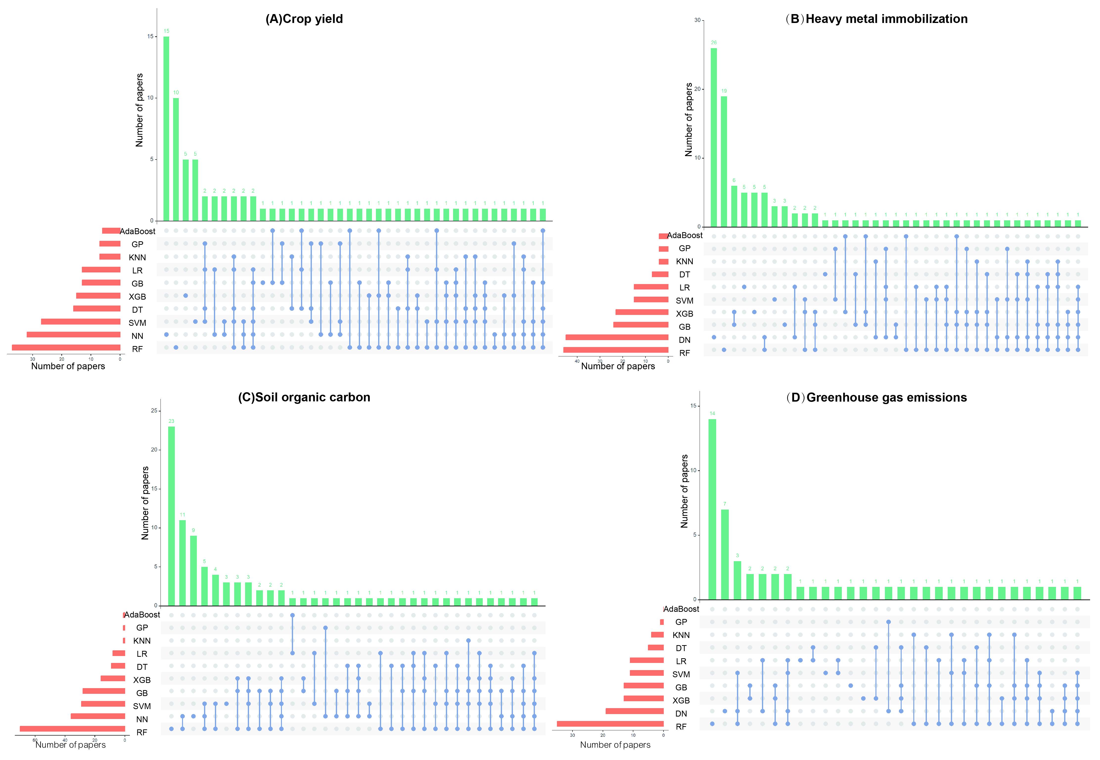
Fig. 6 Publications used AI for acidic soil remediation effect prediction: (A) Crop yield; (B) Heavy metal immobilization; (C) Soil organic carbon; (D) Greenhouse gas emissions. Bar chart on the left shows total publications for each algorithm. The dot chart below illustrates intersections between algorithms, with connecting lines indicating instances where two or more algorithms are applied together in a single study. Top bar chart displays number of publications associated with these algorithmic intersections. Abbreviations: Random Forest (RF), Neural Network (NN), Decision Network (DN), eXtreme Gradient Boosting (XGBoost, XGB), Gradient Boosting (GB), Support Vector Machine (SVM), Linear Regression (LR), Decision Tree (DT), k-Nearest Neighbor (KNN), Gaussian Process (GP), and Adaptive Boosting (AdaBoost). Data sourced from Web of Science 12 January 2026.

References
Abbasi M, Vaz P, Silva J, Martins P (2025) Machine learning approaches for predicting maize biomass yield: leveraging feature engineering and comprehensive data integration. Sustainability 17(1):256.
Altikat A, Alma MH, Altikat S (2022) A comparative study of deep learning neural network architectures and sensitivity analyses for the prediction of color changes in biochar. Int J Energy Res 46(15):20960–20974.
Bradl HB (2004) Adsorption of heavy metal ions on soils and soils constituents. J Colloid Interface Sci 277:1–18.
Breiman L (1996) Bagging predictors. Mach Learn 24(2):123–140.
Du ZL, Sun X, Zheng SN, Wang SY, Wu LN, An Y, Luo YM (2024) Optimal biochar selection for cadmium pollution remediation in Chinese agricultural soils via optimized machine learning. J Hazard Mater 476:135065.
Guo LY, Nkoh NJ, Xu RK (2023) A critical review of the interactions of organic carbon components with soil minerals: Insight from bibliometric analysis of the environmental behaviors of heavy metal(loid)s. J Soils Sediments 23:2396–2416.
Hamrani A, Akbarzadeh A, Madramootoo CA (2020) Machine learning for predicting greenhouse gas emissions from agricultural soils. Sci Total Environ 741:140338.
Heuvelink GBM, Angelini ME, Poggio L, Bai ZG, Batjes NH, van den Bosch R, Bossio D, Estella S, Lehmann J, Olmedo GF, Sanderman J (2021) Machine learning in space and time for modelling soil organic carbon change. Eur J Soil Sci 72(4):1607–1623.
Jiang J, Xu RK, Jiang TY, Li Z (2012) Immobilization of Cu(II), Pb(II) and Cd(II) by the addition of rice straw derived biochar to a simulated polluted Ultisol. J Hazard Mater 229–230:145–150.
Li HL, Ai ZJ, Yang LH, Zhang WJ, Yang ZQ, Peng HY, Leng LJ (2023) Machine learning assisted predicting and engineering specific surface area and total pore volume of biochar. Bioresour Technol 369:128417.
Palansooriya KN, Li J, Dissanayake PD, Suvarna M, Li LY, Yuan XZ, Sarkar B, Tsang DCW, Rinklebe J, Wang XN, Ok YS (2022) Prediction of soil heavy metal immobilization by biochar using machine learning. Environ Sci Technol 56(7):4187–4198.
Page MJ, McKenzie JE, Bossuyt PM, Boutron I, Hoffmann TC, Mulrow CD, Shamseer L, Tetzlaff JM, Akl EA, Brennan SE, Chou R, Glanville J, Grimshaw JM, Hróbjartsson A, Lalu MM, Li TJ, Loder EW, Mayo-Wilson E, McDonald S, McGuinness LA, Stewart LA, Thomas J, Tricco AC, Welch VA, Whiting P, Moher D (2021) The PRISMA 2020 statement: an updated guideline for reporting systematic reviews. BMJ 372:n71.
Rosenberg MS, Adams DC, Gurevitch J (2000) MetaWin-statistical Software for Meta-analysis. Sinauer Associates Inc., Sunderland. https://www.metawinsoft.com/
Sun X, Du ZL, Ding J, Zheng SN, Yao YP, Wu LN, Chen HG, An Y, Luo YM (2026) Machine learning integrated with a causal pathway framework unravels differential mechanisms of biochar-driven soil organic carbon dynamics under cadmium stress. Environ Sci Technol 60(3): 41556313.
Xu RK, Zhao AZ, Ji GL (2003) Effect of low-molecular-weight organic anions on surface charge of variable charge soils. J Colloid Interface Sci 264:322–326.
Xu ZC, Li MW, Zhou R, Xu GR (2025) Machine learning predicted crop yield and soil organic carbon variation after biochar application. Soil Use Manage 41(2):e70092.
Wang Y, Shi WJ, Wen TY (2023) Prediction of winter wheat yield and dry matter in North China Plain using machine learning algorithms for optimal water and nitrogen application. Agric Water Manage 277:108140.
Wu QG, Wang J, He Y, Liu Y, Jiang QJ (2023) Quantitative assessment and mitigation strategies of greenhouse gas emissions from rice fields in China: a data-driven approach based on machine learning and statistical modeling. Comput Electron Agric 210:107929.
Yue JB, Feng HK, Yang GJ, Li ZH (2018) A comparison of regression techniques for estimation of above-ground winter wheat biomass using near-surface spectroscopy. Remote Sens 10(1):66.
Zhang XY, Gu LP, Gui DY, Xu B, Li R, Chen X, Sha ZP, Pan XJ (2024) Suitable biochar application practices simultaneously alleviate N₂O and NH₃ emissions from arable soils: a meta-analysis study. Environ Res 242:117750.

