Supplementary Information
Title: Redox-active Mn loading enhances the electron-shuttling capacity of biochar to promote DNRA in paddy soil
Authors: Jiao Yuan^{a, b}, Dan Yuan^{a,} *, Xinhui Liu^{a, b}, Lin Ma^{a, c}, Chunsheng Hu ª, Shuping Qin ^{a,} *
ªKey Laboratory of Soil Ecology, Center for Agricultural Resources Research, Institute of Genetic and Developmental Biology, The Chinese Academy of Sciences, 286 Huaizhong Road, Shijiazhuang 050021, Hebei, China
^{b}University of Chinese Academy of Sciences, 19 A Yuquan Road, Shijingshan District, Beijing, 100049, China
^{c}State Key Laboratory of Pollution Control and Resource Reuse, School of the Environment, Nanjing University, Nanjing 210023, Jiangsu, China
* Corresponding author; Email: qinshuping@sjziam.ac.cn; Tel.: +86-591-8639 8509
Email: yuandan@ms.sjziam.ac.cn; qinshuping@sjziam.ac.cn;
Tel.: +86-591-8639 8509

Number of pages: 18
Number of Tables: 6
Number of Text: 4
Number of Figures: 6

Table S1 PCR primers for DNRA- and denitrification-related functional genes
Gene | Primer sequence
nrfA | 5’-CART GYC AYG TBG ART A-3’
nrfA | 5’-TWN GGC ATR TGR CAR TC-3’
narG | TAYGTSGGGCAGGARAAACTG
narG | CGTAGAAGAAGCTGGTGCTGTT
nirK | ATCATGGTSCTGCCGCG
nirK | GCCTCGATCAGRTTGTGGTT
nirS | TACCACCCSGARCCGCGCGT
nirS | GCCGCCGTCRTGVAGGAA
nosZ-Ⅰ | CGYTGTTCMTCGACAGCCAG  CGSACCTTSTTGCCSTYGCG
nosZ-Ⅱ | CTIGGICCIYTKCAYAC
nosZ-Ⅱ | GCIGARCARAAITCBGTRC

Table S2 Genomic DNA removal reaction of Real-Time PCR
Component | Volume (μ l)
5×gDNA Eraser Buffer | 2.0
gDNA Eraser | 1.0
Total RNA | 1.0
RNase Free H₂O | Up to 10

Table S3 Reverse Transcription reaction of Real-Time PCR
Component | Volume (μL)
Step 1 Reaction | 10.0
PrimeScript RT Enzyme Mix Ⅰ | 1.0
RT Primer Mix | 1.0
5×PrimeScript Buffer 2 | 4.0
RNase Free H₂O | 4.0
Total | 20

Table S4 The specific capacitance, electron exchange capacity (EEC), Mn content and reductive state Mn content of the original biochar washed by DI water (BC) and the Mn-loaded biochars with varying Mn contents (1MnBC, 2MnBC, 4MnBC and 6MnBC). BC represents the original biochar washed by DI water. 1MnBC, 2MnBC, 4MnBC and 6MnBC represent different treatments with biochars pretreated by 0.1, 0.2, 0.4, 0.6, and 0.8 M MnSO₄·H₂O solutions, respectively.
Biochars/Treatments | DNRA rates | Proportion of DNRA | Mn content | Reductive state Mn | Specific capacitance | EEC
 | mg kg⁻¹ d⁻¹ | % | atom % | % | F g⁻¹ | μmol e⁻ g⁻¹
BC | 0.46±0.001e | 12.2±0.3e | 0.07 | 66.92 | 2.66±0.01e | 363.95
1MnBC | 0.69±0.1d | 18.4±2.8d | 12.35 | 67.29 | 4.31±0.03d | 527.60
2MnBC | 0.92±0.07c | 24.1±1.3c | 18.17 | 78.15 | 6.47±0.01c | 649.17
4MnBC | 1.03±0.01b | 26.9±0.9b | 20.46 | 80.47 | 7.44±0.01b | 733.36
6MnBC | 1.1±0.001a | 27.9±0.5a | 21.23 | 82.62 | 8.40±0.02a | 801.57
Different letters within the same column indicate significant differences among treatments at P < 0.05;
Means ± Standard deviation (n = 3)

Table S5 The concentration of total Mn at the beginning and end of the incubation in in Experiment 1. The data are means ± standard deviation (n = 3).
Treatments | The total Mn concent
 | mg kg⁻¹
CK | 3.84±0.83a
BC | 3.05±0.22a
MnBC | 3.5±0.94a

Table S6 Summary of linear regression statistics for the relationships presented in Figs. 2 and 5.
Figure | Relationship | R² | Exact P
Fig.2d | Total Mn vs EEC | 0.92 | 0.0066
Fig.2d | Total Mn vs Specific capacitance | 0.88 | 0.0120
Fig.2e | Surface Mn vs EEC | 0.80 | 0.0260
Fig.2e | Surface Mn vs Specific capacitance | 0.71 | 0.0460
Fig.2f | Reduced Mn fraction vs EEC | 0.85 | 0.0170
Fig.2f | Reduced Mn fraction vs Specific capacitance | 0.92 | 0.0066
Fig.5e | EEC vs DNRA rate | 0.994 | 1.65045E-4
Fig.5e | EEC vs DNRA proportion | 0.995 | <0.0001
Fig.5f | Specific capacitance vs DNRA rate | 0.990 | 2.71495E-4
Fig.5f | Specific capacitance vs DNRA proportion | 0.994 | 1.18768E-4

Text S1 ^{15N} tracer analysis
In Experiment 1, a ¹⁵N labeling technique was employed to track nitrogen transformations during soil incubation. After the addition of K¹⁵NO₃, 14 mL of headspace gas and 5 mL of soil extract were collected from each flask both at the initiation and termination of the incubation. The isotopic composition of N₂O was quantified using ion currents at m/z 44, 45, and 46, corresponding to ⁴⁴N₂O, ⁴⁵N₂O, and ⁴⁶N₂O, respectively (Morley et al., 2008). Total N₂ production was determined based on ion currents at m/z 28, 29, and 30, representing ²⁸N₂, ²⁹N₂, and ³⁰N₂ (Nicholls et al., 2007). Prior to incubation, flask headspaces were flushed with N₂-free helium, and the absence of residual N₂ was verified, minimizing interference from background atmospheric N₂. The isotopic compositions of NH₄⁺ and NO₃⁻ in soil extracts were determined by sequential steam distillation. Ammonium was first recovered following MgO addition, whereas nitrate was subsequently reduced to ammonium using Devarda’s alloy during a second distillation step (Bremner and Keeney, 1966). The released ammonia was trapped in boric acid, acidified, and converted to (NH₄)₂SO₄ using 0.02 M H₂SO₄. Samples were evaporated to dryness at 80 °C, and the ¹⁵N abundances of NH₄⁺ and NO₃⁻ were analyzed using an elemental analyzer (Sercon SL) coupled to an isotope ratio mass spectrometer (20–20 IRMS; Sercon Ltd., Crewe, UK) (Zhu et al., 2014).

Text S2. Calculation of ¹⁵N Distribution Among Nitrate Transformation Products
- Experimental Design
A ¹⁵N tracer experiment was conducted to evaluate the fate of nitrate-derived N during incubation. All treatments received K¹⁵NO₃ at a rate of 100 mg ¹⁵N kg⁻¹ dry soil with 98 atom% ¹⁵N enrichment. The ¹⁵N atom percentages of NO₃⁻–N and NH₄⁺–N were determined at the beginning and end of incubation, while the abundances of ²⁹N₂ and ³⁰N₂ in the headspace were measured at the end of incubation.
The natural abundance of ¹⁵N was assumed to be:
Fₙₐₜ = 0.003663
where F represents the atom fraction of ¹⁵N.
- Quantification of ¹⁵N Remaining in the NO₃⁻ Pool
The amount of ¹⁵N remaining in the nitrate pool was calculated as:
¹⁵N(NO₃⁻) = C(NO₃⁻) × F(NO₃⁻)
where C(NO₃⁻) is the NO₃⁻–N concentration (mg N kg⁻¹ dry soil) and F(NO₃⁻) is the measured ¹⁵N atom fraction of the nitrate pool.
The net disappearance of labeled nitrate during incubation was calculated as:
Δ¹⁵N(NO₃⁻) = ¹⁵N(NO₃⁻)_{initial} − ¹⁵N(NO₃⁻)_{final}
where “initial” and “final” denote the beginning and end of incubation, respectively.
- Quantification of Nitrate-Derived ¹⁵N Associated with the NH₄⁺ Pool
The amount of excess ¹⁵N associated with the NH₄⁺ pool at the end of incubation was calculated as:
¹⁵N(NH₄⁺)_{excess} = C(NH₄⁺)_{final} × [F(NH₄⁺)_{final} − Fₙₐₜ]
where C(NH₄⁺)_{final} is the NH₄⁺–N concentration at the end of incubation and F(NH₄⁺)_{final} is the corresponding measured ¹⁵N atom fraction.
Because K¹⁵NO₃ was the sole isotopically labeled N source added to the system, excess ¹⁵N detected in the NH₄⁺ pool is consistent with the reduction of nitrate-derived N to NH₄⁺. However, this value represents net accumulation of nitrate-derived ¹⁵N within the NH₄⁺ pool rather than gross DNRA, as NH₄⁺ production, microbial assimilation, immobilization, and dilution by unlabeled mineralized N may occur simultaneously during incubation.
- Quantification of Nitrate-Derived N Recovered as N₂
The atom fraction of ¹⁵N in the N₂ pool was calculated from the measured abundances of ²⁸N₂, ²⁹N₂, and ³⁰N₂:
F(N₂) = [C(²⁹N₂) + 2 × C(³⁰N₂)] / [2 × (C(²⁸N₂) + C(²⁹N₂) + C(³⁰N₂))]
where C(²⁸N₂), C(²⁹N₂), and C(³⁰N₂) represent the concentrations of the corresponding N₂ isotopologues.
The amount of nitrate-derived N recovered as N₂ was estimated as:
N₂–Nderived from nitrate = C(N₂) × [F(N₂) − Fₙₐₜ] / [F(NO₃⁻)_{initial} − Fₙₐₜ]
where C(N₂) is the total N₂ concentration and F(NO₃⁻)_{initial} is the initial ¹⁵N atom fraction of the nitrate pool.
- Partitioning of Nitrate-Derived ¹⁵N
The disappearance of labeled nitrate was partitioned among three operational pools:
Δ¹⁵N(NO₃⁻) = ¹⁵N(NH₄⁺)_{excess} + ¹⁵N(N₂) + ¹⁵N(other)
where:
- ¹⁵N(NH₄⁺)excess represents nitrate-derived ¹⁵N associated with the NH₄⁺ pool;
- ¹⁵N(N₂) represents nitrate-derived N recovered as N₂;
- ¹⁵N(other) represents nitrate-derived N incorporated into other unmeasured pools, including microbial biomass, organic N fractions, dissolved organic N, and other transformation products.
The amount of ¹⁵N in the “other” pool was calculated by difference:
¹⁵N(other) = Δ¹⁵N(NO₃⁻) − ¹⁵N(NH₄⁺)_{excess} − ¹⁵N(N₂)
- Relative Distribution of Nitrate-Derived N
The contribution of each pool was expressed as a percentage of the total disappearance of labeled nitrate:
Contribution (%) = Npool / Δ¹⁵N(NO₃⁻) × 100
where Npool represents nitrate-derived N associated with NH₄⁺, recovered as N₂, or allocated to other pools.

Text S3 Calculation of Cumulative Amounts of N₂O and N₂
At each time point, headspace gas concentrations (ppm) were converted to the mass of gas emitted per unit mass of soil:
C = (c × V_{headspace} × M) / (V_{m} × m_{soil})
Where:
c is N₂O or N₂ concentration in ppm;
M = 28, the N molecular mass in N₂O to report N₂O-N (g mol⁻¹);
V_{headspace} = headspace volume (L);
V_{m} = 24.5, molar volume of gas in 25°C and 1.01$\text{×}$10⁵ Pa (L mol⁻¹);
m_{soil} = soil dry mass in the bottle (kg);
Cumulative amounts were corrected by:
Zero-time correction (subtracting the t = 0 amount; N₂ typically < 20 ppm)

Text S4 RNA Extraction, cDNA Synthesis, and qPCR Quantification
- Total RNA was extracted from soil samples using the Magen Soil RNA Extraction Kit (R4183-03, Magen, China) following the manufacturer’s protocol. RNA concentration and purity were determined using a NanoDrop 2000 spectrophotometer, and RNA integrity was verified by agarose gel electrophoresis.
- DNase treatment was included during cDNA synthesis using the HiScript II 1st Strand cDNA Synthesis Kit (R211-01, Vazyme, China) to remove genomic DNA contamination. The synthesized cDNA was diluted to 5–30 ng µL⁻¹ and used as the template for qPCR.
- qPCR analyses were performed with ChamQ SYBR Color qPCR Master Mix (High ROX Premixed, Q441-02, Vazyme, China) on a QuantStudio 3 Real-Time PCR System (Thermo Fisher Scientific, USA). The reaction setup and cycling conditions are summarized in Tables S2 and S3.
- Gene transcription levels of denitrification-related functional genes were quantified using the standard curve method, and primer amplification efficiencies (E values) were calculated from the slopes of the standard curves for each primer pair. All qPCR reactions were conducted in triplicate, and the CK treatment served as the RT control.

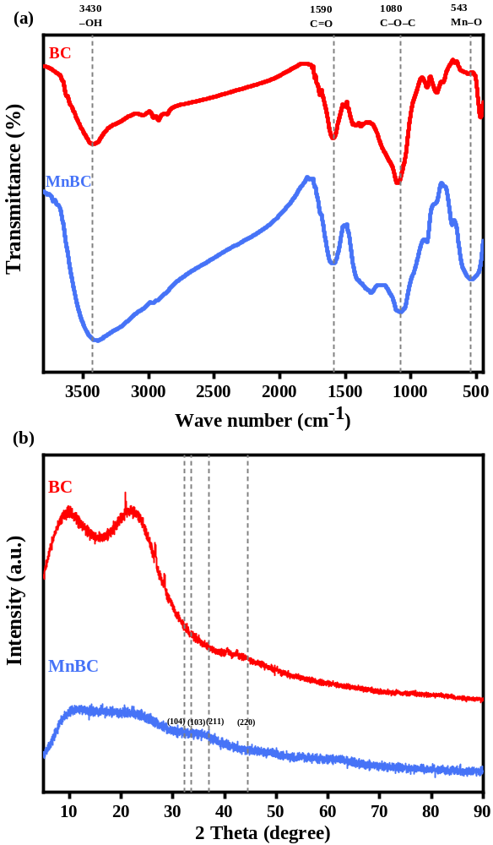
Fig. S1 XRD patterns (a) and FTIR spectra (b) of BC and MnBC. BC and MnBC represent the original biochar washed with DI water and Fe-loaded biochar, respectively.

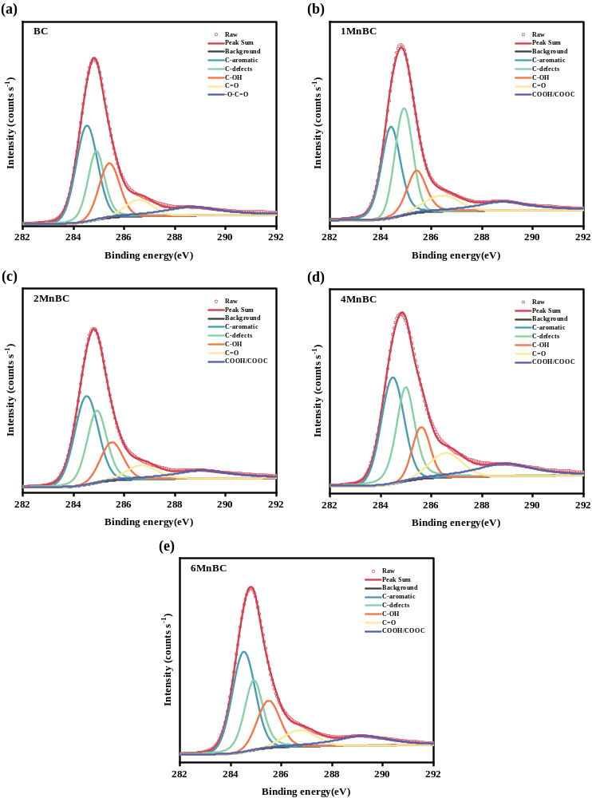
Fig. S2 C 1s binding state levels of XPS results of BC with diﬀerent Mn impregnation mass ratios: (a) BC, (b) 1MnBC, (c) 2MnBC, (d) 4MnBC and (e) 6MnBC. BC represents the original biochar addition treatment. 1MnBC, 2MnBC, 4MnBC and 6MnBC represent different treatments with biochars pretreated by 0.1, 0.2, 0.4 and 0.6 M MnSO₄·H₂O solutions, respectively.
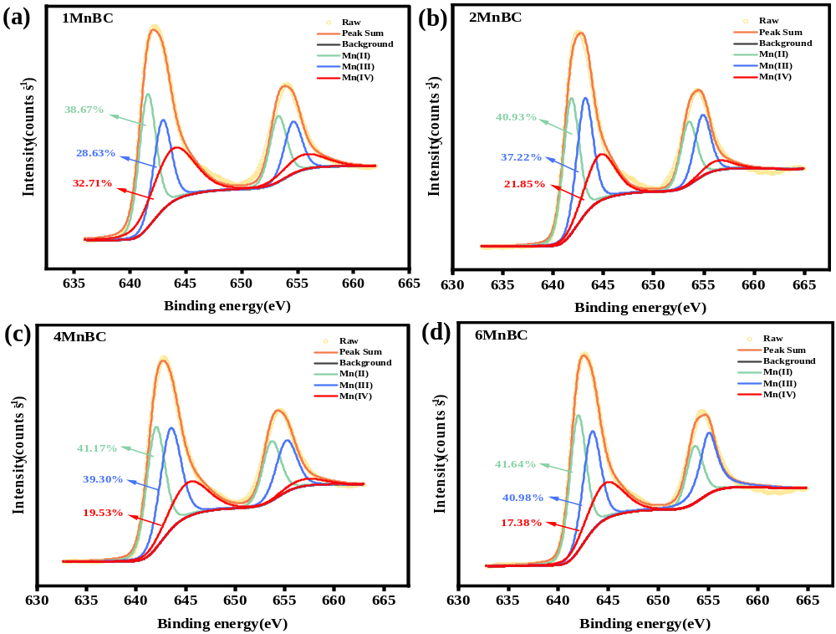
Fig. S3 Mn 2p XPS spectra of biochars with different Fe impregnation mass ratios: (a) 1MnBC, (b) 2MnBC, (c) 4MnBC and (d) 6MnBC. 1MnBC, 2MnBC, 4MnBC and 6MnBC represent different treatments with biochars pretreated by 0.1, 0.2, 0.4 and 0.6 M MnSO₄·H₂O solutions, respectively.

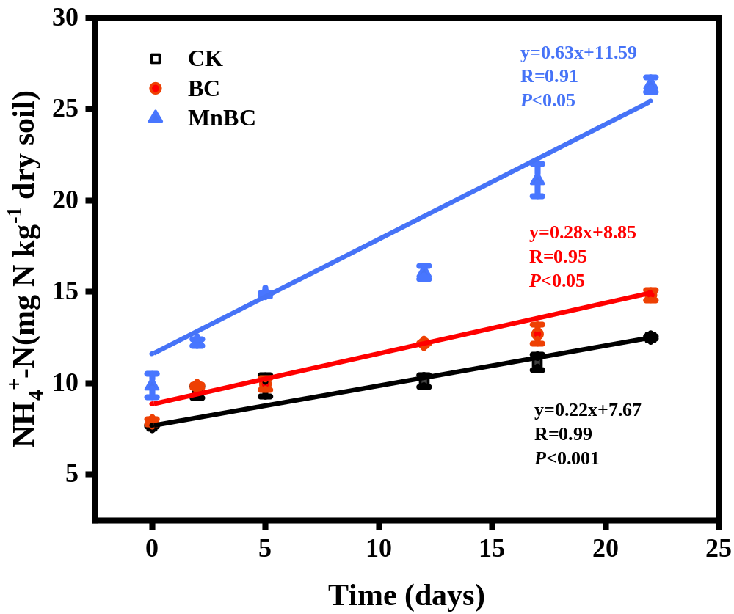Fig. S4 The production rate of NH₄⁺-N concentration (DNRA reaction rate) during the incubation in Experiment 1. Error bars represent the standard deviation (n=3). Control represents the control with only paddy soil; biochar represents the biochar added treatment.

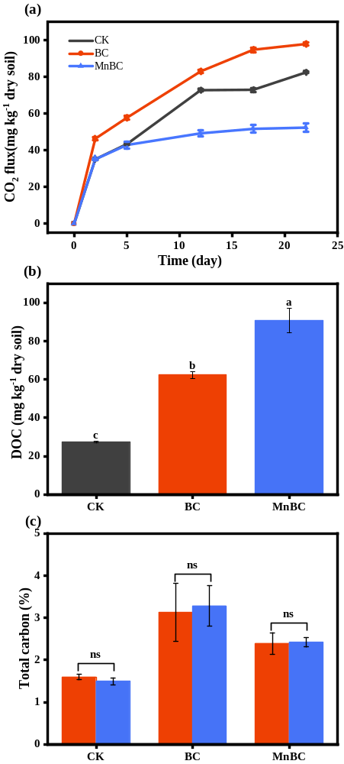
Fig. S5 Soil headspace concentrations of CO₂ over time (a), dissolved organic carbon (DOC) concentrations at the end of incubation (b), and total carbon (TC) contents at the beginning and end of the incubation (c) in Experiment 1. Error bars represent the standard deviation (n = 3). “ns” indicates no significant difference between initial and final TC contents within each treatment (P > 0.05). CK, BC, and MnBC represent the control (no biochar), pristine biochar, and Mn-loaded biochar treatments, respectively. 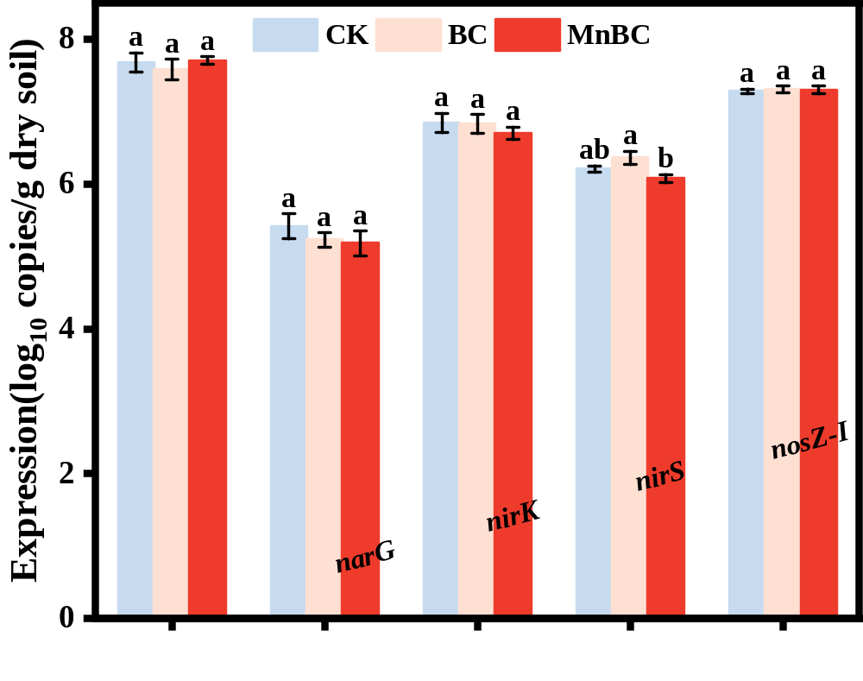
Fig. S6. Relative transcription levels of the denitrification-related functional narG (a), nirK (b), nirS (c), nosZ-I (d), and nosZ-II (e) under CK, BC, and MnBC treatments at the end of incubation (Experiment 1). Values are means ± SE (n = 3). Different lowercase letters indicate significant differences among treatments within each gene according to one-way ANOVA followed by Tukey’s HSD test (P < 0.05).

