Supporting Information
for
Synergetic Effect of Cross-linking and Interfacial Interaction in Carbon Fiber Reinforced Thermoplastic to Enhance its Tensile Strength by Electron-Beam Irradiation

Soonyoung Jung^{1,2}, Se kye Park^{1,3}, Han-do Ghim², Dong Yun Lee³ and Seung Hwa Yoo¹∗
¹Daegyeong Regional Division, Korea Institute of Industrial Technology, 59 Yangho-gil, Yeongcheon-si, Gyeongsangbuk-do, 38822, Republic of Korea
²Department of Advanced Organic Materials Science and Engineering, Kyungpook National University, Daegu, Republic of Korea
³Department of Polymer Science and Engineering, Kyungpook National University, Daegu, Republic of Korea
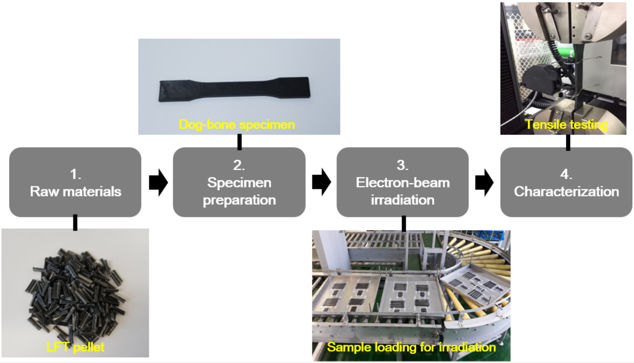
Figure S1. Experimental scheme of this work with representative photos for each step.

Table S1. Mechanical properties of HDPE, CF and HDPE_LFT irradiated at various electron-beam doses.
 |  | HDPE |  |  | CF |  |  | HDPE_LFT
 |  | TS (MPa) | YM (MPa) | SF (%) | TS (GPa) | YM (GPa) | SF (%) | TS (MPa) | YM (MPa) | SF (%)
Dose (kGy) | 0 | 23.3±0.2 | 1450±49 | 103.7±51.7 | 4.13±0.75 | 241.8±7.4 | 1.8±0.3 | 134±1 | 17500±622 | 1.8±0.1
Dose (kGy) | 400 | 24.6±0.1 | 1420±61 | 98.8±11.2 | 4.08±0.74 | 249.4±7.2 | 1.8±0.3 | 156±4 | 18000±778 | 1.9±0.1
Dose (kGy) | 1200 | 25.9±0.1 | 1480±200 | 75.3±5.0 | 4.07±0.62 | 255.8±9.1 | 1.7±0.2 | 167±3 | 18000±632 | 1.8±0.1
Dose (kGy) | 2000 | 27.3±0.5 | 1510±99 | 52.4±5.0 | 4.24±0.72 | 256.2±13.9 | 1.8±0.3 | 172±4 | 17600±634 | 1.8±0.1
*TS: tensile strength, YM: Young’s modulus, SF: strain-to-failure

The Young’s modulus of CFRP could be expressed by the following equations:
E_{c} = V_{m}E_{m} + V_{f}E_{f} (1)
and
E_{c} = (V_{m}E_{m}⁻¹ + V_{f}E_{f}⁻¹)⁻¹ (2)
where, E_{c} is the total composite modulus, V_{m} and V_{f} are the volume fractions of the matrix and fiber respectively in the composite, and E_{m} and E_{f} are the Young’s modulus of the matrix and fibers respectively. Equation (1) and (2) applies for the case of composite materials with the fibers oriented in the direction and transverse of the applied load, respectively. Irrespective of fiber orientation, it could be seen that the Young’s modulus of CFRPs is a function of Young’s modulus and volume fraction of its constituents. In our work, the fiber orientation and volume fraction were identical for all HDPE_LFT dog-bone specimens. By conducting electron-beam irradiation on these specimens, the Young’s modulus of HDPE and CF showed statistically no significant difference for all doses. Therefore, it could be deduced that the Young’s modulus of HDPE_LFTs was not affected by electron-beam irradiation.

Table S2. Tensile strengths (MPa) of HDPE_LFTs estimated from subsidiary experiments.
 |  | (1) | (2) | (3) | (4)
Dose (kGy) | 0 | 134 ± 1 | 117 ± 3 | 110 ± 1 | 110 ± 2
Dose (kGy) | 400 | 156 ± 4 | 132 ± 4 | 149 ± 4 | 141 ± 3
Dose (kGy) | 1200 | 167 ± 3 | 145 ± 4 | 155 ± 6 | 147 ± 6
Dose (kGy) | 2000 | 172 ± 4 | 151 ± 5 | 153 ± 6 | 146 ± 3

To verify our assumption that cross-linking of HDPE and formation/interaction of functional groups of CF and HDPE are critical factors to improve the tensile strength of HDPE based CFRTP, we have conducted several subsidiary experiments and the results are summarized in Table S2. The experimental conditions were such as following:
- 75.0% relative humidity (RH)
- 57.5% RH
- 57.5% RH + 4w% radiation cross-linker (triallyl isocyanurate: TAIC)
- 57.5% RH + 4w% radiation cross-linker (TAIC) + 1w% anti-oxidant (Irganox®1010ED)
Experiment (1) represents the typical condition performed in our work written in the manuscript, which permits free access of oxygen and water vapor included in air to the HDPE_LFT specimens during electron-beam irradiation. In experiment (2), the humidity was significantly lowered during irradiation. Experiment (3) lowered the humidity as experiment (2) and added a radiation cross-linker to promote cross-linking at low doses. Finally in experiment (4), an anti-oxidant was added to suppress the reaction of oxygen with irradiated HDPE_LFT specimens.
Compared to the results shown in the manuscript, the tensile strength of HDPE_LFTs of experiment (2) were all lower before and after irradiation. Therefore, even though radiation cross-linking occurred under same electron-beam dose, the amount of water vapor in air during irradiation was important to improve the tensile strength of HDPE_LFTs. The importance of water vapor could be emphasized that even the tensile strength at 2000 kGy of experiment (2) (151 ± 5 MPa) was lower than the tensile strength at 400 kGy of experiment (1) (156 ± 4 MPa). These results verified that the humidity in air played an important role to enhance the tensile strength of HDPE_LFTs by electron-beam irradiation as discussed in our work.
By comparing the results of experiment (2) & (3), it was clear that the tensile strength of HDPE_LFTs were strongly enhanced by radiation cross-linking of HDPE at low dose (400 kGy). Further irradiation improved the tensile strength until 1200 kGy and seemed to saturate for further irradiation. Despite of radiation cross-linker addition, the tensile strengths of all HDPE_LFTs before and after irradiation were lower compared to those irradiated under humid air condition.
Furthermore, by comparing the results of experiment (3) & (4), similar results were shown that radiation cross-linking of HDPE at 400 kGy significantly improved the tensile strength of HDPE_LFT. However, by introducing an anti-oxidant in HDPE_LFT, the tensile strength improvement was suppressed to yield lower values after irradiation at same doses. These results clearly showed that oxygen also played an important role to enhance the tensile strength of HDPE_LFTs by electron-beam irradiation as discussed in our work.
Therefore, it was obvious that radiation cross-linking of HDPE contributed to improve the tensile strength of HDPE_LFTs. In addition, the oxygen-containing functional group formation in the presence of oxygen/water vapor in air during electron-beam irradiation and its interaction was crucial to further improve the mechanical property of HDPE_LFT.

∗ Corresponding author. Tel: +82 54 339 0524. E-mail: shyoo@kitech.re.kr (Seung Hwa Yoo)

