Supplementary materials

2D/2D composites based on graphitic carbon nitride and MXenes for photocatalytic reactions: A critical review

Petr Praus^{1,2}
¹Department of Chemistry and Physico-Chemical Processes, Faculty of Materials Science and Technology, VSB-Technical University of Ostrava, 17. listopadu 15, 708 00 Ostrava-Poruba, Czech Republic
²Institute of Environmental Technology, CEET, VSB-Technical University of Ostrava, 17. listopadu 15, 708 00 Ostrava-Poruba, Czech Republic

Table S1 Summary table of HER performance
@/MXene/ g-C₃N₄ | MXene/ g-C₃N₄ | g-C₃N₄ | AQE (%) at 420 nm | Hole scavenger | Reference
 | 950 | 66 | 4.3 | TEOA | https://doi.org/10.1039/C7TA04122E
5100 |  | 375 | 3.1 | TEOA | https://doi.org/10.1039/C8CP01123K
 | 88 |  | 1.27 | TEOA | https://doi.org/10.1039/C8TA02706D
1620 |  | 133.3 | 4.16 | TEOA | https://doi.org/10.1002/cssc.201802284
 | 304 | 2.6 | 0.4 | TEOA | https://doi.org/10.1039/C8TA03048K
 | 507 | 51.73 | 3.74 | TEOA | https://doi.org/10.1016/j.apsusc.2018.11.165
 | 5111.8 | 196.8 | 3.654 | TEOA | https://doi.org/10.1021/acsami.9b14985
25124 |  | 5366 | 6.53 | TEOA | https://doi.org/10.1016/j.ceramint.2019.08.203
72.3 |  | 7.1 |  | TEOA | https://doi.org/10.1039/C9NR00168A
 | 17.8 | 0.7 |  | isopropanol | https://doi.org/10.1111/jace.16798
 | 982.8 | 279.5 |  |  | https://doi.org/10.1021/acsaem.0c01590
1409 |  | 174 |  | TEOA | https://doi.org/10.1016/j.apcatb.2019.118539
 | 534 | 250 | 1.61 | TEOA
 | 116.2 | 17.5 |  | TEOA | https://doi.org/10.1016/j.apsusc.2020.145922
54.4 |  |  | 1.6 |  | https://doi.org/10.1016/j.apcata.2020.117869
 | 4425 | 513 | 14.6 | TEOA | https://doi.org/10.1016/j.carbon.2021.04.046
18420 |  | 950 |  | TEOA | https://doi.org/10.1016/j.jcis.2020.09.103
 | 2181 | 393 | 8.6 | TEOA | https://doi.org/10.1016/S1872-2067(20)63559-8
 | 1150 | 150 |  |  | https://doi.org/10.1021/acsami.2c03421
 | 1948 | 118.1 | 3.83 | TEOA | https://doi.org/10.1016/j.apsusc.2021.152180
 | 675.27 |  |  |  | https://doi.org/10.1021/acsami.2c03421
2308 |  | 243 | 8.3 | methanol | https://doi.org/10.1016/j.jcis.2022.12.169
565 |  | 107 | 5.9 | methanol | https://doi.org/10.1016/j.gee.2021.03.011

Table S2. Basic descriptive statistics of HER rates (μmol h⁻¹ g⁻¹)
Statistics | @/MXene/g-C₃N₄ | MXene/g-C₃N₄ | g-C₃N₄
Number | 9 | 14 | 20
Minimum | 54.4 | 17.8 | 0.7
Maximum | 25124 | 5112 | 5366
1st Quartile | 565 | 355 | 62.4
3rd Quartile | 5100 | 1749 | 303
Median | 1620 | 813 | 162
Mean | 6075 | 1356 | 470

Table S3. Basic descriptive statistics of ratios concerning photocatalytic degradation of organic compounds
Statistics | @/MXene/g-C₃N₄ | MXene/g-C₃N₄
Number | 12 | 12
Minimum | 1.137 | 1.075
Maximum | 12.75 | 69.33
1st Quartile | 2.000 | 2.000
3rd Quartile | 4.266 | 4.171
Median | 3.369 | 2.425
Mean | 3.703 | 9.237

Table S4 Summary table of CO₂ reduction performance
CO (µmol g⁻¹ h⁻¹) |  |  | CH4 (µmol g⁻¹ h )
@/MXene/  g-C₃N₄ | MXene/  g-C₃N₄ | g-C₃N₄ | @/MXene/ g-C₃N₄ | MXene₂/  g-C₃N₄ | g-C₃N₄ | Reference
4.39 |  | 1.5 | 1.2 |  | 0.1 | https://doi.org/10.1016/j.apcatb.2020.119006
365 |  | 76 |  |  | 33 | https://doi.org/10.1016/j.cej.2020.125868
 | 11.21 | 1.88 |  | 0.203 | 0.048 | https://doi.org/10.1016/j.jcis.2019.12.091
 | 5.19 | 0.62 |  | 0.044 | 0.021 | https://doi.org/10.1016/j.apcatb.2020.118738
 |  |  |  | 0.99 | 0.07 | https://doi.org/10.1016/j.jcis.2020.08.047
87.34 | 26.56 |  |  |  |  | https://doi.org/10.1016/j.apcatb.2020.119777
 | 3.98 | 3.1 |  | 2.117 | 0.879 | https://doi.org/10.1016/j.apsusc.2021.149111
 | 2.67 | 1.05 |  | 0.66 | 0.37 | https://doi.org/10.1016/j.jallcom.2021.160223
2.88 |  | 0.894 | 0.16 |  | 0.018 | https://doi.org/10.1021/acssuschemeng.1c01155
 | 8.653 | 3.01 |  | 1.233 | 0.213 | https://doi.org/10.1002/solr.202000351
5.88 |  | 0.89 | 1.55 |  | 0 | https://doi.org/10.1016/j.colsurfa.2022.128358
 | 37.75 | 29.04 |  | 51.25 | 7.65 | https://doi.org/10.1016/j.jcou.2022.102238
 | 20.54 | 2.81 |  |  |  | https://doi.org/10.1016/j.jcis.2022.05.064
6.41 |  | 0.79 | 0.26 |  | 0.2 | https://doi.org/10.1016/j.nanoms.2023.02.003

Table S5. Basic descriptive statistics of CO rates (μmol h⁻¹ g⁻¹)
Statistics | @/MXene/g-C₃N₄ | MXene/g-C₃N₄ | g-C₃N₄
Number | 6 | 8 | 12
Minimum | 2.880 | 2.670 | 0.620
Maximum | 365 | 76.0 | 76.0
1st Quartile | 4.013 | 4.283 | 0.891
3rd Quartile | 157 | 25.1 | 3.08
Median | 6.15 | 9.93 | 1.69
Mean | 78.7 | 14.6 | 10.1

Table S6. Basic descriptive statistics of CH₄ rates (μmol h⁻¹ g⁻¹)
Statistics | @/MXeneC₂/g-C₃N₄ | MXene/g-C₃N₄ | g-C₃N₄
Number | 5 | 7 | 11
Minimum | 0.160 | 0.044 | 0.018
Maximum | 955 | 51.25 | 33
1st Quartile | 0.210 | 0.203 | 0.048
3rd Quartile | 478 | 2.12 | 0.879
Median | 1.20 | 0.990 | 0.200
Mean | 191 | 8.07 | 3.87

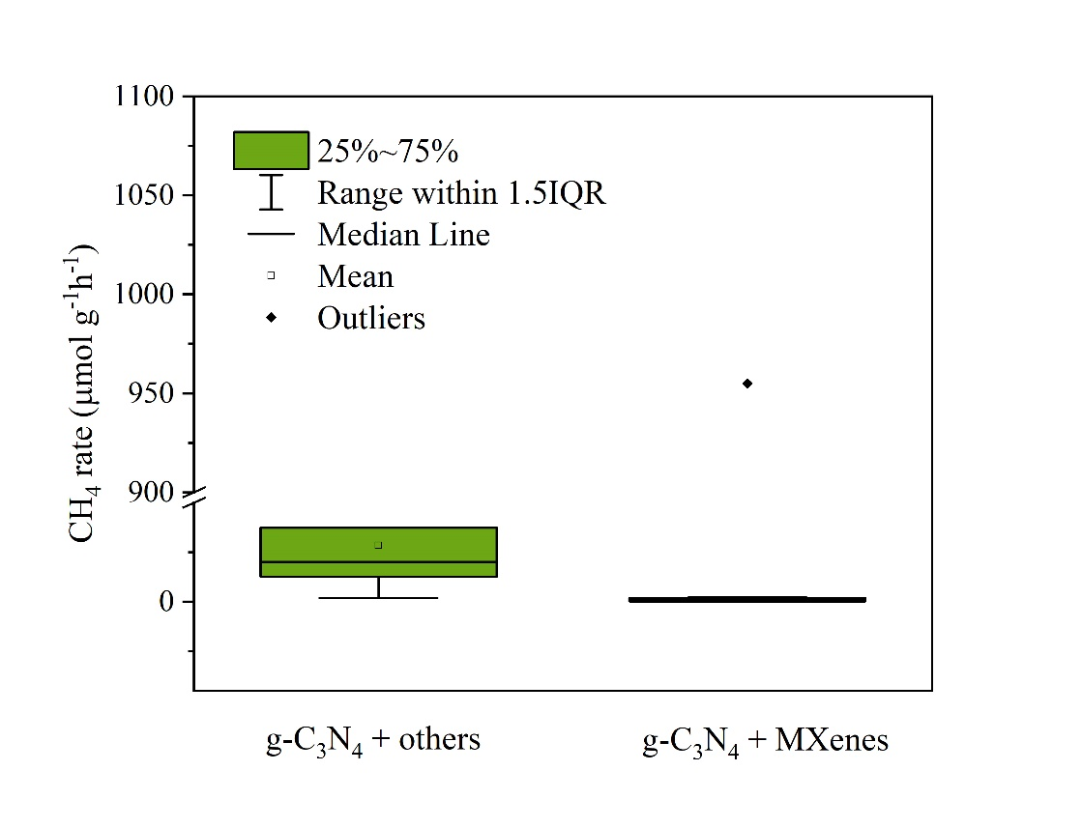
Figure S1. Box plots of CH₄ rate of g-C₃N₄ + other materials and g-C₃N₄ + MXenes.

