Supplementary materials for

Co-Simulation Evaluation of Power Efficiency and Output Capacitance in Standalone PV MPPT Buck Converters Using 200V p-GaN HEMTs

- EPC2215 GaN HEMT SPICE Simulation Code
.subckt EPC2215 gatein drainin sourcein
.param si={aWg*1.200e-03} so={aWg*6.150e-03} sr={aWg}
.param aWg={Wg*1E-3} Wg=1080000 A1={3.625e-02*aWg} k2=1.874e+00 k3=9.000e-02 rpara=5.209e-03
+ rpara_s_factor=2.406e-01 aITc=3.000e-03 arTc=-6.700e-03 k2Tc=6.000e-04
+ x0_0=4.938e+00 x0_0_TC=-2.000e-03 x0_1=-1.285e-01 x0_1_TC=0.000e+00
+ dgs1=4.3e-07 dgs2=2.6e-13 dgs3=0.8 dgs4=0.23
+ ags1={1.045e-09*si} ags2={8.283e-10*si} ags3=1.376e+00 ags4=1.808e-01
+ ags5={0.000e+00*si} ags6=7.480e+01 ags7=1.055e+01
+ agd1={1.124e-15*sr} agd2={1.409e-13*sr} agd3=-6.900e+00 agd4=5.314e+00
+ agd5={2.769e-14*sr} agd6=-2.326e+01 agd7=2.129e+01 agd8={1.081e-15*sr}
+ agd9=-4.326e+01 agd10=1.029e+01
+ asd1={5.053e-11*so} asd2={3.977e-11*so} asd3=-1.941e+01 asd4=2.356e+00
+ asd5={1.449e-11*so} asd6=-8.476e+01 asd7=1.007e+01 asd8={8.934e-11*so}
+ asd9=-3.023e+01 asd10=2.523e+01
+ rg_value=0.4

rd drainin drain {((1-rpara_s_factor)*rpara*(1-arTc*(Temp-25)))}
rs sourcein source {(rpara_s_factor*rpara*(1-arTc*(Temp-25)))}
rg gatein gate {(rg_value)}

Rcsdconv drain source {100000Meg/aWg}
Rcgsconv gate source {100000Meg/aWg}
Rcgdconv gate drain {100000Meg/aWg}

bswitch drain source I=if(v(drain,source)>0,
+ (A1*(1-aITc*(Temp-25))*log(1.0+exp((v(gate,source)-(k2*(1-k2Tc*(Temp-25))))/k3))*
+ v(drain,source)/(1 + (x0_0*(1-x0_0_TC*(Temp-25))+x0_1*(1-x0_1_TC*(Temp-25))*v(gate,source))*v(drain,source))),
+ (-A1*(1-aITc*(Temp-25))*log(1.0+exp((v(gate,drain)-(k2*(1-k2Tc*(Temp-25))))/k3))*
+ v(source,drain)/(1 + (x0_0*(1-x0_0_TC*(Temp-25))+x0_1*(1-x0_1_TC*(Temp-25))*v(gate,drain))*v(source,drain))))

bgsdiode gate source I=if( v(gate,source)>10,
+ (0.125*aWg/1077*(dgs1*(exp((10.0)/dgs3)-1)+dgs2*(exp((10.0)/dgs4)-1))),
+ (0.125*aWg/1077*(dgs1*(exp((v(gate,source))/dgs3)-1)+dgs2*(exp((v(gate,source))/dgs4)-1))))

bgddiode gate drain I=if( v(gate,drain)>10,
+ (0.125*aWg/1077*(dgs1*(exp((10.0)/dgs3)-1)+dgs2*(exp((10.0)/dgs4)-1))),
+ (0.125*aWg/1077*(dgs1*(exp((v(gate,drain))/dgs3)-1)+dgs2*(exp((v(gate,drain))/dgs4)-1))))

C_GS gate source {ags1} TC=0,0
C_CGS1 gate source Q=(0.5*ags2*ags4*log(1+exp((v(gate,source)-ags3)/ags4))+
+ ags5*ags7*log(1+exp((v(source,drain)-ags6)/ags7)))

C_GD gate drain {agd1} TC=0,0
C_CGD1 gate drain Q=(0.5*ags2*ags4*log(1+exp((v(gate,drain)-ags3)/ags4))+
+ agd2*agd4*log(1+exp((v(gate,drain)-agd3)/agd4))+
+ agd5*agd7*log(1+exp((v(gate,drain)-agd6)/agd7))+
+ agd8*agd10*log(1+exp((v(gate,drain)-agd9)/agd10)))

C_SD source drain {asd1} TC=0,0
C_CSD1 source drain Q=(asd2*asd4*log(1+exp((v(source,drain)-asd3)/asd4))+
+ asd5*asd7*log(1+exp((v(source,drain)-asd6)/asd7))+
+ asd8*asd10*log(1+exp((v(source,drain)-asd9)/asd10)))

.ends
- E3M0060065D SiC FET SPICE Simulation Code
Parasitics Included
Tj = Junction Temperature
Tc = Case Temperature
D = Drain
G = Gate
S = Source

.subckt E3M0060065D d g s Tj Tc
.param p11 = -8
.param p12 = 19
.param Rgint = 3

R1022 Tjc 0 1E6
E1022 Tjc 0 value {limit(v(Tj),-55,260)}

R100 gk 0 1E6
E100 gk 0 value {limit(v(g1,s1),-8,19)}

e33 NET3 0 Value {Limit(15.9430u*V(Tj)**2-7.0092m*V(Tj)+2.9816,1.5,3.5)}
R_cc NET3 0 1E6

xgmos d3 d1 gk s1 Tjc NET3 gmos_E3M0060065D

RS s sa 7.68m
Ls sa s1 4.9n
R_Ls sa s1 5

R_g g1 g2 {Rgint}
RG g ga 40.343m
Lg ga g2 8.927n

Rd d da 64.94u
Ld da d3 3.848n
R_Ld da d3 5

Ed Id 0 value {I(Vdrain_s)}
Rdd Id 0 1E6

vdrain_s d3 d1 0
Gheat 0 Tj value {abs((V(d1,s1)*v(Id)))+abs((V(g1,g2)**2/Rgint))}
xCGD d3 g1 cgdmos_E3M0060065D
CGS g1 s1 1011p
R_CGS g1 s1 1E6

R15 dd1 d1 10E6
e15 dd1 d1 value {
+ if (V(gk)>V(NET3),
+ Limit(((7.2992m*V(Tjc)**2+109.4884m*V(Tjc)-271.2992)*(V(gk)**2)+
+ (-184.3411m*V(Tjc)**2-2.7651*V(Tjc)+6784.3)*v(gk)+
+ (856.1240m*V(Tjc)**2+12.8419*V(Tjc)-30456.1))/1000,-3.5,20)
+ ,
+ Limit(((-700.6559u*V(Tjc)**2+181.7979m*V(Tjc)-4.1070)*(V(gk)**2)+
+ (-6.2314m*V(Tjc)**2+1.8296*V(Tjc)-391.8456)*v(gk)+
+ (20.8706m*V(Tjc)**2-5.8408*V(Tjc)-1567.0))/1000,-3.5,2.5)
+ )
+ }

D1 s1 dd1 bodydiode_E3M0060065D
xCds d3 s1 cds_E3M0060065D
R_DS1 d1 s1 0.5G

.model bodydiode_E3M0060065D d(is=0.88p bv=929 n=6 T_abs=25
+ rs=0.060 Tnom=25 tt=0.5n ibv=500u level=1)

R0 N1 Tj 0.130163
R1 N2 N1 0.409989
R2 N3 N2 0.234421
R3 Tc N3 0.217147

C0 Tj 0 0.607m
C1 N1 0 2.81m
C2 N2 0 10.61m
C3 N3 0 83.36m

.ends E3M0060065D

.subckt gmos_E3M0060065D d3 d1 gk s1 Tjc NET3

.func gain(vgs,t) {
+ Limit(((-1.3111u*t**2+142.0330u*t+8.7696m)*vgs**4+
+ (69.4628u*t**2-7.9794m*t-423.1987m)*vgs**3+
+ (-1.3281m*t**2+169.8177m*t+6.8886)*vgs**2+
+ (10.8307m*t**2-1.6485*t-47.7297)*vgs+
+ (-31.9214m*t**2+6.1634*t+209.5068))/1000,0.001,2)
+
+}

.func nval(vgs,t) {
+ Limit(((15.7669u*t**2-2.3604m*t+7.9856m)*vgs**4+
+ (-839.2145u*t**2+124.7502m*t+27.1530m)*vgs**3+
+ (16.1319m*t**2-2.3745*t-6.0628)*vgs**2+
+ (-131.8940m*t**2+19.1419*t+119.4963)*vgs+
+ (372.8966m*t**2-52.5573*t+22.1726))/1000,.005,2)
+}

.func lam(vgs,t) {
+ Limit(((12.7351n*t**2-2.0859u*t-113.8120u)*vgs**5+
+ (-811.0976n*t**2+133.1795u*t+6.2287m)*vgs**4+
+ (19.9872u*t**2-3.2782m*t-125.8459m)*vgs**3+
+ (-234.8839u*t**2+38.5392m*t+1.1486)*vgs**2+
+ (1.2826m*t**2-211.7719m*t-4.5659)*vgs+
+ (-2.5635m*t**2+428.9293m*t+14.9029))/1000,.00001,0.15)
+}

.func lam3(vgs,t) {
+ Limit(((-103.9952u*t**2+266.1324m*t-19.5883)*vgs**2+
+ (-1.4645m*t**2-5.3604*t+373.9261)*vgs+
+ (45.9392m*t**2+19.6122*t-1009.0))/1000,0,3)
+}

.func drain_current(vgs,vds,vth,g,n,l) {
+ g*(vgs-vth)*(log(1+exp(vgs-vth))**2 - log(1+exp(vgs-vth-n*vds))**2)*(1+l*vds)
+}

R1001 gr 0 1E6
E1001 gr 0 value {limit(V(gk),-8,15)}

G2 d1 s1 value {
+ if(V(d3,s1)<=0,
+ if (V(gk)<=V(NET3),
+ 0
+ ,
+ -drain_current(V(gk),V(s1,d3),V(NET3),gain(V(gk),V(Tjc)),nval(V(gk),V(Tjc)),lam3(V(gr),V(Tjc)))*(834.8241n*V(Tjc)**2+166.3685u*V(Tjc)+995.3190m)
+ )
+ ,
+ if (V(gk)<=V(NET3),
+ 0
+ ,
+ drain_current(V(gk),V(d3,s1),V(NET3),gain(V(gk),V(Tjc)),nval(V(gk),V(Tjc)),lam(V(gk),V(Tjc)))*(834.8241n*V(Tjc)**2+166.3685u*V(Tjc)+995.3190m)
+ )
+ )
+ }

.ends gmos_E3M0060065D

.subckt cgdmos_E3M0060065D d3 g1
.param k1=699.33p
.param k2=0.359866
.param ka=2397.706
.param kb=0.13563
.param kc=3.164102

G11 g1 d11 value {
+ k1*(
+ (1+(limit(v(d3,g1),0.1,270))*(1+ka*(1+TANH(kb*V(d3,g1)-kc))/2))**(-k2)
+ )*ddt(v(g1,d3))
+ }
R_CGD d11 d3 1E-4
.ends cgdmos_E3M0060065D

.subckt cds_E3M0060065D d3 s1
.param Cjo = 957p
.param Vj = 2.14
.param M = 0.54

G12 d12 s1 value {
+ (Cjo/(1+(limit(v(d3,s1),0.1,270)/Vj)**M))*ddt(v(d3,s1))
+ }
R_CDS d12 d3 1E-4

.ends cds_E3M0060065D

- Duty-Cycle P&O Algorithm for MATLAB Simulink
function D = DutyRatio(V,I)

Dmax = 0.85;
Dmin = 0;
Dinit = 0.85;
deltaD = 0.000006;
persistent Vold Pold Dold;

dataType = 'double';

if isempty(Vold)
Vold = 0;
Pold = 0;
Dold = Dinit;
end

P = V*I;
dV = V-Vold;
dP = P-Pold;

if dP ~= 0
if dP<0
if dV<0
D = Dold - deltaD;
else
D = Dold + deltaD;
end
else
if dV<0
D = Dold + deltaD;
else
D = Dold - deltaD;
end
end
else D = Dold;
end

if D >= Dmax || D <= Dmin
D = Dold;
end

Dold = D;
Vold = V;
Pold = P;

- MATLAB Simulink Diagram for Proposed PV MPPT System
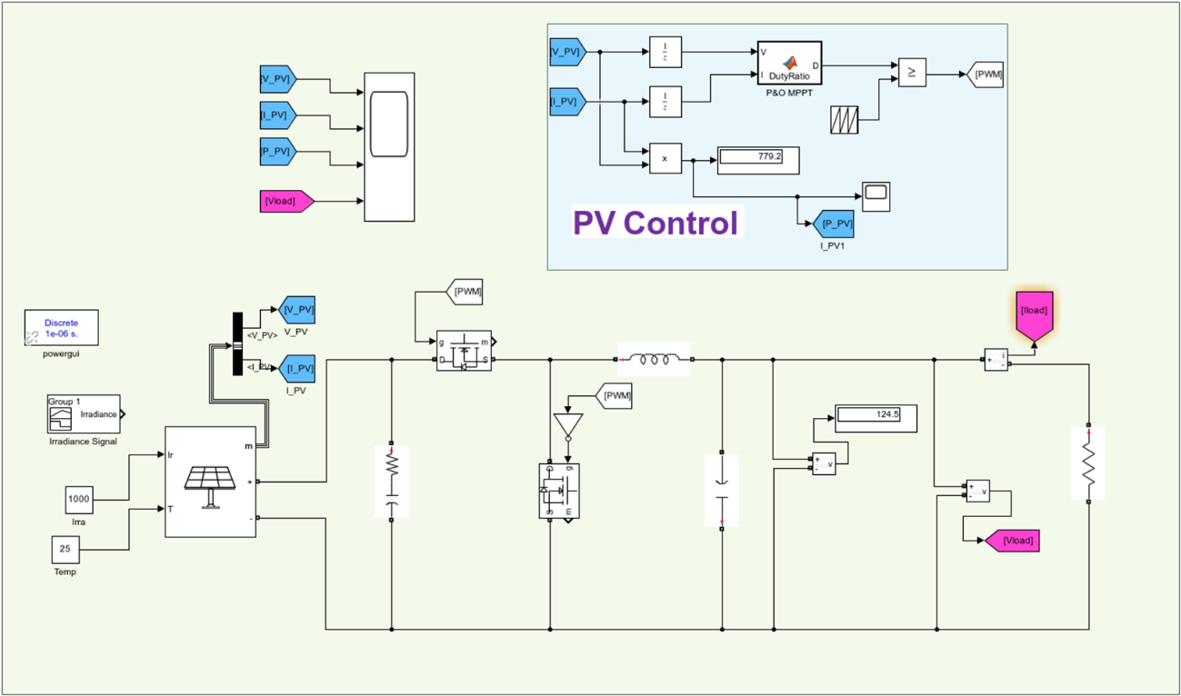
Fig. S1. MATLAB Simulink Diagram for Proposed PV MPPT System
- SPICE Simulation for Power Losses Evaluation

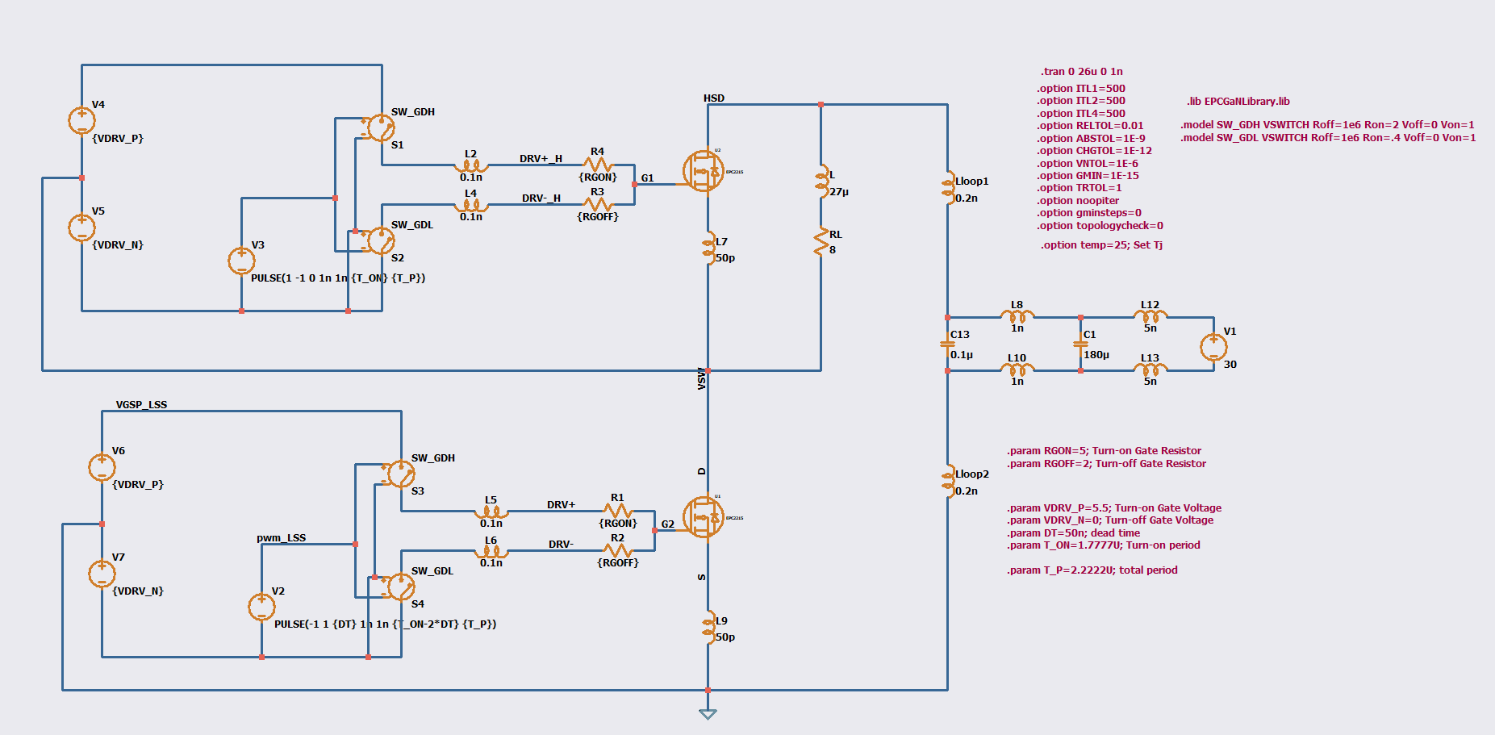
Fig. S2. SPICE simulation of hard switching multi-pulse test

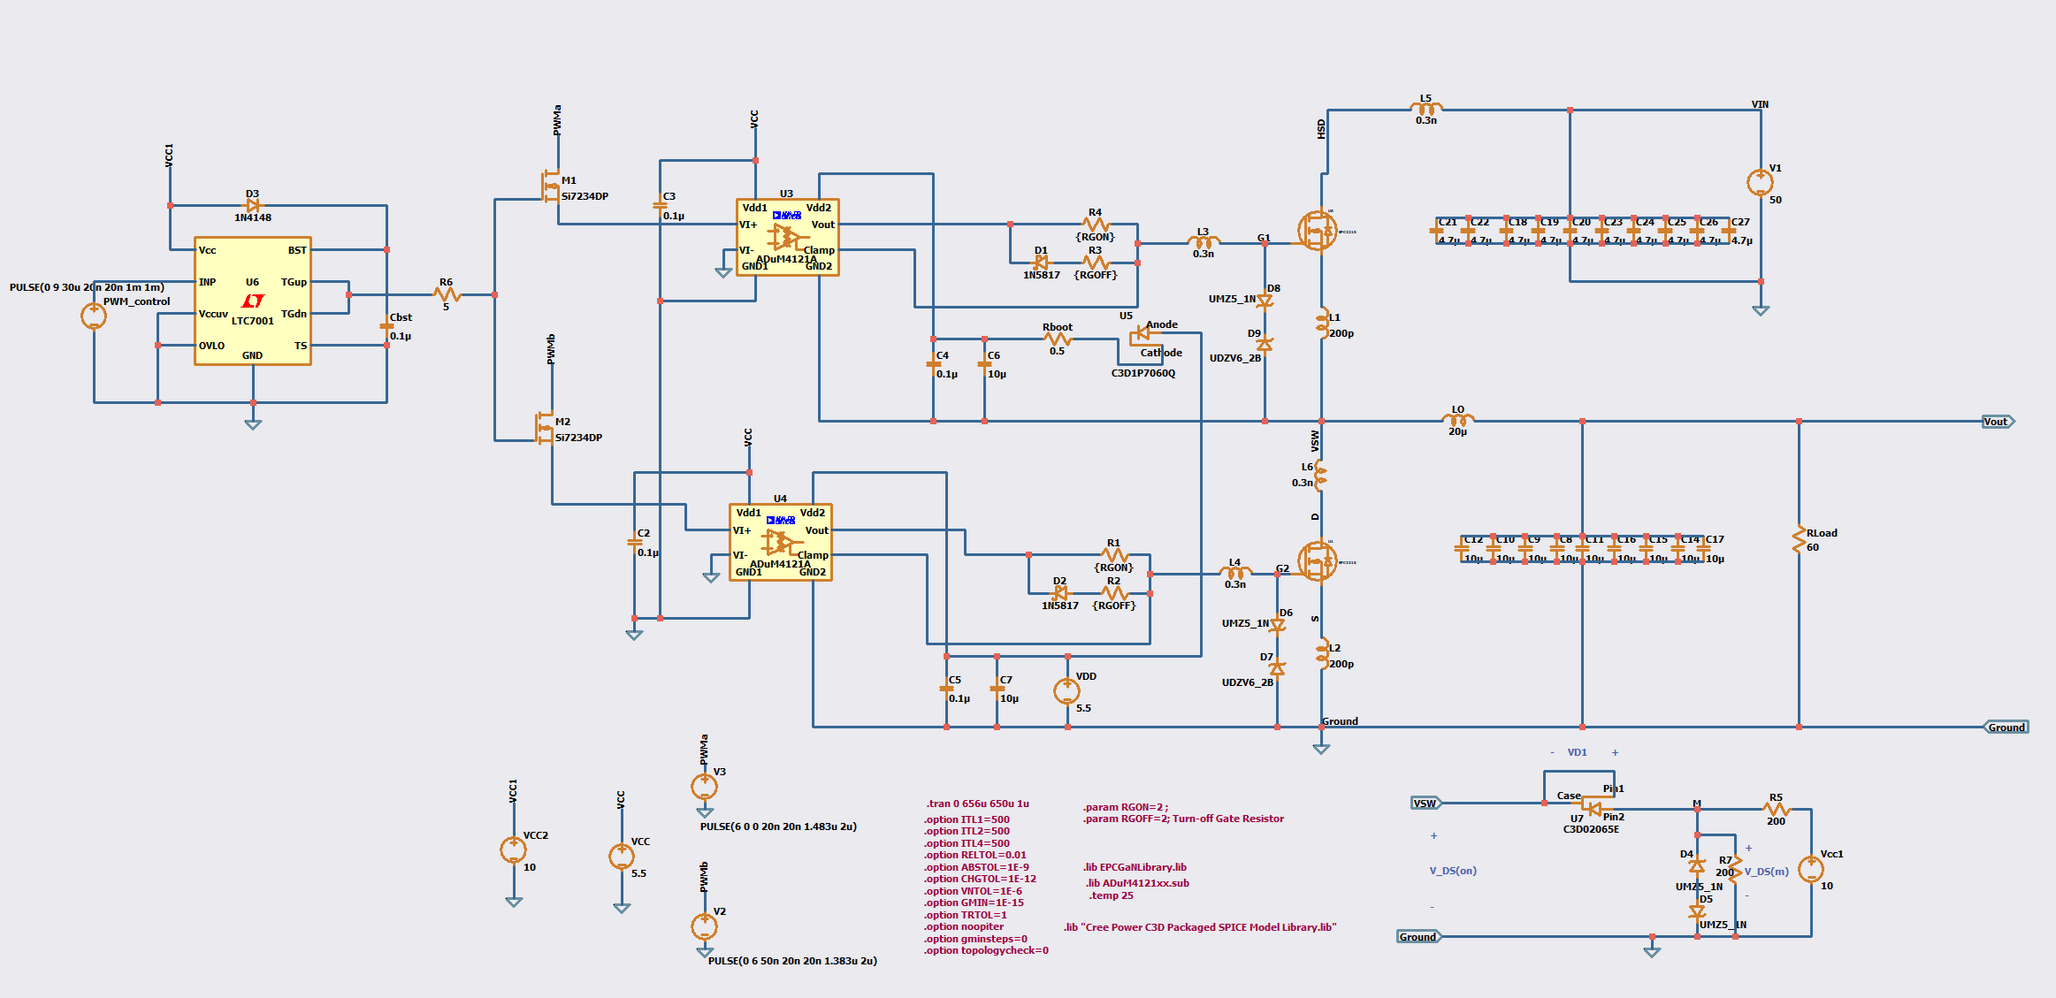
Fig. S3. SPICE hard switching simulation with gate driver modules

- Characterization of C_{ISS}, C_{OSS} and C_{RSS} for EPC2215 GaN HEMT
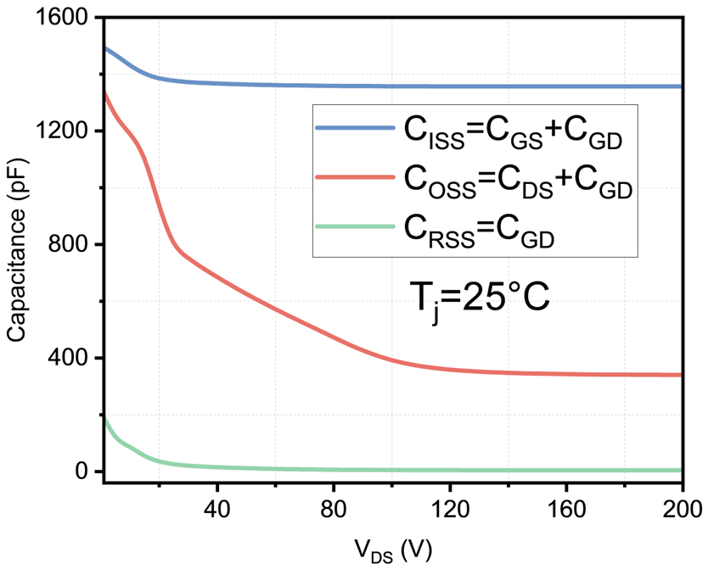
Fig. S4. 6. Characterization of C_{ISS}, C_{OSS} and C_{RSS} for EPC2215 GaN HEMT
- Schematic and Proposed PCB Design for the Hard-Switching-Multi-Pulse Test
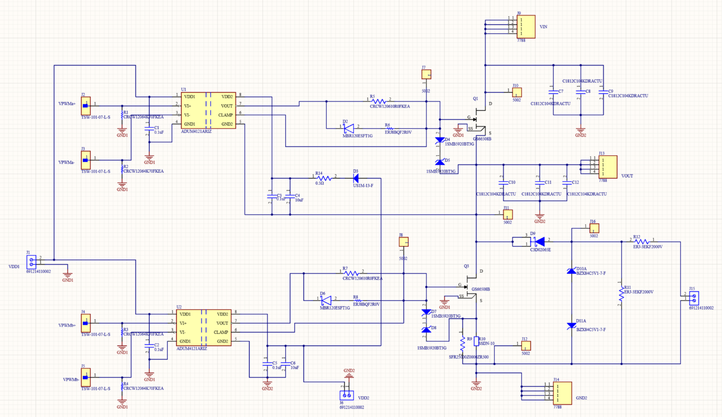
Fig. S5. Schematics of PCB design for the proposed testing

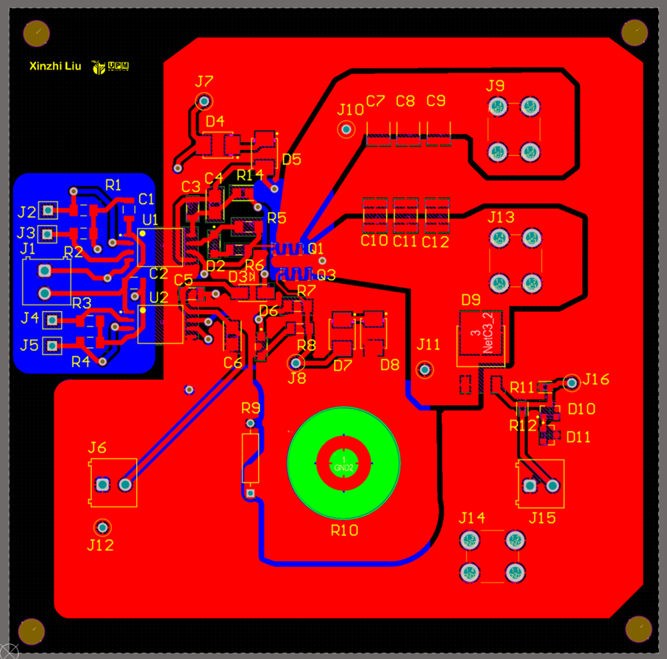
Fig. S6. On-Board GaN Half Bridge Design
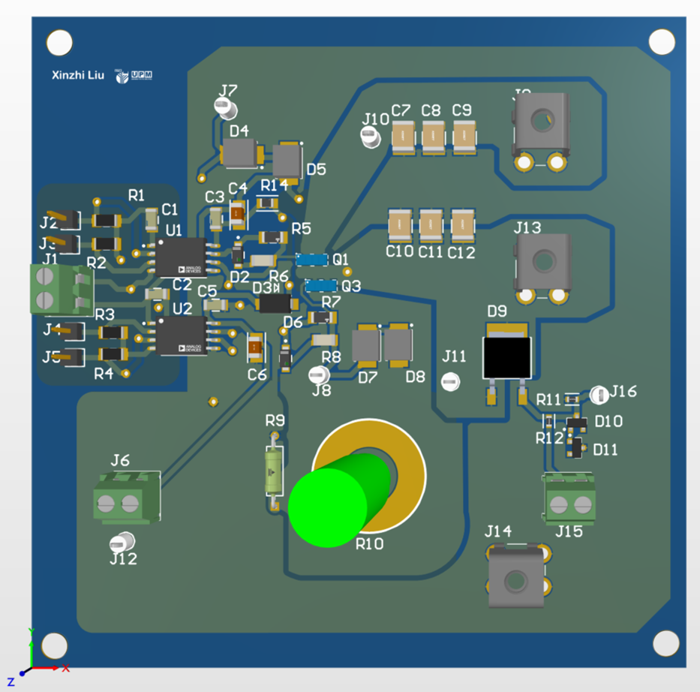
Fig. S7. GaN HEMT PCB 3D layout for hard switching multi-pulse testing

