Camera Configuration and Placement:
Camera selection was a crucial task, and factors such as camera resolution, field of view (FOV), height of the camera, and horizontal and vertical area to be covered were important considerations. Our imaging system consists of multiple OAK-D Pro cameras (Fig. 1) arranged in an overlapping manner, so that the data obtained from both cameras simultaneously can be stitched together. The imaging capability consists of monochrome cameras and color camera. Moreover, the cameras were mounted on a modular system that allows for adjustments in camera height from the ground. This adaptability is key as the size of the pot and plant changes; the camera height can be altered using the remote-control system of the actuator that regulates the height of the camera mount. The relative height of the camera mount with the actuator base, was taken into account.
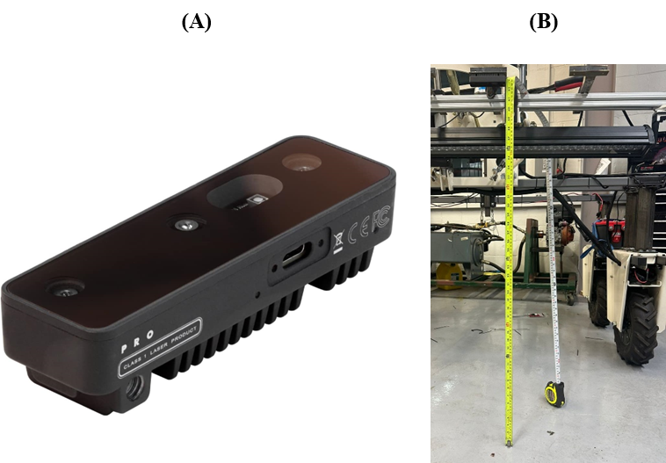
Fig. 1 (A) OAK-D Pro camera used for video data collection, (B) Camera placement on the robotic platform, mounted at a height to optimize the field of view for nursery bed imagery.
Camera placement depends mainly on the FOV of the camera. The FOV is calculated using Eq. (1):
$$FOV=2*arctan^{-1}\left(\frac{Number of Pixels}{2f}\right)$$ | (1)
The OAK-D Pro camera features 4056 horizontal pixels, 3040 vertical pixels, and an effective focal length (f) of 4.52 millimeter (mm). This configuration results in a horizontal angle of view of approximately 69°, with the vertical and diagonal angles of view calculated to be 55° and 81°, respectively. When positioning the cameras 0.80 meter (m) above the ground, the calculated horizontal Field of View (FOV) is 1.10m. The vertical and diagonal FOVs have been determined accordingly (Fig. 2). The cameras are strategically placed at a fixed distance from each other to ensure comprehensive coverage of the plot and sufficient overlap for image stitching between two cameras, as demonstrated (Fig. 2).
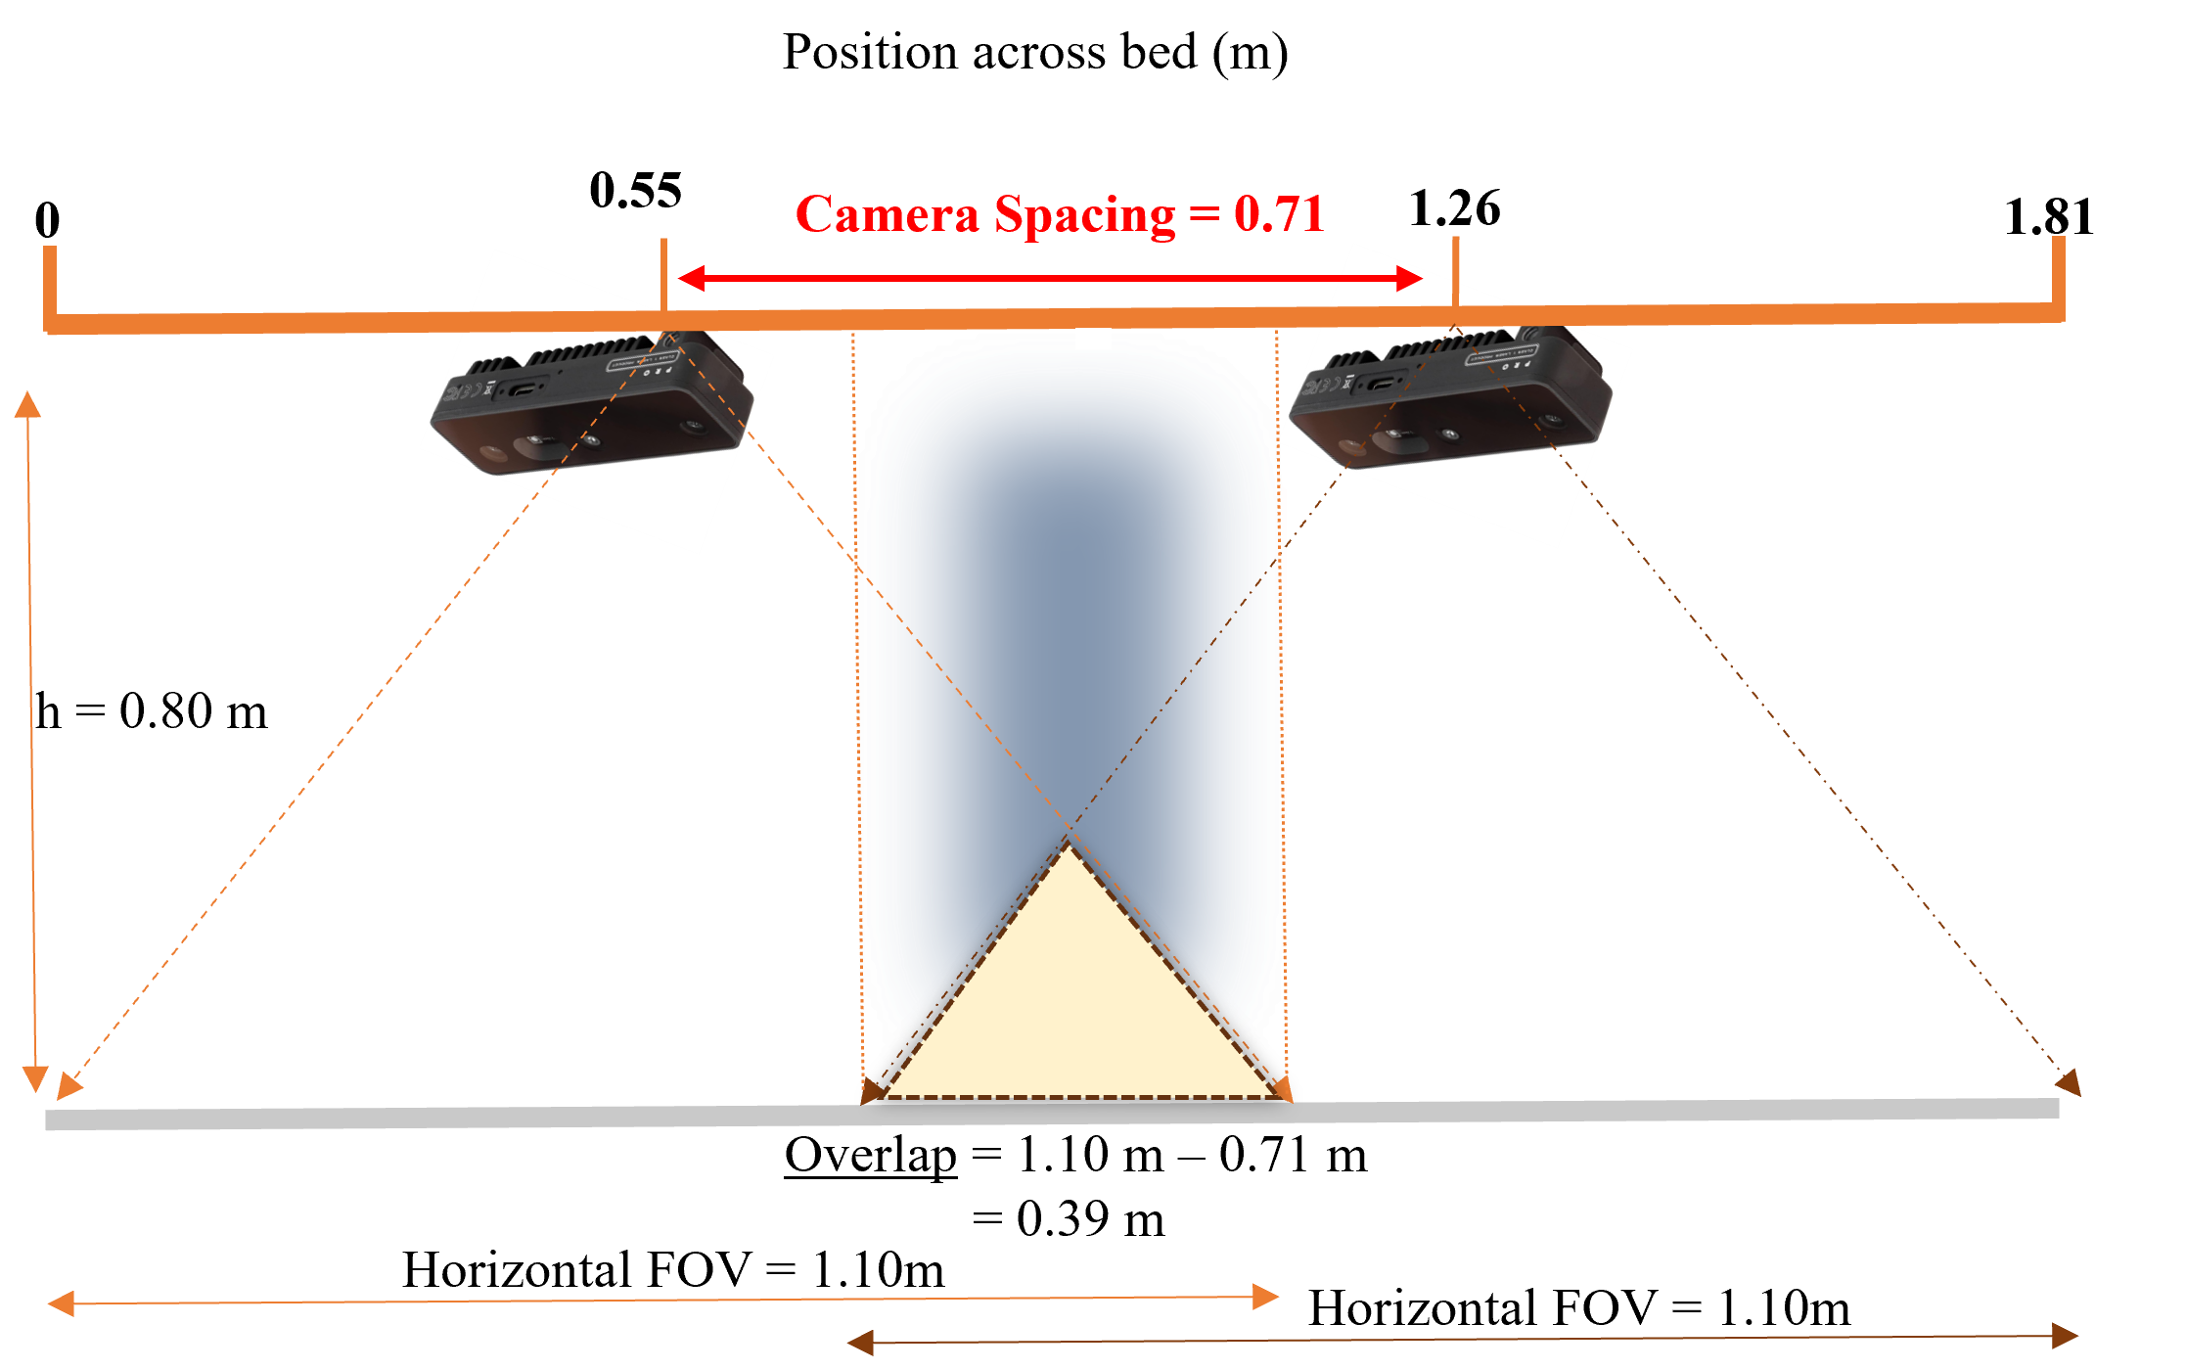
Fig. 2 Two overlapping camera configurations, ensuring consistent overlap between them while covering the entire width of the bed.
The 0.39 m overlap between the multiple OAK-D Pro cameras proved sufficient for image stitching. As plant height increased, the camera’s elevation from the ground was adjusted, leading to an increased overlap between the cameras, which was beneficial for generating panoramas of an entire bed.
Representative counting failure cases are shown in Fig. 3 to illustrate the effect of severe canopy occlusion on instance separation.
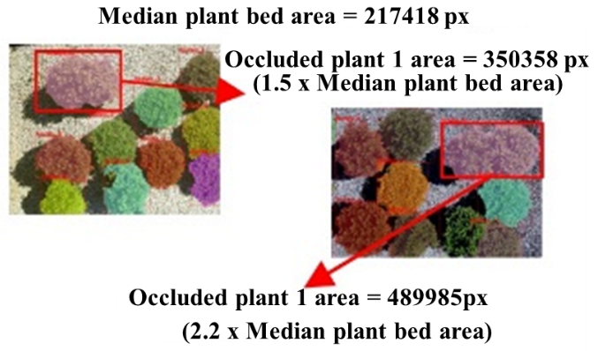
Fig. 3 Representative failure cases illustrating undercounting under severe canopy occlusion.
Red boxes in Fig. 3 highlight plants exhibiting severe canopy occlusion, where adjacent plant canopies physically merged. The occluded plant regions (350,358 px and 489,985 px) represent 1.5 x and 2.2 x the median plant-bed area (217,418 px), respectively, indicating substantial canopy overlap that challenges instance boundary delineation. Under these conditions, the segmentation model tended to produce merged masks, detecting the fused canopy as a single instance rather than two separate plants, resulting in undercounting.

