Iron removal from kaolin waste dumps by chemical (oxalic and citric acids) and biological leaching (Bacillus strain)
Yolanda Sánchez-Palencia¹, David Bolonio¹, Marcelo F. Ortega¹, María-Jesús García-Martínez¹, José Eugenio Ortiz¹, Fernando Rayo², Lucía Arregui², Susana Serrano², Juan F. Llamas¹ and Laureano Canoira^{1*}.
¹Environmental Studies Research Group GEA-UPM, ETS Ingenieros de Minas y Energía, Universidad Politécnica de Madrid. C/ Ríos Rosas 21, 28003 Madrid, Spain. laureano.canoira.lopez@upm.es
²Department of Genetics, Physiology and Microbiology, Faculty of Biology, Universidad Complutense de Madrid, C/ José Antonio Nováis 2, 28040 Madrid, Spain. arregui@bio.ucm.es

Supplementary Material
Geological environment
Kaolin samples were taken from the Caobar SA pit (Fig . 1S) in Poveda de la Sierra (Guadalajara, Central Spain). Kaolin is associated with the Utrillas Sandstone Formation (Albian-Cenomanian, Cretaceous), which consists mainly of arkose sandstone beds with carbonated cement, with some interbeds of muds, and conglomerates. These materials were deposited in fluvial and deltaic environments, with their catchment area originally located in Paleozoic felsic plutonic rocks. Kaolin has a secondary origin, as it derives from the hydrolysis of feldspar grains.
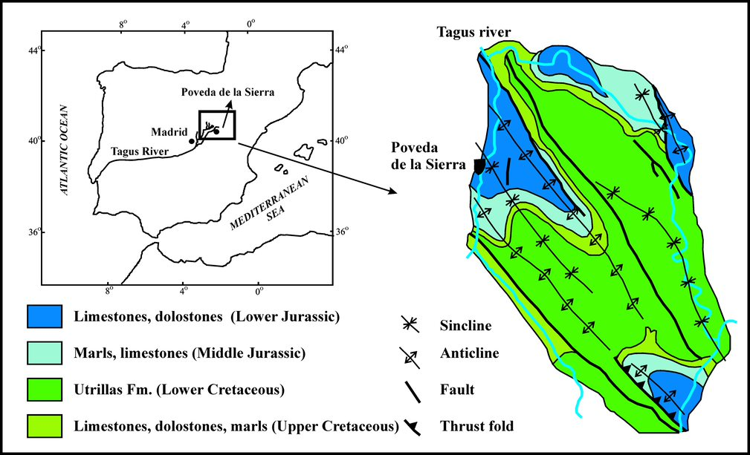
Fig. S1. Geological context of the Poveda de la Sierra pit

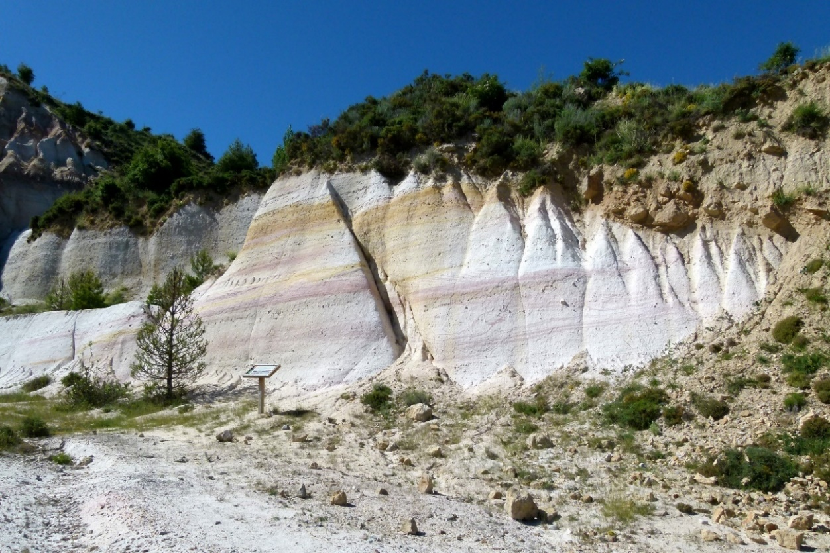
Fig. S2. Utrillas Sandstone Formation outcrop at Poveda de la Sierra, with kaolin beds
The pit contains nine main kaolin levels with various iron contents. Because the proportion of iron must be <0.15% for commercial purposes, only four of the levels are exploited. In the others, the amount of iron is as much as >2.0%.

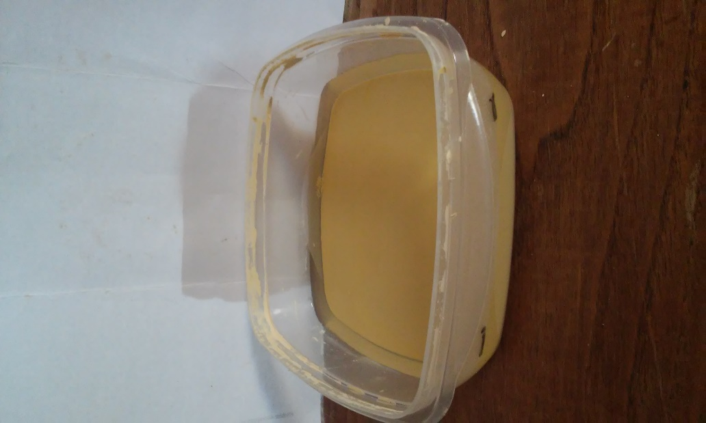

Fig. S3. Chemical lixiviation experiment for high-iron kaolin in 20 mM oxalic acid over a period of 218 days, about half-way through the experiment

