Impact of Ageing on the Thermal and Rheological Properties of Conductive Mastics

ABSTRACT
Mastic plays a vital role in enhancing both cohesion and adhesion within asphalt mixtures, which are critical determinants of their short-term and long-term performance. This study investigates the influence of ageing on the thermal and rheological characteristics of asphalt mastics incorporating conductive fillers graphene, graphite, and magnetite as partial replacements for conventional limestone filler. Five mastic formulations, prepared using 100/150 penetration grade bitumen, were evaluated under virgin, short-term, and long-term ageing conditions. The inclusion of conductive fillers led to a 20–50% increase in thermal conductivity, with only moderate sensitivity to temperature variations from 5 °C to 40 °C . Although thermal conductivity decreased by up to 17% with ageing, the enhancements attributable to the fillers remained substantial. The conducting mastic also showed enhanced thermal stability and protection against overheating. Rheological analyses demonstrated notable increases in complex modulus (G*) as well as improvements in rutting and fatigue resistance, particularly in formulations containing up to 3% graphene. Importantly, even after long-term ageing, the conductive mastics exhibited stable viscoelastic behaviour and maintained Glover–Rowe (G-R) parameter values below critical cracking thresholds, indicating reduced susceptibility to age related cracking. These results highlight the potential of conductive fillers to enhance the thermal efficiency, mechanical performance and long-term durability of asphalt mastics, offering a viable strategy for improving pavement performance under varying service conditions.

Keywords: Ageing, Conductive filler, thermal conductivity, rheology, complex modulus, phase angle.

1. INTRODUCTION
Bituminous mastic constitutes a fundamental component in asphalt mixtures, governing both their short-term functionality and long-term durability. As the phase that binds mineral aggregates, mastic contributes to mixture cohesion and adhesive strength through physicochemical interactions, while simultaneously filling inter-granular voids and bridging micro-defects within the aggregate structure. These functions exert a direct influence on compaction behaviour, resistance to mechanical distress and overall durability under service conditions [1–4]. The significance of mastic is further amplified in pavement preservation techniques such as thin surfacing (≤ 35 mm), micro-surfacing and surface dressing (≤ 25 mm), where elevated binder contents are required to ensure effective aggregate coating and interfacial bonding. In these contexts, the performance of mastic is critical in mitigating premature distresses, including ravelling, bleeding and cracking, particularly under the combined effects of traffic loading and environmental ageing [5–7].
The workability and performance of mastic are influenced by factors such as mixing temperature, substrate temperature during laying and heat retention. Rapid cooling, especially at the mat edges or top surface, can lead to insufficient compaction and poor interlayer bonding, which is particularly critical for thin surface courses [8]. As bitumen possesses low thermal conductivity and high thermal inertia, the addition of thermally efficient fillers can improve heat retention and promote uniform temperature distribution throughout the mastic, enhancing construction quality and long-term performance. Improved thermal conductivity also supports functional benefits such as self-healing and ice- or snow-melting pavements [9–13].
Various fillers and additives have been explored to enhance asphalt performance. Graphite offers high thermal conductivity and cost-effectiveness [46], graphene oxide (GO) improves physical and viscoelastic properties [47], graphene-enhanced plastomeric (GP) modifiers increase stiffness, deformation resistance and service life while lowering embodied carbon [48-49], Graphene nanoplatelets (GNPs) enhance asphalt binders by improving rutting resistance, reducing low-temperature cracking and providing anti-ageing benefits for more durable performance [50]. Conductive additives such as graphene, graphite and magnetite are significantly more expensive than traditional mineral fillers like limestone or granite. Furthermore, these materials are in demand in other industrial sectors, raising concerns regarding scalability and cost-effectiveness. Studies have reported that blending multiple conductive fillers can offer a balanced approach by improving thermal and mechanical properties while optimising overall cost. Blending multiple conductive fillers has been suggested to balance thermal and mechanical improvements while optimising overall cost [14–16].
Ageing remains a critical factor affecting bituminous materials. It increases stiffness and brittleness via oxidation and loss of volatiles, raising the softening point and reducing ductility and fatigue resistance [17]. These changes are closely linked to the colloidal structure of bitumen, where maltenes and asphaltenes govern mechanical and rheological response [18,19]. While the ageing behaviour of conventional mastics is well studied, the effects of ageing on conductive mastics remain underexplored. Most research has focused on optimising filler content, conductivity and mechanical performance, with limited experimental data on how ageing alters thermal and rheological properties.
In recent years, conductive mastics have been explored for multifunctional pavements, enabling self-healing through induction heating, improved thermal regulation and energy harvesting. Most studies, however, have focused on optimising filler content, conductivity and mechanical performance, with limited experimental data on how ageing affects their thermal and rheological properties. Without such evidence, predicting long-term durability and service performance remains challenging.
The present study addresses this gap by providing experimental insights into the effects of long-term ageing on conductive mastics. Thermal and rheological properties including the mechanical performance of conductive mastics were systematically evaluated, providing critical insights into ageing mechanisms and supporting the development of more durable multifunctional pavement materials. Five distinct mastic combinations were prepared using 100/150 penetration grade bitumen. The properties of each were assessed in their virgin state and after laboratory-simulated short-term (6 hours at 140 °C) and long-term ageing (5 days at 85 °C), corresponding to construction and extended in-service conditions, respectively. The results were benchmarked against unmodified bitumen and mastics containing only conventional fillers. Furthermore, the study explores the suitability of using a Dynamic Shear Rheometer (DSR) for evaluating the performance of various mastic compositions.

2. MATERIAL AND EXPERIMENT

2.1 Adopted Constituents

The physical, chemical, thermal and mechanical properties of fillers used in this study are presented in Table 1. The size of the filler particles was less than 0.063mm to comply with BS EN 13108 [20]. A softer grade bitumen (100-150pen) was used for easy of mixing.

Table 1: Properties of the filler [21-25]
Type | Surface area(m²/g) | Physical properties | Density  (g/cm³) | Thermal Conductivity  (WK⁻¹/m) | Elasticity Module (MPa)
Graphene  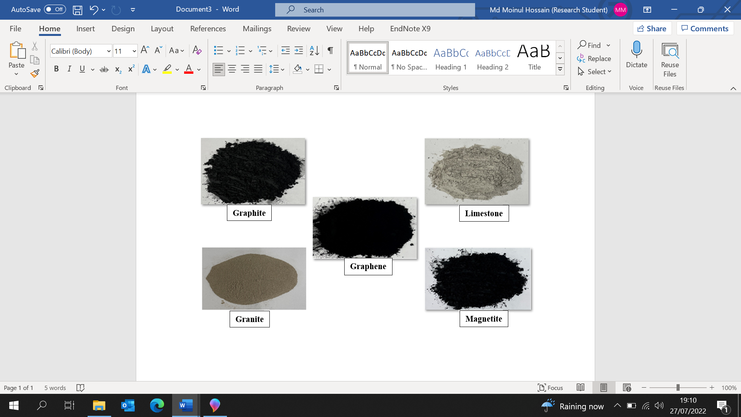 | 2600 | Insoluble, crystal structure,  hexagonal honeycomb lattice one-atom thin (0.345 µm). | 2.25 | 4840-5300 | ~10E+06
Graphite | ~416 | Insoluble, synthetic-  300 mesh (95% <53µm), plentiful carbon allotrope in nature, highly conductive. | 2.26 | Up to1950 | 1.15E+04
Magnetite | ~101 | Water-soluble, spherical shape and  >96% < 63µm, highly conductive and dense. | 4.6 | 9.7 | 2.0E+05
Limestone | 2 to 5 | >1.5%, closer to a spherical shape  and 63 µm. | 2.0 | 0.9 to 2.5 | 3.4E+03

2.2 Mastic Production

Due to the different densities of the fillers, the binder to filler ratio was varied to evaluate the influence of different proportions on thermal and rheological properties. A consistent mixing temperature of 140 °C and mixing rotation speed 1720 rpm was adopted [26] for one hour duration on a hot plate placed in a fume cupboard to allow homogeneous mixing. In total, 5 different combinations of mixtures were manufactured as summarised in Table 2.
Table 2: Filler Proportion in mastic based on total binder content by mass
Mastic ID | Bitumen (%) | Graphene (%) | Graphite (%) | Magnetite (%) | Limestone (%)
B | 100 | x | x | x | x
M1 | 70 | x | x | x | 30
M2 | 67 | 3 | x | x | 30
M3 | 67 | 3 | 10 | 10 | 10
M4 | 67 | 3 | x | 10 | 20
M5 | 67 | 3 | x | 5 | 25
Note: B =Bitumen, LS= Limestone, GR= Graphite, MT= Magnetite, GN= Graphene

The experimental investigations were limited to a maximum graphene content of 3%, as higher dosages would be prohibitively expensive. The cost of graphene typically ranges from approximately $530,000 to $1.48 million per metric tonne (or $481,000 to $1.35 million per US short ton), depending on product quality and production method [52]. Moreover, earlier studies have demonstrated that incorporating more than 4% graphene reduces workability without providing any additional mechanical advantages [27]. Recent findings also indicate that concentrations exceeding 2.5% by weight present significant challenges in achieving uniform dispersion [52]. All mixtures were kept in gravimetric proportion as opposed to volumetric proportion. This process was kept consistent for all mixtures. The 10% graphite (GR) content in the M3 formulation was selected based on preliminary experimental trials and findings from existing literature. Studies have shown that incorporating graphite into asphalt mixtures enhances thermal conductivity and improves anti-ageing properties [16].

2.3 Experimental programme

The testing programme for consistency, thermal properties and rheological properties is presented in Fig. 1.

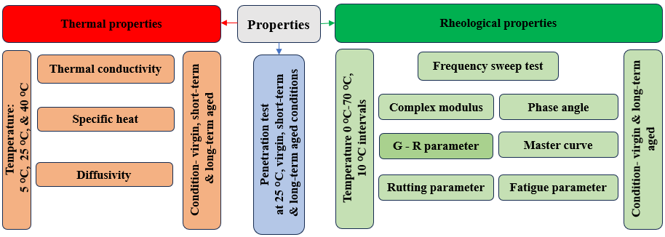
Fig. 1: Experimental programme

2.3.1 Mixture consistency: as shown in Fig. 1, the consistency of all mixtures using needle penetration method was determined at 25 °C, was measured as specified in BS EN 1426:2015, on all virgin, short-term and long-term aged specimens. Although this test is conventionally done on pure bitumen, the testing on asphalt mastic allowed to investigate mixture integrity, and consistency.

2.3.2 Thermal properties: a portable TLS 100 Term-test equipment as specified in ASTM D5930:2001 was used to measure thermal conductivity [31]. Testing comprises inserting a 50mm long, 4mm diameter needle into a 75mm diameter, 100mm height specimen. The probe needle was coated with heat sink compound to eliminate the possibility of heat loss during testing. An illustration of the experimental setup is shown in Fig. 2 (a).

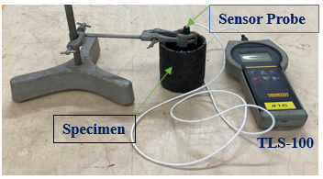
Fig. 2 (a) Thermal conductivity measurement
Thermal conductivity tests were carried out on all mixtures in virgin (V), short-term aged (ST) and long-term aged (LT) conditions at three temperatures: 5 °C , 25 °C and 40 °C. These temperatures were selected to represent cold, moderate and high summer conditions. For 25 °C and 40 °C temperature testing, specimens were kept in an oven for an hour until the temperature reached at required stages. For 5 °C testing, on the other hand, specimens were kept at 5 °C for 24 hours before testing. Each test was repeated five times to assess the robustness of the findings. The observed variation between repetitions, with a standard deviation ranging from 0.01 to 0.03, demonstrates the reliability of the results.
After testing, the mixtures in their virgin state, the samples were aged in a draft oven at 140 °C for six hours to simulate short-term ageing. Once cooled, the same thermal conductivity tests were repeated at 5 °C, 25 °C, and 40 °C, following the same procedure used for the virgin condition. After short-term ageing, all 5 mixtures were then subjected to LT oven ageing at 85 °C for five days as specified in AASHTO R30, then tested at 5 °C , 25 °C and 40 °C again. It is important to note that for short-term ageing, the conventional Rolling Thin Film Oven Test (RTFOT) [28] and for long-term ageing, the conventional RCAT (Rotating Cylinder Aging Test) or Pressure Ageing Vessel (PAV) [29-30] for bitumen were not used. This is due to the difficulty in performing such testing for hard asphalt mastic. It was considered that AASHTO mixture ageing protocols are more appropriate to represent mastic ageing.

The other two thermal parameters, Specific heat capacity and Diffusivity, were calculated using the following formula.

Specific heat capacity C_{p} = $\frac{K}{M∆T}$ [34] …………………………. (1)
Diffusivity (a) = $\frac{K}{ρCp}$ [35] ……………………………………… (2)
Where, k=Thermal conductivity, M = Mass and ΔT = Changing time according to TLS-100, ρ = Density, C_{p} = Specific heat.

2.3.3 Rheological properties: The rheological properties, as specified in AASHTO T315-12, were determined in a Dynamic Shear Rheometer (DSR). The test set-up is shown in Fig. 2(b).

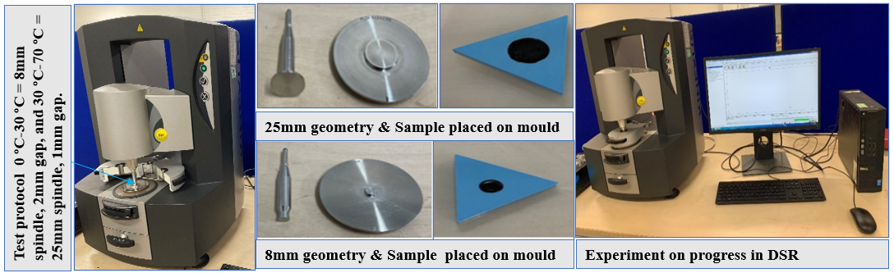
Fig. 2 (b) Dynamic Shear Rheometer test set up

The testing process involved measuring rheological properties through a frequency sweep test at a constant small strain of 1% for each sample [42]. The samples were tested across a frequency range of 0.1 to 15 Hz and a temperature range from 0 °C to 70 °C, every 10 °C interval. The rheological data were used to evaluate the complex modulus, phase angle, rutting and fatigue performance, as well as the structural integrity and long-term cracking potential of the materials [26-43]. A strain amplitude of 1% was used for all frequency sweep tests. This value was selected based on preliminary strain sweep tests performed for each formulation, which confirmed that the measurements remained within the Linear Viscoelastic Region (LVE), ensuring that the complex modulus and phase angle reflect the intrinsic viscoelastic behaviour of the mastics.

2.3.4 Experimental Limitations:

Rheological evaluation in this study was limited to DSR frequency sweep tests, without inclusion of MSCR, BBR, or LAS testing. Consequently, the assessment of non-linear viscoelasticity, low-temperature behaviour and fatigue performance was restricted. The absence of SEM analysis limits the direct visualisation of filler dispersion and interfacial interactions in this study. Although SEM cannot resolve three-dimensional dispersion or quantify inter-particle interactions, its omission reduces the microstructural evidence available to qualitatively support assessments of dispersion uniformity and interface morphology. Similarly, the absence of FTIR or XRD characterisation means that potential chemical interactions remain unverified. The performance extrapolation using master curves and the Time–Temperature Superposition Principle (TTSP) assumes linear viscoelasticity, which introduces some uncertainty in long-term predictions. Furthermore, a sensitivity analysis for graphene dosages above 3% was not performed; and future studies are recommended to explore higher graphene contents to identify performance saturation levels and optimise multi-filler formulations.

3. RESULTS AND ANALYSIS

3.1 Mixture Consistency

In order to investigate the consistency of different mixture combinations, needle penetration testing was conducted in all 5 combinations at their V, ST and LT aged condition. It is important to note that the use of the needle penetration test to assess mixture consistency is empirical in nature and provides only point-based measurements. Consequently, this method lacks the robustness required to accurately characterise material dispersion. The resulting data therefore reflect only local uniformity and cannot conclusively verify the overall homogeneity of the mixture. The test is also valuable for identifying trends in the ageing behaviour of the material resulting from the incorporation of conductive fillers.

The results are presented in Fig. 3. As expected, the penetration values of all conductive mixes were approximately 40% lower than bitumen (B) and approximately 20% lower than the conventional mastic (M1). The standard deviation of the penetration values ranged between 0.03 and 0.09 cm (3–9 dmm), indicating good repeatability and acceptable variability within the tested bituminous mastics.

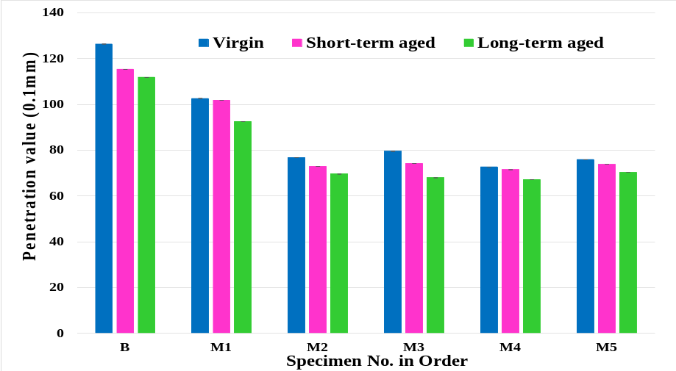
Fig. 3: Penetration test at all conditions

The results also revealed a consistent decrease in penetration as the material transitioned from the virgin to the long-term aged state. A reduction of approximately 3–9% was observed for all specimens following short-term (ST) ageing. In contrast, long-term (LT) ageing led to an additional decrease, with most specimens, including pure bitumen, exhibiting a total reduction of 6–12% compared with their virgin state. Given that the overall trend of penetration reduction is consistent across all mastic compositions, it can be inferred that the inclusion of conductive fillers does not promote any additional oxidation of the bitumen during ageing.

3.2 Thermal Properties
The average of five thermal conductivity measurements with standard deviation error for all 5 combinations evaluated are summarised in Figs. 4-7.

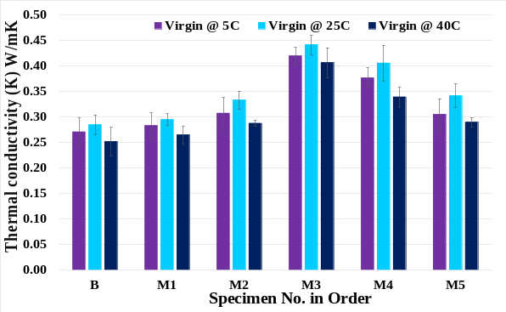 | 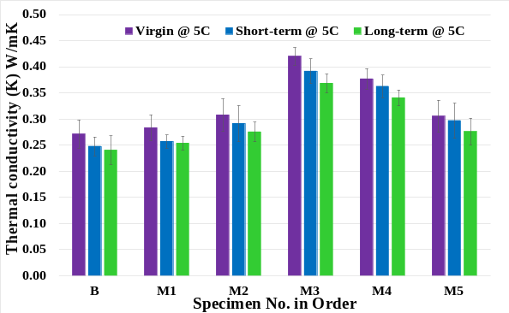
Fig. 4: Thermal conductivity @ virgin condition at all test temperatures | Fig. 5: Thermal conductivity @ Virgin, short-term and long-term at 5 °C
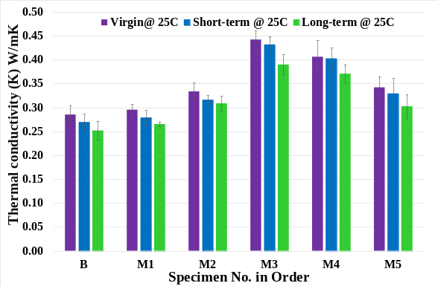 | 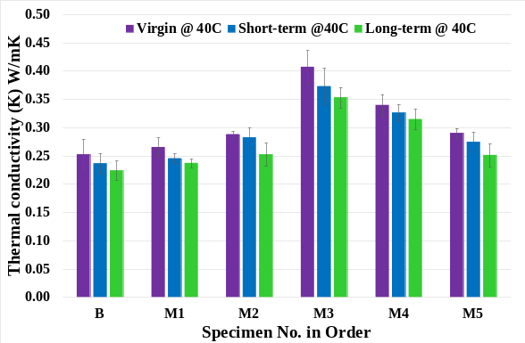
Fig. 6: Thermal conductivity @ Virgin, short-term and long-term at 25 °C | Fig. 7: Thermal conductivity @ Virgin, short-term and long-term at40 °C

3.2.1 Thermal conductivity at virgin condition

Fig. 4 shows that temperature variations have a clear influence on the thermal conductivity of the mastics. All mixtures exhibit a 5–15% increase in conductivity from 5 °C to 25 °C, followed by a 5–10% decrease at 40 °C. The increase at 25 °C is associated with reduced matrix stiffness and improved particle contact, whereas the decrease at 5 °C likely results from matrix stiffening and diminished inter-particle contact. The drop at 40 °C may be related to softening or structural changes in the mastic matrix that interrupt stable conductive pathways. The highest thermal conductivity is observed for M3 at 25 °C (0.44 W/m·K), while the lowest is recorded for M1 at 40 °C (0.25 W/m·K). M3 consistently demonstrates superior thermal performance across all tested temperatures, which is attributed to the incorporation of graphite that effectively enhances the continuity and efficiency of the conductive network.

3.2.2 Impact of ageing

Figs. 5-7 presents thermal conductivity of all mastic in their virgin, ST and LT aged state tested at 5 °C, 25 °C & 40 °C. It can be seen that conductivity decreases with ageing across all specimens but among all tested combinations, M3 and M4 performing best under all ageing conditions. The age-related reduction is likely due to Oxidation of the bitumen matrix leading to increased brittleness and reduced filler mobility. The influence of test temperature on all aged condition appears to be marginal. Overall, thermal conductivity was found to be 10-15% higher at 25 °C compared to both 5 °C and 40 °C at all aged condition. While these findings are not definitive, they suggest that climatic conditions could play a role in the heat flow within a mixture. Moreover, this pattern was consistent across both short-term and long-term aged specimens. Thermal conductivity was found, irrespective of mastic type, reduced by 2.33-10.81% virgin to short-term and 6.45-17.14% virgin to long-term ageing at all mastic specimens. The high conductivity enables more efficient heat transfer, potentially enhancing the self-healing of microcracks within the mixture, particularly during summer or when an external heat source is applied. Furthermore, it may improve the mixture's workability during the laying and compaction.
3.2.3 Impact of filler type
In order to evaluate the impact of filler on mastics thermal conductivity, Table 3 presents percentage increase compared to pure bitumen. The conventional mastic (M1) shows lower thermal conductivity compared to all other formulations, with only a modest increase of around 3–5% relative to the control bitumen. In contrast, the graphene, graphite and magnetite-based mastics (M3–M5) demonstrated a notable improvement, with thermal conductivity increasing by 12–60%. These higher values remained largely consistent even after short-term and long-term ageing. This is beneficial, as improved thermal conductivity can enhance heat transfer throughout the material’s service life, potentially aiding the healing of microcracks during warmer periods and promoting better interaction with fresh material during resurfacing.

Table 3: Percentage increases in thermal conductivity of mixtures compared to control bitumen.

Ageing condition | Test temperature (⁰C) | Percentage of thermal conductivity (%) increase compared to the control bitumen
Ageing condition | Test temperature (⁰C) | M1 | M2 | M3 | M4 | M5
Virgin | 5 | 4.42 | 13.5 | 54.87 | 38.94 | 12.61
Virgin | 25 | 3.58 | 16.98 | 61.38 | 42.46 | 20
Virgin | 40 | 5.15 | 14.2 | 55.09 | 34.66 | 14.99
Short-term oven aged | 5 | 3.71 | 17.59 | 58.03 | 46.33 | 19.85
Short-term oven aged | 25 | 3.57 | 17.4 | 60.52 | 49.67 | 22.38
Short-term oven aged | 40 | 3.9 | 19.55 | 57.83 | 37.95 | 19.22
Long-term oven aged | 5 | 5.57 | 14.56 | 53.24 | 41.68 | 14.81
Long-term oven aged | 25 | 5.32 | 18.45 | 49.81 | 42.35 | 16.14
Long-term oven aged | 40 | 5.9 | 12.69 | 57.73 | 40.57 | 12.24

3.2.4 Specific heat and diffusivity

Materials with high specific heat and low diffusivity offer better thermal stability, energy storage, and protection against overheating. The specific heat capacity and diffusivity for all mastics including control bitumen (B) is shown in Figs. 8a & 8b.
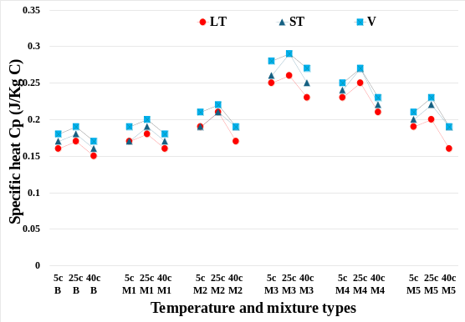 | 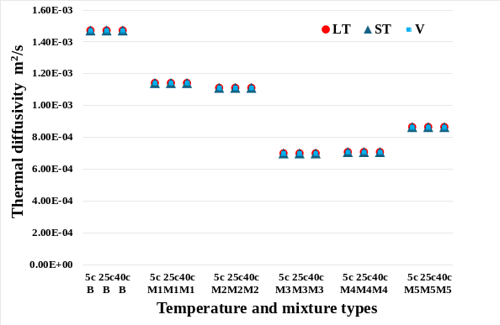
Fig. 8a: Temperature (°C ) and mixture types of vs Specific heat | Fig. 8b: Temperature (°C ) and mixture types of vs Diffusivity

It is clear from results that the conductive mastic shows a notable improvement in heat capacity (Fig. 8a) compared to regular bitumen and conventional mastic across all tested temperatures and ageing conditions. While ageing generally led to a reduction in heat capacity, the M3 mastic still performed around 40–55% better than both bitumen and conventional mastic. Other mixes (M2, M4, and M5) also demonstrated noticeable improvements, suggesting that regardless of the type or amount of conductive filler used, their inclusion helps to enhance the thermal stability and heat storage capacity of the mastic. Likewise, as expected, the thermal diffusivity (Fig. 8b) of all conductive mastics was lower than that of the control and conventional mastic, pointing to better heat retention and improved thermal stability [43].

  - Rheological properties

To investigate the viscoelastic behaviour of both virgin and aged mastic, the results of Dynamic Shear Rheometer (DSR) tests conducted at various temperatures and frequencies are analysed and presented below.

    - Complex modulus and phase angle (virgin and long-term aged)

The study focused on rheological analyses of virgin and long-term aged bituminous mastics, with short-term aged specimens excluded from frequency sweep tests. This approach is consistent with the findings of Airey and Rahman [45], who reported that short-term ageing primarily captures early-stage changes during production, resulting in relatively minor alterations in rheological properties compared with long-term ageing.

To demonstrate how the material behaves across a broad range of frequencies, master curves for both phase angle and complex modulus were produced at 40 °C. These curves reflect the viscoelastic characteristics of the conductive mastic over an extended frequency range. The application of the Time–Temperature Superposition Principle (TTSP) enables the construction of master curves that extend the predictive capability of the material’s performance beyond the experimental frequency and temperature range, thereby facilitating the simulation of real-world traffic loading conditions, from slow-moving to high-speed vehicles, under varying thermal environments [41]. The master curves for phase angle and complex modulus are shown in Figs. 9–12.
The time–temperature superposition principle was applied and the Williams-Landel-Ferry (WLF) equation was used to determine shift factors, as shown in Eq. 3.

$$\log{a\left(T\right)=\frac{C_{1}\left(T-T_{ref}\right)}{C_{2}+\left(T-T_{ref}\right)}}$$ | …………. (3)
Where:
a(T) = Shift factor at temperature T
C₁, C₂ = Coefficient to be determined in the WLF equation.
T, T_{ref} = Temperature, reference temperature. From the slope and intercept of the linear form of the WLF equation with respect to the reference temperature.

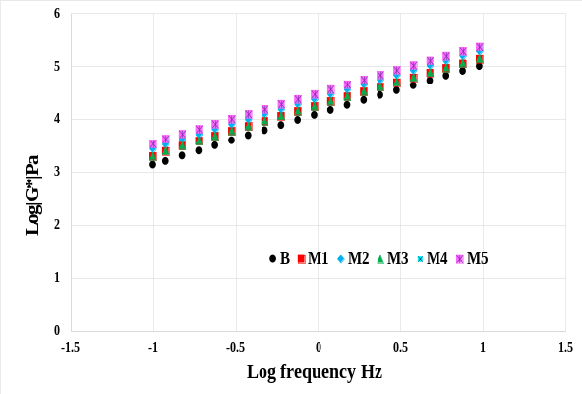 | 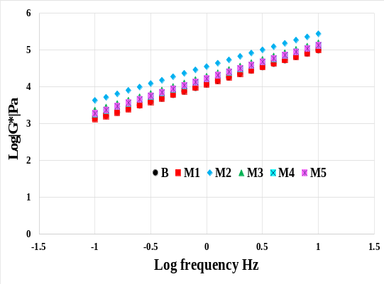
Fig. 9: Complex modulus master curve @ 40 °C for virgin mastic | Fig. 10: Complex modulus master curve @ 40 °C for aged mastic
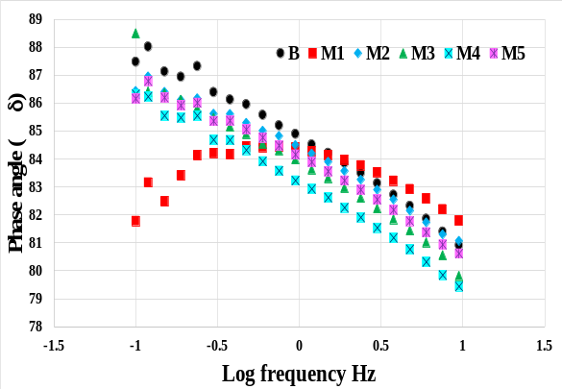 | 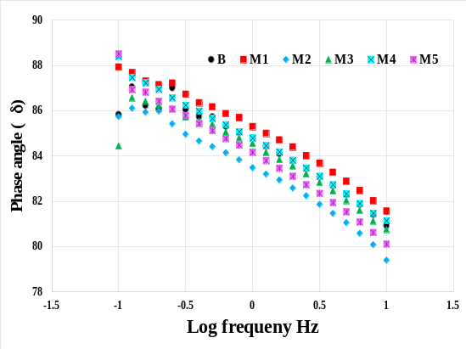
Fig. 11: Phase angle master curve @ 40 °C for virgin mastic | Fig. 12: Phase angle master curve @ 40 °C for aged mastic

The reference temperature of 40 °C was selected because it is commonly used in asphalt binder rheological testing according to AASHTO M 320 and AASHTO T 315 [51], representing a typical high service temperature for pavement applications in moderate climates. Using 40 °C as the reference allows consistent comparison of phase angle and complex modulus with previous studies and ensures that the master curves reflect realistic high-temperature performance relevant to asphalt mixture design [51]. Figs. 9-10. Frequency dependence of the storage modulus (Log G′) for virgin and aged samples. B and M1 show an increase in modulus after ageing, indicating stiffening, whereas the conductive mixes (M2–M5), on the other hand, show a lower modulus that supports flexibility and better anti-ageing behaviour, accompanied by only slight changes in phase angle (as illustrated in Figs. 11-12) in both the virgin and long-term aged conditions, indicating robust viscoelastic behaviour of conductive mastics (M2-M5) across a wide frequency spectrum. The presence of conductive fillers enhances both stiffness and stability, making this material suitable for high-performance pavement applications.

To illustrate the material response across a wide range of frequencies, additionally, the values corresponding to frequencies of 1 Hz and 15 Hz are summarised in Tables 4a and 4b. When examining the impact of ageing, as shown in Table 4a, the complex moduli of most conductive mastics have decreased, with reductions ranging from 10-15%, and even up to 50% for M3 (67% B + 10% LS + 10% GR + 10% MT + 3% GN) and M4 (67% B + 20% LS + 10% MT + 3% GN), as shown in Tables 4a and 4b. This observation is unexpected, as mastic moduli are typically expected to increase with ageing, as in B & M1. On the other hand, the results in Table 4b, suggests that irrespective of mastic type, the elasticity only reduces by 10-15% and remain relatively consistent with ageing.

Table 4a: Complex modulus at 20 °C and 40 °C
Mastic ID | Complex Modulus (MPa) @ 20 °C |  |  |  | Complex Modulus (MPa) @ 40 °C
Mastic ID | 1 Hz |  | 15 Hz |  | 1 Hz |  | 15 Hz
Mastic ID | virgin | LTA | virgin | LTA | virgin | LTA | virgin | LTA
B | 0.19 | 0.92 | 1.30 | 6.63 | 0.02 | 0.01 | 0.20 | 0.15
M1 | 0.28 | 1.17 | 2.15 | 8.17 | 0.01 | 0.01 | 0.12 | 0.15
M2 | 2.15 | 1.35 | 11.26 | 8.24 | 0.05 | 0.03 | 0.45 | 0.27
M3 | 4.25 | 2.09 | 16.51 | 10.79 | 0.07 | 0.03 | 0.67 | 0.28
M4 | 3.31 | 1.35 | 14.77 | 7.08 | 0.05 | 0.02 | 0.44 | 0.24
M5 | 3.44 | 2.06 | 17.66 | 11.45 | 0.04 | 0.02 | 0.39 | 0.24

Table 4b: Phase angle at 20 °C and 40 °C
Mastic ID | Phase Angle (º) @ 20 °C |  |  |  | Phase Angle (º) @ 40 °C
Mastic ID | 1 Hz |  | 15 Hz |  | 1 Hz |  | 15 Hz
Mastic ID | virgin | LTA | virgin | LTA | virgin | LTA | virgin | LTA
B | 72 | 71 | 63 | 60 | 84 | 84 | 78 | 80
M1 | 76 | 71 | 68 | 60 | 84 | 85 | 80 | 81
M2 | 68 | 67 | 59 | 57 | 83 | 84 | 79 | 78
M3 | 64 | 68 | 55 | 57 | 83 | 84 | 77 | 79
M4 | 66 | 68 | 56 | 58 | 82 | 84 | 77 | 78
M5 | 68 | 67 | 58 | 56 | 84 | 83 | 79 | 78

To determine the cause of moduli reduction, whether it was due to higher strain rate (1%) leading to internal damage of the mastic, additional tests were conducted. These tests involved repeating the experiments for all mixtures at a strain rate of 1% and further investigations on the M2 mix (67% B + 3% GN+ 30% LS) at reduced strain rates of 0.5% and 0.1%. In the repeating the tests, it was observed that there were no changes in modulus compared to the previous series of tests, both in the virgin and LT aged conditions. This finding suggests that the reduction in modulus is not caused by internal damage.

Moreover, the tests conducted at reduced strain rates revealed a consistent trend of complex moduli reduction with ageing across all frequencies and test temperatures. The findings at 1Hz and 15Hz, as well as at 20 °C and 40 °C, are summarised in Table 5.

Table 5: Complex modulus and phase angle at different strain rate
Mastic M3  V=Virgin  A= Aged | Complex modulus (MPa) |  |  |  |  |  | Phase Angle (Degree)
Mastic M3  V=Virgin  A= Aged | 1 Hz |  |  | 15 Hz |  |  | 1 Hz |  |  | 15 Hz
Mastic M3  V=Virgin  A= Aged | Strain rate |  |  |  |  |  | Strain rate
Mastic M3  V=Virgin  A= Aged | 0.1 % | 0.5% | 1% | 0.1% | 0.5% | 1% | 0.1% | 0.5% | 1% | 0.1% | 0.5% | 1%
M2, V@40 °C | 0.07 | 0.05 | 0.05 | 0.71 | 0.57 | 0.50 | 79.7 | 82.7 | 83.3 | 76.5 | 78.1 | 77.6
M2, A@40 °C | 0.03 | 0.03 | 0.03 | 0.29 | 0.30 | 0.34 | 82.8 | 83.0 | 82.0 | 77.5 | 76.7 | 75.8
M2, V@20 °C | 4.46 | 3.72 | 2.51 | 25.70 | 22.60 | 13.0 | 65.0 | 69.6 | 69.0 | 53.0 | 59.1 | 60.3
M2, A@20 °C | 2.98 | 1.23 | 1.33 | 17.39 | 7.34 | 6.68 | 65.3 | 66.0 | 63.4 | 53.9 | 54.5 | 52.5

The results demonstrate that regardless of the strain rate, the overall moduli decreased in the aged condition during both low and high frequency testing. Conversely, the phase angle exhibited a slight increase in the aged condition, suggesting that the ductility of the conductive mastic remained relatively unchanged. The reduction of complex moduli is probably due to the microstructural changes in the mixture matrix. The results indicate that conductive mastics may have the potential to exhibit improved anti-ageing, rheological and self-healing properties.
3.3.2 Rutting performance

In terms of the rutting parameter G∗/sin δ, it is crucial to ensure that the asphalt binder is sufficiently stiff to resist applied stresses and elastic enough to recover its original shape once those stresses are removed. This parameter reflects the binder’s resistance to rutting under repeated heavy traffic loading. With each loading cycle, the elastic portion of the binder helps recover some of the stress, while the remainder is dissipated as heat, deformation, or crack propagation. According to Superpave specifications, a minimum bond strength of 1 kPa is required for unaged asphalt binders to ensure adequate rutting resistance. Since rutting typically occurs in the early life of the pavement, there are no specified limits for this parameter in long-term aged binders [32]. As illustrated in Figs. 13 and 14, which show the rutting parameter as a function of temperature at 1 Hz and 15 Hz.
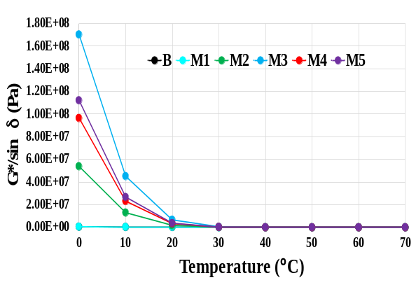 | 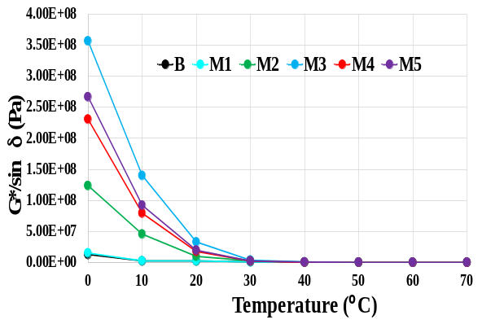
Fig. 13: Rutting parameter @ 1Hz | Fig. 14: Rutting parameter @ 15Hz

As anticipated, the rutting parameter (G*/sin δ) exhibited an exponential decline with increasing temperature, reflecting the typical softening behaviour of bituminous materials under thermal loading. Conductive mastics demonstrated markedly higher resistance at lower temperatures, indicating enhanced stiffness and deformation resistance in cooler conditions. However, beyond 40°C, to examine further, the results at 40 °C to 70 °C are summarised in Table 6.

Table 6: Rutting parameter at 1Hz & 15Hz
Mastic ID | 40 °C MPa |  | 50 °C MPa |  | 60 °C MPa |  | 70 °C MPa
Mastic ID | 1Hz | 15Hz | 1Hz | 15Hz | 1Hz | 15Hz | 1Hz | 15Hz
B | 0.0148 | 0.1495 | 0.0027 | 0.0301 | 0.0006 | 0.0073 | 0.0002 | 0.0021
M1 | 0.0113 | 0.1157 | 0.0021 | 0.0235 | 0.0005 | 0.0057 | 0.0002 | 0.0017
M2 | 0.0477 | 0.3912 | 0.0097 | 0.0839 | 0.0026 | 0.0220 | 0.0009 | 0.0071
M3 | 0.0668 | 0.5566 | 0.0125 | 0.1199 | 0.0033 | 0.0319 | 0.0012 | 0.0108
M4 | 0.0355 | 0.3142 | 0.0066 | 0.0647 | 0.0016 | 0.0165 | 0.0005 | 0.0052
M5 | 0.0364 | 0.3283 | 0.0066 | 0.0658 | 0.0016 | 0.0170 | 0.0005 | 0.0055

It is evident that, in comparison to pure bitumen (B) and the control mastic (M1), the conductive mastics consistently exhibited substantially greater rutting resistance at elevated temperatures ranging from 40 °C to 70 °C, with improvements of approximately 100–400% under both slow (1 Hz) and fast (15 Hz) loading conditions. For instance, at 60 °C, modified mastic M2 (comprising 67% bitumen, 3% graphene and 30% limestone) achieved bond strengths of 0.0026 MPa (2.6 kPa) at 1 Hz and 0.0220 MPa (22 kPa) at 15 Hz, while M3 (67% bitumen, 10% limestone, 10% graphite, 10% magnetite and 3% graphene) recorded 0.0033 MPa (3.3 kPa) at 1 Hz and ) 0.0319 MPa (31.9 kPa) at 15 Hz. These findings highlight the considerable improvement in rutting resistance provided by the inclusion of hard conductive fillers, particularly under high-temperature conditions.

3.3.3 Fatigue performance
Fatigue in asphalt materials is generally associated with low to intermediate temperature ranges, typically between 0 °C and 30 °C and occurs after years of service and under repeated traffic loading. The fatigue parameter G∗ sin δ, is representative of fatigue characteristics of bitumen. The Superpave specification limits the fatigue parameter to a maximum of 5,000 kPa to ensure adequate flexibility and resistance to cracking [44]. The fatigue parameter against temperature at 1 Hz and 15 Hz is presented in Figs. 15 and 16.

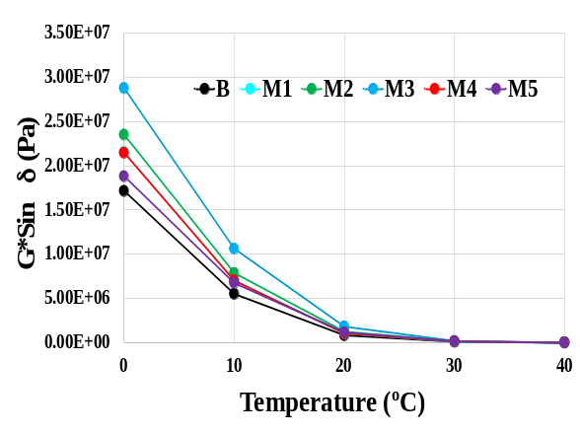 | 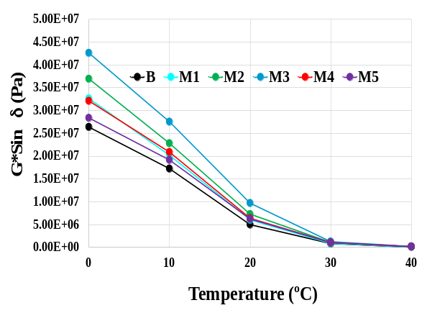
Fig.15: Fatigue Parameter @ 1Hz | Fig.16: Fatigue Parameter @ 15Hz

As expected, the fatigue parameter showed an exponential decline with increasing temperature, which is typical of the softening behaviour of bituminous materials under thermal stress. The conductive mastics exhibited noticeably higher resistance at lower temperatures, indicating better resistance to fatigue at low to intermediate temperature i.e., 20 °C. In order to conduct a comparative analysis, the results at 1Hz and 15Hz are summarised in Table 7.
Table 7: Fatigue parameter at 1Hz & 15Hz
Mastic ID | 0 °C MPa |  | 10 °C MPa |  | 20 °C MPa |  | 30 °C MPa
Mastic ID | 1Hz | 15Hz | 1Hz | 15Hz | 1Hz | 15Hz | 1Hz | 15Hz
B | 17.15 | 26.38 | 5.51 | 17.26 | 0.82 | 5.00 | 0.11 | 0.84
M1 | 21.52 | 32.62 | 7.06 | 20.18 | 1.04 | 6.05 | 0.11 | 0.89
M2 | 23.50 | 36.94 | 7.87 | 22.80 | 1.24 | 7.28 | 0.15 | 1.08
M3 | 28.77 | 42.60 | 10.62 | 27.52 | 1.81 | 9.71 | 0.18 | 1.27
M4 | 21.46 | 32.10 | 7.00 | 20.88 | 1.03 | 6.39 | 0.15 | 1.08
M5 | 18.81 | 28.37 | 6.74 | 19.16 | 1.16 | 6.23 | 0.15 | 1.06

It can be seen that, with the exception of M5, the conductive mastics generally exhibit improved performance over pure bitumen (B) and the control mastic (M1) across the temperature range of 0 °C to 30 °C. The improvement is more pronounced at higher frequencies (15 Hz) and ranges from approximately 25–120% in G∗ sin δ. At lower frequencies (1 Hz), some mastics, such as M4, show performance comparable to or slightly lower than M1 at 10–20 °C. Among the tested formulations, M3 (67% bitumen + 10% limestone + 10% graphite + 10% magnetite + 3% graphene) exhibited the highest performance, followed by M2 (67% bitumen + 3% graphene + 30% limestone) and M4 (67% bitumen + 3% graphene + 10% magnetite + 20% limestone). Overall, these results indicate that conductive mastics can enhance the mechanical response under repeated loading, with the degree of improvement depending on both temperature and loading frequency.

3.3.4 Structural Integrity
In order to evaluate the structural integrity and time-temperature equivalency of the mastic combinations [33], the complex modules vs phase angle, known as black diagrams, are plotted for all virgin and aged combinations and presented in Figs. 17 and 18.
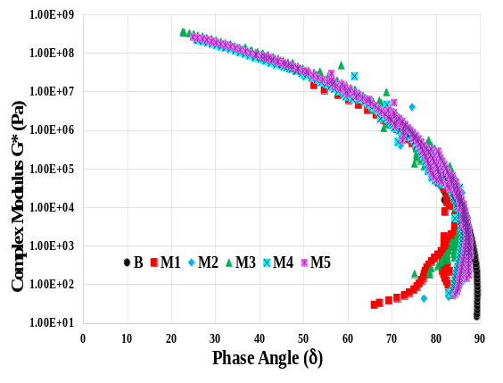 | 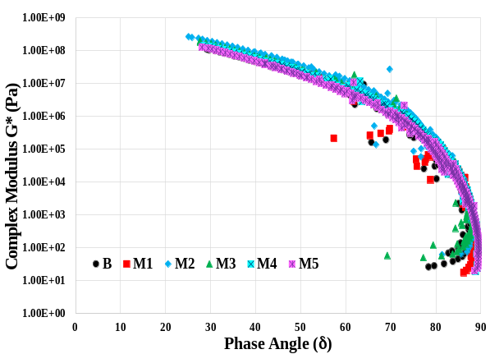
Fig. 17: Black diagram at virgin condition | Fig. 18: Black diagram at aged condition

The Black diagram evaluates bitumen's viscoelastic behaviour without TTSP, identifying anomalies and distinguishing binder types through smoothness of curves [33]. The addition of conductive fillers M2–M4 significantly increases stiffness compared to B and M1. As shown in (Fig. 17), M3, which exhibits the highest complex modulus (G*) and the lowest phase angle (δ), is the stiffest and most elastic under unaged conditions. M5 demonstrates a moderate improvement over B but slightly underperforms compared to the other modified mixtures. Overall, the incorporation of conductive mastics enhances viscoelastic performance, improving both stiffness and elastic response.
The analysis revealed some rheological inconsistencies in pure bitumen (B) and conventional mastic (M1) due to ageing (Fig. 18), indicating microstructural changes and possible reduction in rheological stability and potential susceptibility to long-term performance issues such as cracking or stiffness loss. While mixes M2–M5 either maintain similar or marginally better thermorheologically behaviour, indicating improved strength and formulation stability, as well as long-term durability.

3.3.5 Long-term cracking performance
The Glover-Rowe (G-R) parameter, a rheological index, is used to assess how likely an asphalt binder is to crack due to long-term ageing [36-39]. Although the method is developed for bitumen, researchers have used the same concept for mastic [40] and asphalt mixture [41]. In order to do the analysis, the complex shear modulus (G*) and phase angle (δ) at 10 °C and 0.1 Hz from the DSR frequency sweep test was used. According to Glover- Rowe, a G-R value of 180 kPa (Eq. 1) signals the beginning of damage in the binder. If the value exceeds 600 kPa (Eq. 2), the binder is considered highly susceptible to block cracking in pavements [40]. On a Black Space plot (complex modulus against phase angle plot), a binder’s position relative to this "damage zone" helps indicate its resistance to cracking.
Damage onset: G∗ (cosδ)² /sinδ=180 kPa………….(1)
Significant cracking: G∗ (cosδ)² /sinδ=600 kPa ………….(2)
Fig. 19 presents the Black Space diagram with Glover–Rowe (G-R) parameters for various conductive mastics and the control bitumen. Mastic M5, comprising 25% limestone, 5% magnetite and 3% graphene, exhibits the most favourable performance, with a G-R parameter of 192 kPa, indicating the lowest risk of cracking based on the damage onset criterion. This is followed by the control binder (B) at 286 kPa, M4 at 321 kPa, M1 at 351 and M3 at 388 kPa. The higher G-R value of the control sample is attributed to the use of a softer bitumen grade (100/150), which may compromise both mechanical and thermal performance.
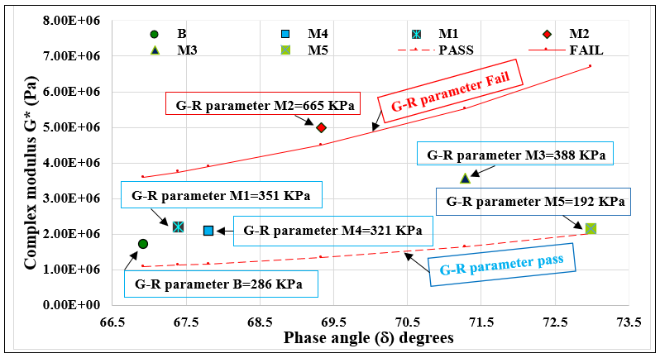
Fig. 19: Black space diagram of different mastic

Mastic M2 exhibits the highest G-R value (665 kPa), showing the greatest susceptibility to cracking. While conductive fillers generally improve cracking resistance, performance is highly formulation dependent. In this case, M2 (3% graphene + limestone, without graphite or magnetite) exceeded the critical threshold of 600 kPa, reflecting poorer cracking resistance due to the lack of synergistic interactions among multiple fillers. These values demonstrate that as bitumen ages, it becomes increasingly brittle, shifting upwards on the diagram and indicating higher cracking potential. In formulations such as M2, the G–R parameter considerably exceeds the critical threshold. To provide a more balanced discussion, it could be emphasised that the beneficial effects of conductive fillers are formulation dependent. If the formulation is not well optimised, as in the case of M2, the addition of conductive fillers may even adversely affect long-term cracking resistance.
The incorporation of conductive fillers mitigates this effect, enhancing flexibility and resistance to cracking as evidenced by the downward shift in position on the diagram. In order to compare between virgin and long-term aged state, the G-R parameters were compared and presented in Fig. 20.
Fig. 20: Comparison of G-R parameter Virgin and Long-term aged conditions

The G–R parameter analysis indicated that samples B, M1, and M2 exhibited a significant increase in stiffness after ageing, with values more than doubling compared to their original (unaged) state. In contrast, samples M3, M4 and M5 decreased to 51-69% of their original values. These findings suggest that the use of conductive fillers helps improve long-term performance by reducing the negative effects of ageing.
These findings highlight the synergistic role of multi-filler systems (graphite, magnetite, graphene) in mitigating ageing effects, which has not been systematically addressed in earlier studies [26]. Furthermore, the application of the Glover–Rowe (G-R) parameter provides new insights into the cracking potential of conductive mastics, offering a more rigorous evaluation of long-term durability.

3.3.6 Enhancing Conductive Mastic Performance

The study highlights that the performance and selection of conductive mastics combination depends on the synergistic interaction of fillers and the balance between functionality, complementary benefits and cost. For example, graphite and magnetite, a low-cost material, provides economical bulk conductivity, while a relatively expensive graphene enhances thermal stability and overall conductivity due to its superior electrical and surface properties. Together, they establish efficient thermal pathways with conventional filler that support localised self-healing. Magnetite further contributes by improving density and particle packing, reducing voids and increasing stiffness and durability under load. Achieving uniform filler dispersion is crucial for maintaining continuous conductive networks and preventing weak zones caused by particle clustering. This uniform distribution enhances the thermal and rheological properties of the mastics, improving their resistance to cracking and deformation. These properties are expected to further enhance the adhesion and cohesion characteristics of the conductive asphalt mixture, resulting in improved thermal and mechanical performance and consequently, greater durability in pavement applications.

4. CONCLUSIONS

Based on the experimental investigations, the following conclusions can be drawn regarding the impact of ageing on the thermal and rheological properties of conductive mastics:

(i) Mixture consistency: Needle penetration testing revealed that all conductive mastics show approximately 20% lower penetration than conventional mastic, but maintained consistent ageing trends, with reductions of 6–12% after long-term ageing. The test reliably highlights local consistency and ageing behaviour despite its empirical, point-based nature limiting the ability to fully characterise mixture homogeneity. Overall, the inclusion of conductive fillers does not accelerate bitumen oxidation, confirming their compatibility in modified mastics.

(ii) Thermal properties: The addition of conductive fillers improved the thermal conductivity of bituminous mastics compared to pure bitumen and conventional formulations, showing increases of 12–60% across low (5 °C), moderate (25 °C), and elevated (40 °C) temperatures. A maximum value of 0.44 W/m·K was observed at 25 °C. Although the measurements were taken at relatively broad temperature intervals, the results suggest an overall enhancement in the thermal performance of the conductive mastics. Conductive mastics also exhibit higher specific heat capacity 40–55% greater than pure bitumen and conventional mastic and lower thermal diffusivity, leading to better heat retention and stability. Ageing reduces thermal conductivity by 2–17%, depending on the filler type, but mastics with multiple conductive fillers maintain the best performance. These enhancements can improve microcrack healing and facilitate heat transfer during paving and service.

(iii) Rheological properties

Impact of ageing: Conductive mastics demonstrated improved resistance to ageing compared with conventional mastics. The increase in complex modulus after ageing remained within 10–50%, suggesting moderate stiffness development and enhanced load-bearing capacity without significant brittleness. Similarly, the phase angle showed only minor changes (≤10–15%), indicating that conductive fillers contributed to maintaining a balanced elastic response over extended ageing periods.
Rutting resistance: At elevated temperatures, conductive mastics demonstrated a substantial enhancement in rutting resistance, with improvements of 100–400% over pure bitumen. This superior performance highlights their ability to maintain structural integrity under heavy traffic loading and high-temperature conditions, ensuring long-term stability of pavement structures.

Cracking resistance: The addition of conductive fillers improved fatigue performance, reducing susceptibility to cracking under repeated loads. Among the mastics, M3 exhibited the highest fatigue resistance, with improvements of approximately 68% at 0 °C, 59% at 10 °C and 120% at 20 °C compared to the control, indicating enhanced durability and extended service life.

Furthermore, the G-R parameter, applied here for the first time to conductive mastics, offered valuable insights into long-term cracking behaviour. The results indicated that conductive fillers effectively reduced cracking susceptibility, with M3, M4 and M5 decreasing to 51–69% of their original values after ageing, attributed to the synergistic effect of multiple fillers.

Overall, among all formulations, the M3 system (graphite + magnetite + graphene) showed the best performance, combining enhanced rutting and fatigue resistance with the lowest G-R values after ageing. The study confirms the synergistic anti-ageing mechanisms of multi-filler conductive mastics and validates the G-R parameter as a reliable indicator of cracking resistance. Economically, graphite offers a cost-effective alternative to graphene and their hybrid use provides an optimal balance between performance and affordability. Conductive mastics demonstrate strong potential for durable, multifunctional and large-scale pavement applications.

The effects of conductive fillers are not universal but dependent on the specific formulation. While the Conclusion emphasises their benefits, it should also recognise that certain formulations, such as M2 where the G-R parameter greatly exceeded the critical threshold can negatively impact long-term cracking resistance.

Future research could focus on further optimising filler combinations for different climatic conditions and exploring in greater depth how conductive mastics affect the mechanical, thermal and durability performance of asphalt mixtures. Such studies would help to refine material selection and pavement design strategies, contributing to more durable and reliable road surfaces across diverse service environments.

Availability of Data and Materials
Available upon reasonable request from the corresponding author.

REFERENCES

[1] Xu, S., Zhao, Z., Wang, H., Wan, C., Wang, X., Wang, Z., & Zhang, X. (2025). Fatigue Failure Criteria of Asphalt Binders and Asphalt Mixtures: A Comprehensive Review. Materials, 18(14), 3267. https://doi.org/10.3390/ma18143267
[2] Delaporte B., Benedetto D., Chaverot P. H., & Gauthier G. (2008). Effect of ultrafine particles on linear viscoelastic properties of mastics and asphalt concretes. Transportation Research Record, 2051, 41–48. doi: 10.3141/2051-06.
[3] Wang, Z., Jin, X., Sun, Y., & Wang, S. (2024). Micromechanics approach to calculate the adsorbed asphalt film thickness on mineral fillers and evaluate physiochemical interactions. International Journal of Pavement Engineering, 25(1). https://doi.org/10.1080/10298436.2024.2303670
[4] Cui, Y., Si, C., Li, S., Jia, Y., & Guo, B. (2024). Iron Tailings as Mineral Fillers and Their Effect on the Fatigue Performance of Asphalt Mastic. Materials, 17(12), 2927. https://doi.org/10.3390/ma17122927
[5] Dash, S. B., Choudhary, R., Kumar, A., & Sharma, A. (2024). Characterization of Asphalt Filler Mastics with Industrial By-Products as Fillers under the Coupled Effect of Aging and Moisture. Transportation Research Record. https://doi.org/10.1177/03611981241240763
[6] Remišová E., and Holý M. (2017). Changes of Properties of Bitumen Binders by Additives Application. IOP Conference Series: Materials Science and Engineering, Volume 245, Issue 3.
[7] Petersen C. J. (1984). “Chemical composition of asphalt as related to asphalt durability—state of the art,” Transportation Research Record, vol. 999, pp. 13–30.
[8] Stępień, J., Dudała, M., Maciejewski, K., Ramiączek, P., & Iwański, M. M. (2025). Influence of Compaction Methods on Properties of Roller-Compacted Concrete Pavement Wearing Surfaces. Materials, 18(3), 492. https://doi.org/10.3390/ma18030492
[9] Shaopeng W., Mingyu C., Jizhe Z. (2011). Laboratory investigation into thermal response of asphalt pavements as solar collector by application of small-scale slabs, Appl. Therm. Eng. 31 (10) 1582–1587.
[10] Wang H., Wu S., Chen M., Zhang Y. (2010). Numerical simulation on the thermal response of heat-conducting asphalt pavements, Phys. Scr., T 42 (38).
[11] Gürer C., Fidan U., Icon O., & Korkmaz E. B. (2022). Investigation of using conductive asphalt concrete with carbon fiber additives in intelligent anti-icing systems, international journal of pavement engineering. https://doi.org/10.1080/10298436.2022.2077941
[12] Hasan R., Mehta Y., Decarlo C., Elshaer M. (2021). Laboratory Evaluation of Electrically Conductive Asphalt Mixtures for Snow and Ice Removal Applications, Transportation Research Record: Journal of the Transportation Research Board, Volume 2675, Issue 8. https://doi.org/10.1177/03611981219958
[13] Wu S., Mo L., Shui Z., & Chen Z. (2005). Investigation of the conductivity of asphalt concrete containing conductive fillers. Carbon, 43(7), 1358-1363.
[14] Wu S., Pan P., Chen M., & Zhang Y. (2013). Analysis of characteristics of electrically conductive asphalt concrete prepared by multiplex conductive materials. Journal of materials in civil engineering, 25(7), 871-879.
[15] Vo H. V., Park D. W., Seo W. J., & Yoo B. S. (2017). Evaluation of asphalt mixture modified with graphite and carbon fibers for winter adaptation: Thermal conductivity improvement. Journal of Materials in Civil Engineering, 29(1), 04016176.
[16] Pan, P., Wu, S., Xiao, Y., Wang, P., & Liu, X. (2014). Influence of graphite on the thermal characteristics and anti-ageing properties of asphalt binder. Construction and Building Materials, 68, 220–226. https://doi.org/10.1016/j.conbuildmat.2014.06.018
[17] Qu X., Liu Q., Guo M., Wang D., & Oeser M. (2018). Study on the effect of aging on physical properties of asphalt binder from a microscale perspective. Construction and Building Materials, 187, 718-729. https://doi.org/10.1016/j.conbuildmat.2018.07.188
[18] Oliviero R. C., Spadafora A., Teltayev B., Izmailova G., Amerbayev Y., & Bortolotti V. (2015). Polymer modified bitumen: Rheological properties and structural characterization. Colloids and Surfaces A: Physicochemical and Engineering Aspects, 480, 390-397. https://doi.org/10.1016/j.colsurfa.2015.02.048
[19] Yang Z, Zhang X., Zhang Z., Zou B., Zhu Z., Lu G., Xu W., Yu J., & Yu H. (2018).
Effect of Aging on Chemical and Rheological Properties of Bitumen. Polymers, 10(12), 1345. https://doi.org/10.3390/polym10121345
[20] British Standards Institution. BS EN 13108–1:2016 Bituminous mixtures – Material specifications. British Standards Institution, London, UK

[21] Güler Ö., Bağcı N. (2020). A short review on mechanical properties of graphene reinforced metal matrix composites. Journal of Materials Research and Technology. Volume 9, Issue 3, P6808-6833.
[22] Perpetuus Advanced Materials, (2023, July 15) http://perpetuusam.com
[23] Inoxia Ltd - Woven Wire Mesh, Chemicals, Ball Milling, (2023, July 15) https://www.inoxia.co.uk
[24] Cho W., Kwon S., & Choi J. (2009). The thermal conductivity for granite with various water contents. Engineering Geology, 107(3-4), 167-171.
[25] Çanakci H., Demirboğa R., Burham K. M., & Şirin O. (2007). Thermal conductivity of limestone from Gaziantep (Turkey). Building and Environment, 42(4), 1777-1782.
[26] Nazki A. M., Chopra T., Chandrappa A. K. (2020). Rheological properties and thermal conductivity of bitumen binders modified with graphene. Construction and Building Materials. Volume 238, 117693.
[27] Liu Z., Gu X., Dong X., Cui B., & Hu D. (2023). Mechanism and performance of graphene modified asphalt: An experimental approach combined with molecular dynamic simulations. Case Studies in Construction Materials, 18, e01749. https://doi.org/10.1016/j.cscm.2022.e01749.
[28] A. Shalaby A. (2002). Modelling short-term aging of asphalt binders using the rolling thin film oven test. Can. J. Civ. Eng. 2002; 29:135–144. doi: 10.1139/l01-086.
[29] European Committee for Standardization; Brussels, Belgium: (2014). Bitumen and Bituminous Binders—Determination of the Resistance to Hardening under Influence of Heat and Air—Part 3: RFT Method.
[30] Verhasselt A. (2003). Short-and long-term ageing of bituminous binders-simulation with the RCAT method; Proceedings of the Sixth International RILEM Symposium on Performance Testing and Evaluation of Bituminous Materials; Zurich, Switzerland. pp. 167–173,14–16.
[31] American Society for Testing and Materials
ASTM D5930: (2001). Standard Test Method for Thermal Conductivity of Plastics by Means of a Transient Line-Source Technique. D.C. American Society for Testing and Materials, Washington.
[32] Al-Khateeb, G.G., Ramadan, K.Z. (2015). Investigation of the effect of rubber on rheological properties of asphalt binders using superpave DSR. KSCE J Civ Eng 19, 127–135. https://doi.org/10.1007/s12205-012-0629-2
[33] Wang H., Liu X., Apostolidis P., Scarpas T. (2018). Rheological behaviour and its chemical interpretation of crumb rubber modified asphalt containing warm-mix additives. Transport. Res. Rec. 578 2672(28), 337-348.
[34] Roesler J., Sen S. (2015). Impact of Pavements on the Urban Heat Island. Tier 1 University Transportation Michigan State University, Okemos.
[35] Ng S. C, Low S. K, Tioh H. N. (2011). Newspaper sandwiched aerated lightweight concrete wall panels–thermal inertia, transient thermal behaviour and surface temperature prediction
Energy Buildings, 43 (7), pp. 1636-1645.
[36] Glover C. J, Davison R. R, Domke C. H (2005). Development of a new method for assessing asphalt binder durability with field validation. Texas Dept Transp 1872:1–334
[37] Ahmed, R.B., Hossain K., Aurilio, M. (2021). Effect of rejuvenator type and dosage on rheological properties of short-term aged binders. Mater Struct 54, 109 (2021). https://doi.org/10.1617/s11527-021-01711-z
[38] Carpani, C., Bocci, E., & Bocci, M. (2025). Rheological and performance characterisation of cold bituminous mastics made with different bitumen emulsions and mineral fillers. Road Materials and Pavement Design, 26(sup1), 633–653. https://doi.org/10.1080/14680629.2025.2494077
[39] Mensching, D. J., Rowe, G. M., & Sias Daniel, J. (2016). A mixture-based Black Space parameter for low-temperature performance of hot mix asphalt. Road Materials and Pavement Design, 18(sup1), 404–425. https://doi.org/10.1080/14680629.2016.1266770
[40] Guo M., Guan M., Tan Y., & Du X. (2025): Using rheology to study the effect of aging on fatigue performance of asphalt binder, Road Materials and Pavement Design, DOI: 10.1080/14680629.2024.2447817
[41] Zhang, R., Sias, J. E., & Dave, E. V. (2022). Evaluation of the cracking and aging susceptibility of asphalt mixtures using viscoelastic properties and master curve parameters. Journal of Traffic and Transportation Engineering (English Edition), 9(1), 106-119. https://doi.org/10.1016/j.jtte.2020.09.002
[42] Jing, R., Varveri, A., Liu, X., Scarpas, A., & Erkens, S. (2019). Rheological, fatigue and relaxation properties of aged bitumen. International Journal of Pavement Engineering, 21(8), 1024–1033. https://doi.org/10.1080/10298436.2019.1654609
[43] Huang, Q., Qian, Z., Hu, J., & Zheng, D. (2020). Evaluation of Stone Mastic Asphalt Containing Ceramic Waste Aggregate for Cooling Asphalt Pavement. Materials, 13(13), 2964. https://doi.org/10.3390/ma13132964
[44] Chen, L., Chen, J., Li, M., Li, J., & Li, Y. (2023). Study of fatigue performance of fiber reinforced high-viscosity asphalt mastic based on rheology. Construction and Building Materials, 400, 132784. https://doi.org/10.1016/j.conbuildmat.2023.132784
[45] Airey, G., Rahman, M. and Collop, A. (2004) ‘Crumb rubber and bitumen interaction as a function of crude source and bitumen viscosity’, Road Materials and Pavement Design, 5(4), pp. 453–475.
[46] Wen, Y., Chen, C., Zhou, H., Li, X., Wang, X., Zhou, X., Xie, X., & Mai, Y. (2024). In situ three-roll mill exfoliation approach for fabricating asphalt/graphite nanoplatelet composites as thermal interface materials. Composites Science and Technology, 252, 110627. https://doi.org/10.1016/j.compscitech.2024.110627
[47]Li, Z., Guo, T., Chen, Y., Wang, Y., Niu, X., Tang, D., Hao, M., Zhao, X., & Liu, J. (2023). Preparation and Properties of Composite Graphene/Carbon Fiber Pouring Conductive Asphalt Concrete. Polymers, 15(8), 1864. https://doi.org/10.3390/polym15081864
[48] Hoang, HG.T., Nguyen, TA., Nguyen, HL. Ly, HB. (2025). An Effective Extreme Gradient Boosting Approach to Predict the Physical Properties of Graphene Oxide Modified Asphalt. Int. J. Pavement Res. Technol. (2025). https://doi.org/10.1007/s42947-025-00636-y
[49] Eskandarsefat, S., Allen, B., de Ferrariis, L. Raven, P., Sangalli, L.(2025). A Graphene-Enhanced Plastomeric Asphalt Modifier: A Case Study in Oxfordshire, UK. Int. J. Pavement Res. Technol. (2025). https://doi.org/10.1007/s42947-025-00600-w
[50] Najafi, M., Shafabakhsh, G., Moghimi, S. Rahmani, B. (2025) Experimental investigation of rheological characteristics of graphene nanoplatelets-modified asphalt binders at low and high temperatures. Innov. Infrastruct. Solut. 10, 474. https://doi.org/10.1007/s41062-025-02247-9
[51] American Association of State Highway and Transportation Officials (2024) Standard Method of Test for Determining the Rheological Properties of Asphalt Binder Using a Dynamic Shear Rheometer (DSR). Available at: https://store.accuristech.com/standards/aashto-t-315-24?product_id=293205
[52] Wu, S., and O. Tahri. (2021). “State-of-art carbon and graphene family nanomaterials for asphalt modification.” Road Mater. Pavement Des. 22 (4): 735–756. https://doi.org/10.1080/14680629.2019.1642946.

